**POWER-SHARING**

**Learning Points**

* Power Sharing
* Majoritarianism
* Ethnicity
* Community Government
* Civil War
* Prudential and Moral Power sharing
* Vertical Division of Power
* Reserved Constituencies
* Coalition Government

**Learning Outcomes**

Students will be able to….

* Define power sharing and explain its significance in a democratic society
* Understand examples of power sharing in different countries, such as Belgium and Sri Lanka.
* critically analyze the necessity and effectiveness of power sharing in various political systems.
* Connect theoretical concepts to real-life scenarios, such as local governance, community participation, and conflict resolution in diverse societies.

**Power-sharing:** Power-sharing is the distribution of power among the organs of the government like–legislature, executive, and judiciary. It is an intelligent step to ensure the stability of political order. Besides, power-sharing also includes sharing at the different levels like union, state, and local.

**Story of Belgium and Sri Lanka**

**Belgium:**

Belgium is a small European country, smaller in area than Haryana state.

**Borders:** France, the Netherlands, Germany, and Luxembourg.

**Population:** Just over one crore, with a complex ethnic composition.

**Language breakdown:** 59% Dutch speakers in Flemish region, 40% French speakers in Wallonia, and 1% German speakers. In Brussels, 80% speak French and 20% speak Dutch.

**Tensions:** Dutch-speaking community felt disadvantaged compared to the French-speaking minority, leading to conflicts in the 1950s and 1960s.

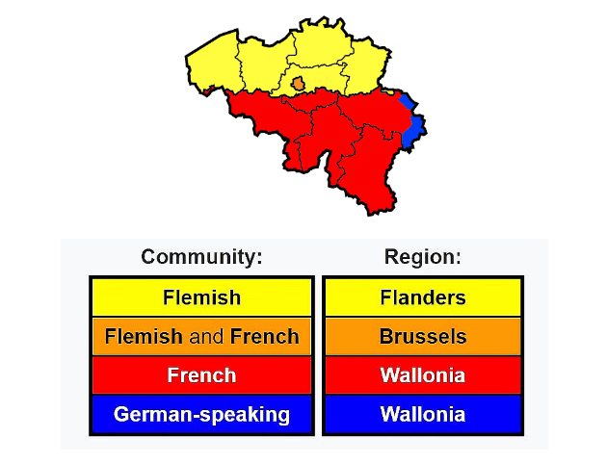

**Sri Lanka**

Sri Lanka is an island nation close to Tamil Nadu with a population similar to Haryana.

**Population:** Around two crore, with significant diversity.

**Social groups:** 74% Sinhala speakers, 18% Tamil speakers, including Sri Lankan Tamils and Indian Tamils. **Religion:** Majority of Sinhala speakers are Buddhists, while Tamils are mostly Hindus or Muslims.

**Concentration:** Sri Lankan Tamils are mainly in the north and east of the country.

**Possibilities:** Potential conflicts due to demographic majorities could lead to partition and power struggles.

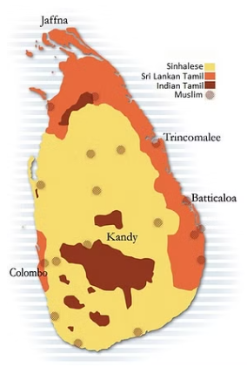

**Majoritarianism in Sri Lanka**

* **Majoritarian:** A concept which signifies a belief that the majority community should be able to rule a country in whatever way it wants is known as Majoritarian. In this type of rule, they disregard the wishes and needs of the minority.
* Post-independence in 1948, Sri Lanka saw the rise of majoritarianism by the Sinhala community leaders aiming for political dominance.
* Majoritarian measures were adopted to establish Sinhala supremacy, including making Sinhala the sole official language in 1956. Preferential policies favored Sinhala individuals for university and government positions.
* Sri Lankan Tamils, who felt marginalized and discriminated against by government policies.
* Efforts by Tamil parties for official language recognition, regional autonomy, and equal opportunities were repeatedly denied.
* The situation escalated in the 1980s with the formation of groups advocating for an independent Tamil state, leading to a civil war. The conflict resulted in significant loss of life, displacement of families, and economic and social setbacks in Sri Lanka, despite its prior achievements in economic development, education, and health.
* The civil war, which concluded in 2009, profoundly impacted the country's societal fabric and economic well-being.

**Civil War:** A violent conflict between opposing groups within a country is known as a civil war. Sometimes it becomes so intense that it appears like a war.

**Accommodation in Belgium**

* Belgian leaders acknowledged regional differences and cultural diversities, amending the constitution four times between 1970 and 1993 to facilitate coexistence.
* The constitution mandates equal Dutch and French-speaking ministers in the central government, preventing unilateral decisions by any single community.
* Significant powers of the Central Government were delegated to the State Governments of the two regions, emphasizing their autonomy.
* Brussels houses a separate government where both communities have equal representation, fostering acceptance and balance.
* A 'community government' elected by Dutch, French, and German-speaking individuals, irrespective of residence, oversees cultural, educational, and language matters.
* The Belgian model, though intricate, successfully averted conflicts and linguistic divisions, playing a role in the establishment of the European Union headquarters in Brussels.
* Comparative Insights Belgium exemplifies unity through power-sharing arrangements that respect diverse community interests, ensuring mutual acceptance and cohesion.

**Ethnicity:** A social division based on shared culture. Most people belonging to the same ethnic group believe in their common descent because they have similarities of physical type or culture or both. They may not have the same religion or nationality, e.g, French-speaking, Dutch-speaking, Sinhala speaking, etc.

**Why Power Sharing is Desirable?**

**Social Stability:** Power sharing reduces the likelihood of conflicts between social groups, which in turn minimizes violence and political instability. Imposing the majority's will may seem appealing initially, but it can harm national unity in the long term.

**Democracy's Essence:** Power sharing embodies the essence of democracy. Democratic governance involves sharing power with those impacted by decisions, allowing them a say in governance and a stake in the system.

**Prudential Reasons:** Focus on the positive outcomes that power sharing can bring, emphasizing its practical benefits.

**Moral Reasons:** Highlight the intrinsic value of power sharing itself, beyond its outcomes, by stressing the importance of citizen participation and stakeholder involvement in governance.

**Forms of Power-Sharing**

**1.Power-Sharing between Different Organs of the Government**

* This kind of power sharing also known as **Horizontal Power Sharing**
* The power division is horizontal where different organs of the government at the same level exercise different powers in their jurisdiction.
* This is easily seen in Indian democracy the legislature judiciary and executive function on the same level and yet have different jurisdictions.

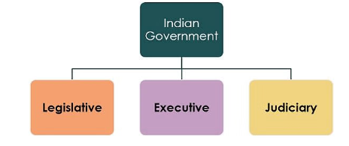

**2. Power-Sharing between Different Levels of Government**

* This kind of power sharing also known as **Vertical Power Sharing**
* This refers to the system where the power is distributed among various levels of government such as the central and provincial governments.
* This system is also known as federalism. India is a prime example of the federal system of government.
* In certain matters, the power-sharing is so exclusive that certain subjects are only exclusive to the union government or the state government.

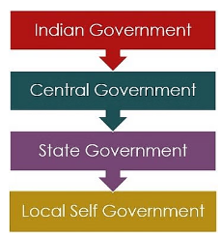

3. **Power-Sharing between Different Social Groups**

* Also known as **Community Power Sharing**
* In this, various weak social groups are represented in the legislatures or administration through various reservations.
* This gives the various social groups a voice and power which might not have been given in other types of government.

**Reserved Constituencies:** It is a system in which constituencies are reserved in the Assemblies and the Parliament for minorities in order to give them a fair share in power.

**4. Power-Sharing between Different Political Groups**

* There are various political groups in the society like political parties, pressure groups, and other Public Interest groups which have a significant influence over the decision-making and law-making process in a democracy.
* Sometimes, political parties form an alliance and participate in direct power-sharing when they form a **coalition government.**
* **Coalition Government:** When the alliance of two or more parties gets elected and forms a government it is known as the Coalition Government. This is another form of power-sharing.