|  |  |
| --- | --- |
|  | Hospital Road |
| Dr Bob |  |
|  | 02/02/1945 |

Dear, Dr Bob,

**Pablo Picasso, 12345, DOB: 25/10/1881**

|  |  |
| --- | --- |
| Main diagnoses: | 1. Head Flu |
| Plan: | 1. Time |
| Medications: | 1. Nil |

Pablo had a cold. He is already feeling better

Yours sincerely,

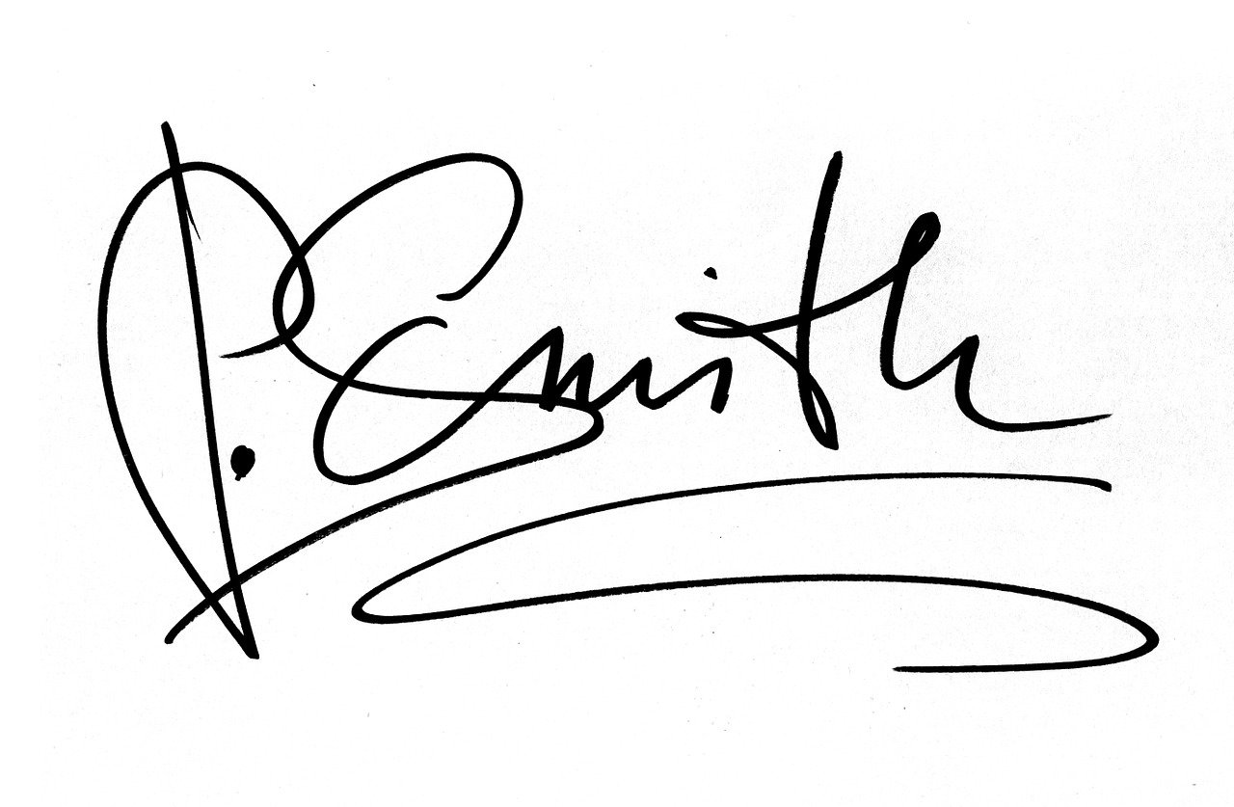

Dr Peter Smith MB

Consultant