Elec 490/498 Project Final Design Report
Group 42
Flying Wi-Fi Network
Junze Yan, Spiro Li, Zihao Li, Zongzhe Yuan
Submitted April 10, 2023
Course Instructor: Ning Lu

Executive summary
The project "Engineering a Flying Wi-Fi Network" aims to develop a drone-based Wi-Fi system to address the growing need for airborne communication networks. In recent years, these networks have garnered significant attention for their potential applications, including collecting data from sensors in hard-to-reach locations, extending cellular network coverage, and facilitating communication between RFID readers and tags in battery-free networks. This article outlines the project's objectives, methods, recent progress, and challenges the team faces. The primary goal of this project is to create a drone-based Wi-Fi system by retrofitting a network station and Wi-Fi pod onto a drone. This system has the potential to significantly enhance connectivity in various scenarios, such as during natural disasters or in remote areas lacking infrastructure. In addition, the team plans to experiment with multiple physical placements of antennas and pods on the drone to achieve optimal performance without compromising flight stability and safety. These adjustments aim to ensure a balance between network efficiency and drone performance. This article summarizes the team's recent work, including a review of relevant literature on drone-based communication networks, detailed planning for follow-up arrangements, and budget allocation for different aspects of the project. At this stage, one critical challenge is ensuring the drone's performance will not be negatively affected, potentially causing safety hazards. To address this issue, the team conducts thorough tests and simulations to identify and mitigate potential risks. Due to regulatory requirements, all team members involved in the project must obtain an operating license issued by the government to fly drones. As part of the project's initial phase, four team members have already acquired their drone licenses, allowing them to begin testing and implementing the proposed Wi-Fi system. The "Engineering a Flying Wi-Fi Network" project holds immense promise for the future of communication networks. By leveraging drone technology, this innovative system can potentially revolutionize connectivity in various scenarios, from disaster relief operations to remote area coverage. As the team continues to address challenges and refine their approach, the successful development of this drone-based Wi-Fi system could significantly impact how we communicate and access information in future years.
Table of Contents
Executive summary i
Table of Figures iii
Problem Scope and definition 1
Design process overall 2
Interface Specifications 4
Performance Specifications 4
Analysis and key decisions 4
Project Compliance with Blueprint Target 5
Hardware-part specifications table: 5
Software-part specifications table: 5
Social, safety, environmental, economic, regulatory compliance and professional 7
Hardware Implementation 9
Software Implementation 10
Test 13
Evaluation 16
Applies and Evaluation Tools 21
Project Planning and Budgeting 22
Project Planning 22
Budgeting 26
Project Reflections 27
Challenges Encountered 27
Future Recommendations 28
Conclusion/Implications 28
References 30
Appendix 31

Table of Figures
Figure 1: UAV classification [2], Fig. 2] 2
Figure 2: Block Diagram for the Flying Wi-Fi 3
Figure 3: Hardware Implementation 9
Figure 4: Software Implementation 10
Figure 5: Drone Final Design 12
Figure 6: Distanced Speed vs. Distance 13
Figure 7: Ping vs. Distance 14
Figure 8: Signal Strength vs. Distance 15
Figure 9: Flying Wi-Fi Access Point Survey 18
Figure 10: Drone Noise Level 19
Figure 11: Download Speed Satisfaction 20
Figure 12: Common Network Function 20
Figure 13: Overall Experience 21
Figure 14: Gantt Chart Zoom-in 25
Figure 15: Setup Wireless Wide Area Network (WWAN) 31
Figure 16: Turn on the Firewall of Accepting WWAN 32
Figure 17: Broadcasting the Wi-Fi 32
Figure 18: Gantt Chart 33

Table 1: Hardware-part Specification Table 5
Table 2: Software-part Specification Table 7
Table 3: Signal Strength Evaluation Matrix 16
Table 4: Division of Labor 24
Table 5: Budgeting 26

Problem Scope and definition
Drones, previously used primarily for military purposes, are now finding their way into a growing number of civilian and commercial uses [1]. According to Figure 1, there are seven common drone application domains. The focus of this project is to design a flying access point which can provide an internet connection to the people on the ground. As an emerging technology, current research on flying access points is insufficient. The proposed drone-based Wi-Fi system has the potential to revolutionize communication in a variety of industries, such as agriculture, environmental monitoring, and disaster response. By leveraging drone technology, the system can access hard-to-reach areas and collect data that was previously impossible or difficult to obtain. Drones equipped with Wi-Fi technology can fly over an area where traditional infrastructure is damaged and provide internet access. Moreover, flying Wi-Fi can be used for large outdoor events, where large crowds of people gather, and traditional Wi-Fi infrastructure may not be able to handle the traffic. The problem scope and requirements must be clearly defined to ensure the project's success. This includes identifying the specific locations and events where the flying Wi-Fi technology will be used. The target audience and their connectivity needs are also included. Considering the drone's technical specs, such as range, battery life, and payload capacity, is also crucial for ensuring Wi-Fi coverage is effective.
In conclusion, this project uses drones equipped with Wi-Fi technology to act as mobile access points in remote areas and outdoor events. By defining the problem's scope and requirements, the team can develop a solution that provides reliable and affordable internet access to those who need it most.
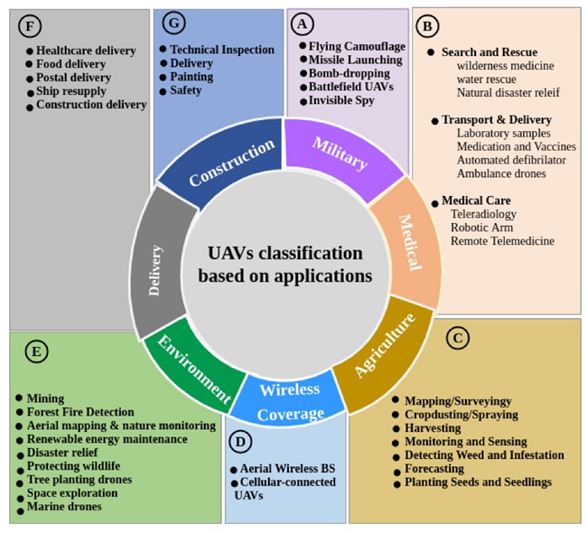
Figure 1: UAV classification [2], Fig. 2]

Design process overall
The basic function of this project is to build an operational flying Wi-Fi that receives the signal from a ground station and extends it. As instructed, the main component required to design is the network station, i.e., the single-board computer on the drone. Moreover, how to arrange the position of the pod and antennas to achieve the best performance is another significant consideration.
As shown in the block diagram, the first component that needs to be implemented is the base station. A ground Wi-Fi station is required and will be set to connect the Wi-Fi processor. For drone operation, a basic controller is required. The drone platform will be a multirotor design that can provide stable flight and maneuverability in different environments. Moreover, in order to implement the potential crowd recognition task, an extra computer should be integrated to run real-time recognition algorithms. There is no need to design and manufacture the drone since a pre-made DJI drone will be given. However, certain modifications are required, such as installing the Wi-Fi access point, mounting a battery case, and installing antennas. After all the components are installed, a proper wire connection is necessary. For the network component, a single board computer will be coded to work as the Wi-Fi pod and to control the GPS unit for range measuring. Other than implementing basic Wi-Fi, the bonus object of this project is to design a 5-G network. In that case, proper emulation can be conducted on the ground using an emulator before assembling.
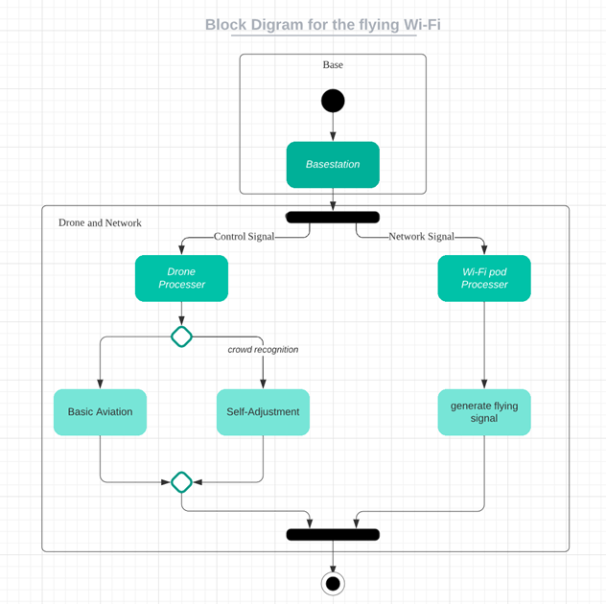
Figure 2: Block Diagram for the Flying Wi-Fi

Interface Specifications
Basic inputs for drone controllers include but are not limited to a function button, power button, 5D button, flight pause button, control sticks, and touchscreen. Output components include an image display screen, speaker, and HDMI port for video output [3]. For the network pod, the main input is the ground Wi-Fi signal and power supply. The main user interface is the controller, which will be used to navigate the drone. Another interface is the network modifier, which will be used to control the on-ground Wi-Fi generator.

Performance Specifications
Since the DJI controller is able to provide a reliable long-range transmission at a distance of up to 10 km [3], the main operation limitation of the flying Wi-Fi is the network signal. The network's quality and range will be affected by the signal frequency, transmission power, and equipment operating environment [4]. The Wi-Fi module will be a high-power transceiver that can broadcast a signal over a specific frequency band, such as 2.4GHz or 5GHz. The normal operation outdoor range is 100 meters to 250 meters, depending on different antennae [5]. In order to provide acceptable internet access for 2 to 4 people, the ideal internet speed should reach 50Mbps.

Analysis and key decisions
The flying Wi-Fi system's performance and efficiency will be optimized using analysis and modelling tools during the design phase. Wi-Fi modules are evaluated under different conditions, such as distance, interference, and weather, using internet simulation software. Selecting the appropriate components and technologies for each subsystem will be one of the key decisions in the design process. The flying Wi-Fi system will be tested with different batteries and configurations to maximize its flight time and payload capacity. The Wi-Fi modules will also be tested to find the most reliable and efficient option for broadcasting.

Project Compliance with Blueprint Target

Hardware-part specifications table:
 | Specification | Target value | tolerance | Achieved
1 | Access Point battery life | 10 hours | 10% | 3 hours
2 | Quality of installation of power supply and access point  (How long should the firm stay without loosening) | 24 hours | 20% | 168 hours and more
3 | Wire connection quality of power supply and access point | 24 hours | 20% | 168 hours and more
4 | Total hardware weight | 500 grams | 10% | 273 grams
Table 1: Hardware-part Specification Table
For the hardware part, three of four original specifications are achieved. Although the battery life of the access point is unsatisfactory, the total weight of the hardware is over half of the payload, which leaves room for a larger capacity battery.

Software-part specifications table:
1 | Functional requirements | Specification met?
1.1 | Configure the chip to act as an access point. | Yes
1.2 | Control the network through coding, such as speed limit, control the number of people connected, etc. | Yes
1.3 | Allow relevant personnel to test network quality on mobile devices or ground base stations | Yes
1.4 | Implement a 5-G network as a bonus goal | No
1.5 | Extract the drone camera image and use the object detection algorithm to track specific users for better network quality. (Bonus goal) | No
2 | Interface requirements
2.1 | Basic inputs for drone controllers include but are not limited to a function button, power button, 5D button, flight pause button, control sticks, and touchscreen. Output components include an image display screen, speaker, and HDMI port for video output. | No
2.2 | The power button, reset button, and USB interface on the single-chip microcomputer (Raspberry Pi or Arduino UNO) | Yes
2.3 | Basic IP network protocols, single chip microcomputer configuration IDE, Ping commands for evaluation | Yes
3 | Performance requirements
3.1 | Provides a signal range of 50 to 100 meters in an outdoor environment | No (30m for best performance, 40m maximum range)
3.2 | In an outdoor environment, provide a stable network for 1 or 2 people | Yes
Table 2: Software-part Specification Table
The bonus goal of the project is not achieved. Implementing a 5-G network requires costly adapters and most current single-board computers do not support a 5-G network. Another bonus goal is to implement a crowd-tracking system. However, due to the use of DJI's commercial drones, the user does not have access to the drone system API. The original performance requirement for the signal range is from 50 to 100 meters. In the actual test, due to the obstruction of the building and the limitation of the adapter, this requirement cannot be realized.

Social, safety, environmental, economic, regulatory compliance and professional
The "Engineering a Flying Wi-Fi Network" project aims to develop a drone-based Wi-Fi system which has the potential to impact communication networks significantly. There are benefits and challenges from various perspectives, such as social, safety, environmental, economic, regulatory compliance, and professional aspects.
From a social standpoint, this system can improve connectivity in remote and underserved areas, leading to better access to essential services and improved quality of life for communities. However, safety concerns must be addressed by ensuring the drone's performance is not negatively affected by the Wi-Fi components and by conducting rigorous testing and simulations to identify and mitigate potential risks.
Environmentally, drones can have a reduced footprint compared to traditional infrastructure, but it is essential to consider their energy consumption and impact on wildlife. Therefore, measures should be taken to minimize noise pollution, reduce energy use, and prevent adverse effects on local ecosystems.
Economically, the drone-based Wi-Fi system can promote growth by attracting investments, supporting local businesses, and creating new job opportunities. However, the initial investment and ongoing maintenance costs must be carefully weighed against the potential economic benefits.
Regarding regulatory compliance, all team members must obtain government-issued operating licenses to fly drones, and the system must adhere to airspace regulations and privacy laws. Lastly, from a professional development perspective, this system presents opportunities for growth in various fields, such as engineering, computer science, and communication technology.
In conclusion, the drone-based Wi-Fi system can revolutionize connectivity while presenting challenges that must be addressed. Proper planning, testing, and compliance could profoundly impact how we communicate and access information in the future.
Implementation
The implementation process includes both software implementation and hardware implementation. The software implementation process includes setting up the network extension ability of the Raspberry Pi through the operating system called OpenWRT [6]. And hardware implementation includes installing the Wi-Fi access point onto the drone and setting up the Wi-Fi access point.

Hardware Implementation
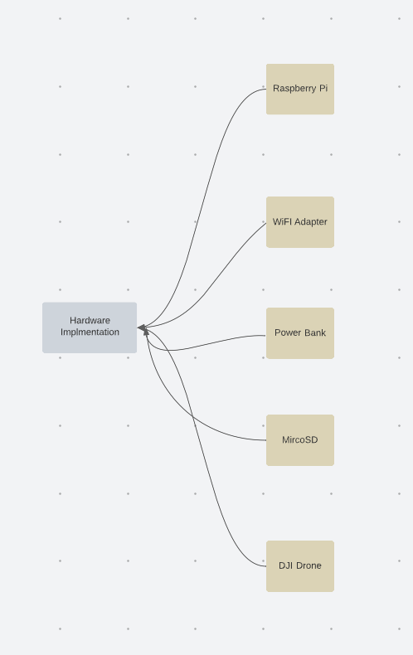
Figure 3: Hardware Implementation
The flow chart of the hardware implementation is listed above in Figure 3. The diagram describes the basic hardware requirements for the implementation.
The hardware components used for this project included a Raspberry Pi B, a USB Wi-Fi adapter (Wireless Wi-Fi USB Dongle Stick Adapter RT5370 150Mbps), a small power bar (Charmast 10400 Smallest PD Portable Charger, Mini Power Bank USB C 20W PD & QC 3.0 Quick Charge External Battery Pack), and a SanDisk 256GB Ultra microSD UHS-I Memory Card to install the OpenWRT system for the Raspberry Pi. The drone used for this project was provided by the instructor and was a brand-new DJI Mavic.
To begin the hardware setup, the Raspberry Pi was first screwed onto the Raspberry Pi box. The box was then taped onto the drone, ensuring that it was securely fastened and would not drop out during flight. The USB Wi-Fi adapter was plugged into one of the USB-A ports on the Raspberry Pi. Then, the power bar was connected to the Raspberry Pi's power port using a USB-C cable.
The power bar was used to provide power to both the Raspberry Pi and the USB Wi-Fi adapter. It was chosen for its compact size, lightweight and high-power output.

Software Implementation
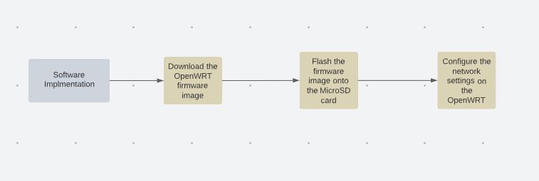
Figure 4: Software Implementation
The flow chart of the software implementation process is shown in the graph above in Figure 4.
The software used for this project was the OpenWRT operating system, which is a Linux-based system that is designed to be compatible to multiple adapters and flexible. OpenWRT is particularly well-suited for embedded devices such as the Raspberry Pi, as it allows for easy customization and configuration of the device's networking and security settings.
To set up OpenWRT on the Raspberry Pi, the first step was to download the appropriate image file from the OpenWRT website. The image file was then installed onto the SanDisk 256GB Ultra microSDXC UHS-I Memory Card using the Raspberry Pi Imager software.
Once the image file was installed onto the memory card, it was inserted into the Raspberry Pi's memory card slot. The Raspberry Pi was then connected to a monitor and a keyboard using an ethernet cable, and the power bar was turned on to power the device.
When booting up, the Raspberry Pi displayed a command prompt, indicating that the OpenWRT operating system was running. The next step was to configure the device's networking settings. This was done by accessing the OpenWRT system interface by typing the Raspberry Pi's IP address which is set to be 10.71.71.1. ,and the Vim text editor was used to configure the board.
In the command interface, the network settings were configured to allow the Raspberry Pi to act as a Wi-Fi access point. This was done by setting the device's network mode to wireless wide area network and configuring the appropriate ID and password.
Once the network settings were configured, the USB Wi-Fi adapter was set up to act as a Wi-Fi extender. This was done by configuring the device's networking settings to connect to an existing Wi-Fi network as a client and then forwarding the network traffic to Raspberry Pi's Wi-Fi access point.
The detailed setup procedures and blocks of code are included in the Appendix section.
With the software and hardware properly configured, the Raspberry Pi was ready to act as a flying Wi-Fi access point. When the drone was flown, it extended the original Wi-Fi network, in this case, a home Wi-Fi, allowing users to connect to the network from a greater distance away.
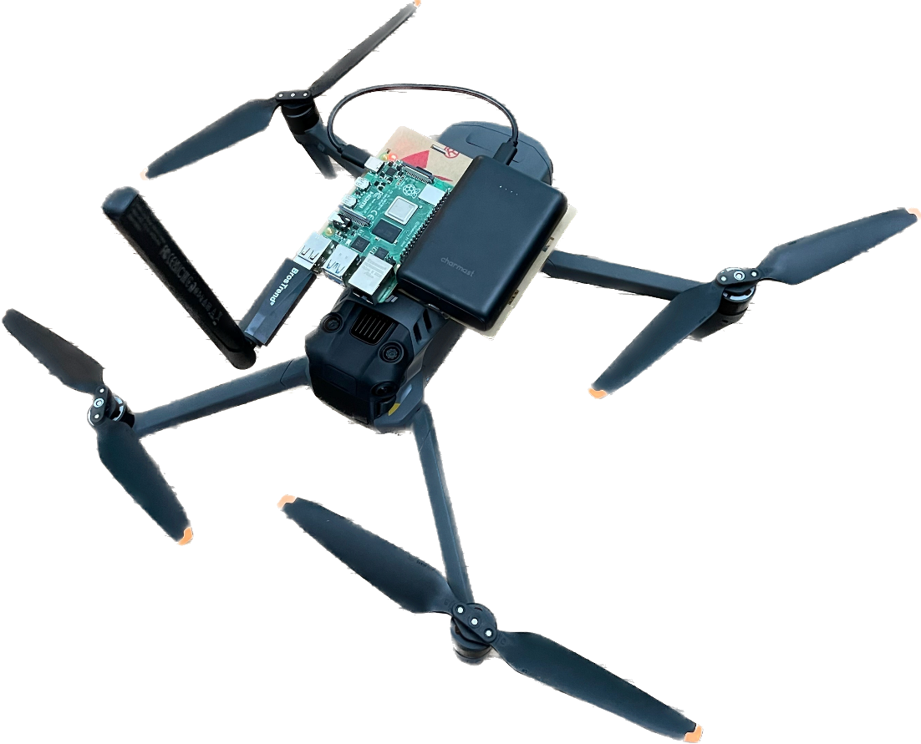
Figure 5: Drone Final Design
The final design is shown in the figure above in Figure 5.
Overall, implementing a flying Wi-Fi access point using a Raspberry Pi and OpenWRT is a relatively straightforward process that can be achieved with a few basic hardware components and some software configuration. The Raspberry Pi and USB Wi-Fi adapter used in this project were lightweight and easy to install on the drone, while the OpenWRT operating system provided a flexible and customizable platform for configuring the device's networking settings. Therefore, this design demonstrates the potential for using a low-cost and easy installation approach to extend the Wi-Fi.
Testing and Evaluation
The testing and evaluation are performed based on the home's Wi-Fi condition. The findings and evaluation are discussed based on the download speed, delay (ping), and signal strength. After trying different angles of the antenna of the USB adapter, there is no significant difference between those angles. Therefore, the angle of the antenna is tested shown in Figure 5.

Test
In order to evaluate the performance and find the ideal distance for flying the drone, testing was carried out from both smartphones and laptops end. With the Raspberry Pi connected to the home Wi-Fi, two smartphone apps were used for testing. The first app, Wi-Fi Analyzer, was used to test the download speed and ping of the network. The second app, iWifi, was used to test the signal strength of the network. For the laptop testing, the Google Fiber network test was used. The testing was carried out in two stages, with the first stage being the ground test and the second stage being the drone test. For the ground test, the distances were measured every ten meters, with data being collected at each distance. The testing was performed to get a basic idea of the network's performance. After the ground testing, the drone was flied in the backyard, with the distance being controlled using the DJI app combined with the DJI controller.
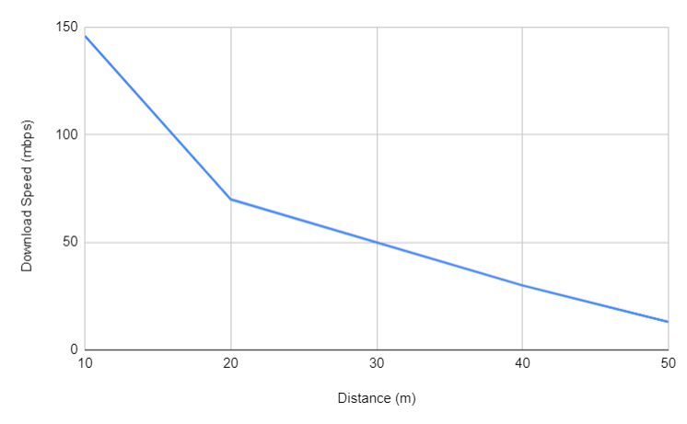
Figure 6: Distanced Speed vs. Distance
The first app used for smartphone testing, Wi-Fi Analyzer, provided details about the download speed and ping of the network. As shown in Figure 6 above, the download speed decreases as the distance from the Wi-Fi access point increases.
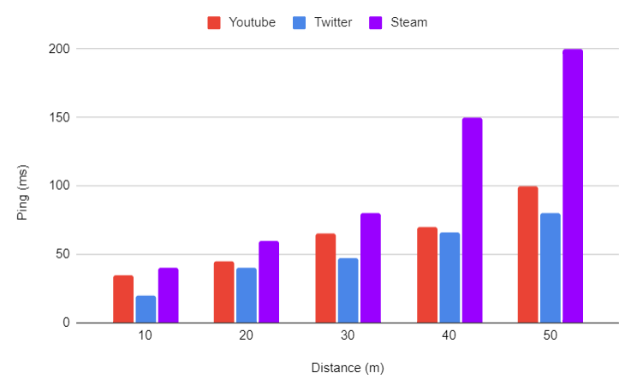
Figure 7: Ping vs. Distance
For the latency test shown in Figure 7, the app gave detailed information on the network's performance when streaming videos, using Twitter, and gaming. Based on the results obtained, it was found that the download speed was good enough to support video streaming and using social media apps, but gaming would not be supported due to the high latency. The ping was also found to be good enough to support video streaming and using social media apps.
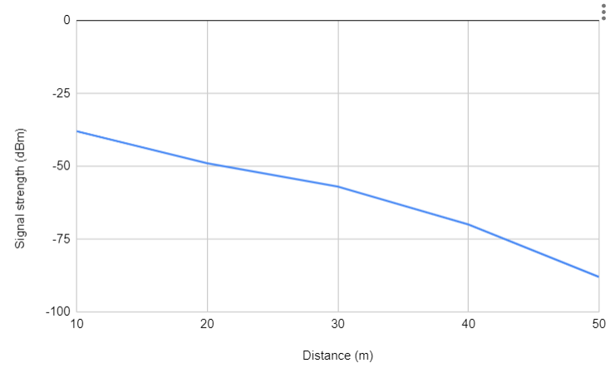
Figure 8: Signal Strength vs. Distance
The second app used for smartphone testing, iWifi, was used to test the signal strength of the network shown in Figure 8. Based on the signal strength test, the drone's optimal distance was found to be 30 meters since the distance allows high-quality streaming. The Google Fiber network test was used for laptop testing [7]. The test provided detailed information on the download speed, upload speed, and latency of the network. Based on the results obtained, a similar result was found that the network's download speed was good enough to support video streaming and using social media apps, but gaming would not be supported. The upload speed was also found to be good enough to support using social media apps. The latency was found to be good enough to support video streaming and using social media apps.

Evaluation
SIGNAL STRENGTH | QUALITY TO EXPECT | REQUIRED LEVEL FOR
-30 dBm | Maximum signal strength, you are probably standing right next to the access point/router.
-50 dBm | Anything down to this level can be regarded as excellent signal strength. | Gaming
-60 dBm | This is still good, reliable signal strength. | Video streaming (Highest Quality)
-67 dBm | This is the minimum value for all services that require smooth and reliable data traffic. | Video streaming/streaming (not the highest quality)
-70 dBm | The signal is not very strong, but mostly sufficient. | Web, email, and the like
-80 dBm | Minimum value required to make a connection. You cannot count on a reliable connection or sufficient signal strength to use services at this level.
-90 dBm | It is very unlikely that you will be able to connect or make use of any services with
Table 3: Signal Strength Evaluation Matrix
To evaluate the network's performance, an evaluation matrix was used on signal strength shown in Table 3 [8]. The matrix provides a range of values that indicate the network's performance based on the signal strength. The values range from -30 dBm, which indicates maximum signal strength, to -90 dBm, which indicates the network's inability to connect or make use of any services.
According to the evaluation matrix, anything down to -50 dBm can be regarded as excellent signal strength, which is ideal for gaming. At -60 dBm, the signal strength is still good and reliable for video streaming at the highest quality. The minimum value for all services that require smooth and reliable data traffic for video streaming is -67 dBm, while -70 dBm is sufficient for web browsing, email, and similar activities. At -80 dBm, the minimum signal strength required to make a connection, the network's performance may not be reliable or sufficient for all services. Finally, at -90 dBm, the network's performance is severely impacted, and it is unlikely that any services can be accessed.
Based on the signal strength and ping test results obtained during the testing process, gaming would not be supported unless a 5G adapter was used. The drone's optimal distance was found to be 30 meters, which allowed for high-quality streaming without any issues. However, beyond this distance, the maximum allowable distance is 40 meters, and the network's performance began to be not usable over that distance.
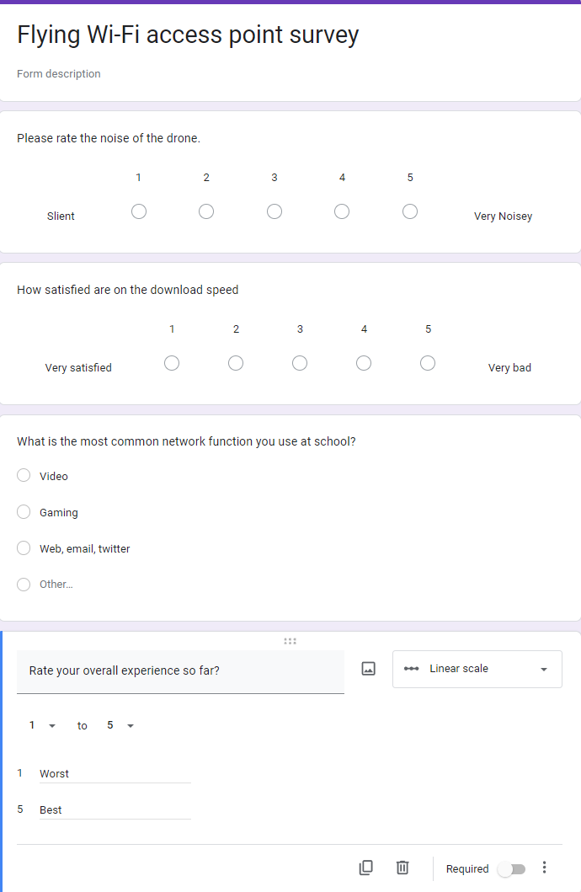
Figure 9: Flying Wi-Fi Access Point Survey
For the user experience of the Wi-Fi extension, there are eight participants invited to test the network that flied 40 meters above the ground. After 10 minutes of connecting to the Wi-Fi and performing daily activities, the users filled in a questionnaire to provide some subjective feedback in terms of the design, which is shown Figure 9.
The results of the feedback are provided in the following figures and explained in detail.
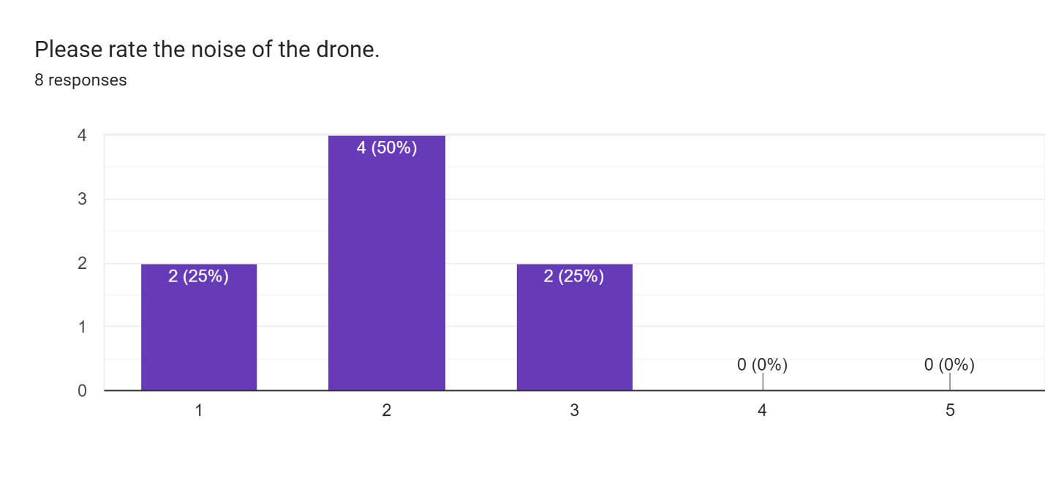
Figure 10: Drone Noise Level
When rating the noise level of the drone, there are 50% of the user believed the noise level was low, 25% of the user believed the drone was silent, and 25% of the user thought that the noise level was acceptable. The results are shown in Figure 10.
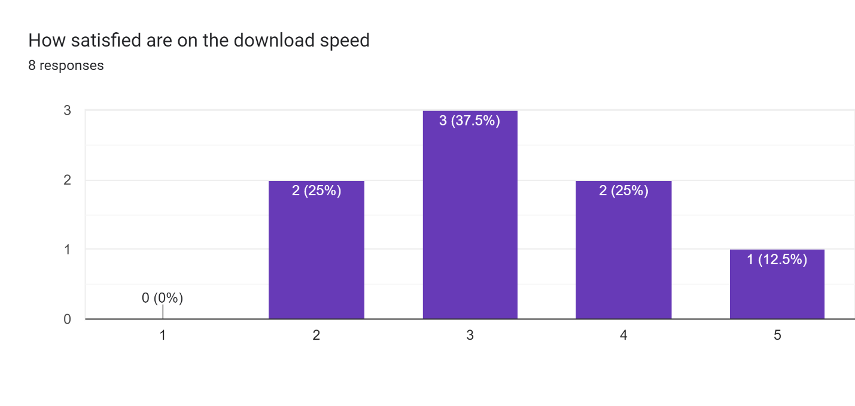
Figure 11: Download Speed Satisfaction
When rating the network download speed of the drone, 25% of the users believed that the download speed was good. 37.5% of the users rated the download speed as acceptable, 25% of the users believed that the speed was bad, and 1 % of the user believed that the speed was very bad. The results are shown in Figure 11.
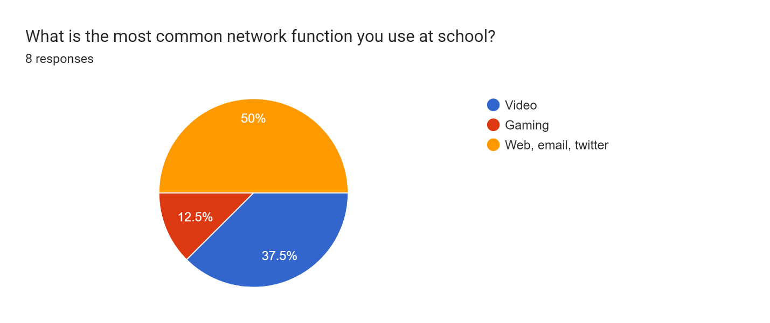
Figure 12: Common Network Function
In terms of daily habits, 50% percent of the users used the internet to visit webpages; 12.5% of the users played games; 37.5% of the users watched videos. The result is shown in Figure 12.
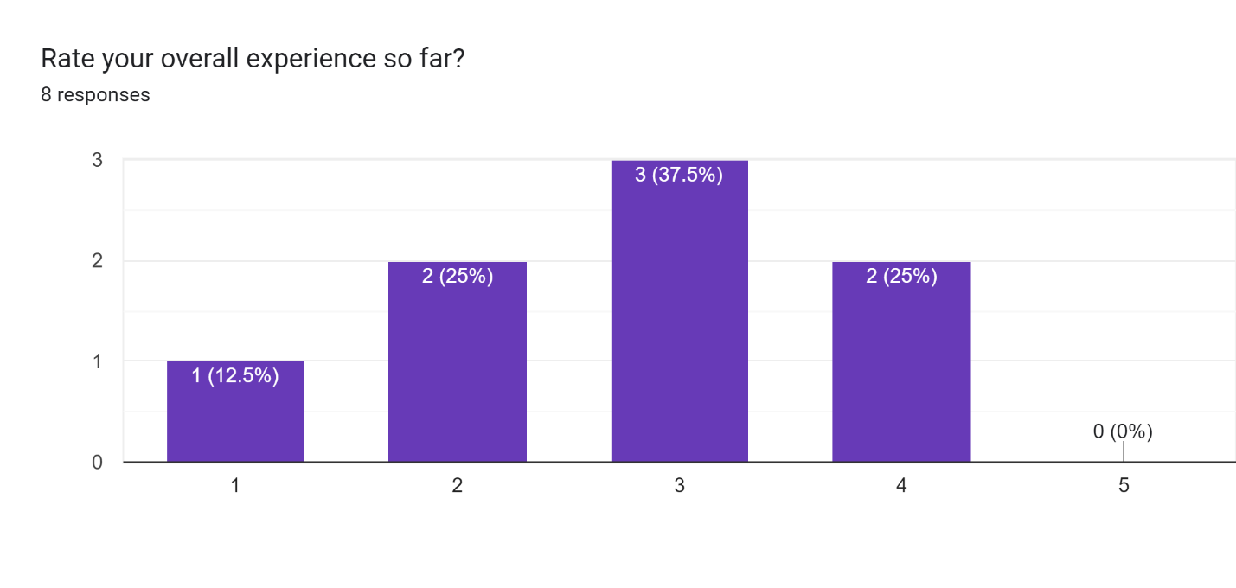
Figure 13: Overall Experience
Last but not least, the overall user experience ratings were collected. 12.5% percent of users rated the experience as the poorest; 25% of the users rated the experience as bad; 37.5% of the users rated the experience as acceptable; 25% of the user rated the experience as good. The results are shown in Figure 13.
After further study, the user who believed the experience was bad always used Wi-Fi to play video games. And those users who often visited webpages considered the experience as acceptable or good.

Applies and Evaluation Tools
In order to ensure that the testing was accurate and reliable, a rigorous process was used to select and evaluate the hardware and software tools we used during testing. The team first researched and selected the most appropriate apps for testing signal strength and download/upload speeds on smartphones. Then, the team chose Wi-Fi Analyzer and iWifi based on their high user ratings and positive reviews. More importantly, the iWifi is the only free application that supports the signal strength detection function.
For the laptop end, the team chose the Google Fiber Network Test due to its accuracy and reliability in measuring network performance. The team choose the DJI app and controller to fly the drone as the DJI Mavic is the most reliable commercial drone that can fly over 1 hour in windy environment.
Throughout the testing process, the team carefully monitored the tools and equipment to ensure they were functioning properly and providing accurate data. Two members also took care to calibrate tools as needed and adjust the testing process and address any issues that arose. Therefore, the selection and use of tools were appropriate and effective in evaluating the network's performance for drone streaming purposes.

Project Planning and Budgeting

Project Planning
In phase 1, the schedule indicates the general research slots of the project and the work in the proposal. The specific time of bi-weekly meetings with the TA and the Supervisor was also scheduled. In phase 2, the schedule shows the plan for the research on the project and preparation for the testing. Blueprint and CheckIn were conducted in phase 2. The break between the fall term and winter term was also noticed. In phase 3, the testing and evaluation of the drone was implemented. Finally, in phase 4, the Open House and Final Report was delivered to show the work the team has done for the project. The division of labor in the Table 4. A zoom-in of the Gantt chart is shown in Figure 14. The detailed Gantt chart is shown as Figure 18 in the Appendix.
No. | Milestone | Due date | Responsible member(s)
1 | General research for the project, biweekly meeting with the supervisor, discussion about work objective and scope, project planning, research for interface and performance specification. | Week 5 | Junze Yan, Spiro Li, Zihao Li, and Zongzhe Yuan
2 | Research for testing and evaluation, equipment and software required, proofread, and submit the proposal, discussion about WBS, and bi-weekly meeting with TA. | Week 8 | Junze Yan, Spiro Li, Zihao Li, Zongzhe Yuan
3 | Research for budget, discussion about potential problem and mitigation, research for wider impact, proofread and submit the blueprint. | Week 11 | Spiro Li, Zongzhe Yuan
4 | Proofread and submit the CheckIn, materials acquisition, drone license, drone, AP installation and setup. | Week 13 | Junze Yan, Spiro Li, Zihao Li, Zongzhe Yuan
5 | Network distance measurement, initial test, software monitoring and data collection, initial data visualization and analysis | Week 16 | Junze Yan, Zihao Li
6 | Second test, software monitoring and data collection, second data visualization and analysis, repeat the procedure as above if needed, bonus feature. | Week 19 | Zihao Li, Zongzhe Yuan
7 | Design poster and Open House | Week 22 | Junze Yan, Spiro Li, Zihao Li, Zongzhe Yuan
8 | Final deliverable | Week 23 | Junze Yan, Spiro Li
9 | Final project report | Week 24 | Junze Yan, Spiro Li, Zihao Li, Zongzhe Yuan
Table 4: Division of Labor
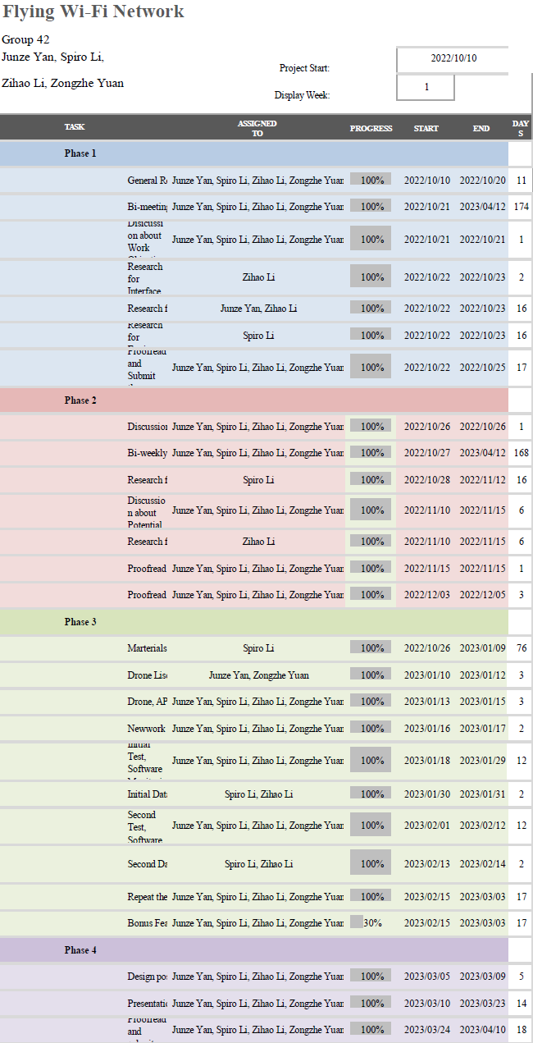
Figure 14: Gantt Chart Zoom-in

Budgeting
No. | Objects | Supplier | Estimated cost
1 | Raspberry Pi 4 Model B | Seed studio | $290.22
2 | Power Bank | Charrnast CA | $28.98
3 | Wireless Wi-Fi Adapter #1 | BrosTrend | $31.63
4 | Wireless Wi-Fi Adapter #2 | EASTTECH | $33.89
5 | Wireless Wi-Fi Adapter #3 | ‎Ugreen | $37.28
6 | SD/MicroSD Card Reader | Vanja | $11.29
7 | Raspberry Pi Set-top Box Kit (Case with Fan, Heatsinks, Extension Board) | GeekPi | $25.99
8 | 256GB Memory Card | SanDisk | $30.85
Contributions from other sources
1 | Mavic 3 Drone | DJI | N/A
2 | Cables | N/A | N/A
3 | Electrical Insulation Tape | N/A | N/A
4 | Drone License | Transport Canada | N/A
 | SUM |  | $490.13
Table 5: Budgeting
As shown in Table 5, the DJI Mavic 3 drone is provided by the supervisor. Cables, electrical insulation tape, and drone license are provided by team members, which are not purchased recently. The sum of the reimbursement is $490.13, which falls into the limit of $600. The testing is in the backyard of a team member’s house. The applied operating system and software are OpenWrt system, Google Fiber Internet Speed Test, Wi-Fi Analyzer, and iWi-Fi, respectively.

Project Reflections

Challenges Encountered
While designing the drone-based Wi-Fi system, here are the challenges the team encountered in terms of battery life and weight, adaptor compatibility, maintenance, signal interference, and signal strength.
Firstly, it is the trade-off between battery life and weight. The weight of the drone and the size of the battery are considered to ensure that it can fly for an extended period without compromising the performance of the Wi-Fi system.
Secondly, an adaptor compatible with OpenWrt was required for the Wi-Fi system to function properly. This meant that the team had to select an adapter that would be compatible with our Wi-Fi system and ensure that it could support the necessary operating system.
The third challenge that the team faced was maintenance. Drones require regular maintenance, which can be costly and time-consuming. The team had to ensure that the drones were in good working condition and had enough spare parts to replace any damaged components if necessary.
Fourthly, Wi-Fi signals can be disrupted by obstacles such as buildings and trees, which may make it difficult to maintain a consistent signal between the drone and ground stations. The flight path of the drone is planned to avoid any obstacles that could interfere with the Wi-Fi signal.
Finally, signal strength was also a challenge. Wi-Fi signals can be affected by distance and signal strength, which may limit the range of the drone-based system. We had to ensure that the drone was flying within an optimal distance to maximize the signal strength and range of the Wi-Fi system.

Future Recommendations
There are several technological advancements that can be implemented in the future for the flying Wi-Fi project. Firstly, the security of the network system can be improved by implementing a Virtual Private Network (VPN) at the access point. This will provide a more secure and encrypted connection for users who access the network. With a VPN in the system, unauthorized access to the network can be prevented to a greater extent, ensuring that important data can be protected.
Secondly, the project could use fully autonomous drones that move with the crowd by using object detection functionality. These drones can be used to provide smoother network access for groups of people outdoors. Specifically, there will be significantly enhanced convenience of large gatherings like concerts or sports events. With the object detection functionality, the labour costs can be reduced to negligible. Only coordination and maintenance of the drones are needed.
Finally, changing the Wi-Fi adapter with a 5G adapter can significantly enhance the network speed and meet the demands of network-intensive tasks such as live streaming and gaming. With a 5G adapter, users can experience faster data transfer speed and reduced lagging, providing a better overall experience when using the wireless network. This technology can be particularly useful in areas where 5G internet is not popularized. Overall, these future directions of technical advancement can reflect the great prospect of the flying Wi-Fi project, ensuring users have faster and safer access to the internet.

Conclusion/Implications
The "Engineering a Flying Wi-Fi Network" project aims to develop a drone-based Wi-Fi system to improve airborne communication networks in various scenarios, such as disaster relief and remote areas. The team is working on retrofitting a network station and Wi-Fi pod onto a drone, optimizing placements without compromising safety, and addressing drone performance and protection through testing and simulations. The project focuses on providing internet access to people on the ground and transforming communication in agriculture, environmental monitoring, and disaster response industries. Defining problem scope and requirements, as well as considering drone specifications, is crucial for success. The implementation consists of software and hardware components, configuring the Raspberry Pi's network extension capabilities and installing the Wi-Fi access point onto the drone. Future advancements include implementing VPNs for enhanced security, using fully autonomous drones with object detection for large outdoor gatherings, and replacing Wi-Fi adapters with 5G adapters to improve network speeds. These advancements show great potential for the flying Wi-Fi project, ensuring users faster and safer internet access.

References

[1] | S. A. H. Mohsan,, N. Q. H. Othman,, Y. Li,, M. H. Alsharif, and M. A. Khan,, "Unmanned aerial vehicles (UAVs): practical aspects, applications, open challenges, security issues, and future trends," Intelligent Service Robotics, pp. 109-137, 2023.
[2] | F. Pasandideh,, J. P. J. da Costa,, R. Kunst,, N. Islam,, W. Hardjawana, and E. Pignaton de Freitas,, "A Review of Flying Ad Hoc Networks: Key Characteristics, Applications, and Wireless Technologies," Remote Sensing, p. 4459, 1 2022.
[3] | "DJI Smart Controller - DJI," DJI Official, [Online]. Available: https://www.dji.com/ca/smart-controller. [Accessed 24 10 2022].
[4] | "Queen s University Library Learnin CWNA: Certified Wireless Network Administrator Official Study Guide, Fourth Edition," [Online]. Available: https://queensu.skillport.com/skillportfe/assetSummaryPage.action?assetid=RW$7647:_ss_book:63510#summary/BOOKS/RW$7647:_ss_book:63510. [Accessed 24 10 2022].
[5] | N. Tengyuen, "12 Wireless Router Antenna Distance Coverage Comparison," GeckoandFly, 2 1 2020. [Online]. Available: https://www.geckoandfly.com/10213/wireless-router-antenna-distance-coverage-comparison/. [Accessed 24 10 2022].
[6] | OpenWrt, "OpenWrt Wireless Freedom," 17 11 2022. [Online]. Available: https://openwrt.org/start. [Accessed 10 4 2023].
[7] | Google, "Google Fiber," Alphabet, September 2022. [Online]. Available: https://fiber.google.com/. [Accessed 10 April 2023].
[8] | J. P. Tumusok and J. Newth, "Wi-Fi Signal Strength: Waht is a good signal and how do you measure it," Eyenetwworks, 14 October 2021. [Online]. Available: https://eyenetworks.no/en/wifi-signal-strength/. [Accessed 10 April 2023].

Appendix
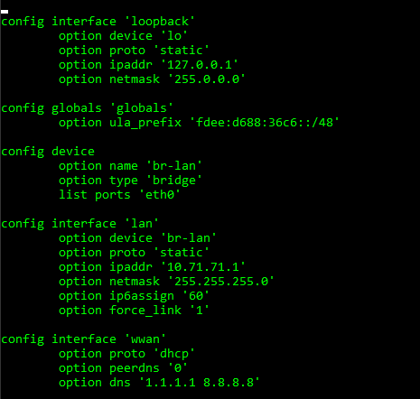
Figure 15: Setup Wireless Wide Area Network (WWAN)
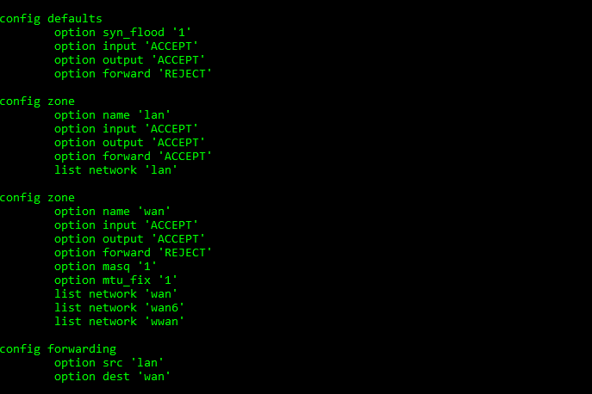
Figure 16: Turn on the Firewall of Accepting WWAN
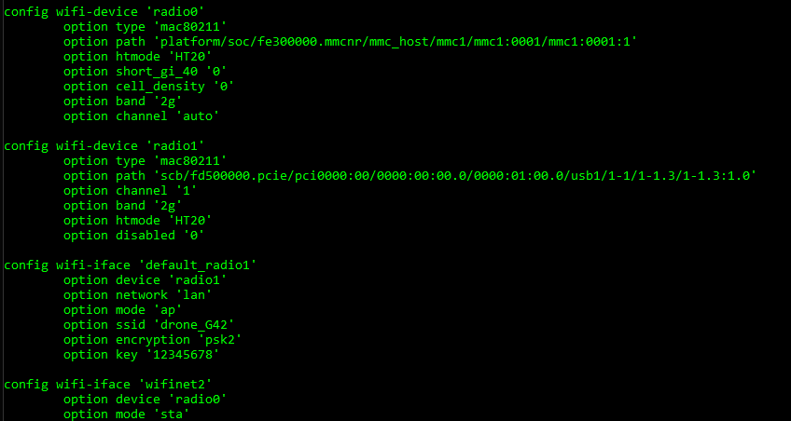
Figure 17: Broadcasting the Wi-Fi

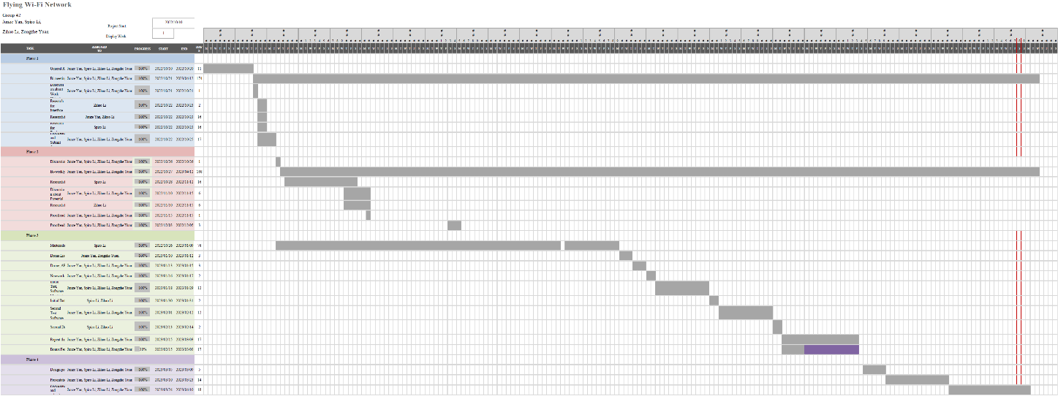
Figure 18: Gantt Chart

