  - PORTFOLIO CASE STUDY

Digital Marketing for an AI Traffic Management System
  - An evidence-led B2G acquisition and measurement design for municipal traffic-management pilots
Spiros Grouztidis
Public English edition • 16 October 2026

Scope notice. This is an educational portfolio scenario. All campaign performance is synthetic. The report does not describe a real company, customer, deployment, or verified product result.
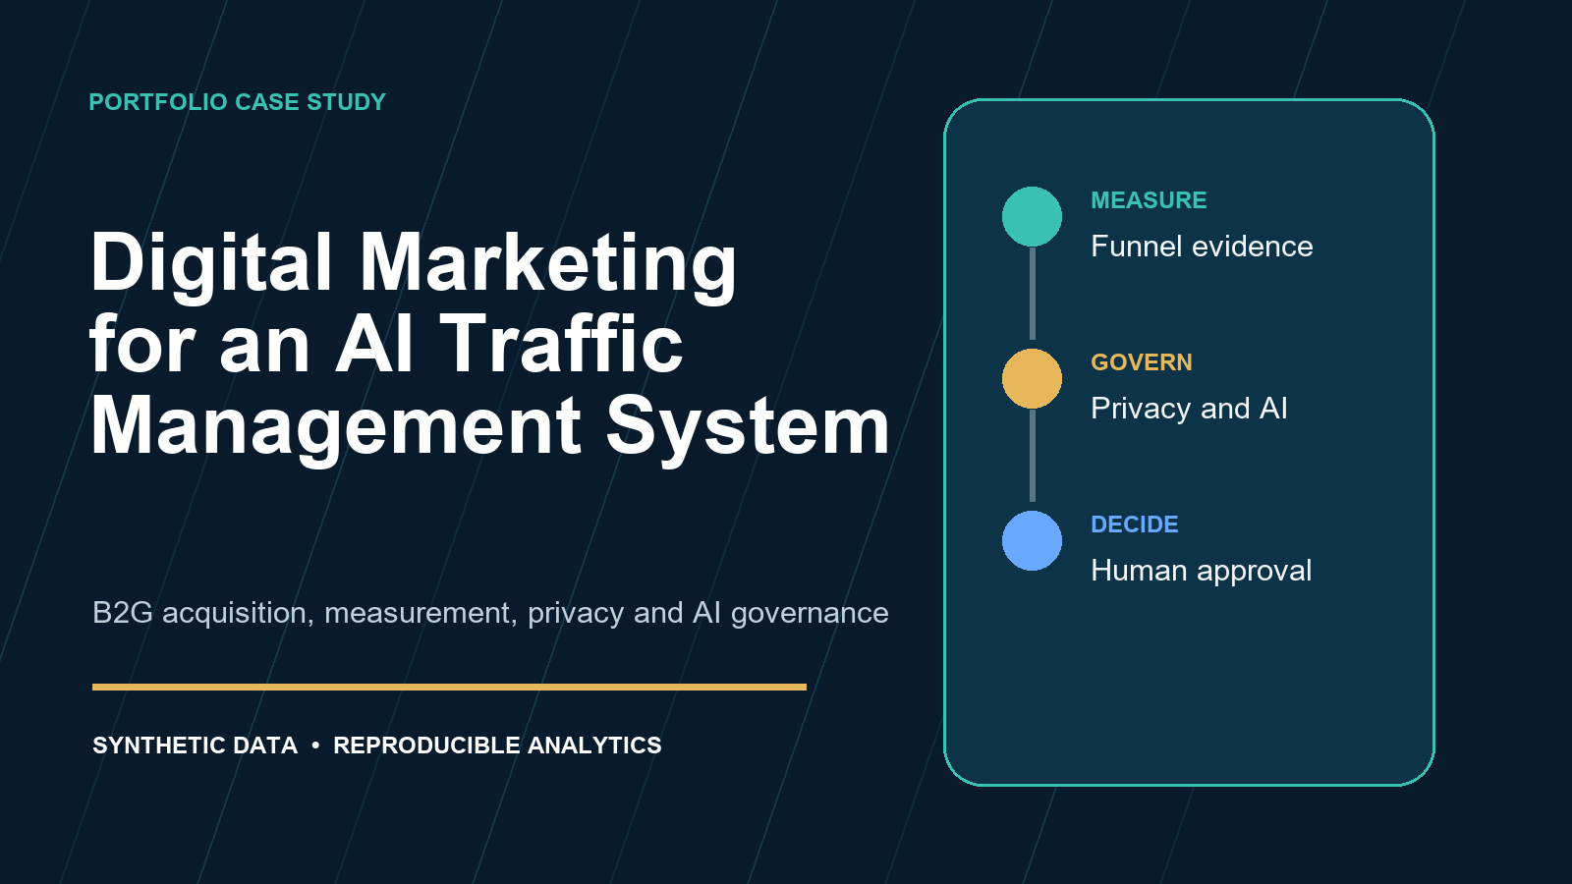

Executive summary
The original university presentation proposed digital marketing for an AI-enabled traffic solution. This public edition converts that concept into a governed decision system. It defines the municipal buying committee, campaign taxonomy, qualification stages, privacy controls, AI claim controls, and an executable model for channel metrics and constrained budget recommendations.

Portfolio value
- Demonstrates B2G positioning beyond consumer-style impressions and clicks.
- Shows reproducible analytics with transparent assumptions and synthetic data.
- Connects marketing decisions to procurement readiness, privacy, security, and AI accountability.
- Separates promotional claims from operational traffic evidence.

Decision rule
Use channel scores to structure review, not to automate spending. A human owner must assess legal basis, data quality, buying-committee progress, channel saturation, and evidence status before reallocating budget.

1. Context and opportunity
European urban-mobility policy emphasises integrated planning, measurable indicators, sustainable mobility, and digital solutions. The commercial opportunity is therefore not a generic promise to use AI. It is a bounded pilot that helps a public buyer test a specific operational outcome with safety, governance, and procurement evidence.
Market signal | Implication for marketing
Sustainable Urban Mobility Plans | Align content with approved local mobility objectives and indicators.
Innovation procurement | Offer staged proof, acceptance criteria, and a credible route from pilot to scale.
AI governance | Explain intended purpose, oversight, evidence, and failure handling.
Data protection | Minimise campaign data and keep it separate from operational traffic telemetry.

Positioning
The recommended message is: test whether adaptive traffic management can improve agreed local outcomes inside a controlled pilot, with explicit baselines, human override, transparent evaluation, and documented conditions for scale.

2. Municipal buying committee
Role | Decision concern | Required evidence
Executive sponsor | Public value and accountability | Outcome baseline and citizen-impact narrative
Mobility owner | Safe and reliable operation | Pilot boundary, monitoring, fallback, operational KPIs
IT and security | Integration and resilience | Architecture, logs, access controls, recovery
Procurement | Fair competition and value | Scope, acceptance criteria, exit and ownership terms
DPO and legal | Lawful and proportionate processing | Data map, retention, DPIA trigger, contracts
Finance | Affordability and uncertainty | Pilot cost, TCO range, sensitivity and risk

A contact becomes a qualified opportunity only when an operational problem, accountable owner, plausible procurement route, and access to the necessary reviewers have been recorded.

3. Funnel and channel design
Stage | Buyer action | Marketing evidence | Exit criterion
Discover | Recognises a mobility problem | Outcome briefing and local context | Relevant stakeholder engages
Explore | Compares intervention options | Architecture and governance overview | Problem and owner confirmed
Qualify | Tests organisational fit | Readiness checklist and discovery workshop | Qualified lead criteria met
Evaluate | Builds internal case | Pilot plan, acceptance measures, risk register | Opportunity committee formed
Procure | Selects compliant route | Scope, pricing model, evidence pack | Procurement path documented
Pilot | Runs bounded evaluation | Baseline, monitoring, and review plan | Pilot commitment recorded

Channel roles
- LinkedIn: reach named professional audiences with outcome and governance content.
- Search: capture active intent around smart traffic pilots and procurement questions.
- Email: support account-based outreach with documented suppression and purpose rules.
- Webinars: bring the full buying committee into a technical evidence session.
- Innovation platforms: establish procurement and funding relevance.
- Trade media: build category awareness while controlling claims and attribution limits.

4. Measurement model
KPI | Formula | Use
CTR | clicks / impressions | Message-channel response
Engagement rate | engaged sessions / landing sessions | Content relevance proxy
Lead conversion | qualified leads / landing sessions | Qualification effectiveness
Opportunity conversion | opportunities / qualified leads | Buying-committee progression
Pilot conversion | pilot commitments / opportunities | Procurement and commercial progress
Cost per opportunity | spend / opportunities | Pipeline efficiency

UTM parameters provide campaign labels. They do not establish consent, identity, or causation. Contact-level activity remains in controlled systems. The public dataset contains aggregate synthetic counts only.

5. Synthetic scenario results
Channel | Engaged | CPL | CPO | Score | Budget share
Email | 74.7% | €94 | €282 | 91.0 | 22.3%
Webinars | 79.8% | €169 | €490 | 82.3 | 20.2%
Search | 64.9% | €203 | €900 | 70.1 | 17.2%
LinkedIn | 60.6% | €270 | €912 | 67.2 | 13.9%
Innovation platforms | 67.6% | €252 | €709 | 66.9 | 16.4%
Trade media | 46.9% | €474 | €1800 | 30.5 | 10.0%

Email and webinar activity perform strongly in the scenario because they create high-intent interactions with named buying committees. Search contributes greater volume. Trade media remains useful for awareness, but its example pipeline efficiency is weaker. These findings are generated from synthetic inputs.

6. Recommendation logic
Component | Weight | Rationale
Engagement | 20% | Signals content relevance
Lead efficiency | 25% | Rewards efficient qualification
Opportunity efficiency | 25% | Rewards buying-committee progression
Strategic fit | 20% | Preserves B2G and pilot relevance
Data confidence | 10% | Reduces confidence in incomplete channels

Each channel receives at least 10% and at most 30% of the illustrative budget. This avoids abrupt concentration from a small sample. The allocation is an auditable heuristic. It does not estimate causal incremental return.

Required human review
- Confirm the campaign has a lawful and documented operating basis.
- Check whether conversions represent one account or many independent accounts.
- Review procurement timing and buying-committee coverage.
- Verify that product claims remain within owned evidence.
- Record the decision, owner, rationale, and review date.

7. Privacy and AI governance
Domain | Control | Evidence
Consent | Gate optional tags and preserve preference state | Configuration and test log
Minimisation | Collect campaign and funnel fields required for the stated purpose | Data dictionary
Retention | Delete or aggregate data on an approved schedule | Retention rule and deletion evidence
Claims | Link each capability or impact statement to an evidence owner | Claims register
AI oversight | Define intended purpose, intervention, logging, and fallback | System card and test plan
Separation | Keep marketing analytics outside operational traffic data flows | Architecture decision record

Classification under the EU AI Act depends on the intended purpose and actual deployment. A real supplier must obtain qualified legal and technical analysis rather than infer classification from marketing language.

8. Risk register
ID | Risk | Likelihood | Impact | Primary control | Owner
R1 | Campaign tracking begins before valid consent | Medium | High | Consent management, tag gating, regional validation | Marketing Operations
R2 | Public-sector contacts are used without a lawful outreach basis | Medium | High | Purpose review, suppression list, documented outreach rules | DPO and Legal
R3 | Synthetic performance is presented as production evidence | Medium | High | Prominent labels, provenance notes, no customer claims | Portfolio Owner
R4 | AI capability claims exceed tested system boundaries | High | High | Claims register, technical review, evidence owner | Product and AI Lead
R5 | A channel is scaled from low-volume or biased data | Medium | Medium | Confidence threshold, minimum sample size, human review | Growth Lead
R6 | Procurement journey is reduced to a consumer funnel | High | Medium | Buying-committee stages, tender readiness, long-cycle attribution | B2G Sales Lead
R7 | Traffic-system deployment creates safety or resilience risk | Low | Very High | Pilot sandbox, fail-safe mode, simulation, rollback | Engineering and Municipality
R8 | Personal data leaks through campaign exports | Low | High | Aggregate repository data, access controls, retention schedule | Data Owner

9. Ninety-day implementation roadmap
Period | Work | Exit evidence
Days 1–15 | Confirm buyer problem, data boundary, claims status, and funnel definitions | Approved scope and data dictionary
Days 16–30 | Build governed campaign registry, landing pages, and consent tests | Launch checklist and test log
Days 31–45 | Publish evidence assets and run initial account-based outreach | Campaign registry and engagement baseline
Days 46–60 | Run webinar and pilot-readiness discovery | Qualified account notes and objections
Days 61–75 | Review channel quality, procurement stage, and claims | Decision record and experiment backlog
Days 76–90 | Present pilot business case and controlled next-quarter allocation | Pilot proposal and approved budget

10. Limitations
- Campaign values are synthetic and are not market benchmarks.
- The scoring weights reflect a portfolio scenario and require sensitivity analysis in practice.
- Last-known campaign attribution does not establish causal contribution.
- Public-sector sales cycles may span budgets, elections, tenders, grants, and policy changes.
- Traffic-control safety, security, and AI performance are outside this marketing analysis.
- Jurisdiction-specific procurement and direct-marketing requirements are not legal advice.

Conclusion
A credible digital-marketing system for public-sector AI links every message to evidence, every campaign to a governed purpose, every lead to a buying committee, and every budget recommendation to accountable human review. The portfolio value lies in this operating model and its reproducible artefacts.

References
- European Commission. Sustainable urban mobility planning and monitoring. 2026. https://transport.ec.europa.eu/transport-themes/urban-transport/sustainable-urban-mobility-planning-and-monitoring_en
- European Commission. The New EU Urban Mobility Framework. 2021. https://transport.ec.europa.eu/system/files/2021-12/com_2021_811_the-new-eu-urban-mobility.pdf
- European Commission. Intelligent transport systems for roads. 2026. https://transport.ec.europa.eu/transport-themes/smart-mobility/road_en
- European Commission. Innovation procurement. 2026. https://commission.europa.eu/funding-and-tenders/tools-public-buyers/innovation-procurement_en
- European Union. Regulation (EU) 2024/1689, Artificial Intelligence Act. 2024. https://eur-lex.europa.eu/eli/reg/2024/1689/oj
- European Union. Regulation (EU) 2016/679, General Data Protection Regulation. 2016. https://eur-lex.europa.eu/eli/reg/2016/679/oj
- European Data Protection Board. Guidelines 05/2020 on consent under Regulation 2016/679. 2020. https://www.edpb.europa.eu/sites/default/files/files/file1/edpb_guidelines_202005_consent_en.pdf
- Google Analytics Help. Collect campaign data with custom URLs. 2026. https://support.google.com/analytics/answer/10917952
- NIST. Artificial Intelligence Risk Management Framework 1.0. 2023. https://doi.org/10.6028/NIST.AI.100-1

