Table of Contents

1. Introduction 2

1.1. CAE: Computer-Aided Engineering 2

1.2. The Finite Element Method 3

1.2.1. The basic features 3

1.2.2. Some remarks 4

1.3. Plane Elasticity 6

1.3.1 Plane Stress 8

1.3.2. Development of Weak Form 9

1.3.3. Finite Element Model 10

1.3.4. Eigenvalue and Transient Problems 12

1.3.5. Computation of element matrices 12

1.4. Fluid-Structure Interaction (FSI) 15

1.5. C/C++ capabilities for improving performance 15

# Introduction

## CAE: Computer-Aided Engineering

CAE, or Computer-Aided Engineering, is a term used to describe the entire product engineering procedure, from design and virtual testing with complex analytical algorithms to manufacturing planning. Computer-aided engineering is prevalent in nearly every industry that uses design software to create products. CAE is the next step not only in designing a product but also in supporting the engineering process, as it enables tests and simulations of the product's physical properties to be conducted without the need for a physical prototype. Finite Element Analysis, Computational Fluid Dynamics, Thermal Analysis, Multibody Dynamics, and Optimizations are the most frequently employed simulation analysis types in the context of CAE.

Utilizing the benefits of engineering simulation, particularly when combined with the power and speed of high-performance cloud computing, it is possible to significantly reduce the cost and duration of each design iteration cycle, as well as the duration of the overall development process. The standard CAE workflow begins with the generation of an initial design, followed by the simulation of the CAD geometry. The simulation results are then evaluated and applied to the design improvement process. This procedure is repeated until all product specifications are met and virtually confirmed. In case of any weak spots or areas where the performance of the digital prototype does not meet expectations, engineers and designers can improve the CAD model and test the effects of their changes by simulating the revised design. This process expedites product development because physical prototypes are not required in the early stages of development.

Simulating with CAE methods requires no more than a few hours, whereas building a physical prototype could take days or even weeks. Since it is necessary to construct a physical prototype of a product prior to beginning serial production, simulation can help reduce the number of prototypes. When planning to integrate simulation techniques into the product development process, it is essential to understand the product's environment (forces, temperatures, etc.). Understanding these conditions is essential for properly configuring a simulation. Any simulation's predictive value is limited to the precision of its boundary conditions. In addition to predicting environmental factors, engineering simulation has historically been a complex endeavor, reserved primarily for experienced engineers and simulation specialists. Modern CAE simulation tools, attempt to overcome these limitations by enabling inexperienced users with limited understanding of physical processes and solver characteristics to generate insightful simulation results.

Even with modern computers, it is difficult to simulate complex geometries due to the high computing power required. Large corporations with an advanced IT infrastructure host and run simulations on their own servers. However, the rise of HPC (High Performance Computing) now gives smaller companies access to the same simulation tools and capabilities that were previously only available to a select few. This disruption in the market for simulation products has made it possible for all designers to simulate their products.

## The Finite Element Method

The finite element method is a powerful and general numerical method that can be applied to real-world problems involving multi-physics, complex geometry, and boundary conditions. In the finite element method, a given domain is viewed as a collection of subdomains, and the governing equation is approximated over each subdomain using one of the traditional variational methods or any other suitable method. It is easier to represent a complicated function as a collection of simple polynomials, which is the primary motivation for seeking approximate solutions on a collection of subdomains. Obviously, each segment of the solution must be compatible with its neighbors in the sense that the function and, if applicable, its derivatives up to a specified order are continuous (single-valued) at the connecting points.

### The basic features

The superiority of the finite element method over other competing techniques can be attributed to three unique characteristics. Detailed below are these characteristics.

* A domain of the problem (***Ω***) that is geometrically complex is represented as a mesh of subdomains with simple geometry. Subdomains are referred to as finite elements. In this instance, the term "domain" refers to the geometric region over which the equations are solved. Note that not all geometric shapes qualify as finite elements; only those that allow the derivation of approximation functions qualify as finite elements. Actually, the discretized domain is a collection of points.
* Over each finite element, algebraic relations between the values of the duality pairs (i.e., cause and effect or primary and secondary degrees of freedom) of the problem at element nodes are generated using (a)statements corresponding to the problem's governing equations and (b) an approximation method. Alternately, one may obtain the correlations using physical principles directly. In theory, any appropriate method of approximation can be used to derive the algebraic relations. The resultant set of algebraic equations between the nodal values of the duality pairs (e.g. displacements and forces) is referred to as a finite element model.
* The equations from all components, are constructed (i.e., elements are returned to their original positions on the mesh) utilizing (a) continuity of the primary variables (e.g. displacements) and (b)balance of the secondary variables (e.g., forces)

Multiple stages of engineering analysis incorporate approximations. The split of the entire domain into finite elements may not be precise (i.e., the collection of elements, where **N** is the number of elements, may not perfectly match the original domain ), hence introducing inaccuracy into the domain (and, consequently, the boundary data) being modeled.

The second phase involves the derivation of element equations. Generally, the dependent unknowns (***u***) of a problem are estimated utilizing the fundamental concept that any continuous function can be represented by a linear combination of known functions (***φi***) and indeterminate coefficients (***ci***). By solving the governing equations in a weighted-integral sense across every element, algebraic connections among the indeterminate coefficients **ci** are produced. The approximation functions are frequently assumed to be polynomials and are generated using interpolation theory concepts. Consequently, these are also known as interpolation functions. Thus, approximation errors are introduced in the second stage during both the representation of the solution u and the evaluation of the integrals.

Finally, errors are introduced during the system of equations' solution. Clearly, some of the errors described above can be zero. When all errors are zero, we have the exact solution to the problem (which is not the case for the majority of two- and three-dimensional problems).

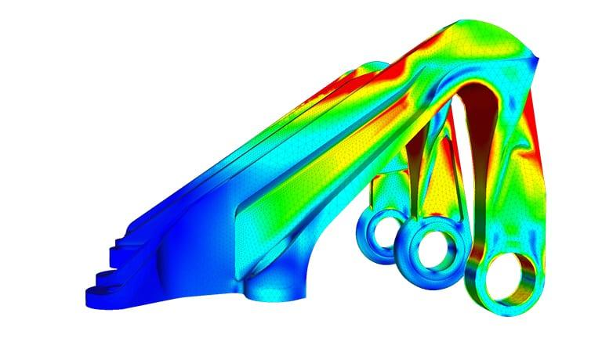

*Figure 1: Finite element analysis of an aircraft’s bearing bracket*

### Some remarks

In summary, the finite element method divides a given domain into subdomains called finite elements and develops an approximation of the solution over each element. The partition of an entire domain into subsections permits simple representation of the whole solution by functions defined within each element that capture local effects (such as high gradients in the solution).

Following are the three fundamental steps of the finite element method:

1. To represent both the geometry and the solution to the problem, subdivide the entire domain.
2. Seek an approximation of the solution as a linear combination of nodal values and approximation functions over each element, and establish the algebraic relations between the nodal values of the solution.
3. Assemble the elements and solve for the solution in the whole domain.

Although the above steps are the core of the finite element method, there are several features that need to be mentioned:

* Depending on the shape of the domain, its geometry can be discretized into a mesh of more than one type of element (by shape or order). For instance, one can approximate an irregular domain using a combination of rectangles and triangles. Nonetheless, the element interfaces must be compatible in that the solution must be uniquely defined along the interface.
* If more than one type of element is employed in the domain's representation, one of each type must be isolated and its equations developed.
* In engineering problems, the governing equations are differential equations. Two reasons prevent most equations from being solved over an element. First, they prohibit the exact solution. Here is where variational methods become relevant. Second, the discrete equations derived from variational methods cannot be solved independently of the remaining elements because the ensemble of elements is subject to continuity, boundary, and/or initial conditions.
* In general, the assembly of elements is based on the assumption that the solution (and possibly its derivatives in higher-order equations) is continuous at the boundaries.
* In general, the collection of finite elements is subject to initial and/or boundary conditions. After the boundary and/or initial conditions have been imposed, the discrete equations associated with the finite element mesh are solved.
* There are three sources of error in a finite element solution: (a) those resulting from the approximation of the domain, (b) those resulting from the approximation of the solution, and (c) those resulting from numerical computation (e.g., numerical integration and round-off errors in a computer). The estimation of these errors is typically not straightforward. However, they can be estimated for classes of elements and problems under specific conditions.
* The accuracy and convergence of the finite element solution are dependent on the differential equation, its weighted integral form, and the element employed. "Accuracy" refers to the difference between the exact solution and the finite element solution, whereas "convergence" refers to the accuracy as the number of mesh elements increases.
* Usually, a two-step formulation is followed for time-dependent problems. In the first step, the differential equations are approximated using the finite element method in order to produce a set of ordinary differential equations in time. In the second step, the differential equations in time are solved exactly or approximatively using variational or finite difference methods in order to obtain algebraic equations, which are then solved for the nodal values. Alternately, the finite element method may be utilized at both approximation stages.
* Today's desktop computers are more powerful than the supercomputers that were available when the finite element method was first implemented. Therefore, the analysis time is drastically reduced, assuming the mesh used to model the issue is adequate. Even automatic mesh generation programs cannot guarantee meshes that are free of irregularly shaped elements and have a sufficient number of elements in regions with high gradients in the solution, both of which lead to a loss of accuracy or, in the case of nonlinear problems, non-convergence of solutions.

## Plane Elasticity

Elasticity is a field of solid mechanics concerned with the stress and deformation of solid continua. Linearized elasticity is concerned with small deformations in linear elastic solids (i.e., strains and displacements are very small). Due to geometry, boundary conditions, and externally applied loads, a class of elasticity problems have solutions (displacements and stresses) that are independent of one of the coordinates. Such issues are referred to as plane elasticity problems. These plane elasticity problems are categorized as plane strain problems and plane stress problems. A pair of coupled partial differential equations expressed in terms of the two components of the displacement vector characterizes both classes of problems.

The material description, also known as the Lagrangian description, is the basis for describing the motion of an elastic body occupying the volume with closed boundary. Three-dimensional linearized elasticity has the following equations of motion (assuming strains are infinitesimally small and the material obeys Hooke's law):

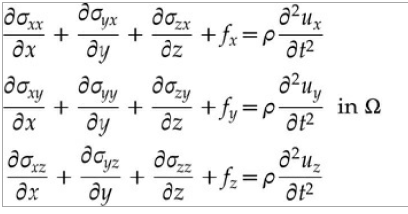

Here, (***ux, uy, uz***) are components of the displacement vector ***u*** along the ***x****,* ***y***, and ***z*** (material) coordinates, respectively, ***σξη*** are the components of the stress tensor **σ** acting on a plane perpendicular to the ξ axis and in the direction of the η, axis, (***fx, fy, fz***) are the components of the body force vector **f**, measured per unit volume, and **ρ** is the mass density. The equations of motion are derived using the principle of balance of linear momentum.

The principle of balance of angular momentum, in the absence of body moments or couples, leads to the symmetry of the stress tensor:



Thus, in **3D** elasticity, there are only six stress components that are independent. There are nine unknowns in the three equations of motion, which include three displacements and six stresses. Using the stress–strain and strain–displacement relationships, we express the six stresses in terms of three displacements in order to have three unknowns in three equations. Hooke's law is expressed as:

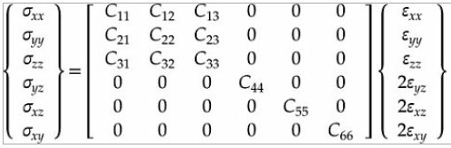

where, ***Cij* = *Cji***are the material parameters, called material stiffness coefficients, of a linear elastic medium. The stiffness coefficients ***Cij*** can be expressed in terms of the nine engineering material constants (***E1, E2, E3, G23, G13, G12, ν23, ν13***, and ***ν12***) as follows:

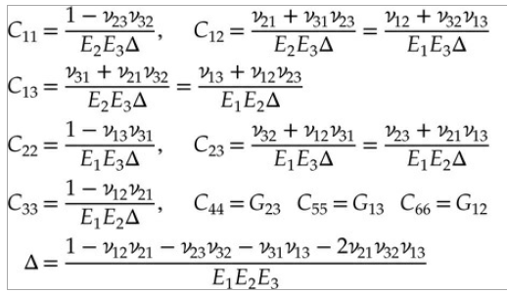

Where*,* ***Ei*** are Young’s moduli, ***Gij*** are the shear moduli, and ***νij*** are the Poisson ratios. The strain-displacement relations of linear elasticity are:

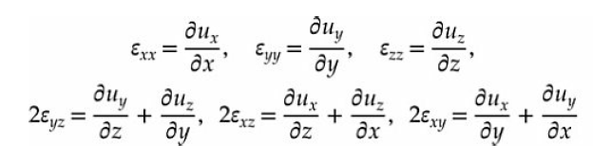

where ***εxx***, ***εyy*** and so on are the strain components in the rectangular Cartesian system.

### 1.3.1 Plane Stress

A state of plane stress is defined as one in which the following stress field exists:

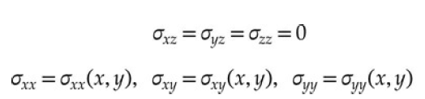

An example of a plane stress problem is provided by a thin plate under external loads applied in the ***xy*** plane (or parallel to it) that are independent of z. The top and bottom surfaces of the plate are assumed to be traction-free, and the specified boundary forces are in the ***xy*** plane so that ***fz*** = 0 and ***uz*** = 0.

The strain field associated with the stress field in is

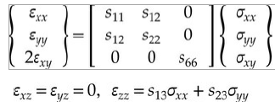

where ***sij*** are the elastic compliances

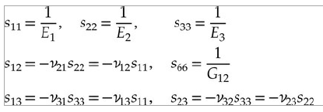

The inverse is given by

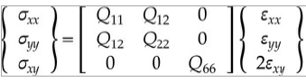

where ***Qij*** are the plane stress-reduced elastic stiffness coefficients

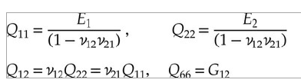

### 1.3.2. Development of Weak Form

This section focuses on the development of the weak form of the plane stress equations. We employ the principle of virtual displacements as expressed by matrices relating displacements to strains, strains to stresses, and the equations of motion.

Let ***Ωε*** be a plane elastic finite elements with volume ***Ve*** = ***Ωe*** * (-***he***/2, ***he***/2).



where ***Se*** = ***Γe*** × (−***he***/2, ***he***/2) is the surface of the volume element ***Ve***; and he is the thickness of the finite element ***Ωe; δ*** denotes the variational operator ***σij*** and ***εij*** are the components of stress and strain tensors, respectively and***fi*** and are the components of the body force and boundary stress vectors, respectively. The correspondence between the (***x, y***) components and (***x1, x2***) components of the stress and strain tensors is given by

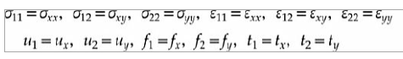

In the above equation, the first term represents the virtual strain energy stored in the body, the second term represents the kinetic energy stored in the body, the third term represents the virtual work done by the body forces, and the fourth term represents the virtual work done by the surface tractions. Consistent with the plane elasticity assumptions, we assume that all quantities are independent of the z-coordinate thickness. Hence, we obtain

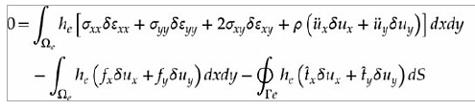

wherein, now, ***fx*** and ***fy*** are body forces per unit area and ***tx*** and ***ty*** are boundary forces per unit length. When the stresses are expressed in terms of strains and strains in terms of displacements the equation takes the form:

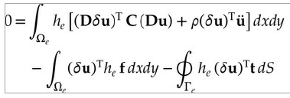

### 1.3.3. Finite Element Model

In this section, we develop the finite element model of the plane elasticity equations in vector form. Examining the weak form reveals that ***ux*** and ***uy*** are the principal variables, which must be carried as the principal nodal degrees of freedom. In addition, only the first derivatives of ***ux*** and ***uy*** with respect to x and y are represented in the weak forms. Therefore, ***ux*** and ***uy*** must be approximated by an interpolation function from the Lagrange family that is at least linear. The linear triangular and linear quadrilateral elements are the simplest elements that satisfy these conditions. Despite the fact that ***ux*** and ***uy*** are independent of one another, they are components of the displacement vector. Therefore, both components must be approximated using the same type and degree of interpolation. Let ***ux*** and ***uy*** be approximated by the finite element interpolations (the element label *e* is omitted in the interest of brevity)



At the moment, we will not restrict ***ψj*** to any specific element so that the finite element formulation to be developed is valid for any admissible element. For example, if a linear triangular element (*n* = 3) is used, we have two ux,i and uy,i (*i* = 1, 2, 3) degrees of freedom per node and a total of six nodal displacements per element. For a linear quadrilateral element (*n* = 4), there are a total of eight nodal displacements per element. Since the first derivatives of *ψi* for a triangular element are element-wise constant, all strains (*εxx*, *εyy*, *εxy*) computed for the linear triangular element are element-wise constant. Therefore, the linear triangular element for plane elasticity problems is known as the *constant-strain triangular (CST) element*. For a quadrilateral element the first derivatives of *ψi* are not constant: ∂*ψi*/∂*ξ* is linear in η, and constant in *ξ*, and ∂*ψi*/∂η is linear in *ξ* and constant in η.

The finite element approximation in Eq. (12.4.1) can be expressed in vector form as



where ***Ψ*** is a 2 × 2*n* matrix and ***Δ*** is a 2*n* × 1 vector of nodal degrees of freedom:

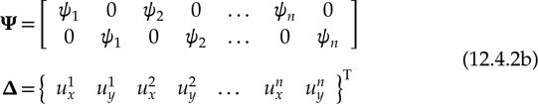

The strains are



where **D** is

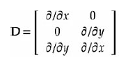

and **B** is a 3 × 2*n* matrix

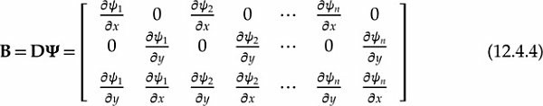

To obtain the vector form of the finite element model, we substitute the finite element expansion into the virtual work statement and obtain

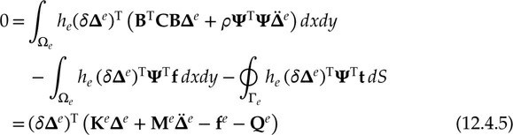

Since the above equation holds for any *arbitrary* variations ***δΔ***, it follows (from the Fundamental Lemma of variational calculus) that the coefficient of ***δΔ*** in the expression should be identically zero, giving the result



where

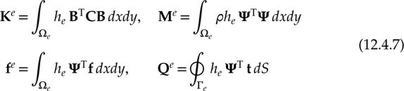

The element mass matrix **M***e* and stiffness matrix **K***e* are of order 2*n* × 2*n* and the element body-force vector **f***e* and the vector of internal forces **Q***e* is of

order 2*n* × 1, where *n* is the number of nodes in a Lagrange finite element (a triangle or quadrilateral).

### 1.3.4. Eigenvalue and Transient Problems

For natural vibration study of plane elastic bodies, we seek a periodic solution of the form



where *ω* is the frequency of natural vibration. Then the system’s equation reduces to an eigenvalue problem



For transient analysis, using a time-approximation like the famous Newmark integration scheme, equations can be reduced to the following system of algebraic equations:



where

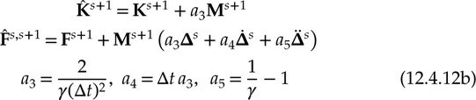

where γ is the parameter in the (α, γ)-family of approximation.

### 1.3.5. Computation of element matrices

For the linear triangular (i.e., CST) element, the ***ψie*** and its derivatives are given by

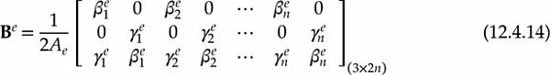

where *Ae* is the area of the triangular element. Since **B***e* and **C***e* are independent of *x* and *y*, the element stiffness matrix for the CST element is given by



For the case in which the body force components *fx* and *fy* are element-wise constant (say, equal to fx0e and fy0e respectively), the load vector **F***e* has the form

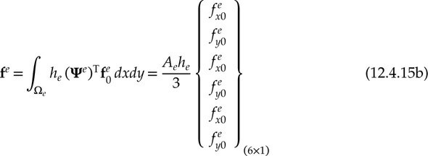

For a general quadrilateral element, it is not easy to compute the coefficients of the stiffness matrix by hand. In such cases we use the numerical integration. However, for a linear rectangular element of sides *a* and *b*, the element coefficient matrices in can be used to obtain the stiffness matrix. For example, the submatrices in for the linear element are given by

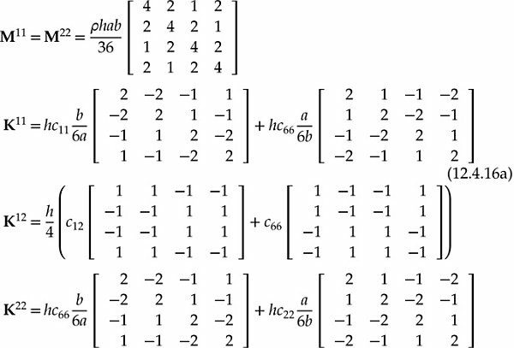

For a linear quadrilateral element with constant body force components (*fx*0, *fy*0), the load vector is given by

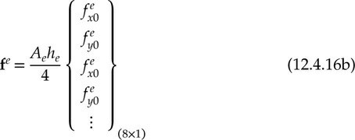

The vector **Q***e* is computed only when a portion of the boundary Γ*e* of an element Ω*e* falls on the boundary Γσ of the domain Ω on which tractions are specified (i.e., known). Computation of **Q***e* involves the evaluation of line integrals (for any type of element).For plane elasticity problems, the surface tractions *tx* and *ty* take the place of *qn* in the single-variable problems. However, it should be noted that *tx* and *ty* are the horizontal and vertical components (i.e., parallel to the coordinate lines *x* and *y*) of the traction vector **t**, which, in general, is oriented at an angle to the boundary line (or curve), which itself is oriented at an angle to the global coordinate axis *x*. In practice, it is convenient to express the surface traction **t** in the element coordinates. In that case, **Q***e* can be evaluated in the element coordinates and then transformed to the global coordinates for assembly. If **Q***e* denotes the element load vector referred to the element coordinates, then the corresponding load vector referred to the global coordinates is given by



where **R** is the transformation matrix

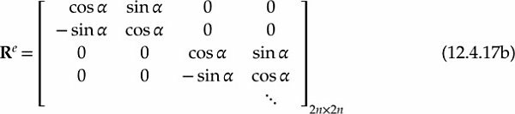

and ***α*** is the angle between the global *x*-axis and the traction vector **t**.

## Fluid-Structure Interaction (FSI)

## C/C++ capabilities for improving performance