

< Stargazers />

User manual



GitHub Stargazers is a simple App to search GitHub users and repos, and see the people that put a on a them (also known as Stargazer).



It is a React Native Expo App, so it runs on Android, iOS and also on the web using a browser.

The App has two main screens accessible from the bottom navigation bar: Stargazers and Profile.

In the Stargazers screen we can search for GitHub users and repos.

An upper toggle lets you choose between Search mode and List mode:

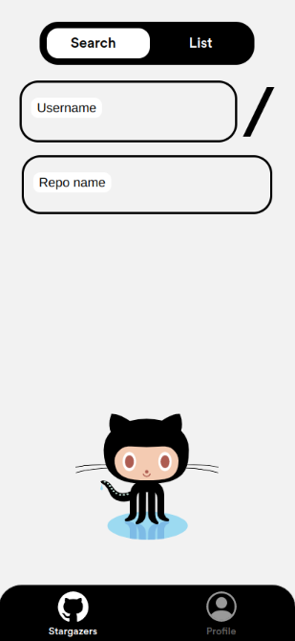

In Search mode you can search for a specific repo. Type in the repo owner username and the repo name. Press Enter and the App will search for that repo for you. If it finds it, the App will show you all its detail (more on the detail screen later).

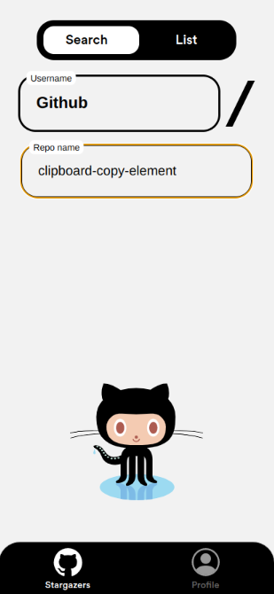

In List mode you can see all the repos owned by a specific user. Type in a GitHub user username and press Enter. The App will search for that user for you.

If it find such user it will show you a list of all the repos owned by that user:

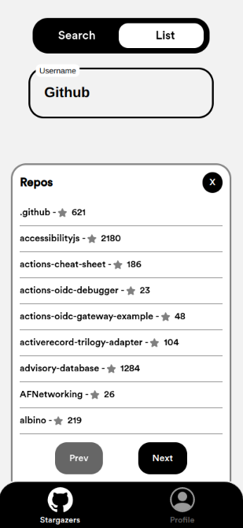

If the user owns many repos, the list will be scrollable and subdivided in pages.

By entering a GitHub username and repo name in Search mode, or by entering a GitHub username and selecting a repo from the results, a repo detail screen will be shown:

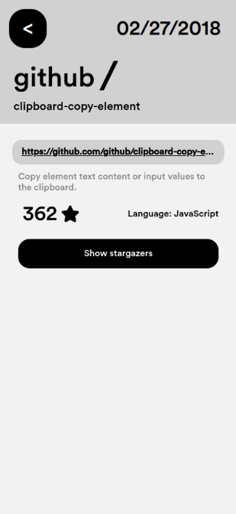

On the top right corner we will have the creation date of the repo, followed below by the repo owner username and the name of the repo itself.

Below, a link to the GitHub website of the repo. By tapping it, the browser will bring you to that page, so you can see files, branches and all sorts of stuff.

Then we can have a brief description, followed by the number of Stargazers and the programming language the repo is mainly developed in.

If the repo has at least one Stargazer, by tapping the button Show Stargazers you will finally see the list of all repo Stargazers:

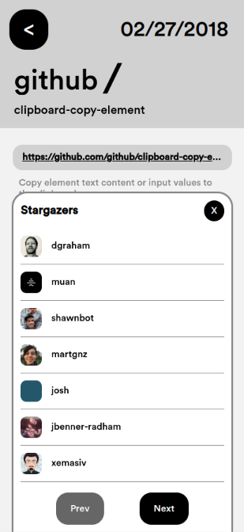

If the repo is appreciated by lots of GitHub users, the list will be scrollable and subdivided in pages.

Quick note: by using this App you will sooner or later encounter this error:

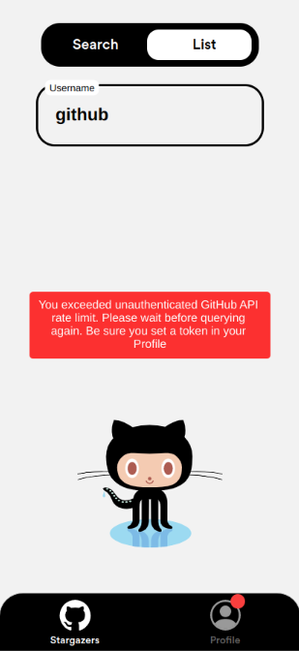

Basically, GitHub allows "guest" users to search inside its database just a limited amount of times (about 60 requests per hour). After that it wont give you any more data.

But, if we have a GitHub account we can easily remove this limit. That's where the Profile screen comes in place.

In the Profile screen we can paste a GitHub Personal Access Token and save it. Once done we will have virtually no limit in querying GitHub database. If you have a GitHub account and want to learn how to create a Personal Access Token, just tap on "More info".

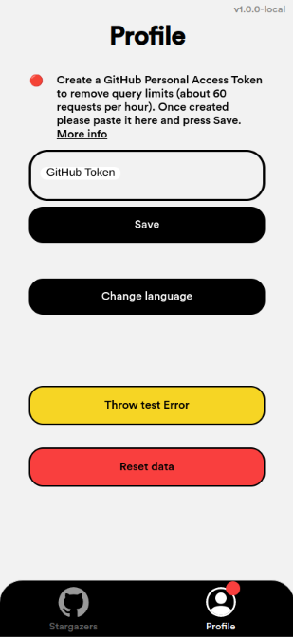

In this screen we can also cycle through available languages, throw a test Error (just for development purposes) and reset app data (token included, so you would have to enter it again).