**BOOTH’S ALGORITHM**

PROBLEM STATEMENT

Implement the Booth’s algorithm for multiplying binary numbers

SOLUTION

In this project, we have designed an implementation of the Booth’s Algorithm for multiplication.  
The program takes two numbers from user as input in Decimal Format. Then, in the backend, it converts the numbers into Binary Format and then, executes the Booth’s Algorithm on the numbers and on the Java console it displays the final output after multiplication to the user while it also creates a text file (.txt) and generates all the step by step logic behind the final output.

*Programming Language: Java*

ASSUMPTIONS

The following are the assumptions that I have taken while building the two-pass assembler:

1. Floating point numbers will not be considered.
2. Signed numbers can be considered as input.
3. The input numbers are entered in decimal (Base 10) format
4. Negative numbers are added with valid “ - ” sign
5. Positive numbers are added without any “ + ” sign

INPUT FILES

The following files is the input files of the project:

1. BoothsAlgo.java

Java file containing the program for the implementation of Booth’s Algorithm

OUTPUT FILES

The following files are part of the output file of the project:

1. Output.txt

Text file containing the final result after implementation of Booth’s Algorithm

GETTING STARTED

Please follow these instructions to use the assembler:

1. Open the .java file
2. Select the target folder’s directory where you want the output file to be created
3. Copy this directory into the .java program
4. Execute the program
5. The desired final output file is created in the same directory

REFERENCES

The following are a list of references to further increase your understanding of the topic.

1. <https://en.wikipedia.org/wiki/Booth%27s_multiplication_algorithm> (Wikipedia)
2. <https://www.geeksforgeeks.org/computer-organization-booths-algorithm/> (GeeksForGeeks)
3. <https://www.youtube.com/watch?v=qVmZmZnYTI&list=PLQW97ngfDtC8ZtAU7NPi8S1eA5OtXufLp&index=3&t=0s> (YouTube)
4. <https://www.youtube.com/watch?v=DHhcnjEKEFo> (YouTube)

DEVELOPER AND SUPPORT

If you have any issues regarding this project, feel free to contact me.

Piyush Sharma [piyush19316@iiitd.ac.in](mailto:piyush19316@iiitd.ac.in)   
+91- 9315118733

**UNDERSTANDING THE BOOTH’S ALGORITHM PROJECT**

The main objective behind this whole project is to design an algorithm that multiplies two signed binary numbers by implementing Booth’s algorithm.

According to Wikipedia, “ *Booth's multiplication algorithm is a*[*multiplication algorithm*](https://en.wikipedia.org/wiki/Multiplication_algorithm)*that multiplies two signed*[*binary*](https://en.wikipedia.org/wiki/Base_2)*numbers in*[*two's complement notation*](https://en.wikipedia.org/wiki/Two%27s_complement)*. The*[*algorithm*](https://en.wikipedia.org/wiki/Algorithm)*was invented by*[*Andrew Donald Booth*](https://en.wikipedia.org/wiki/Andrew_Donald_Booth)*in 1950 while doing research on*[*crystallography*](https://en.wikipedia.org/wiki/Crystallography)*at*[*Birkbeck College*](https://en.wikipedia.org/wiki/Birkbeck,_University_of_London)*in*[*Bloomsbury*](https://en.wikipedia.org/wiki/Bloomsbury)*,*[*London*](https://en.wikipedia.org/wiki/London)*. Booth's algorithm is of interest in the study of*[*computer architecture*](https://en.wikipedia.org/wiki/Computer_architecture)*. ”*

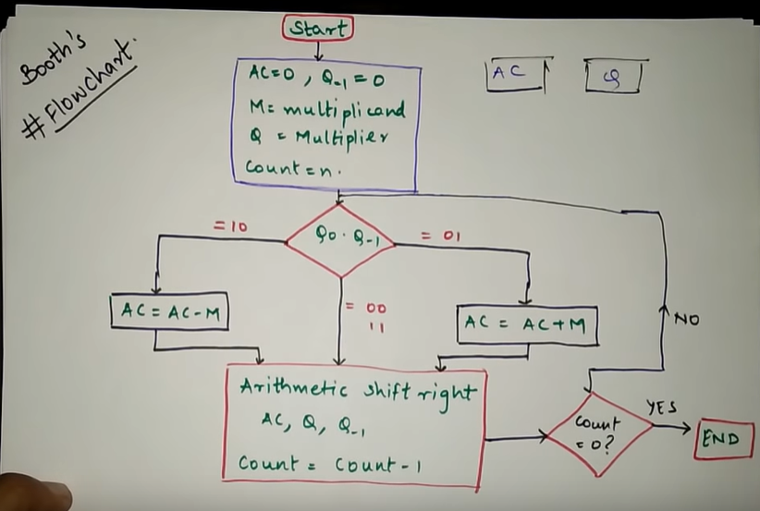

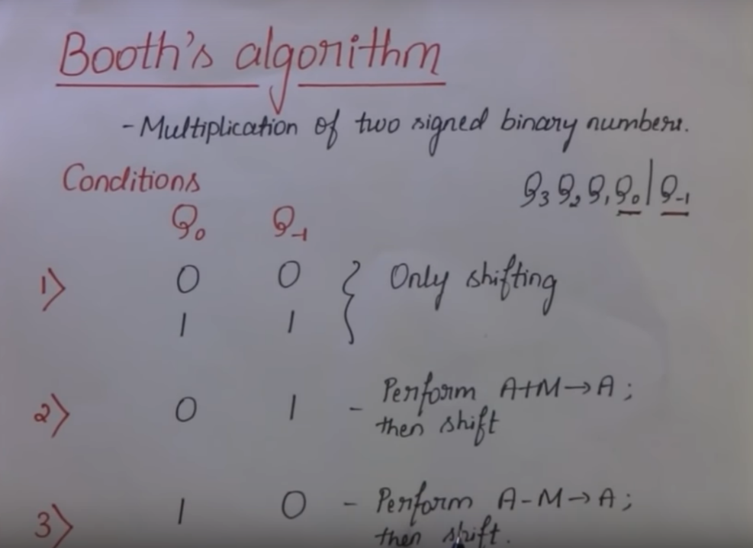

**LIST OF FUNCTIONS**

Herby, follows a list of all the functions used in the Java program for the assembler:

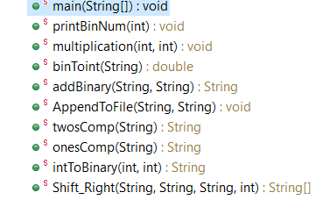

FUNCTIONS AND THEIR EXPLAINATION

Hereby, follows the list of functions used in the program with a quick explanation about them.   
The list is sorted in the order of the appearance of the functions in the code.

**public** **static** **void** main(String[] args)

The execution of the program begins with main(). This is the first function to be executed when the assembler is loaded. It contains the function call to PrintBinNum and Multiplication of the program.

**public** **static** **void** printBinNum (**int** n)

This program is used to print the 2 input decimal numbers into binary and display it to the user

**public** **static** **void** multiplication(**int** x, **int** y)

**public** **static** String addBinary(String a, String b)

**public** **static** **void** AppendToFile(String fileName, String s)

This program opens the given file in append mode to write and produce an output to the system and also displays an error message whenever any error is encountered during operation of the whole program.

**public** **static** String twosComp(String str)

Creates a new StringBuffer to hold the existing string (str).

Checks each element of the stringBuffer (s) until the EOL and performs 2s Complement

**public** **static** String onesComp(String str)

Creates a new StringBuffer to hold the existing string (str)

Checks each element of the stringBuffer (s) until the EOL and

replaces 0s with 1 and 1s with 0 to perform 1s Complement

Converts the StringBuffer back to a String and then returns it

**public** **static** String intToBinary(**int** a,**int** bits)

Converts the given integer a into a binary number and then

adds leading 0s to it until the length is eqaul to no. of bits and then returns the final number of binary as a string value

**public** **static** String[] Shift_Right(String AC, String multiplier, String qm1, **int** count)

RUNNING THE ASSEMBLER

Herby are few pictures of the working of the Java Program

