**MATLAB ASSIGNMENT**

**PROBLEM STATEMENT:**   
  
**EXPERIMENT 1**   
  
Observe the time gaps between your next 30 WhatsApp messages.  
Plot a histogram of your data using MATLAB.  
Fit a density function on to your data, by using the appropriate MATLAB tools.  
Based on your distribution, find the probability that the time elapsed until your next message is less than the expected time gap.  
  
**EXPERIMENT 2**Repeat Experiment 1, but this time, record the time gaps between messages from one person - a person you communicate with sufficiently often.  
  
**NOTE** : Do the following for both experiments:

Observe the time gaps between the next 10 messages you receive. If a time gap is less than the expected time gap, mark the observation as a Heads, otherwise as Tails.   
Record the number of Heads and Tails

**FILES:  
  
INPUT FILES**This project contains 3 files in total:  
  
Piyush_dataSet_2019316.xlsx Excel File  
Containing the sample input data  
  
Piyush_experiment1_2019316.m MATLAB File  
Containing the working code for Experiment 1  
  
Piyush_experiment2_2019316.m MATLAB File  
Containing the working code for Experiment 2

**OUTPUT FILES**This project does not produce any output file. The result of the project is displayed on the MATLAB screen and required graphs pop-up.

**WORKING DEMO FOR EXPERIMENT 1:**

**INPUT**

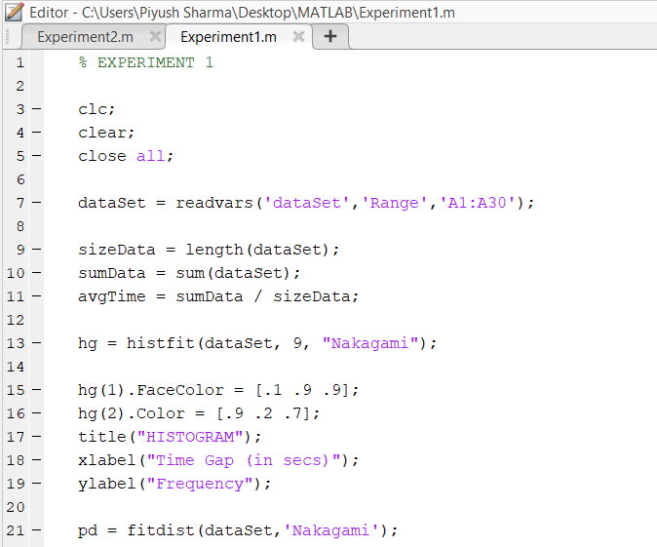

This is a snippet of the code for Experiment 1

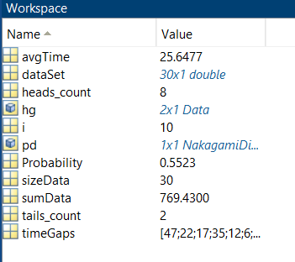

This is a snippet of the workspace containing all the variables for Experiment 1

**OUTPUT**

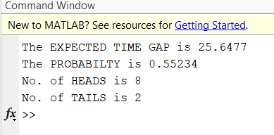

This is a picture of the command window that displays the final output result

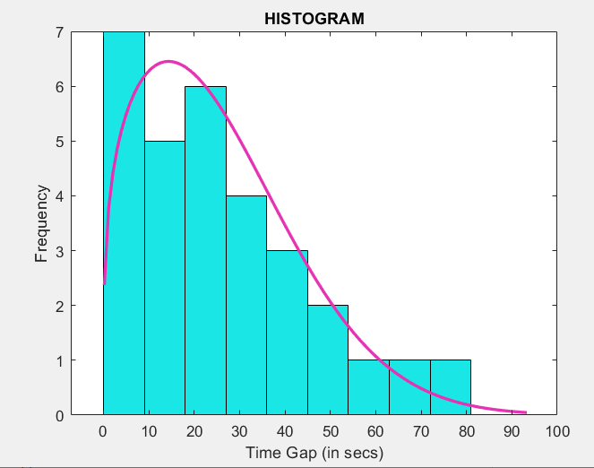

This is a picture of the histogram that is finally outputted as result.

**EXPLAINATION FOR THE CODE:**

% EXPERIMENT 1

clc;

clear;

close all;  
% Clears the editor and the workspace to create a fresh new file

dataSet = readvars('dataSet','Range','A1:A30');  
% Generates the dataset from the Excel sheet for Experiment 2

% Containing the time gaps for 30 messages from same person

% Saves it in a variable 'dataSet'

sizeData = length(dataSet);

sumData = sum(dataSet);

avgTime = sumData / sizeData;  
% Program to find the expected time gap of the given data set by

% Finding the average of the complete data set by

% Dividing the sum of whole data by total number of elements

% Alternatively, we can use mean(dataSet) or

% .mu operation to calculate the expected time gap

hg = histfit(dataSet, 9, "Nakagami");  
% .Plotting the histogram using the histfit() function which takes 3 inputs. The first one is the sample input data, the second is the number of bars to be printed and the third is the name of the distribution to be plotted.

hg(1).FaceColor = [.1 .9 .9];

hg(2).Color = [.9 .2 .7];  
% This is used to change the color of the histogram and the lines using RGB

title("HISTOGRAM");

xlabel("Time Gap (in secs)");

ylabel("Frequency");  
% This is used to put suitable titles on x and y axes for better identification.

pd = fitdist(dataSet,'Nakagami');  
% This function calculates the probability density and also calculates the mu and sigma and uses the chosen distribution function and given inputted dataset.

Probability = cdf(pd , avgTime);

timeGaps = readvars('dataSet','Range','B1:B10');

% Generates the dataset from the Excel sheet for Experiment 2

% Containing the time gaps for 10 messages from differnt person

% Saves it in a variable 'dataSet'

heads_count = 0;

tails_count = 0;  
% This is used to initialize two variables that will store int data

for i = 1:size(timeGaps)

if ( timeGaps(i) < avgTime )

heads_count = heads_count + 1;

else

tails_count = tails_count + 1;

end

end

% Program to check if the given time gap is less than the expected time gap

% If yes, mark it as head. If no, mark is as tails

% Also print the output;

disp("The EXPECTED TIME GAP is " + avgTime);  
% This function displays the average time gap on the display screen

disp("The PROBABILTY is " + Probability);  
% The PROBABILTY that the time elapsed until your next message is less than the expected time gap is

disp("No. of HEADS is " + heads_count);

disp("No. of TAILS is " + tails_count);  
% This function displays the heads and tails count;  
  
  
  
**REFERENCES:**In this MATLAB code, I have used ‘Nakagami Distribution’ and ‘Kernel Distribution’. To read and understand these topics, please refer to the below links:  
  
<https://en.wikipedia.org/wiki/Nakagami_distribution>  
<https://in.mathworks.com/help/stats/nakagami-distribution.html>  
<https://en.wikipedia.org/wiki/Kernel_density_estimation>  
<https://in.mathworks.com/help/stats/kernel-distribution.html>  
  
**SUPPORT:**This MATLAB code has been written by Piyush Sharma and is available on my GitHub profile. If you have any queries or doubts, regarding this. Please feel free to contact me at *piyush19316@iiitd.ac.in*