

Boeing Autonomous
SolidWorks Assembly and Parts Drawing Files
By: Elise C., Selina C., Jacob K., Marek L., Desirae M., Natasa P., Lily Q.

Brakes Subsystem
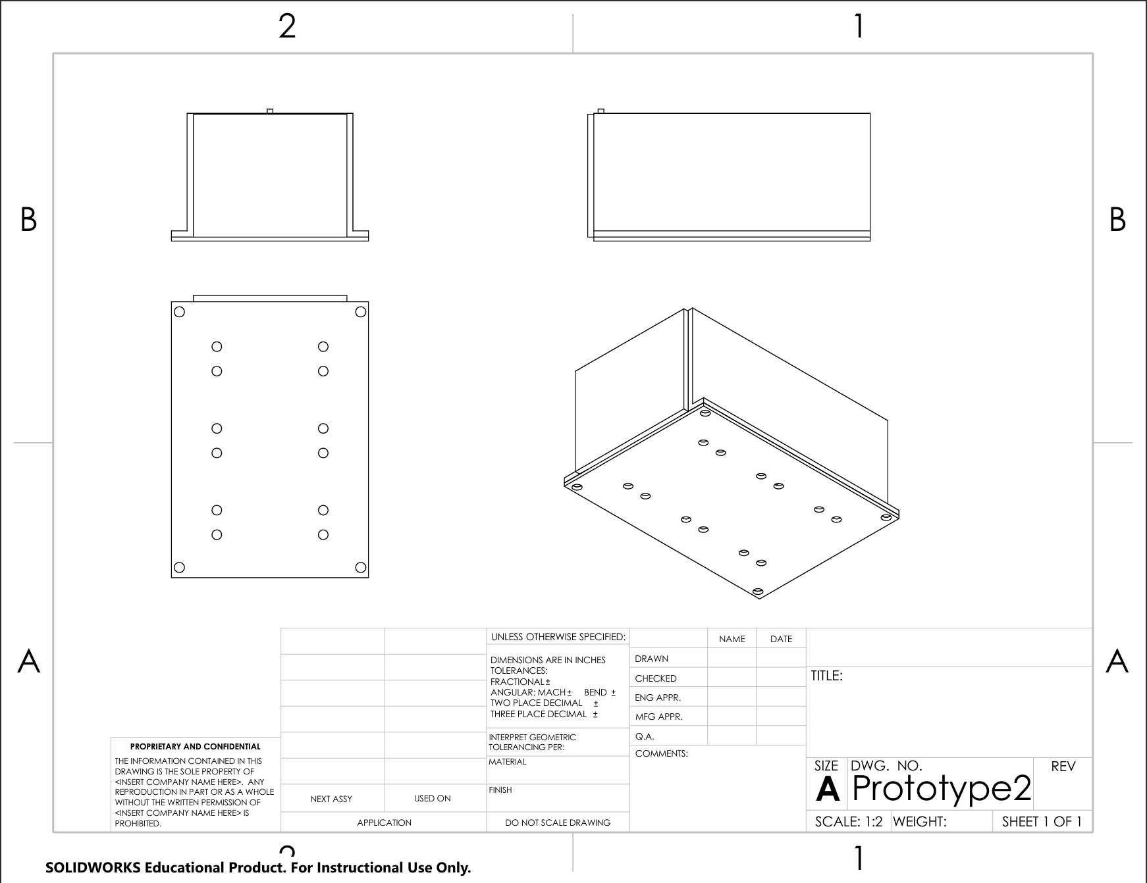
Figure 1: Prototype 2 Assembly Drawing

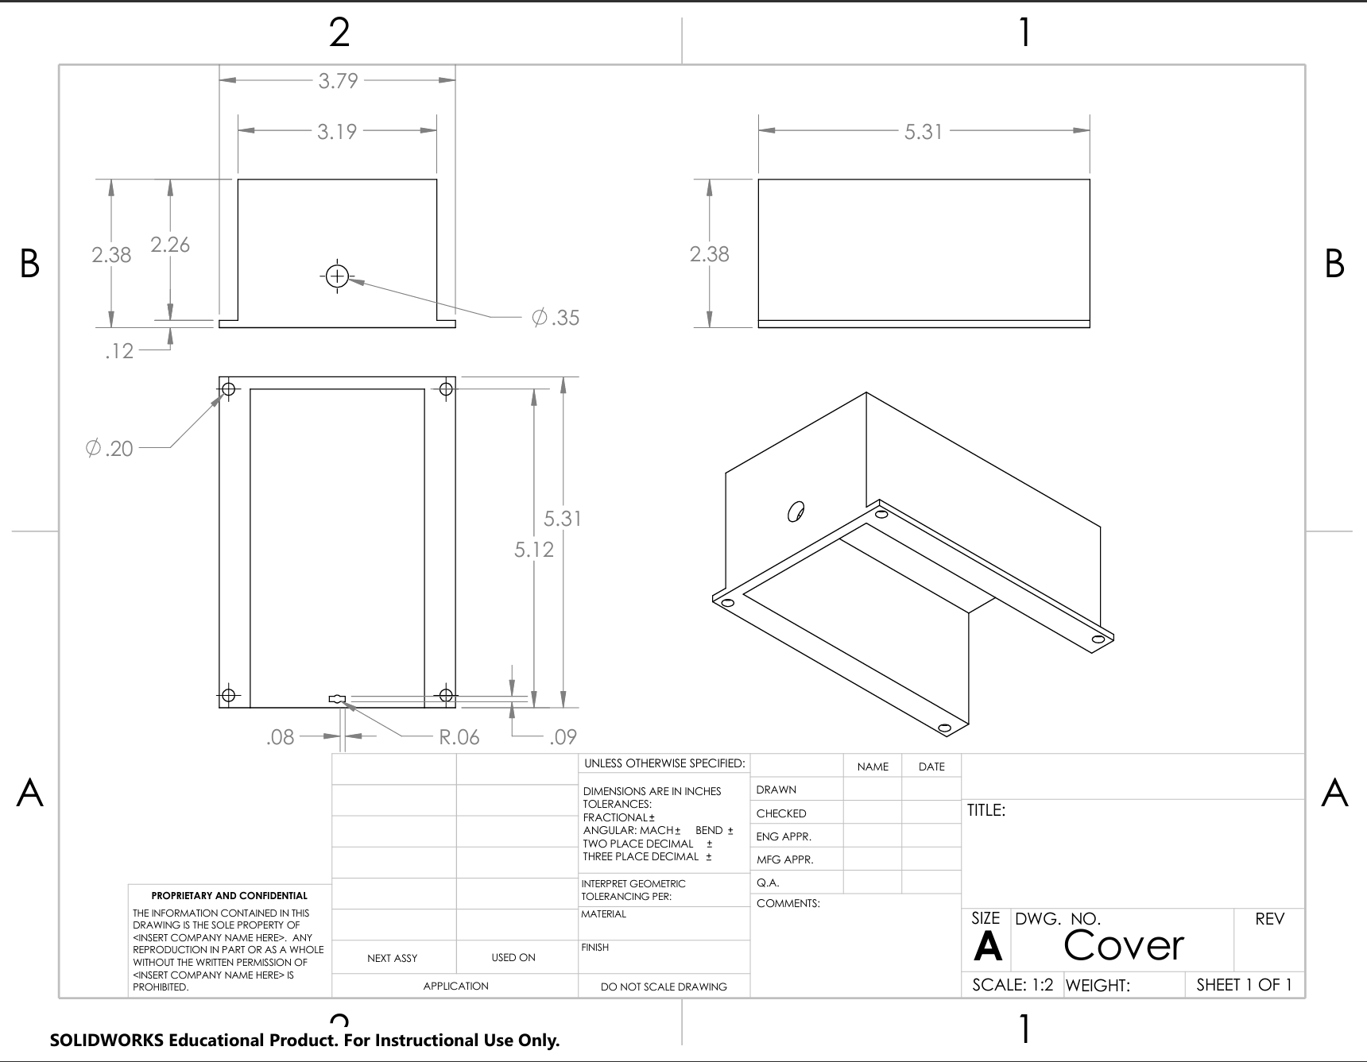
Figure 2: Prototype 2 Cover Drawing
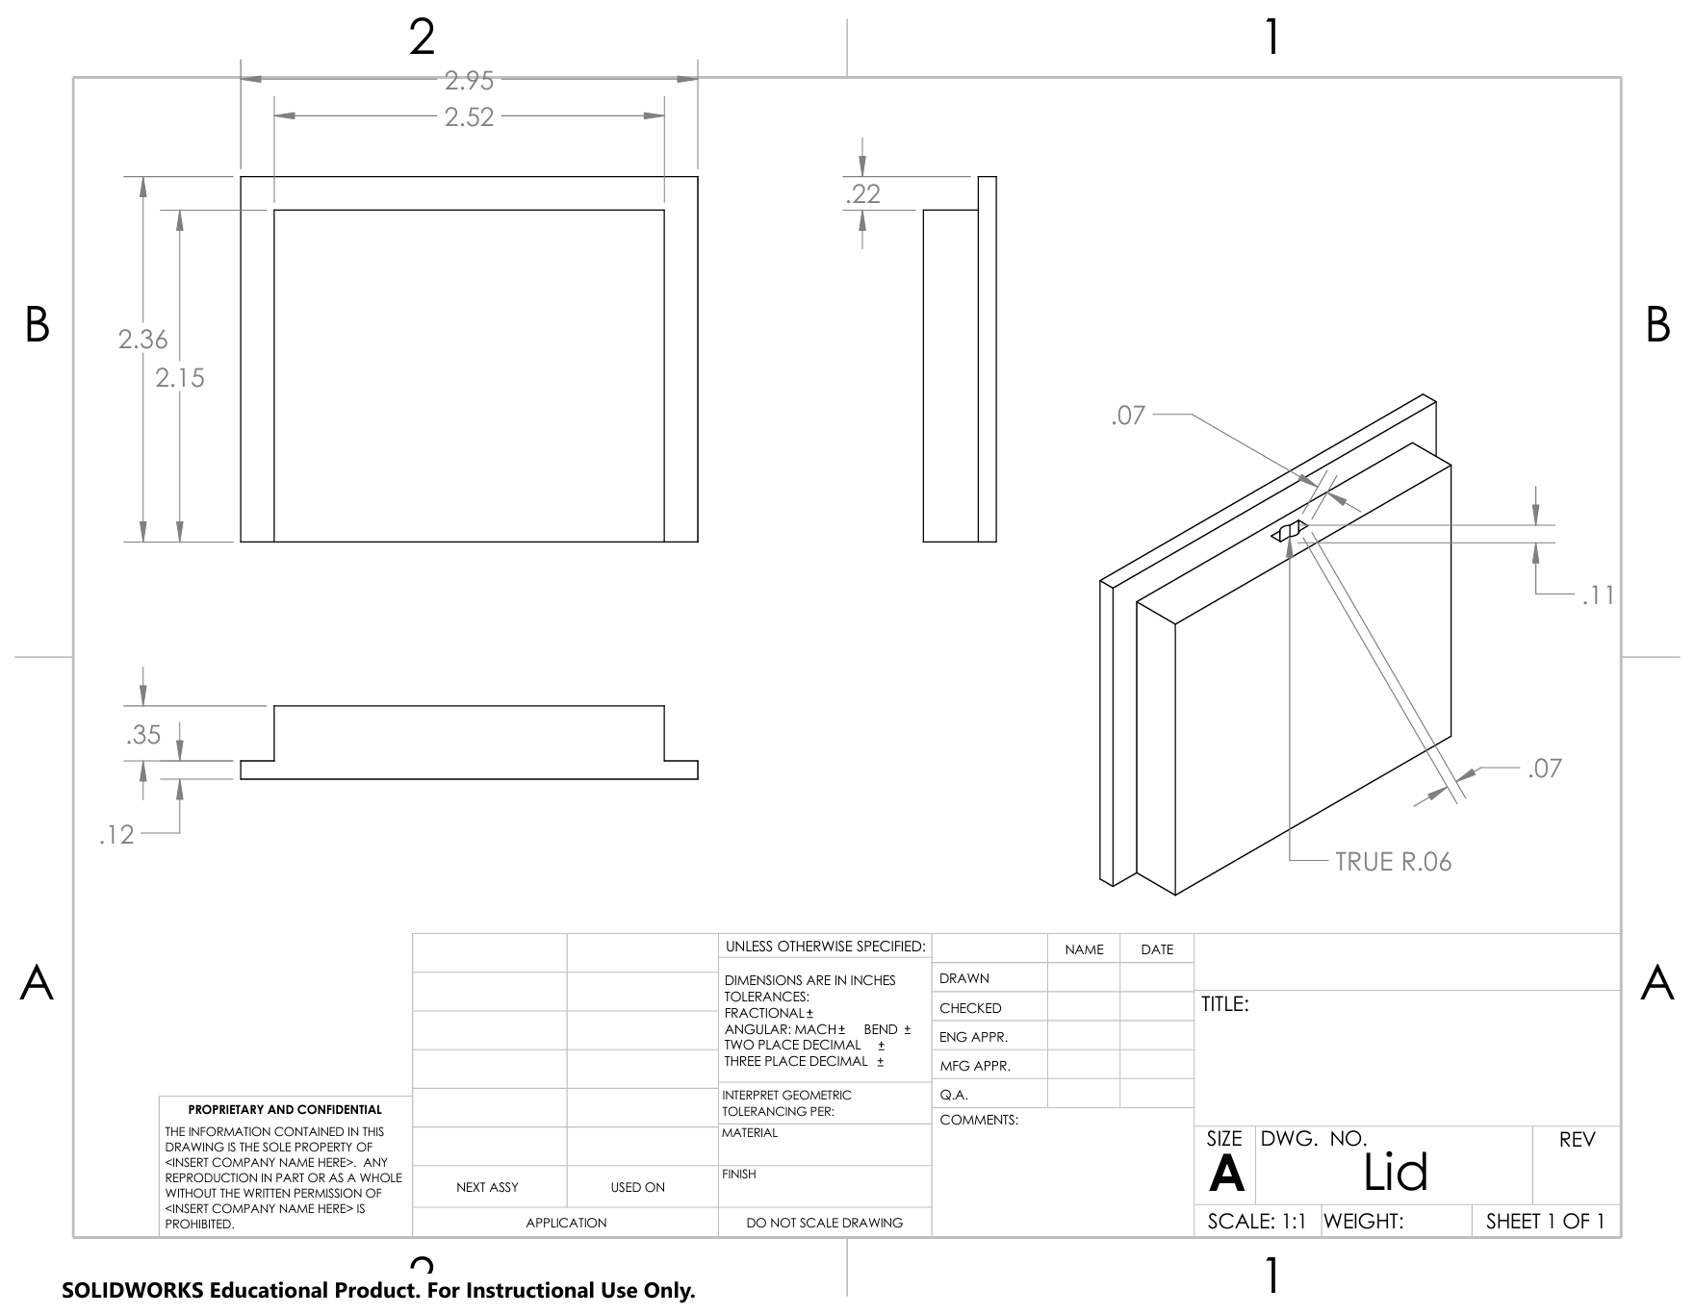
Figure 3: Prototype 2 Lid Drawing
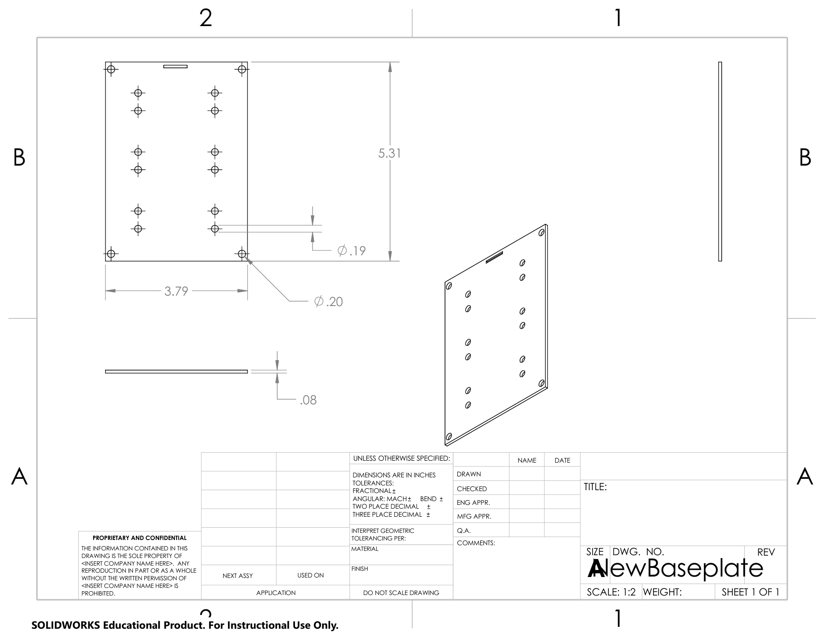
Figure 4: Prototype 2 New Base Plate Drawing
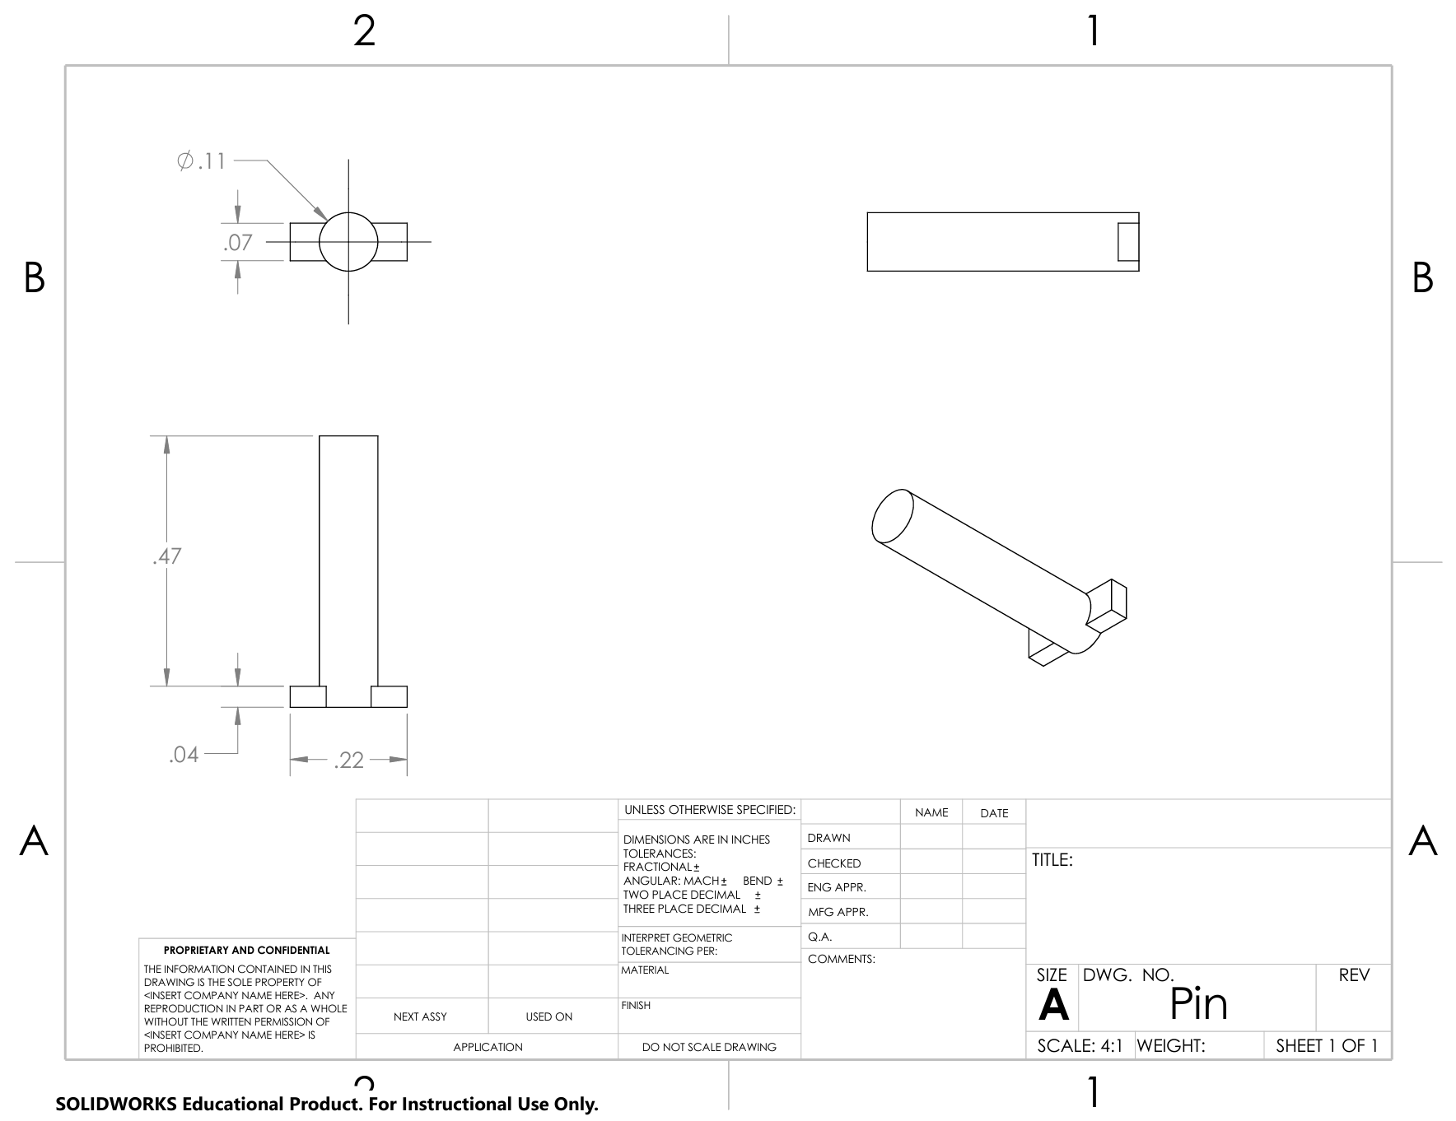
Figure 5: Prototype 2 Pin Drawing
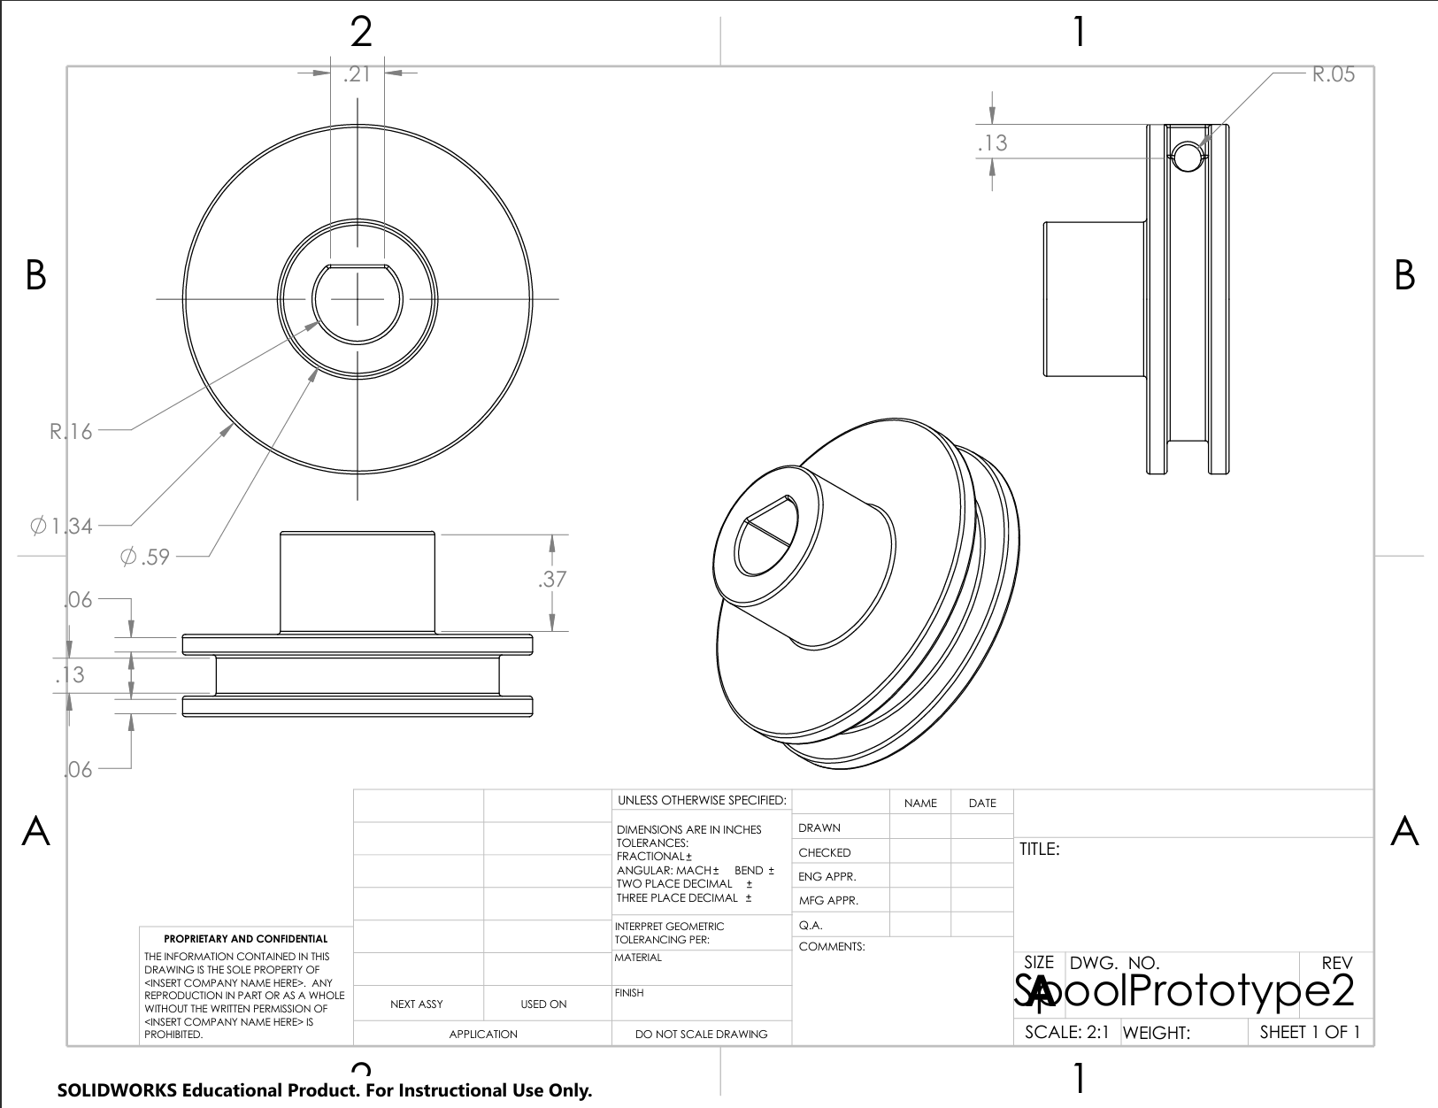
Figure 6: Prototype 2 Spool Drawing
Steering
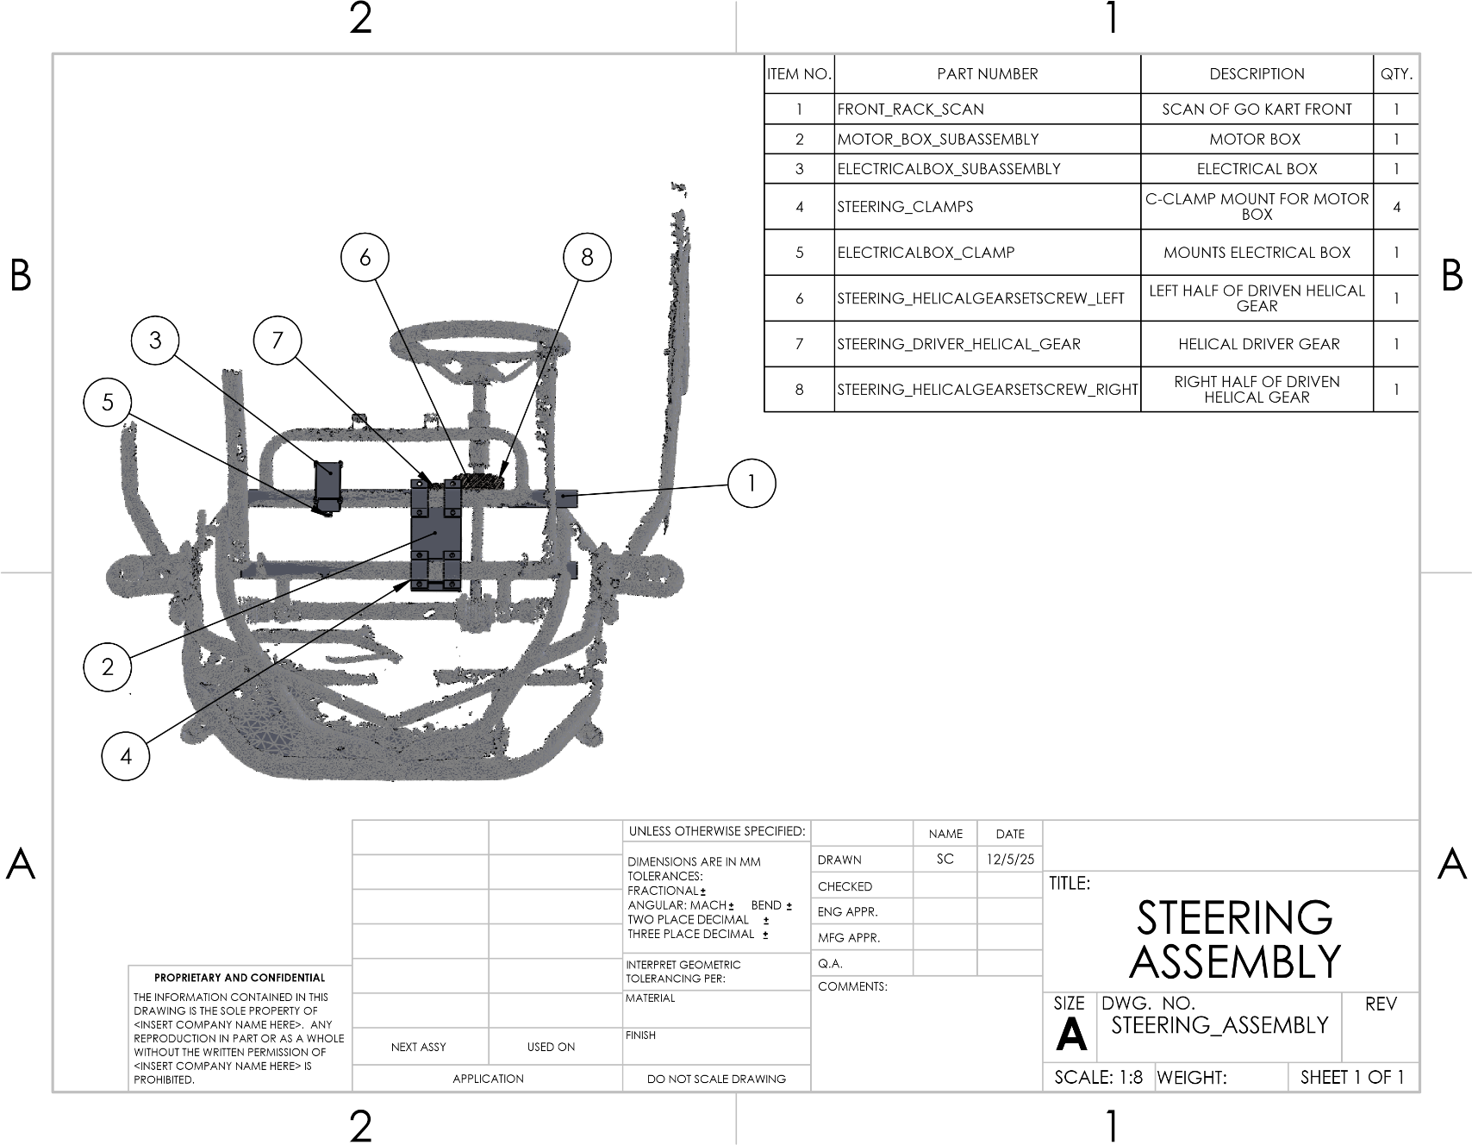
Figure 7: STEERING ASSEMBLY
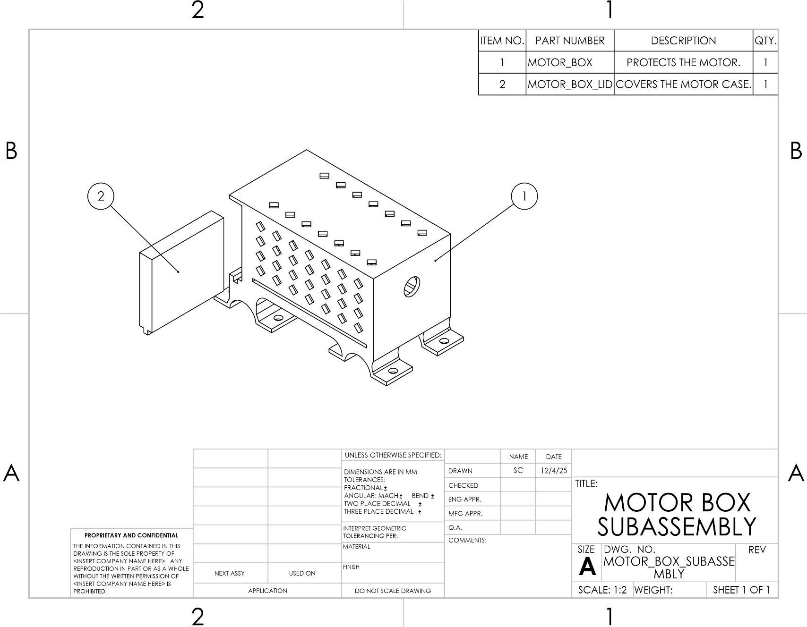
Figure 8: MOTOR BOX SUBASSEMBLY

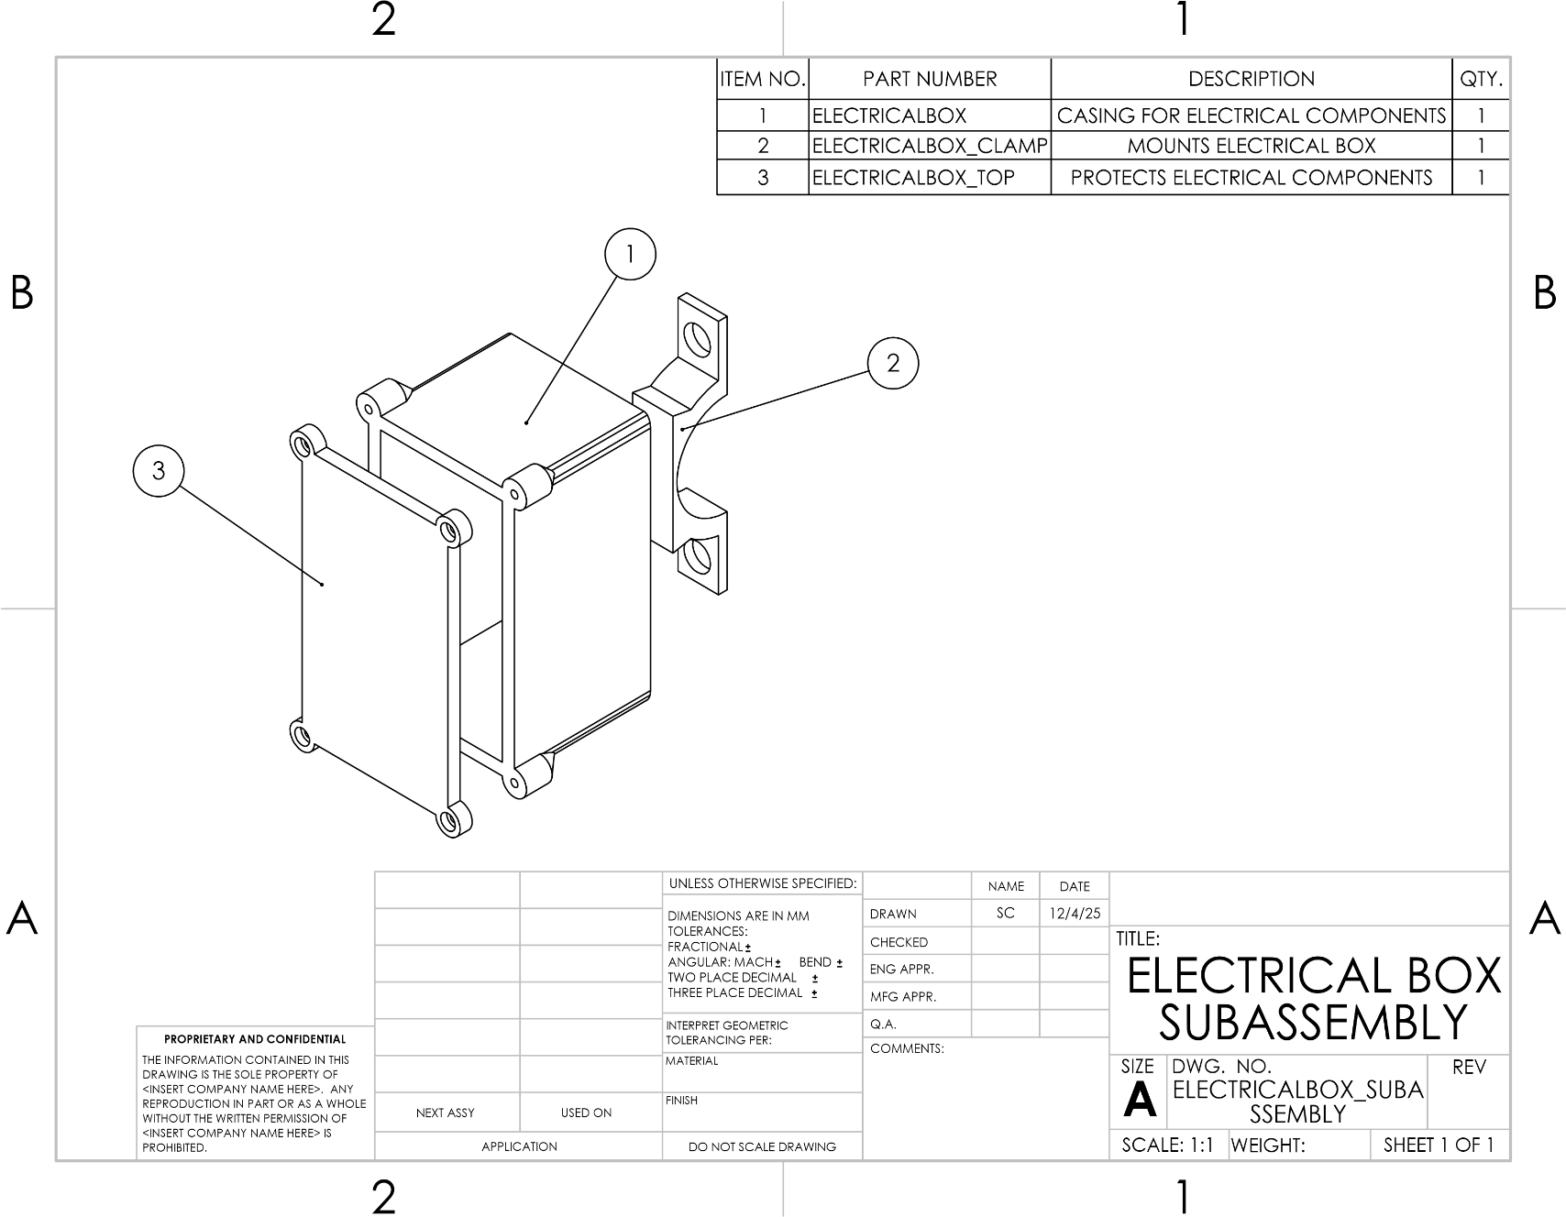
Figure 9: ELECTRICAL BOX SUBASSEMBLY

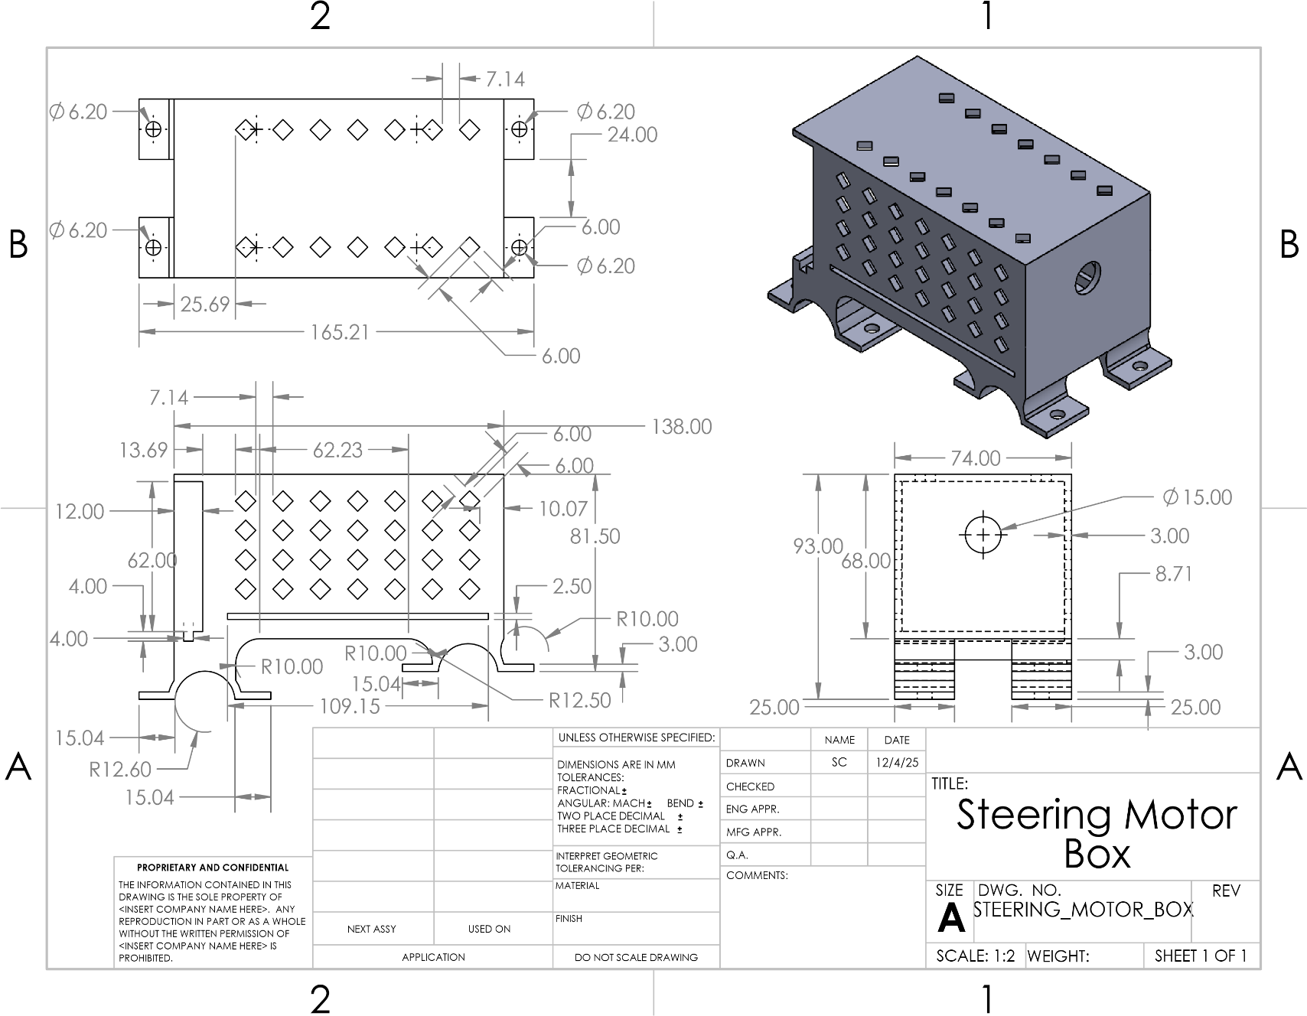
Figure 10: STEERING MOTOR BOX
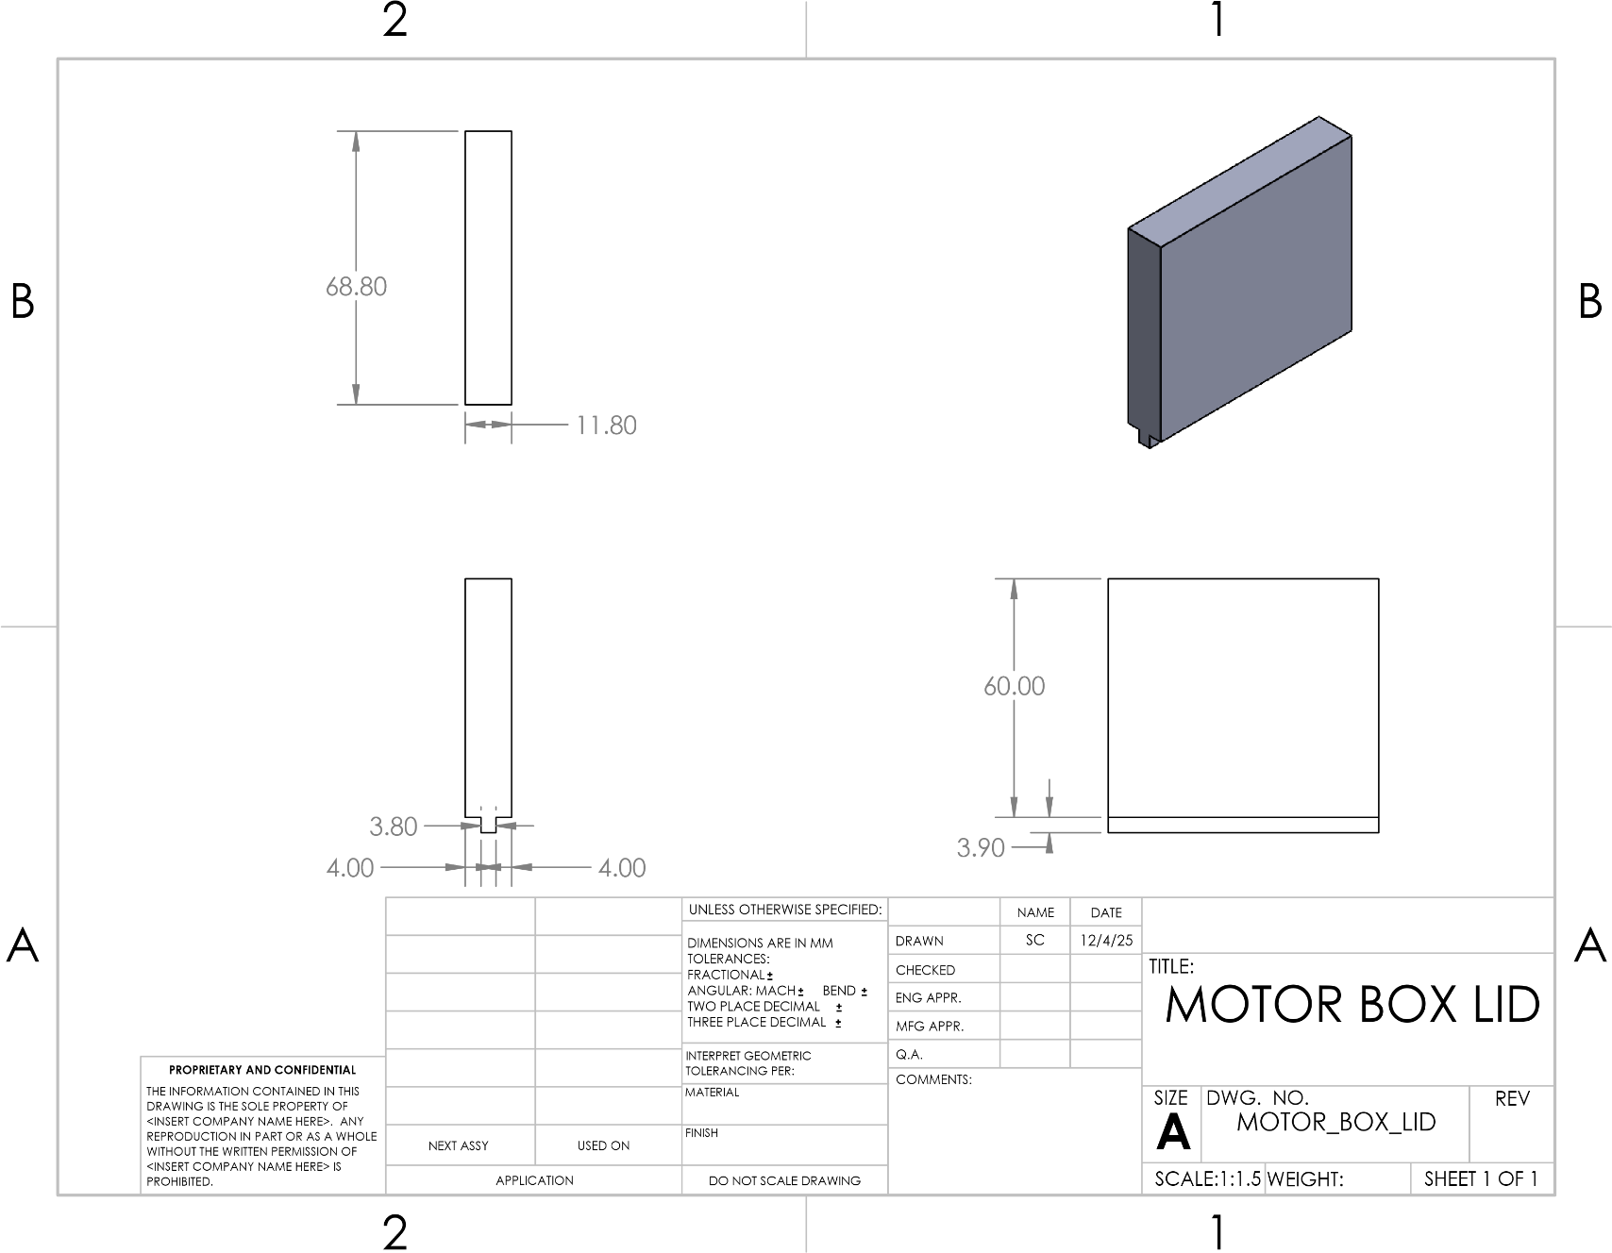
Figure 11: MOTOR BOX LID
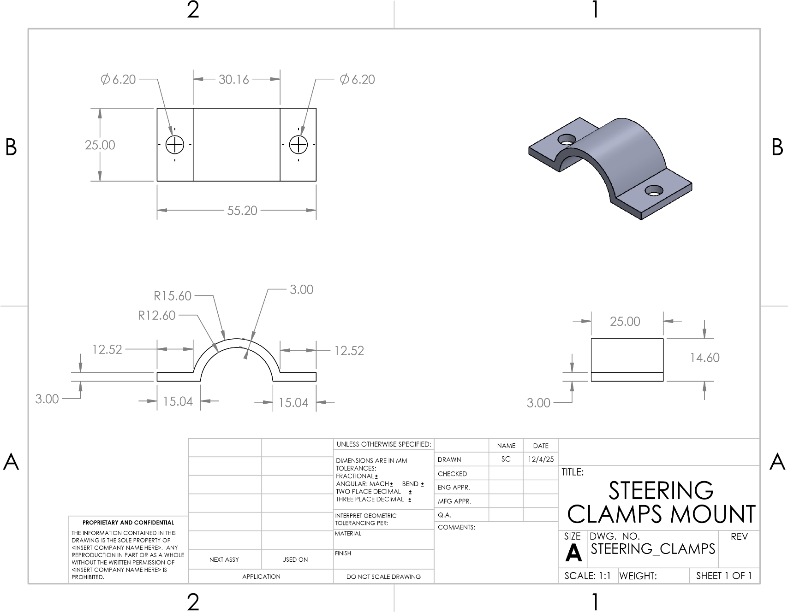
Figure 12: STEERING CLAMPS MOUNT

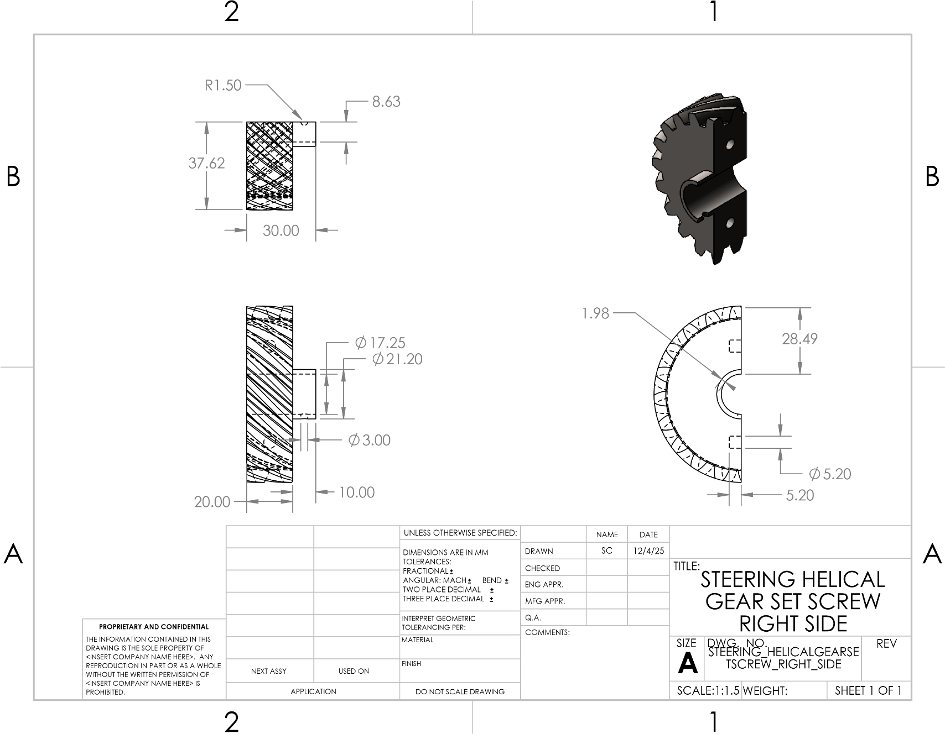
Figure 13: STEERING HELICAL GEAR SET SCREW RIGHT SIDE

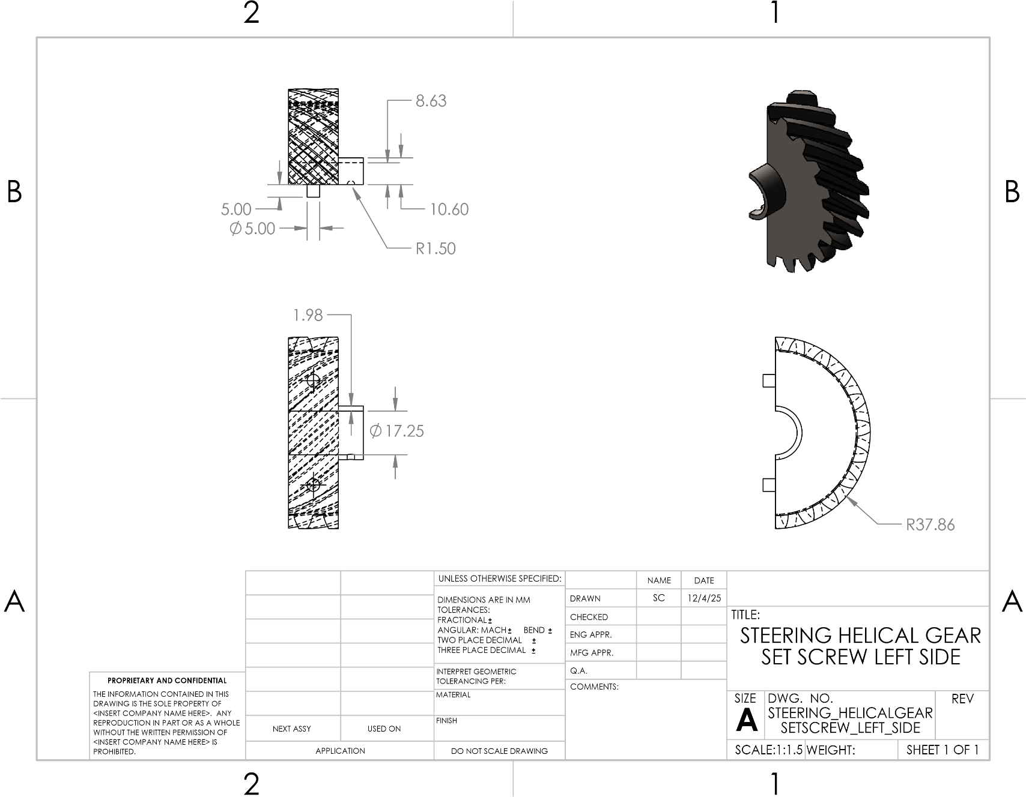
Figure 14: STEERING HELICAL GEAR SET SCREW LEFT SIDE

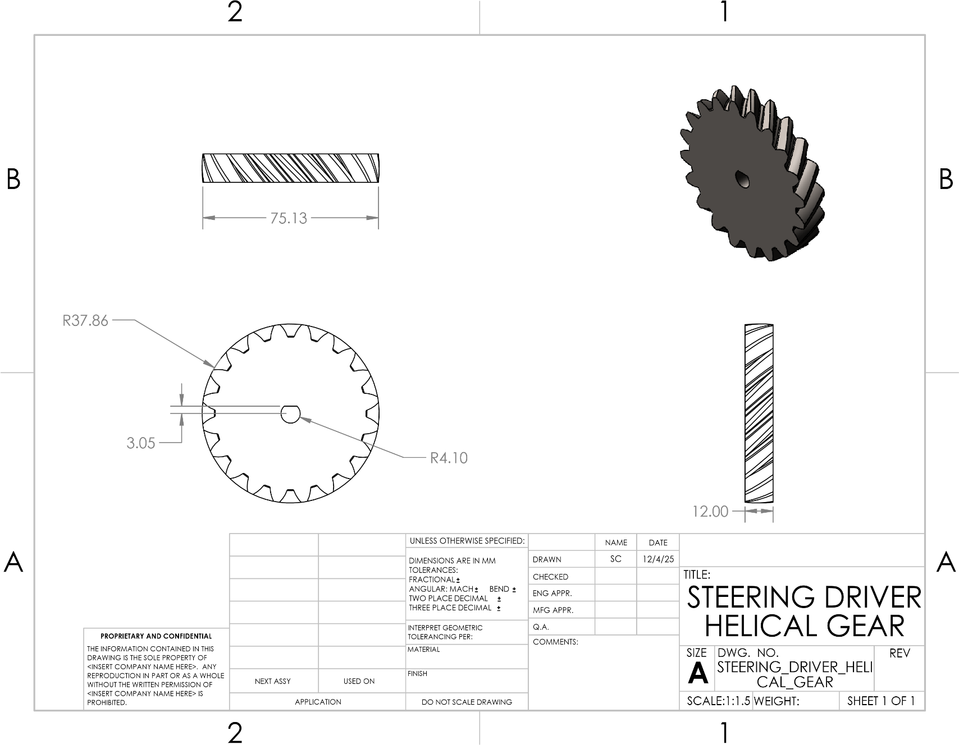
Figure 15: STEERING DRIVER HELICAL GEAR
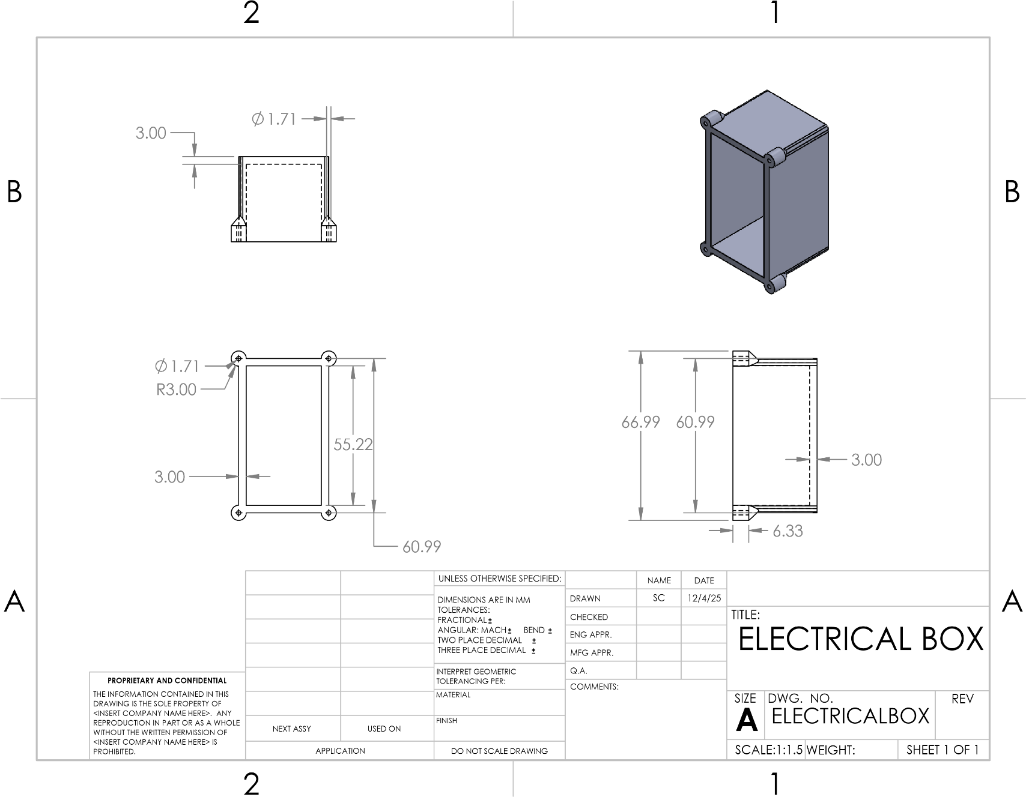
Figure 16: ELECTRICAL BOX
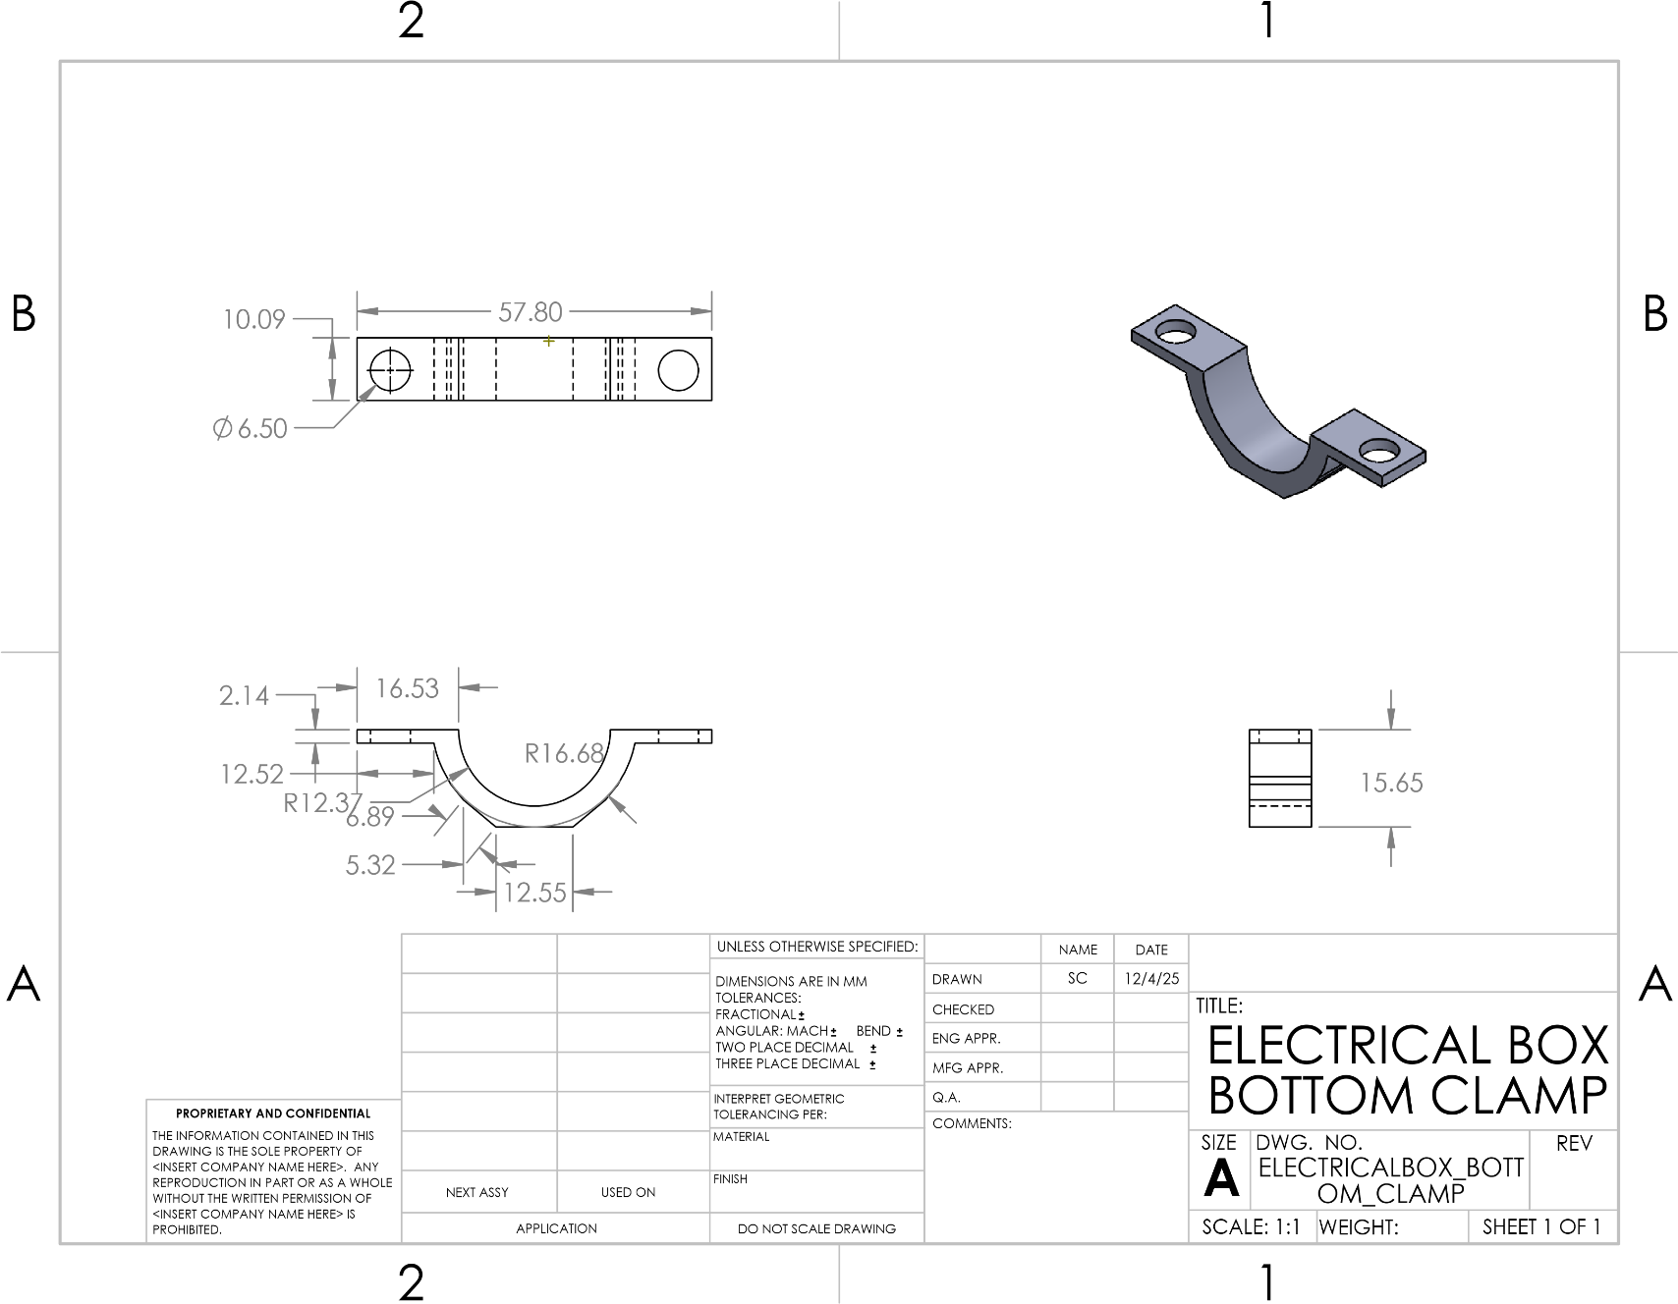
Figure 17: ELECTRICAL BOX BOTTOM CLAMP
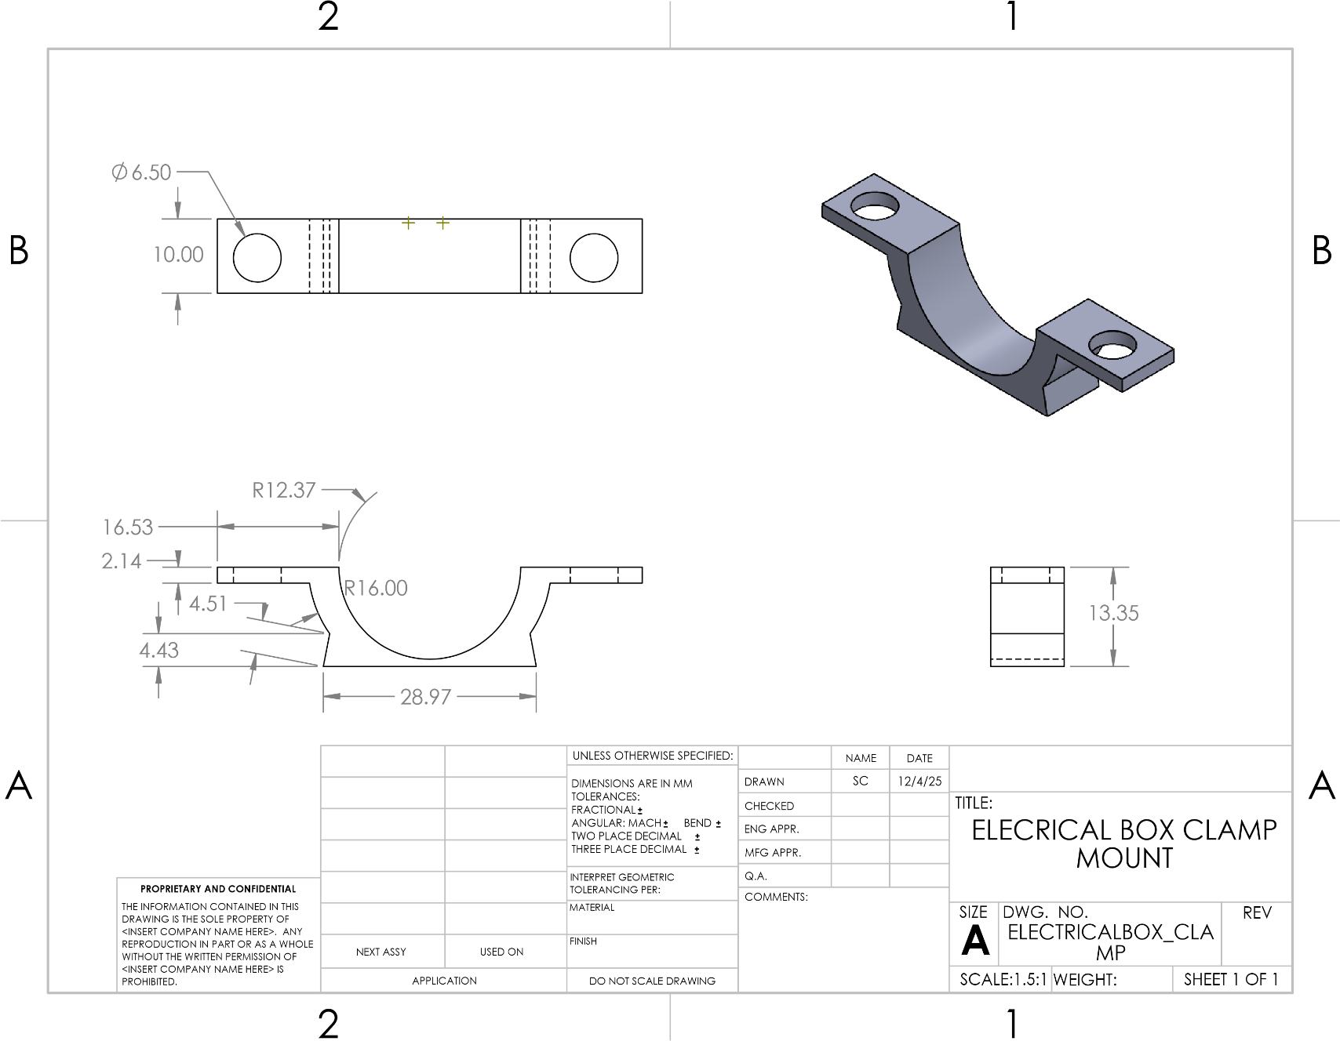
Figure 18: ELECTRICAL BOX CLAMP MOUNT
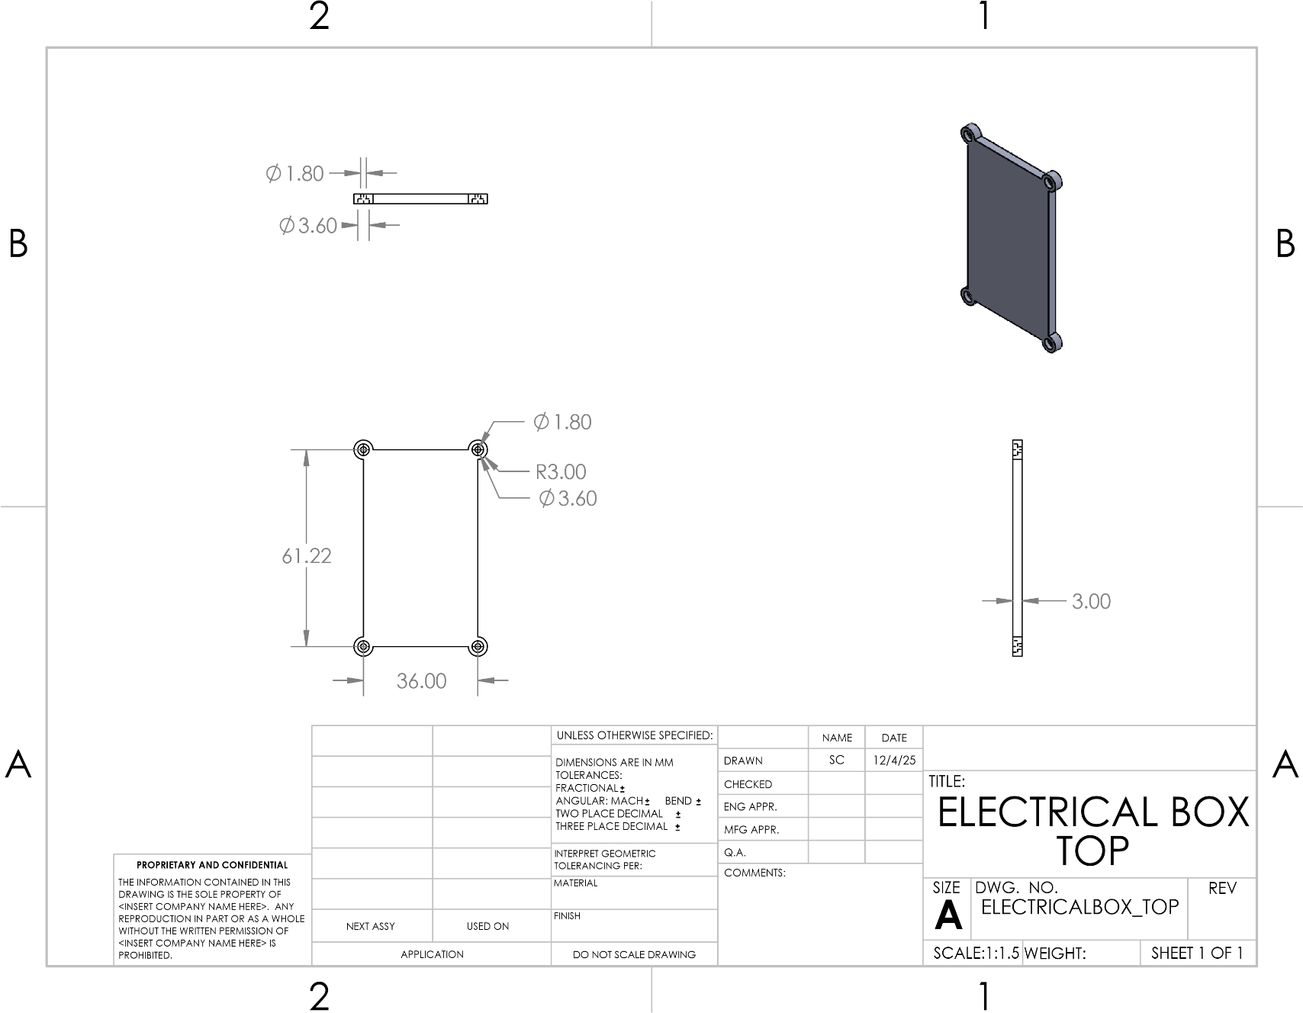
Figure 19: ELECTRICAL BOX TOP

Throttle Subsystem
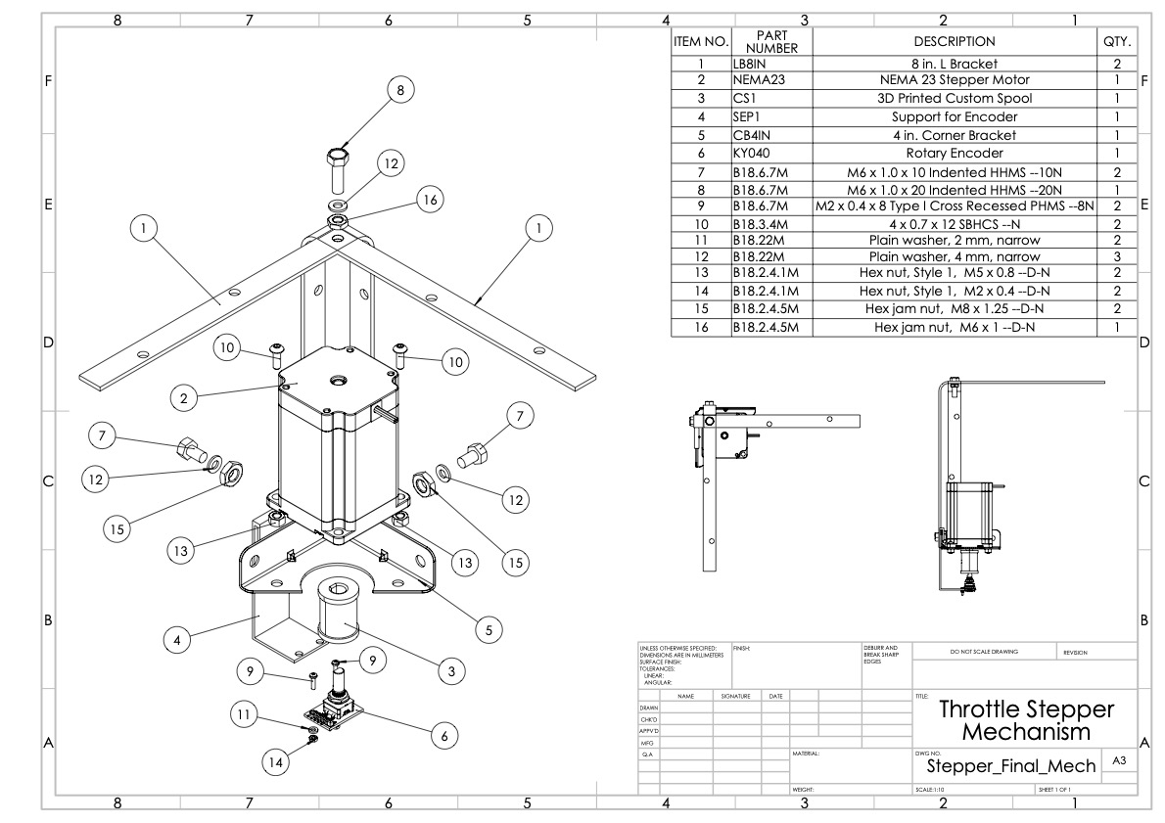
Figure 20: Throttle Stepper Full Mechanism

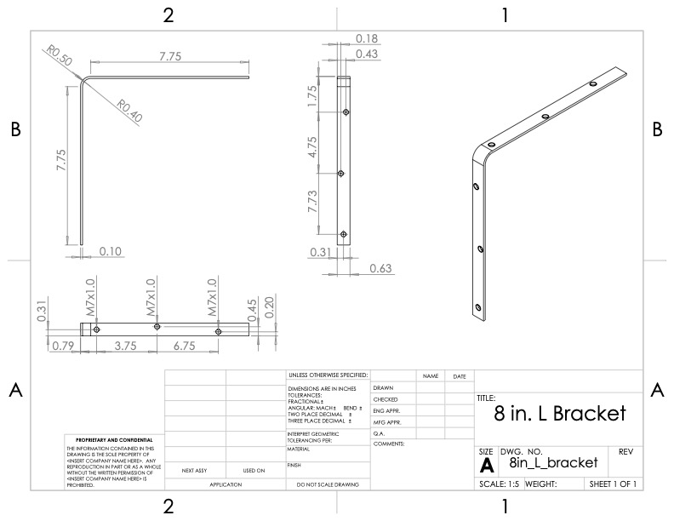
Figure 21: 8 in. L-Bracket [1]
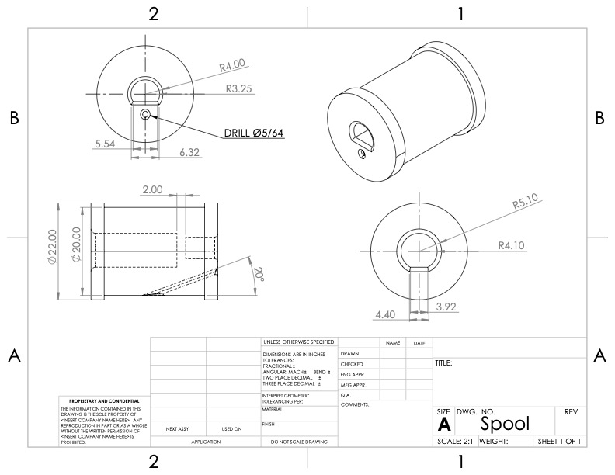
Figure 22: 3D Printed Spool for Stepper Motor
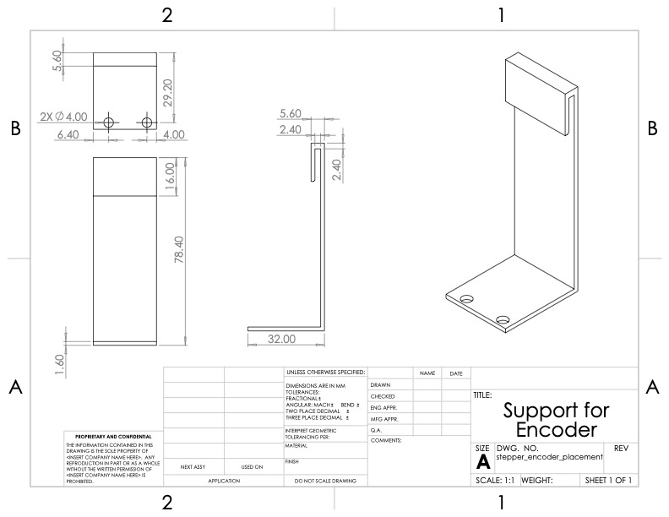
Figure 23: Custom Support for Encoder
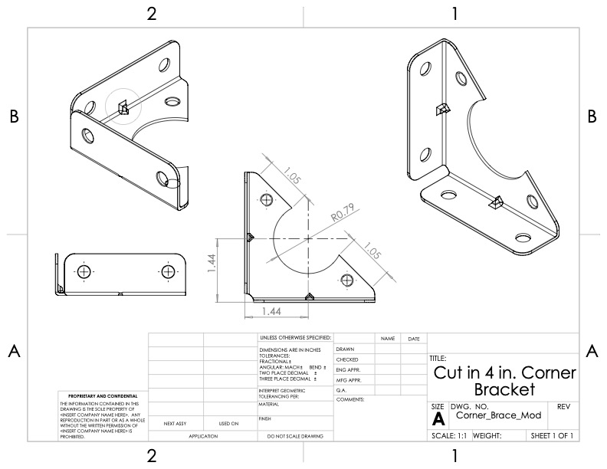
Figure 24: Modified 4in. Corner Bracket (Cut-In) [2]
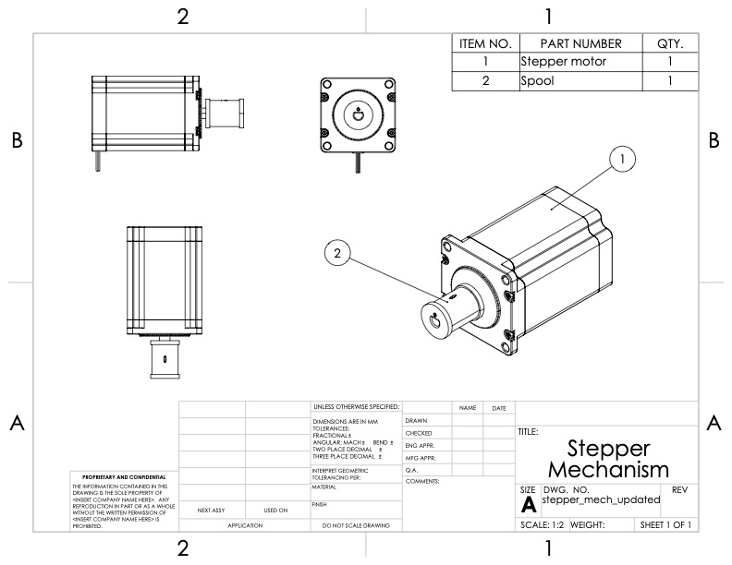
Figure 25: Stepper Motor and Spool Assembly [3]
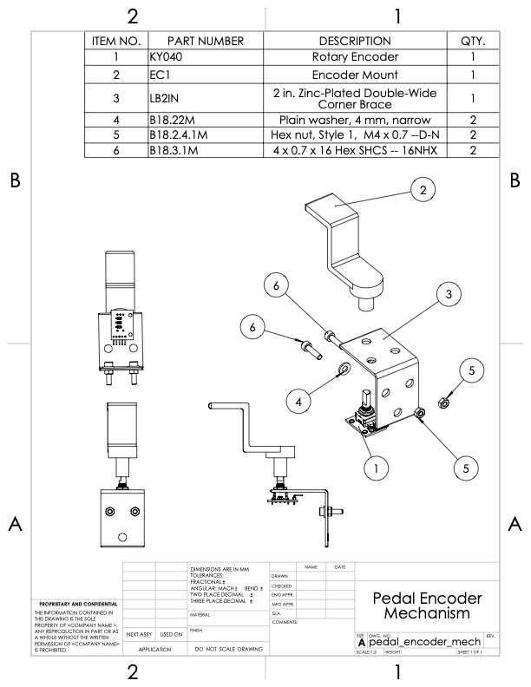
Figure 26: Pedal Encoder Full Mechanism
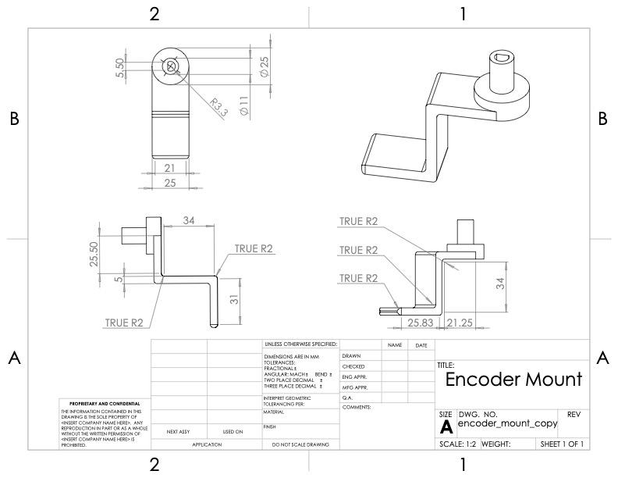
Figure 27: 3D Printed Mount for Encoder
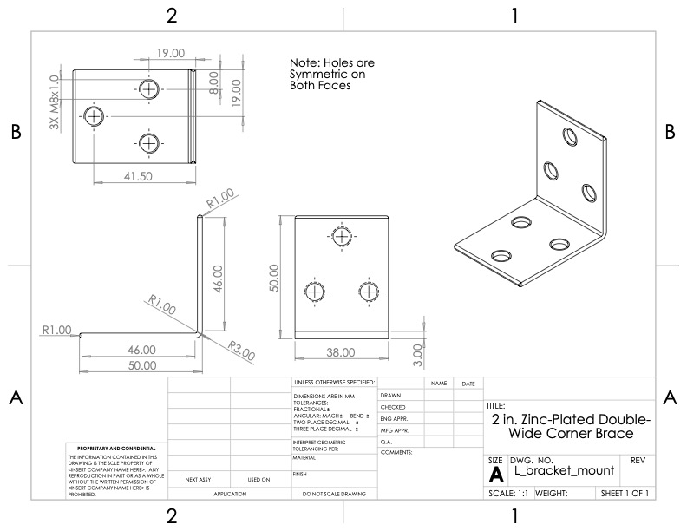
Figure 28: 2 in. Zinc-Plated Double-Wide Corner Brace [4]
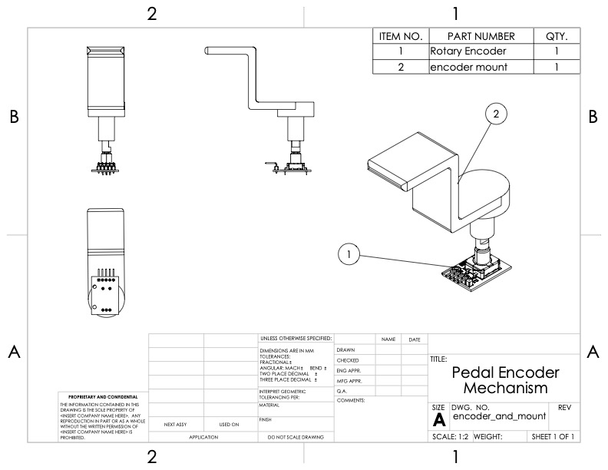
Figure 29: Pedal Encoder and Mount Assembly [5]

References
[1] “(4-Pack) 8 in. Black Corner Brace,” Homedepot.com, 2025. https://www.homedepot.com/p/Everbilt-4-Pack-8-in-Black-Corner-Brace-12704/315016279?source=shoppingads&locale=en-US&fp=ggl&srsltid=AfmBOopRt_Tx5pozCQ4VpkGx4otEtnWvg_OkKf_hQLxkZ-PSEE2rJX2eaks

‌[2] “(2-Pack) 4 in. Zinc-Plated-Heavy Duty Corner Brace,” Homedepot.com, 2025. https://www.homedepot.com/p/Everbilt-2-Pack-4-in-Zinc-Plated-Heavy-Duty-Corner-Brace-24376/327600345

[3] “Nema 23 Stepper Motor 2.4Nm(339.87oz.in) 4A 57x57x82mm 8mm Shaft 4 Wires - 23HS32-4004S | StepperOnline,” Omc-stepperonline.com, 2023. https://www.omc-stepperonline.com/nema-23-stepper-motor-2-4nm-339-79oz-in-4a-57x57x82mm-8mm-shaft-4-wires-23hs32-4004s

[4] “(2-Pack) 2 in. Zinc-Plated Double-Wide Corner Brace,” Homedepot.com, 2025. https://www.homedepot.com/p/Everbilt-2-Pack-2-in-Zinc-Plated-Double-Wide-Corner-Brace-24482/327600343

[5] “360 Degree Rotation Encoder Module,” PiShop.us, 2025. https://www.pishop.us/product/360-degree-rotation-encoder-module/?srsltid=AfmBOorw4x0uUsYIZcAN4De6heMC-ZMMnNWBVMnapdcc_DyHJwFZ0KSt4NA

‌

