In regard to changes on the form, we need the following updated:

1. The “BORRegion” field just says “Non-BOR" if a Feature belonging to another entity is selected but does now show which agency

Needs clarification. Works same as previous application. Where should Agency display? Screenshot would help. If SharePoint list, need detail on extra columns.

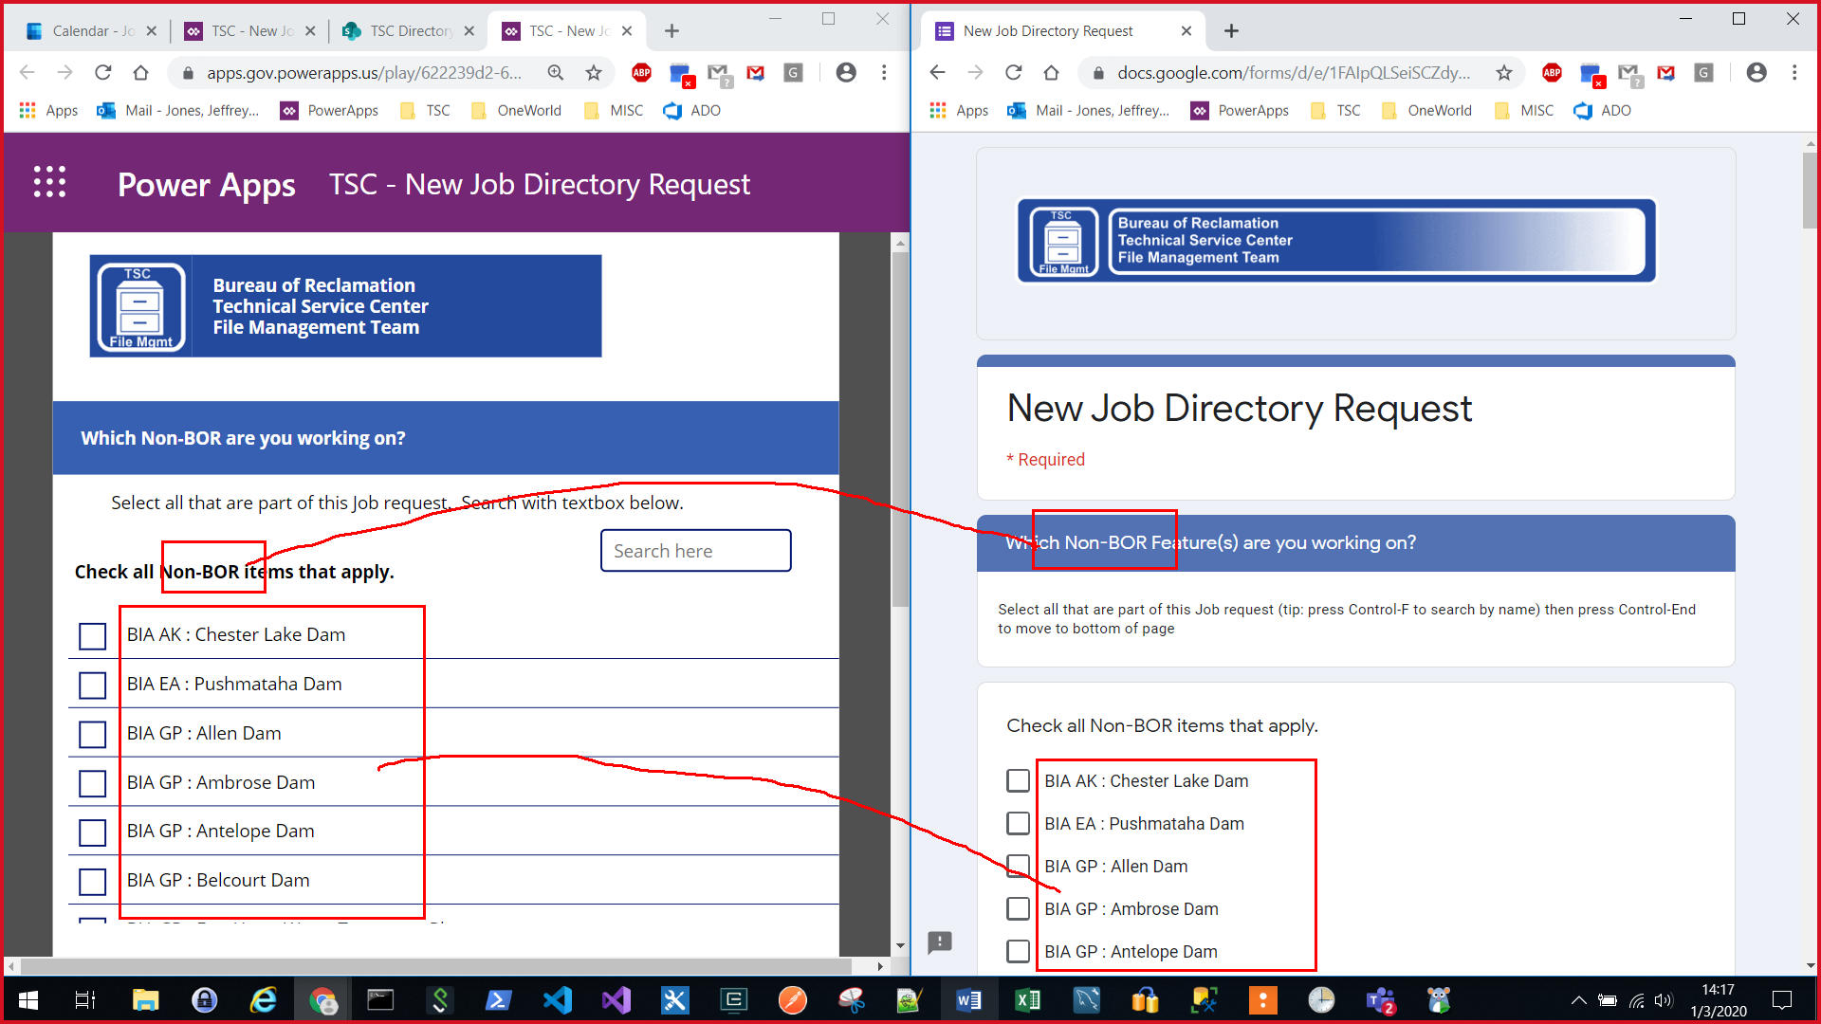

1. Links on the left side of the SharePoint site need to be renamed (Features, Users, Responses) instead of all starting with “TSC-NewJobDirectory"

OK, renamed links

1. Supervisor field needs to be updated to show only the names on this list:
   * [*https://bordams.bor.doi.net/dams/TSC/AuditGroups.csv*](https://bordams.bor.doi.net/dams/TSC/AuditGroups.csv)

OK, updated data. Need update drop down filter (contains “sup”) for single drop down.

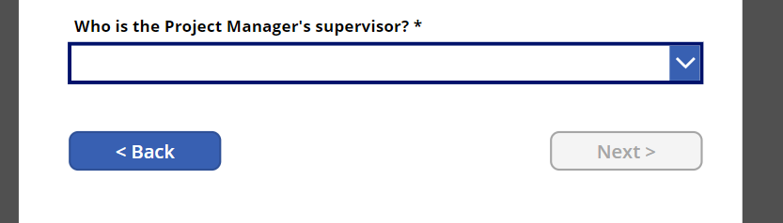

The majority of our concerns, however, are related to how we're supposed to use this to manage our data and restrict permissions:

1. Show how permissions are set up to:
   * The SharePoint site must be read and view only by all personnel in AD Group [TSCStaff@usbr.gov](mailto:TSCStaff@usbr.gov) (not all of DOI)
     + AD Group for TSCstaff controls access to the network as well as the Job Request Form (PowerApps)
   * Only the File Management Team should have access (view and edit) for the Content on this page

Need clarification on user logins in two groups above. Who is within File Management Team? Who is within TSCStaff? Email address listed is not a security group available for granting permission.

[TSCStaff@usbr.gov](mailto:TSCStaff@usbr.gov)

BOR-DRODTSCStaff

IBR8DROGTSCSTAFF

[drotscfilemgmt@usbr.gov](mailto:drotscfilemgmt@usbr.gov)

File Management Team

IBR8DROGTSCFileMgmt

1. Are we able to make changes to this ourselves later?  If so then we need a walk through on how to modify the "form”
   * What if we need to change language for any of the questions?
   * Eventually we’ll need to update all Region names/abbreviations

Please send list of names for who to including in webinar training session. PowerApps can be updated through the browser at <https://gov.create.powerapps.us/>. Lookup data can be updated at <https://doimspp.sharepoint.com/sites/bor-tsc/_layouts/15/viewlsts.aspx?view=14>

1. How are we supposed to use this to track heat tickets like we did with our original google form response spreadsheet?
   * Programs, Committees, Group Quotas, etc. like we had other tabs in the old spreadsheet

Outside of scope for TSC PowerApp form. However, SharePoint online can host workbook XLS files for tracking any external data manually.

1. Can the form responses and data lists be written/read to/from a spreadsheet or access database?
   * The team needs a way to easily update the data used for the form as well as an easy way to use the data produced from the form

Data must be stored in SharePoint Lists. However, MS Access can be used to connect SharePoint Lists for bulk updates, reporting, and data management.