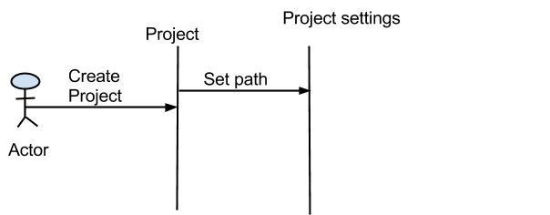

Fig: SD_projectname_createproject

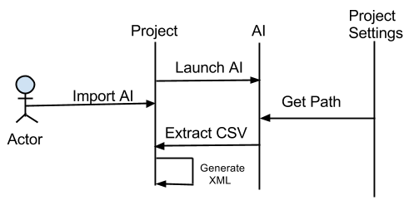

SD_projectname_importAI

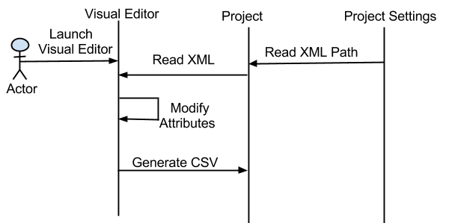

Fig:SD_project_launchvisualeditor.

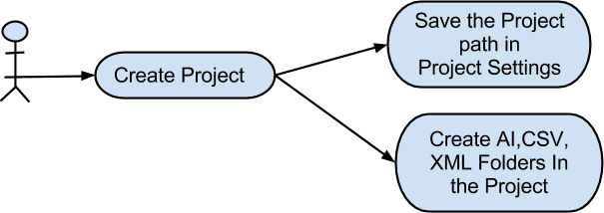

Fig:UC_project_createproject.
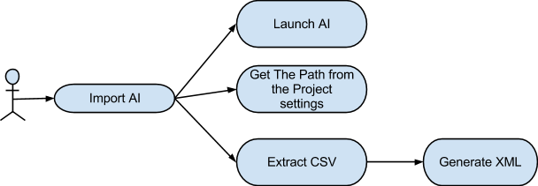

Fig:UC_project_importAI

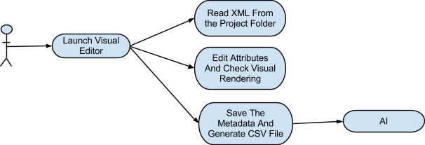

Fig:UC_project_launchvisualeditor.

