COMPUTER NETWORKS: COURSE PROJECT
Cross-Layer Protocol Analysis of a Mobile Application
Group G1: Google Meet
Traffic class: Real-time communication | Paired group: G2 (Zoom)
Duration | 2 weeks (14 days), 5 students per group
Checkpoint | End of Day 7: raw captures + partially filled data tables
Final submission | Day 14: this completed template + all files listed in the Submission Details Sheet
Instructor | Dr. Wilson
Start date / Due date | ____ / ____ / ______ ____ / ____ / ______

How to use this document: This is both your task sheet and your report template. Fill every table, paste screenshots into the boxes, and replace the sample graphs with your own. Anything shown in grey italics or marked SAMPLE is illustrative only and must not appear in your final submission.

1. Submission Details Sheet
Group number | G1
Application | Google Meet
Paired group | G2 (Zoom)
Date of submission
Where to submit | Upload link / folder: ______________________________________

1.1 Group members and roles
# | Name | Roll no. | Role | Email | Signature
1 | C SHANMUKHA PADMA KUMAR |  | R1 Capture lead | cspk1694@protonmail.com  26mcmt01@uohyd.ac.in | SPKUMAR
2 |  |  | R2 Application-layer analyst
3 |  |  | R3 Transport & network analyst
4 |  |  | R4 Link & physical analyst
5 |  |  | R5 Metrics & report lead

1.2 Files to submit
# | Item | File name format | Done
1 | This completed template (DOCX and PDF) | G1_GoogleMeet_Report.docx / .pdf | ☐
2 | Raw captures (all scenarios, all runs) | G1_<scenario>_<wifi|cell>_R<run>.pcapng e.g. G1_loss2_wifi_R1.pcapng | ☐
3 | Metrics data sheet | G1_metrics.xlsx (or .csv) | ☐
4 | Graphs (PNG, 150 dpi or better) | G1_fig<n>_<name>.png | ☐
5 | Screen recordings used for app-level timing | G1_<scenario>_R<run>.mp4 (trimmed) | ☐
6 | Scripts / notebooks (if used) | G1_analysis.py / .ipynb | ☐
7 | Presentation slides (10 min) | G1_slides.pdf | ☐
8 | Cross-validation note signed by paired group | G1_crosscheck.pdf | ☐

Folder structure (zip the top folder):
G1_GoogleMeet/
├── report/ (items 1, 8)
├── captures/ (item 2)
├── data/ (items 3, 6)
├── figures/ (item 4)
├── recordings/ (item 5)
└── slides/ (item 7)

1.3 Declaration
We confirm that all captures were taken on our own devices and accounts, that no third-party traffic was captured, that all call/chat participants were group members who consented, and that the data reported is our own.
R1 | R2 | R3 | R4 | R5
SPKUMAR CHALLA

1.4 For instructor use
Component | Max | Awarded
Checkpoint (Day 7) submitted on time | Pass/Fail
Group component | 60
Individual components (see Section 12) | 40
Total | 100

2. Objective and Scope
Analyse Google Meet across the full protocol stack, from the application layer down to the physical layer, and measure its performance in terms of throughput, delay, loss (and jitter), and application-layer efficiency under controlled network conditions. Your results will be merged with the other five groups to produce a class-wide ranking of six applications.
Learning outcomes:
- Identify the protocols an app actually uses at each layer, with packet-level evidence.
- Measure network-level and user-visible performance, and relate the two.
- Explain how protocol choices (TCP vs UDP vs QUIC, persistent connections, buffering) affect behaviour under delay and loss.
- Build and defend a multi-criteria ranking.

2.1 Expected protocol stack (hypothesis)
This is what public documentation and prior studies suggest. Apps change often: your job is to confirm or correct each row with evidence in Section 7.1.
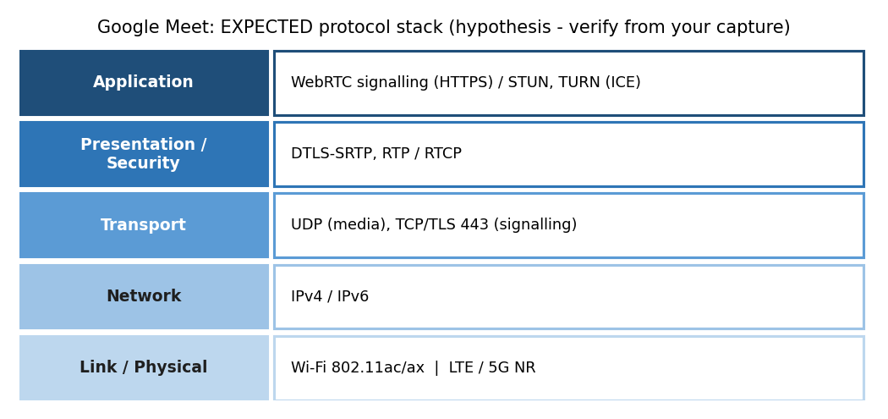
Figure 1: Expected stack for Google Meet. Verify every layer from your own capture.

2.2 Experimental task (identical for every run)
Two group members join the same Meet call (phone to phone, or phone to laptop) for 2 minutes with camera and microphone ON. Use the same meeting link and same lighting/movement for every run. The phone under test is the one being captured.
Devices needed: 2 devices with Google Meet; 1 Linux laptop as hotspot (or Android with PCAPdroid).

3. Tools
Tool | Use in this project | Platform
Wireshark / tshark | Capture and analysis: protocol hierarchy, conversations, I/O graphs, TCP analysis, RTP stream analysis | Windows / Linux / macOS
PCAPdroid | Per-app capture on the phone without root; export .pcapng for Wireshark | Android
tcpdump | Command-line capture on the hotspot laptop | Linux / macOS
tc netem | Inject delay, loss and jitter on the hotspot interface | Linux
clumsy | Delay/loss injection if the hotspot is a Windows laptop | Windows
Network Link Conditioner / rvictl | Impairment and capture for iPhones (requires a Mac with Xcode) | macOS / iOS
Speedtest (Ookla) or fast.com | Record a baseline before every session | Any
Network Cell Info Lite | Cellular RAT, band, RSRP, SINR for the physical-layer section | Android
WiFi Analyzer / Wi-Fi details screen | RSSI, channel, band, link speed | Android / Windows
Screen recorder (60 fps) | Frame-accurate timing of app-level delays | Phone built-in
Excel or Python (pandas, matplotlib) | Data sheet, normalization, graphs | Any
In-app statistics | On a laptop participant: More options > Troubleshooting & help shows network and CPU load. On phones rely on RTP analysis. | App

3.1 Recommended capture setup
Phone connects to a Linux laptop hotspot. The laptop captures and impairs traffic on the hotspot interface (e.g., wlan0), so every packet passes through one controlled point.
# create hotspot (NetworkManager)
nmcli dev wifi hotspot ifname wlan0 ssid CN-G1 password <pass>

# capture everything from the phone
sudo tcpdump -i wlan0 -w G1_baseline_wifi_R1.pcapng

# scenarios (run ONE at a time; delete before the next)
sudo tc qdisc add dev wlan0 root netem delay 150ms
sudo tc qdisc change dev wlan0 root netem loss 2%
sudo tc qdisc change dev wlan0 root netem delay 300ms loss 5%
sudo tc qdisc show dev wlan0 # screenshot this as proof
sudo tc qdisc del dev wlan0 root # back to baseline

Note: netem on the hotspot interface impairs traffic toward the phone (egress). That is acceptable for this project; state it in your limitations. Groups that also shape the uplink using an IFB device earn credit for rigour.
Alternative (no laptop): capture on the phone with PCAPdroid and select only the target app. You cannot inject loss this way, so pair it with clumsy or netem on a shared hotspot for the impairment scenarios.

4. Two-Week Task Plan
R1 Capture lead · R2 Application layer · R3 Transport & network · R4 Link & physical · R5 Metrics & report. Tick the Done column as you go; the instructor may ask to see this at the checkpoint.
Day | Task | Owner | Output | Done
1 | Kick-off: read this document, assign roles, install all tools, agree on the test task | All | Roles filled in Section 1.1 | ☐
2 | Set up hotspot, test capture and netem; dry run of the task; confirm the app traffic is visible | R1, R4 | Screenshot S1, S2 | ☐
3 | Baseline on Wi-Fi: 3 runs + Speedtest before each | R1 (+ all as participants) | 3 pcaps, recordings | ☐
4 | Scenario: +150 ms delay, 3 runs | R1 | 3 pcaps | ☐
5 | Scenario: 2% loss, 3 runs | R1 | 3 pcaps | ☐
6 | Scenario: 5% loss + 300 ms, 3 runs; record Wi-Fi link details | R1, R4 | 3 pcaps, S10 | ☐
7 | Cellular (4G/5G) baseline, 3 runs; record RAT/band/RSRP. CHECKPOINT upload | R4, R1 | Checkpoint submission | ☐
8 | Protocol mapping per layer with evidence (Section 7.1) | R2, R3, R4 | Screenshots S3-S6 | ☐
9 | Extract metrics with Wireshark/tshark into data sheet (Sections 7.2-7.4) | R2, R3, R5 | Filled tables | ☐
10 | Cross-validation: swap one pcap with paired group, each recomputes 3 metrics | R5 + paired R5 | Cross-check note | ☐
11 | Plot graphs (Section 9) and compute robustness ratios | R5, R3 | Figures | ☐
12 | Submit class data sheet row; compute normalized scores and ranking (Section 10) | R5 | Ranking table | ☐
13 | Write analysis, limitations and individual sections; build slides | All | Draft report | ☐
14 | Final review, export PDF, zip folder, submit; 10-min presentation | All | Final submission | ☐

4.1 Role-wise checklists
R1 Capture lead
Hotspot and capture pipeline working (S1) | ☐
netem applied and verified for every scenario (S2) | ☐
All 15 captures named correctly | ☐
Speedtest baseline logged for each session | ☐
Screen recordings trimmed and named | ☐

R2 Application-layer analyst
List of DNS names contacted (S3) | ☐
SNI and ALPN of every major connection (S4) | ☐
Application protocol identified and justified | ☐
App-level delay metrics extracted from recordings | ☐
Efficiency table (connections, DNS, overhead) | ☐

R3 Transport & network analyst
Protocol hierarchy (S5) and conversations (S6) | ☐
TCP vs UDP vs QUIC share of bytes | ☐
Handshake RTT, retransmissions or jitter per run | ☐
IPv4 vs IPv6 usage; server locations (by RTT) | ☐
Robustness ratios | ☐

R4 Link & physical analyst
Wi-Fi: band, channel, width, RSSI, link speed (S10) | ☐
Cellular: RAT (LTE/NR), band, RSRP, SINR | ☐
Wi-Fi vs cellular comparison table (7.4) | ☐
Explain how PHY conditions bound the observed throughput | ☐
Note any interference or signal changes during runs | ☐

R5 Metrics & report lead
Data sheet maintained with all runs | ☐
Means and standard deviations | ☐
Graphs to specification (Section 9) | ☐
Normalization, scoring and ranking (Section 10) | ☐
Cross-validation with paired group; final assembly | ☐

5. Test Scenarios
Scenario code | Condition | Network | Runs
baseline | No impairment | Wi-Fi | 3
delay150 | +150 ms delay | Wi-Fi | 3
loss2 | 2% random loss | Wi-Fi | 3
stress | 5% loss + 300 ms delay | Wi-Fi | 3
baseline | No impairment | 4G / 5G (cellular) | 3

Rules for every run:
- Close all other apps; enable airplane mode then Wi-Fi only (or mobile data only for cellular runs).
- Clear app cache where the task says so; keep app version identical across runs (note it).
- Start capture, then start screen recording, then perform the task; stop in reverse order.
- Record date, time, location, and Speedtest result for each session in the data sheet.
Optional bonus experiment: Block UDP (iptables -A FORWARD -p udp -j DROP on the hotspot, keep DNS) and observe whether Meet falls back to TCP/TLS 443 or a TURN relay. Compare delay and jitter.

6. Metrics and How to Measure Them
Metric | Method
Average / peak throughput | Statistics > I/O Graphs (1 s interval) or: tshark -r f.pcapng -q -z io,stat,1
Handshake RTT | Field tcp.analysis.initial_rtt for TCP; time from QUIC Initial to server's Handshake for QUIC
Time to first byte | Time from TLS/QUIC handshake completion to first large server-to-client packet
TCP retransmission % | tcp.analysis.retransmission count ÷ total TCP data packets × 100
Jitter / RTP loss | Telephony > RTP > RTP Streams > Stream Analysis
Protocol overhead ratio | (Total bytes − payload bytes) ÷ total bytes; use frame.len vs tcp.len / udp.length
Connections, DNS lookups | Statistics > Conversations; count of dns.flags.response == 0
Robustness (degradation) ratio | Metric under stress ÷ metric at baseline (for delay/loss: lower is better)
Call setup time (s) | Screen-record at 60 fps; time from tapping Join to first remote video frame.
Jitter (ms) | Wireshark: Telephony > RTP > RTP Streams > Stream Analysis (decode UDP media as RTP if needed).
RTP packet loss (%) | RTP Stream Analysis 'Lost' column (sequence-number gaps).
Video quality adaptation | Note resolution drops / freezes visible on screen under loss.

6.1 Useful Wireshark filters for Google Meet
Display filter | Purpose
stun | ICE connectivity checks; shows candidate addresses and whether a TURN relay is used
dtls | DTLS handshake that sets up SRTP keys
rtp || rtcp | Media and control packets (enable the rtp_udp heuristic: Analyze > Enabled Protocols)
udp && !dns && !quic | Isolates media flows
tls.handshake.extensions_server_name contains "google" | Signalling endpoints

6.2 Useful tshark commands
tshark -r f.pcapng -q -z io,stat,1 # throughput per second
tshark -r f.pcapng -q -z conv,tcp # TCP conversations
tshark -r f.pcapng -q -z conv,udp # UDP conversations
tshark -r f.pcapng -Y "tcp.analysis.retransmission" | wc -l # retransmissions
tshark -r f.pcapng -Y "tls.handshake.type==1" -T fields \
-e tls.handshake.extensions_server_name | sort | uniq -c # SNI list
tshark -r f.pcapng -Y "dns.flags.response==0" -T fields -e dns.qry.name | sort | uniq -c
tshark -r f.pcapng -Y "tcp.analysis.initial_rtt" -T fields -e tcp.analysis.initial_rtt
tshark -r f.pcapng -q -z rtp,streams # RTP streams (if decoded)

7. Results: Fill-in Tables

7.1 Protocol map (evidence required for every row)
Layer | Expected | Observed (yours) | Evidence (filter, packet #) | Shot #
Application | WebRTC signalling over HTTPS; ICE with STUN/TURN |  | How: DNS names, TLS/QUIC SNI, ALPN value in ClientHello (h2 / h3 / http/1.1)
Presentation / Security | DTLS-SRTP (keys via DTLS), SRTP/SRTCP media |  | How: TLS version in ServerHello, QUIC version field, DTLS records
Transport | UDP for media; TCP/TLS 443 for signalling (and fallback) |  | How: Statistics > Protocol Hierarchy; port numbers; TCP vs UDP flows in Conversations
Network | IPv4 / IPv6 |  | How: IP version field; IPv4 vs IPv6 addresses in Endpoints; TTL / Hop limit
Link / Physical | Wi-Fi 802.11ac/ax or LTE / 5G NR |  | How: Phone Wi-Fi details (band, channel, link speed, RSSI); cellular RAT and band, RSRP/SINR from Network Cell Info
SAMPLE row (do not copy): Transport | UDP 443 | QUIC over UDP 443 for 94% of bytes; TCP 443 only for 2 API calls | Protocol Hierarchy; frames 12-15 (QUIC Initial) | S5

7.2 Performance measurements (Wi-Fi scenarios)
Scenario | Run | Avg tput (Mbps) | Handshake RTT (ms) | Call setup (s) | Jitter (ms) | Total MB | Notes
baseline | R1 | 7.14
baseline | R2 | 7.60
baseline | R3 | 7.01
baseline | Mean ± SD
delay150 | R1 | 6.65
delay150 | R2 | 6.63
delay150 | R3 | 7.44
delay150 | Mean ± SD
loss2 | R1 | 7.21
loss2 | R2 | 7.19
loss2 | R3 | 7.72
loss2 | Mean ± SD
stress | R1 | 1.16
stress | R2 | 0.75
stress | R3 | 0.91
stress | Mean ± SD
SAMPLE row (do not copy): loss2 | R1 | 1.72 | 31 | 2.3 | 19 | 14.8 | resolution dropped to 360p at t = 22 s

7.3 Application-layer efficiency (baseline, mean of 3 runs)
Parameter | Value | Comment
Number of TCP connections
Number of QUIC / UDP flows
DNS queries / unique domains
TLS versions and ALPN values seen
Protocol overhead ratio (%)
Bytes per useful unit (define it)
Connection reuse / multiplexing observed?
Keep-alive / idle traffic (bytes per min)

7.4 Wi-Fi vs cellular (baseline)
Parameter | Wi-Fi | Cellular | Comment
Technology / band / channel
Signal (RSSI dBm / RSRP dBm)
Link speed / SINR
Avg throughput (Mbps)
Handshake RTT (ms)
Call setup (s)
Jitter (ms)

7.5 Robustness
Metric | Baseline | Stress | Ratio | Interpretation
Avg throughput
Handshake RTT
Call setup (s)
Jitter (ms)

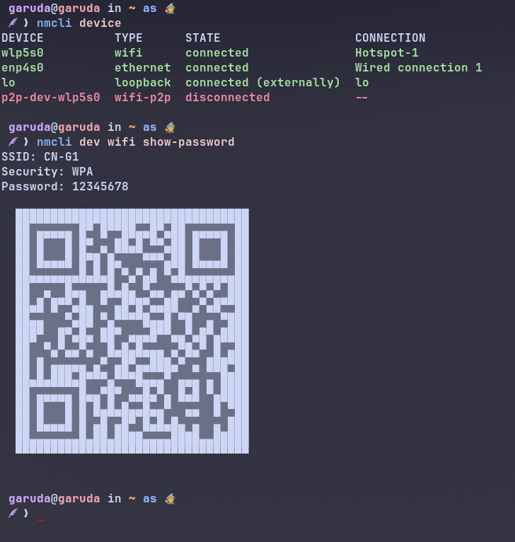
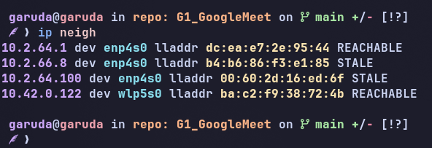
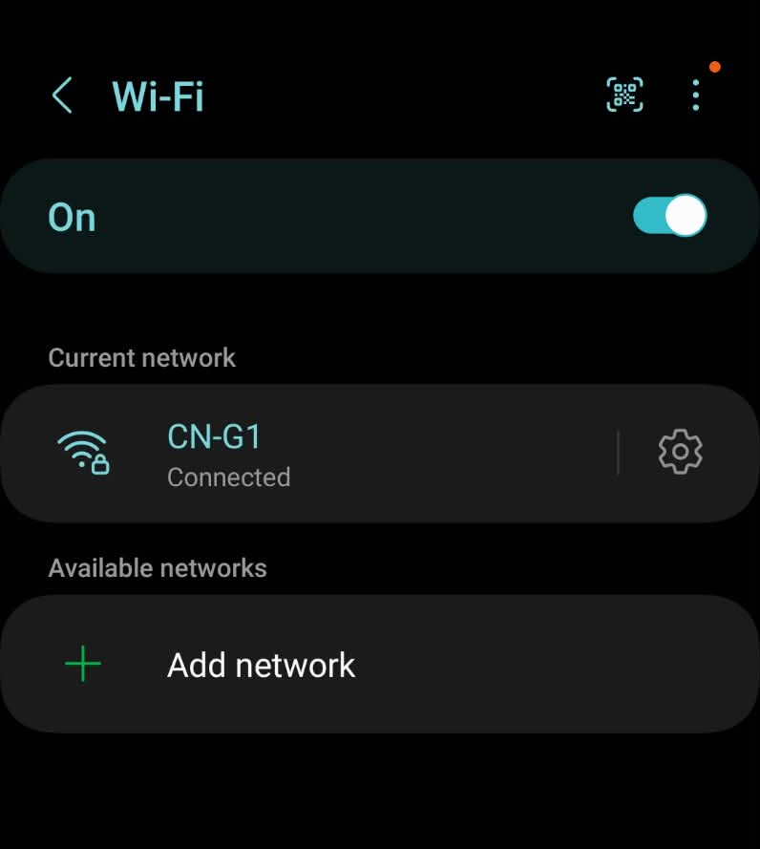
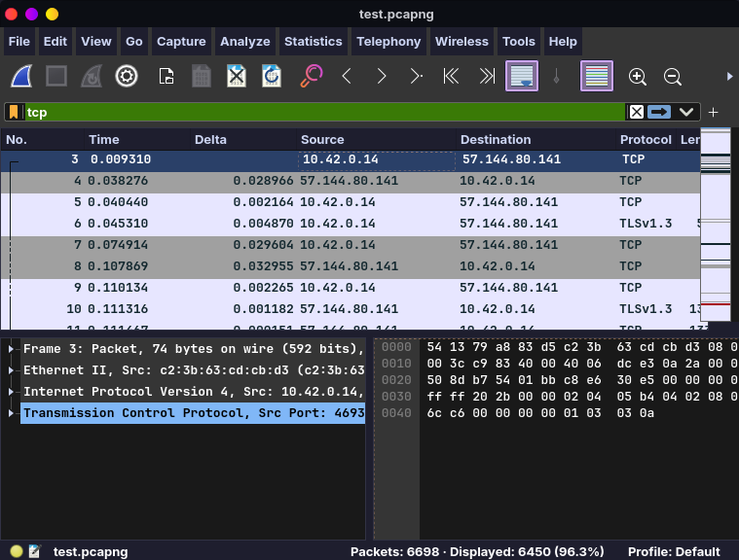
8. Screenshot Evidence
Every screenshot must show the filter bar or window title so the reader can reproduce it. Crop, but do not edit.
S1: Capture setup running (Wireshark/PCAPdroid + hotspot)
Filter / location: Desktop / phone
IP address of phone (wlp5s0)

Hotspot setup done

hotspot connected capture being done on wireshark
Observation (1-2 lines): The test phone is connected to the CN-G1 Wi-Fi hotspot, and packet capture on the Linux hotspot interface confirms that traffic from the phone is being captured successfully.
IP address of phone is 10.42.0.122
Laptop hotspoot: 10.42.0.1

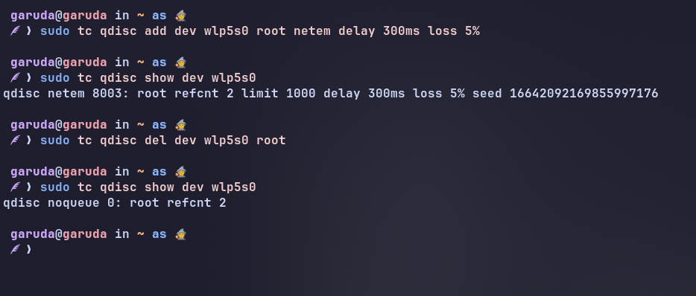
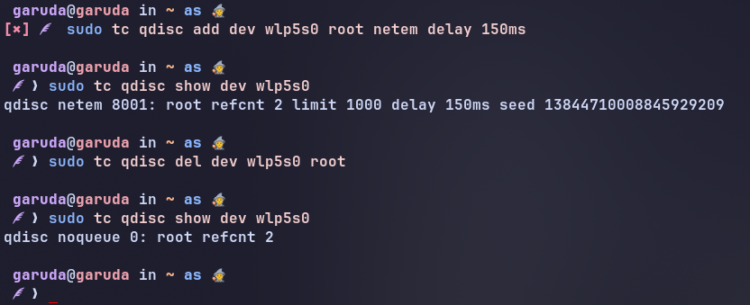
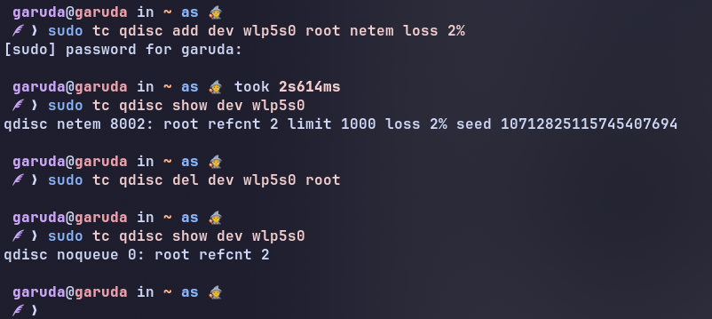
S2: netem configuration for each scenario
Filter / location: tc qdisc show dev wlan0
2% loss

150 ms delay

300 ms delay and 5% loss
Observation (1-2 lines): The tc netem configuration was successfully applied to the hotspot interface, allowing controlled delay and packet-loss conditions to be introduced for the required test scenarios.

S3: DNS queries made by the app
Filter / location: dns.flags.response == 0
[ Paste screenshot here ]
Observation (1-2 lines):

S4: TLS ClientHello / QUIC Initial with SNI and ALPN
Filter / location: tls.handshake.type == 1 or quic
[ Paste screenshot here ]
Observation (1-2 lines):

S5: Protocol Hierarchy
Filter / location: Statistics > Protocol Hierarchy
[ Paste screenshot here ]
Observation (1-2 lines):

S6: Conversations (sorted by bytes)
Filter / location: Statistics > Conversations
[ Paste screenshot here ]
Observation (1-2 lines):

S7: I/O graph: baseline vs 2% loss
Filter / location: Statistics > I/O Graphs
[ Paste screenshot here ]
Observation (1-2 lines):

S8: Loss evidence: TCP Expert Info or RTP analysis
Filter / location: Analyze > Expert Information
[ Paste screenshot here ]
Observation (1-2 lines):

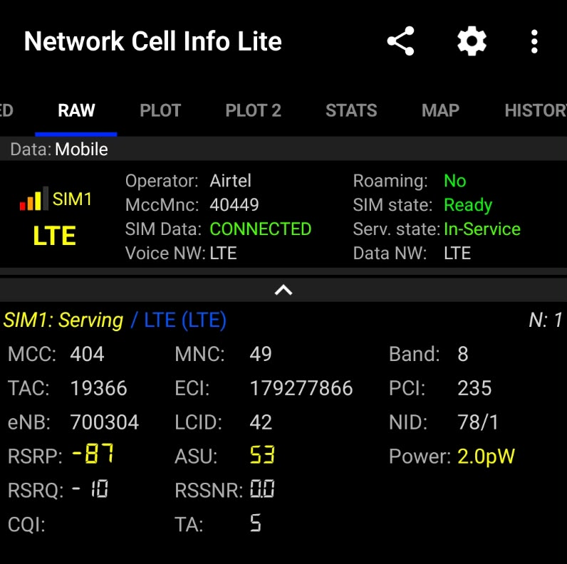
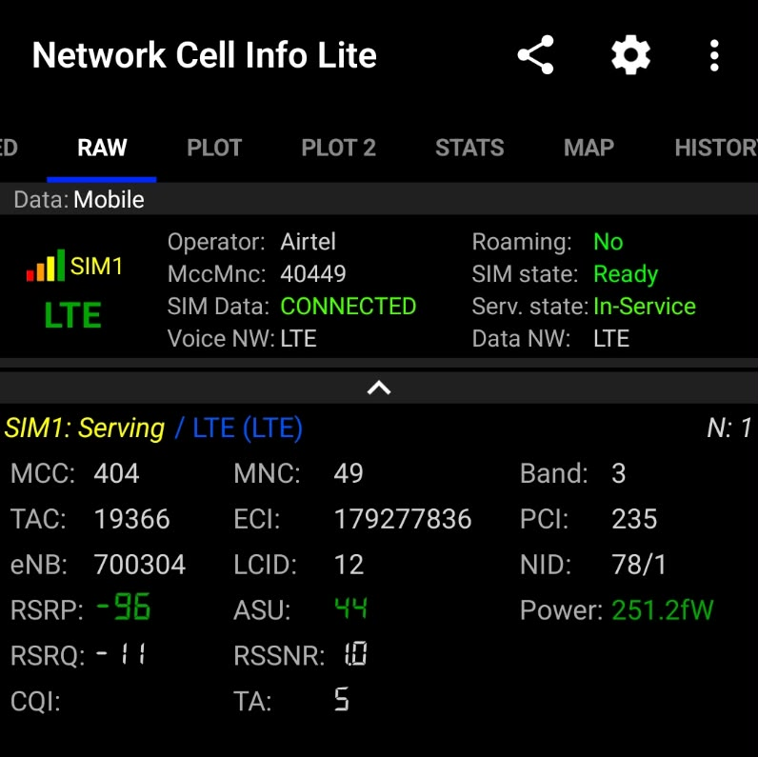
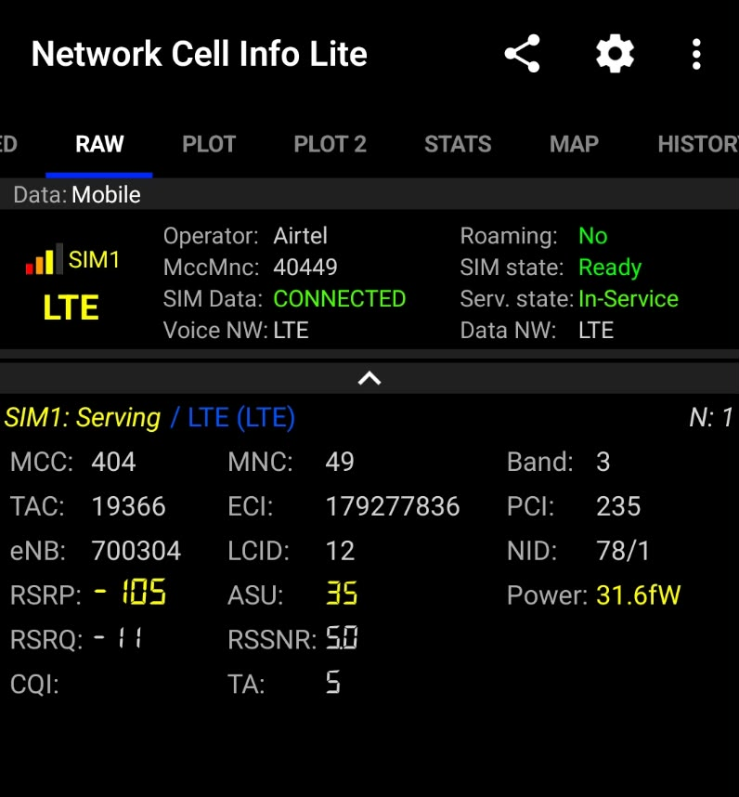
S9: In-app statistics or screen-recording frame used for timing
Filter / location: App
[ Paste screenshot here ]
Observation (1-2 lines):

S10: Wi-Fi and cellular link details
Filter / location: Phone settings / Network Cell Info
Raw capture for R1 Raw capture for R2 Raw capture for R3
Observation (1-2 lines): The cellular connection is LTE on Band 3, with RSRP values ranging from −87 dBm to −105 dBm across the runs; RSRQ and RSSNR are also recorded.

S11: STUN binding request/response
Filter / location: stun
[ Paste screenshot here ]
Observation (1-2 lines):

S12: RTP Stream Analysis window (jitter, lost)
Filter / location: Telephony > RTP > Stream Analysis
[ Paste screenshot here ]
Observation (1-2 lines):

9. Required Graphs (samples shown)
The graphs below use made-up illustrative data so you know what is expected. Produce the same five graphs from your own data and paste them in place of the samples. Every graph needs axis labels with units, a legend, and a caption stating what it shows.
Graph 1: Throughput over time, baseline vs 2% loss
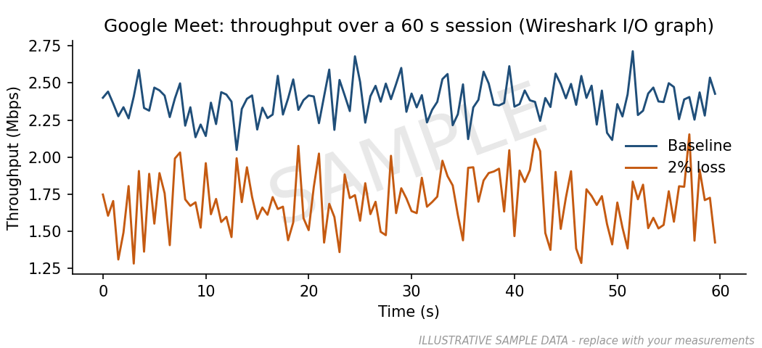
SAMPLE ONLY. Must show: 1 s bins, both scenarios on the same axes. Discuss the ON/OFF pattern or steady rate.
Graph 2: Network delay vs user-visible delay per scenario
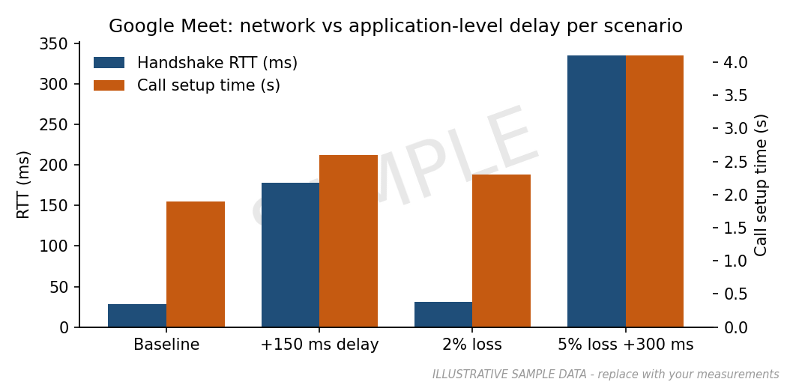
SAMPLE ONLY. Must show: handshake RTT and your app-level delay for all four scenarios.
Graph 3: Jitter (ms) per scenario (mean ± SD)
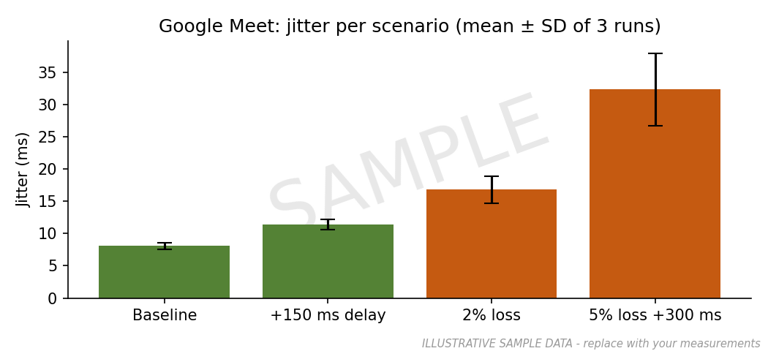
SAMPLE ONLY. Must show: error bars from 3 runs.
Graph 4: Wi-Fi vs cellular
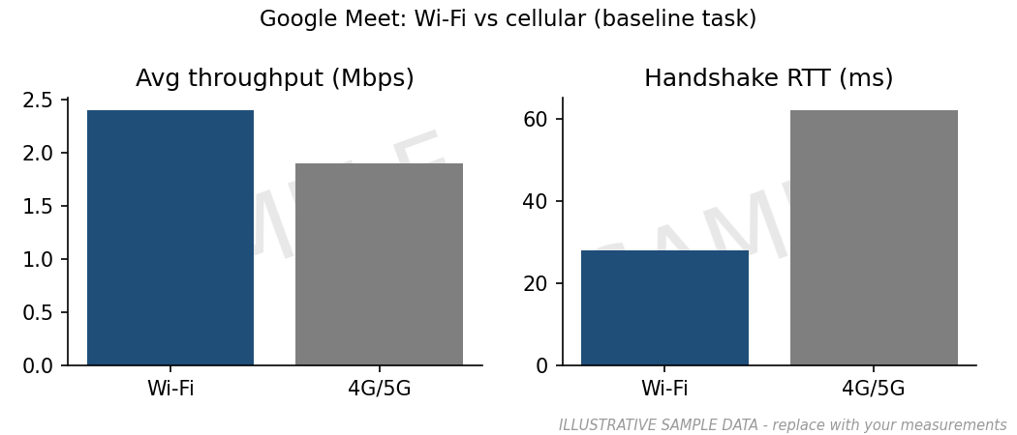
SAMPLE ONLY. Must show: throughput and RTT at baseline on both networks.
Graph 5: Normalized scores vs paired app (G2 (Zoom))
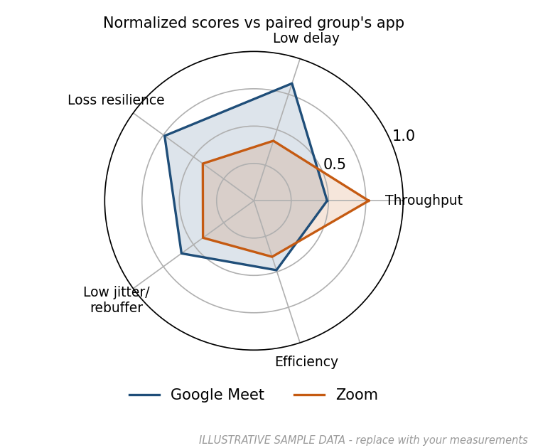
SAMPLE ONLY. Must show: the five normalized criteria from Section 10 for both apps. Get the paired group's numbers after Day 12.

10. Scoring and Ranking
All six groups submit their mean values to the class data sheet on Day 12. Each group then computes the scores for all six apps using the same formulas, so rankings are reproducible.

10.1 Normalization
- Higher-is-better (throughput): norm = (x − min) ÷ (max − min)
- Lower-is-better (delay, jitter, loss, overhead): norm = (max − x) ÷ (max − min)
- min and max are taken across the six apps for the same scenario.
Note: Comparing raw throughput across classes is unfair: Spotify needs far less bandwidth than YouTube. For the cross-class ranking, use the robustness ratios from Section 7.5 for throughput and delay; use raw values only for the within-pair comparison.

10.2 Weights for your class (Real-time communication)
Criterion | Weight | Metric used
Delay / jitter | 0.40 | Mean of normalized handshake RTT and app-level delay (and jitter where available)
Loss resilience | 0.30 | Normalized jitter (ms) under loss2 and stress
Throughput | 0.10 | Normalized throughput robustness ratio
Efficiency | 0.20 | Normalized overhead ratio, connections and DNS lookups
Total | 1.00
You may propose different weights in your discussion, but compute the official ranking with these.

10.3 Worked example (sample numbers)
Suppose under 2% loss the six apps' handshake RTTs range from 24 ms (min) to 44 ms (max) and your app measures 31 ms. Lower is better, so norm = (44 − 31) ÷ (44 − 24) = 0.65.
Criterion | Normalized (sample) | Weight | Weighted
Delay / jitter | 0.65 | 0.40 | 0.260
Loss resilience | 0.72 | 0.30 | 0.216
Throughput | 0.55 | 0.10 | 0.055
Efficiency | 0.80 | 0.20 | 0.160
Score |  |  | 0.691

10.4 Your scoring table
Metric | Your value | Min | Max | Direction | Normalized | Weight | Weighted
Handshake RTT |  |  |  | Lower
Call setup (s) |  |  |  | Lower
Jitter (ms) |  |  |  | Lower
Throughput ratio |  |  |  | Higher
Overhead ratio |  |  |  | Lower
Connections + DNS |  |  |  | Lower
Final score

10.5 Class ranking (fill after Day 12)
Rank | App | Class | Score | Rank in class
1
2
3
4
5
6
Extension (optional, extra credit): recompute the ranking with TOPSIS or with AHP-derived weights and explain any rank changes.

11. Analysis and Discussion
Answer each question with reference to your tables and graphs (e.g., 'Graph 2 shows...'). Aim for 100-150 words per question.
Q1. Why does Meet carry media over UDP rather than TCP? Support with your delay/jitter data.

Q2. How does the app react to 2% and 5% loss: lower resolution, lower frame rate, freezes?

Q3. Was a direct peer path used or a relay? What does this do to RTT?

Q4. How does the jitter buffer trade delay for smoothness?

11.1 Example of a weak vs strong observation
Weak | "Under loss the app became slow."
Strong | "Under 2% loss, handshake RTT barely changed (28 → 31 ms), but the app-level delay rose by 21% (1.9 → 2.3 s) and jitter more than doubled (8 → 19 ms, Graph 3). The network path is not slower; recovery from lost packets is what the user feels." (sample numbers)

11.2 Conclusions (where does your app rank and why?)

11.3 Limitations (encryption, single device, CDN variation, egress-only impairment, etc.)

12. Individual Contributions
Each member writes 300-400 words on their own role: what they did, what they found, and one thing that surprised them. This section is marked individually and supports the viva.
R1 Capture lead: Name ____________________

R2 Application-layer analyst: Name ____________________

R3 Transport & network analyst: Name ____________________

R4 Link & physical analyst: Name ____________________

R5 Metrics & report lead: Name ____________________

12.1 Assessment rubric
Component | Marks | What earns full marks
Group component | 60
Protocol map accuracy | 10 | Every layer confirmed or corrected with packet evidence
Measurement rigour | 15 | All scenarios, 3 runs, SD reported, controlled conditions documented
Graphs and analysis | 15 | Five graphs to spec; answers cite data; cause-effect explained
Ranking and justification | 10 | Correct normalization; weights applied; rank defended
Presentation | 10 | Clear 10-min talk; handles questions
Individual component | 40
Role section (Section 12) | 20 | Specific, data-backed, shows understanding of own layer
Viva | 15 | Can explain own screenshots and numbers
Peer evaluation | 5 | Average of group members' confidential ratings

12.2 Cross-validation note (with paired group)
Metric recomputed by paired group | Our value | Their value | Match (±10%)?
Avg throughput (baseline R1) |  |  | ☐
Handshake RTT (loss2 R1) |  |  | ☐
Jitter (ms) (stress R1) |  |  | ☐
Paired group R5 name and signature: _______________________________

