RAG E2E application
UI Home page view
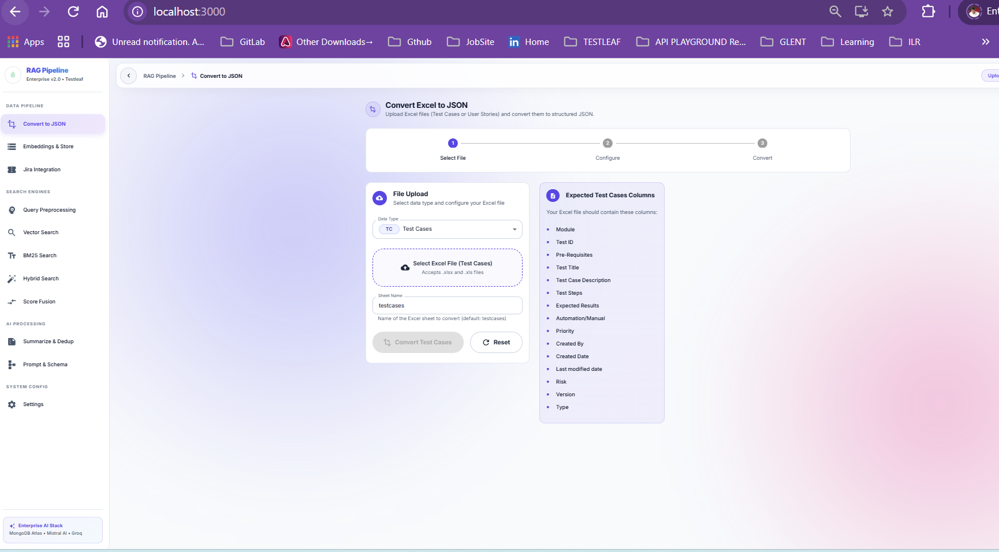

User Stories radio button is generated and can fetch user stories base on given User story id in the “Prompt & Schema” page as shown below
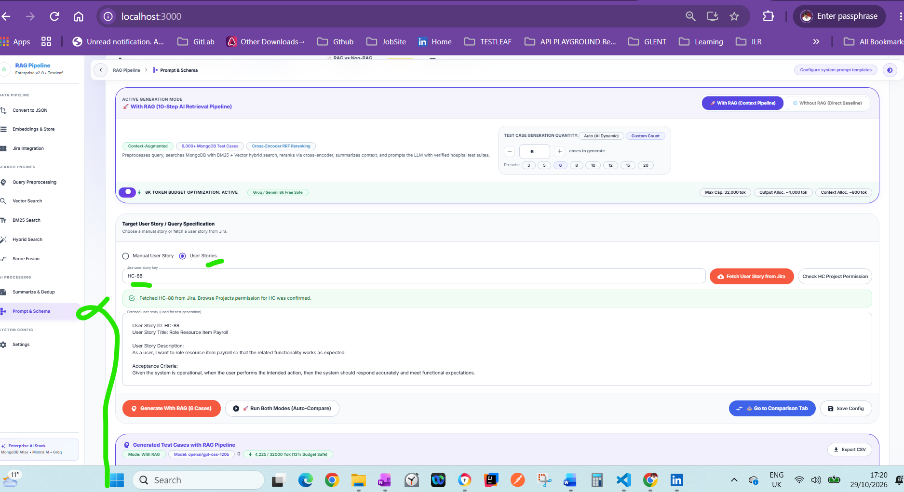

Testcase generated when clicked on “Generate with RAG”
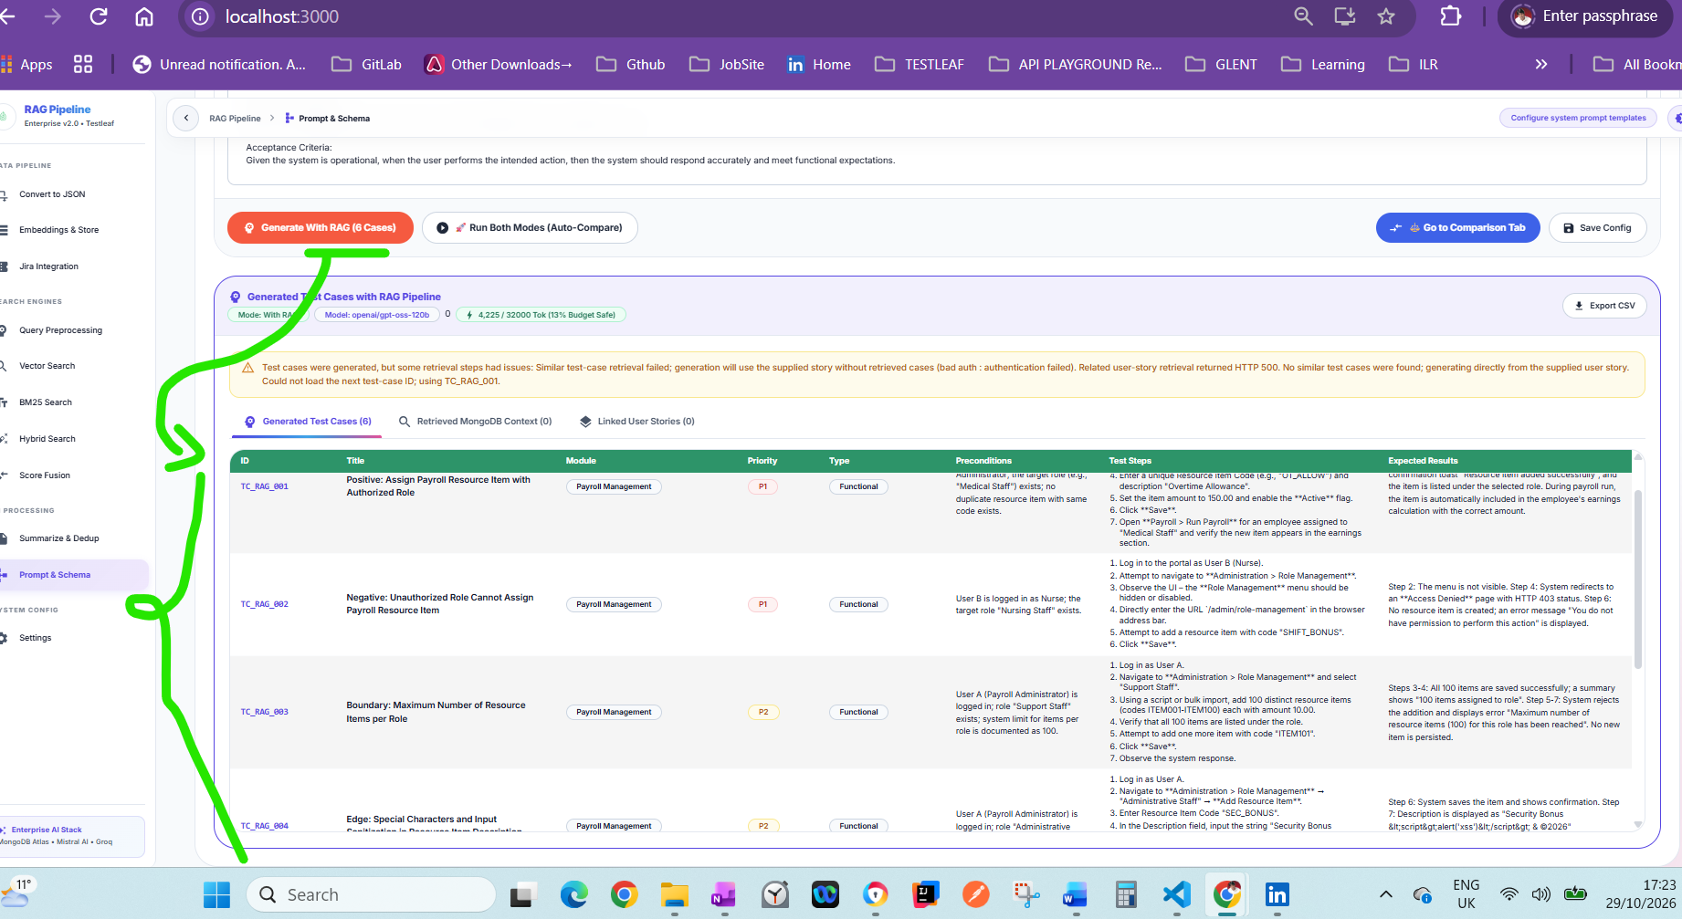
Additional I tried to create Jira Integration new tab in the RAG E2E
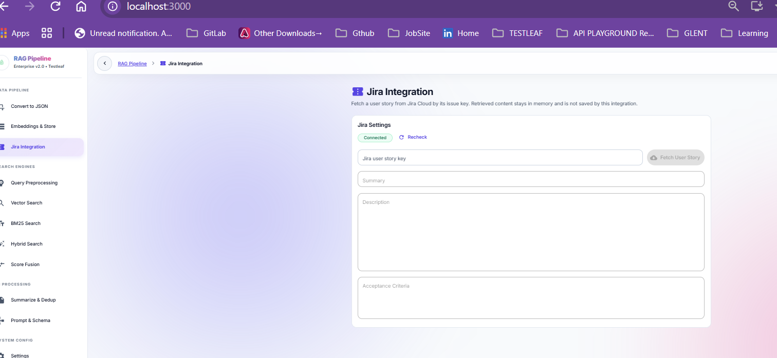

User stories are fetched
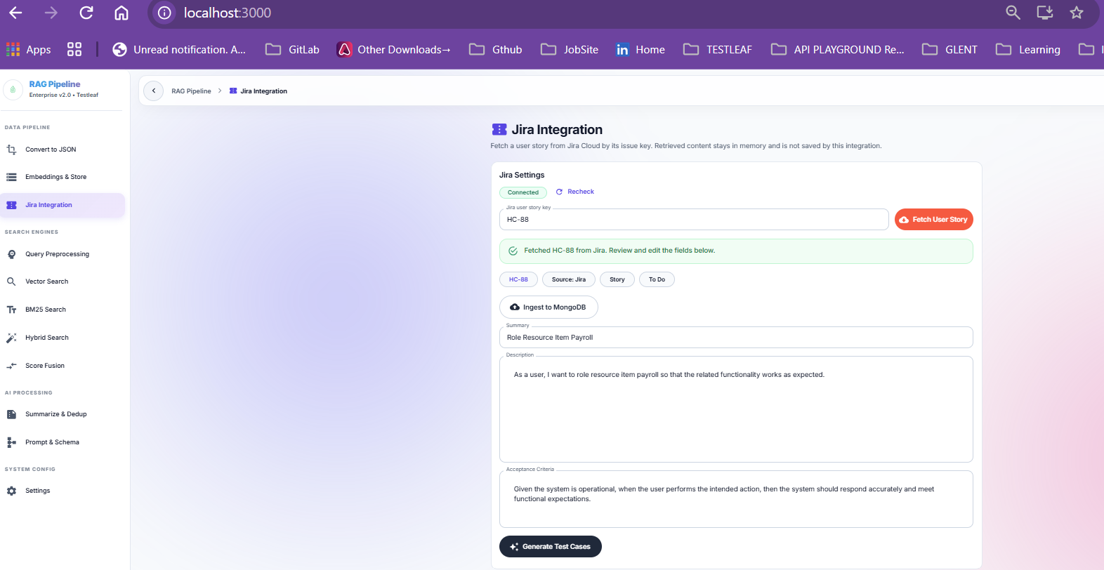
Generate testcases when click on button ‘Generate testcases’
