Able to create MCP agents
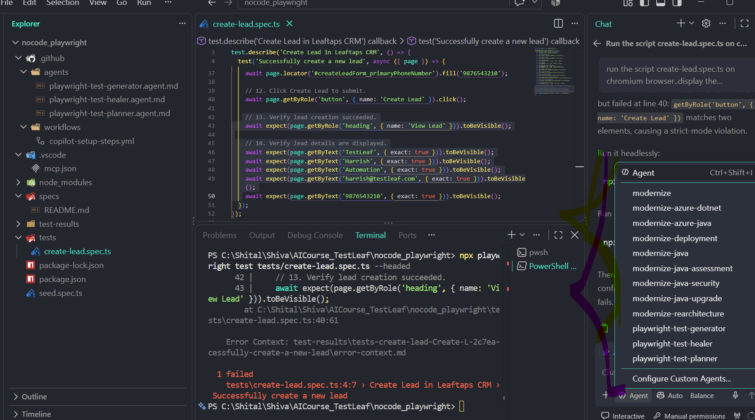
Using MCP playwright test generator ..able to create script – create-lead.spec.ts and able to run the script but end up with some error
