Assignment_1:
If the classroom activity has not been completed, please complete it.

* Add a radio button for **Accept Link** and another radio button for **File Upload**.
* If **Accept Link** is selected, display and populate the input box for entering the link.
* If **File Upload** is selected, display the file upload option.

Sample Prompt:
Analyze my entire project as an API Architect.
Currently, after launching the agent, the application navigates directly to the Upload File page. I want to introduce a new UI feature before this page by adding a radio button with two options: Upload File and Upload Link. The existing Upload File flow is already implemented and should remain unchanged. If the user selects Upload Link, the application should accept a URL as input and generate test cases from the content available at that link. identify the impacted files. Do not implement any changes yet; only provide the list of impacted files. Once the analysis is complete, I will proceed with the implementation in Agent Mode.

This is output you see when the project is run using npm run dev command
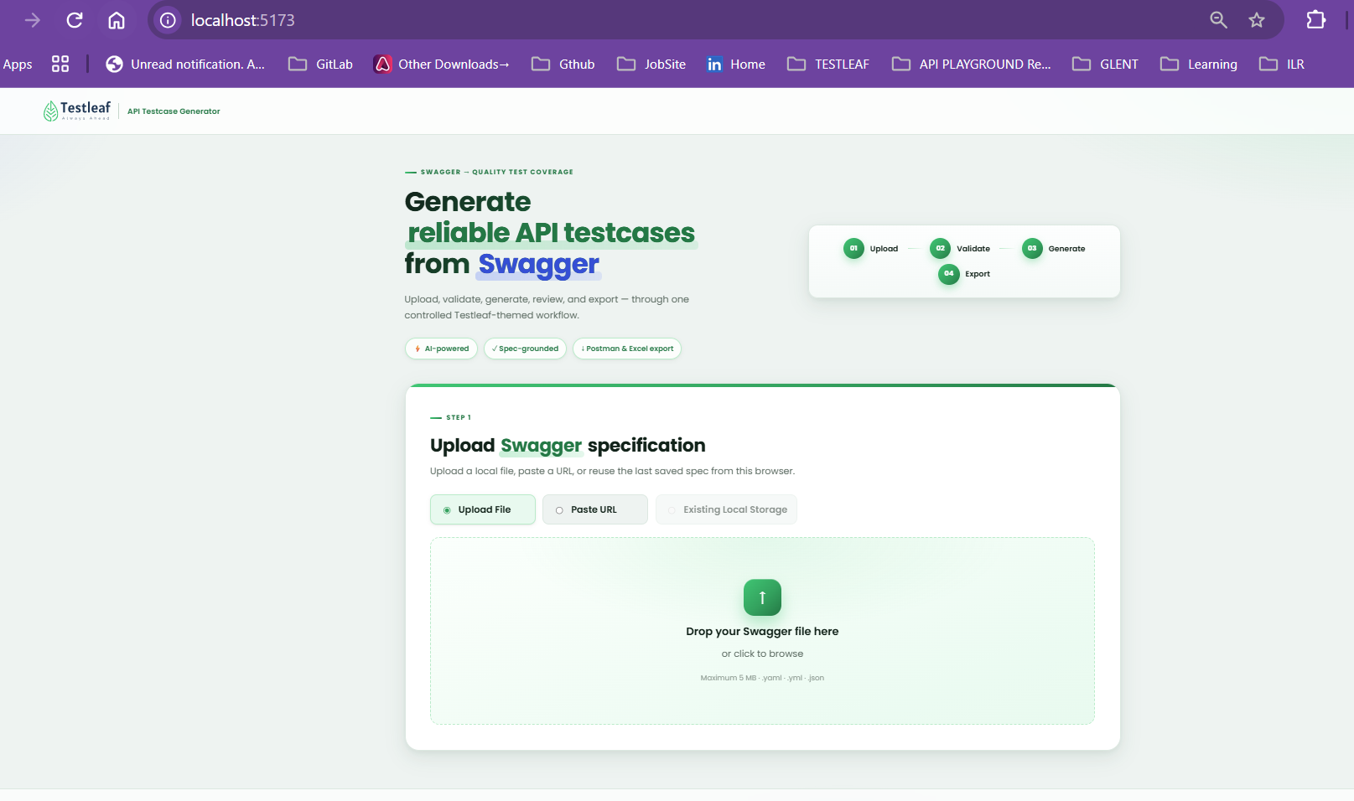

We can see below the UploadFile and PasteURL radio buttons
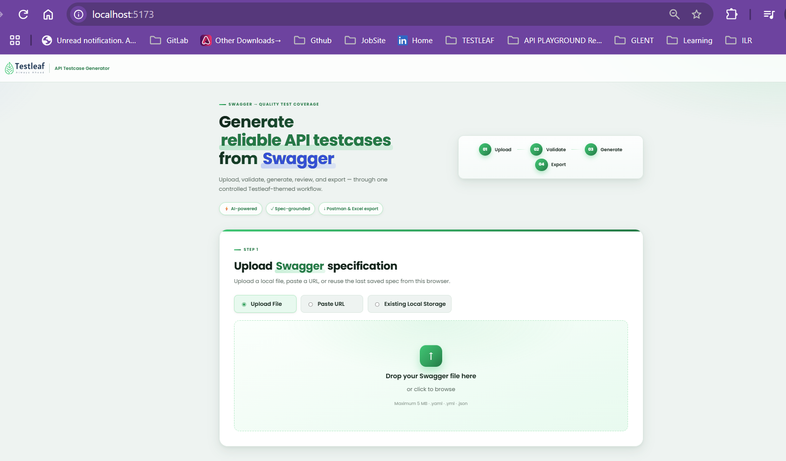
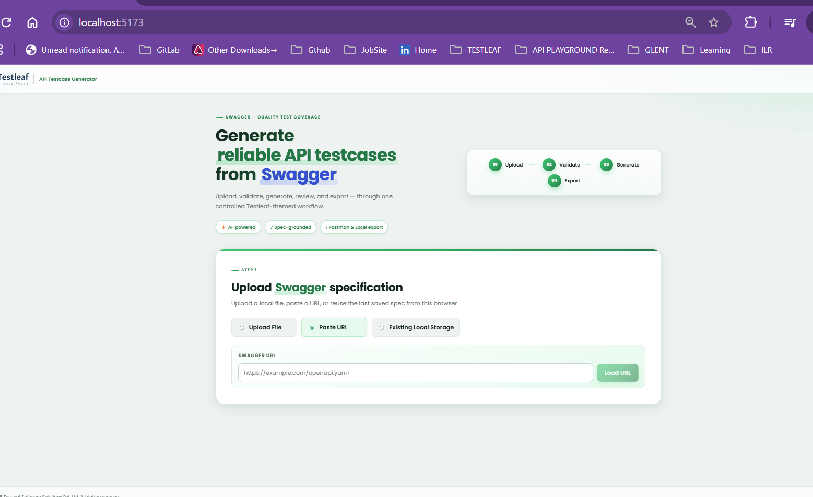
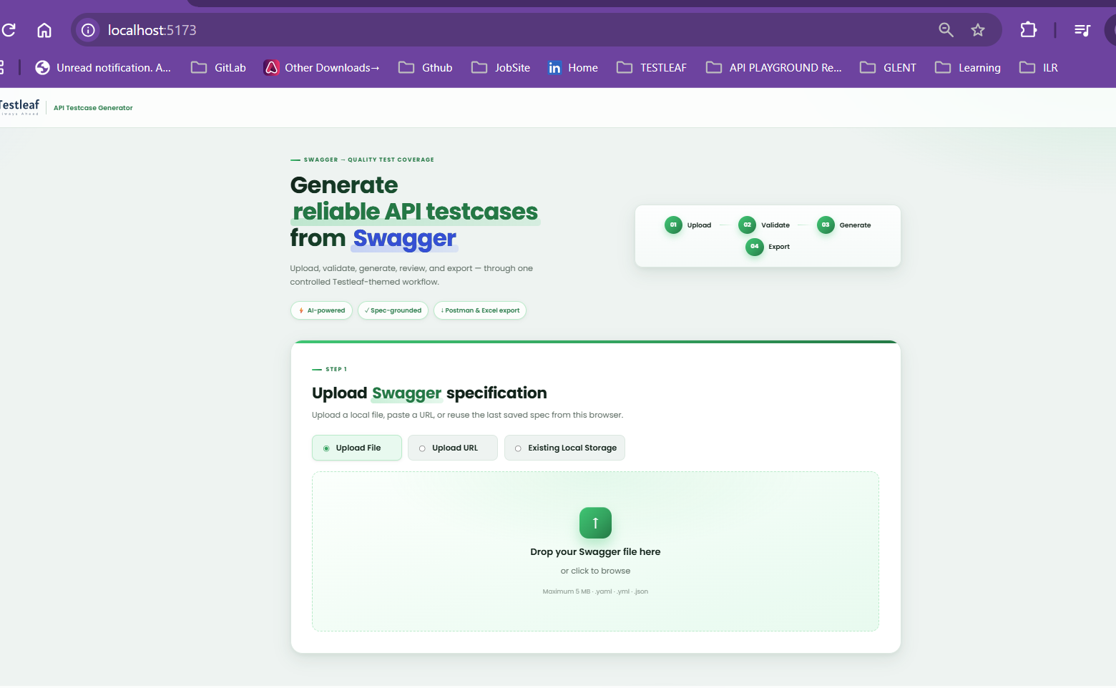
Validating the Upload URL radio is working as expected
Use the below json url
https://petstore.swagger.io/v2/swagger.json
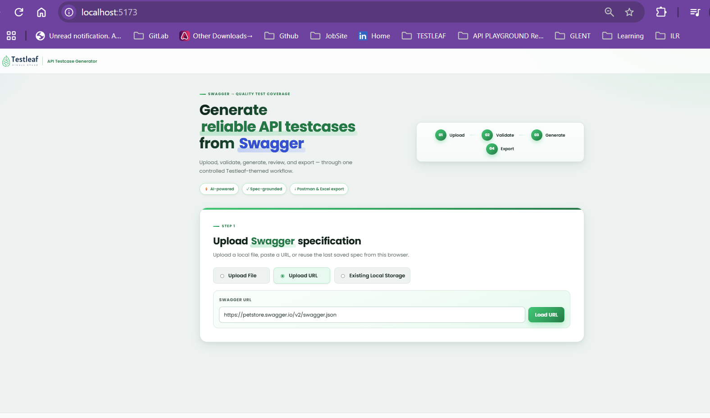
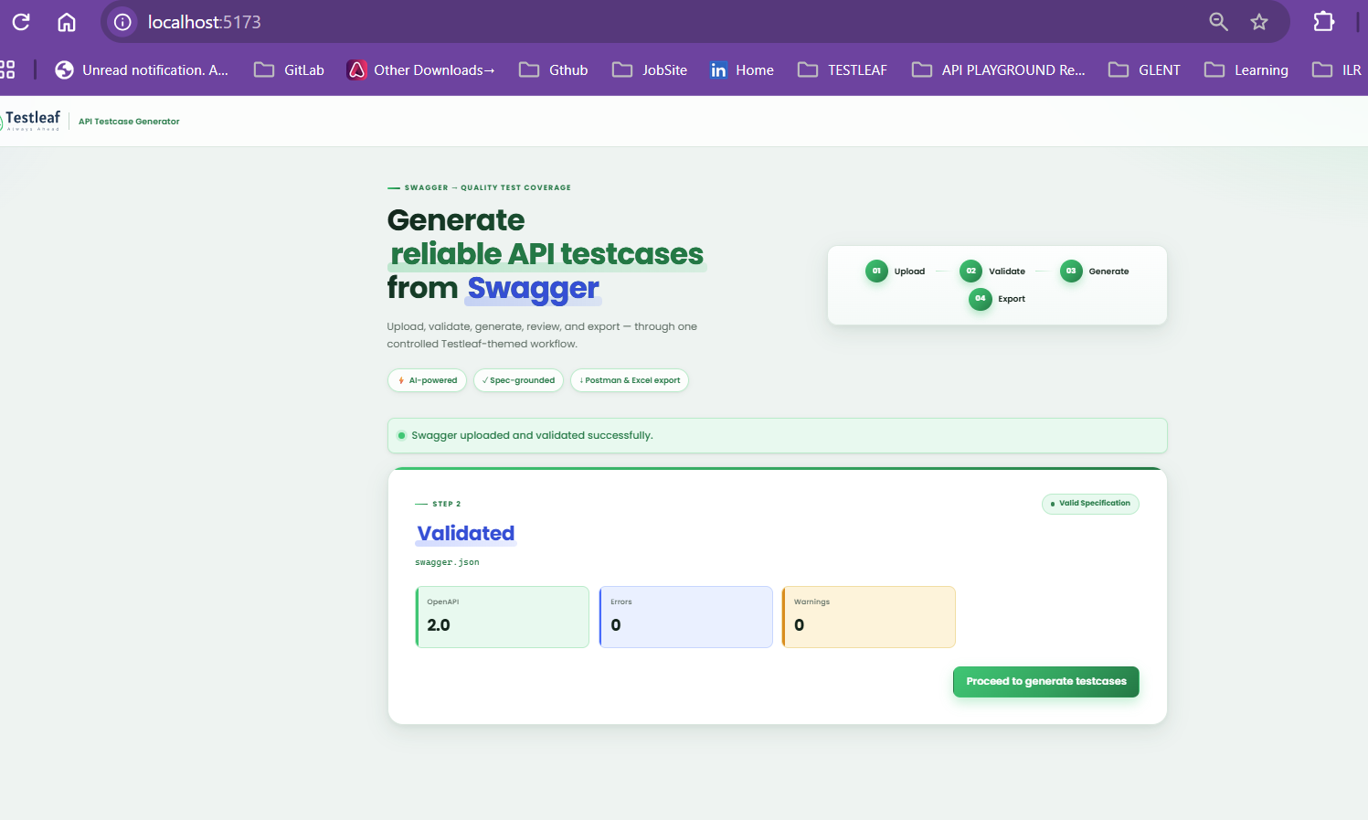
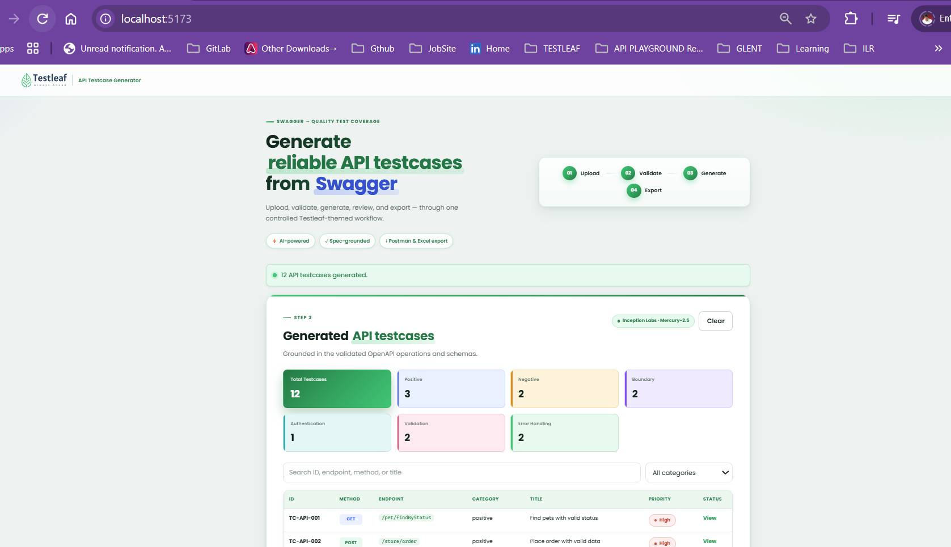
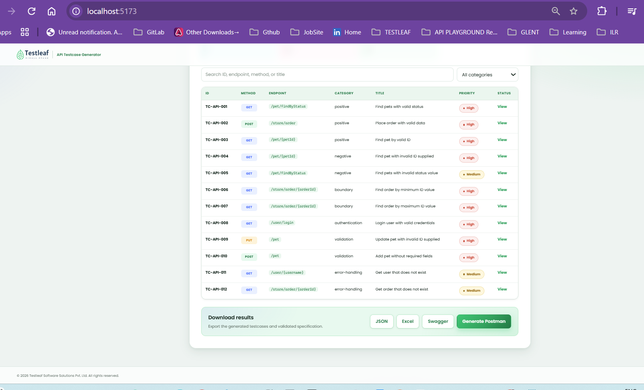

Assignment_2:
Enhance the existing application by implementing a feature that automatically categorizes the generated test cases into standard testing types such as Smoke, Sanity, Regression, Functional.
Once the test cases are generated, the application should classify each test case into the most appropriate category and display the categorized results in a structured and user-friendly format
The new functionality should seamlessly integrate with the existing test case generation workflow without impacting current features
