Part 2. Exploratory Factor Analysis

1. calculate Euclidian distances
No need to rescaling the Data, otherwise problems might arise as calculating the Euclidean distance
## crunchy creamy sweet chocolaty healthful calorie
## Balisto 4.465116 1.906977 4.045455 3.863636 2.279070 4.093023
## Bounty 1.978723 3.212766 4.437500 3.437500 1.659574 4.229167
## Duplo 4.020000 2.520000 4.480000 4.280000 1.632653 4.280000
## KinderBueno 3.770833 4.448980 4.571429 3.795918 1.488889 4.306122
## KinderRiegel 1.700000 4.060000 4.700000 4.520000 1.687500 4.300000
## KitKat 4.540000 2.160000 4.300000 4.140000 1.565217 4.280000
## Lion 4.186047 3.372093 4.568182 4.046512 1.568182 4.636364
## Mars 1.780000 4.320000 4.760000 3.860000 1.456522 4.560000
## Snickers 3.583333 3.437500 4.448980 3.958333 1.422222 4.604167
## Twix 4.140000 3.360000 4.540000 3.760000 1.510638 4.480000
## rich addiction accessible handy wrapping image
## Balisto 3.421053 2.921053 3.487179 4.000000 3.414634 3.162791
## Bounty 3.534884 3.048780 4.022727 3.957447 3.911111 3.446809
## Duplo 3.093023 3.266667 3.978723 4.061224 3.553191 4.060000
## KinderBueno 3.476190 3.622222 3.833333 3.795918 3.729167 3.440000
## KinderRiegel 3.444444 4.022222 4.468085 4.408163 4.000000 4.480000
## KitKat 3.266667 3.155556 4.145833 3.816327 3.531915 3.960000
## Lion 3.820513 3.250000 3.800000 4.000000 3.550000 3.439024
## Mars 3.666667 2.891304 4.250000 4.142857 3.489362 4.163265
## Snickers 3.600000 2.931818 4.347826 4.250000 3.276596 4.387755
## Twix 3.577778 3.282609 4.276596 4.040816 3.595745 3.960000
## commercial
## Balisto 3.179487
## Bounty 2.904762
## Duplo 4.367347
## KinderBueno 3.000000
## KinderRiegel 4.446809
## KitKat 3.895833
## Lion 3.205128
## Mars 3.978261
## Snickers 4.347826
## Twix 4.063830
# 表similarity matrix/ calculate euclidian distances----
products.dist <- dist(products.mean) # 算得是均值的Euclidean distance
products.dist
## Balisto Bounty Duplo KinderBueno KinderRiegel KitKat
## Bounty 3.057018
## Duplo 2.023991 2.874081
## KinderBueno 2.959558 2.314692 2.587829
## KinderRiegel 4.422568 2.617738 3.049584 3.034293
## KitKat 1.569771 3.114505 0.905386 2.738831 3.745032
## Lion 1.947468 2.419498 1.802404 1.372694 3.346816 1.737796
## Mars 4.092170 1.915837 3.055841 2.547024 1.631278 3.613951
## Snickers 2.829710 2.583265 1.418313 2.252880 2.504016 1.889563
## Twix 2.333038 2.593565 1.215404 1.776849 2.902997 1.434470
## Lion Mars Snickers
## Bounty
## Duplo
## KinderBueno
## KinderRiegel
## KitKat
## Lion
## Mars 2.877263
## Snickers 1.790236 2.097552
## Twix 1.188520 2.605959 0.961563
sm<-as.matrix(products.dist)
write.csv(sm, file = "DistanceMatrix.csv")
summary(products.dist)
## Min. 1st Qu. Median Mean 3rd Qu. Max.
## 0.9054 1.7902 2.5040 2.3945 2.9030 4.4226
boxplot(products.dist)
library("psych")
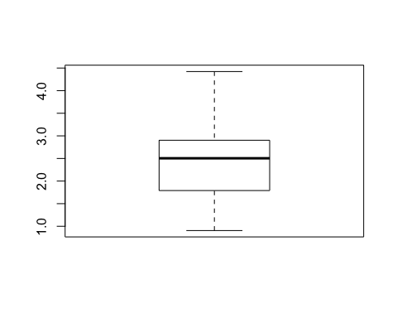
describe(products.dist)
## vars n mean sd median trimmed mad min max range skew kurtosis
## X1 1 45 2.39 0.81 2.5 2.37 0.82 0.91 4.42 3.52 0.24 -0.38
## se
## X1 0.12

2.Suitability of factor analysis
Assumption: the model assumes that some factors linearly influence the observed model.Check beforehand:
- inverse correlation matrix
- Anti-image matrix
- Kaiser-Meyer-Olkin-Criteria
- Bartlett’s test of sphericity
Check afterwards
- communalities h2
- reproduced correlation matrix R_hat
Factor analysis is based on a covariance matrix between variables. In other words, the candidate variables must have a certain correlation. If there is no correlation between the variables, or the correlation is small, the factor analysis will not be a suitable analysis method. The Kaiser-Meyer-Olkin measure of sampling adequacy allows us to know, whether this dataset is suitable for the degree of factor analysis?
# Check beforehand
library("psych")
library("lattice")
names(attribute)
## [1] "Person" "Product" "crunchy" "creamy" "sweet"
## [6] "chocolaty" "healthful" "calorie" "rich" "addiction"
## [11] "accessible" "handy" "wrapping" "image" "commercial"
# inverse and partial correlations
p <- solve(cor(attribute[,3:15], use="complete.obs"))
levelplot(p, main="Inverse & partial correlations")
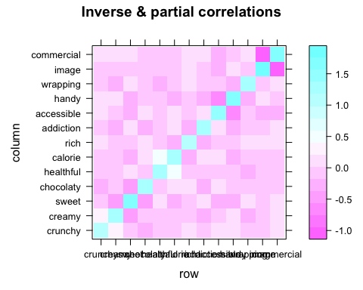
# anti-image
pr <- -p/sqrt(outer(diag(p), diag(p)))
levelplot(pr, main="Anti-Image correlation")
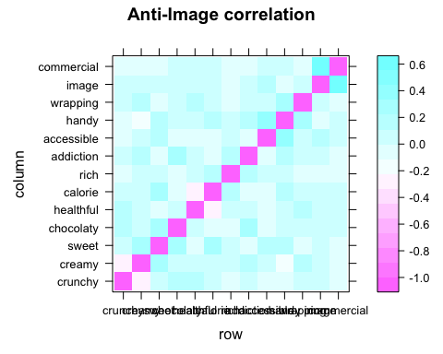
# Kaiser-Meyer-Olkin & MSA
KMO(attribute[,3:15])
## Kaiser-Meyer-Olkin factor adequacy
## Call: KMO(r = attribute[, 3:15])
## Overall MSA = 0.7
## MSA for each item =
## crunchy creamy sweet chocolaty healthful calorie
## 0.45 0.65 0.75 0.71 0.55 0.65
## rich addiction accessible handy wrapping image
## 0.74 0.76 0.79 0.74 0.77 0.69
## commercial
## 0.66
##KMO检验的数值变化从0——1，一般来说，KMO大于0.9适合作因子分析，若国小，表明变量偶对之间的相关不能被其他变量解释，进行因子分析不合适。KMO的值为0.7时为“还好’,0.6时为”中等”，0，5时就为“糟糕”了。本例中为近似0.7，表示还可以做因子分析。
# Bartlett test of sphericity
cortest.bartlett(attribute[,3:15])
## R was not square, finding R from data
## $chisq
## [1] 1235.126
##
## $p.value
## [1] 1.414912e-207
##
## $df
## [1] 78
## wiki: Bartlett's test (see Snedecor and Cochran, 1989) is used to test if k samples are from populations with equal variances. Equal variances across populations is called homoscedasticity or homogeneity of variances. Some statistical tests, for example the analysis of variance, assume that variances are equal across groups or samples. The Bartlett test can be used to verify that assumption.
## Bartlett检验的目的是确定所要求的数据是否曲子多元正态分布的总体，若差异检验的F值显著，表示索取数据来自正态分布，可以做进一步的分析。你给的结果中，sig显著，表示数据取自正态分布，很适合做因子分析。
# 几种不同的因子分析解释度。我应该会用ml
library("psych")
scree(attribute[,3:15])
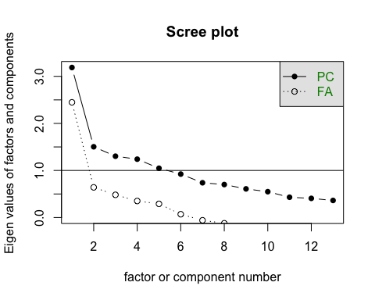
# principal component extraction
principal(attribute[,3:15], nfactors=4, rotate="none")
## Principal Components Analysis
## Call: principal(r = attribute[, 3:15], nfactors = 4, rotate = "none")
## Standardized loadings (pattern matrix) based upon correlation matrix
## PC1 PC2 PC3 PC4 h2 u2 com
## crunchy -0.06 0.37 0.22 0.74 0.73 0.27 1.7
## creamy 0.46 -0.26 0.12 -0.49 0.53 0.47 2.7
## sweet 0.64 -0.36 0.15 0.16 0.59 0.41 1.8
## chocolaty 0.47 0.09 0.31 0.41 0.49 0.51 2.8
## healthful 0.17 0.71 0.28 -0.23 0.67 0.33 1.7
## calorie 0.40 -0.60 -0.13 0.32 0.64 0.36 2.5
## rich 0.37 -0.23 0.37 -0.05 0.32 0.68 2.7
## addiction 0.52 0.12 0.43 0.01 0.47 0.53 2.1
## accessible 0.66 0.02 -0.16 -0.11 0.47 0.53 1.2
## handy 0.67 0.02 0.08 0.00 0.46 0.54 1.0
## wrapping 0.47 0.29 0.12 -0.28 0.40 0.60 2.6
## image 0.60 0.28 -0.53 0.06 0.72 0.28 2.4
## commercial 0.53 0.26 -0.61 0.14 0.74 0.26 2.5
##
## PC1 PC2 PC3 PC4
## SS loadings 3.19 1.50 1.30 1.24
## Proportion Var 0.25 0.12 0.10 0.10
## Cumulative Var 0.25 0.36 0.46 0.56
## Proportion Explained 0.44 0.21 0.18 0.17
## Cumulative Proportion 0.44 0.65 0.83 1.00
##
## Mean item complexity = 2.1
## Test of the hypothesis that 4 components are sufficient.
##
## The root mean square of the residuals (RMSR) is 0.09
## with the empirical chi square 681.06 with prob < 9.9e-123
##
## Fit based upon off diagonal values = 0.8
# principal axis extraction
fa(attribute[,3:15], nfactors=4, rotate="none", fm="pa")
## maximum iteration exceeded
## Factor Analysis using method = pa
## Call: fa(r = attribute[, 3:15], nfactors = 4, rotate = "none", fm = "pa")
## Standardized loadings (pattern matrix) based upon correlation matrix
## PA1 PA2 PA3 PA4 h2 u2 com
## crunchy -0.06 0.49 0.54 0.39 0.69 0.31 2.9
## creamy 0.39 -0.24 -0.06 -0.22 0.26 0.74 2.4
## sweet 0.59 -0.30 0.22 0.09 0.49 0.51 1.8
## chocolaty 0.39 0.06 0.25 0.05 0.22 0.78 1.8
## healthful 0.15 0.47 0.10 -0.41 0.42 0.58 2.3
## calorie 0.37 -0.38 0.08 0.37 0.43 0.57 3.1
## rich 0.29 -0.14 0.16 -0.08 0.14 0.86 2.3
## addiction 0.44 0.04 0.21 -0.17 0.27 0.73 1.8
## accessible 0.58 -0.01 -0.03 -0.05 0.34 0.66 1.0
## handy 0.60 -0.03 0.14 -0.09 0.39 0.61 1.2
## wrapping 0.39 0.11 0.05 -0.24 0.22 0.78 1.9
## image 0.60 0.30 -0.35 0.17 0.60 0.40 2.4
## commercial 0.55 0.31 -0.41 0.27 0.64 0.36 3.1
##
## PA1 PA2 PA3 PA4
## SS loadings 2.59 0.98 0.81 0.73
## Proportion Var 0.20 0.08 0.06 0.06
## Cumulative Var 0.20 0.27 0.34 0.39
## Proportion Explained 0.51 0.19 0.16 0.14
## Cumulative Proportion 0.51 0.70 0.86 1.00
##
## Mean item complexity = 2.1
## Test of the hypothesis that 4 factors are sufficient.
##
## The degrees of freedom for the null model are 78 and the objective function was 2.5 with Chi Square of 1235.13
## The degrees of freedom for the model are 32 and the objective function was 0.34
##
## The root mean square of the residuals (RMSR) is 0.04
## The df corrected root mean square of the residuals is 0.07
##
## The harmonic number of observations is 500 with the empirical chi square 152.71 with prob < 1.1e-17
## The total number of observations was 500 with Likelihood Chi Square = 168.64 with prob < 1.7e-20
##
## Tucker Lewis Index of factoring reliability = 0.71
## RMSEA index = 0.093 and the 90 % confidence intervals are 0.079 0.107
## BIC = -30.22
## Fit based upon off diagonal values = 0.96
## Measures of factor score adequacy
## PA1 PA2 PA3 PA4
## Correlation of (regression) scores with factors 0.91 0.82 0.81 0.77
## Multiple R square of scores with factors 0.82 0.68 0.66 0.59
## Minimum correlation of possible factor scores 0.64 0.36 0.33 0.19
# maximum likelihood extraction
fa(attribute[,3:15], nfactors=4, rotate="none", fm="ml")
## Factor Analysis using method = ml
## Call: fa(r = attribute[, 3:15], nfactors = 4, rotate = "none", fm = "ml")
## Standardized loadings (pattern matrix) based upon correlation matrix
## ML1 ML2 ML3 ML4 h2 u2 com
## crunchy -0.03 -0.04 0.11 0.18 0.05 0.95 1.9
## creamy 0.32 0.19 -0.03 0.12 0.15 0.85 1.9
## sweet 0.52 0.44 -0.17 0.18 0.52 0.48 2.5
## chocolaty 0.37 0.20 0.08 0.46 0.39 0.61 2.4
## healthful 0.15 -0.15 0.59 0.10 0.40 0.60 1.3
## calorie 0.32 0.30 -0.45 -0.03 0.40 0.60 2.7
## rich 0.23 0.26 0.04 0.00 0.12 0.88 2.0
## addiction 0.38 0.18 0.22 0.23 0.28 0.72 2.9
## accessible 0.60 0.17 0.10 -0.32 0.50 0.50 1.8
## handy 0.57 0.34 0.20 -0.24 0.55 0.45 2.3
## wrapping 0.37 0.08 0.29 -0.08 0.23 0.77 2.1
## image 0.73 -0.44 -0.09 0.03 0.73 0.27 1.7
## commercial 0.61 -0.36 -0.11 -0.01 0.52 0.48 1.7
##
## ML1 ML2 ML3 ML4
## SS loadings 2.56 0.97 0.80 0.52
## Proportion Var 0.20 0.07 0.06 0.04
## Cumulative Var 0.20 0.27 0.33 0.37
## Proportion Explained 0.53 0.20 0.16 0.11
## Cumulative Proportion 0.53 0.73 0.89 1.00
##
## Mean item complexity = 2.1
## Test of the hypothesis that 4 factors are sufficient.
##
## The degrees of freedom for the null model are 78 and the objective function was 2.5 with Chi Square of 1235.13
## The degrees of freedom for the model are 32 and the objective function was 0.32
##
## The root mean square of the residuals (RMSR) is 0.05
## The df corrected root mean square of the residuals is 0.07
##
## The harmonic number of observations is 500 with the empirical chi square 175.67 with prob < 9.4e-22
## The total number of observations was 500 with Likelihood Chi Square = 156.62 with prob < 2.4e-18
##
## Tucker Lewis Index of factoring reliability = 0.736
## RMSEA index = 0.089 and the 90 % confidence intervals are 0.075 0.102
## BIC = -42.25
## Fit based upon off diagonal values = 0.95
## Measures of factor score adequacy
## ML1 ML2 ML3 ML4
## Correlation of (regression) scores with factors 0.92 0.83 0.76 0.69
## Multiple R square of scores with factors 0.85 0.68 0.57 0.47
## Minimum correlation of possible factor scores 0.70 0.36 0.14 -0.05
# unweighted least squares extraction
fa(attribute[,3:15], nfactors=4, rotate="none")
## Factor Analysis using method = minres
## Call: fa(r = attribute[, 3:15], nfactors = 4, rotate = "none")
## Standardized loadings (pattern matrix) based upon correlation matrix
## MR1 MR2 MR3 MR4 h2 u2 com
## crunchy -0.07 0.85 0.39 -0.15 0.91 0.09 1.5
## creamy 0.38 -0.26 0.02 0.16 0.24 0.76 2.1
## sweet 0.59 -0.15 0.34 -0.03 0.49 0.51 1.8
## chocolaty 0.39 0.15 0.18 0.06 0.21 0.79 1.8
## healthful 0.15 0.34 -0.26 0.46 0.42 0.58 2.8
## calorie 0.37 -0.22 0.35 -0.35 0.43 0.57 3.6
## rich 0.29 -0.08 0.18 0.12 0.14 0.86 2.3
## addiction 0.44 0.08 0.10 0.24 0.27 0.73 1.8
## accessible 0.58 -0.03 -0.03 0.04 0.34 0.66 1.0
## handy 0.60 0.01 0.11 0.14 0.39 0.61 1.2
## wrapping 0.39 0.07 -0.07 0.25 0.22 0.78 1.9
## image 0.60 0.16 -0.38 -0.26 0.60 0.40 2.3
## commercial 0.55 0.17 -0.42 -0.38 0.64 0.36 2.9
##
## MR1 MR2 MR3 MR4
## SS loadings 2.59 1.08 0.88 0.75
## Proportion Var 0.20 0.08 0.07 0.06
## Cumulative Var 0.20 0.28 0.35 0.41
## Proportion Explained 0.49 0.20 0.17 0.14
## Cumulative Proportion 0.49 0.69 0.86 1.00
##
## Mean item complexity = 2.1
## Test of the hypothesis that 4 factors are sufficient.
##
## The degrees of freedom for the null model are 78 and the objective function was 2.5 with Chi Square of 1235.13
## The degrees of freedom for the model are 32 and the objective function was 0.34
##
## The root mean square of the residuals (RMSR) is 0.04
## The df corrected root mean square of the residuals is 0.07
##
## The harmonic number of observations is 500 with the empirical chi square 152.47 with prob < 1.3e-17
## The total number of observations was 500 with Likelihood Chi Square = 168.07 with prob < 2.2e-20
##
## Tucker Lewis Index of factoring reliability = 0.712
## RMSEA index = 0.093 and the 90 % confidence intervals are 0.079 0.106
## BIC = -30.79
## Fit based upon off diagonal values = 0.96
## Measures of factor score adequacy
## MR1 MR2 MR3 MR4
## Correlation of (regression) scores with factors 0.91 0.93 0.83 0.77
## Multiple R square of scores with factors 0.82 0.86 0.69 0.59
## Minimum correlation of possible factor scores 0.64 0.72 0.38 0.18

3. How many factors to choose? large increase of explained variance in at least two or three items
DA2 Parallel analysis of Horn 根据Horn, 选择4个component比较合适，不过3个也可以，因为多一个的提升也不大 Adjusted eigenvalues > 1 indicate dimensions to retain. (4 components retained)
## 可用/ Test/ DA2 Parallel analysis of Horn ----
library("foreign")
library("paran")
## Loading required package: MASS
x <-attribute[,-c(1,2)]
paran(x, centile=95, all=T, graph=T)
##
## Using eigendecomposition of correlation matrix.
## Computing: 10% 20% 30% 40% 50% 60% 70% 80% 90% 100%
##
##
## Results of Horn's Parallel Analysis for component retention
## 390 iterations, using the 95 centile estimate
##
--------------------------------------------------
Component Adjusted Unadjusted Estimated Eigenvalue Eigenvalu Bias
## --------------------------------------------------
## 1 2.849394 3.188346 0.338952
## 2 1.249905 1.503445 0.253540
## 3 1.109502 1.302805 0.193303
## 4 1.094227 1.239937 0.145710
## 5 0.949717 1.046915 0.097197
## 6 0.864338 0.922971 0.058633
## 7 0.718379 0.738174 0.019794
## 8 0.718399 0.700422 -0.01797
## 9 0.658253 0.608501 -0.04975
## 10 0.633059 0.548641 -0.08441
## 11 0.552326 0.430693 -0.12163
## 12 0.569848 0.406696 -0.16315
## 13 0.563806 0.362448 -0.20135
## --------------------------------------------------
##
## Adjusted eigenvalues > 1 indicate dimensions to retain.
## (4 components retained)
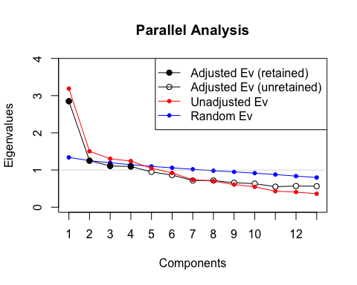
library("psych")
fa.parallel(x, fa="pc")
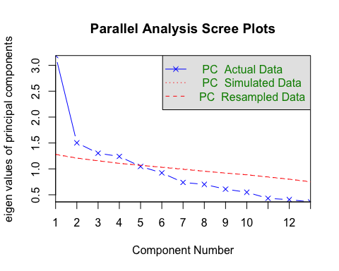
## Parallel analysis suggests that the number of factors = NA and the number of components = 4
## 根据Horn, 选择4个component比较合适，不过课堂上老师认为3个比较好
## Adjusted eigenvalues > 1 indicate dimensions to retain. (4 components retained)
# Scree Plots For FA with Parallel Ananlysis
tmp <- attribute[,3:15]
fa.parallel(tmp, n.obs=500, fa="fa",
main="Scree Plots for FA with Parallel Analysis")
## Warning in fa.parallel(tmp, n.obs = 500, fa = "fa", main = "Scree Plots for
## FA with Parallel Analysis"): You specified the number of subjects, implying
## a correlation matrix, but do not have a correlation matrix, correlations
## found
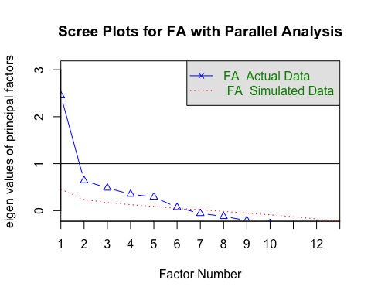
## Parallel analysis suggests that the number of factors = 6 and the number of components = NA
### End of the Test DA2 Parallel analysis of Horn
# correlation matrix by gender
library(psych)
tmp <- bars.gender[,3:15]
par(mfrow = c(2,1))
options(digits=2)
female <- cov(bars.gender[1:10,3:15])
cor.plot(female)
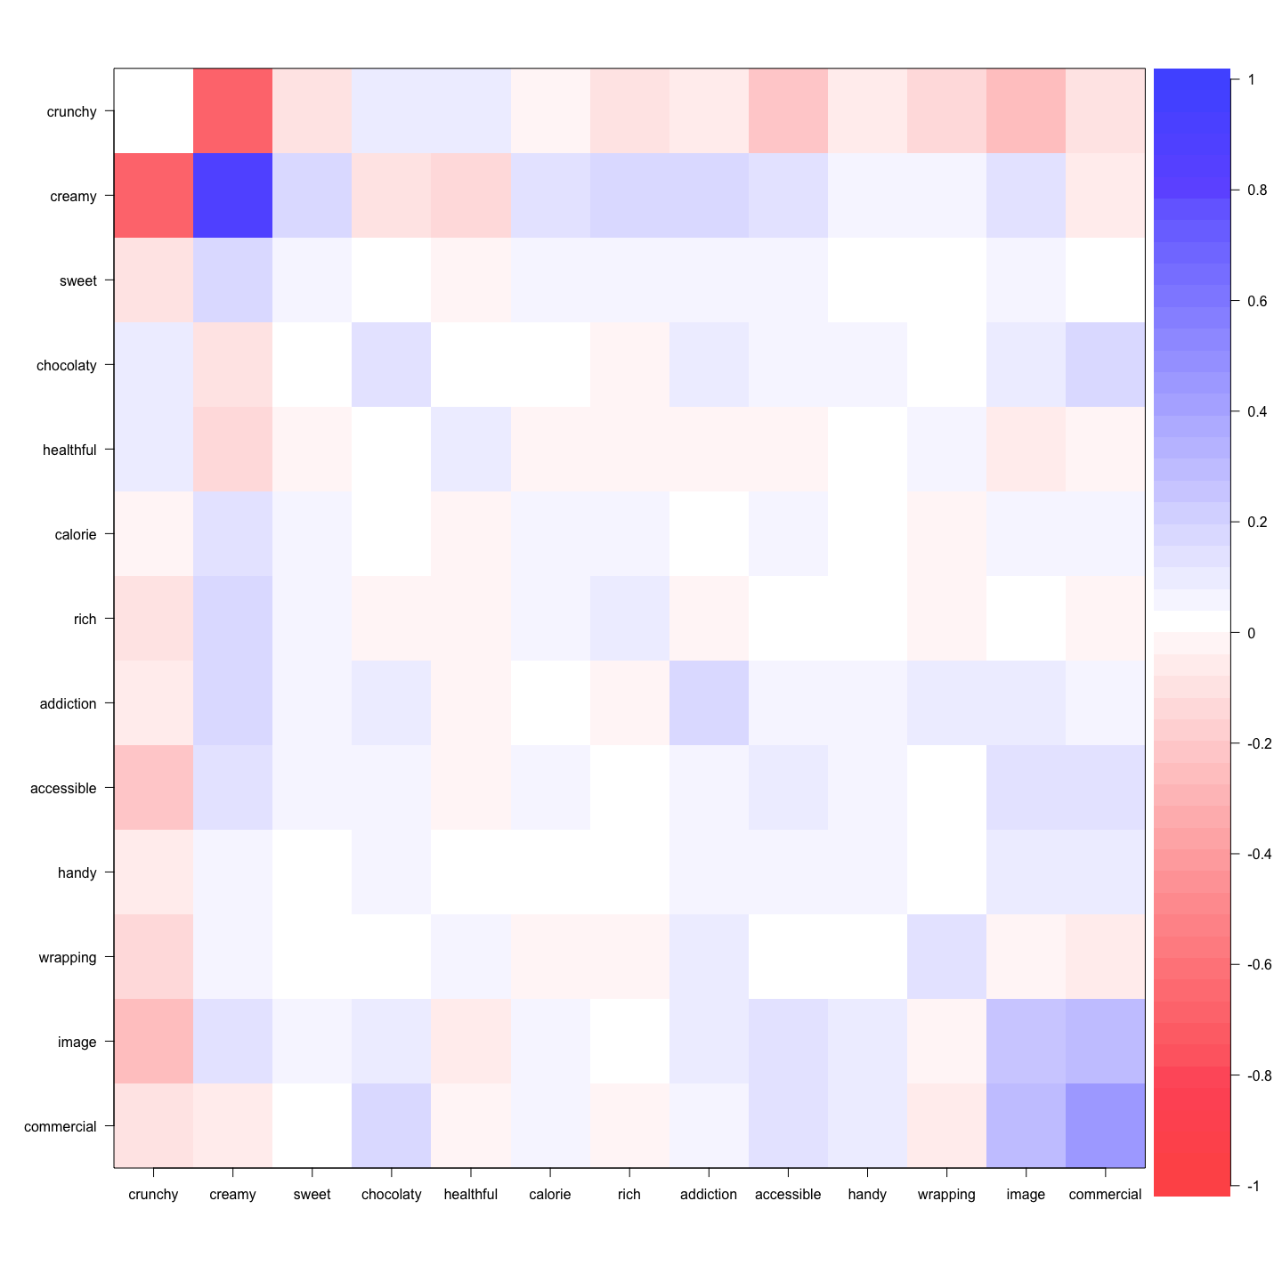
male <- cov(bars.gender[11:20,3:15])
cor.plot(male)
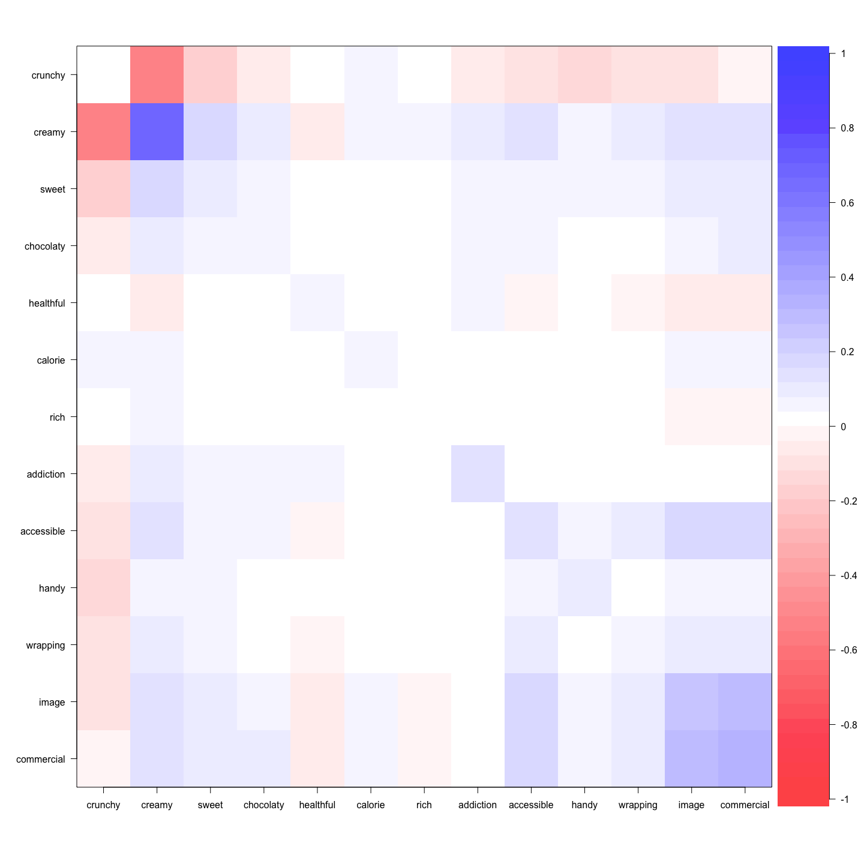

4. EFA Rotation
library("psych")
# ML with Kaiser normalization
factanal(attribute[,3:15], factors=3)
##
## Call:
## factanal(x = attribute[, 3:15], factors = 3)
##
## Uniquenesses:
## crunchy creamy sweet chocolaty healthful calorie
## 0.98 0.84 0.53 0.83 0.57 0.59
## rich addiction accessible handy wrapping image
## 0.86 0.76 0.65 0.59 0.77 0.41
## commercial
## 0.33
##
## Loadings:
## Factor1 Factor2 Factor3
## crunchy -0.121
## creamy 0.376 0.111
## sweet 0.582 0.347
## chocolaty 0.385 0.129
## healthful 0.232 -0.605
## calorie 0.268 0.114 0.571
## rich 0.355
## addiction 0.472
## accessible 0.511 0.299
## handy 0.617 0.172
## wrapping 0.420 0.132 -0.185
## image 0.232 0.729
## commercial 0.123 0.806
##
## Factor1 Factor2 Factor3
## SS loadings 1.99 1.38 0.899
## Proportion Var 0.15 0.11 0.069
## Cumulative Var 0.15 0.26 0.329
##
## Test of the hypothesis that 3 factors are sufficient.
## The chi square statistic is 235 on 42 degrees of freedom.
## The p-value is 1.1e-28
# oblimin rotation without Kaiser normalization
fa1 <- fa(attribute[,3:15], nfactors=3)
## Loading required namespace: GPArotation
fa1
## Factor Analysis using method = minres
## Call: fa(r = attribute[, 3:15], nfactors = 3)
## Standardized loadings (pattern matrix) based upon correlation matrix
## MR1 MR3 MR2 h2 u2 com
## crunchy -0.07 0.00 0.13 0.021 0.98 1.5
## creamy 0.41 -0.01 0.00 0.168 0.83 1.0
## sweet 0.68 -0.02 -0.16 0.486 0.51 1.1
## chocolaty 0.38 0.04 0.11 0.166 0.83 1.2
## healthful 0.05 0.03 0.67 0.465 0.54 1.0
## calorie 0.40 0.07 -0.44 0.380 0.62 2.0
## rich 0.40 -0.11 0.03 0.139 0.86 1.2
## addiction 0.47 -0.03 0.24 0.265 0.73 1.5
## accessible 0.44 0.23 0.06 0.339 0.66 1.6
## handy 0.58 0.08 0.13 0.395 0.60 1.1
## wrapping 0.33 0.07 0.28 0.213 0.79 2.1
## image 0.06 0.74 0.04 0.600 0.40 1.0
## commercial -0.05 0.82 -0.03 0.637 0.36 1.0
##
## MR1 MR3 MR2
## SS loadings 2.03 1.38 0.87
## Proportion Var 0.16 0.11 0.07
## Cumulative Var 0.16 0.26 0.33
## Proportion Explained 0.48 0.32 0.20
## Cumulative Proportion 0.48 0.80 1.00
##
## With factor correlations of
## MR1 MR3 MR2
## MR1 1.00 0.40 -0.01
## MR3 0.40 1.00 0.11
## MR2 -0.01 0.11 1.00
##
## Mean item complexity = 1.3
## Test of the hypothesis that 3 factors are sufficient.
##
## The degrees of freedom for the null model are 78 and the objective function was 2.5 with Chi Square of 1235
## The degrees of freedom for the model are 42 and the objective function was 0.48
##
## The root mean square of the residuals (RMSR) is 0.06
## The df corrected root mean square of the residuals is 0.08
##
## The harmonic number of observations is 500 with the empirical chi square 261 with prob < 1.9e-33
## The total number of observations was 500 with Likelihood Chi Square = 237 with prob < 4.9e-29
##
## Tucker Lewis Index of factoring reliability = 0.69
## RMSEA index = 0.097 and the 90 % confidence intervals are 0.085 0.11
## BIC = -24
## Fit based upon off diagonal values = 0.92
## Measures of factor score adequacy
## MR1 MR3 MR2
## Correlation of (regression) scores with factors 0.87 0.88 0.77
## Multiple R square of scores with factors 0.76 0.78 0.60
## Minimum correlation of possible factor scores 0.53 0.56 0.19
# apply Kaiser normalization
fa2 <- fa(attribute[,3:15], nfactors=3, rotate="none")
fa2 <- kaiser(fa2)
fa2
##
## Call: NULL
## Standardized loadings (pattern matrix) based upon correlation matrix
## MR1 MR2 MR3 h2 u2
## crunchy -0.03 0.14 0.00 0.021 0.98
## creamy 0.39 -0.09 -0.01 0.168 0.83
## sweet 0.60 -0.30 -0.01 0.486 0.51
## chocolaty 0.39 0.02 -0.05 0.166 0.83
## healthful 0.25 0.65 -0.04 0.465 0.54
## calorie 0.24 -0.52 -0.09 0.380 0.62
## rich 0.39 -0.06 0.09 0.139 0.86
## addiction 0.51 0.14 0.01 0.265 0.73
## accessible 0.43 -0.04 -0.25 0.339 0.66
## handy 0.58 0.00 -0.11 0.395 0.60
## wrapping 0.39 0.20 -0.09 0.213 0.79
## image 0.05 0.01 -0.75 0.600 0.40
## commercial -0.07 -0.05 -0.82 0.637 0.36
##
## MR1 MR2 MR3
## SS loadings 1.95 0.89 1.43
## Proportion Var 0.15 0.07 0.11
## Cumulative Var 0.15 0.22 0.33
## Proportion Explained 0.46 0.21 0.33
## Cumulative Proportion 0.46 0.67 1.00
## MR1 MR2 MR3
## MR1 1.00 -0.10 -0.39
## MR2 -0.10 1.00 -0.02
## MR3 -0.39 -0.02 1.00
# compare loading sets (vector cosines)
factor.congruence(fa1, fa2)
## MR1 MR2 MR3
## MR1 0.98 -0.25 -0.14
## MR3 0.08 -0.03 -1.00
## MR2 0.28 0.95 -0.04

5. EFA Scores
library("psych")
# ML with Kaiser normalization
fa1 <-factanal(attribute[,3:15], factors=3, scores="regression")
head(fa1$scores)
## Factor1 Factor2 Factor3
## [1,] -1.342 -0.57 -1.15
## [2,] -0.017 -0.78 -0.19
## [3,] 0.134 -0.70 -0.64
## [4,] -0.417 -1.42 0.85
## [5,] 0.584 -0.36 -1.22
## [6,] -0.733 0.35 -0.94
# oblimin rotation without Kaiser normalization
fa2 <- fa(attribute[,3:15], nfactors=3)
head(fa2$scores)
## MR1 MR3 MR2
## [1,] -1.70 -0.93 0.81
## [2,] -0.15 -0.74 0.09
## [3,] -0.20 -0.68 0.60
## [4,] -0.33 -1.42 -0.98
## [5,] 0.14 -0.27 1.38
## [6,] -0.97 0.16 0.74
# compare scores
cor(fa1$scores, fa2$scores)
## MR1 MR3 MR2
## Factor1 0.95 0.346 0.25
## Factor2 0.30 0.973 0.12
## Factor3 0.32 0.034 -0.94
# caci 的
a.fa.gender<-fa(bars.gender[,3:15],fm="ml", max.iter=1000,SMC=TRUE,scores='Anderson',nfactors=4, rotate ="varimax")
a.fa.gender
## Factor Analysis using method = ml
## Call: fa(r = bars.gender[, 3:15], nfactors = 4, rotate = "varimax",
## scores = "Anderson", SMC = TRUE, max.iter = 1000, fm = "ml")
## Standardized loadings (pattern matrix) based upon correlation matrix
## ML2 ML4 ML1 ML3 h2 u2 com
## crunchy -0.18 -0.01 -0.29 -0.66 0.55 0.449 1.5
## creamy 0.67 0.01 0.05 0.73 1.00 0.005 2.0
## sweet 0.59 0.03 0.40 0.40 0.67 0.333 2.6
## chocolaty -0.08 0.69 -0.07 0.02 0.49 0.510 1.1
## healthful -0.64 -0.19 -0.30 -0.12 0.55 0.448 1.7
## calorie 0.92 0.11 0.23 -0.29 1.00 0.005 1.4
## rich 0.65 -0.26 -0.23 0.08 0.55 0.453 1.6
## addiction -0.07 0.16 0.01 0.58 0.36 0.636 1.2
## accessible 0.28 0.36 0.86 0.21 1.00 0.005 1.7
## handy 0.15 0.29 0.48 0.07 0.34 0.659 1.9
## wrapping -0.18 -0.17 0.50 0.47 0.53 0.466 2.5
## image 0.16 0.80 0.42 0.20 0.89 0.110 1.8
## commercial 0.03 0.93 0.37 0.00 1.00 0.005 1.3
##
## ML2 ML4 ML1 ML3
## SS loadings 2.68 2.37 1.99 1.88
## Proportion Var 0.21 0.18 0.15 0.14
## Cumulative Var 0.21 0.39 0.54 0.69
## Proportion Explained 0.30 0.27 0.22 0.21
## Cumulative Proportion 0.30 0.57 0.79 1.00
##
## Mean item complexity = 1.7
## Test of the hypothesis that 4 factors are sufficient.
##
## The degrees of freedom for the null model are 78 and the objective function was 12 with Chi Square of 165
## The degrees of freedom for the model are 32 and the objective function was 2.9
##
## The root mean square of the residuals (RMSR) is 0.08
## The df corrected root mean square of the residuals is 0.12
##
## The harmonic number of observations is 20 with the empirical chi square 19 with prob < 0.97
## The total number of observations was 20 with Likelihood Chi Square = 32 with prob < 0.44
##
## Tucker Lewis Index of factoring reliability = 0.98
## RMSEA index = 0.2 and the 90 % confidence intervals are 0 NA
## BIC = -63
## Fit based upon off diagonal values = 0.96
## Measures of factor score adequacy
## ML2 ML4 ML1 ML3
## Correlation of (regression) scores with factors 1.00 1.00 0.99 1.00
## Multiple R square of scores with factors 1.00 0.99 0.99 0.99
## Minimum correlation of possible factor scores 0.99 0.98 0.98 0.98
EFA <-print(fa(bars.gender[,3:15], fm="ml", nfactors =4, scores='Anderson',rotate ="varimax")$ loadings ,cut =0.3)
##
## Loadings:
## ML2 ML4 ML1 ML3
## crunchy -0.659
## creamy 0.673 0.735
## sweet 0.594 0.395 0.396
## chocolaty 0.691
## healthful -0.639 -0.305
## calorie 0.919
## rich 0.647
## addiction 0.578
## accessible 0.360 0.862
## handy 0.479
## wrapping 0.500 0.469
## image 0.803 0.425
## commercial 0.928 0.365
##
## ML2 ML4 ML1 ML3
## SS loadings 2.68 2.37 1.99 1.88
## Proportion Var 0.21 0.18 0.15 0.14
## Cumulative Var 0.21 0.39 0.54 0.69
fa.diagram(EFA, simple = TRUE)
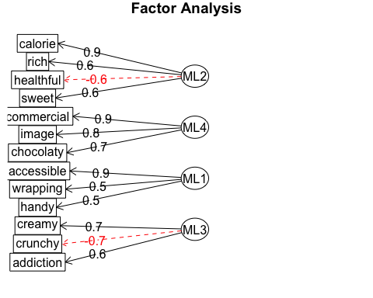
# • 不要性别
EFAscore<- aggregate(a.fa.gender$scores[,1:2], by=list(bars.gender$Group.1) ,mean)
colnames(EFAscore)[1] <- c("Product")
EFAscore
## Product ML2 ML4
## 1 Balisto -1.25 -0.6532
## 2 Bounty -0.75 -1.6787
## 3 Duplo -0.77 1.2540
## 4 KinderBueno 0.50 -0.8642
## 5 KinderRiegel -0.27 0.9020
## 6 KitKat -0.97 -0.0064
## 7 Lion 1.30 -0.5829
## 8 Mars 1.14 0.3883
## 9 Snickers 0.81 0.8924
## 10 Twix 0.27 0.3487
# ••••最后efa图/ test----
EFAscore<- aggregate(a.fa.gender$scores[,1:2], by=list(bars.gender$Group.1) ,mean);EFAscore
## Group.1 ML2 ML4
## 1 Balisto -1.25 -0.6532
## 2 Bounty -0.75 -1.6787
## 3 Duplo -0.77 1.2540
## 4 KinderBueno 0.50 -0.8642
## 5 KinderRiegel -0.27 0.9020
## 6 KitKat -0.97 -0.0064
## 7 Lion 1.30 -0.5829
## 8 Mars 1.14 0.3883
## 9 Snickers 0.81 0.8924
## 10 Twix 0.27 0.3487
plot(EFAscore$ML2,EFAscore$ML4, ylim = c(-2, 2), xlim = c(-2, 2),
xlab = "ML2", ylab = "ML4",pch = 19,
main = "EFA Scores")
text(EFAscore$ML2,EFAscore$ML4, labels = EFAscore$Group.1, cex = 1, pos = 4) # label the value
## type="n") tells R not to plot symbols.
## Instead, we add the brand labels to the plot with text(x, labels).
abline(h = 0, v = 0, col = "grey")
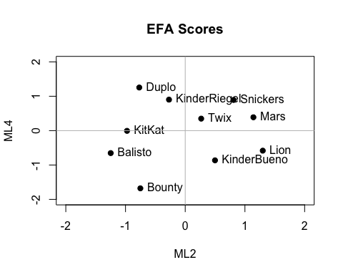
# Test 完
#• 前两个factor
plot(EFAscore$ML2,EFAscore$ML4, xlab = "Factor 1", ylab = "Fator 2", main = "EFAscore",
pch = 19, ylim = c(-5.5, 5.5), xlim = c(-5.5, 5.5))
text(EFAscore$ML2,EFAscore$ML4, labels = EFAscore$Product, cex = 1, pos = 4)
abline(h = 0, v = 0, col = "grey")

# • attribute 前两个的plot
factor.plot(a.fa.gender$loadings[,c("ML2", "ML4")], labels=rownames(a.fa.gender$loadings))
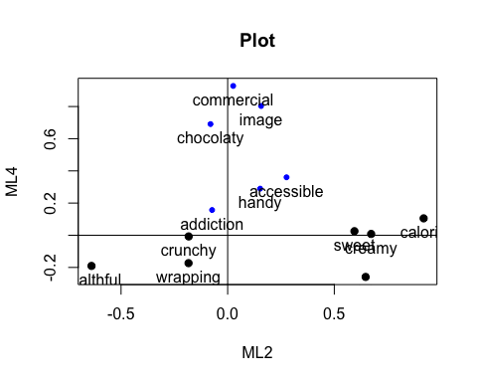
write.csv(EFAscore, file = "EFAscore")
## Test图/ EFA_ ml orthogonal rotation----

