Spencer Plant
CMPUT 291 - Lab Section H01
Assignment 1

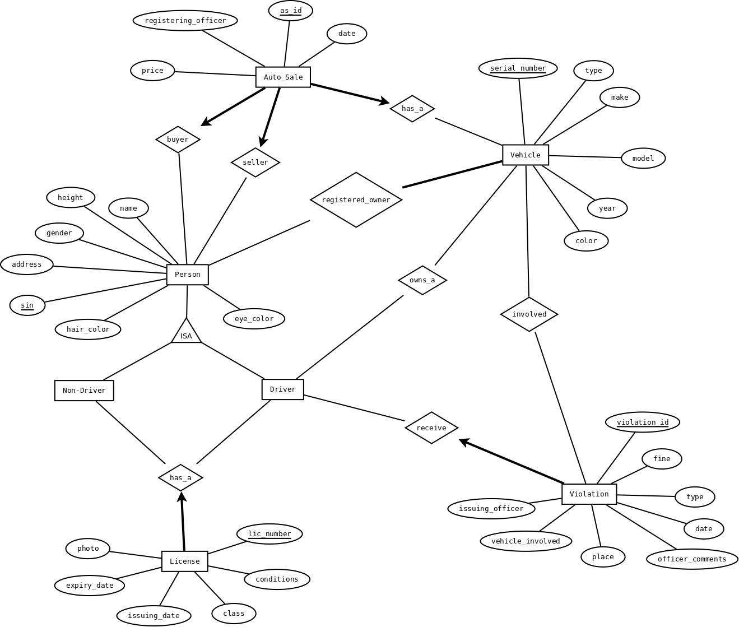

CREATE TABLE License (
lic_number INTEGER,
conditions CHAR(50),
class INTEGER,
issuing_date CHAR(20),
expiry_date CHAR(20),
photo VARBINARY(max),
PRIMARY KEY (lic_number),
)

CREATE TABLE Person (
sin INTEGER,
address CHAR(50),
gender INTEGER,
height INTEGER,
name CHAR(50),
eye_color CHAR(20),
hair_color CHAR(20),
PRIMARY KEY (sin)
)

CREATE TABLE Violation (
violation_id INTEGER,
fine INTEGER,
type CHAR(20),
date CHAR(20),
officer_comments CHAR(100),
place CHAR(50),
vehicle INTEGER,
issuing_officer INTEGER,
PRIMARY KEY (violation_id)
)

CREATE TABLE Vehicle (
serial_number INTEGER,
type CHAR(20),
make CHAR(20),
model CHAR(20),
year INTEGER,
color char(20),
PRIMARY KEY (serial_number)
)

CREATE TABLE Auto_Sale (
as_id INTEGER,
price INTEGER,
registering_officer INTEGER,
date CHAR(20)
PRIMARY KEY (as_id)
)

CREATE TABLE buyer (
FOREIGN KEY (sin) REFERENCES Person(sin)
FOREIGN KEY (as_id) REFERENCES Auto_Sale(as_id)
)

CREATE TABLE seller (
FOREIGN KEY (sin) REFERENCES Person(sin)
FOREIGN KEY (as_id) REFERENCES Auto_Sale(as_id)
)

CREATE TABLE registered_owner (
FOREIGN KEY (sin) REFERENCES Person(sin)
FOREIGN KEY (serial_number) REFERENCES Vehicle(serial_number)
)

CREATE TABLE owns_a (
FOREIGN KEY (sin) REFERENCES Person(sin)
FOREIGN KEY (serial_number) REFERENCES Vehicle(serial_number)
)

CREATE TABLE involved (
FOREIGN KEY (serial_number) REFERENCES Vehicle(serial_number)
FOREIGN KEY (violation_id) REFERENCES Violation(violation_id)
)

CREATE TABLE receive (
FOREIGN KEY (sin) REFERENCES Person(sin)
FOREIGN KEY (violation_id) REFERENCES Violation(violation_id)
)

CREATE TABLE has_a (
FOREIGN KEY (sin) REFERENCES Person(sin)
FOREIGN KEY (lic_number) REFERENCES License(lic_number)
)

Extra Sources:

For including photo in CREATE TABLE, I used Darin Dimitrov's answer on this page:
http://stackoverflow.com/questions/416881/insert-picture-into-sql-server-2005-image-field-using-only-sql

I also consulted with a previous 291 student, Daniel Shin.

