

LawAid: AI-Powered Legal Assistant & Law Management System

Submitted By
Team SysVision

Rahid Karim
ID: 0112410175
Ahnaf Shahriar
ID: 0112410540
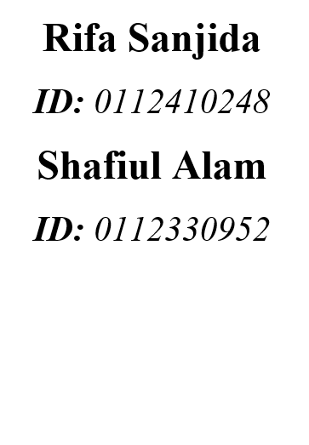
Sk. Istiaq Arefin
ID: 0112410323
Nafseen Hossain
ID: 0112410164
Sumaiya Akther
ID: 0112410318

Abstract

LawAid is an AI-powered legal consultation and law management platform designed to address the fragmented, costly, and city-concentrated nature of legal access in Bangladesh. The platform connects clients with verified lawyers for online or in- person consultation, equips lawyers with a full practice-management toolkit, and offers the general public free access to a bilingual (Bangla and English) AI assistant that explains basic laws and the consequences of breaking them. Core features include AI-matched lawyer search and recommendations, flexible appointment booking across video, audio, and text-chat formats, a case-management dashboard, and secure escrow-based payments with QR-verified receipts. To validate demand, the team conducted a survey of clients and lawyers, gathering insight on trust barriers, pricing expectations, and feature priorities; findings showed strong support for AI-based matching, bilingual legal literacy tools, and verified lawyer profiles. A benchmark study against five existing platforms (UkilBD, FindMyAdvocate, PathLegal, LawRato, and DoNotPay) confirmed that no competitor combines verified consultation, case management, and public legal literacy in a single system. LawAid's key risk lies in building trust and a lawyer network from zero, while carefully scoping its AI- generated legal information to limit liability. The system is positioned to modernize legal service delivery in Bangladesh by improving accessibility, transparency, and trust for both clients and legal professionals.

Acknowledgement

We would like to express our sincere gratitude to our course instructor for the System Analysis and Design at United International University for their continuous guidance, valuable feedback, and support throughout the development of this project. Their insights on system analysis methodology, feasibility study, and design practices were instrumental in shaping LawAid from an initial proposal into a well-researched platform concept.

We are also thankful to all the survey respondents clients, everyday users, and practicing lawyers who generously shared their time and honest feedback, which directly informed our feature prioritization and SWOT analysis.

Table of Contents

CHAPTER 1: Introduction 1
  - Purpose 1
  - Problem Statement 1
    - Problem Background 1
    - Problem Description 1
    - Problem Reasoning 2
  - Goal 2
  - System Development Life Cycle (SDLC) 3
CHAPTER 2: System study and information gathering 6
  - Introduction 6
  - Information Sources 6
    - Internal Sources 6
    - External Sources 6
  - Information Gathering 7
    - Internal Information Gathering 7
    - External Information Gathering 7
  - Similar websites 7
CHAPTER 3: Requirements Elicitation & System Analysis 9
  - Introduction 9
  - Survey 9
    - Survey methodology 9
    - Survey Results 10
  - Gap Analysis 17
  - Benchmark 18
CHAPTER 4 :Functional Requirements 19
  - Introduction 19
  - Functional Requirements by Module 19
    - User Registration & Verification 19
    - Lawyer Search & AI Matching 20
    - Appointment Booking & Consultation 20
    - Case Management 20
    - Payments & Verification 21
    - Bilingual AI Legal Assistant 21
    - Ratings, Reviews & Trust 21
    - Notifications & Security 21
    - Administration 22
CHAPTER 5: External & Non-Functional Requirements 23
  - Introduction 23
  - Non-Functional Requirements 23
    - Security 23
    - Privacy 24
    - Usability 24
    - Performance 24
    - Reliability & Availability 25
    - Scalability 25
    - Maintainability 25
CHAPTER 6: Feasibility & Project Management Analysis 26
  - Introduction 26
  - Feasibility Analysis 26
    - Technical Feasibility 26
    - Economic Feasibility 26
    - Operational Feasibility 26
    - Legal Feasibility 27
    - Schedule Feasibility 27
  - SWOT Analysis and Strategy 27
CHAPTER 7: Design 29
  - Introduction 29
  - Use case diagrams and use case descriptions 29
    - Use case Diagram 29
    - Use case Descriptions 30
  - Activity diagram 34
  - Data Flow Diagram 35
  - Class diagram 35
  - Sequence diagram 36
  - State diagram 37
  - CRC Card 38
CHAPTER 8: Prototype Design 39
Chapter 9: Conclusion 49
  - Conclusion 49
  - Reference 49
  - Future work 51

CHAPTER 1: Introduction

Purpose

The purpose of this project is to design and propose LawAid, an AI-powered legal consultation and law management platform aimed at simplifying access to legal help in Bangladesh. The platform is intended to connect clients with verified lawyers for online or in-person consultation, provide lawyers with a complete practice- management toolkit, and give the general public free access to a bilingual (Bangla and English) AI legal assistant that explains basic laws, rights, and the consequences of breaking them. This document presents the system analysis and design work carried out for LawAid, including the project proposal, technology stack, feature set, benchmark study against existing platforms, survey-based feasibility analysis, and the resulting SWOT analysis and strategy.

Problem Statement

Problem Background

Access to legal assistance in Bangladesh has traditionally relied on personal networks, word-of-mouth referrals, and physical visits to lawyers' chambers. Legal services remain heavily concentrated in urban centers, leaving ordinary citizens in less- connected areas with limited options for finding trustworthy legal representation. At the same time, existing digital lawyer directories in the market both local and international tend to address only a single piece of the problem: some offer lawyer listings, some offer AI-based legal chatbots, and some offer case-management tools, but none combine verified consultation, case management, and public legal literacy into a single, unified system.

Problem Description

Through direct research and a survey of both clients and lawyers, several recurring problems were identified:

      - Difficulty finding trustworthy lawyers a majority of respondents reported relying almost entirely on personal word-of-mouth referrals to find legal help, with no reliable digital alternative.
      - Lack of legal literacy most citizens have little to no plain-language access to information about their basic legal rights and the risks or penalties associated with breaking the law, leaving them unaware of their situation until a dispute has already escalated.

      - Fragmented and opaque processes a majority of survey respondents described their experience with existing legal-help platforms or methods as frustrating, citing manual, back-and-forth processes for scheduling, communication, and payment.
      - Inefficient practice management for lawyers a large share of lawyers reported facing manual workflow bottlenecks, including scheduling conflicts, document handling, and payment tracking, with no integrated digital tool to manage their practice.
      - Lack of trust and transparency in payments a majority of respondents considered secure, verifiable payment methods necessary to trust a legal- service platform, a feature largely absent from current solutions.

Problem Reasoning

These problems persist because the existing market only offers partial solutions. Lawyer-directory platforms such as UkilBD, FindMyAdvocate, PathLegal, and LawRato focus primarily on discovery and booking, but lack integrated case management, secure payment verification, or public legal-literacy tools. AI-driven platforms such as DoNotPay offer legal information but have no lawyer marketplace behind them. As a result, users are forced to piece together multiple disconnected tools or fall back on informal referral networks to get from "I have a legal problem" to "I have verified, affordable legal help." This gap is compounded by low public legal awareness, which means many disputes could be avoided or resolved earlier if plain-language legal information were easily accessible before a lawyer is even needed

Goal

The goal of this project is to design a single, integrated platform LawAid that closes this gap by combining three functions that currently exist only in isolation across competing platforms: verified lawyer discovery and consultation, end-to-end case and practice management for lawyers, and free bilingual legal literacy for the general public. Specifically, LawAid aims to:

- Give clients faster, cheaper, and location-independent access to verified lawyers through AI-assisted matching and flexible consultation formats (video, audio, chat, or in-person).
- Give lawyers a digital practice-management channel that reduces manual workflow bottlenecks and helps them reach new clients.
- Give the general public free, plain-language legal literacy that can help prevent disputes before formal legal help is required.
- Establish trust through verified lawyer profiles (NID and Bar Council certification), transparent ratings, and secure, QR-verified escrow payments.

System Development Life Cycle (SDLC)

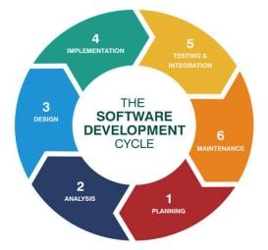
For the design and development of LawAid, the Agile (Iterative-Incremental) SDLC model has been adopted. This model was chosen over a traditional linear approach such as Waterfall because LawAid's requirements were not fixed at the outset they needed to be refined through real user feedback, and the project itself was carried out in stages that mirror Agile's iterative cycle: propose, evaluate, gather feedback, and revise.

Why Agile fits LawAid:
- Evolving requirements the initial feature list proposed in Presentation 1 was deliberately treated as a draft, not a final specification. It was validated (and in several cases merged, added to, or kept unchanged) only after survey data was collected from real clients and lawyers, which is characteristic of Agile requirement refinement rather than a fixed upfront specification.
- Incremental delivery of understanding each phase of the project proposal, tool selection, benchmark analysis, feasibility survey, and SWOT built incrementally on the previous one rather than being planned in full detail from the start.
- Continuous stakeholder feedback the survey of clients and lawyers functioned as an Agile feedback loop, directly shaping the final feature list (e.g., the addition of the 24/7 SOS emergency lawyer finder and data-privacy trust seals came directly from survey responses, not the original plan).
- Risk mitigation through early validation because LawAid enters a market with established competitors and must build a lawyer network from zero, Agile's short feedback cycles allow high-risk assumptions (trust, lawyer acquisition, AI liability) to be tested and adjusted early, rather than discovered late in a long linear development cycle

Phases followed in this project:

Planning

This phase defines the project's purpose, scope, and feasibility before any design work begins. For LawAid, this involved identifying the core problem (fragmented, costly, and inaccessible legal help in Bangladesh), defining the project's motivation and target users (clients, lawyers, and the general public), and outlining how the platform would help each group. The output of this phase is the project proposal, along with an initial selection of the technology stack (Figma, React.js/Next.js, Flutter, Node.js/Express, FastAPI, PostgreSQL, OpenAI/Gemini API, and others) to be used in later stages.

Requirement Analysis

This phase gathers and validates what the system actually needs to do, based on real stakeholder input rather than assumption. For LawAid, this was done through an online survey of clients and lawyers covering 23 questions on legal-help habits, pain points, and feature preferences. The findings such as strong demand for AI-based lawyer matching, an emergency SOS feature, and secure QR-verified payments directly shaped the final, validated feature list. A benchmark study against five existing platforms (UkilBD, FindMyAdvocate, PathLegal, LawRato, DoNotPay) was also conducted here to confirm that LawAid's proposed feature set offered genuine differentiation.

System Design

This phase translates the validated requirements into a concrete system architecture and user experience. It covers UI/UX design (in Figma), the two-sided portal architecture (a Client App and a Lawyer Dashboard, as confirmed necessary by survey data), the database schema, API structure, and how core modules lawyer search and matching, appointment booking, video/audio/chat consultation, case management, payments, and the AI chatbot will interact. Security design also falls here, including role-based access control, end-to-end encryption, and JWT-based authentication.

Implementation

This is the coding phase, where the designed system is actually built. The frontend (React.js/Next.js for web, Flutter for mobile) and backend (Node.js/Express.js, Python/FastAPI) are developed according to the system design, with third-party integrations the AI API (OpenAI/Gemini) for the legal chatbot and matching engine, Cloudinary for media, Google Maps API for location, and SSLCommerz/bKash/Nagad for payments wired into the core modules. Implementation is expected to proceed incrementally, module by module, in line with the project's Agile approach.

Testing

This phase verifies that each module functions correctly, securely, and as intended before release. For LawAid, this includes functional testing of core flows (lawyer search, booking, payment, chatbot responses), verification testing of lawyer profile checks (NID and Bar Council certification), security testing of encryption and access control, and usability testing to confirm the interface matches the mobile-first, gender- inclusive design informed by the survey findings. Given the platform handles legal and financial data, this phase also includes checking that AI-generated legal answers remain scoped appropriately to avoid liability risk.

Deployment

This phase releases the platform to real users. LawAid is expected to launch as a standalone platform (as validated by survey data showing most respondents currently use no digital legal tools), rolled out to early clients and lawyers. Deployment includes setting up production infrastructure, configuring live payment gateways (SSLCommerz, bKash, Nagad) and cloud storage, and onboarding an initial base of verified lawyers to address the platform's biggest early risk starting with zero lawyers on the network.

Maintenance

This final, ongoing phase covers monitoring the live platform, fixing issues, and evolving the system based on continued user feedback consistent with the Agile cycle used throughout the project. For LawAid, this includes maintaining AI chatbot accuracy over time, expanding the lawyer network, refining features based on usage patterns, patching security vulnerabilities, and iterating on features identified as valuable but not yet built (e.g., further refinements to the SOS emergency feature or notification system).

CHAPTER 2: System study and information gathering

Introduction

Before finalizing the design of LawAid, it was necessary to study the current landscape of legal-service access in Bangladesh and gather information directly from the people the platform is meant to serve. This chapter describes the sources of information used in developing LawAid, the methods used to gather that information, and a comparison between the current state of legal-help access and the desired state that LawAid aims to achieve. The information-gathering process combined direct survey research with clients and lawyers alongside a structured benchmark study of existing legal-service platforms, ensuring that the final feature list was grounded in real user needs rather than assumption alone.

Information Sources

Internal Sources

Internal sources refer to information gathered directly from the primary stakeholders of the proposed system the people who would actually use LawAid. This included:
- General clients/users seeking legal help, who provided insight into how they currently find lawyers, what frustrates them about existing methods, and what features they would value in a legal-service platform.
- Practicing lawyers, who provided insight into the operational challenges of managing a legal practice and reaching clients digitally, including scheduling, document handling, and payment tracking.

External Sources

External sources refer to information gathered by studying systems and platforms outside the project team's direct control. This included a benchmark analysis of five existing legal-service platforms UkilBD, FindMyAdvocate, and PathLegal (Bangladesh), LawRato (India), and DoNotPay (USA) examined across 12 comparable features such as verified lawyer search, AI matching, booking, case management, payment verification, and bilingual support. This external study helped identify gaps in the current market that LawAid could address, and confirmed that no existing competitor combines verified consultation, case management, and public legal literacy into a single platform.

Information Gathering

Internal Information Gathering

Internal information was gathered through an online survey distributed via Google Forms and shared through social media and other online communication channels. The survey consisted of 23 questions targeted at general users/clients and lawyers separately, covering topics such as:

      - Demographics (gender, age range, occupation)
      - Current methods used to find or reach clients/lawyers
      - Satisfaction with existing legal-help platforms or methods
      - Feature preferences (AI-based matching, video/audio/chat consultation, case management, secure payments, bilingual AI assistant, emergency lawyer finder, notifications, and access control)
      - Pricing expectations and trust factors
      - Concerns or hesitations about adopting a new platform

External Information Gathering

External information was gathered through a structured benchmark study, comparing LawAid's proposed feature set against five existing platforms across 12 features (satisfying the ≥ 2n = 10 minimum benchmark requirement). Each competitor was evaluated on whether it offered verified lawyer search, AI-based matching, free and paid booking, in-app video/audio calls, real-time chat, case management, payment and QR verification, ratings and reviews, confidential lawyer reporting, a public AI legal chatbot, bilingual support, and identity/certificate verification. This comparison was documented in a feature matrix and used to identify LawAid's competitive positioning, strengths, and honest weaknesses.

Similar websites

As part of the system study, five existing platforms operating in the legal-service space were examined to understand how the market currently addresses (or fails to address) the problems LawAid aims to solve. These platforms formed the basis of the project's benchmark analysis and are described below.

UkilBD (Bangladesh)

UkilBD is a Bangladesh-based lawyer directory and advice platform. It allows users to search for and view lawyer profiles and offers general legal advice content. It provides verified lawyer search/filtering and ratings and reviews, but lacks AI-based

lawyer matching, in-app video/audio consultation, case management, and payment or QR verification. Bangla and English support is only partial.

FindMyAdvocate (Bangladesh)

FindMyAdvocate is a Bangladesh-based platform centered on AI-matched advocate booking. It stands out among local competitors for offering AI lawyer matching and real-time chat, along with free and paid booking and ratings/reviews. However, it does not offer in-app video/audio calls, case management, payment/QR verification, or full bilingual support.

PathLegal (Bangladesh)

PathLegal combines a lawyer directory with legal document services and a basic case- management tool. It is the only local competitor offering a case-management dashboard, but it lacks AI-based lawyer matching, in-app calling, real-time chat, and payment verification, and its booking, ratings, and bilingual support are only partial.

LawRato (India)

LawRato is a large-scale lawyer marketplace operating in India, with a lawyer network far exceeding any of LawAid's Bangladeshi competitors (10,000+ advocates). It offers verified lawyer search, free and paid booking, ratings and reviews, and partial in-app calling and payment verification. However, it has no AI-based matching, no real-time chat, no case management, and no bilingual (Bangla) support reflecting its focus on the Indian market rather than Bangladesh specifically.

DoNotPay (USA)

DoNotPay is a US-based AI consumer-legal chatbot, best known for automating consumer disputes and basic legal tasks through AI. It is the only benchmarked platform offering a public AI legal chatbot as its core feature, but it has no lawyer marketplace, verified lawyer search, booking system, case management, or payment verification behind it it is a standalone AI tool, not an end-to-end legal service platform.

CHAPTER 3: Requirements Elicitation & System Analysis

Introduction

Following the system study and information-gathering process described in Chapter 2, this chapter presents the requirements elicitation and system analysis carried out for LawAid. Requirements elicitation is the process of identifying, collecting, and validating what the proposed system must do and how it must behave, based on direct input from stakeholders rather than assumption. For LawAid, this process combined structured survey research with clients and lawyers, a competitive benchmark study of five existing legal-service platforms.
The requirements gathered through this process were used to move LawAid from an initial, approximate feature list proposed in the early project stages to a final, validated feature list grounded in real stakeholder demand. This chapter documents the functional and non-functional requirements identified through that process, along with the analysis techniques (survey design, gap analysis and benchmark comparison) used to arrive at them. The goal of this chapter is to establish a clear, traceable link between what users said they need and what LawAid is being designed to deliver, ensuring that subsequent design and implementation decisions in later chapters are grounded in validated requirements rather than assumption

Survey

Survey methodology

- Survey Type: Online questionnaire.
- Number of Question : 23
- highest response : 59

Survey Questions:
Question #1: What is your gender?
Question #2: What is your age range?
Question #3: Which of these best describes you?
Question #4: Which method do you currently rely on most to find a lawyer or legal help?
Question #5: Which platform(s) do you currently use to find clients or lawyer? Question #6: How would you rate your overall experience with existing legal-help platforms or methods?
Question #7: What has been your biggest challenge in managing your practice or reaching clients digitally?
Question #8: What has been your biggest challenge in accessing legal help so far?

Question #9: What do you think would AI-based lawyer matching be useful to you? Question #10: If you needed a legal consultation, how would you prefer to arrange an appointment?
Question #11: Which consultation format would you prefer most?
Question #12: Do you find any necessity of a case-management dashboard for your practice?
Question #13: What is your opinion on whether secure payments with QR code- verified receipts are necessary to gain trust?
Question #14: Do you think a bilingual AI chatbot that explains basic legal information would be useful?
Question #15: In your perspective, do you feel that lawyer profile verification would be important when choosing a lawyer?
Question #16: Which factor would most influence your decision to trust and use LawAid?
Question #17: What fee range would feel reasonable to you for one online legal- consultation session?
Question #18: In your perspective, do you think an emergency lawyer finder feature would be useful?
Question #19: What is your opinion about receiving notifications and reminders for appointments, court hearings, and payment due dates?
Question #20: When using an online legal service platform, do you think role-based access control and encryption is important?
Question #21: What concern, if any, would make you hesitant to use LawAid?
Question #22: Tick up to 3 features you would personally use most?
Question #23: Based on what you know about LawAid, how likely would you be to recommend it to others?

Survey Results:

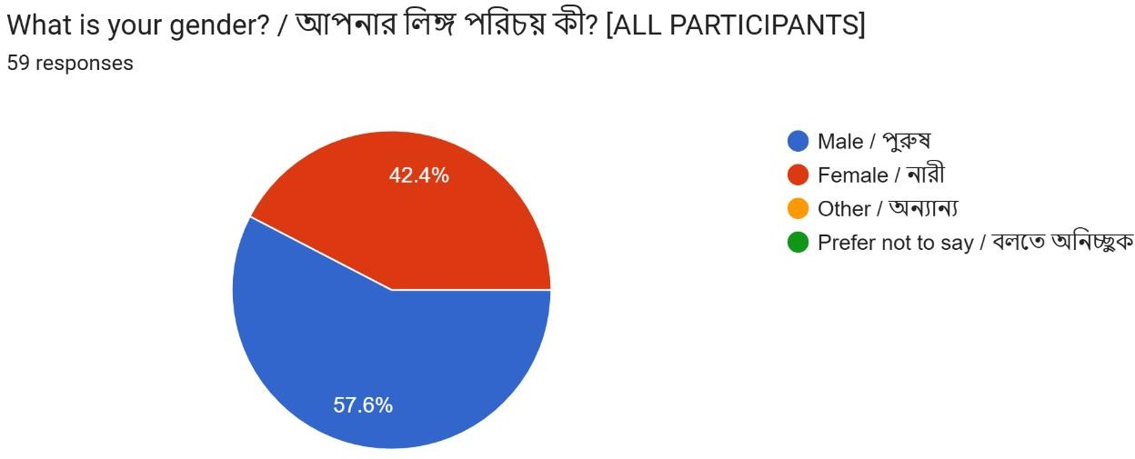

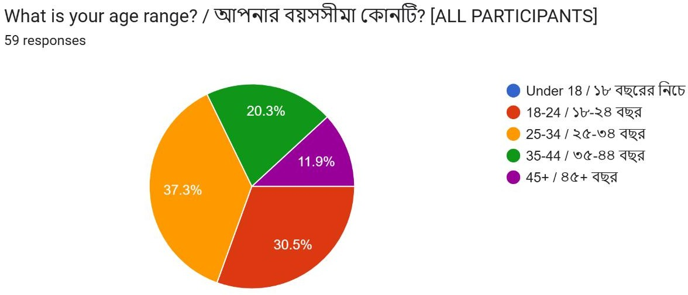

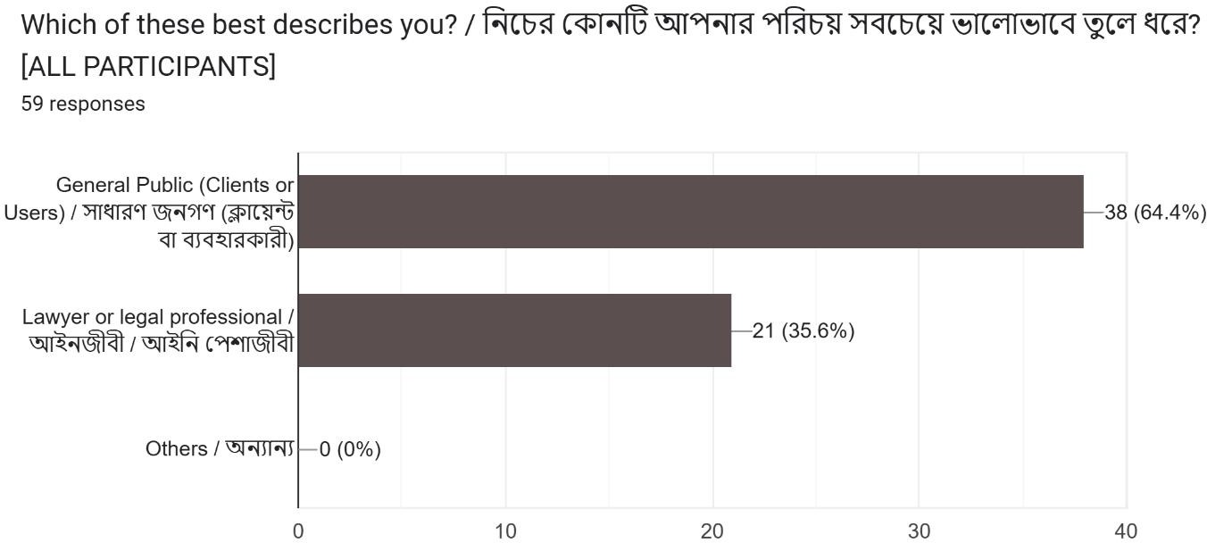

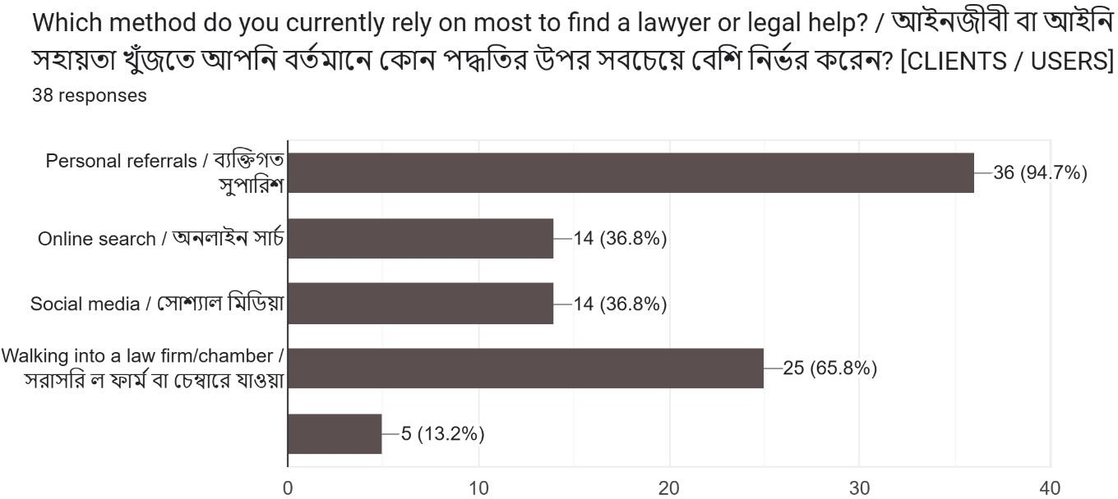

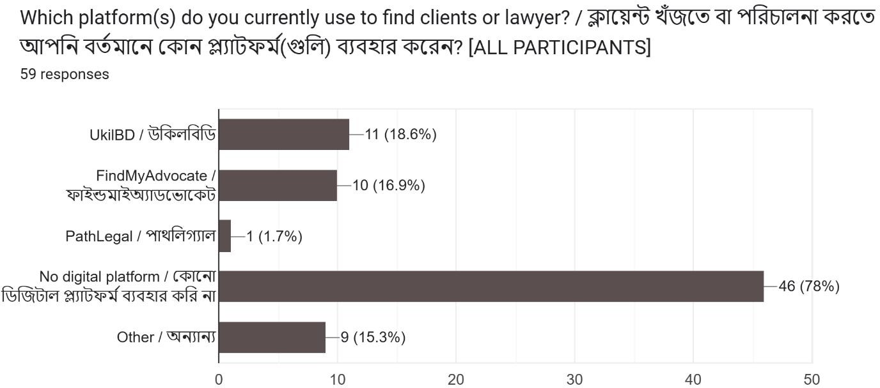

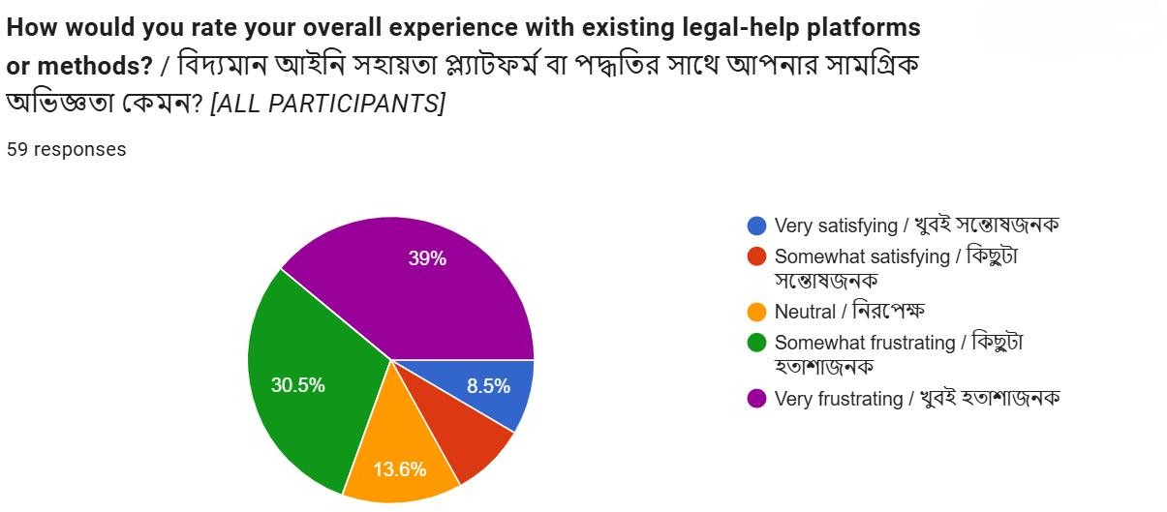

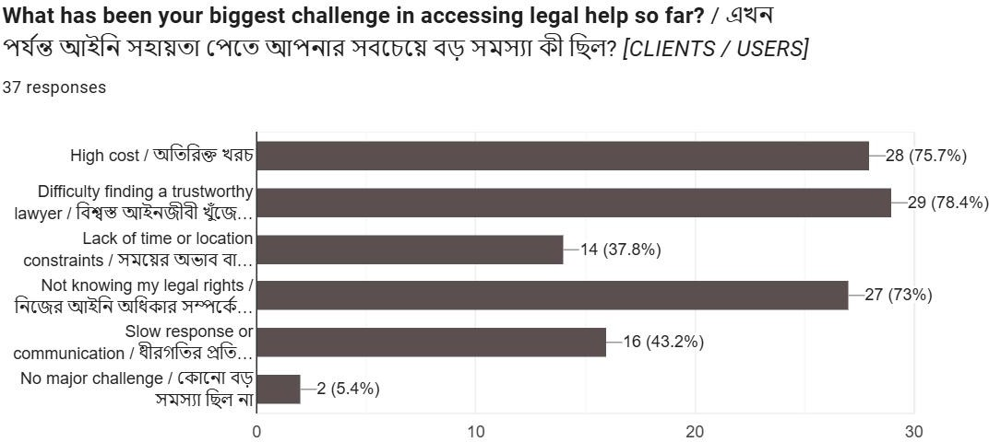

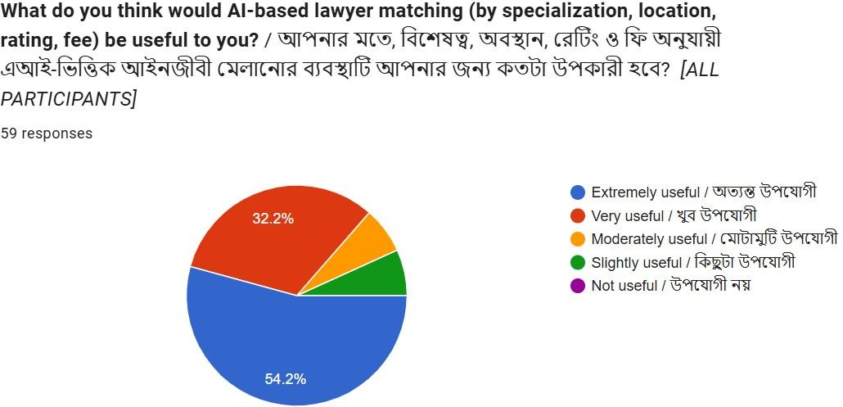

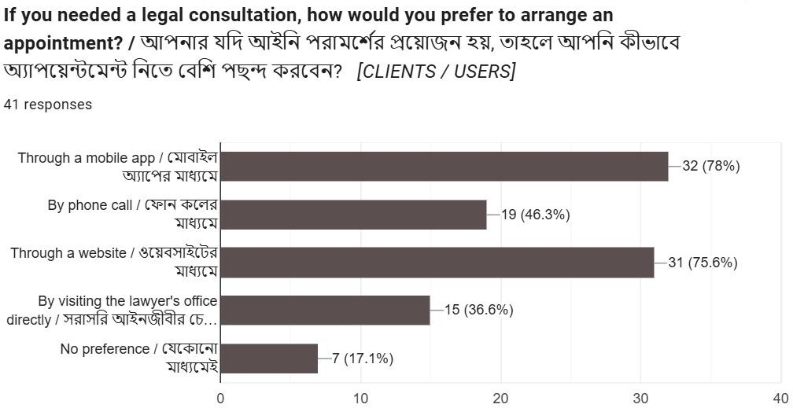

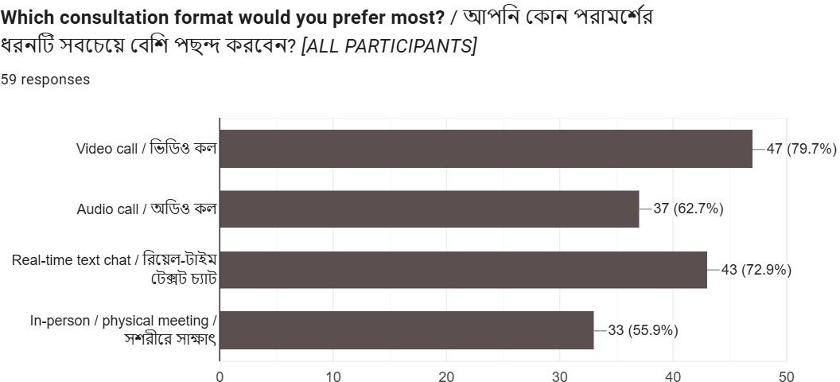

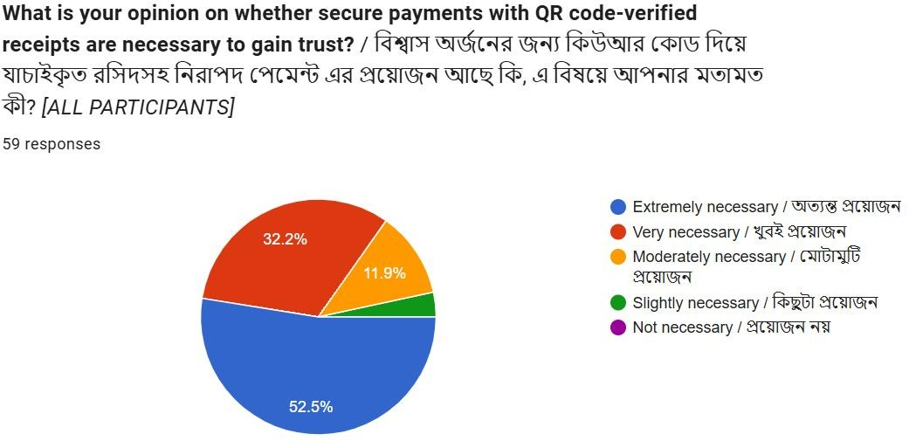

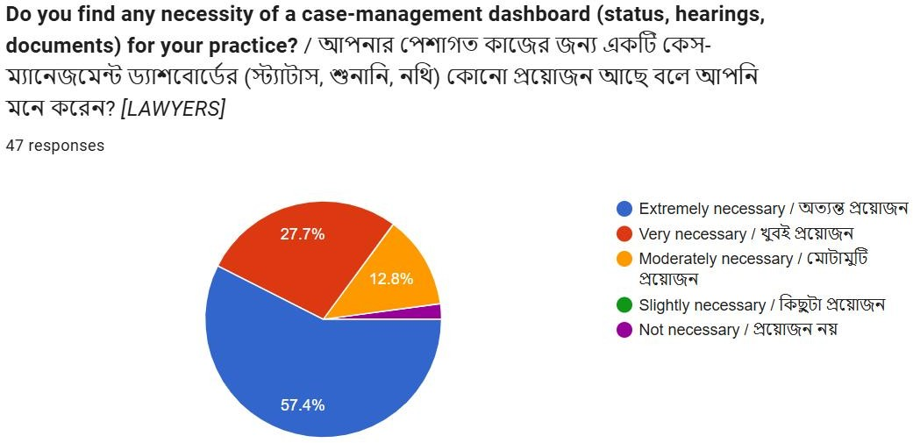

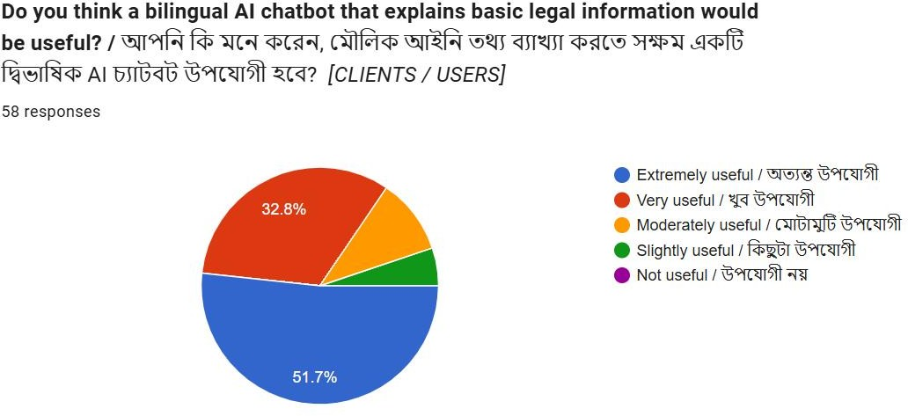

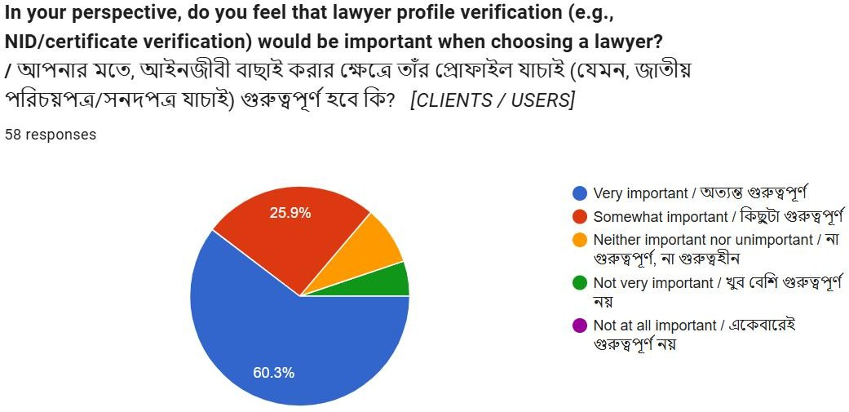

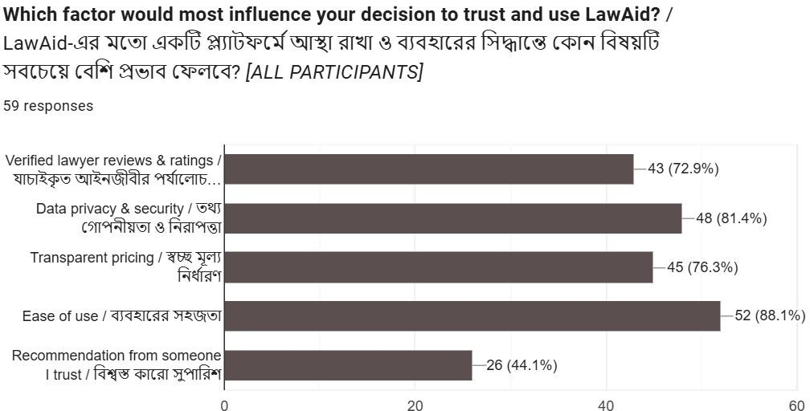

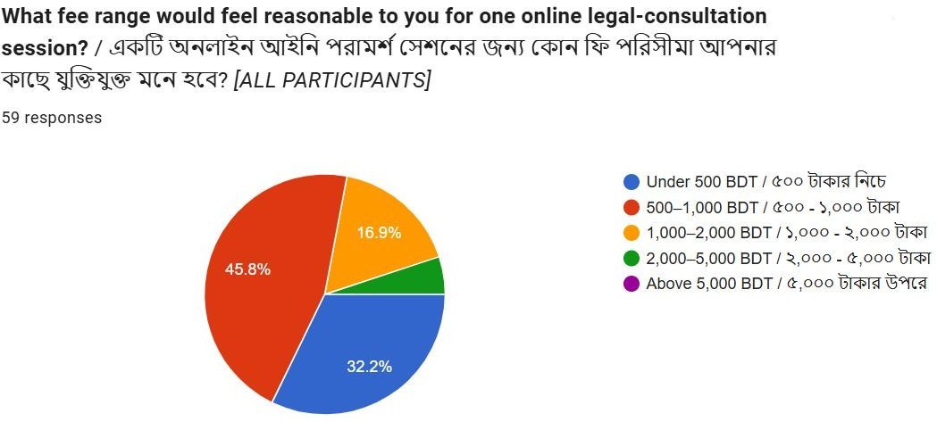

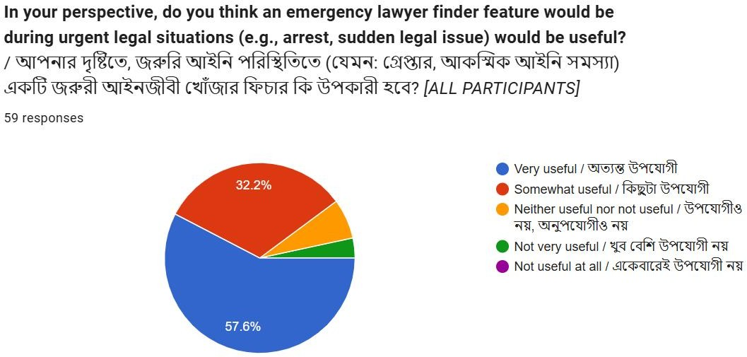

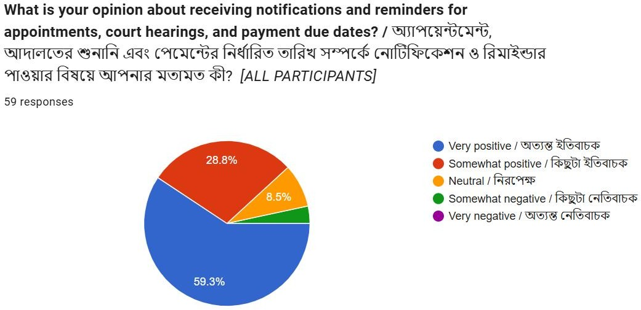

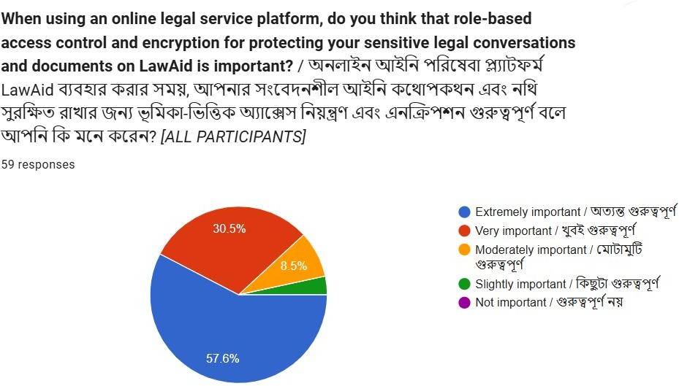

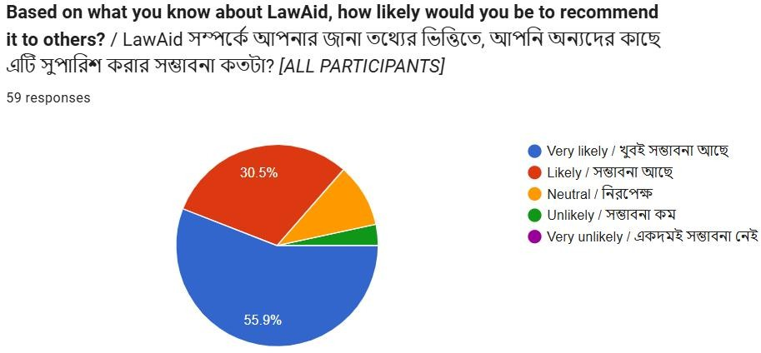

Gap Analysis

Feature area | Current state (competitors) | Gap identified | LawAid's response
AI lawyer matching | Only 1 of 5 competitors (FindMyAdvocate) offers this | Most platforms rely on manual search only | AI-powered matching by specialization, location, rating, and fee
In-app video/audio calling | Only partial support (LawRato); none offer full support | Users must leave the platform to consult remotely | Native in-app video, audio, and real-time chat
Case management dashboard | Only 1 of 5 competitors (PathLegal) offers this | Lawyers have no integrated way to track cases/hearings | Full case-management dashboard for lawyers and clients
Payment + QR verification | No competitor offers full support; only partial (LawRato) | No fraud-resistant, verifiable payment method exists | Escrow payments with QR- verified digital receipts
Public AI legal chatbot | Only 1 of 5 competitors (DoNotPay) offers this, with no lawyer marketplace attached | No platform combines legal literacy with lawyer access | Bilingual AI legal assistant integrated into the same platform
Bangla + English support | Partial at best across all competitors | No platform fully serves Bangladesh's bilingual user base | Full bilingual support across the platform
Confidential misconduct reporting | No competitor offers this | No accountability mechanism for lawyer conduct | Confidential reporting system alongside public ratings

Benchmark

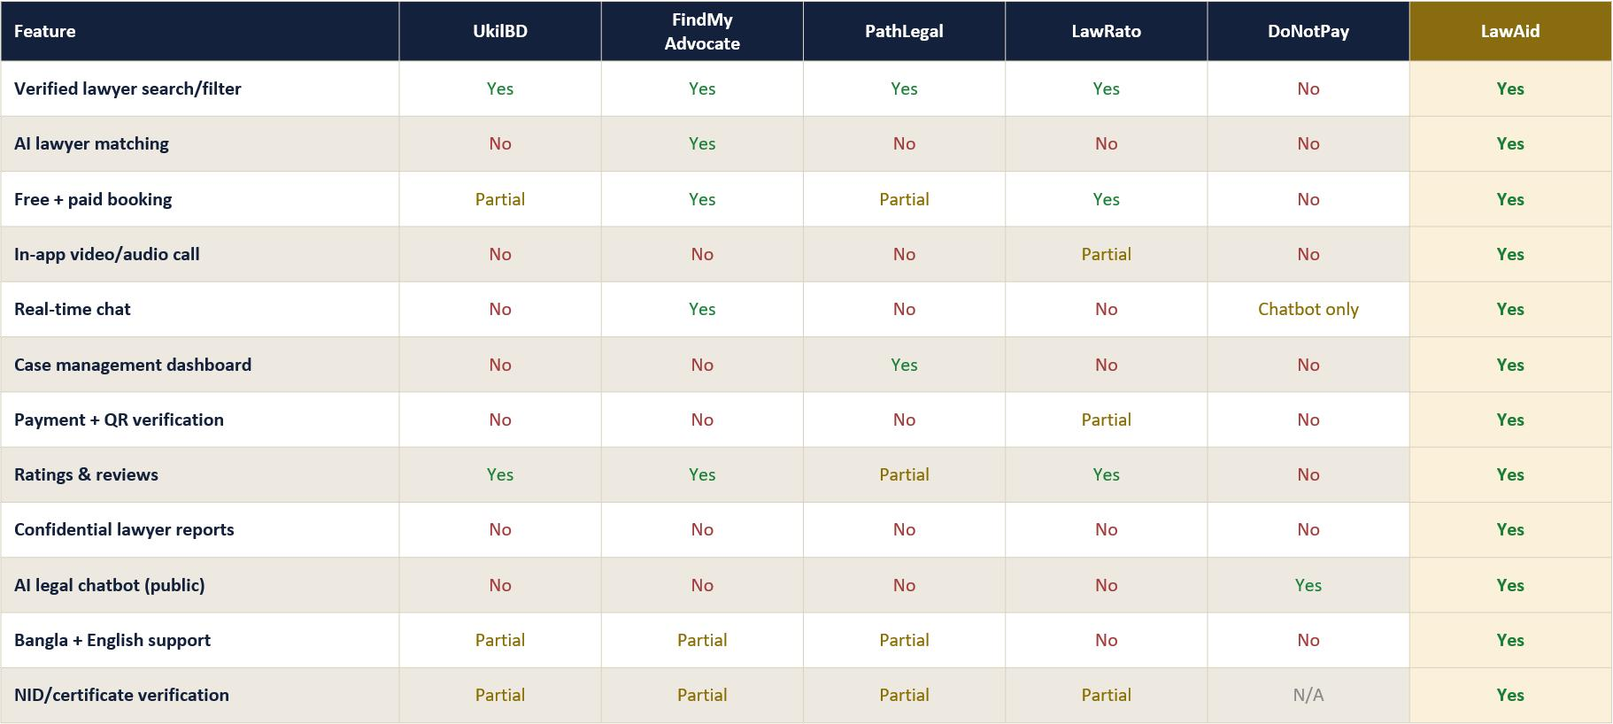

CHAPTER 4 :Functional Requirements

Introduction

This chapter presents the functional requirements of LawAid the specific behaviors, features, and capabilities the system must provide to satisfy the needs identified through the requirements elicitation and gap analysis in Chapter 3. Functional requirements define what the system does: the actions available to each type of user (clients, lawyers, and administrators), the inputs they provide, and the outputs or system responses they can expect.

Each requirement documented in this chapter traces back to a specific need surfaced either through the benchmark study of competing platforms or through the client and lawyer survey, ensuring that no feature is included without a validated justification. Where relevant, requirements are grouped by the core modules identified in the project proposal and final feature list: lawyer discovery and AI matching, appointment booking and consultation, case management, payments and verification, the bilingual AI legal assistant, and platform-wide security and access control.

The functional requirements in this chapter are intended to serve as the foundation for the system design and modeling work presented in later chapters, including use case diagrams, activity diagrams, and the eventual implementation plan. They describe the expected behavior of LawAid from the perspective of each user role, independent of how the system will be technically implemented.

Functional Requirements by Module

The functional requirements below are organized by the core modules of LawAid, as defined in the project's final feature list. Each requirement is numbered for traceability and specifies the responsible actor(s).

User Registration & Verification

      - FR-1: The system shall allow a user to register as either a Client or a Lawyer, with separate registration flows for each role.
      - FR-2: The system shall require lawyers to upload a valid National ID (NID)
and Bar Council certificate during registration for identity verification.

      - FR-3: The system shall display a verification badge on a lawyer's profile only after their NID and Bar Council certificate have been reviewed and approved.
      - FR-4: The system shall allow users to log in securely using JWT-based authentication.
      - FR-5: The system shall allow users to reset a forgotten password through a secure recovery process.

Lawyer Search & AI Matching

      - FR-6: The system shall allow clients to search for lawyers by specialization, location, rating, and fee.
      - FR-7: The system shall provide AI-powered lawyer recommendations
based on the client's stated legal issue and search criteria.
      - FR-8: The system shall display each lawyer's profile, including specialization, verification status, ratings, reviews, and consultation fees.
      - FR-9: The system shall allow clients to view and sort search results by rating, price, or relevance.

Appointment Booking & Consultation

      - FR-10: The system shall allow clients to book a free or paid appointment
with a selected lawyer.
      - FR-11: The system shall allow clients to choose between video call, audio call, real-time text chat, or in-person (physical) consultation.
      - FR-12: The system shall display a lawyer's available time slots and allow clients to select and confirm a slot without requiring phone calls or manual back-and-forth.
      - FR-13: The system shall allow lawyers to accept, reschedule, or decline a booking request.
      - FR-14: The system shall support live video and audio calling and real-time chat directly within the platform for confirmed consultations.
      - FR-15: The system shall send automated reminders and notifications (push and SMS) for upcoming appointments, court hearings, and payment due dates.
      - FR-16: The system shall provide a 24/7 emergency lawyer finder (SOS) feature that instantly connects a client to an available lawyer for urgent legal situations.

Case Management

      - FR-17: The system shall provide lawyers and clients with a case management dashboard to track case status, progress, and updates.
      - FR-18: The system shall allow lawyers to log and track court hearing dates
within a case.
      - FR-19: The system shall allow lawyers and clients to upload, store, and retrieve case-related documents within the platform.

      - FR-20: The system shall allow lawyers to update the status of a case (e.g., open, in progress, closed) visible to the associated client.

Payments & Verification

      - FR-21: The system shall support secure online payments through

SSLCommerz, bKash, and Nagad.
      - FR-22: The system shall process consultation payments through an escrow mechanism, releasing funds to the lawyer only after the consultation is confirmed complete.
      - FR-23: The system shall generate a QR-verified digital receipt for every completed payment.
      - FR-24: The system shall allow clients to view their payment history and download receipts.
      - FR-25: The system shall allow a client to dispute a transaction if a service was not delivered as expected.

Bilingual AI Legal Assistant

      - FR-26: The system shall provide a free, public AI chatbot accessible without requiring a paid consultation.
      - FR-27: The system shall allow the AI chatbot to respond in both Bangla and English, based on user preference or input language.
      - FR-28: The system shall enable the AI chatbot to explain basic laws, citizens' rights, and the consequences of breaking specific laws in plain language.
      - FR-29: The system shall scope AI chatbot responses to general legal information only, and shall prompt the user to book a verified lawyer for case-specific legal advice.

Ratings, Reviews & Trust

      - FR-30: The system shall allow clients to rate and review a lawyer after a completed consultation.
      - FR-31: The system shall display a lawyer's average rating and review count on their public profile.
      - FR-32: The system shall allow clients to submit a confidential report against a lawyer for unethical or unprofessional conduct.
      - FR-33: The system shall route confidential misconduct reports to platform administrators only, and shall not display them publicly.

Notifications & Security

      - FR-34: The system shall enforce role-based access control, restricting each user (client, lawyer, admin) to actions and data permitted for their role.

      - FR-35: The system shall encrypt sensitive data, including case documents and payment information, using end-to-end encryption.
      - FR-36: The system shall send push notifications and SMS alerts for appointments, hearings, and payment deadlines.
      - FR-37: The system shall log all critical actions (bookings, payments, document uploads) for audit and dispute-resolution purposes.

Administration

      - FR-38: The system shall provide administrators with a panel to review and approve or reject lawyer verification submissions.
      - FR-39: The system shall allow administrators to suspend or remove a lawyer or client account found in violation of platform policy.
      - FR-40: The system shall allow administrators to review confidential misconduct reports and take appropriate action.

CHAPTER 5: External & Non-Functional Requirements

Introduction

While Chapter 4 defined what LawAid must do through its functional requirements, this chapter defines how well the system must do it, along with the external constraints it must operate within. Non-functional requirements describe the quality attributes of the system performance, security, usability, reliability, and scalability that determine whether LawAid is not just functional, but trustworthy and usable in practice. Given that LawAid handles sensitive legal, personal, and financial data, these requirements are especially critical to the platform's success and to user adoption.

External requirements, in turn, capture constraints imposed on the system from outside its own design including the hardware, software, legal, and regulatory environment in which LawAid must operate. These include dependencies on third- party services (such as payment gateways, AI APIs, and cloud infrastructure), compliance obligations relevant to handling legal and financial data in Bangladesh, and platform compatibility expectations across web and mobile.

The requirements in this chapter are drawn directly from the survey findings discussed in Chapter 2 and Chapter 3 for example, respondents' strong emphasis on data privacy, ease of use, and payment security translates directly into specific non- functional requirements around encryption, usability, and transaction integrity. Together with the functional requirements in Chapter 4, this chapter completes the requirements baseline that will guide LawAid's system design, described in the chapters that follow.

Non-Functional Requirements

Non-functional requirements are grouped below by quality attribute. Each is grounded in either the survey findings from Chapter 2 or the general operating needs of a platform handling legal, personal, and financial data.

Security

      - NFR-1: The system shall encrypt all sensitive data including case documents, personal identification, and payment information using end-to-end encryption, both in transit and at rest.
      - NFR-2: The system shall enforce role-based access control, ensuring clients, lawyers, and administrators can only access data and actions permitted for their role.

      - NFR-3: The system shall authenticate all user sessions using JWT tokens
with appropriate expiry and refresh handling.
      - NFR-4: The system shall never expose a client's or lawyer's uploaded identification documents (NID, Bar Council certificate) to any party other than platform administrators during verification.
      - NFR-5: The system shall process all payments through PCI-compliant gateways (SSLCommerz, bKash, Nagad) and shall not store raw card or account details on LawAid's own servers.

Privacy

      - NFR-6: The system shall comply with a clearly published data privacy policy, addressing the high level of privacy concern identified among survey respondents.
      - NFR-7: The system shall keep confidential misconduct reports visible only to administrators, never to the reported lawyer or the public.
      - NFR-8: The system shall allow users to request the deletion of their personal data, in line with standard data-protection practice.

Usability

      - NFR-9: The system shall provide a mobile-first, intuitive interface, reflecting survey data showing the majority of respondents are 18–34 and expect a modern digital experience.
      - NFR-10: The system shall support full bilingual functionality (Bangla and English) across all user-facing screens, not only the AI chatbot.
      - NFR-11: The system shall maintain an inclusive, gender-balanced interface design, consistent with the platform's near-even gender split of expected users.
      - NFR-12: The system shall allow a client to complete a lawyer search and booking in a minimal number of steps, without requiring phone calls or manual coordination.

Performance

      - NFR-13: The system shall load search results and lawyer profiles within 2–3 seconds under normal network conditions.
      - NFR-14: The system shall support real-time video, audio, and chat consultations with minimal latency, comparable to standard consumer video- calling applications.
      - NFR-15: The AI legal chatbot shall return a response to a user query within a few seconds under typical load.

Reliability & Availability

      - NFR-16: The system shall be available 24/7, particularly to support the emergency (SOS) lawyer-finder feature, which depends on continuous uptime.
      - NFR-17: The system shall maintain transaction integrity for all payments, ensuring that a payment is never charged without a corresponding confirmed booking, and vice versa.
      - NFR-18: The system shall retain uploaded case documents reliably for the duration of a case, with backup mechanisms to prevent data loss.

Scalability

      - NFR-19: The system architecture shall support a growing number of lawyers and clients without significant degradation in performance, given the platform's early-stage need to scale its lawyer network from zero.
      - NFR-20: The system shall be designed so that new features (e.g., additional payment methods, additional languages) can be added without major architectural rework.

Maintainability

      - NFR-21: The system shall be built using a modular architecture (separate services for search/matching, booking, payments, chatbot, and case management) to allow independent updates and maintenance of each module.
      - NFR-22: The system shall log errors and critical actions in a way that supports efficient debugging and audit review by the development team.

CHAPTER 6: Feasibility & Project Management Analysis

Introduction

Having defined LawAid's functional, non-functional, and external requirements in Chapters 4 and 5, this chapter examines whether the proposed system is practically achievable and how its development can be effectively planned and managed. Feasibility analysis evaluates LawAid from multiple angles technical, economic, operational, legal, and scheduling to determine whether the platform can realistically be built, sustained, and adopted given the team's resources, the identified market gap, and the constraints surrounding a legal-services platform operating in Bangladesh.and also describe about SWOT analysis also.

Feasibility Analysis

Feasibility analysis evaluates LawAid across five dimensions to confirm the platform is realistic to build, sustain, and adopt.

Technical Feasibility

LawAid's proposed stack (React.js/Next.js, Flutter, Node.js/Express, FastAPI, PostgreSQL) is mature and well-documented. AI, payments, maps, and storage are all handled through existing third-party APIs rather than custom-built infrastructure, keeping technical risk low. The main challenge is securely integrating these multiple services, not the core engineering itself.

Economic Feasibility

Relying on third-party APIs keeps upfront infrastructure cost low. Survey data validated a workable price point (78% preferring sessions under 1,000 BDT), supporting a consultation-fee revenue model. The main economic risk is the cost of acquiring lawyers and marketing to build trust from zero, alongside variable AI API usage costs — both need to be weighed against consultation revenue.

Operational Feasibility

Survey findings showed strong validated demand across nearly every proposed feature (e.g., 86.4% found AI matching useful; 89.8% wanted the SOS feature), and a clear two-sided user base (64.4% clients, 35.6% lawyers) supports the dual-portal design. The main operational risk is trust 49.2% cited privacy concerns and 42.4%

cited payment concerns which LawAid addresses through verification and escrow payments, but must maintain consistently after launch.

Legal Feasibility

LawAid's lawyer verification is designed to align with Bar Council of Bangladesh standards, and its AI chatbot includes a disclaimer scoping it to general information rather than formal legal advice, limiting liability. As a payment intermediary, it must also comply with financial and data-protection regulations applicable in Bangladesh. Feasible, but should be reviewed with legal counsel before commercial launch.

Schedule Feasibility

The team already delivered the proposal, benchmark study, survey, and SWOT analysis as sequential phases under the Agile SDLC, showing the timeline is manageable. Because the system is modular, features can be built and released incrementally, with a focused MVP (AI chatbot, verified search, video consultation) launched before lower-priority features.

SWOT Analysis and Strategy

Building on the feasibility analysis above, this section presents LawAid's SWOT analysis, summarizing the internal strengths and weaknesses and external opportunities and threats identified through the project's benchmark study and survey.

Strengths  - All-in-one legal service platform  - Verified lawyer profiles  - AI-powered lawyer matching  - Bilingual AI legal assistant  - Multiple consultation options  - Strong case-management system  - Secure and transparent payment system | Opportunities  - Large untapped digital legal market  - High dissatisfaction with existing legal- help methods  - Digitization of traditional lawyer referrals  - Growing demand for online consultation  - High demand for AI-based legal assistance  - Increasing need for trustworthy lawyer discovery  - Clear competitive differentiation
Weaknesses  - Cannot fully guarantee lawyer service quality  - AI answers require careful control | Threats  - Traditional lawyer referral habits  - Competition from existing legal-service platforms

Strategy: LawAid can use its AI-powered features, verified lawyer profiles, online consultation, and secure payment system to modernize traditional legal services and provide easier access to trusted legal help. By focusing on user trust, simple digital services, and accurate AI assistance, LawAid can take advantage of the growing demand for online legal services while reducing its main weaknesses and threats.

CHAPTER 7: Design

Introduction

This chapter presents the system design of LawAid, translating the functional and non-functional requirements established in Chapters 4 and 5 into a structured, visual model of how the system behaves and how data moves through it. Where earlier chapters defined what LawAid must do and how well it must do it, this chapter focuses on how the system is organized to deliver those requirements from the perspective of its users, its processes, and its data flow.

Three complementary modeling techniques are used to capture this design from different angles:

    - Use case diagrams and use case descriptions, which identify the system's actors (clients, lawyers, and administrators) and the discrete interactions each actor has with LawAid, such as searching for a lawyer, booking a consultation, or verifying a lawyer profile. Each use case is further detailed through a structured description covering its actors, preconditions, main flow, and outcomes.
    - Data Flow Diagrams (DFDs), which model how information moves through LawAid between users, system processes, and stored data helping to
visualize how a request (e.g., booking an appointment or submitting a payment) is processed internally by the system.
    - Activity diagrams, which illustrate the step-by-step flow of key processes and decision points within LawAid, such as the client journey from login through consultation booking to case management, capturing branching logic and the sequence of actions across a complete task.

Use case diagrams and use case descriptions

Use case Diagram:

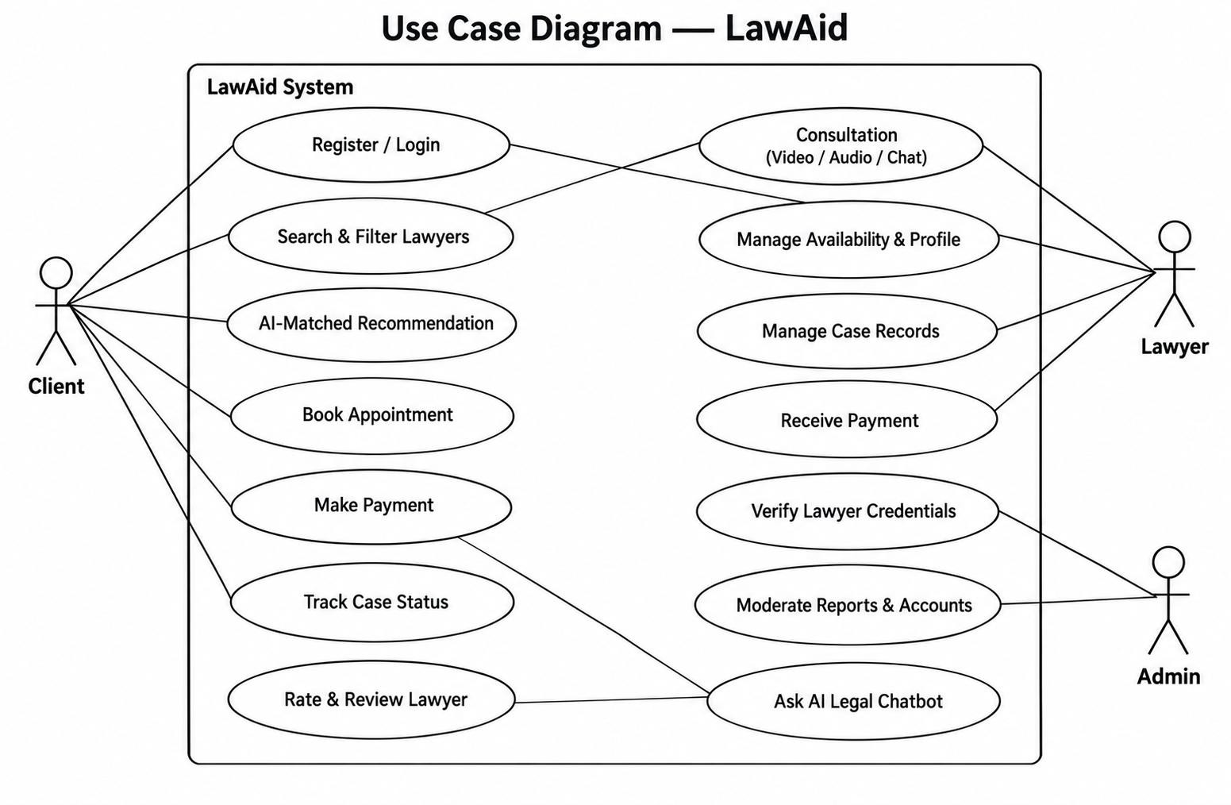
Fig: Use Case Diagram of LawAid

Use case Descriptions

Three Major use case description:

- Use Case Name: Book Appointment

Description: Allows a client to schedule a consultation with a verified lawyer of their choice, selecting a preferred date, time, and consultation format (video, audio, chat, or in-person), without requiring phone calls or manual back-and-forth coordination.

Stakeholders & Interest:

  - Client: Wants a fast, convenient way to secure legal consultation at a time that works for them.
  - Lawyer: Wants organized, conflict-free bookings that fit their availability.
  - Admin: Wants booking activity to be logged and traceable for dispute resolution.

Primary Actor: Client

Pre-condition:

  - Client is registered and logged in.
  - Client has searched for and selected a verified lawyer.
  - Lawyer's availability is visible in the system.

Success Scenario:

- Client selects a lawyer's profile and views available time slots.
- Client chooses a date, time, and consultation format (video, audio, chat, or in- person).
- System confirms slot availability and reserves it.
- Client proceeds to payment to confirm the booking.
- Lawyer receives a booking notification and accepts the appointment.
- System sends confirmation and reminder notifications to both parties.

Alternative Scenario:

  - If the selected slot is no longer available, the system prompts the client to choose another slot.
  - If the lawyer declines or reschedules, the client is notified and offered alternative slots.
  - If payment fails, the booking is held temporarily and released if not completed within a set time.

Post-condition:

  - Appointment is confirmed and visible on both the client's and lawyer's dashboards.
  - Both parties receive reminders ahead of the scheduled consultation.

- Use Case Name: Ask AI Legal Chatbot

Description: Provides free, bilingual (Bangla and English) access to an AI assistant that explains basic laws, citizens' rights, and the consequences of breaking specific laws, without requiring a paid consultation.

Stakeholders & Interest:

  - General Public / Client: Wants quick, plain-language answers to legal questions before deciding whether a lawyer is needed.
  - Admin: Wants chatbot responses to stay within safe, general-information boundaries to limit liability.

Primary Actor: General Public / Client

Pre-condition:

  - Chatbot is accessible without requiring registration or login.
  - User has a legal question or topic in mind.

Success Scenario:

- User opens the AI legal chatbot and selects a language (Bangla or English).
- User types or asks a legal question.
- System processes the query through the AI API and returns a plain-language explanation of the relevant law, right, or consequence.
- System prompts the user to book a verified lawyer if the matter requires case- specific legal advice.

Alternative Scenario:

  - If the query is outside the chatbot's scope (e.g., requests specific legal advice or case representation), the system responds with a disclaimer and redirects the user to lawyer search/booking.
  - If the AI service is temporarily unavailable, the system displays an error message and suggests retrying later.

Post-condition:

  - User receives general legal information relevant to their query.
  - User is optionally routed toward booking a lawyer for further help.

- Use Case Name: Verify Lawyer Credentials

Description: Allows a platform administrator to review a lawyer's submitted National ID (NID) and Bar Council certificate during registration, and approve or reject their verified status before they can appear as a verified lawyer to clients.

Stakeholders & Interest:

  - Admin: Wants to ensure only legitimately licensed lawyers are verified on the platform.
  - Lawyer: Wants a fair, timely review so they can begin receiving client bookings.
  - Client: Wants assurance that "verified" lawyers are genuinely credentialed.

Primary Actor: Admin

Pre-condition:

  - Lawyer has completed registration and uploaded NID and Bar Council certificate.
  - Submission is pending review in the admin panel.

Success Scenario:

- Admin opens the pending verification queue.
- Admin reviews the lawyer's submitted NID and Bar Council certificate.
- Admin confirms the documents are valid and match Bar Council of Bangladesh records.
- System marks the lawyer's profile as verified and displays a verification badge.
- Lawyer is notified that their profile is now live and visible in client search results.

Alternative Scenario:

  - If documents are invalid, incomplete, or fail verification, the admin rejects the submission and the system notifies the lawyer with a reason.
  - If a rejected lawyer resubmits corrected documents, the review process restarts from step 1.

Post-condition:

  - Lawyer's profile is either marked verified and publicly visible, or remains unverified pending resubmission.
  - Verification decision is logged for administrative record-keeping.

Activity diagram

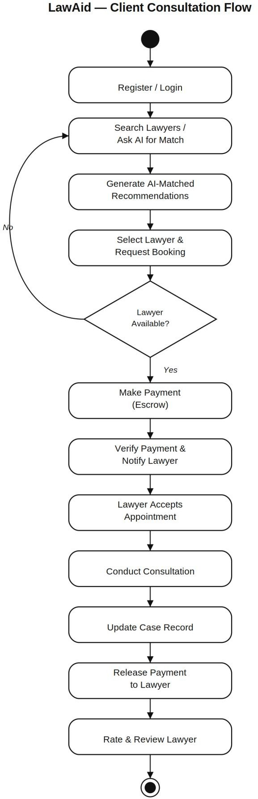

Fig: Activity Diagram of Client Consultation Flow in LawAid

Data Flow Diagram
35

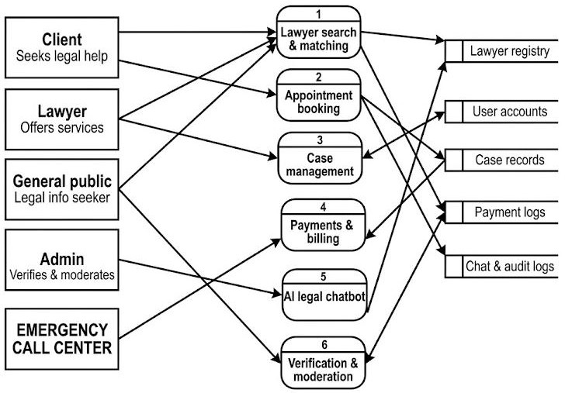

Fig: DFD of LawAid

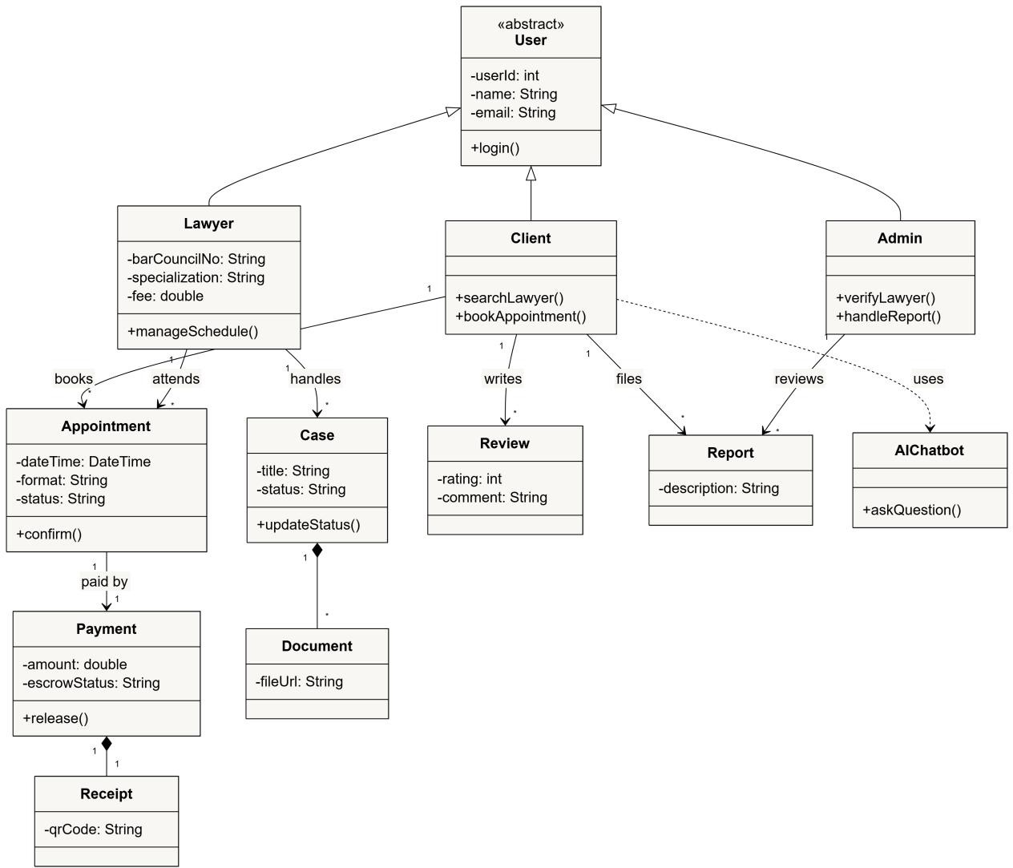Class diagram
Fig: Class Diagram of LawAid

Sequence diagram

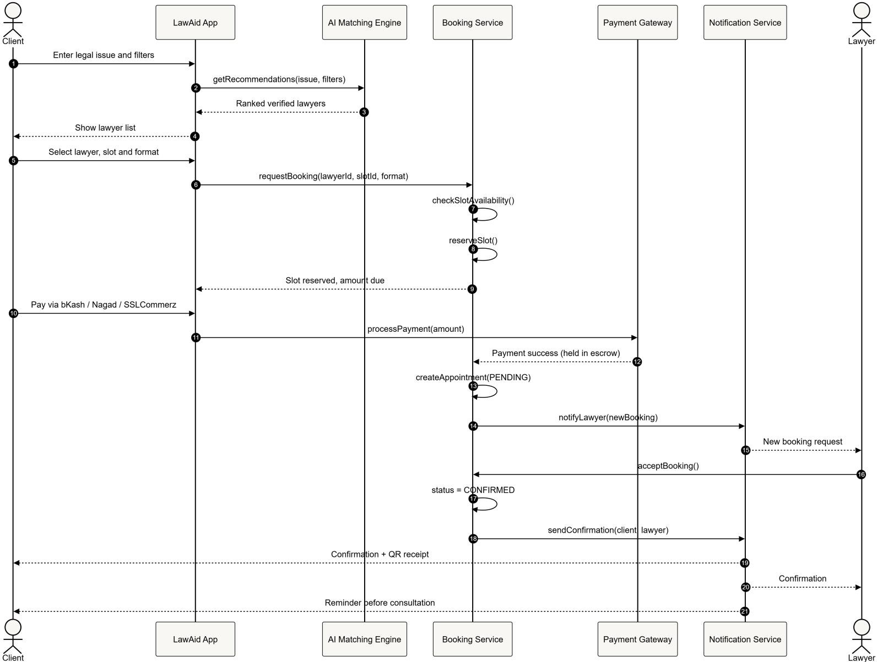

Fig: Sequence Diagram of LawAid

State diagram

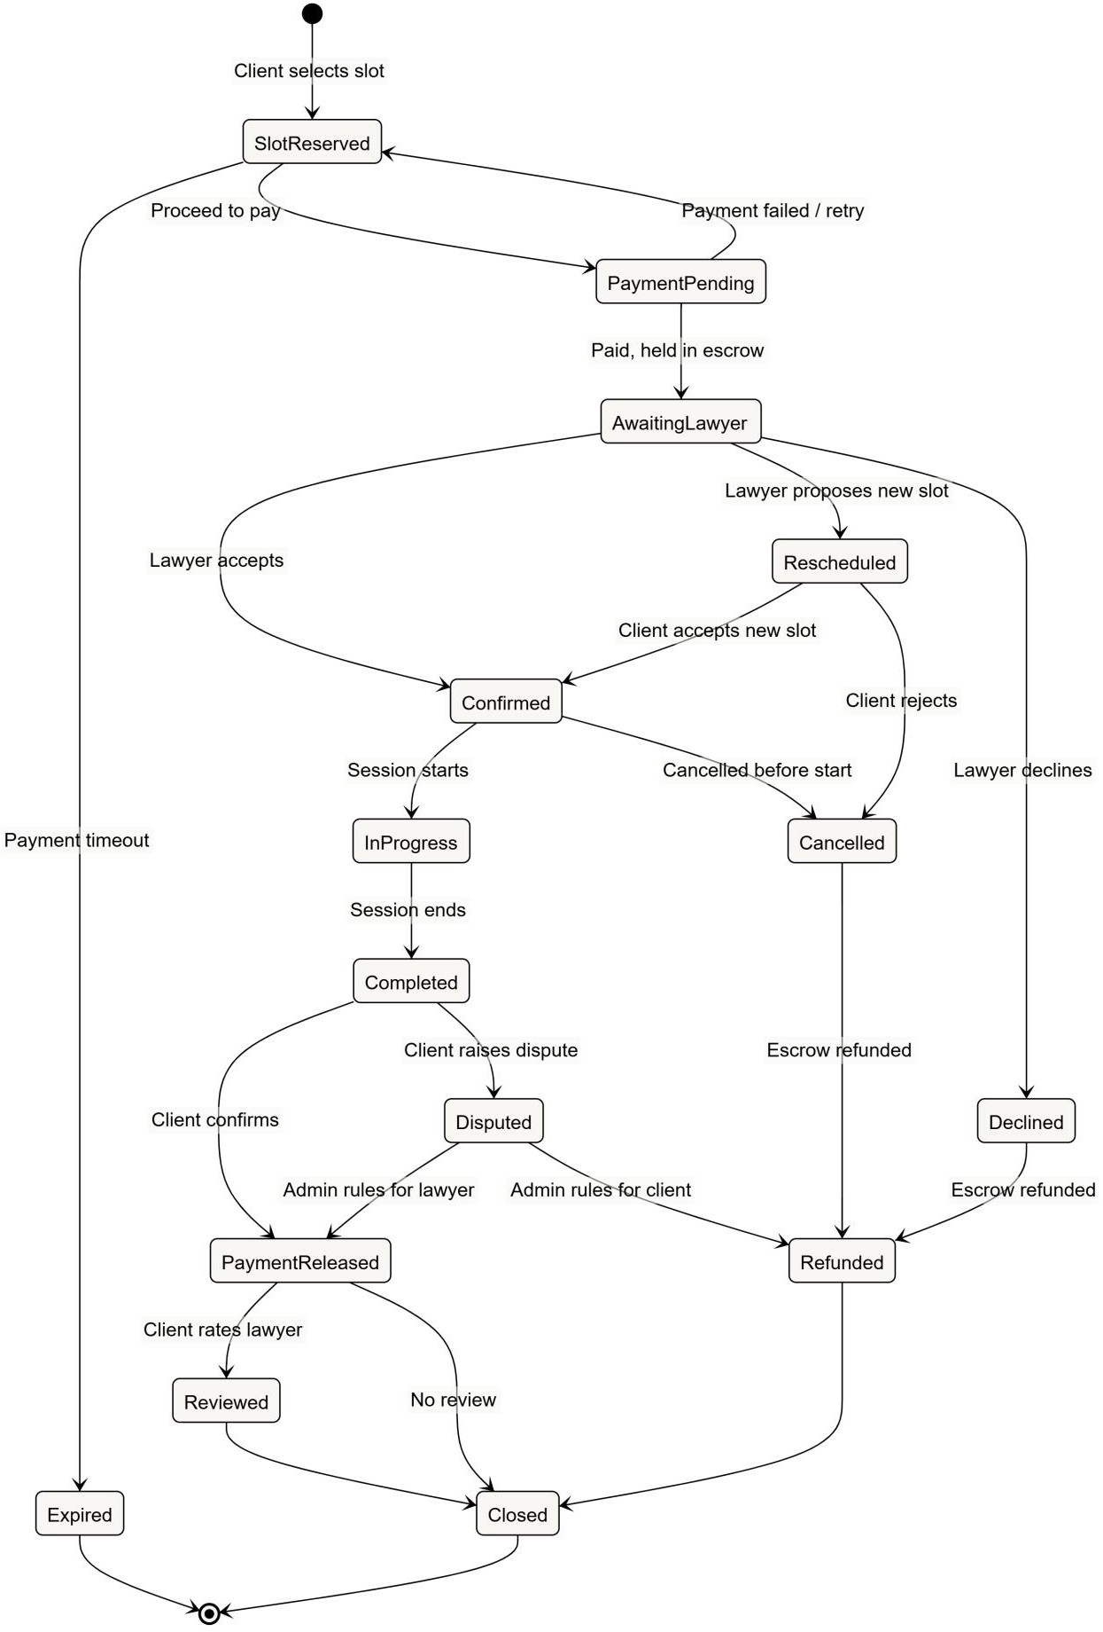

Fig: State Diagram of LawAid

CRC Card:

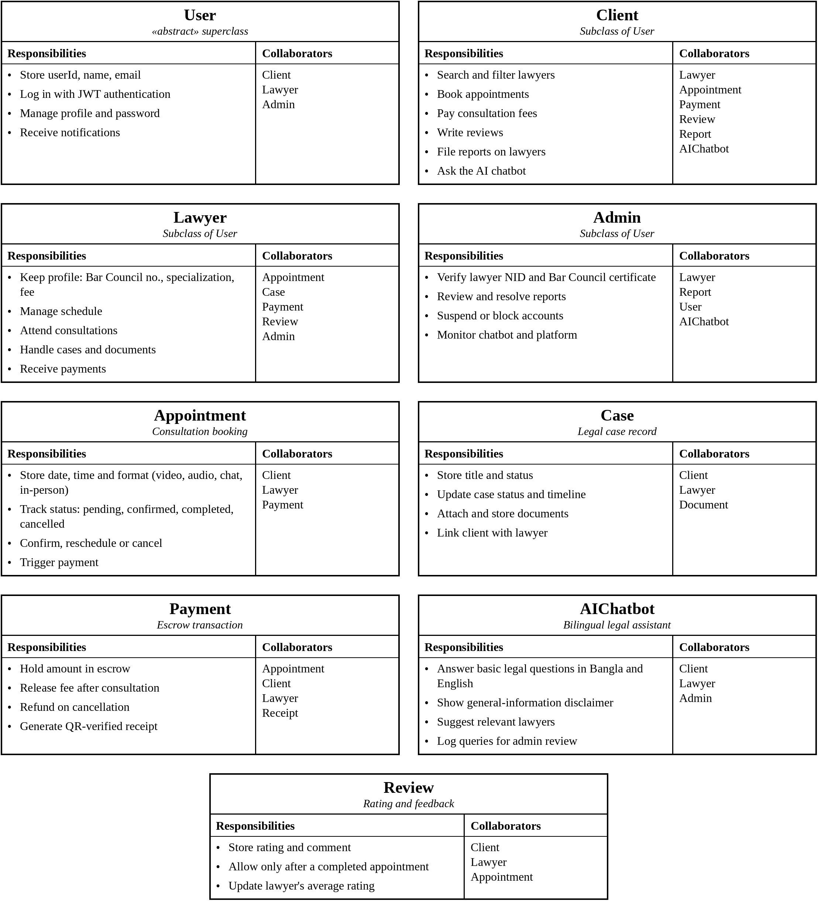

Fig: CRC Card of LawAid

CHAPTER 8: Prototype Design

Introduction
This chapter presents the prototype and UI design process of LawAid – Smart Legal Consultation and Court Management Platform. The UI is designed to provide a simple, professional, and user-friendly experience for clients and lawyers. The system helps clients find verified lawyers, book consultations, communicate with lawyers, and manage legal cases. Lawyers can manage clients, cases, consultations, and messages through their dedicated dashboard.

Prototyping Tools Used
To design a clear and interactive prototype, the following tools were used:
    - Figma: Used to create high-fidelity UI designs, wireframes, screen layouts, and interactive prototypes. Figma also helped maintain consistency across client and lawyer interfaces.
    - Canva: Used to create supporting visual elements such as banners, graphics, icons, and other visual assets used in the interface.

UI Design
The UI design of LawAid focuses on simplicity, professionalism, accessibility, and easy navigation. Since the platform is related to legal services, the design uses a clean and trustworthy visual style to help users easily understand legal services and perform important actions such as finding lawyers, booking consultations, and managing cases.

Rules of UI Design
The design follows standard UI guidelines and usability principles to provide a consistent and understandable experience for both clients and lawyers.

Key UI Principles Followed
      - Simplicity and Clarity:
Clear labels, simple layouts, and organized information are used so users can easily understand available legal services and actions.

Consistency:
Consistent navigation, buttons, colors, icons, cards, and typography are maintained throughout the platform.

Accessibility:
Readable font sizes, sufficient contrast, clear icons, and simple navigation are used to make the system easier to use.

User Feedback:
The interface provides confirmation messages, status indicators, notifications, and clear feedback after important actions such as booking a consultation or sending a message.

Role-Based Design:
Separate interfaces are provided for Clients and Lawyers, allowing each user type to access relevant features and information.

Color Palette
- Primary Colors: Dark navy and blue tones are used to represent professionalism, trust, and reliability.
- Secondary Colors: White and light neutral shades are used to maintain readability and create a clean interface.
- Accent Colors: Orange/yellow accents are used for important buttons, highlights, and calls to action.

Typography
- Headings: Bold and clear typography is used to create a strong visual hierarchy.
- Body Text: A simple sans-serif font is used for better readability.
- Buttons and Labels: Clear and readable text is used so users can quickly understand available actions.
- Accessibility: Font sizes, spacing, and contrast are optimized for comfortable reading.

Layout
- Navigation: A simple top navigation is used for the public website, while dashboards use structured sidebar navigation for easier access to different modules.
- Card-Based Interface: Lawyers, consultations, cases, and services are presented using organized cards.
- Dashboard Layout: Client and lawyer dashboards provide quick access to important information and actions.
- Responsive Design: The interface is designed to adapt to desktop, tablet, and mobile screen sizes.
- Visual Hierarchy: Important actions such as Get Started, Find Lawyer, Book Consultation, and Confirm Schedule are visually highlighted.

Key Screens Covered in Prototype
- Client Module: Home/Landing Page, verified lawyer search, lawyer details, appointment booking, consultation scheduling, online consultation, case management, messaging, profile/settings, and notifications.
- Lawyer Module: Lawyer dashboard, client management, case management, consultation management, appointment management, messaging, profile/settings, and notifications.
- Admin Module: Admin dashboard, user management, lawyer verification, client/lawyer management, case and consultation management, appointment management, legal service management, reports and analytics, notifications, content management, and system settings.

  - Prototype Screenshots

Web Application Screens (W1, W2, ...) W1: Web Screen 1 (Landing Page)
      - Welcome message and introduction to the platform.
      - Options to sign up or log in.
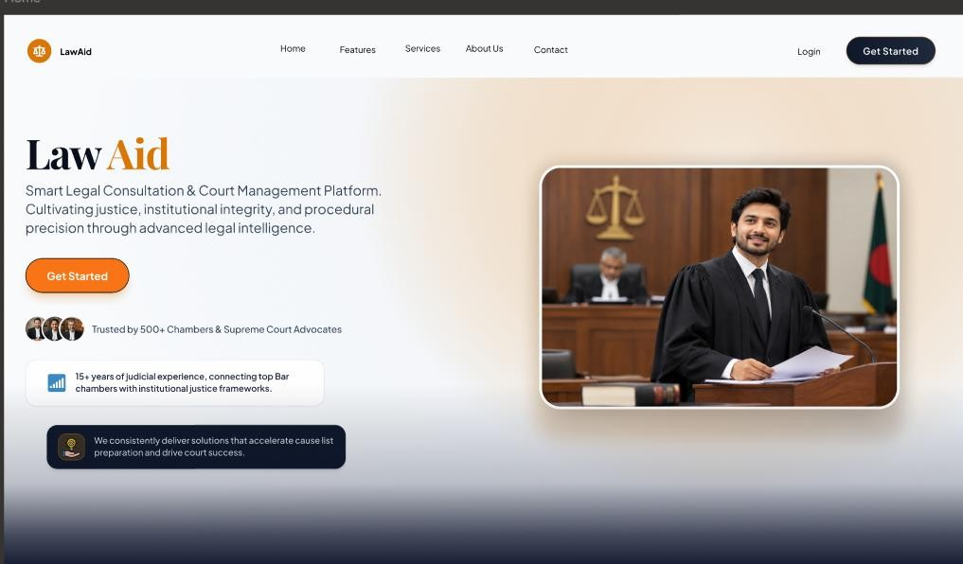

W2: Web Screen 2 (Role Access)
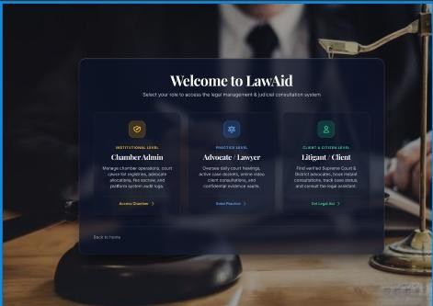

W3: Web Screen 3 (Admin DashBoard):
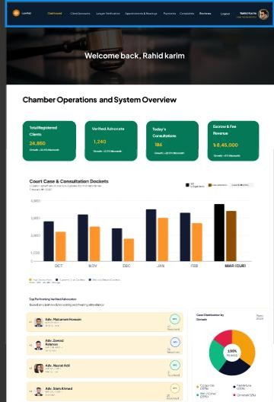

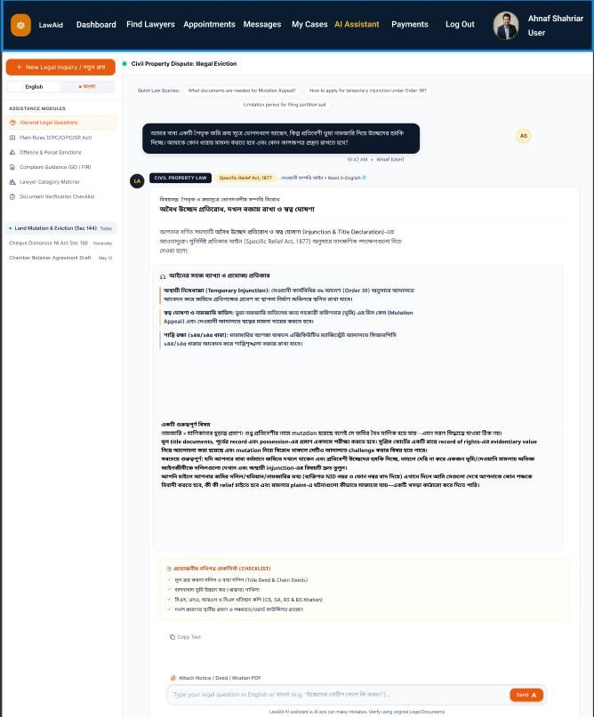
W4: Web Screen 4 (AI Assistant):

42

W5: Web Screen 5 (Lawyer DashBoard):
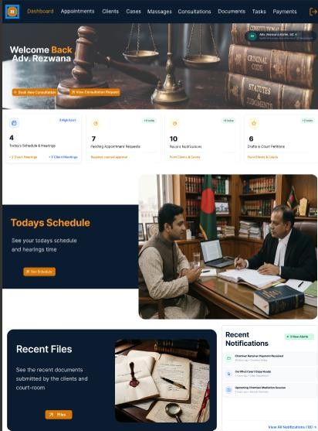

W6: Web Screen 6 (Lawyer Cases):
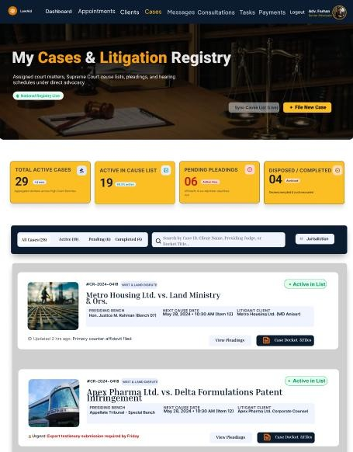

    - Mobile Application Screens (M1, M2, ...) M1: Mobile Screen 1 (Home Page):
45


M2: Mobile Screen 2 (Login):
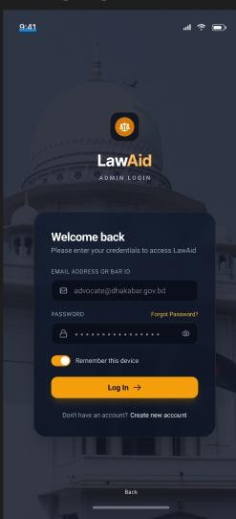

M3: Mobile Screen 3 (Admin Control):
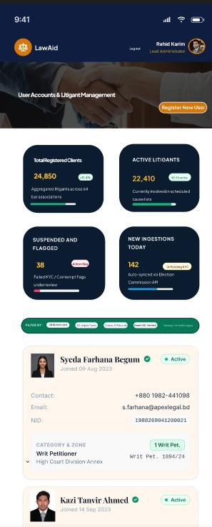

M4: Mobile Screen 4 (Client Dashboard):
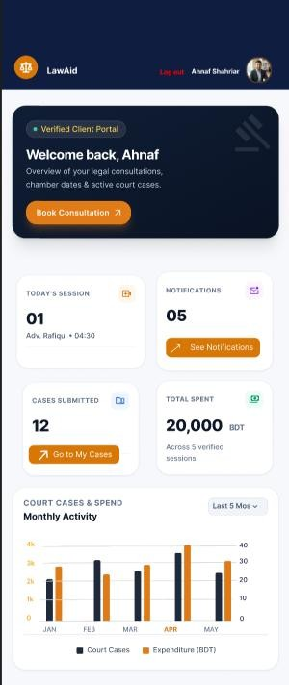

M5: Mobile Screen 5 (Lawyer Consultation):
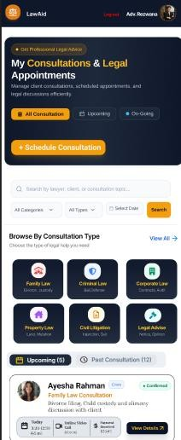


M6: Mobile Screen 6 (Lawyer message):
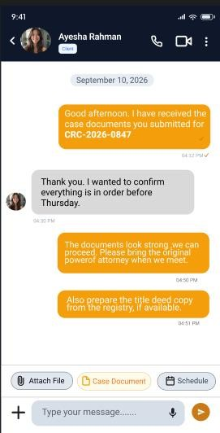

    - Navigation Flow

- Users start at the Landing Page.
- After login, users are directed to their role-based Dashboard.
- From the dashboard, users can access features through the navigation menu/sidebar.
- Each section provides easy navigation back to the Dashboard and other relevant sections.

UI Design Principles Summary

The LawAid prototype maintains a clean, professional, and user-friendly interface, prioritizing easy navigation, accessibility, and efficient legal service management. The screen structure allows clients to quickly find lawyers, schedule consultations, manage cases, and communicate with lawyers, while lawyers can efficiently manage clients, cases, consultations, and messages

Chapter 9: Conclusion

Conclusion

This Software Requirements Specification (SRS) document presents a detailed and structured description of the requirements for the LawAid system. The document defines the system’s objectives, scope, functional requirements, non-functional requirements, and design considerations to ensure a clear understanding among all stakeholders.
LawAid aims to simplify access to legal services by providing lawyer search, case management, consultation scheduling, secure communication, and AI-assisted legal support. The system addresses common challenges such as difficulty in finding suitable legal assistance, managing case information, and maintaining communication between clients and lawyers.
The requirements outlined in this SRS provide a strong foundation for the system’s design, development, testing, and future enhancement. By following these specifications, the project team can develop a system that is user-friendly, secure, reliable, and efficient while meeting the needs of both clients and lawyers. The document can also serve as a reference for future improvements and integration of additional legal services.

Reference

- A. Sarkar, "Over 45 lakh cases pending in courts," The Daily Star, Jul. 6, 2025. [Online]. Available: https://www.thedailystar.net/news/bangladesh/news/over-45- lakh-cases-pending-courts-3933306
It reports that 45,16,603 cases were pending across the Appellate Division, High Court and lower courts as of December 31, 2024, up from 17,89,914 in 2008. This is a strong opening statistic. The Daily Star

- "Over 46 lakh cases pending across courts in Bangladesh: Law minister," The Daily Star, 2026. [Online]. Available: https://www.thedailystar.net/news/the- parliament-watch/parliament/news/over-46-lakh-cases-pending-across-courts- bangladesh-law-minister-4218096
This is the most recent figure: 46,39,476 cases pending at all levels as of March 31, 2026. The Daily Star

- Government of Bangladesh, Legal Aid Services Act, 2000 (Act No. VI of 2000). This is the basis of the state legal aid system (NLASO). Cite it when you explain that free legal aid exists but is hard to reach.

- A. T. Wasi, W. Faisal, M. R. Islam, and M. M. Bappy, "Exploring possibilities of AI-powered legal assistance in Bangladesh through large language modeling," arXiv:2410.17210, 2024.

- A. T. Wasi, W. Faisal, M. R. Islam, and M. R. Parvez, "Mina: A multilingual LLM-powered legal assistant agent for Bangladesh for empowering access to justice," arXiv:2511.08605, 2025.
Mina is very close to LawAid's bilingual assistant idea, so it's worth reading and mentioning in your benchmark.

- S. Aftahee et al., "Assessing the reliability of large language models in the Bengali legal context: A comparative evaluation using LLM-as-judge and legal experts," arXiv:2511.05627, 2025.

- Federal Trade Commission, "FTC finalizes order with DoNotPay that prohibits deceptive 'AI lawyer' claims," Feb. 2025. [Online]. Available: https://www.ftc.gov/news-events/news/press-releases/2025/02/ftc-finalizes-order- donotpay-prohibits-deceptive-ai-lawyer-claims-imposes-monetary-relief-requires

- M. Dahl, V. Magesh, M. Suzgun, and D. E. Ho, "Large legal fictions: Profiling legal hallucinations in large language models," J. Legal Anal., vol. 16, no. 1, pp. 64– 93, 2024, doi: 10.1093/jla/laae003.
It found LLMs hallucinate at least 58% of the time on legal questions and often accept users' incorrect legal assumptions. Semantic Scholar

- V. Magesh, F. Surani, M. Dahl, M. Suzgun, C. D. Manning, and D. E. Ho, "Hallucination-free? Assessing the reliability of leading AI legal research tools," J. Empir. Leg. Stud., vol. 22, no. 2, pp. 216–242, 2025, doi: 10.1111/jels.12413.
Even specialized legal AI tools from LexisNexis and Thomson Reuters hallucinated 17% to 33% of the time. Institution for Social and Policy Studies

- Government of Bangladesh, Personal Data Protection Ordinance, 2025
(Ordinance No. 61 of 2025).
It was gazetted on 6 November 2025 as Bangladesh's first standalone data protection law, with an 18-month compliance window. Since Parliament has sat since then, check the ordinance's current status before you submit. Bd-scl

- Government of Bangladesh, Cyber Security Ordinance, 2025. It was promulgated on May 21, 2025, repealing the Cyber Security Act 2023. Wikipedia

- Bangladesh Bar Council, Canons of Professional Conduct and Etiquette, under the Bangladesh Legal Practitioners and Bar Council Order, 1972. These rules restrict lawyers from advertising and soliciting clients. They matter for how you describe lawyer profiles and "recommendations."

Future work

Grounded and verifiable AI legal assistant
The current bilingual chatbot only gives general legal information. A future version could be built on retrieval-augmented generation (RAG) over an official corpus of Bangladeshi Acts, ordinances and gazettes. Every answer would then cite the exact Act and section it relies on, and the assistant would decline to answer when the law does not cover a question. Open-source work has already started building Bangla and English question answering over Bangladeshi laws that cites the exact Act and section and refuses when the law does not cover the question, which shows the approach is practical. Because legal AI tools still produce incorrect or fabricated information [8], [9], a panel of practising lawyers should regularly review a sample of chatbot answers before any expansion of the assistant's scope. GitHub

Integration with the national e-Judiciary system
In the long term, LawAid could connect to official court systems. Then clients and lawyers could see hearing dates and case status inside the case-management dashboard, instead of entering them by hand. This is becoming realistic because cause lists for all courts have been made fully accessible online, and an "e-Judiciary" project is in the pipeline to digitise the entire judicial process, from case filing to record management. Bangladesh Post

Referral to free legal aid
Many users who need legal help cannot afford a private lawyer. A future module could assess whether a user may qualify for state legal aid under the Legal Aid Services Act, 2000 [3], and direct them to the nearest district legal aid office. This would make LawAid useful to low-income users as well as paying clients.

Low-bandwidth, voice and offline access
To reach users outside major cities, LawAid could add Bangla voice input and output for users with low literacy. It could also offer a lightweight mode for slow mobile networks and SMS notifications for hearing dates. Recent research shows that a small legal AI model can run fully offline at 1.6 GB on a Pixel 6 with no network access, so an offline version of the legal assistant in the mobile app is a realistic future goal. arXiv

Legal document automation
LawAid could offer guided templates for common documents such as legal notices, affidavits, rental agreements and power of attorney. The system would fill them in from the user's answers, and a verified lawyer would review each one before it is finalised. Given the FTC's action against DoNotPay [7], these documents should never be presented as a replacement for a lawyer's review.

Online dispute resolution and mediation
Many civil and family disputes could be settled before reaching court. A future module could support online mediation sessions with certified mediators, using LawAid's existing video, chat and payment features. This could help users avoid long delays in an overloaded court system [1], [2].

Smarter and fairer lawyer matching
The AI matching engine could be improved using real outcome data such as consultation ratings, case type and response time. The system should also explain why each lawyer was recommended. Its recommendations should be checked regularly so that new lawyers, female lawyers and lawyers outside Dhaka are not unfairly ranked lower.

Full data-protection compliance
Before commercial launch, LawAid should complete a formal compliance review against the Personal Data Protection Ordinance, 2025 [10]. The Ordinance gives organisations an 18-month compliance window, placing the effective enforcement deadline at approximately May 2027. The review would cover consent flows, data storage within Bangladesh for sensitive client files, retention policies, and appointing a data protection officer. Bd-scl

Pilot deployment and evaluation
Finally, the team plans to run a pilot with a small group of lawyers and clients in one or two districts. The pilot would measure task completion time, user satisfaction (for example, with the System Usability Scale), booking completion rate, and chatbot answer accuracy. The results would guide the next development cycle, in line with the Agile model adopted in Section 1.4.

