Table of Contents

SHARDIC
Sharded Encryption for Threshold-Recoverable Vaults — and Protected-Action Ceremonies
Enforcing Multi-Person Integrity for High-Stakes Data Recovery and Capability Authorization
White Paper — Version 2.0
July 2026
Project repository: github.com/splashd1/shardic

Abstract
Conventional file encryption is monolithic: whoever holds the key, or controls the system that holds it, controls access to the plaintext — permanently and unilaterally. shardic replaces that single point of control with a threshold-recoverable model. A file or directory is encrypted once under a randomly generated data encryption key (DEK), and that DEK is then split — using Shamir’s Secret Sharing over GF(256) — into T shares distributed to T independent trustees. No fewer than a threshold of D trustees, each supplying an individually held codeword, can ever reconstruct the key. Below that threshold, the remaining shares carry zero information about the key — a guarantee that holds regardless of computing power, not merely one that is expensive to break.
This version extends the paper past that starting point. shardic’s threshold-recovery mechanism was never intrinsically about files — it is a mechanism for enforcing that no single party can unilaterally invoke something. Sections 1–3 describe the mature, largely-implemented core exactly as before: the operational need, the CLI walkthrough, and the cryptographic mechanics, updated to reflect that shardic-envelope and ceremony formation have since moved from proposed design to running code. Sections 4–5 are new: they generalize the protected value from “a file” to a shardic protected action code (SPAC) — any enabling value for a protected capability, not only a decryption target — and walk two notional missions through the full ceremony lifecycle this generalization makes possible. Section 6 extends the security discussion to the new material; Section 7 restates what this design guarantees and what remains explicitly open.
Read end to end, the design is best understood as four layers, each built on top of the last without altering what the layer below it guarantees: sharded protection, shardic-envelope, ceremony formation, and SPAC. §1.6 states that stack explicitly before the paper works through it section by section.
Everything described from Section 4 onward is a design proposal, not shipped functionality — flagged as such throughout, in the same spirit as §3.6/§3.7 flagged shardic-envelope before it shipped.

1. The Need for Threshold-Recoverable Protection

1.1 Conventional Data Encryption: Monolithic, Single-Point Control
The standard model of symmetric encryption is simple: a key is generated, data is encrypted under it, and the key is stored or shared so that plaintext can later be recovered from the ciphertext. That simplicity is also the model’s structural weakness. Whoever possesses the key — a person, a process, a single server — has complete and unilateral power over the data it protects. Access is a binary, anonymous fact: either you hold the key, or you don’t. There is no way, within the cryptography itself, to require that access be a joint decision, or to prove after the fact who authorized a given recovery.
This single-point-of-control property persists even when the key management around it becomes more sophisticated. Wrapping a symmetric key with a public key so it can only be unwrapped by whoever holds the matching private key changes who the single point of control is, but not that there is one — the private key becomes the new monolithic secret. Locking a key inside an HSM, a safe, or a physically secured server changes where the single point of control lives, but a single compromised operator, a single coerced administrator, or a single stolen credential is still sufficient to defeat it. None of these supplements change the underlying shape of the trust model: one secret, one holder, one point of failure.
For routine data protection this is an acceptable, even desirable, trade-off — simplicity and low friction usually outweigh the risk. It becomes a liability precisely in the cases organizations care about most: root credentials, master keys, and archives whose disclosure or misuse by a single rogue, insider threat, or compromised party would be catastrophic.

1.2 Sharded Encryption: Enforcing Multi-Person Integrity
Sharded, threshold-recoverable encryption addresses this by removing the single point of control from the cryptography itself, rather than relying on policy or process to compensate for it. Instead of one key held by one party, the key is mathematically split into T pieces (“shares”), distributed to T independent trustees, with a threshold D set below T. Recovering the plaintext requires at least D trustees to each independently choose to participate. Critically, this is not merely operationally enforced (e.g. by requiring D signatures at an application layer) — it is information-theoretically enforced: with the underlying Shamir’s Secret Sharing construction, any collection of fewer than D shares carries mathematically zero information about the key, no matter how much computing power is applied against it.
The practical effect is that:
- No single trustee — including whoever originally created the vault — can ever recover the data alone.
- A rogue insider, a coerced employee, or a single compromised account is insufficient to cause disclosure; a collusion of at least D independent parties is required.
- The trustee pool can absorb the loss or unavailability of up to T − D trustees without losing recoverability — unlike a strict N-of-N or two-person rule, which has no slack.
- Every recovery event has a natural audit trail: the specific set of trustees who each chose to supply a codeword.
This shifts data protection from “who holds the key” — a fact about custody — to “who agreed to unlock it” — a fact about consent, distributed across independent parties who cannot individually override the group.

1.3 Representative Use Cases
Threshold-recoverable encryption is the right tool wherever policy, regulation, or risk tolerance already implies that no single party should be able to unilaterally decrypt something, and where access is rare and high-stakes rather than continuous and routine. Representative examples include:

Break-glass access to critical infrastructure
A root certificate-authority private key, a production database master key, or a SCADA override credential is locked in a vault with, say, T=7 trustees — a mix of senior engineers, security officers, and an executive — and a D=4 threshold. Day to day, nobody has access to the key at all. It is reconstructed only for a genuine emergency, and only if four of the seven trustees each independently agree to participate.

Diceware-style estate and succession planning
A family or founder splits access to a password manager’s master vault, or other key-person credentials, among relatives, a lawyer, and a business partner (T=5, D=3), using memorable, whole-word codewords that trustees can actually commit to memory rather than write down.

Government and public-sector applications
- Generalized two-person-rule systems (“any 3 of 7 officials”) that tolerate absence or incapacitation without weakening the no-lone-actor requirement of the classic two-key model.
- Escrowed decryption keys for classified or lawful-intercept archives, split across officials from different branches or agencies so that no single agency — or a rogue insider within one — can unilaterally decrypt.
- Continuity-of-government credentials that must survive the loss of some custodians while still requiring majority agreement to invoke.
- Election-system tabulation keys split among representatives of multiple parties or observers.

Business and regulated-industry applications
- M&A escrow and dispute-resolution vaults — deal terms or sensitive documents released only by quorum of board members, outside counsel, and an escrow agent.
- Cryptocurrency or treasury cold storage — splitting root key material behind a multisig wallet among founders or board members so no single executive can move funds alone.
- Whistleblower or source-protection archives, releasable only if a threshold of editors or lawyers agree.
- Regulated data with explicit separation-of-duties requirements (e.g. SOX, HIPAA “minimum necessary” contexts) — a technical enforcement of an existing compliance control rather than a policy statement alone.
Where this approach fits best: rare, high-stakes, offline “break-glass” access with a small, semi-static trustee set, where the vault file itself must be safely storable and shareable without leaking metadata about who holds what. It is a poor fit for frequent or live authorization, for revoking a single trustee without a full re-split, or for online multi-party protocols — those are better served by threshold-signature schemes (e.g. FROST) or HSM-backed multisig, which support key rotation and live quorum that this static, split-once design does not attempt to provide. §4 revisits this boundary once the protected value stops being assumed to be a file.

1.4 How Threshold Secret Sharing Works, Conceptually
Section 3.2 gives the precise, byte-by-byte construction. Before that, it’s worth building the intuition for why a threshold scheme works at all — because the obvious first guess at how to “split a key into pieces” is not what shardic does, and doesn’t have the properties §1.2 just promised.
The obvious guess, and why it falls short. Imagine cutting the 32-byte DEK into four 8-byte chunks and handing one chunk to each of four trustees — or the slightly cleverer version, XOR-splitting, where each share is random and the last one is defined so that all of them XOR back to the key. Both can be made information-theoretically sound in the narrow sense that holding fewer than all the pieces reveals nothing. But both share the same structural flaw: they are all-or-nothing schemes. Reconstruction needs every single piece, with no way to ask for “any D of T.” Lose one trustee, permanently, and the key is gone forever — exactly the fragility §1.2 said threshold recovery exists to avoid.
The actual idea: hide the secret as a point only enough hints can locate. Picture the DEK not as a string of bytes but as a single point on a graph — specifically, where a straight line crosses the vertical axis. Draw that line so it also happens to pass through T other points, one assigned to each trustee. Handing a trustee “their” point tells them nothing on its own: infinitely many different lines pass through any single point, each crossing the axis somewhere completely different, so every possible secret remains equally possible. But hand over any two trustees’ points together, and there is exactly one straight line that passes through both of them — which means there is exactly one place it crosses the axis. Two points determine a line; that’s what makes D = 2 work.
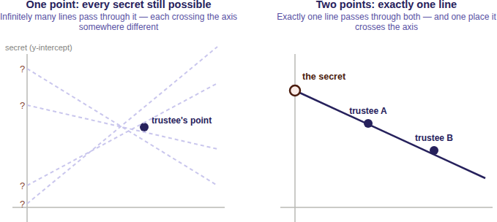
Raise the threshold to three, and the trick generalizes: instead of a straight line, use a curve with one more bend (a parabola), which takes three points to pin down uniquely rather than two. One or two points still leave every possible secret equally plausible — the curve simply isn’t determined yet. This is the general pattern: a threshold of D is implemented as a curve that requires exactly D points to fix, with T points handed out, one per trustee, all lying on that same curve. Because the curve only needs any D of its T points — not a particular D, and not all T — the scheme absorbs losing up to T − D trustees exactly as §1.2 described, something an all-or-nothing chunk or XOR split can never offer.
Why partial progress isn’t a thing here. A combination lock rewards partial knowledge — get two of three digits right and you are, in a real sense, close. A threshold secret share does not work that way. One trustee’s point, or even D − 1 of them together, doesn’t narrow the secret down to a short list of likely candidates; it leaves every possible value exactly as plausible as before. There is no partial credit, no “getting warmer,” and no way to make attempts and rule out candidates one collusion at a time — the Dth point doesn’t refine the answer, it is the precise moment the answer springs into existence.
shardic’s actual implementation replaces “a line” or “a curve on a graph” with a polynomial of degree D − 1 evaluated over a finite field, applied independently to each byte of the DEK — the same idea above, made precise and computable. §3.2 picks up exactly there. For a complete, standalone treatment — including the exact polynomial construction and why the arithmetic runs over GF(256) instead of real numbers — see Appendix A.

1.5 From Data to Capability: A Preview
Everything above frames the protected value as a file — an archive recovered, once, into plaintext on disk. That framing was never load- bearing for the underlying guarantee: what threshold recovery actually enforces is that a secret value comes into existence only when D independent parties each choose to contribute toward it. A file’s plaintext is one instance of “a secret value” — not the only one. Section 4 makes that generalization explicit and names it: a shardic protected action code (SPAC) is any enabling value for a protected capability — financial access, a physical safety interlock, a sensitive document, an account credential — of which “decrypt this archive” is the narrowest possible case. Sections 2–3 describe the mature core exactly as it exists today; readers only interested in the file-vault tool can stop at the end of §3.

1.6 The Capability Stack: How the Layers Build on Each Other
It’s worth naming the stack explicitly before working through it section by section, since each layer changes what’s actually possible without invalidating anything the layer beneath it guarantees:
- Sharded protection (§1–§3.5, implemented). The core guarantee: a secret is split so that no fewer than D of T independently held shares can ever reconstruct it, and below that threshold, zero information about the secret exists to extract. This alone is sufficient for the personal, estate, and business scenarios in §1.3 — a family splitting a password manager’s master key, a company escrowing a root credential — using the three codeword modes described in §6.2.
- shardic-envelope (§3.6, implemented). Wraps each trustee’s codeword in public-key encryption under a keypair the trustee already controls, removing the human-memorability ceiling that otherwise caps how strong an individual codeword can practically be (§6.2 revisits what this changes about codeword mode selection in §6.4).
- Ceremony formation (§3.7, implemented). Turns “who holds a codeword” from an ad hoc, once-per-vault trust decision into a tracked, repeatable process: candidate trustees are registered against an identity provider, a specific quorum is selected and invited for a given vault, declined or timed-out slots backfill automatically, and delivery of each wrapped codeword is a single-read, addressed event rather than an out-of-band handoff.
- SPAC (§4–§5, design proposal). Generalizes the protected value itself from “a file’s plaintext” to any enabling code for a protected capability, and generalizes the ceremony from one fixed shape into something tailorable per deployment — which trustees, which local-unlock factors, which RTO — to fit the CONOPS and embedment environment of a specific client system.
Each layer is a strict superset of the guarantees below it: nothing at layer 2 weakens layer 1’s information-theoretic threshold, and nothing at layer 4 weakens layer 2 or 3’s already-implemented mechanics. A deployment can stop at any layer and still have a complete, sound system — layer 4 is simply where this paper’s remaining open work lives.
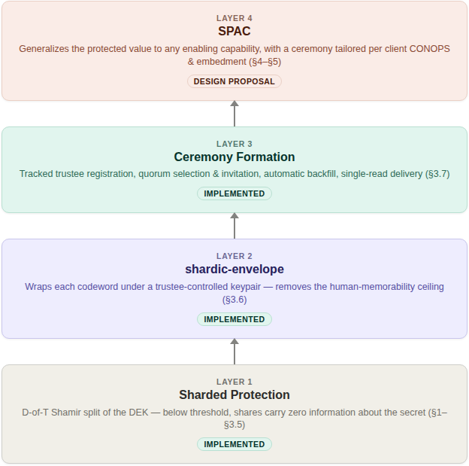

2. Concept of Operations
This section walks through the tool exactly as an operator experiences it: first the encryption (vault creation) sequence, then the decryption (recovery) sequence, using the command-line interface. The GUI exposes the same two operations through the same underlying library, so the sequence of decisions is identical — only the interaction surface changes.

2.1 Operator Walkthrough: Creating a Vault
An operator with a directory of sensitive files decides on two numbers before doing anything else: how many trustees (T) will hold a codeword, and how many of them (D) must agree to recover the data. In this walkthrough, five trustees are established with a threshold of three:
$ python3 vault_create.py \
--input ./secret_docs \
--trustees 5 --threshold 3 \
--word-count 3
Left at its defaults, the tool:
- Reports which key-derivation function will protect each share (Argon2id if available, otherwise PBKDF2), since this affects recovery speed and offline-guessing resistance.
- Defaults to --memorable mode when no fixed word length is given, drawing codewords from the bundled EFF long wordlist rather than synthetic strings.
- Reports its own combinatorial strength estimate for a single trustee’s codeword phrase, so the operator can judge — before distributing anything — whether the chosen word count is adequate for the stakes involved.
- Archives the input into a single blob, generates a random 256-bit data encryption key, and encrypts the archive under it.
- Splits that key into the requested number of Shamir shares and protects each one under its own randomly generated codeword.
- Writes one self-contained .krypt file, plus one text file per trustee containing only that trustee’s codeword.
The actual output of the run above:
[i] Share protection KDF: pbkdf2 {'iterations': 400000}
[i] No --word-length given: defaulting to --memorable mode (whole real words).
[*] Memorable mode: loaded 7772 whole, real candidate words from the bundled EFF wordlist
[*] Estimated codeword strength: ~39 bits combinatorial per trustee (before any KDF
stretching). Recovery cracks each codeword independently, so this per-codeword
number -- not a 5-trustee total -- is the real security margin; raising
threshold/trustee counts does not substitute for it.
[*] Archiving 'secret_docs' ...
[*] Split DEK into 5 shares, threshold 3
[*] Wrote vault container: vault_out/ce28by1pn9z8wib2.krypt (11388 bytes)
[+] Wrote 5 trustee codeword files to: vault_out/trustee_words/
Distribute each trustee_N.txt to exactly one trustee (out of band, e.g. in person
or over a channel they individually control), then DELETE these files from this
machine. Recovery needs only the single .krypt file + any 3 of the 5 codewords.
The operator’s remaining job at this point is entirely procedural, not cryptographic: distribute each trustee_N.txt to exactly one trustee, out of band, over a channel that trustee individually controls — and then delete the local copies. The tool deliberately does not automate distribution; who receives which codeword, and how, is a trust decision that belongs to the operator, not the software.

2.2 Operator Walkthrough: Recovering a Vault
At recovery time, any three of the five trustees supply their codewords — the operator does not need to know or specify which three:
$ python3 vault_recover.py vault_out/ce28by1pn9z8wib2.krypt \
--word "broadside-repulsion-subway" \
--word "valuables-repeater-oversleep" \
--word "winking-portly-diffusion"
Actual output:
[i] This vault requires 3 of 5 codewords to recover.
[i] Share protection KDF: pbkdf2
[+] Codeword accepted (1/3).
[+] Codeword accepted (2/3).
[+] Codeword accepted (3/3).
[*] Reconstructing DEK from recovered shares ...
[*] Decrypting archive ...
[*] Success. Recovered contents extracted to: /tmp/wp_demo/recovered_out
Two operational details are worth calling out. First, codewords can be entered in any order — recovery does not ask “which trustee are you,” it simply tries each supplied codeword against every not-yet-matched share until one authenticates (see §3.4). Second, if fewer than D codewords match, or any of them are wrong, the tool reports how many were accepted and stops — it never writes partial or best-guess output.

2.3 shardic-prime: A Mandatory-Trustee Variant
The base scheme treats every trustee identically — any D of T codewords recover the vault, full stop. shardic-prime is a separate variant, with its own CLI tools and its own container format, that adds one essential trustee on top of the base scheme: the prime trustee’s codeword must always be among those supplied, no matter how many other codewords are gathered. The remaining trustees form an ordinary interchangeable pool for the rest of the threshold.
This fits situations where one specific role — an estate’s executor, an organization’s security lead — must always sign off, while the people backing them up can be any qualifying subset. In T=4, D=3 prime-trustee terms, that means 1 prime trustee plus 3 pool trustees, and recovery needs the prime’s codeword plus any 2 of the 3 pool codewords:
$ python3 vault_create_prime.py --input ./my_directory \
--trustees 4 --threshold 3 \
--word-length 6 --word-count 2
$ python3 vault_recover_prime.py VAULT.krypt
All three pool codewords, gathered without the prime trustee’s, recover nothing — a property guaranteed by the construction itself (§3.5), not merely enforced by the CLI. As with the base scheme, recovery does not require the operator to say in advance which supplied codeword belongs to the prime trustee; it is identified automatically once decryption succeeds. §4 revisits the prime trustee’s role directly — it turns out to generalize to a hardware-embodied instance without requiring any new mathematics at all.

3. Technical Mechanics
This section describes how the .krypt container actually protects data: how the data encryption key is generated, how Shamir’s Secret Sharing protects its recovery, how each individual share is, in turn, protected by a codeword-derived key, and how the scheme has since extended into public-key-wrapped delivery and multi-party ceremony formation.

3.1 Archive and Data Encryption Key
Vault creation proceeds in a fixed sequence:
- The input file or directory is bundled with tar into a single blob, so any input shape — one file or an entire directory tree — is handled uniformly. The archive is deliberately left uncompressed (mode "w", not "w:gz") so ciphertext size does not vary with plaintext compressibility any more than strictly necessary — compression can otherwise leak information about content through size alone.
- A random 256-bit data encryption key (DEK) is generated using a cryptographically secure random source (secrets.token_bytes).
- The archive is encrypted exactly once, under that DEK, using AES-256-GCM with a randomly generated 96-bit nonce. GCM provides both confidentiality and built-in tamper detection: any modification to the ciphertext causes authentication to fail rather than silently decrypting to garbage.
At this point, the DEK is the single piece of secret material standing between the ciphertext and the plaintext — exactly as in conventional symmetric encryption. What differs from the conventional model is what happens to that key next.
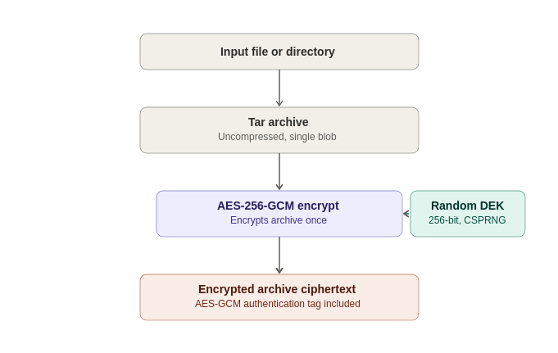

3.2 Shamir’s Secret Sharing over GF(256)
Rather than being stored or handed to a single custodian, the DEK is split using a byte-wise implementation of Shamir’s Secret Sharing (SSS) over the finite field GF(2⁸) — the same construction used by classic tools such as ssss, and the same field arithmetic AES itself uses (generator 3, reduction polynomial 0x11B).
The construction, applied independently to each of the DEK’s 32 bytes:
- Each byte of the secret becomes the constant term of a random polynomial of degree D − 1, with the remaining coefficients drawn uniformly at random.
- Each of the T shares is that polynomial evaluated at a distinct x-coordinate (1 through T), across all 32 byte positions simultaneously.
- Reconstruction takes any D shares and applies Lagrange interpolation at x = 0, independently per byte position, to recover the original secret byte.
Why this is information-theoretic, not merely computational. A polynomial of degree D − 1 is uniquely determined by any D points on it — but with only D − 1 points, every possible value of the constant term (the secret byte) remains equally consistent with those points. An attacker holding D − 1 shares therefore learns exactly zero bits about the DEK, regardless of computing power, time, or future cryptanalytic advances against AES itself. This is the property that separates threshold recovery from key-splitting schemes built on secret-sharing-flavored encryption tricks that are only computationally, not information-theoretically, hard to break below threshold. “Information-theoretic” security means a guarantee that holds regardless of computing power — not because breaking it is hard, but because the information needed to break it simply isn’t there.
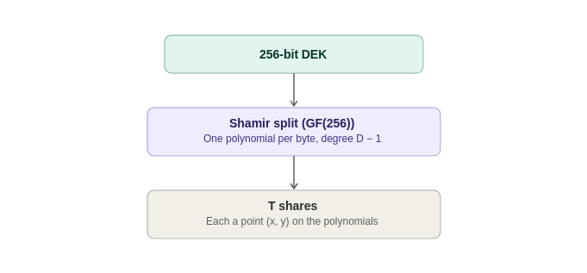

3.3 Codeword-Derived Key Protection of Shares
A raw Shamir share is still just data — if written to disk unprotected, whoever possesses D of them could reconstruct the DEK without any trustee’s cooperation at all. Each share is therefore itself individually encrypted before being placed in the vault:
- A random, human-typeable codeword is generated for the share (see §5’s mission vignettes and §6.2 for the available modes: memorable, dictionary, and synthetic).
- A random salt is generated, and a 256-bit key is derived from the codeword and salt using one of two supported key-derivation functions: PBKDF2-HMAC-SHA256 (400,000 iterations by default — a zero-extra-dependency baseline) or Argon2id (time_cost=4, memory_cost=256 MiB, parallelism=4 by default — memory-hard, and preferred when the optional argon2-cffi package is available, since memory-hardness raises the cost of large-scale parallel GPU/ASIC guessing far more than an equivalent-wall-clock PBKDF2 setting does).
- The share (its x-coordinate plus its 32 y-bytes) is encrypted with AES-256-GCM under that derived key, using its own random nonce.
The vault records, per share, only an opaque triple: {salt, nonce, ciphertext}. Which KDF method and parameters were used are recorded once in the container’s metadata — self-describing, so recovery never needs to be told out-of-band which settings a given vault used.
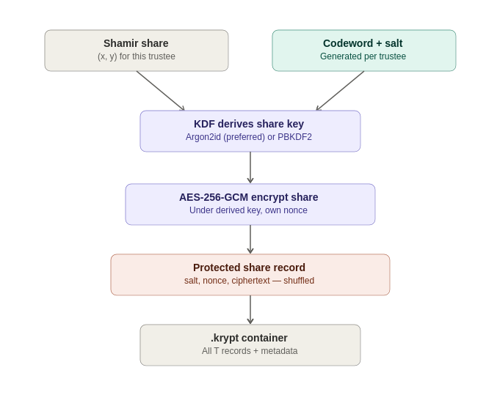

3.4 The .krypt Container and Zero-Leakage Indexing
All of the above — metadata and ciphertext — is bundled into a single .krypt file: an 8-byte magic header, a length-prefixed JSON metadata block, and the raw AES-GCM ciphertext of the archive (stored as raw bytes, not base64-encoded, avoiding a ~33% size penalty). This is deliberate: there is exactly one file to copy, email, or upload, with nothing to accidentally separate from a companion metadata file.
The metadata’s list of protected shares carries no mapping from record to trustee, and no mapping from record to codeword — each entry is simply an opaque {salt, nonce, ciphertext} triple, and the order of entries in the file is randomly shuffled at creation time. Recovery works by trial matching: each codeword the operator supplies is tried, via its derived AES-GCM key, against every not-yet-matched share record in the vault. GCM’s authentication tag makes this a reliable oracle — the correct pairing decrypts successfully, and every incorrect pairing fails fast with an authentication error rather than producing plausible-looking garbage.
With T in the tens, this exhaustive trial is effectively instantaneous, and it has a meaningful security consequence: the .krypt file, examined on its own, reveals nothing about which share belongs to which trustee, or how many codewords would need to be compromised together to threaten a specific subset of the data. Seizing the file, or several codewords, in isolation yields no assignment information beyond what successful decryption itself reveals.
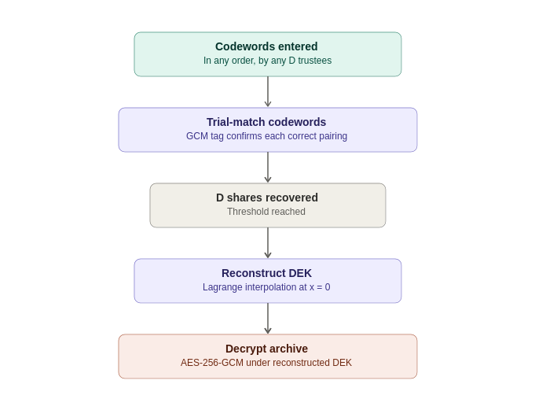

3.5 How shardic-prime Varies
shardic-prime layers a one-time-pad mask over the ordinary Shamir construction described above, rather than introducing new field arithmetic. Given the DEK as the secret:
mask = random bytes, same length as the DEK
masked_secret = DEK XOR mask
pool_shares = split_secret(masked_secret, pool_threshold, pool_size)
The prime trustee’s codeword protects mask directly — an all-or-nothing pad, not a point on a Shamir polynomial. Recovery requires both mask and at least pool_threshold pool shares:
masked_secret = reconstruct_secret(pool_shares)
DEK = masked_secret XOR mask
Without mask, the pool shares — even all of them — reconstruct only masked_secret, which is uniformly random and indistinguishable from noise without the mask to remove. Without at least pool_threshold pool shares, mask alone reveals nothing either. Both halves of the construction retain the same information-theoretic guarantee as the base scheme; layering them is what makes the prime trustee mathematically essential rather than merely conventionally required.
A shardic-prime vault is tagged in its own metadata ("scheme": "prime-trustee") specifically so it can never be opened by, or confused with, the base scheme’s recovery tool, and vice versa — the two container formats are deliberately incompatible rather than silently cross-readable.
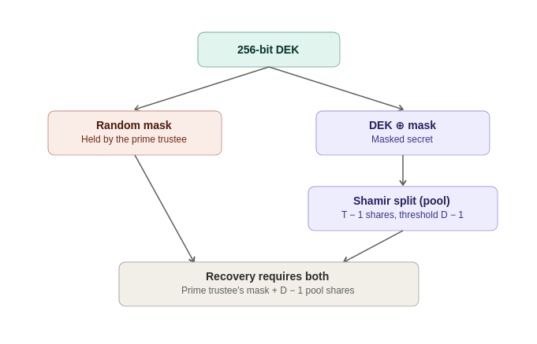
This one-time-pad construction turns out to be the load-bearing piece of everything in §4: because mask is just a value, nothing about reconstruct_secret_with_prime() requires that value to be held by a human. §4.2 reuses this exact code, unmodified, to bind the same mathematics to a piece of hardware instead.

3.6 shardic-envelope: Public-Key-Wrapped Codewords (Implemented)
Every codeword mode described in §6.2 — memorable, dictionary, synthetic — ultimately protects a share with something a human being can recall or transcribe, and §6.1 establishes that this individual codeword strength, not the Shamir/AES layer, is the design’s real computational bottleneck. shardic-envelope removes that ceiling entirely for trustees willing to hold a cryptographic keypair, by wrapping each trustee’s codeword in public-key encryption under a key they already control — rather than under a memory limit. As of this writing, shardic-envelope is implemented and demonstrated end-to-end (shardic_envelope_crypto.py, demo/combiner/app.py), not merely proposed — the design intent below is now running code.
- Operates strictly on the output of vault creation — the plaintext files a trustee would otherwise have received — rather than modifying vault_core.py itself, so the existing encrypt/split/KDF path is untouched and the base scheme’s guarantees are unaffected.
- Wraps each codeword in a hybrid, ECIES-style envelope (X25519 ECDH + HKDF-SHA256 + AES-256-GCM), deliberately shaped to mirror the vault’s existing {salt, nonce, ciphertext} share-record convention rather than inventing a new format.
- The combiner — the service that holds .krypt ciphertext and every wrapped envelope, and orchestrates registration and recovery — never receives a plaintext codeword at any point, only shards derived locally by each trustee and re-wrapped for the combiner’s own public key on the way back.
Recovery is unchanged from a trustee’s point of view in the base scheme: they still supply a plaintext codeword or its derived shard. What changes is provisioning — the trustee’s own device decrypts an envelope locally, once, to obtain the value they would otherwise have had to memorize or write down themselves.

3.7 Ceremony Formation, Credentials, and Delivery (Implemented)
§3.6 raises two questions that a follow-on design phase answers with running code, not just a sketch: how does a trustee’s public key get established and trusted in the first place, and how does an operator convene a specific quorum of trustees for a given vault rather than improvising trust decisions ad hoc each time?
- Registration. Candidate trustees are drawn from a dedicated Keycloak group, queried via a read-only service account scoped to that group. Each trustee’s keypair is generated client-side only — the private key never transits, or is even briefly held by, any server shardic controls. This deliberately keeps identity/selection (Keycloak’s job) cleanly separated from key custody (never Keycloak’s job) — a compromised or unavailable identity provider can block registration, but cannot on its own expose a DEK, forge a share, or weaken the D-of-T guarantee.
- Ceremony formation. An operator (authenticated via a dedicated shardic-operator realm role, replacing an earlier shared static admin token) selects T primary trustees plus an ordered backup list from the registered candidate pool, and issues invitations. Declined or timed-out invitations backfill automatically from the ordered backup list — race-safe, so a late acceptance from an already-backfilled slot is rejected rather than silently double- filling it. A ceremony is formed once every slot is accepted, or failed if the backup list is exhausted first. An explicit separation-of-duties check blocks the operator who forms a ceremony from also self-selecting as one of its trustees.
- Delivery. Wrapped envelopes are deposited at an authenticated, single-read drop point, addressed by trustee identity rather than a contact channel. The trustee fetches their own envelope themselves, once. “Exactly once” redemption functions as a detection mechanism — a second read attempt on an already-claimed envelope is a signal something is wrong, not a guarantee nothing can go wrong.
- Recover. Unaffected. §2.2’s walkthrough describes the same underlying act either way.
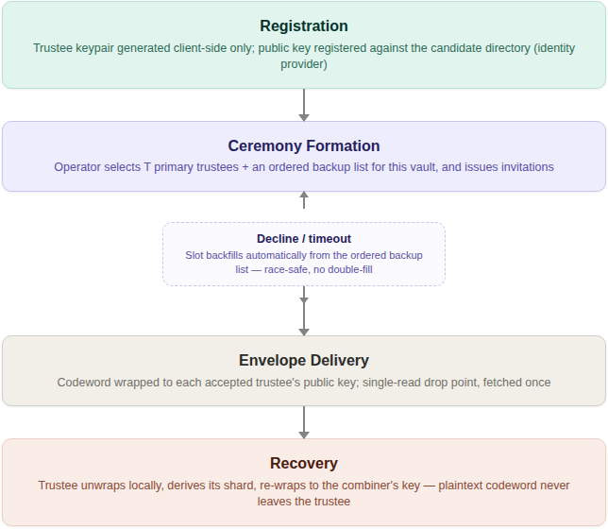
The organizing principle across all of this: identity and selection stay cleanly separated from key custody, and both stay separated from the offline, fail-closed recovery math described in §3.1–§3.4. A compromised identity provider or a stalled ceremony can block provisioning; neither can, on its own, weaken the D-of-T guarantee itself. §4 builds directly on top of this ceremony-formation machinery — it is reused unmodified for the pool-trustee side of a SPAC ceremony.

4. The SPAC Ecosystem: Extending shardic Beyond File Decryption
Status: design proposal. shardic’s protection can be extended beyond the demonstrated file protection and supporting shardic-envelope ceremony that has been fielded to deliver a much more critical level of protection at system level.This section, moves beyond the fielded capabiility of §1–§3. shardic Protected Action Code (SPAC) describes a proposed extension that is targeting the flexibility to be embeddable in a variety of clients. As such there is no existing implementation yet, though the target systems,concepts, and embodiment are under exploration. What is clear is that the SPAC capability and life-cycle elements will be consistent, though manifested in a variety of ways to address the client system security, performance, and CONOPS needs.

4.1 From Data to Capability: PT SPAC and CT SPAC
§1.5 previewed the reframe; here is the full statement of it. The plaintext shardic protects has never had to be a file — it is, more generally, the enabling value for some protected action: gaining financial access, arming a safety-critical system, unlocking a sensitive document, or granting account access, wherever “the right D-of-T parties agreed” should be the actual gate on the action, not merely a procedural approval layered on top of it. A shardic protected action code (SPAC) names that enabling value; PT SPAC and CT SPAC name its plaintext and ciphertext forms, in exactly the same relationship as any other plaintext/ciphertext pair in this project. “Decrypt this file” is simply the special case where the protected action is “the codeword holder gets to read the plaintext” — the same mechanism, applied to the narrowest possible action.
This reframe has real precedent outside cryptography. Permissive Action Links (PAL) — a code required to authorize a safety-critical action, withheld until an authorized multi-party release procedure completes — is the closest existing analog for gating a capability rather than merely data. Two-Person Integrity / the Two-Man Rule (the doctrinal basis for “no single individual can access or execute X alone”) is the vocabulary for what the trustee threshold, plus the separation-of-duties enforcement already described in §3.7, already implement. Both sit alongside, not instead of, the commercial patterns already used throughout this design — HSM M-of-N quorum authorization, FIDO2, TPM sealing — which answer how to build the mechanics once the why is established.

4.2 The Shardic Client Module and the Fielded Prime Element
A consuming system — the thing that actually executes the protected action — is built with a “plugin” at the critical-path point where the PT SPAC is needed. During development and test, the real PT SPAC sits in that pipeline directly, so the system can be validated end-to-end. Before fielding, PT SPAC is swapped for a CT SPAC embedded in a shardic client module at that same plugin point — the consuming system’s analog of the trustee apps and combiner described in §3.6–3.7, except this one lives inside somebody else’s execution pipeline rather than being shardic’s own frontend. The interface between the client module and the shardic ceremony infrastructure is treated as a formal contract (an Interface Control Document, in the sense that term is used in systems engineering) rather than an informal library call, given what is plugged into it.
The discipline already established in §3.6 — never persist a secret value longer than strictly necessary — extends past the combiner into this new boundary: PT SPAC should exist in the client module’s memory only long enough to hand off to (or itself trigger) the protected action, then be zeroized. This is a new boundary for an existing invariant, not a new invariant.
Fielded-system binding is the property that makes this safe to field at all: a copied CT SPAC, combined with a fully legitimate D-of-T trustee quorum, must not be sufficient to arm the protected action on a different instance of the client module than the one it was emplaced into. This needs no new cryptography — it reuses §3.5’s mask/pool one-time-pad construction unmodified, with one substitution: the fielded system’s own hardware-sealed secret stands in for mask. The device performing this role is named a Fielded Prime Element — a hardware-embodied instance of the prime-trustee role from §2.3/§3.5, just as a shardware-token (§4.3) is the device and a shard is the value it carries, a Fielded Prime Element is the device and mask is the value it holds:
mask = the fielded system's own hardware-sealed secret
(PUF/secure-element, non-extractable, generated once at
emplacement, never leaves this hardware, never typed by
a human, never a codeword)
pool_shares = ordinary trustee shares, delivered by shardware-token or
network exactly as in §3.6-3.7
DEK = reconstruct_secret_with_prime(mask, pool_shares) -- unmodified
CT_SPAC = AES-256-GCM(PT_SPAC, DEK) -- unmodified
Copy CT_SPAC to different hardware and bring a full legitimate trustee quorum along; reconstruction still fails, because mask is bound to one specific piece of silicon and was never extractable from it. This design is deliberately scoped to one specific piece of hardware, full stop — no multi-unit redundancy. If the fielded hardware is replaced, mask is gone with it; there is no export path, matching the position this project already takes on a lost trustee device (re-provision, don’t migrate the secret).

4.3 shardware-token: Hardware-Based Ceremony Variants
Two variants exist for how a physical hardware token participates in a ceremony, differing in how much trust the token itself has to carry:
Physical carriage. A hardware token can simply be the transport for an already-wrapped shard, replacing a network hop with a courier, hand-off, or safe-deposit retrieval — useful for a ceremony that wants to run entirely air-gapped past registration. The token itself can be genuinely dumb storage: since the shard is already public-key-wrapped before it ever reaches the token, there is nothing unencrypted on it to protect. The open question this variant leaves is identity — without a live authenticated session, “whose shard is this” needs either an attesting operator or a trustee-held signing key.
PUF-sealed embed/extract. A hardened variant answers that question cryptographically instead. The token generates its own keypair locally at “embed” time (vault creation), receives a shard wrapped to that keypair, and seals it into PUF/secure-element-backed storage that requires a matching physical measurement of the chip itself to ever reproduce the storage key — the standard “fuzzy extractor” construction used by real hardware such as SRAM-PUF and ring-oscillator-PUF secure elements. At “extract” time (recovery), the token only releases its shard against a vault-signed extraction grant: a short-lived, token-bound, nonce-fresh authorization, chained back to a rarely-touched root signing key through an intermediate that is rotated on a policy schedule rather than touched per ceremony. A single, live, human operator authorizes each grant — sufficient because the operator can only approve or deny a request a genuine physical token already originated; the real multi-party control is the trustee-token convening itself, not the operator headcount.
Both variants keep the underlying confidentiality guarantee identical to §3.6’s network path — physical carriage changes what carries a value, never what protects it.

4.4 Roles and Governance
A SPAC ceremony introduces roles beyond the trustee/operator pair already established in §3.7, each answering a distinct question and each deliberately kept separate from the others so that no single compromised role can undermine the whole ceremony:
Role | Answers | Held by
Trustee (pool) | Who must jointly agree to recover? | Ordinary shardic-envelope trustees, unchanged from §3.6–3.7
Fielded Prime Element | What binds recovery to one specific piece of fielded hardware? | The fielded system’s own sealed secret — never a party at all
Local custodian | Who is physically present to authorize the fielded hardware’s own local unseal? | Whoever holds the deployment’s chosen possessed (key/token) or known (PIN/passphrase) factor — a role, not an identity, so it transfers across shift changes without re-provisioning
Operator | Who authorizes a given extraction request? | A single, on-call shardic-operator-equivalent role, barred from authorizing a grant naming their own token
Approver | Who attests that the value being protected is the correct, tested one? | An authority independent of whoever performs the wrap/emplacement step, holding a distinct signing key from the extraction-grant chain
The Approver’s role deserves particular emphasis because it closes a gap that is easy to miss: AES-256-GCM already guarantees that a CT SPAC decrypts to exactly what was originally encrypted, or fails loudly — but it says nothing about whether what was encrypted was correct in the first place. An accidental stale value, or a malicious substitution at wrap time, would otherwise sail through untouched. The Approver signs a commitment to the validated PT SPAC at approval time, independent of the wrap operator; that commitment is checked once, slowly and thoroughly, at emplacement, and again, cheaply and quickly, at every arming event via a fast wrapped-MAC derived from the same approval — so verifying authenticity never has to trade away timeliness.

4.5 Availability, Latency, and CONOPS Trade-offs
Not every SPAC deployment has the same tolerance for how long a ceremony takes. Recovering a file vault comfortably tolerates a slow, deliberate, hours-long process; releasing time-critical financial access or a safety-critical authorization plausibly cannot. Rather than impose one universal answer, this design treats the target RTO (recovery time objective) as a per-deployment parameter, driven by the actual CONOPS — the concept of operations describing who the trustees, operator, and custodians really are, how they are staffed, and what infrastructure already exists to reach them.
Three points in a ceremony drive nearly all of the achievable latency, and each is a real trade against resistance to unauthorized access, not merely a performance knob:
- Convening the quorum. Pre-forming a ceremony ahead of the moment of need (§3.7’s ceremony-formation machinery, reused unmodified) converts “select, invite, wait for acceptance” into a one-time setup cost paid before the RTO clock starts — the single largest lever available. An ad hoc, cold-start convening can take hours; a pre-formed, on-call quorum can respond in seconds to minutes.
- Share delivery. A network path is near-instant; physical carriage (§4.3) is inherently minutes to days, depending on distance and custody logistics. Air-gap independence and a tight RTO are largely mutually exclusive properties — a deployment chooses the one it actually needs.
- Endgame unlock. A single operator and a single local custodian are each fast, cryptographically sufficient decisions — but a lone authorized person who cannot be reached is a single point of availability failure, distinct from being a single point of authorization. An on-call backup roster for both roles, modeled on §3.7’s ordered-backup-list mechanism, protects availability without weakening the one-authorizer, one-custodian property at all.
None of these levers ever reduce how many independent parties are cryptographically required — every latency improvement here comes from pre-positioning and parallelizing already-required inputs, never from requiring fewer of them. A fast, pre-formed, networked, single-tap ceremony is genuinely fast, but a coerced or compromised set of already-standing parties moves through it just as fast; a slow, physically-carried, dual-custodian ceremony is genuinely slow, but that same friction is often a deliberate deterrent that creates real-world opportunities for something to be noticed before completion. Stating a target RTO is therefore also, implicitly, stating how much of that friction a given mission is willing to trade away — a decision the CONOPS has to make on purpose, not something this design should default on its behalf. §5 walks two notional missions through exactly this trade.

5. Notional Missions and Ceremony Lifecycle
Status: illustrative, notional. Both vignettes below are constructed examples, not descriptions of any real system or deployment. They’re intended to walk the full SPAC lifecycle — approval, emplacement, fielded operation, ceremony formation, and arming — against a concrete “as-is” baseline. Numeric trustee counts and thresholds are for illustration.

5.1 Vignette A: Escrowed Authorization of a High-Value Treasury Disbursement
Mission. A financial institution’s treasury system can execute wire disbursements above a defined threshold only with genuine, non- bypassable multi-party authorization, replacing a conventional dual-control approval workflow.
As-is baseline. Two named officers each approve a pending disbursement in a web application. The control is enforced entirely by application logic and an audit log: a single compromised administrator account, a shared or hijacked session, or two coerced approvers acting under common pressure can produce two valid-looking approvals with no cryptographic guarantee that either approval reflects genuine independent intent. The audit trail records that two accounts clicked “approve” — it cannot prove that two independent human decisions actually occurred.
Notional shardic-SPAC design.
- PT SPAC: the treasury system’s high-privilege disbursement-signing credential.
- T=5 pool trustees (treasury officers), D=3 pool threshold, plus one Fielded Prime Element embedded in the treasury platform’s own HSM-backed appliance — the disbursement can never be signed on any other machine, even by the same five officers.
- Approver: the controller function, independent of whoever operates vault creation, cryptographically attesting that the wrapped credential is the correct, currently-authorized signing key.
- Ceremony formation: a standing, pre-formed quorum of treasury officers with an ordered backup list, per §3.7 — no ad hoc convening required at disbursement time.
- Operator: a compliance officer, authorizing each extraction request; barred from also being one of the five treasury-officer trustees.
- Local custodian: a data-center technician holding a physical key-switch at the appliance itself.
- Delivery and RTO: network share delivery (§4.3), targeting an RTO of minutes — appropriate for time-sensitive treasury operations, at the cost of the air-gap property a slower design could otherwise offer.
Lifecycle walkthrough. Approval — the controller validates the signing credential in a test environment and signs a commitment to it. Emplacement — the credential is wrapped as CT SPAC, split across the five officer-trustees and the appliance’s Fielded Prime Element, and destroyed everywhere else. Fielded operation — the appliance runs normally, holding only CT SPAC. Ceremony — a disbursement above threshold triggers a notification to the standing quorum; three of five officers respond, the compliance officer authorizes the extraction grant, the on-site custodian’s key-switch unlocks the Fielded Prime Element locally. Arming — DEK reconstructs, the fast wrapped-MAC check confirms the credential matches the controller’s original approval, the disbursement executes, and every secret value involved is zeroized immediately after.
Dimension | As-is (dual-control app logic) | shardic-SPAC
Protection | Enforced by software/process; bypassable by whoever administers it | Enforced by mathematics; below-threshold shares carry zero information regardless of administrator access
Safety | Silent failure modes possible if application logic has a bug | Fail-loud: AES-GCM authentication rejects any incorrect or tampered value outright
Assurance | Audit log proves which accounts clicked approve, not which people independently chose to | Non-repudiable: reconstruction is only possible if D independent trustees each supplied a genuine share

5.2 Vignette B: Notional Safety-Interlock Release Authorization
Mission. A notional platform’s safety interlock must transition from a safed to an operational state only upon a release-enable value becoming available, and only through the deliberate, independent agreement of multiple authorized parties — the same organizational problem Permissive Action Links (§4.1) solve, described here purely at the level of the authorization ceremony, with no operational or technical detail about any actual system.
As-is baseline. A physical lock or sealed code, held by a single on-duty officer, released under a procedural two-person-rule enforced by human witnessing rather than any cryptographic mechanism. A single coerced or compromised individual with physical access, acting alone, can potentially defeat a procedural control; there is no mathematically non-repudiable record of which specific individuals authorized a given release, only paper logs and witness attestations that can themselves be falsified or coerced.
Notional shardic-SPAC design.
- PT SPAC: the notional release-enable value.
- T=5 pool trustees (a qualified duty crew), D=3 pool threshold, plus a Fielded Prime Element embedded in the platform’s own secure-element hardware.
- Local custodian factor: dual key-switches (the “two local factors” option from §4.4), reflecting that a safety-critical interlock plausibly warrants the strongest available local control rather than the single-custodian default.
- Approver: an independent technical authority, distinct from the operational chain, attesting that the embedded value is the correctly certified one — not a stale or substituted version.
- Ceremony formation: a standing, pre-formed, on-alert quorum, targeting an RTO of seconds to low minutes.
- Operator: a command-authority representative, authorizing the extraction grant as the cryptographic analog of an authorized release order.
Lifecycle walkthrough. Approval — the technical authority validates and signs a commitment to the release-enable value. Emplacement — the value is wrapped as CT SPAC and split across the duty crew and the platform’s Fielded Prime Element; the plaintext is destroyed everywhere else. Fielded operation — the platform holds only CT SPAC, indefinitely, with no live dependency on the crew, the operator, or the network. Ceremony — an authorized release order triggers convening of the standing duty crew; three of five respond, the command-authority operator authorizes the extraction grant, both local key-switches turn simultaneously. Arming — DEK reconstructs, the fast integrity check confirms the value matches the technical authority’s original certification, the interlock transitions state, and every secret value is zeroized immediately after.
Dimension | As-is (procedural two-person rule) | shardic-SPAC
Protection | A single coerced/compromised individual with physical access is a structural risk | Mathematically requires genuine independent agreement from D distinct trustees, not merely two people in a room
Safety | A wrong or substituted code may not be detected until use | Fail-loud at multiple points: AES-GCM authentication, plus an independent approver-signed integrity check before the value is trusted
Assurance | Paper logs and witness statements, alterable or coercible after the fact | A ceremony’s participant set is a fact about which independent parties each supplied a genuine cryptographic contribution — not a claim resting on anyone’s later testimony

6. Security Discussion
§6.1–§6.3 below characterize codeword strength as it applies to the base, human-facing shardic tools described in §1–§3.5 — the case where a trustee actually generates, recalls, or transcribes their own codeword by hand, and where this analysis stays directly relevant for anyone using the base scheme on its own. Once a deployment adopts shardic-envelope, ceremony formation, or SPAC (§3.6 onward), this line of discussion becomes largely moot: an envelope-delivered codeword is never memorized, so it can be generated with entropy on par with ordinary cryptographic key material rather than being bounded by what a human can recall. §6.1–§6.3 are retained here because the base scheme remains a fully supported, standalone capability in its own right; §6.4 states the envelope-era amplification explicitly.

6.1 Two Different Kinds of Strength: Key Length vs. Trustee Threshold
It is worth being explicit about which parts of this design are information-theoretically secure and which are only computationally secure, because they respond to completely different levers.
- The 256-bit DEK, and the Shamir split protecting it, are effectively unconditional: below the threshold D, shares carry zero information about the key regardless of an attacker’s computing power, and AES-256 itself has no known practical cryptanalytic shortcut. Raising T or D changes how many independent parties must collude, not how hard any individual share is to attack directly — each is already effectively unbreakable on its own.
- Each individual codeword, by contrast, is only as strong as its own guessing space and KDF cost — this is ordinary computational security, and it is squarely the operator’s responsibility to size correctly. Because shares are trial-matched independently (§3.4), a higher threshold D does not compensate for weak codewords: an attacker only ever needs to crack D individual codewords, each on its own merits, never the full set at once, and never in combination.
In short: raising trustee counts strengthens the collusion requirement; it does nothing for a codeword that is individually too weak. The two knobs must both be tuned, and neither substitutes for the other.

6.2 Codeword Modes: Security and Usability Trade-offs
Three codeword generation modes are available, trading recall difficulty against density of entropy per character. This trade-off is the original underpinning of codeword-based share protection, and it remains exactly the right toolkit for the personal and business scenarios in §1.3, where a trustee is genuinely expected to memorize or hand-transcribe their own codeword. §6.4 revisits which mode is the better default once that assumption no longer holds.

Memorable mode (default)
Draws whole, real, unfiltered-by-length words from a dictionary — the bundled EFF long wordlist (7,772 words, ~12.9 bits/word) by default. This is the classic diceware approach: real words engage semantic memory in a way synthetic syllables do not, so a trustee can actually recall a phrase rather than needing to store it. It is also, per word, the strongest of the three sources — a larger, unfiltered candidate pool beats a length-filtered one.

Dictionary mode
Words of exactly a specified length are drawn from a supplied wordlist file. Useful when every codeword should have a uniform visible shape, but filtering a natural-language dictionary down to one length typically leaves only hundreds to low thousands of candidates — roughly 8–11 bits per word, meaningfully weaker than memorable mode’s unfiltered pool.

Synthetic mode
Pronounceable random words are generated from an alternating consonant/vowel pattern at a specified length, with no dictionary at all. This produces far more combinations per length than a natural-language dictionary can (roughly 3.36 bits per character from the base alphabet sizes), but the syllables carry no meaning, making them denser but harder to actually remember than real words of equivalent length.
In every mode, word count is what actually establishes a real security margin — each additional word roughly multiplies the guessing space.

6.3 Tuning Options
Beyond codeword mode and count, two further levers match protection strength to threat model and operating constraints: KDF selection and cost (Argon2id’s memory-hardness resists parallel GPU/ASIC offline guessing far better than PBKDF2 at equivalent wall-clock cost), and trustee count and threshold (raising T − D increases tolerance for unavailable or lost trustees; raising D relative to T raises the bar for collusion at the cost of requiring more participants for every legitimate recovery). Because the KDF choice is fixed at creation time and recorded in the vault’s own metadata, recovery always applies exactly the settings the vault was created with — no fallback, negotiation, or downgrade attack against the KDF is possible after the fact.

6.4 Impact of shardic-envelope and Ceremony Formation
Because §3.6’s construction changes what protects a codeword — a private key instead of human memory — it changes the analysis in this section rather than sitting outside it.
The direct security benefit is removing the memorability ceiling that shapes §6.2 entirely: a codeword that only needs to survive one local decryption, immediately before use, can be made arbitrarily long and high-entropy with no usability penalty at all, pushing each individual codeword’s computational security arbitrarily close to §6.1’s information-theoretic guarantee. Because memorability was the only reason §6.2 traded density for recall, that trade stops applying the moment a codeword is never recalled by a human at all: synthetic mode — the densest bits-per-character of the three, and previously the least usable — becomes the natural baseline for any envelope-provisioned trustee. Memorable and dictionary mode remain the correct choice specifically where a human still holds their own codeword in their head or on paper — the standard personal and business deployments of §1.3 — but they are no longer the default assumption once §3.6 is in play; mnemonic effort simply stops being a variable worth optimizing for. That gain relocates rather than eliminates the trust dependency: the trustee’s private key becomes a new single point of failure per share, and credential resolution introduces a new trust boundary of its own. Ceremony formation’s separation-of-duties enforcement (§3.7) directly mitigates one specific instance of this: an operator who forms a ceremony cannot also self-select as one of its trustees, closing off the most direct form of operator self-dealing.

6.5 Security Considerations Specific to SPAC
The SPAC extension in §4–§5 introduces failure modes that have no analog in the file-vault core, each addressed by a specific design choice rather than left to policy:
- Fielded-system binding. Without §4.2’s Fielded Prime Element construction, a copied CT SPAC and a legitimate trustee quorum would be sufficient to arm the protected action anywhere, not only on the intended hardware. Binding is enforced by reusing §3.5’s one-time-pad mathematics unmodified — an algebraic guarantee, not a policy one.
- Content authenticity versus ciphertext integrity. AES-GCM guarantees a CT SPAC decrypts to exactly what was encrypted; it says nothing about whether what was encrypted was correct. The Approver role (§4.4) closes this gap with an independently signed commitment, checked at both emplacement and arming.
- Single-operator and single-custodian sufficiency. Neither role being singular weakens the overall guarantee, because neither can originate a ceremony action alone — an operator can only approve or deny a request a genuine physical or cryptographic event already triggered. This is a sufficiency argument, not an availability one; §4.5’s on-call backup rosters address availability separately, without reintroducing a second decision-maker into any single step.
- RTO as a stated trade, not a free variable. §4.5 makes explicit that faster ceremonies are not free — every latency reduction is pre-positioning of already-required inputs, and a CONOPS that chooses a fast, networked, pre-formed ceremony is choosing a different resistance profile against unauthorized access than a slow, physically-carried, dual-custodian one, on purpose.

7. Summary

7.1 What Sets This Apart From Conventional Symmetric Encryption
Conventional symmetric file encryption answers the question “how do we keep this secret?” shardic answers a different question: “how do we ensure no single party can unilaterally expose this secret — or invoke this capability?” The cryptographic primitives underneath — AES-256-GCM, a KDF, random key material — are entirely standards-based and standard. What is different is the structure of control imposed on top of them: the protected value never exists in a form any one party can extract, because it is never stored whole in the first place. It exists only fleetingly, in memory, at the moment enough independent parties have each chosen to contribute their share of it — whether that value decrypts a file, as in §1–§3, or arms a protected action, as in §4–§5.
Math beats policies and permissions for enforcement. This is a categorically stronger guarantee than access-control policies, multi-approval workflows, or organizational procedure layered on top of ordinary encryption — those are enforced by software or process and can be bypassed by whoever administers them. Threshold recovery below D trustees is enforced by mathematics and cannot be bypassed by any administrator, insider, or software defect in the recovery tool itself.

7.2 Advantages
- No lone-actor risk: recovery is mathematically impossible below the trustee threshold, not just procedurally discouraged.
- Graceful tolerance of trustee loss: any D of T is sufficient, so the design survives unavailable, incapacitated, or non-cooperating trustees up to T − D of them.
- Zero metadata leakage: the vault file alone reveals no trustee-to-share mapping, even under direct inspection or partial compromise.
- Self-describing recovery: KDF method and parameters travel with the vault, so recovery never depends on external configuration matching what was used at creation.
- A mandatory-signer variant (shardic-prime) is available without weakening the underlying guarantees, for cases where one specific role must always participate — and, per §4, that role generalizes to a hardware-embodied Fielded Prime Element with no new mathematics required.
- Fail-closed behavior throughout: insufficient or incorrect codewords, unavailable KDF dependencies, or corrupted containers are reported explicitly and stop the operation — the design contains no silent-degradation path that would produce partial or misleading output.
- Generalizes past file decryption entirely: the same guarantee that protects a vault’s plaintext can, per §4–§5, gate an arbitrary protected action, with the fielded-system-binding and approver mechanisms needed to do so safely already designed.

7.3 Limitations and Mitigations
- Codeword strength is the real bottleneck for the base scheme. The Shamir/AES layer is effectively unbreakable; an individual codeword is only as strong as its generation mode, length, and count. Mitigation: use adequate word count, prefer Argon2id where available, and adopt shardic-envelope (§3.6) for trustees who can bear key custody.
- This is a static, split-once design at its core. Revoking or replacing a single trustee requires a full re-split and re-distribution of a new vault; there is no live key-rotation or online quorum protocol. Mitigation: this tool is intentionally scoped to rare, high-stakes, offline “break-glass” access and deliberate-ceremony SPAC arming; frequent or live multi-party authorization should instead use threshold-signature schemes (e.g. FROST) or HSM-backed multisig.
- The .krypt container, and by extension a CT SPAC bundle, is a single point of availability failure even though it is not a single point of access failure. Mitigation: back up the container durably; there is only one artifact to protect.
- It doesn’t scale limitlessly — the system is implemented with a ceiling at 255 shares, and makes practical sense for double-digit trustee counts. Mitigation: use it where it fits; the ceiling is an operational-practicality boundary, not a cryptographic one.
- The SPAC extension (§4–§5) is, as stated throughout, an unimplemented design. Several parameters remain explicitly open rather than decided: the concrete LocalUnlockFactor category for a given deployment, the specific PUF/secure-element hardware to target, and the wire format for extraction-grant certificates. Mitigation: none of these gaps weaken the cryptographic core described in §3.1–§3.5, which every SPAC construction reuses unmodified — they are integration and deployment decisions, not open cryptographic questions.
- The Windows build path has not yet been verified against a real Windows environment as of this writing. Mitigation: Linux CLI, GUI, and AppImage builds have been independently verified; Windows verification is tracked as an open item.
Taken together, these limitations describe the boundary of the problem this design is built to solve — rare, high-stakes recovery and authorization requiring genuine multi-party agreement — rather than deficiencies within that boundary. Within it, the core guarantee stands on solid ground, whether what it protects is a file’s plaintext or a protected action’s enabling code: no fewer than D independently held contributions will ever bring that value into existence, and that guarantee does not degrade, weaken, or silently fail under any of the failure modes considered in its design.

Appendix A: Shamir’s Secret Sharing, Explained
§1.4 and §3.2 walk through Shamir’s Secret Sharing (SSS) at the depth needed to follow the rest of this paper. This appendix is the complete, standalone treatment those sections point to — the same source document maintained in the project repository as docs/sss_explained_for_shardic.md, reproduced here in full so the paper is self-contained.

A.1 The Problem It Solves
Say you have a secret — a key, a password, a number — and you want to split it among several people so that:
- Any D of them together can reconstruct it exactly.
- Any group of fewer than D learns nothing about it, not even a probabilistic edge.
That’s a (D, T) threshold scheme: T total shares, D required to recover. Shamir’s Secret Sharing (SSS), published by Adi Shamir in 1979, solves this using a simple fact from algebra: a polynomial of degree D−1 is uniquely determined by D points, and completely undetermined by any fewer.

A.2 The Intuition, Before the Math
It’s worth seeing why this works before the formula, because the obvious first guess at “splitting a secret into pieces” isn’t it, and doesn’t have the properties above.
The obvious guess, and why it falls short. Imagine cutting a secret key into equal chunks and handing one chunk to each trustee — or the slightly cleverer version, XOR-splitting, where each share is random and the last one is defined so that all of them XOR back to the key. Both can be made information-theoretically sound in the narrow sense that holding fewer than all the pieces reveals nothing. But both share the same structural flaw: they are all-or-nothing schemes. Reconstruction needs every single piece, with no way to ask for “any D of T.” Lose one trustee, permanently, and the secret is gone forever — exactly the fragility a threshold scheme exists to avoid.
The actual idea: hide the secret as a point only enough hints can locate. Picture the secret not as a string of bytes but as a single point on a graph — specifically, where a straight line crosses the vertical axis. Draw that line so it also happens to pass through T other points, one assigned to each trustee. Handing a trustee “their” point tells them nothing on its own: infinitely many different lines pass through any single point, each crossing the axis somewhere completely different, so every possible secret remains equally possible. But hand over any two trustees’ points together, and there is exactly one straight line that passes through both of them — which means there is exactly one place it crosses the axis. Two points determine a line; that’s what makes D = 2 work.
Raise the threshold to three, and the trick generalizes: instead of a straight line, use a curve with one more bend (a parabola), which takes three points to pin down uniquely rather than two. One or two points still leave every possible secret equally plausible — the curve simply isn’t determined yet. This is the general pattern: a threshold of D is implemented as a curve that requires exactly D points to fix, with T points handed out, one per trustee, all lying on that same curve. Because the curve only needs any D of its T points — not a particular D, and not all T — the scheme absorbs losing up to T − D trustees, something an all-or-nothing chunk or XOR split can never offer.
That curve is a polynomial. The next section makes it precise.

A.3 The Precise Construction
You already know the geometric version from precalculus: two points determine a line (degree 1), three points determine a parabola (degree 2). In general, D points determine a unique polynomial of degree D−1 — no more, no fewer. Shamir’s insight is to hide the secret as the constant term of such a polynomial, then hand out points on its curve as shares.
- To split a secret S into T shares with threshold D, build a polynomial of degree D−1:
- f(x) = S + a₁x + a₂x² + ... + a_(D-1)x^(D-1)
- where a₁, ..., a_(D-1) are random coefficients, and the constant term is the secret: f(0) = S.
- Generate T shares by evaluating this polynomial at T distinct nonzero x-values:
- share_i = (i, f(i)) for i = 1, 2, ..., T
- Distribute one (x, f(x)) point to each of the T trustees.
Reconstruction: given any D of these points, you can fit the unique degree-(D−1) polynomial that passes through them, using Lagrange interpolation, and evaluate it at x = 0 to recover f(0) = S.

A.4 Why Fewer Than D Shares Reveal Nothing
This is the part that separates SSS from “encryption” in the usual sense — it’s not computationally hard to break with fewer shares, it’s information-theoretically impossible.
With only D−1 points, there are infinitely many degree-(D−1) polynomials passing through them — one for every possible value of f(0). Each candidate secret is equally consistent with the data you have. You haven’t narrowed the search space at all; you’ve learned literally zero bits about S. This is a much stronger guarantee than most cryptography offers, where security rests on a hard computational problem (factoring, discrete log) that could in principle be broken by a smarter algorithm or bigger computer. Here, there’s no algorithm to break — the information simply isn’t present in D−1 shares.
It also means there’s no such thing as partial progress. A combination lock rewards partial knowledge — get two of three digits right and you are, in a real sense, close. A threshold secret share does not work that way. D−1 points together don’t narrow the secret down to a short list of likely candidates; they leave every possible value exactly as plausible as before. There’s no “getting warmer,” and no way to make attempts and rule out candidates one collusion at a time — the Dth point doesn’t refine the answer, it’s the precise moment the answer springs into existence.

A.5 Why GF(256) Instead of Real Numbers
If you did this arithmetic over the real numbers, you’d run into two problems: fractions creep into Lagrange interpolation, and floating-point rounding would silently corrupt the secret. So SSS is done instead over a finite field — a closed, exact number system with no rounding.
Shardic uses GF(256), the finite field with 256 elements, which conveniently maps one field element to exactly one byte (2⁸ = 256). Every arithmetic operation — polynomial evaluation, interpolation — is closed within this system, so shares and reconstructed secrets are exact bytes with no precision loss. This is also why GF(256) has a hard structural ceiling: with only 256 possible nonzero x-coordinates (well, 255, since 0 is reserved for the secret’s evaluation point), you can’t hand out more than 255 distinct shares without either colliding x-values or moving to a bigger field (GF(2¹⁶)) or a prime-field construction. It’s not a tunable setting — it’s the size of the number system itself.

A.6 How This Becomes Shardic
Shardic doesn’t split your file with SSS — it splits the encryption key.
- Your file is encrypted with AES-256-GCM under a randomly generated Data Encryption Key (DEK). This is fast, standard symmetric encryption — SSS is never applied to bulk data because polynomial math over GF(256) doesn’t scale to megabytes efficiently.
- That 256-bit DEK is the “secret” S fed into Shamir’s construction, split into T shares under threshold D — i.e., any D trustees can reconstruct the DEK; fewer cannot, even in principle.
- Each share is further protected by a memorable codeword, run through a KDF (Argon2id or PBKDF2) so that possessing the raw share bytes isn’t enough — you also need the human-memorized word.
- At recovery time, once D correct codewords unlock D shares, Lagrange interpolation reconstructs the DEK, and AES-GCM decrypts the file.
So the security model has two independent layers stacked: AES-GCM protects the bulk data computationally (hard to break, but not impossible in principle), while Shamir’s Secret Sharing protects the key itself information-theoretically (impossible to break with insufficient shares, full stop, regardless of computing power).

A.7 Where Shardic Extends the Textbook Scheme
A few things shardic adds on top of vanilla SSS that are worth knowing, since they’re not part of Shamir’s original 1979 construction:
- Zero-leakage indexing: normally you’d store metadata mapping “codeword A → share 3” for lookup convenience. Shardic doesn’t — it brute-trials each entered codeword against all unmatched share records, using the AES-GCM authentication tag as a correctness oracle. This means the metadata file itself leaks no information about which codeword belongs to which share, closing a side-channel that a naive implementation would otherwise expose.
- shardic-prime: a variant that designates exactly one trustee as the mandatory prime trustee — reconstruction fails without their codeword specifically, no matter how many of the remaining pool trustees are gathered. This isn’t native to pure threshold SSS (which treats all D-of-T combinations as equally valid) and requires an additional constraint — a one-time-pad-style mask layered over the ordinary Shamir split — on top of the polynomial construction.
- Entropy transparency: the system warns rather than silently degrades if your chosen KDF parameters or codeword strength fall below a safe threshold — a UX layer around the crypto, not a change to the math itself.

A.8 The One-Sentence Summary
Shamir’s Secret Sharing turns “split a secret among T people, any D of whom can recover it” into a simple geometry fact — a degree-(D−1) polynomial needs exactly D points to pin down — and shardic uses that fact to protect not your file directly, but the single key that unlocks it, so that reconstructing access requires genuine cooperation among trustees rather than trusting any single point of failure.

