# bamazon app

Week 12 Homework

Instructions for Customer App and Manager App

**Customer App Instructions**

1. You will need to run npm install before using the bamazon app.

2. To run the bamazon customer app go to gitBash terminal and run the following command:

node bamazon.js

A list of items for sale will be displayed.

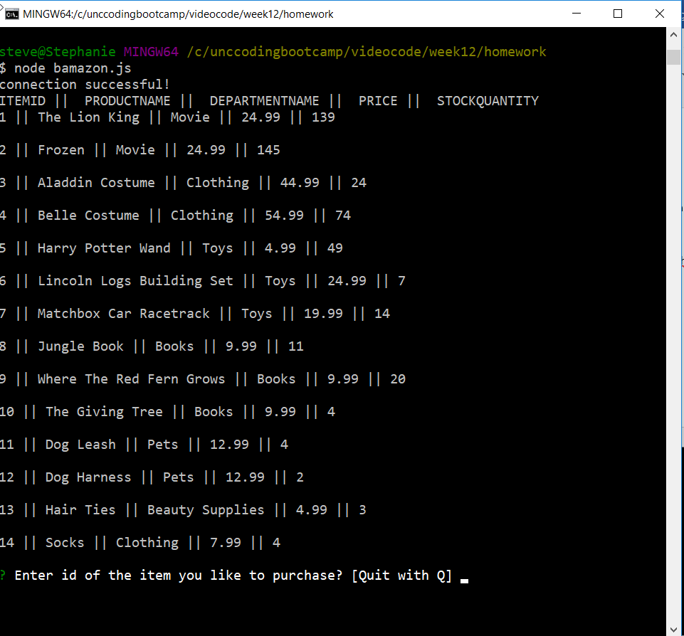

3. Enter the itemid of the item you wish to purchase (ex itemid 3) and press the enter key.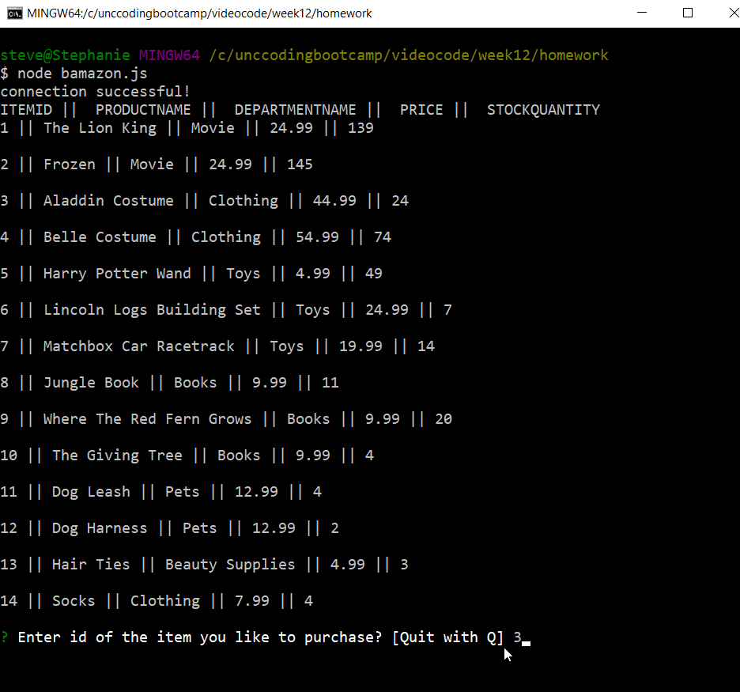

4. Enter how many of the item you wish to purchase (ex 2) and press the enter key.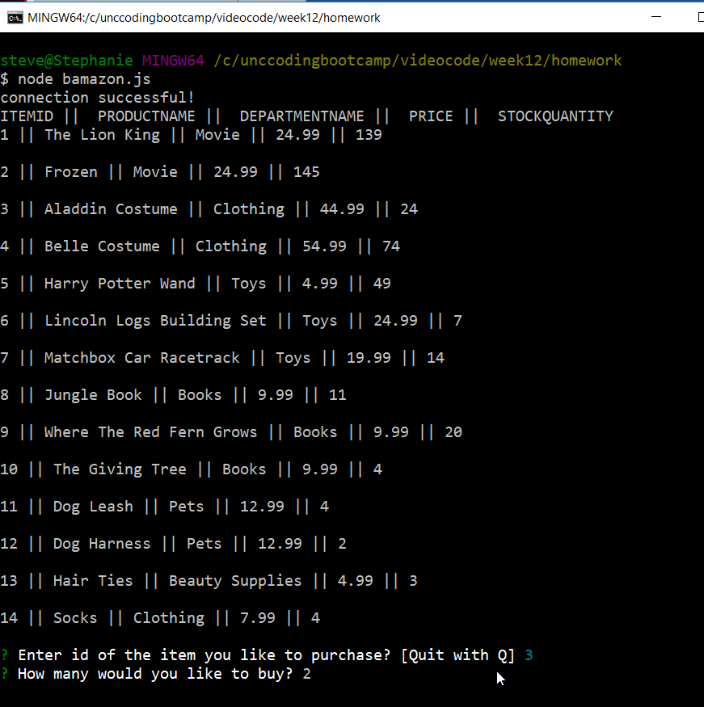

5. If you would like to order more items follow steps 3 and 4 above.

6. When you are finished ordering items hold down the Shift Key and press Q.

**Manager App Instructions**

1. You will need to run npm install before using the bamazon app.

2. To run the bamazon manager app go to gitBash terminal and run the following command:

node bamazonManager.js

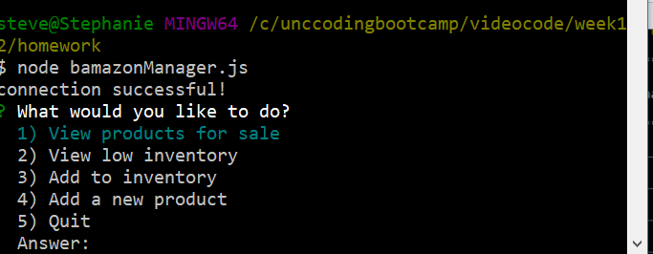

3. Enter 1 beside Answer: to View a list of products for sale

Enter 2 beside Answer: to view low inventory

Enter 3 beside Answer: to add additional inventory to an item

Enter 4 beside Answer: to add a new product

Hold down the Shift Key and press Q to exit the application

4. When adding additional inventory follow these steps

a. Select 3 to add additional inventory

b. Enter the itemid of the item you are adding additional stock to.

d. Enter the number of additional items you want to add to stock. 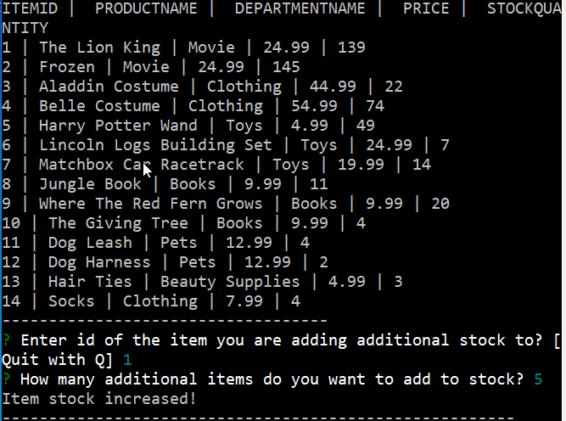

A message will be displayed if the stock was entered correctly.

Select 1 to view a list of products. The updated stock amount can be viewed here.

5. When adding a new product follow these steps

a. Select 4 to add a new product

b. Enter the name of the item you wish to submit.

c. Enter the department the item should be placed in.

d. Enter the price the item will be sold for.

e. Enter the number of the items that are being added to stock.

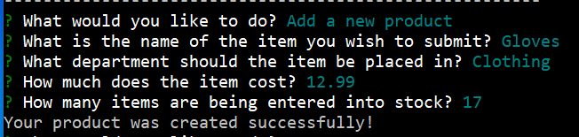

A message will be displayed if the product was entered correctly.

Select 1 to view a list of products. The new product can be viewed here.

6. If you would like to continue viewing stock, viewing low inventory, adding new stock or adding new products follow steps 3 through 5 above.

7. When you are finished hold down the Shift Key and press Q.