Below is the list of fish metrics for the report:

|  |  |  |  |  |
| --- | --- | --- | --- | --- |
| **DISCIPLINE** | **METRIC** | **MAP PRODUCTS** | **TIME SERIES GRAPH** | Comment |
| Towed-diver surveys | Total Large Fish Biomass | Spatial maps with data per segment by year | yes |  |
|  | Total Shark Abundance | Spatial maps with data per segment by year | TBD |  |
|  | Total Jack Biomass | Spatial maps with data per segment by year | TBD |  |
|  | Key Species Encounters | Spatial maps with data per segment by year | No | Key species ot include humphead wrasse, bumphead parrotfish, others TBD |
|  |  |  |  |  |
| REA | Total Fish Biomass excluding sharks and jacks | Bubble Maps | yes | Longer term time series, to pre 2010, require calibration between methods |
|  | Biomass By Consumer Group | Bubble Maps | TBD |  |
|  | Parrotfish Biomass | Bubble Maps | TBD |  |

For each of the products, the idea is to have the data displayed in both the archipelagic chapter showing comparisons across the PRIM and in the individual island chapters. I’ve put together a very rough example of what the sections might look like in the report based on what we talked about as a group and past reports. The bullets indicate some of the figures that will be included under that section. It may be unclear so please let me know if you have questions.

**MOCK CHAPTER**

1. **Archipelagic Comparisons**

**…**

* 1. **Reef Fishes**
     1. Total fish biomass
* Fish biomass across all Pacific Islands

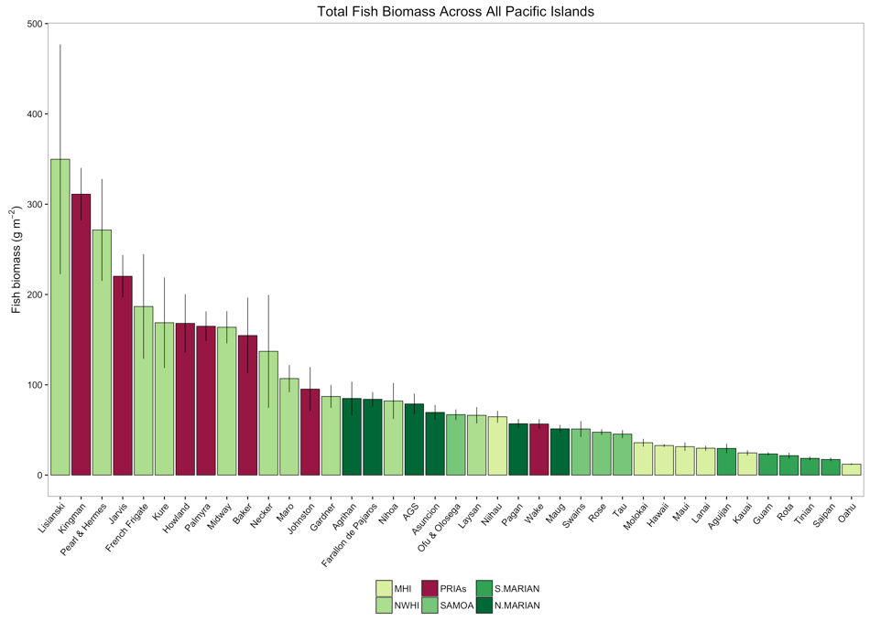

* Fish biomass across PRIM (plot & map of 7 islands: total and consumer groups)

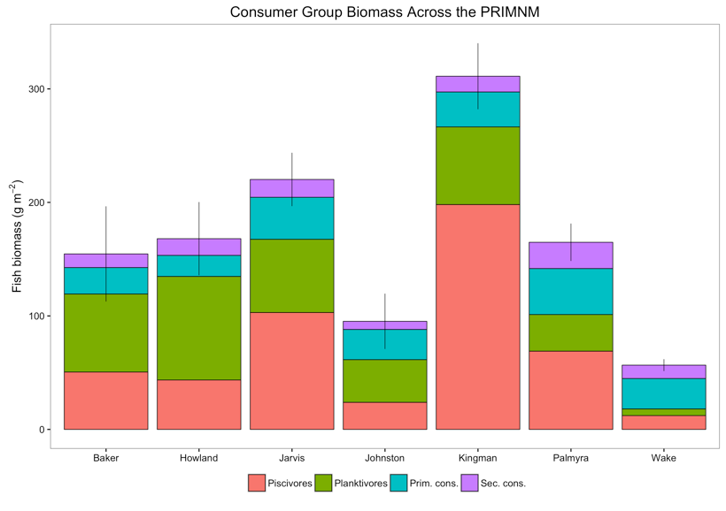

* + 1. Large fish biomass
* Fish biomass across Pacific Islands

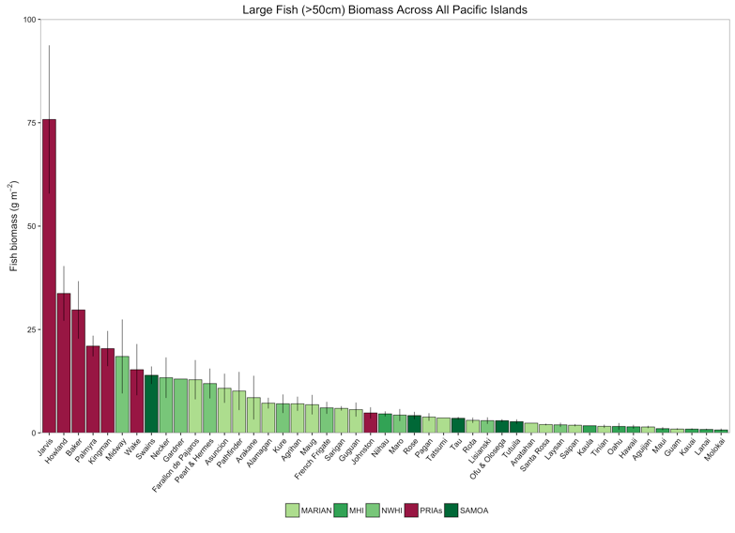

* Biomass across PRIM (mean biomass of large fish across study period similar to SPC plot as well as map)
  + By family rather than consumer group (similar to pg. 24 of Marianas overview report)
* Shark abundance (plot and map)
* Jack Biomass (plot and map)
  + 1. Size class distribution
* Similar to page 25 of Marianas Overview Report
  1. **Species of Concern**
     1. Species of Interest
        1. ESA Corals
        2. Reef Sharks
* Map of key sightings
  + - 1. Rare, Large Fishes
* Map of key sightings (i.e. humphead wrasse, bumphead parrotfish; PIRO is concerned with invasive *Omobranchis rotundiceps obliquus* – if present, may want to show map of sightings over time)

…

* 1. Biodiversity
     1. Coral
     2. Algae (tbd)
     3. Benthic Cryptobiota (comparison with just other PRIMNM)
     4. Microbiota
     5. Reef Fishes
* Species accumulation

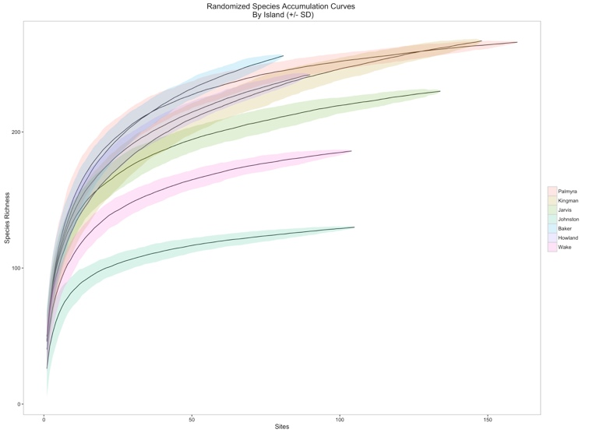

* Potentially Shannon diversity? Not sure how to depict this in the report

1. **Howland**

…

* 1. **Reef Fishes**
     1. Total Fish Biomass
        1. Total fish
           1. Yearly maps (change over time)

Maps of each consumer group and of total fish biomass

* + - * 1. Bar plots (change over time)

Bar plot would just be total biomass stacked by consumer group similar to archipelagic plot

* + 1. Parrotfish biomass (from SPC)
       1. Yearly maps (change over time)
       2. Bar plot?
    2. Large Fish Biomass, Jack biomass, shark abundance
       1. Yearly maps (change over time)
       2. Bar plots
          1. Total biomass stacked by family