Goldilocks and the Three Bears

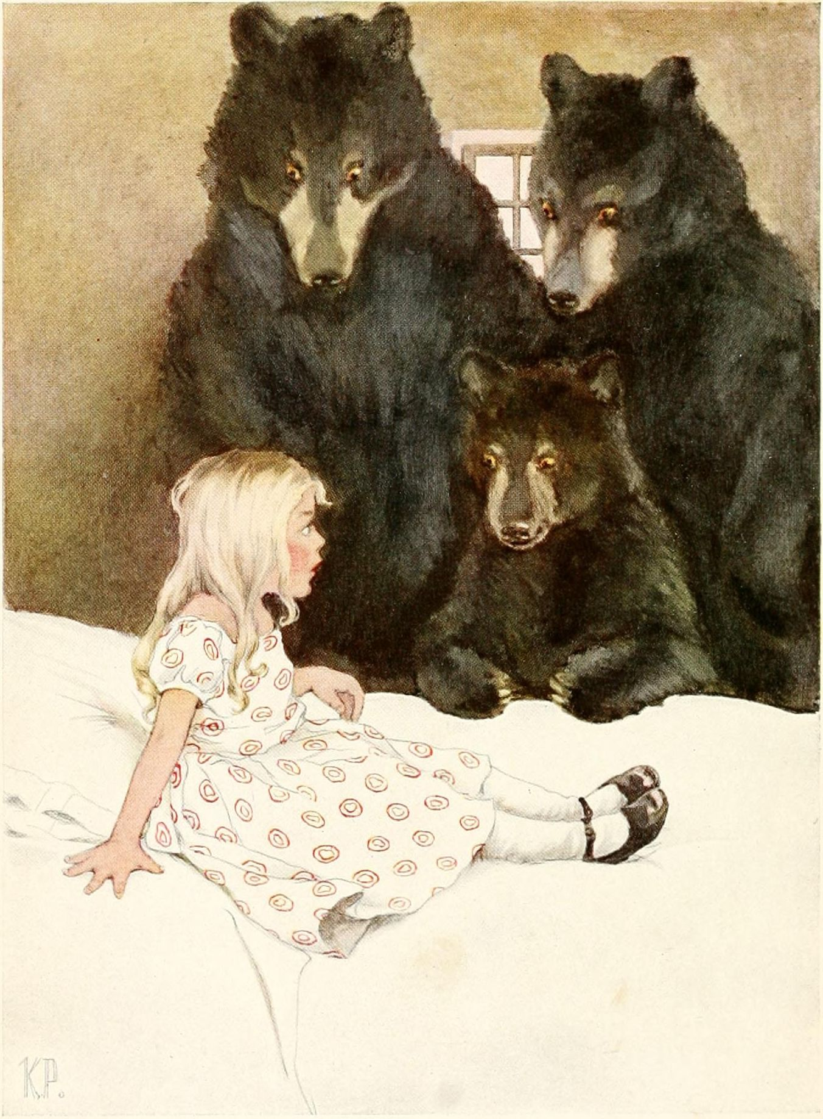
There was once a little girl whose hair was so bright and yellow that it glittered in the sun like spun-gold. For this reason, she was called Goldilocks.
One day Goldilocks went out into the meadows to gather flowers. She wandered on and on, and after a while, she came to a forest, where she had never been before. She went on into the forest, and it was very cool and shady.
Presently she came to a little house, standing all alone in the forest, and as she was tired and thirsty, she knocked at the door. She hoped the good people inside would give her a drink and let her rest a little while.
Now, though Goldilocks did not know it, this house belonged to three bears. There was a great big father bear, and a middling-sized mother bear, and a dear little baby bear, no bigger than Goldilocks herself. But the three bears had gone out to take a walk in the forest while their supper was cooling, so when Goldilocks knocked at the door, no one answered her.
She waited awhile, and then she knocked again, and as still nobody answered her, she pushed the door open and stepped inside. There, in a row, stood three chairs. One was a great big chair, and it belonged to the father bear. And one was a middling-sized chair, and it belonged to the mother bear, and one was a dear little chair, and it belonged to the baby bear. And on the table stood three bowls of smoking hot porridge. "And so," thought Goldilocks, "the people must be coming back soon to eat it."
She thought she would sit down and rest until they came, so first, she sat down in the great big chair, but the cushion was too soft. It seemed as though it would swallow her up. Then she sat down in the middle-sized chair, and the cushion was too hard, and it was not comfortable. Then she sat down in the dear little chair, and it was just right and fitted her as though it had been made for her. So there she sat, and she rocked, and she rocked, and she sat, and she sat, until with her rocking and her sitting, she sat the bottom right out of it.
And still, nobody had come, and there stood the bowls of porridge on the table. "They can't be very hungry people," thought Goldilocks to herself, "or they would come home to eat their suppers." And she went over to the table to see whether the bowls were full.
The first bowl was a great big bowl with a great big wooden spoon in it, and that was the father bear's bowl. The second bowl was a middle-sized bowl, with a middle-sized wooden spoon in it, and that was the mother bear's bowl. And the third bowl was a dear little bowl, with a dear little silver spoon in it, and that was the baby bear's bowl.
The porridge in the bowls smelled so very good that Goldilocks thought she would just taste it.
She took up the great big spoon and tasted the porridge in the great big bowl, but it was too hot. Then she took up the middle-sized spoon and tasted the porridge in the middle-sized bowl, and it was too cold. Then she took up the little silver spoon and tasted the porridge in the dear little bowl, and it was just right, and it tasted so good that she tasted and tasted and tasted and tasted until she tasted it all up.
After that, she felt very sleepy, so she went upstairs and looked about her, and there were three beds all in a row. The first bed was the great big bed that belonged to the father bear. And the second bed was a middling-sized bed that belonged to the mother bear, and the third bed was a dear little bed that belonged to the dear little baby bear.
Goldilocks lay down on the great big bed to try it, but the pillow was too high, and she wasn't comfortable at all.
Then she lay down on the middle-sized bed, and the pillow was too low, and that wasn't comfortable either.
Then she lay down on the little baby bear's bed, and it was exactly right, and so very comfortable that she lay there and lay there until she went fast asleep.
Now while Goldilocks was still asleep in the little bed, the three bears came home again, and as soon as they stepped inside the door and looked about them, they knew that somebody had been there.
“Somebody's been sitting in my chair," growled the father bear in his great big voice, "and left the cushion crooked."
"And somebody's been sitting in my chair," said the mother bear, "and left it standing crooked."
"And somebody's been sitting in my chair," squeaked the baby bear, in his shrill little voice, "and they've sat and sat till they've sat the bottom out," and he felt very sad about it.
Then the three bears went over to the table to get their porridge.
“What's this‽" growled the father bear, in his great big voice, "somebody's been tasting my porridge, and left the spoon on the table."
"And somebody's been taking my porridge," said the mother bear in her middle-sized voice, "and they've splashed it over the side."
"And somebody's been tasting my porridge," squealed the baby bear, "and they've tasted and tasted until they've tasted it all up." And when he said so, the baby bear looked as if he were about to cry.
"If somebody's been here, they must be here still," said the mother bear, so the three bears went upstairs to look.
First, the father bear looked at his bed. "somebody's been lying on my bed and pulled the covers down," he growled in his great big voice.
Then the mother bear looked at her bed. "Somebody's been lying on my bed and pulled the pillow off," said she in her middle-sized voice.
Then the baby bear looked at his bed, and there lay little Goldilocks with her cheeks as pink as roses, and her golden hair all spread over the pillow.
"Somebody's been lying in my bed," squeaked the baby bear joyfully, "and here she is still!"
Now when Goldilocks in her dreams heard the great big father bear's voice, she dreamed it was the thunder rolling through the heavens.
And when she heard the mother bear's middle-sized voice, she dreamed it was the wind blowing through the trees.
But when she heard the baby bear's voice, it was so shrill and sharp that it woke her right up. She sat up in bed, and there were the three bears standing around and looking at her.
"Oh, my goodness me!" cried Goldilocks. She tumbled out of bed and ran to the window. It was open, and out she jumped before the bears could stop her. Then home she ran as fast as she could, and she never went near the forest again. But the little baby bear cried and cried because he had wanted to play with the pretty little girl.

http://gutenberg.org/files/49001/49001-h/49001-h.htm

