Personal data (actual on 2014/07/15)
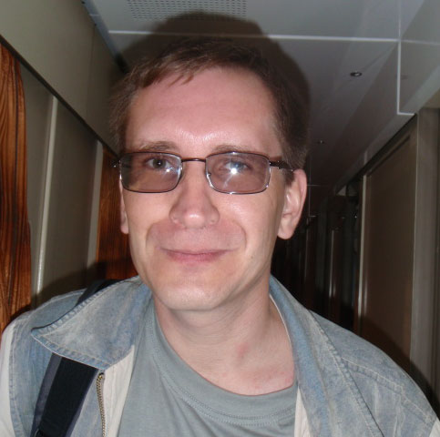 | Name: Sergey Plekhov  Date of birth: 1973/12/03  Marital status: married, 3 children  Citizenship: the citizen of Russia  E-Mail: splekhov@gmail.com  Skype: sergey.plekhov  Mobile phone: +7-921-314-68-02

Interesting vacant positions
Database Developer/Administrator in ISP or another company with wide appliance of LAN and WAN technologies.

Education
Far Eastern State university, faculty of the general biology, ecology and soil science.
Specialisation: the biologist, the teacher of biology and chemistry (5 years). Has finished with the recommendation in postgraduate study.
The diploma: "Using Cluster Analysis to distinguish species of Unioniformes from the Russian Far East."

Operational experience
- Since October 2013 to present time: Luxoft, Saint Petersburg, SL3 Support Engineer. Deployment and support of Credit risk system in Deutschebank, based on Java and Cloudera Hadoop. Wrote a performance monitoring dashboard for this system in Play Framework (Java), PDFbox, Poi, H2, Oracle 11g. Working tools: Eclipse, Git, PL/SQL Developer, Apache Oozie, Lotus Notes, Jira, Confluence, Sharepoint. Console Java apps. with Oracle, JPA(Hibernate4), Apache POI.
- Since March 2011 to October 2013: Vintelligent Inc, Saint Petersburg, Database Engineer. Managing of production and QA environments in SPb and USA based on Oracle VirtualBox, VMware ESXi 3.5, 4.0, 5.0. Installation, configuration, tuning and patching of Oracle 9i, 10g, 11g in Linux and Windows envs. Shell/Perl/PHP programming (with Oracle, PosgreSQL, MySQL). Mercurial, Borland StarTeam – installation, administration and usage. Racoon-based FreeBSD VPNs.
- Since March 2008 to March 2011: NebuAD/RedAril, Saint Petersburg, Operations Engineer. Creation and deployment of QA and monitoring ETL system (PHP5 + Smarty + FusionCharts + Oracle 10.2.0). Sybase PowerDesigner, PL/SQL Developer, Bugzilla, Subversion (using clisnt and setup SVN server both). Monitoring of ETL processes on Oracle on a basis of opensource solutions (Hyperic). Working on additional plugins for Hyperic and development existing procedures for company’s ETL (Perl, DBD::Oracle, PL/SQL). Administration of high loaded Oracle servers on OS Linux RedHat 5.1, CentOS 5.1-2, Fedora Core 6-9. Setup of Cisco Catalyst 2900 XL series, Juniper SSG5 and another switches and routers. SVN, Puppet, Cacti, Nagios and much more. Deployment and administering of CruiseControl system.
- Since February 2003 till March 2008: PROMT LTD, Saint Petersburg, System Administrator, WEB-developer. Participation in working on sites www.online-translator.com, www.promt.com, (ru/de/fr/es), designing of databases and interfaces to them on PHP, Perl + MySQL-PostgreSQL. C, C++ (gcc) – porting of some company’s applications from Windows platform to Linux. Turning and administration of ftp://ftp.promt.ru, ftp://ftp.promt.com (Proftpd). Servicing of high loaded servers on collocation hostings: Linux (Slackware 9), FreeBSD 4.x, Windows 2000-2003 (SPb, WebPlus/iWEB, Canada); on dedicated hosting – FC4 (USA), Slackware (SPb, Peterhost). Setup and administration (Bind, TLD registration) mail servers translate.ru, mail.e-promt.com; antispam solutions on base of Postfix+Amavisd+Clamav+SpamAssassin. CVS, VSS. Iptables+ulogd, traffic accounting, snmpd+mrtg, nagios, etc. Billing development for ASP translation system. Load balancing solutions on the basis of Apache mod_proxy_balancer, nginx. Operational experience with the systems which are under high loading 24x7.
- Since June 2001 till January 2003: Joint-Stock Company "VZLJOT", Saint Petersburg, DBA/DBD. Designing interfaces to company’s ERP system, database structure development, administration of SQL-servers, firewalls, mail servers (Qmail). MS Access+ODBC+MySQL, PostgreSQL, development of 1С modules for data transfers between MySQL and MS SQL, user’s support.

Certificates
The full list of current certificates is accessible on site BrainBench for the 21043 identifier.

Additional skills
- English language: Upper-intermediate (according with internal Luxoft testing).
- Planning and realization of network security on various levels;
- Team working experience without a team-leading;
- Initiative, responsible, capable to make decisions quickly in critical conditions;
- User’s support experience;

Hobbies
Aikido, bicycle, rollers, skis, rafting.

