Magento SMS PRO Manual v1.0
This extension will allow you to send SMS to your customers and/or yourself (shop owner) over the Nexmo SMS gateway.

Installation
After you extract archive you must:
- Open “root” folder and select all folders.
- Copy & paste them into your magento store root folder (where you also have folder “app”, “lib”, “skin”, “var” and others)
- When asked if you want to merge and/or replace files click yes to all.

- Go to magento backend and clear all cache.

Configuration
Magento SMS PRO is very easy to use. In the next sections we will show you how configure it and how to use it.
First go to SMS PRO configuration page: System > Configuration > SMS PRO
In “General” tab you will have to enter your Nexmo account key and secret. You can find this information in your Nexmo account https://dashboard.nexmo.com/login
You should also enter your name or number of the SMS sender (e.g. MyCompany) and the number you want to receive SMS messages (shop owner number).

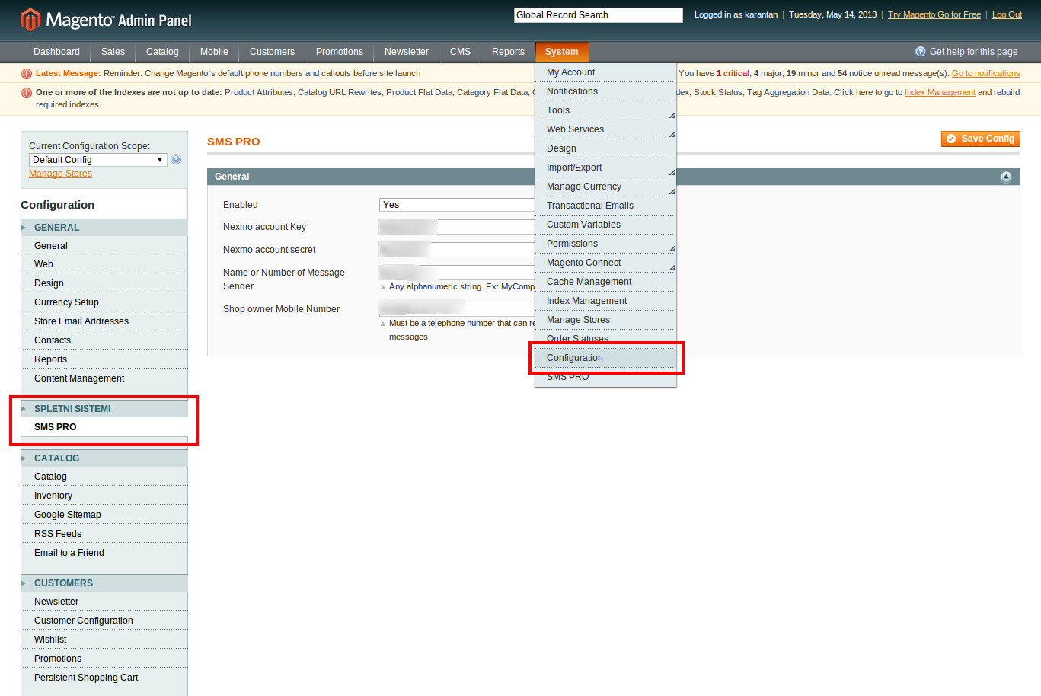Illustration 1: SMS PRO Configuration page

Events
You can create different events to take effect when customers or system administrator triggers this event.
When you select “Send on (event)” you will see that “Message Template” will be filled with some predefined data. You can modify this template to your needs. You will also see that you can select SMS recipient. It can be sent to customer, shop owner or both. Shop owner number is set in the SMS PRO configuration page. See the Configuration section for more details.

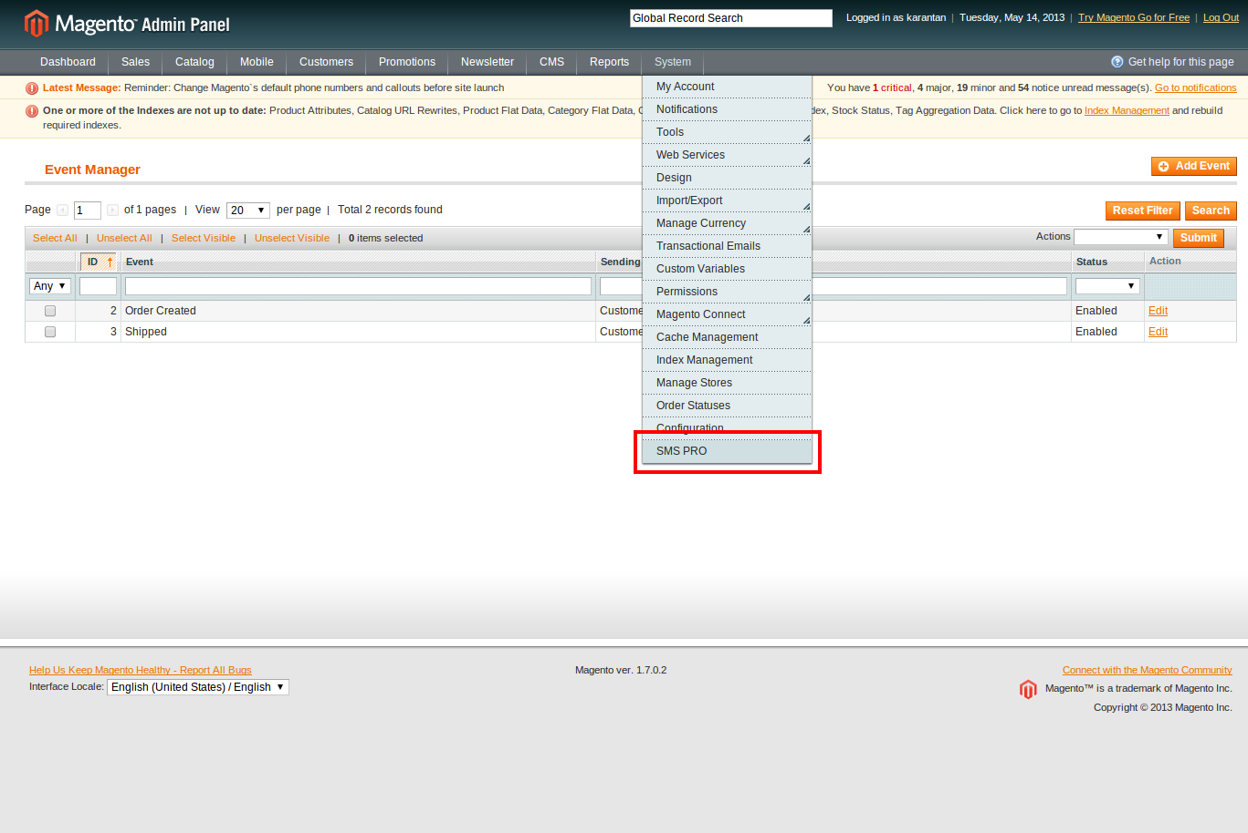Illustration 2: SMS PRO Event Menu

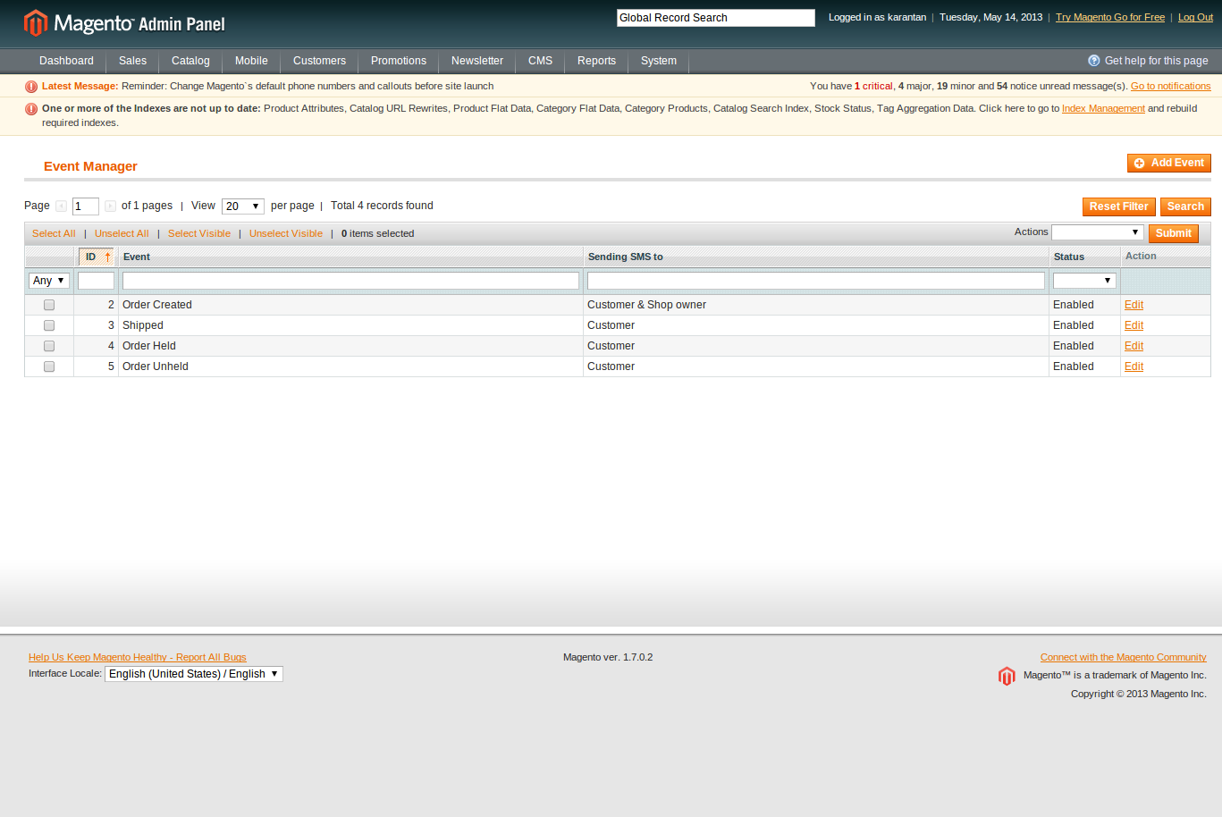Illustration 3: SMS PRO Event Index

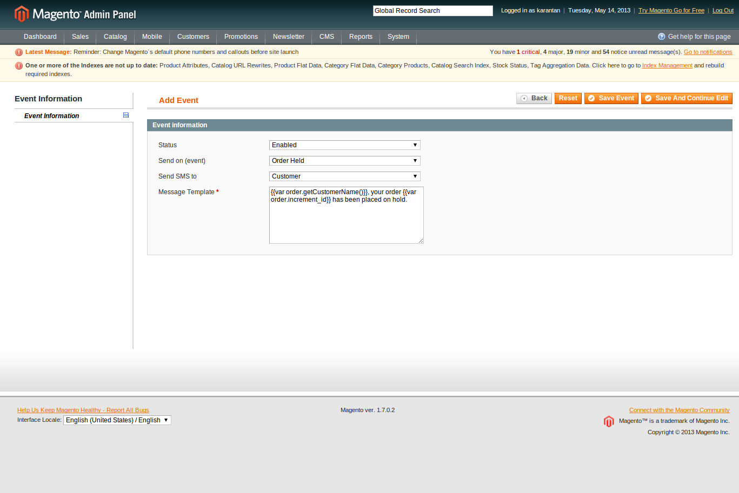Illustration 4: SMS PRO Add Event

Messages
You can see Pending, Sent and Failed SMS messages in Sales > SMS PRO Messages
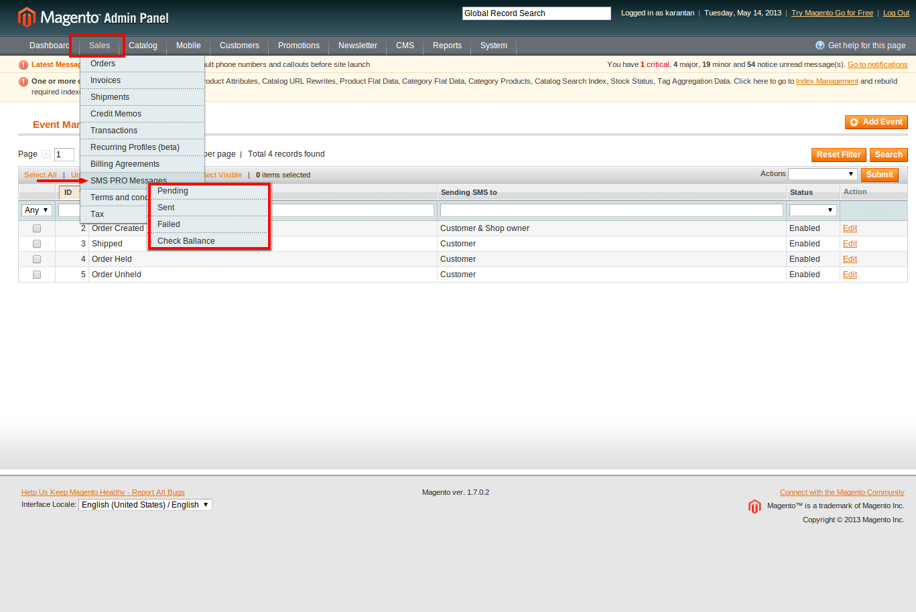Illustration 5: SMS PRO Messages Menu
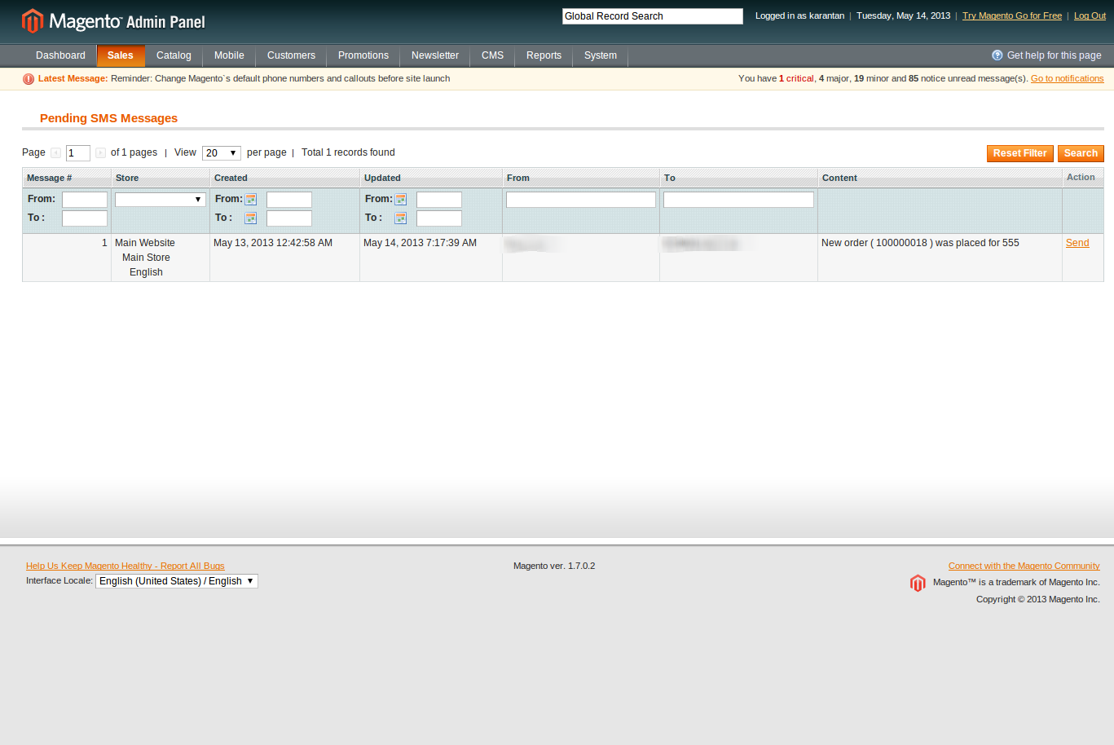Illustration 6: Pending Messages

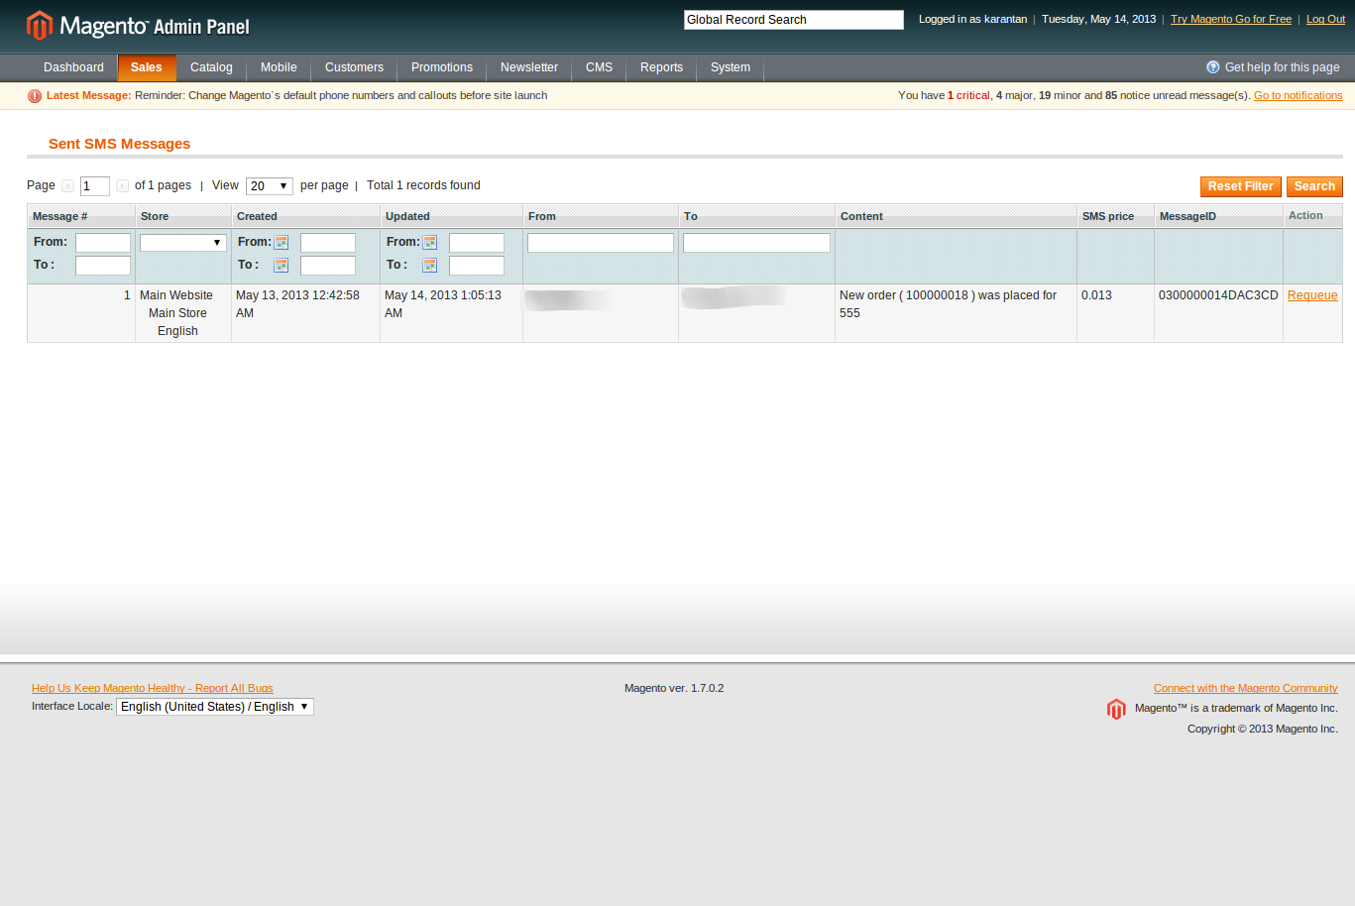Illustration 7: Sent Messages

Illustration 8: Failed Messages

You can also check your Nexmo account balance in the “Check ballance” tab.
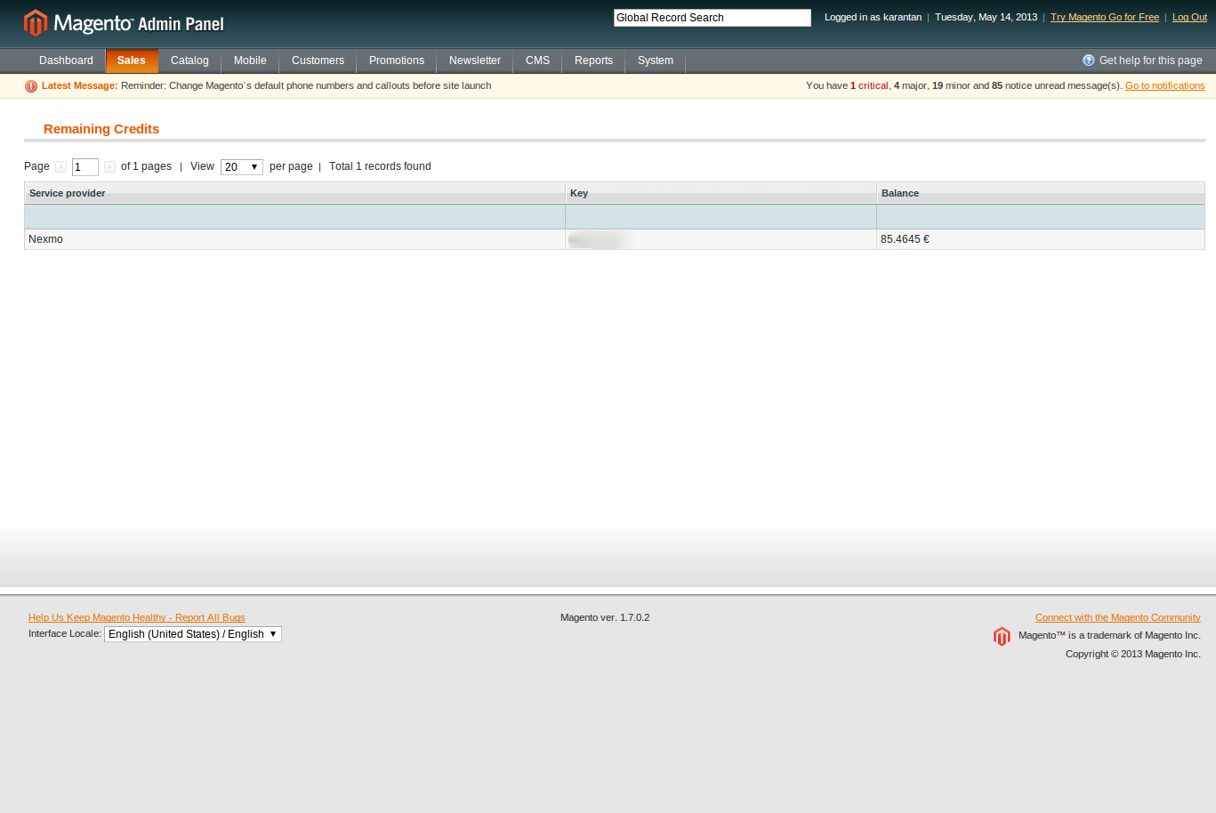Illustration 9: Ballance

Contact
If you have any questions about this module send us email on info@spletnisistemi.si.

