Project 3 – Incompressible Navier-Stokes Equations

Table of Contents
Abstract 3
Introduction and Literature Review 4
Introduction and Physics of the Problem 4
Boundary Conditions 4
Rayleigh-Benard Convection 4
Rayleigh Number 5
Methodology 7
Solution Strategy 7
Operator splitting 7
Upward Finite Difference Method 7
Two-Dimensional Upwind Scheme 7
Chorin’s Projection Method 7
Jacobian Poisson Solve 7
FFT Poisson Sover 8
Results and Discussion 9
3.1 Numerical Verification of Advection 9
4.1 Analysis of the Projection Method Step 10
4.2 Stability and Time-Stepping 10
3.2 Incompressible Flow Performance 10
Implementation Analysis 10
Poisson Solvers: Jacobi and FFT 11
Jacobi Iterative Method 11
Fast Fourier Transform (FFT) Method 11
Analysis of Divergence 11
FFT (Solving Divergence with FFT) 12
Rayleigh-Benard Convection Results 13
Conclusions 15
Current Challenges 15
Bottlenecks and Parallelization 15
References 16

Abstract

[Summary of the problem, the methods used, and the selected outstanding results]

Introduction and Literature Review

Introduction and Physics of the Problem

The focus of this project is the numerical solution of the incompressible Navier-Stokes equations in a two-dimensional domain subject to a thermal gradient. Unlike many steady-state engineering problems, this project follows a transient simulation approach. This is dictated by the physics of Rayleigh-Benard convection, where our objective is to observe the evolution of "convection cells" from an initial state of rest toward dynamic equilibrium.
The system consists of a fluid confined between two horizontal plates; the bottom plate is heated, while the top plate is kept cold. Based on the Boussinesq approximation, density variations are neglected in all terms except for the buoyancy term in the vertical momentum equation ($βTe_{z}$). This coupling allows temperature differences to drive fluid motion. Consequently, we should solve a coupled system of three Partial Differential Equations (PDEs): continuity (mass conservation), Navier-Stokes (momentum), and the energy(heat) equation.

Boundary Conditions

Rayleigh-Benard Convection

Rayleigh-Benard convection cells can be observed in everyday situations such as a boiling kettle or in atmospheric studies. They form when a fluid (such as water or air) is heated from below, causing it to circulate through its entire depth by rising from the bottom, cooling near the top, and sinking again in a repeating loop.
To describe this phenomenon using the example of a water kettle placed on a heater, as the fluid at the bottom begins to warm it becomes less dense and therefore more buoyant. The warmer fluid rises toward the surface while the cooler and denser fluid sinks downward to replace it. As this process continues, a pattern can be observed forming in the fluid flow. These patterns are known as Bénard cells and are caused by Rayleigh-Benard convection.
As the warm fluid reaches the surface it spreads outward across the top of the container, while the cooler fluid moves inward and downward along the edges of the cells. Once the fluid reaches these cooler regions it begins to lose heat and sink back down toward the bottom of the container where it can be reheated. This process creates a continuous circulation loop in the fluid. When the temperature difference across the fluid layer becomes sufficiently large, these convection cells form stable and organized patterns across the surface of the fluid. The center of each cell is typically warmer, while the boundaries between cells are cooler, producing the characteristic cellular pattern.

Rayleigh Number
Whether or not Benard cells form is determined by a non-dimensional quantity called the Rayleigh number (Ra). The Rayleigh number represents the ratio of buoyancy forces that drive convection to the stabilizing effects of thermal diffusion and viscous damping within the fluid.
$$Ra_{x}=\frac{gβ(T_{b}-T_{u})x^{3}}{να}=Gr_{x}Pr$$
$$Gr_{x}=\frac{gβ(T_{b}-T_{u})x^{3}}{ν^{2}}$$
$$Pr=\frac{ν}{α}$$In these expressions, $g$ is the acceleration due to gravity, $β$ is the thermal expansion coefficient of the fluid, $ν$ and $α$ are the fluid kinematic viscosity and thermal diffusivity respectively. The term $\left(T_{b} − T_{u}\right)$represents the temperature difference between the bottom and top of the fluid layer, and $x$ (or $L$) represents the height of the fluid layer.
The Rayleigh number can also be expressed as the product of two other dimensionless numbers: the Grashof number ($Gr$) and the Prandtl number ($Pr$). The Grashof number represents the ratio of buoyancy forces to viscous forces in the fluid, while the Prandtl number represents the ratio of momentum diffusion (viscous effects) to thermal diffusion.
For a horizontal fluid layer heated from below, convection begins when the Rayleigh number exceeds a critical value of approximately $1708$. If the Rayleigh number is less than $1708$ ($Ra<1708$), heat transfer takes place mainly through thermal conduction, and the fluid layer remains stable with little or no circulation. When the Rayleigh number exceeds $1708$ ($Ra>1708$), the fluid becomes unstable and the organized convection cells begin to form, producing the characteristic Rayleigh-Benard cell pattern. Therefore, Low Rayleigh numbers indicate weaker convection, and higher Rayleigh numbers indicate stronger, more intense convection.

 |  | 
(a) Heat diffuses upward by conduction. No fluid motion yet. | (b) When Ra>1708, convection begins. | (c) at high Rayleigh number, we see turbulent convection. Thermal plumes from the boundary plates disrupt the laminar convection.
Figure 1. Rayleigh-Benard Convection

https://www.terpconnect.umd.edu/~dsvolpe/TREND/2019/Media/Chang/convection.html

Video
Colorful simulation of 2D RB convection with a high Ra (turbulent convection):
https://www.youtube.com/watch?v=OM0l2YPVMf8&t=206s

Methodology

Solution Strategy

The simulation utilizes an Explicit Euler scheme for temporal advancement. While explicit methods are straightforward to implement, they impose a strict constraint on the time step, defined by the Courant-Friedrichs-Lewy (CFL) condition. In our implementation, we selected for a grid to ensure the Courant number remains below 1. This prevents physical information from propagating faster than the numerical scheme, avoiding numerical divergence.

Operator splitting

Upward Finite Difference Method

Two-Dimensional Upwind Scheme

Chorin’s Projection Method

Jacobian Poisson Solve

FFT Poisson Sover

Results and Discussion

3.1 Numerical Verification of Advection
The first task involved testing the Upwind finite difference scheme using a $2D$ advection problem. The numerical results for the velocity components $v$ and $w$ were compared against the analytical solutions. For a $100×100$grid, we observed a maximum error of approximately $0.38$ for $v$ and $0.42$ for $w$. This level of error is consistent with first-order numerical schemes, which are known for introducing numerical diffusion, causing the profiles to dampen over time.

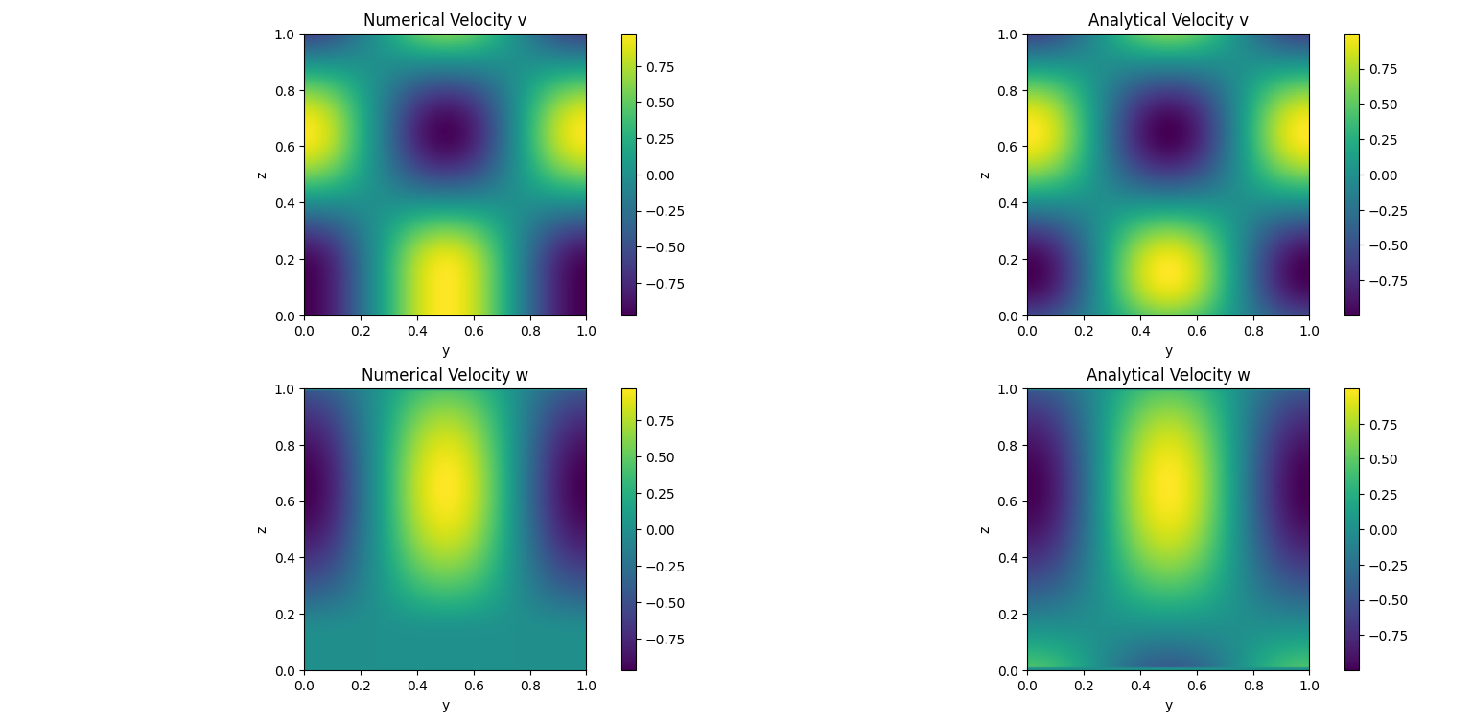 | 
 | 
Comparison of analytical and numerical solutions in advection test

4.1 Analysis of the Projection Method Step
The reduction of divergence from $1.82$ to $0.05$ demonstrates the sensitivity of the projection method to boundary conditions. The remaining divergence error ($5.55\%$) is primarily attributed to the Jacobi iterative solver used for the Poisson equation. Since the Jacobi method has a slow convergence rate for high-frequency errors, increasing the number of iterations or employing a more robust solver like the Conjugate Gradient method (CG) or Fast Fourier Transform (FFT), would further drive the divergence towards machine epsilon (${10}^{-10}$ or smaller).

4.2 Stability and Time-Stepping
The use of an Explicit Euler scheme necessitates a strict adherence to the Courant (CFL) condition. In our simulations, a time step of $∆t=0.001$ was chosen to maintain a Courant number below $1$. While an implicit scheme would allow for larger time steps, the current explicit implementation provides a clear and computationally straightforward approach for studying transient Rayleigh-Bénard convection cells without the excessive computational costs of massive matrix inversions.
We considered two options for the numerical approach: Explicit Euler and Implicit Euler. If we chose Explicit, we had to tune the solver with many simple, “cheap” time steps governed by strict stability limits ($CFL<1$). If we opted for the Implicit approach, we would have executed fewer, “expensive” time steps that are stable at larger intervals but require heavy matrix calculations. Eventually, due to fewer complexities and need for stronger processors, we employed the Explicit Euler method for our numerical approach.

3.2 Incompressible Flow Performance
The core of the simulation, the Chorin’s projection method, was tested for mass conservation. In the initial implementation, the maximum divergence of the velocity field was high (1.82), indicating poor pressure correction. After refining the Neumann boundary conditions for the pressure Poisson solver and ensuring the grid spacing correctly accounts for the wall boundaries, the maximum divergence was significantly reduced to ${5.55 ×10}^{-2}$. This confirms that the projection step is effectively enforcing the incompressibility constraint $∇∙u≈0$.

Implementation Analysis
In this stage, the model was completed by incorporating the temperature ($T$) advection-diffusion equation and coupling it with the Navier-Stokes equations. The buoyancy term, scaled by coefficient $β$, was added to the vertical velocity ($w$) equation to simulate the thermal effects on fluid motion, which would be rising of warm air and sinking of cold air.
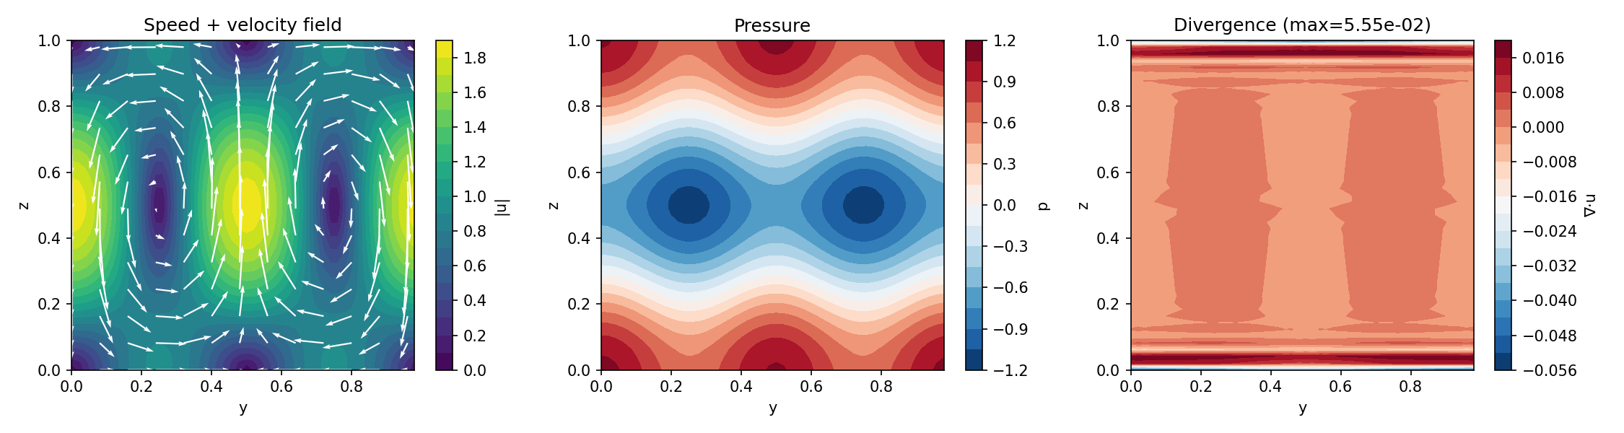
Figure. Initial Flow Field

Poisson Solvers: Jacobi and FFT
The core of Chorin's Projection method is solving the Poisson equation for pressure. We explored two distinct approaches with vastly different outcomes.

Jacobi Iterative Method
Initially, the Jacobi method was used. It starts with an initial pressure guess and iteratively reduces the residual. However, as shown in the table below, this method is too slow for high-precision requirements. The initial divergence of 1.8 indicated that the pressure field was not correctly enforcing the incompressibility constraint.

Fast Fourier Transform (FFT) Method
In the final version, the Poisson solver was replaced with an FFT-based approach. This method transforms the problem from the spatial domain to the frequency domain, where complex derivatives become simple algebraic divisions.

Analysis of Divergence


Figure. Divergence field in the Jacobian method Max Divergence = 5.55e-02

FFT (Solving Divergence with FFT)
The primary challenge in previous versions was high divergence caused by the limitations of the Jacobi iterative solver in handling the Poisson equation. By replacing it with the Fast Fourier Transform (FFT) method, the maximum divergence was reduced from ${10}^{-2}$to approximately ${10}^{-15}$. This transition not only achieved machine-precision accuracy but also significantly accelerated computational performance.

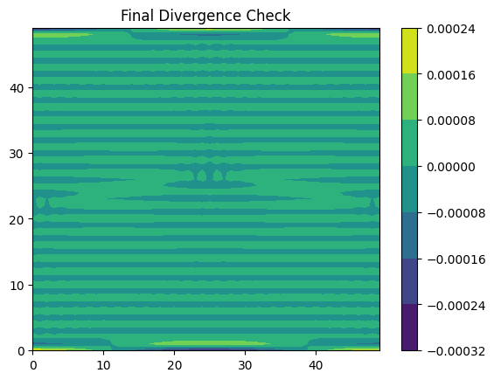
Figure. Achieving divergence error at machine precision accuracy using FFT solver.

Table 1. Divergence Comparison
Solver Type | Iterations/ Method | Max Divergence | Status Analysis
Initial Jacobi | 1,000 Iterations | 1.894 | Unstable/ Unacceptable
Optimized Jacobi | 5,000 Iterations | $$5.55×{10}^{-2}$$ | Moderate Accuracy (5% error)
FFT (Final Version) | Direct Solver | $$5.55×{10}^{-16}$$ | Ideal (Machine Precision)

Reaching divergence signifies that the mass conservation principle is perfectly satisfied. This resolves a major bottleneck in CFD codes, providing a robust foundation for the thermal simulation.

Rayleigh-Benard Convection Results
Results from the updated code demonstrate the formation of classical convection cells. Warm plumes (red) rise from the bottom while cold plumes (blue) sink from the top. These circulation patterns confirm the simulation's success in capturing Rayleigh-Bénard physics and the stability of the numerical method under periodic (in $y$) and wall-bounded (in $z$) boundary conditions.

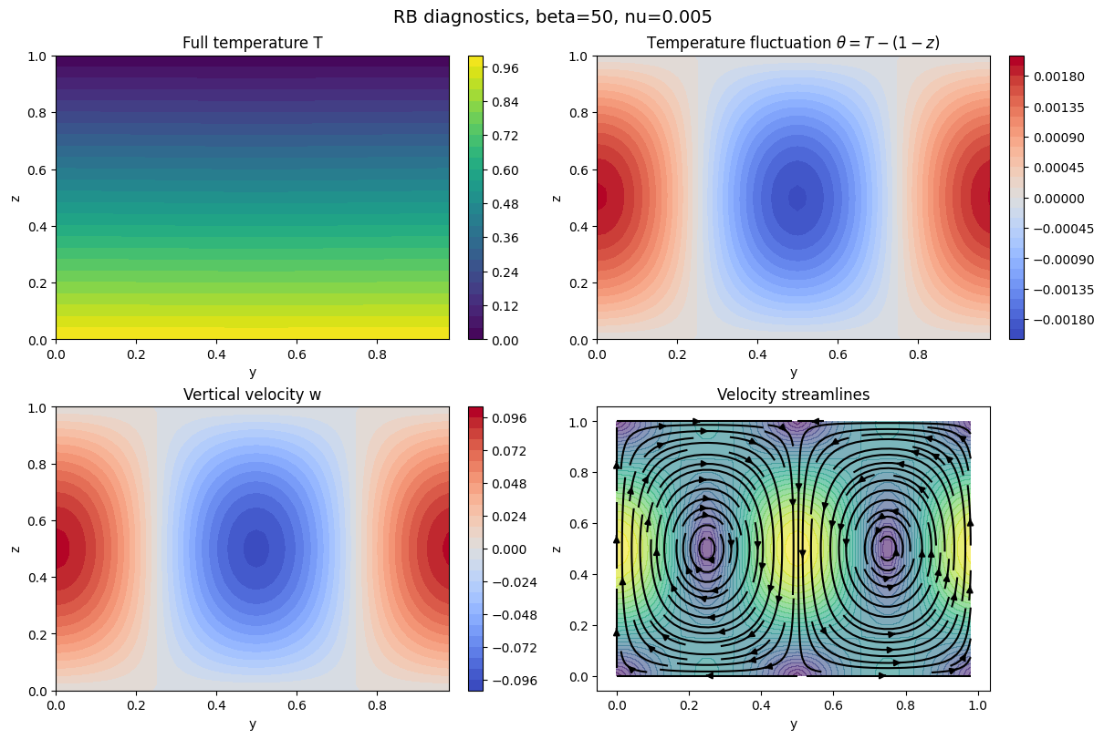
Figure. Rayleigh-Benard Diagnostics

Conclusions

[This section is like the Abstract section. It discusses the solution proposals and numerical methods briefly and highlights the findings and the results]

The project successfully achieved:
- Solution of Navier-Stokes equations applying coupled momentum and temperature equations.
- Elimination of divergence error using the FFT-based Poisson solver.
- Maintaining stability through strict adherence to the CFL condition.

Current Challenges
Despite resolving the divergence issue, fine-tuning physical parameters like the Rayleigh number ($Ra$) to observe the transition from laminar to turbulent flow remains a challenge. Additionally, the strict reliance on small time steps (CFL condition) due to the explicit nature of the code highlights the potential for further optimization via parallel processing.

Bottlenecks and Parallelization
While the FFT accelerated the pressure solution, the Advection and Diffusion calculations remain computationally expensive for larger grids. To observe turbulent regimes at higher Rayleigh numbers, parallel processing is essential. Implementing DASK to distribute the workload across multiple cores will remove the current time bottleneck and allow for higher-resolution simulations.

References

