**CHAPTER 1**

**INTRODUCTION**

The ingenious brain tracker is a device that uses the Brain-computer interfaces (BCI) which are the system that allows the user to translate brain activities into a set of commands for the computer to understand to control any computer application or Neuroprosthesis. Several methods are existing to detect brain activity such as magneto encephalography (MEG), Functional Magnetic Resonance Imaging (FMRI) and Electroencephalogram (EEG). But EEG signals have rapid response time and are inexpensive method relative to other methods, so it is widely used to monitor brain activity in BCI research. In 2025, widespread applications will use brain signals as an important source of information. Routine applications in professional context, personal health monitoring, and medical treatment. [1].The upcoming future where humans and information technology are seamlessly and intuitively connected by integrating various bio signals, from brain activity. Game, health, education, and lifestyle companies will be associated to brain and other bio signals to develop applications and electronic gadgets for a wider community. People want to monitor their brain states to provide them with reliable estimates of their mental capacity and performance level. But the EEG has rapid response time and is inexpensive method relative to other methods, so it is mostly used in the BCI research. The aim of human computer interaction (HCI) is to improve the interactions between human and computers. Because most computers lack understanding of user’s emotions, sometimes they are unable to respond to the user’s needs automatically and correctly. However human emotion plays a vital role in perception, cognition and social behavior [2]. The EEG signals are recorded as a weak potential by placing the electrodes on the scalp and analyze to establish a BCI system. The recorded EEG signals are processed offline to extract features and classify emotions. In this work EEG signals are recorded in real time and processed using wavelets to extract significant features for emotion analysis.

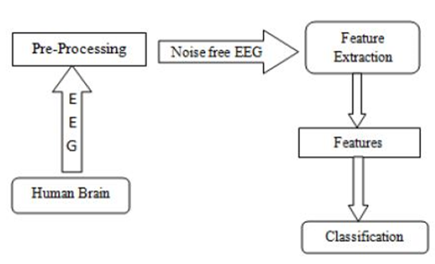

**Figure.1.1:** Basic BCI block diagram

The Fig.1 shows the block diagram for BCI. From the BCI signal analysis, it is observed that, EEG signal has been acquired from the scalp of the brain using EEG acquisition set-up. The acquired raw EEG signal is preprocessed. Preprocessing in EEG signal is to remove the baseline and performing its average of the signal from the original signal. The noise free EEG signal is analyzed by using wavelet transform to extract all the fundamental frequency components of EEG signal i.e. alpha, beta, gamma, delta and theta. The frequency sub band separation of EEG signal for emotion classification is based only on the decomposition of the signal to certain levels. This is followed by feature extraction from these sub bands. Classification of emotions is carried out on the basis of these features. Wavelets and Neural Networks are used for Classification and Detection of brain waves as they provide distinct features. However, selection of appropriate multilevel decomposition of brainwave signals in identifying the prominent features from the EEG signal provides a scope for development of Novel Algorithm.

Numerous patients are alluded to a neurologist to have an electroencephalogram (EEG), which records electrical motivations from the nerves in the head. "Electro" alludes to the electrical driving forces sent starting with one nerve cell then onto the next. These motivations are the way nerves converse with one another and get data from the mind. "Encephalo" alludes to the head, and "gram" alludes to the printed record. EEG exams are finished by putting cathodes on the scalp and seeing what the electrical motivations look like when the patient is alert, snoozing, in a room with a glimmering light or infrequently when the patient is requested that inhale profoundly again and again. At the point when the EEG is done, no power is put into or taken out of the patient. The electrical signs that the mind produces are essentially recognized and printed out on a PC screen or a bit of paper. An EEG decides the understanding's level of readiness or awareness is normal, irregularities in particular piece of the mind, propensity to have seizures or writhing and specific sort of epilepsy. Some of the times a patient may tend to have seizures, however his or her EEG is ordinary at the specific time it is finished. That is on account of individuals with a seizure inclination may have variations from the norm that go back and forth from hour to hour or normal. In these cases, a rehash EEG or a more drawn out time of EEG observing may be valuable.

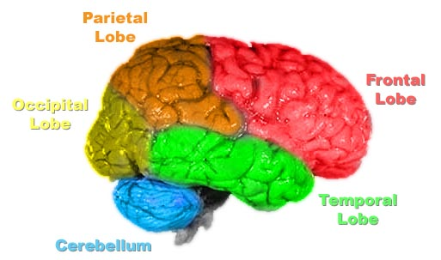

**Figure 1.2:** Human Brain

The interesting thing is that the 5 types of brainwaves measured and reported originate from different parts of the brain. They also have extremely low amplitudes which are measured in microvolts (µV) and low frequencies. The fundamental frequencies of the human EEG waves are:

**Delta:** It has a frequency of 3 Hz or below. It tends to be the highest in amplitude and the slowest waves. It is typical as the dominant beat in infants up to one year and in stages 3 and 4 of sleep. It is typically most prominent frontally in grown-ups (e.g. FIRDA - Frontal Intermittent Rhythmic Delta) and posterior in children e.g. OIRDA - Occipital Intermittent Rhythmic Delta).

**Theta:** It has a frequency of 3.5 to 7.5 Hz and is classified as "moderate" movement. It is perfectly typical in children up to 13 years and in sleep however irregular in grown-ups. It can likewise be seen in generalized circulation in diffuse disorders, for example, metabolic encephalopathy or some instances of hydrocephalus.

**Alpha:** It has a recurrence somewhere around 7.5 and 13 Hz. It is generally best found in the back districts of the head on every side, being higher in sufficiency on the overwhelming side. It shows up when shutting the eyes and unwinding, and vanishes when opening the eyes or alarming by any component (considering, figuring). It is the real cadence found in ordinary loose grown-ups.

**Beta:** The beta movement is "quick" action. It has a recurrence of 14 and more prominent Hz. It is generally seen on both sides in symmetrical conveyance and is most clear frontally. It is emphasized by narcotic trance-like medications particularly the benzodiazepines and the barbiturates. It might be non-attendant or lessened in zones of cortical harm. It is large viewed as an ordinary beat. It is the prevailing cadence in patients who are ready or restless or have their eyes open.

**Gamma:** Gamma waves are in the recurrence scope of 31Hz and up. It is believed that it mirrors the instrument of awareness. Beta and gamma waves together have been connected with consideration, recognition and insight.

**Table 1.1:** Commonly recognized frequencies

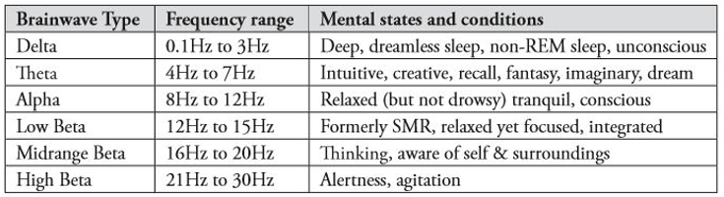

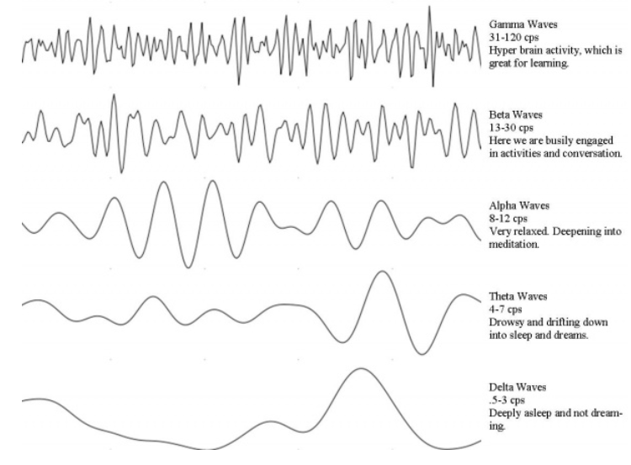

**Figure 1.3:** Brain Wave Graph

The goal of this project is to gain knowledge of the two domains i.e. Brain-Computer Interfaces, especially methods for analyzing brain waves, and the NeuroSky mind wave bad equipment. From this research, a prototype software application should be implemented that is able to read brain wave input from an EEG device, classify them, and make them be part of the or the only, user input to a game. A simple example scenario is as follows: A user is wearing the NeuroSky mindset that forwards brain wave signals to the software application. In order to get general information about the user brain wave pattern, a series of mental task scenarios must be executed by the user. This information will then be used to train a classiﬁcation system so it can learn to recognize and thus map diﬀerent brain patterns to actions.

An fMRI scan is a functional magnetic resonance imaging scan that measures and maps the brain’s activity. An fMRI scan uses the same technology as an MRI scan. An MRI is a noninvasive test that uses a strong magnetic field and radio waves to create an image of the brain. The image an MRI scan produces is just of organs/tissue, but an fMRI will produce an image showing the blood flow in the brain. By showing the blood flow it will display which parts of the brain are being stimulated. As I mentioned above, the fMRI looks at blood flow in the brain to detect areas of activity. Glucose is the brain's primary source of energy, but glucose is not stored in the brain. So when parts of the brain need energy to perform an action, more blood flows in to transport glucose to the active areas, thus more oxygen-rich blood enters the area. For example, when you are speaking there is glucose and oxygen-rich blood flowing to the part of your brain designated to speaking.

During an fMRI scan the patient is asked to perform a specific task to increase oxygen-rich blood flow to a certain part of the brain. Such as tap their thumb against their fingers, look at pictures, answer questions on a screen, think about actions based off a picture (ex: they see a picture of a book and think about actions like read a book, write a book, buy a book), etc. For the tasks where the patient is asked a question, most of the time the patient is told to just think about the answer that way the speech part of the brain is not activated as well. The primary reason for an fMRI scan is to help map a patient's brain before they go into brain surgery. Creating this map will help doctors better understand the regions of the brain linked to critical functions such as speaking, walking, sensing, or planning.

Magneto encephalography (MEG) is the newest, most advanced method of recording and evaluating the brain while it is actively functioning. This recording provides a direct measurement of the ongoing function of normal neurons and can pinpoint the location of malfunctioning neurons. MEG can be used either to evaluate the brain’s spontaneous activity (e.g., for epilepsy) or to check its response to specific external stimuli (e.g., for mapping motor and sensory areas, language, vision and other functions). MEG can localize epileptic activity more accurately than any other noninvasive modality can without the smearing and blurring that affect the electroencephalogram (EEG). Due to a very large number of sensors, as well as the absence of any effect from skull or scalp, MEG has an inherently high resolution. When we combine MEG with the high resolution anatomic images obtained via MRI, we can localize the neuronal activity to a specific sub lobar area, usually to a specific gyrus or sulcus.

Cognitive-behavioral interventions for children with autism spectrum disorders (ASD) have emerged in the last two decades, and these interventions are now regarded as evidence-based. However, reviews conducted so far often focus on speciﬁc areas and do not examine broad trends in the development of relevant research in this area. This current trend analysis provided an overview of the development in the research of cognitive-behavioral interventions for children with ASD. This study is based on a total of 103 reports located through a database keyword search and ancestral search. It was observed that early stage qualitative case studies have been gradually replaced by experimental studies, while the use of randomized, controlled trials is still limited. Participants included were mainly children with ASD and typical cognitive ability, and demographic description was often incomplete. Programs used were heterogeneous and often replicated. A heavy reliance on rating scales rather than behavioral observation and insuﬃcient data on eﬀect maintenance and generalization were observed. Very recently, researchers conducted supplementary analysis on intervention data and provided information not available in original trial reports. A trend to include younger participants (i.e., children at or below 8 years of age) was observed. Although a substantial number of experimental group studies have been conducted, the proportion of randomized, controlled trials and sample sizes did not increase as expected. Consequently, there is the need for larger scale randomized, controlled trials. A major problem was incomplete participant description, in particular measures of autistic symptomology and intelligence. There is the need for more comprehensive participant descriptions that allow readers to identify the characteristics of children with ASD who may benefit from the intervention.

**CHAPTER 2**

**LITERATURE SURVEY**

Autism spectrum disorder (ASD) is a developmental disorder characterized by diﬃculties in social communication as well as restricted and repetitive patterns of behaviors and interests. ASD may also be associated with co morbid anxiety disorders, depression, other emotional diﬃculties, and problematic behaviors. There is considerable variation in symptomology among aﬀected individuals, and their intellectual ability may range from above average to intellectual disability. Overall, the population with ASD is extensively heterogeneous which means that an array of interventions targeting diﬀerent issues may be required.

Cognitive-behavioral interventions have been practiced widely with the general population since mid-last century and are considered to be evidence-based. Cognitive-behavioral interventions were developed from traditional behavioral strategies integrated with cognitive therapy, emphasizing social cognition, and facilitating behavioral changes through cognition. Unlike traditional behavioral approaches, cognitive behavioral interventions include both training to address speciﬁc areas of cognition and behavioral strategies to address skill and behavior deﬁcits, with an emphasis on the development of self-control and coping skills, which are claimed to lead to greater generalization and maintenance. The application of cognitive-behavioral interventions to the population with ASD came several decades after initial use with the general population. Research on Cognitive-behavioral interventions for children with ASD began to ﬂourish in the mid-2000s, and now these approaches are regarded as evidence-based. Intervention research often evolves from small-scale or less-controlled pilot studies which establish a prima facie case for an intervention, to more-controlled and larger experimental studies and ﬁnally, to replications to conﬁrm ﬁndings and provide evidence of external validity. Single group pilot studies at earlier stages may assist in ﬁne-tuning the intervention design, and controlled single subject studies can be used to evaluate the contribution of individual components to treatment eﬀect at later stage with experimental randomized group studies at later stages also providing stronger veriﬁcation of treatment eﬀectiveness. It is thus of interest to track how research designs used to explore the eﬀects of cognitive-behavioral interventions for children with ASD evolved over the last two decades. Cognitive-behavioral interventions address a variety of mental disorders and psychological distress in the general population and behavioral problems and skill deﬁcits in typically developing children. Cognitive-behavioral interventions have also been used with individuals having diﬀerent medical conditions, physical disabilities, and intellectual disability. Noting the versatility of cognitive behavioral interventions when implemented with the general population, its feasibility with a wide range of individuals with ASD is suggested. Given their potentially widely diﬀerent applications, it would be informative to examine the change over time in the focus of cognitive-behavioral intervention studies for children with ASD to determine the primary skills and problems addressed.

Cognitive-behavioral interventions are considered as a family of interventions for the general population and the cognitive-behavioral intervention programs for children with ASD are found to be very diverse in their features and are not limited to addressing psychological problems alone. Program features of particular interest would include manualization, intensity, setting, the professional administrating the procedures, and persons involved; all of which have the potential to mediate treatment eﬀects. It would be of interest to outline this diversity and how such features change over time, as such information would provide a reﬂection of the evolution of cognitive-behavioral interventions. Examination of the variations in participant demographics would help to identify the characteristics of children included in cognitive-behavioral intervention studies. In addition, clear information about such factors as severity of autistic symptomatology and intelligence of participants is important to forming judgments regarding the external validity of the research. Consequently, determining the extent to which such information is present in research regarding cognitive-behavioral interventions and changes over time may be of use in characterizing extant research and highlighting directions for future study. A variety of measures have been employed in assessing outcomes of cognitive-behavioral interventions including self-reports and behavior observations. Each approach has potential advantages and disadvantages. For example, self-reports are easily conducted and provide access to subjective states, such as anxiety, but do not necessarily reﬂect objective changes in actual behavior or performance. Objective performance data is more diﬃcult and resource intensive to collect, but can provide evidence of changes in real-world behavior, supporting self-report data. While changes in subjective outcomes, like anxiety, are undoubtedly desirable in themselves, it would be surprising if they were not accompanied by at least some objective behavioral change (e.g., reduced school refusal, increased social participation, etc.). Understanding the types of measures employed and their change over time may oﬀer insight into the types of data on which evaluations of cognitive-behavioral interventions are based and suggest directions for future research. It is suggested that one particular advantage of cognitive-behavioral interventions is the potential for generalization and maintenance of treatment eﬀect. Thus, an important outcome evaluation of cognitive-behavioral intervention studies would involve data on maintenance and generalization, and it is important to understand the extent to which these variables are addressed in research studies and how this may have developed since the early years. A number of trend reviews have been conducted to provide a broad overview of the development of behavioral intervention research in children with ASD. These trend reviews have identiﬁed the prevailing patterns in behavioral intervention research and suggested new directions for future research. There are a number of systematic reviews of cognitive-behavioral interventions for children with ASD. For example, Danial and Wood (2013) examined the methods and results of cognitive-behavioral interventions targeting anxiety, disruptive behavior, and core autism symptoms. Ho, Stephenson, and Carter (2014) conducted a meta-analysis of cognitive-behavioral interventions eﬀectiveness based on randomized, controlled trials. Another meta-analysis was conducted by Ung, Selles, Small, and Storch (2015) who included only anxiety treatments for youths with high-functioning ASD. These reviews all focused on speciﬁc areas and did not typically examine broad trends over time. Trend analyses, unlike systematic reviews, do not focus on eﬀectiveness or speciﬁc areas but on the general characteristics and foci of research and how they change over time. [4]

The brain has always fascinated humans, and particularly a German scientist named Hans Berger, who discover electroencephalography (EEG) about 80 years ago. After this, new methods for exploring it have been found and we can categorize them into two main groups. Invasive and non-invasive. An invasive approach requires physical implants of electrodes in humans or animals, making it possible to measure single neurons or very local ﬁeld potentials. A non-invasive approach makes use of, for instance, magnetic resonance imaging (MRI) and EEG technology to make measurements. Both gives diﬀerent perspectives and enables us to look inside the brain and to observe what happens. In EEG, brain-related electrical potentials are recorded from the scalp. Pairs of conductive electrodes made of silver, for example, are used to read this electricity. The diﬀerence in voltage between the electrodes are measured, and since the signal is weak (30-100µV) it has to be ampliﬁed. Current occurs when neurons communicate. The simplest event is called action potential, and is a discharge caused by fast opening and closing of Na+ and K+ ion channels in the euron membrane. If the membrane depolarize to some threshold, the neuron will “ﬁre”. Tracking these discharges over time reveals the brain activity [3].

The term ‘bio-signal’ is defined as any signal measured and monitored from a biological being, although it is commonly used to refer to an electrical bio-signal. Electrical bio signals (bio-electrical signals) are the electrical currents generated by electrical potential diﬀerence across a tissue, organ or cell system like the nervous system. Typical bio-electrical signals are ECG (Electrocardiogram), EMG (Electromyogram), EEG (Electroencephalogram) and EOG (Electrooculogram). GSR (Galvanic skin response) and HRV (Heart rate variability) are also thought of as bio-electrical signals, although they are not measured directly from electrical potential diﬀerence. Neuro means brain; therefore, ‘neuro-signal’ refers to a signal related to the brain. A common approach to obtaining neuro-signal information is an Electroencephalograph (EEG), which is a method of measuring and recording neuro-signals using electrodes placed on the scalp. [Reference paper]

There are many methods for feature extraction and classification which is analyzed and adopted by different authors. EEG data base has been collected for four emotional states by giving an external stimulus that is by movie elicitation which is designed for acquiring subjects. Different Classifiers are used for statistical features in time domain and frequency domain. K-NN algorithm, Multilayer Perceptron and SVM are used as classifiers. It has been developed a new feature extraction method for a user-independent emotion recognition system namely HAF-HOC from electroencephalograms (EEGs) is considered. Novel filtering procedure is used for the feature extraction Hybrid Adaptive Filtering (HAF), for an efficient extraction of the emotion-related EEG-characteristics was developed by applying Genetic Algorithms for six distinct emotions , is considered by providing a higher classification rates up to 85.17 percent. The EEG signals for 4 different participants from the dataset**.** The extracted data set is then decomposed into different sub bands with the help of wavelet transform using Matlab. Author has analyzed the EEG signals for 4 different participants from the dataset**.** The extracted data set is then decomposed into different sub bands with the help of wavelet transform using Matlab. Different frequency ranges of EEG signals such as alpha, beta, gamma, theta &delta for classifying two classes of emotions named as High arousal (HA) and Low arousal (LA) are considered. Neural network classifiers such as improved particle swarm optimization (IPSO) and probabilistic neural network (PNN) are developed to determine an optimal nonlinear decision boundary between the extracted features from the six basic emotions like sadness, happiness, anger, fear, disgust and surprise. In EEG signals are classified using two emotions (i.e., positive and negative) by giving an external stimulus. The power spectrum features, are analyzed with an accuracy rate of about 85.41% by using SVM Classifier. A modified adaptive filtering algorithm for signal preprocessing is proposed in this system for removing the noise and artifacts in EEG signal. The adaptive neuro fuzzy inference system is also proposed for classifying and analyzing the emotions based on the features selected. The efficacy of extracted features for classifying five types of emotional states relax, mental task, and memory related task, pleasant, and fear. For this purpose support vector machine classifier was employed to classify the five emotional states by using salient global features. EEG data was collected by showing and playing different audio-video stimuli to acquire the proper emotions. For classification of data LDA Classifier was used with a classification rate of 84.37% for happiness and for relaxed state it is 92.70%. [2]

Brain–computer interfaces (BCI’s) give their users communication and control channels that do not depend on the brain’s normal output channels of peripheral nerves and muscles. Current interest in BCI development comes mainly from the hope that this technology could be a valuable new augmentative communication option for those with severe motor disabilities—disabilities that prevent them from using conventional augmentative technologies, all of which require some voluntary muscle control. Over the past five years, the volume and pace of BCI research have grown rapidly. In 1995 there were no more than six active BCI research groups, now there are more than 20. They are focusing on brain electrical activity, recorded from the scalp as electroencephalographic activity (EEG) or from within the brain as single-unit activity, as the basis for this new communication and control technology. In recognition of this recent rapid development and its potential importance for those with motor disabilities, the National Center for Medical Rehabilitation Research of the National Institute of Child Health and Human Development of the National Institutes of Health sponsored a workshop on BCI technology. This workshop, also supported by the Eastern Paralyzed Veterans Association and the Whitaker Foundation and organized by the Wadsworth Center of the New York State Department of Health, took place in June of 1999 at the Rensselaerville Institute near Albany, New York. Fifty scientists and engineers participated. They represented 22 different research groups from the United States, Canada, Great Britain, Germany, Austria, and Italy.

Their principal goals were:

* To review the current state of BCI research.
* To define the aims of basic and applied BCI research.
* To identify and address the key technical issues.
* To consider development of standard research procedures and assessment methods.

On the first day, one person from each group gave a brief summary of his or her group’s current work and future plans. The substance of these talks is presented in the peer-reviewed papers that follow this article. They range from descriptions of a variety of functioning EEG-based or single-unit based BCI’s, to analyses of the correlations between EEG or single-unit activity and the brain’s conventional motor outputs, to investigations of issues important for BCI applications, to BCI software development. Together they constitute a comprehensive review of the present state of BCI research. The following two days were devoted to six discussion sessions, each led by a panel of five to seven people; and each addressing a set of questions focused on a single important aspect of BCI research and development. Evenings were occupied with demonstrations of BCI technology and by poster presentations. The discussion sessions were designed to cover the full range of crucial issues, from the essential features of any BCI, to the brain activity it uses, to the algorithms that translate that activity into control signals, to user–system interactions, to research methods and standards, to practical applications in rehabilitation settings. The sections that follow, written by the panel chairmen, summarize the contents and conclusions of these discussions. Taken together, these summaries touch on each key issue at least once and often more than once and in different ways [6].

Recently, a new attributes of human-centric or human computer interaction incorporated with digital media has been revolutionized the numerous ﬁelds including wellness and quality of life. Most importantly, such technologies are the key interest to vast potential for various medical applications. Monitoring brain activities with brain computer interfacing (BCI) has enabled a real-time healthcare monitoring application for many neurological disorder and disabled patients. This ﬁeld has the potential to shift clinic centric technologies to patient centric technologies by monitoring brain activities. Generally BCI utilized to performs four distinct tasks. Converting neurological input signals into electrical signals; extracting features; gathering important information; and combine all meaningful information for useful purposes. Recent advancements in low-power, wearable embedded system technology, faster sensing and computing technologies aided with wireless communication have made possible the real-time brain activity monitoring. Also the advance has been made in detecting neural signal and converting them into requires signals which can governs the devices. In this scenarios, the information is transmitted either wired or wirelessly by user into computer system using a multiple distributed EEG (electroencephalogram) electrodes or sensors placed over human head. In this scenario, the information is transmitted either wired or wirelessly by user into the Computer system using a multiple, distributed EEG (electroencephalogram) electrodes or sensors placed over human head. From this we can study of human computer an interface which is based on real time EEG recording and its recognition. Also we have proposed a new algorithm for brain state recognition using Open vibe software. This algorithm includes concentration level recognition and behavior state and some innovative tools and methods are developed through integration for implementation of EEG-based interaction and immersion. This study should lead to EEG based applications Implementation like serious monitoring of patients. The NeuroSky Mind Wave headset is to collected raw data from human brain. The accessed Data from the NeuroSky headset are then plotted through the Application Program Interface of NeuroSky Inc. using a processing based program. We assign a subject to perform facial gestures and mental activities tasks like smooth and fast opening and closing eye, blink, concentration and meditation. The real-time raw data was recorded during the subject performed these actions using Open vibe software, Further development of process based algorithms of concentration and meditation level of recognition for Medical applications [5].

Emotions are a great asset in communication and a key element in social interactions. They can be used as mechanisms for signaling, directing attention, motivating and controlling interactions. The interactions can happen through voice commands, visually, using gesture recognition and currently in the field of science ‘directly’ with the human brain. Too much or too less emotions can effect rational thinking and also behavior. Emotion plays a critical role in rational and intelligent behavior. Since long it is argued that emotional intelligence is a better predictor than IQ for measuring how successful a person is in his life time. When we are happy, our perception is biased at selecting happy events, likewise for negative emotions. Similarly, while making decisions, users are often influenced by their affective states. Reading a text while experiencing a negatively valence emotional state often leads to very different interpretation than reading the same text while in a positive state. Emotion is an omnipresent and an important factor in human life. Measuring emotion from brain activity is a relatively new method. People’s mood heavily changes as per the way of communication. Humans also tend to include emotional aspect when communicating with computers. Emotions are great asset in communication and interaction between people. Recognizing and understanding emotions with a computer is one key step towards emotional intelligence.

The various signals from different parts of the brains can be interpreted as different emotions. The application of emotion recognition is in many fields, for e.g. Psychology. The recognition of emotion can also be an asset for disabled people who have difficulties with communication. Thus with the help of EEG based emotion recognition; the computer can actually take a look inside the users head to observe their mental state emotions was prominent over the right posterior regions in the alpha signal. In the recent years many researchers have started using EEG signals in recognizing emotions because they are reliable. But classification results have not been good. Some researchers have got 64% to 70% accuracies using neural network or Bayes classifier. The EEG is a recording of the brain’s electrical activity, in most cases made from electrodes over the surface of the scalp. The neuron components producing the currents are the dendrites, axons and cell bodies. The architecture of the brain is not uniform but varies with different locations. Electrodes consist generally the flat disc connected to an insulated wire. They have identifying names: those on the left side have odd numbers, those on the right side have even numbers and near to it are the midline with small numbers and more lateral with larger numbers. The name includes the first letter of the place where the electrode is placed. We have used the international 10-20 system for the recording of EEG signals, which is standardized system for electrode placemen. It is found that, there have been number of approaches to infer emotions from EEG rhythmic activity. Most emotions are found in the alpha band with different peak frequencies where the right hemisphere shows negative emotions such as fear, disgust and stress whereas the left hemisphere shows positive emotions such as happiness showed that emotions such as joy, aggression and intention results in an increase in the alpha power whereas, emotions such as sorrow and anxiety results in a decrease in the alpha power. As for the valence and the arousal of emotions showed that valence of emotion is associated with asymmetries in the frontal lobe whereas, arousal is associated with generalized activation of both the right and the left frontal lobes. There are different regions of the brain. The electrodes are specific to the regions such as Prefrontal, Frontal, Temporal, Parietal, Central and Occipital. [6]

**CHAPTER 3**

**METHODOLOGY**

**3.1 Flow Chart**

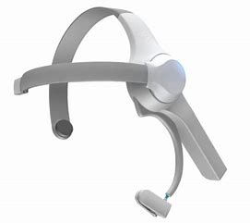

ThinkGear Driver   
(Thinkgear.dll)

ThinkGear Connector

Further  
Processing

Personal Computer

**Figure 3.1:** Flow chart

From the above flow diagram the NeuroSky Mindwave mobile is connected with Bluetooth of the PC. The PC and the Mindwave mobile gets paired. The ThinkGear.dll (Digital link library) contains predefined function which can connect and read the data with Mindwave mobile.

The ThinkGear Connector (TGC) runs as a background process on computer and is responsible for directing headset data from the serial port to an open network socket. It is helpful to continuous data streaming between Mindwave mobile and MATLAB.

MATLAB performs data acquisition and data visualization. This data will be further processed and analysed with the help of other tools.

**CHAPTER 4**

**HARDWARE REQUIREMENTS**

The hardware components used in the current project are very less. The main hardware component used in the current project is NeuroSky Mind Wave band.

**4.1 NEUROSKY MINDWAVE BAND**

The Mindwave Mobile reports the wearer’s mental state in the form of NeuroSky’s proprietary Attention and Meditation Sense algorithms, along with raw wave and information about the brain wave frequency bands. The NeuroSky Mindwave Mobile can be used with supported video games, research software, or a number of other applications for an enhanced user experience. The figure 4.1 shows the pictorial view of the Mindwave Mobile Handset.

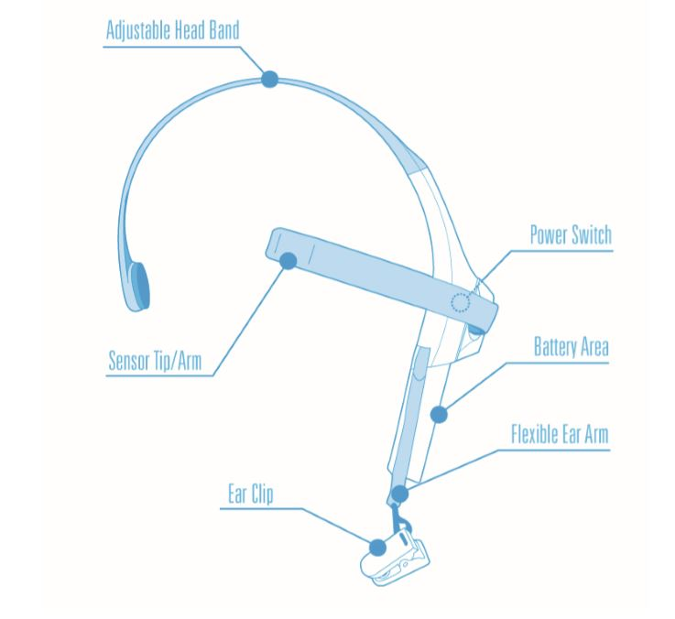

**Figure 4.1:** Mindwave mobile Headset

**4.1.1 Minimum System Requirements for PC/Mac**

The table 4.1 shows the system requirements that are needed for the Mindwave Mobile Handset to be interfaced with the PC or MAC.

**Table 4.1:** Minimum System Requirements for PC/Mac

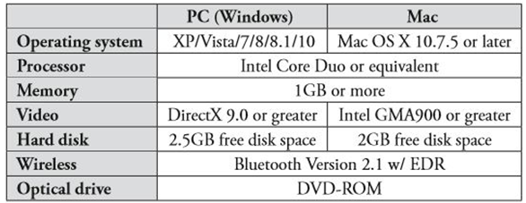

**CHAPTER 5**

**SOFTWARE REQUIREMENTS**

**5.1 MATLAB Software:**

MATLAB (R2010b)

Version 7.11.0.584

MATLAB (matrix laboratory) is a multi-paradigm numerical computing environment. A proprietary programming language developed by MathWorks, MATLAB allows matrix manipulations, plotting of functions and data, implementation of algorithms, creation of user interfaces, and interfacing with programs written in other languages, including C, C++, C#, Java, Fortran and Python.

MATLAB is widely used as a computational tool in science and engineering encompassing the fields of physics, chemistry, math and all engineering streams. MATLAB is used in every facet of computational mathematics like Dealing with Matrices and Arrays, 2-D and 3-D Plotting and graphics, Linear Algebra, Algebraic Equations, Non-linear Functions, Statistics, Data Analysis, Calculus and Differential Equations, Numerical Calculations, Integration, Transforms, Curve Fitting and Various other special functions.



**Figure 5.1:** Matlab Software

**5.1.1 Feature**

* It is a high-level language for numerical computation, visualization and application development.
* It also provides an interactive environment for iterative exploration, design and problem solving.
* It provides vast library of mathematical functions for linear algebra, statistics, Fourier analysis, filtering, optimization, numerical integration and solving ordinary differential equations.
* It provides built-in graphics for visualizing data and tools for creating custom plots.
* MATLAB's programming interface gives development tools for improving code quality maintainability and maximizing performance.
* It provides tools for building applications with custom graphical interfaces.
* It provides functions for integrating MATLAB based algorithms with external applications and languages such as C, Java, .NET and Microsoft Excel.

**5.1.2 Uses of MATLAB**

MATLAB is widely used as a computational tool in science and engineering encompassing the fields of physics, chemistry, math and all engineering streams. It is used in a range of applications including −

* Signal Processing and Communications
* Image and Video Processing
* Control Systems
* Test and Measurement
* Computational Finance
* Computational Biology

**5.2 ThinkGear Connector**

The ThinkGear Connector (TGC) runs as a background process on computer and is responsible for directing headset data from the serial port to an open network socket. It is available on both Windows and OS X. Any language or framework that contains a socket library should be able to communicate with it. TGC is an ideal option for developers working in frameworks like Adobe Flash.

Windows and OS X executable.

Uses socket APIs

Ideal for scripting languages like Flash / Python / Ruby

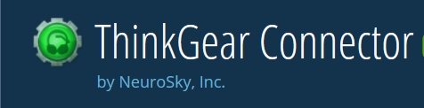

**Figure 5.2:** ThinkGear Connector

**5.3 ThinkGear Communications Driver (ThinkGear.dll)**

* Ideal for C / C++ / C# / Objective-C
* Windows and OS X shared libraries (.dll and .bundle)
* Straight-forward API

The ThinkGear Communications Driver (TGCD) is a native Windows and OS X library that handles all the “heavy-lifting” of interacting with a NeuroSky headset, from setting up the connection to interpreting the data stream received from the ThinkGear chip. The API exposed by TGCD is extremely simple.

TGCD is distributed as a .dll (for Windows) and a .bundle (for OS X), making it suitable for applications written in C or C derivatives (i.e. C++, C#, or Objective-C). The OSX .bundle is only available in 32-bit.

**Chapter-6**

**EXPERIMENTAL SETUP AND RESULT**

**6.1 Experimental Setup**

**Step 1**

Turn on the Bluetooth in the System which is being connected to NeuroSky Mindwave Mobile and pair them each other by entering the pin as “0000”.

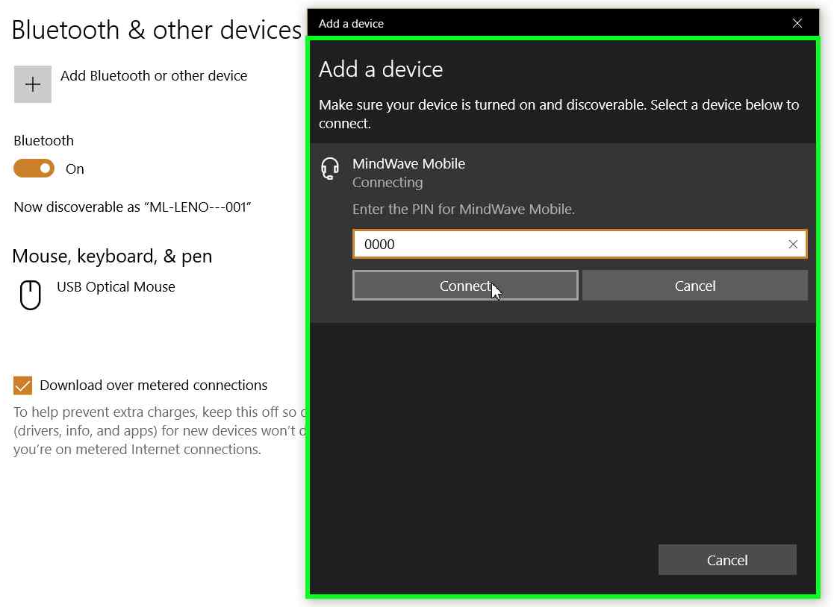

**Figure 6.1:** Pairing of MindWave Mobile to PC

**Step 2**

Wear MindWave Mobile and make the electrode rests on the forehead, above the eyebrow, and the reference clips onto the ear.

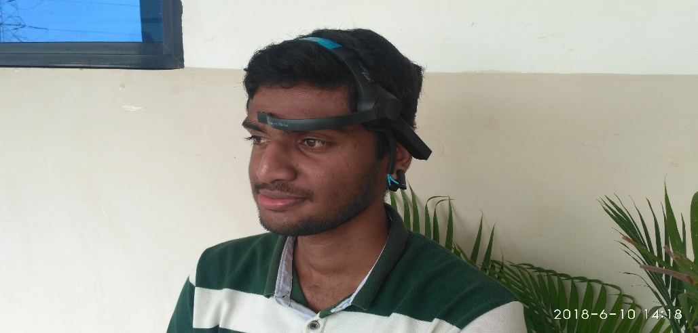

**Figure 6.2:** A person wearing MindWave Mobile

**6.2 Experimental Result**

The matlab code Attention.m will be executed and that will link with the ThinkGear Connector and logs the data streaming on the console and it could log the same into text files.

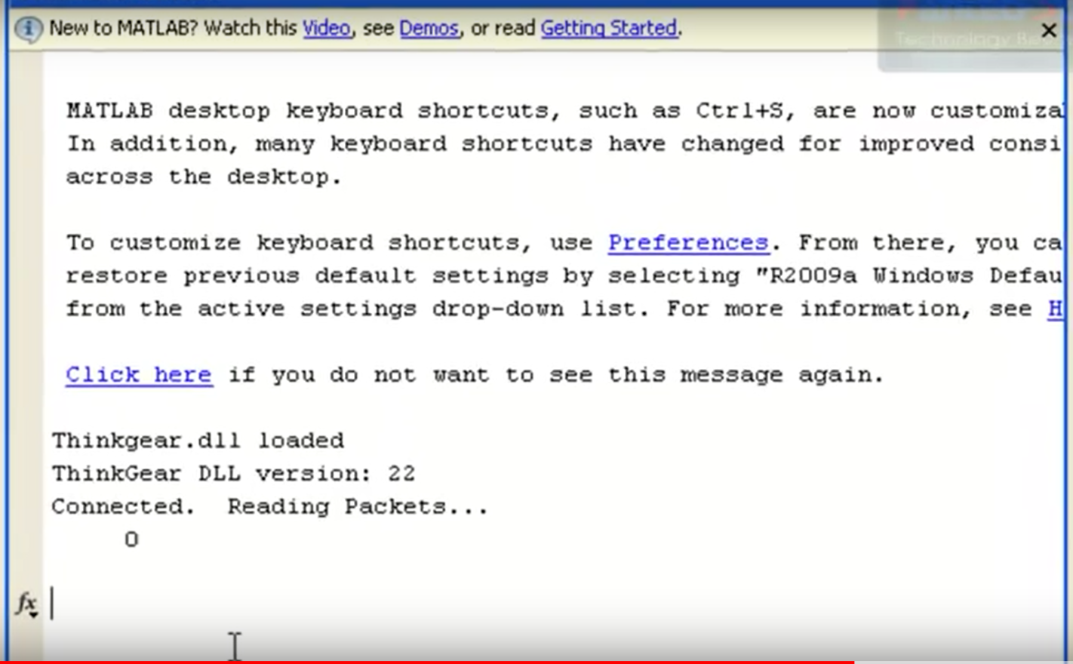

**Figure 6.3:** ThinkGear Connecting to Matlab

The data is simultaneously plotted in with auto scaling. It indicates the fluctuation of the brainwave signal

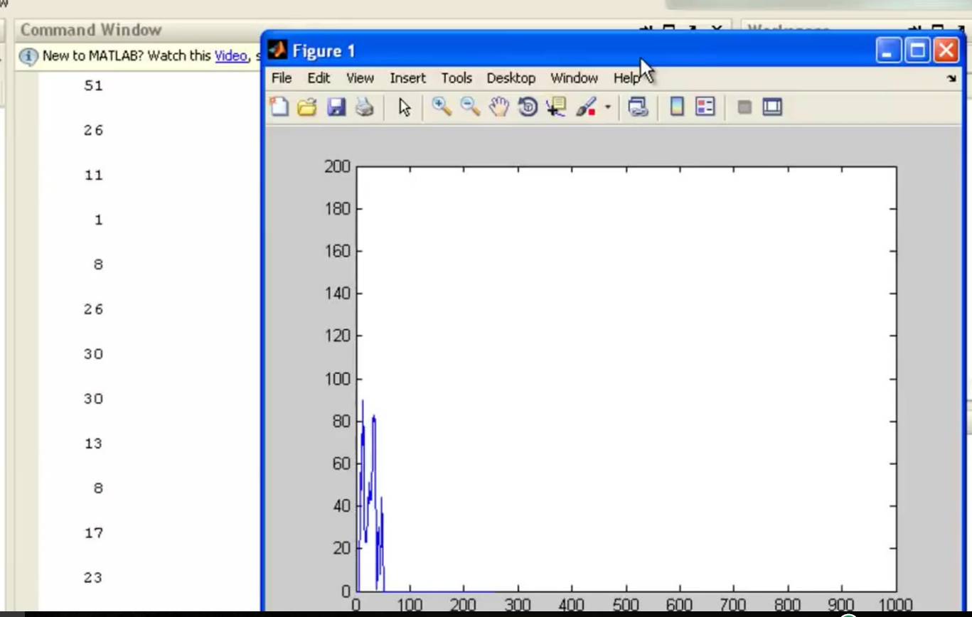

**Figure 6.4:** Graph of the obtained raw data

**CHAPTER 7**

**FUTURE SCOPE**

* **BEHAVIOURAL ANALYSIS**The data obtained in the process can be used to analyse the behaviour of the autism patients by using data analytics. And this could help in predicting upcoming behaviour within a prescribed time.
* **RESEARCH ON MENTAL DISORDER**The data we are getting is in semi-structured form which can be stored in databases. And these data can be used to get in depth understanding of the particular disorders.
* **PREVENTING ABNORMAL BEHAVIOURS**Preventing the patients to enter into abnormal conditions. For example, if a mental disorder patient has detected that he gets furious. Doctors could sedate him before he reach that level.

**CHAPTER 8**

**CONCLUSION**

In this project, we have used attention mode and meditation mode signals which were received from the NeuroSky Mindwave Mobile. And this attention mode contains more beta waves which indicates conscious and alertness of an individual. This is very useful in predicting the behaviours of the individual. Here we are successfully obtaining attention mode data.

Meditation mode is due to the calmness of an individual, which is not useful in treatment of mentally disordered patients.

And by using matlab we have achieved both Data Acquisition and Data Visualisation.

**REFERENCES**

**PAPERS**

1. Mangala Gowri S G, Cyril Prasanna Raj P, Badarinarayan K S, “Novel Algorithm for feature extraction and classification of EEG signals,” IJERT, ISSN: 2278-0181, Vol. 4 Issue 12, December-2015
2. Betty P.V. Ho, Jennifer Stephenson, Mark Carter,” Cognitive-behavioral approaches for children with autism spectrum disorder: A trend analysis”, Faculty of Human Sciences, Macquarie University, NSW, Australia
3. Sravanth Kumar, Vivek Kumar and Bharat Gupta,” Feature Extraction from EEG Signal through One Electrode Device for Medical Application”, 2015 1st International Conference on Next Generation Computing Technologies (NGCT-2015) Dehradun, India, 4-5 September 2015
4. Niels Birbaumer, William J. Heetderks, Dennis J. McFarland, P. Hunter Peckham, Gerwin Schalk, Emanuel Donchin, Louis A. Quatrano, Charles J. Robinson,” Brain–Computer Interface Technology: A Review of the First International Meeting”, IEEE Transactions On Rehabilitation Engineering, VOL. 8, NO. 2, JUNE 2000
5. Kamlesh H. Solanki, Hemangi Pujara,” Brainwave Controlled Robot”, IRJET, p-ISSN: 2395-0072, Volume: 02 Issue: 04 | July-2015.
6. Bharti W. Gawali, Shashibala Rao, Priyanka Abhang, Pramod Rokade and S.C. Mehrotra,” Classification Of Eeg Signals For Different Emotional States”, 1 Department of CS and IT, Dr. B.A.M.University, Aurangabad, Maharashtra, India. 2 Department of Zoology, R.B. Attal College, Georai, Beed.

**BOOKS**

1. Erik Andreas Larsen, “Classification of EEG Signals in a BrainComputer Interface System”, Norwegian University of Science and Technology

**WEBSITE LINKS**

1. http://neurosky.com