visvesVaraya technological university
“jnanasangama” BELAGAVI-590 018
karnataka
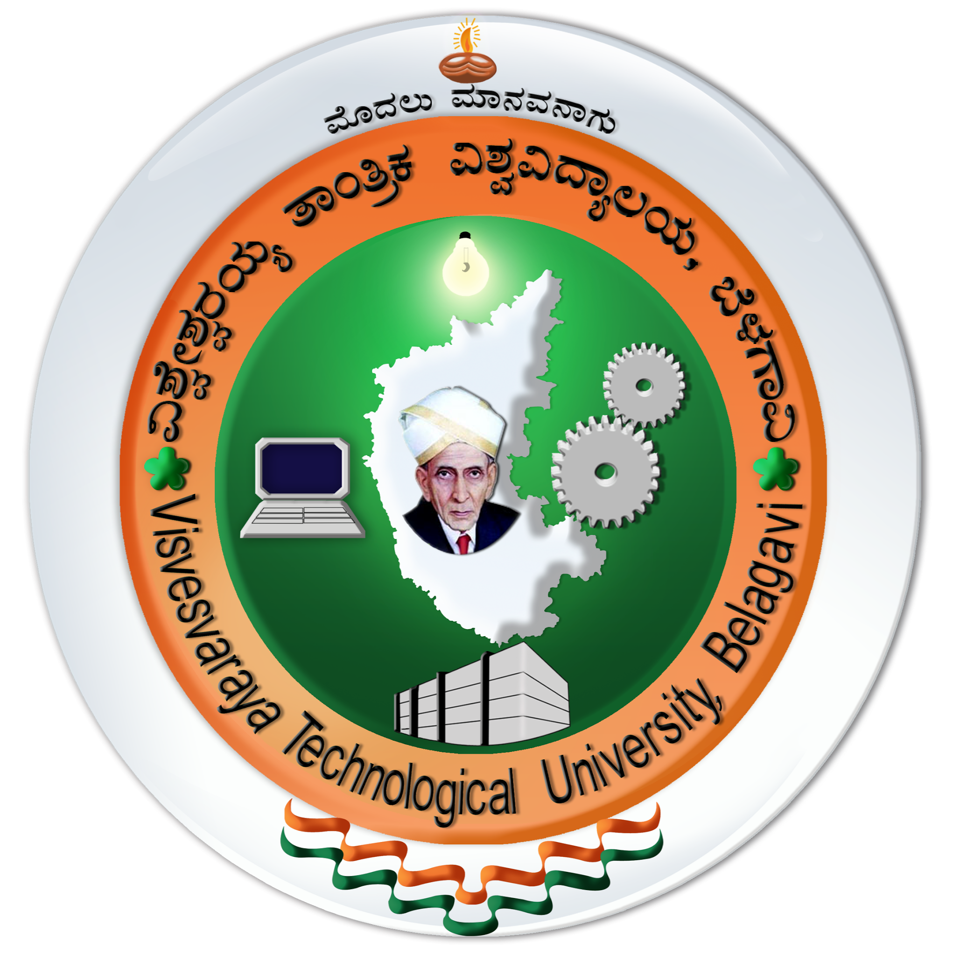
PROJECT REPORT
ON
“Ingenious Brain Tracker”
SUBMITTED IN PARTIAL FULFILLMENT OF THE REQUIREMENTS
FOR THE AWARD OF THE DEGREE OF
BACHELOR OF ENGINEERING
IN
ELECTRONICS AND COMMUNICATION ENGINEERING
Submitted by:
- MANASA M  - NAYANA C P  - MANOHAR N  - LOKESH S P | [1CG14EC056]  [1CG14EC072]  [1CG14EC058]  [1CG14EC052]

Guide:  Mr. RAJENDRA C J,  Assistant professor,  Dept. of ECE,  C.I.T, Gubbi. | HOD:  Dr.RAJAGOPALA R,  Professor & Head,  Dept. of ECE,  C.I.T, Gubbi.




Channabasaveshwara Institute of Technology
(Affiliated to VTU, Belgaum & Approved by AICTE, New Delhi)
(NAAC Accredited & ISO 9001:2015 Certified Institution)
NH 206 (B.H. Road), Gubbi, Tumkur – 572216. Karnataka.
2017-18
DEPARTMENT OF ELECTRONICS & COMMUNICATION ENGINEERING
Channabasaveshwara Institute of Technology
(Affiliated to VTU, Belgaum & Approved by AICTE, New Delhi)
(NAAC Accredited & ISO 9001:2015 Certified Institution)
NH 206 (B.H. Road), Gubbi, Tumkur – 572216. Karnataka.

DEPARTMENT OF ELECTRONICS & COMMUNICATION ENGINEERING
2017-2018
CERTIFICATE
This is to certify that the project work entitled “INGENIOUS BRAIN TRACKER” has been carried out by a NAYANA C P [1CG14EC072], MANASA M [1CG14EC056], MANOHAR N [1CG14EC058] & LOKESH S P [1CG14EC052] bonafide students of CHANNABASAVESHWARA INSTITUTE OF TECHNOLOGY, GUBBI, TUMKUR, in partial fulfillment of the requirement for the award of the degree Bachelor of Engineering in Electronics & Communication Engineering of the Visvesvaraya Technological University, Belagavi during the year 2017-2018. It is certified that all corrections/suggestions indicated for Internal Assessment have been incorporated in the Report deposited in the departmental library. The project report has been approved as it satisfies the academic requirements in respect of Project work prescribed for the said degree.
Signature of Guide  Mr. RAJENDRA C J,  Assistant professor,  Dept. of ECE,  C.I.T, Gubbi. | Signature of HOD  Mr. RAJAGOPALA R,  Professor & Head,,  Dept. of ECE,  C.I.T, Gubbi.

Signature of Principal
Dr. SURESH D S,
Principal,
C.I.T, Gubbi.
External Viva
Examiners Name | Signature
Channabasaveshwara Institute of Technology
(Affiliated to VTU, Belgaum & Approved by AICTE, New Delhi)
(NAAC Accredited & ISO 9001:2015 Certified Institution)
NH 206 (B.H. Road), Gubbi, Tumkur – 572216. Karnataka.
DEPARTMENT OF ELECTRONICS & COMMUNICATION ENGINEERING
2017 -18
UNDERTAKING
We the students NAYANA C P [1CG14EC072], MANASA M [1CG14EC056], MANOHAR N [1CG14EC058] & LOKESH S P [1CG14EC052] of VIII Semester B.E. in ELECTRONICS AND COMMUNICATION ENGINEERING, C.I.T, GUBBI, TUMKUR declare that Project work entitled “INGENIOUS BRAIN TRACKER” has been carried out and submitted in partial fulfillment of the requirements for the award Bachelor of Engineering in Electronics & Communication Engineering of the Visvesvaraya Technological University , Belagavi during the academic year 2017-18.

- MANOHAR N  [1CG14EC058] | - MANASA M  [1CG14EC056]
- NAYANA C P  [1CG14EC072] | - LOKESH S P  [1CG14EC052]

Channabasaveshwara Institute of Technology
(Affiliated to VTU, Belgaum & Approved by AICTE, New Delhi)
(NAAC Accredited & ISO 9001:2015 Certified Institution)
NH 206 (B.H. Road), Gubbi, Tumkur – 572216. Karnataka.

DEPARTMENT OF ELECTRONICS & COMMUNICATION ENGINEERING
2017-18
BONAFIDE CERTIFICATE
This is to certify that the Project work “INGENIOUS BRAIN TRACKER” is a bonafide work of NAYANA C P [1CG14EC072], MANASA M [1CG14EC056], MANOHAR N [1CG14EC058] & LOKESH S P [1CG14EC052] students of VIII semester B.E., in ELECTRONICS AND COMMUNICATION ENGINEERING carried out at Channabasaveshwara Institute of Technology, Gubbi, Tumkur, in partial fulfillment of the requirements for the award of Bachelor of Engineering in Electronics and communication engineering of Visvesvaraya Technological University, Belagavi under my supervision and guidance. Certified that to the best of my knowledge the work reported here in does not from part of any other thesis on the basis of which degree or award was conferred on earlier occasion to this or any other candidates.
Signature of Guide
Mr. RAJENDRA C J
Assistant Professor,
Dept., of ECE,
C.I.T, Gubbi.

ACKNOWLEDGEMENT
A GREAT DEAL OF TIME AND LOT OF EFFORT have gone into completing this project report and documenting it. The number of hours spent in getting through various books and other materials related to this topic chosen by us have reaffirmed its power and utility in doing this project.
Several special people have contributed significantly to this effort. First of all we are grateful to our institution Channabasaveshwara Institute of Technology, Gubbi, which provides us an opportunity in fulfilling our most cherished desire of reaching our goal.
We acknowledge and express our sincere thanks to our beloved Director & Principal, Dr. Suresh D S, for his many valuable suggestion and continued encouragement by supporting us in our academic endeavors.
We express our sincere gratitude to Dr. Rajagopala R, Professor & Head, Department of ECE, for providing his constructive criticisms and suggestions.
Our hearty thanks to beloved Department coordinator Mr. Sekar R, Assistant Professor, Department of ECE, for his valuable inspiration and motivation during the documentation and report preparation.
We extend gratitude to our project guide Mr. Rajendra C J, Assistant Professor, Department of Electronics & Communication Engineering, for his guidance, support and suggestions throughout the period of this project work.
Our whole hearted thanks to CITRIS. They are extremely helpful in assisting us in using the excellent facilities of the center
Finally we would like to express our sincere thanks to all teaching and non-teaching staff; they were extremely helpful in assisting us in using the excellent facilities of the institute.
Project Associates
MANOHAR N [1CG14EC058]
NAYANA C P [1CG14EC072]
MANASA M [1CG14EC056]
LOKESH S P [1CG14EC052]

