**Let’s play SCAAAAAVENGER HUNT!!**



Relax! SuperProcure is not going to ask you to run around the city of Pasadena, looking for clues, only to end up with a gold coin in your own pocket.

SuperProcure wants to build an alert management tool for Beetle Nut Solutions, a premiere ~~Shooting Service Provider~~ Beetle nut service company, so that its customers don’t have to go on a scavenger hunt to find the best quality Beetle nut.

A spreadsheet is provided to you containing the location details of all the ~~Sharp shooters of~~ branches of Beetle Nut Solutions in the city of Pasadena.

The spreadsheet also contains the pin codes covered by the branch and its delivery boys

You are supposed to accomplish the following tasks –

1. Parse the data from the spreadsheet and store the details of these branches in a database
2. Provide username and password to each branch so that a user representing that branch can log into the system
3. Create an administrator account (so that all the company data can be viewed at one place)
4. Now that the back end programming is taken care of, create a cool and sleek UI , which asks customers to enter their contact details and a pin code and does the following

|  |  |
| --- | --- |
| **Client Side Action** | **Server Side Action** |
| Displays the details of the branches serving that pincode | An alert (like that in Facebook page) should be generated for all the branches present in that pin code. (Use socket)  Alert to be generated for the Administrator as well |
| If a pin code for e.g. 743121 is served by multiple branches then | An alert should go to all the branches serving that pin code.  Alert to be generated for the Administrator as well |
| If a pin code is not served by any branch – “Bad Bad luck, No Donut for you!!” | Alert to be generated only for the Administrator |

1. The alerts generated should be persistent in nature i.e. no branch/administrator should miss such alerts i.e. if a user is not logged into the system at the time the alert got generated, he/she should be able to view them once they log back in with the appropriate time stamp

7. Alerts should be displayed in a cool way so that the user can get alerted and can take some action

8. The system should be able to differentiate between new alerts and old alerts like how facebook/twitter does it i.e., old notifications are not highlighted

**You have around 72 hours to finish this task, because….**

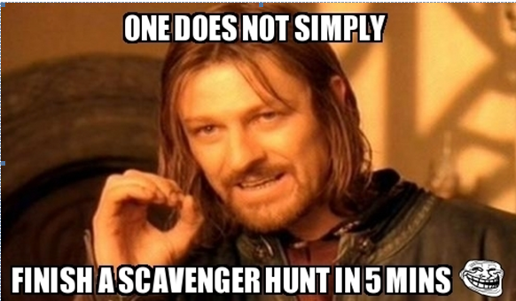

**Submission Rules**

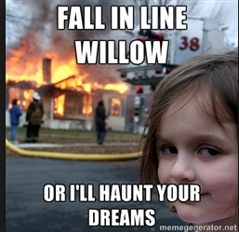

* You need to code in ReactJS and NodeJS only
* The submission will include the following –
  + Documentation to support your work with appropriate screenshots
  + Source code in .zip or .rar format
  + Host the program in any cloud and share the credentials with us so that we can test and view the application
* You need to submit your assignment before the deadline mentioned in the email, so that we have enough time to evaluate your solution

Cheating will be treated very seriously and we will not be moving forward with your candidature in the recruitment process. (SuperProcure have tools that can mark statements which have been copied!!)

**The following are OK**:

* Finding code samples from the web and providing appropriate citation

**The following are considered CHEATING:**

* Having someone else produce code for you
* Having someone else correct your code for you (we got tools to find out if the code is copied or not)
* Copying code you find on the web
* Calling us to ask the solution (If you do that, WE WILL HUNT YOU DOWN and get a selfie clicked with you and put it on our wall of fame (or shame)☺!!)

Have fun coding!