**Project Description**   
This project is for a small/medium online department store. They have hundreds of grocery items at their warehouse. All items must be listed on the website along with their quantities and prices.

A consumer must be able to sign up and purchase groceries. The system should present customers with delivery options and must be able to schedule the delivery. Users must be able to select payment methods.

**Design Overview**

The system should be able to receive and process orders from online customers. All transactions will be done online. Customers will have the ability to place, update, cancel, track their orders online. Employees will have access to customers orders and transactions. Employees will be able to manage payments and inventories.

**Database**   
The system will have tables for employee, customer, product, product_category, product_brand, product_supplier, order, payment, and order_product.

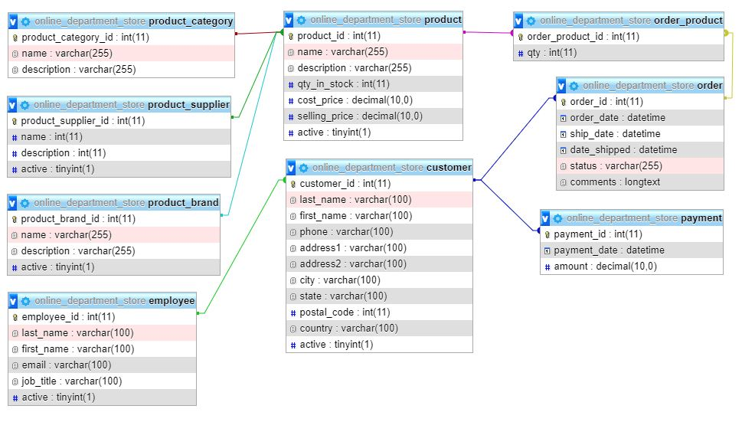

**Database Retrieval**

Employees will have access to products, employees, customers and their transactions like orders and payments. Employees will be able to manage products, product brand, product category, product supplier, employees and customers information. Employees will be able to manage orders of customers. Customers will have access to products and they will be able to purchase and schedule shipping of their orders.

**Database Update**

Employees will be able to add employee, product, customer, product brand, product supplier, product category. Customers will be able to insert and update, payment and orders. Updates and insertions to the database will be made through the system’s UI. The database is designed to restrict deletion of related records. The system will have database access levels.