SPM5b Quickstart
8/10/2005

By Dianne Patterson, Ph.D.
Cognition and NeuroImaging Labs
University of Arizona, Tucson AZ
http://cnl.web.arizona.edu/index.html

Overview
SPM5b is a work in progress that is expected to be finished by November, 2005. It requires Matlab 6.5 or higher. This is a quick SPM5b "how to" guide for those of you who are already accustomed to spm. If you'd like sample data or the latest incarnation of this document, check here:

http://tinyurl.com/9jp5o

Under Docs you'll find tutorials, including this SPM5bQuickstart.doc. Under BlockData you'll find the file blockfh.nii used in the examples below. Please let me (dkp@u.arizona.edu) know if you find any inaccurate information, or you find the material difficult to follow. The documentation is a work in progress too, but with no end in sight.

SPM5b is different than previous spms in two important ways:
1) It adds a bunch of analysis options. I don't describe those here. You can still do a pretty familiar "classic" spm analysis, though.
2) The user interface has changed to make batching much easier and this is very nice. I'm going to show you how that works.

Nifti
SPM5b is designed to work with the nifti format. The nifti format has a couple of incarnations, one is essentially the spm format you are already accustomed to (an img hdr pair for each time point). The other is a single file with the extension *.nii. The nifti *.nii format is nice for a couple of reasons:
- It's compatible with a variety of different programs
- Your spm analysis directories will be tidier because nifti bundles up all the image and hdr information for your run into one file.

Generating a Nifti nii file: Afni generates a *.nii file if you run 3dAFNItoNIFTI on a BRIK and HEAD pair, e.g.,

> 3dAFNItoNIFTI blockfh+orig

If you aren't familiar with afni (a free unix based image processing program), you can learn more here: http://cnl.web.arizona.edu/afni.htm

Inside the nii file: When you display the functional nii file in spm5b, you'll notice that by default, your filename is displayed with ",1" after it, for example: blockfh.nii,1. This "1" refers to the first volume.

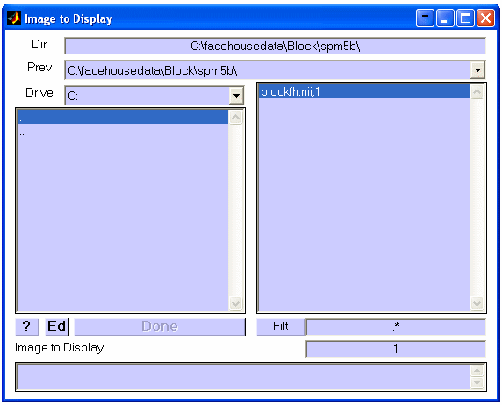

On the lower right is a Filt button and textbox (filter for limiting what gets displayed), and below that is a number 1, you can change this to 2 or 3 or 4…etc to display a different volume.

How To
Start spm5b at the Matlab command prompt. Note that if you have several versions of spm installed at the same time, you'll need to make sure the spm5b directory and subdirectories are first in the matlab path. Start spm5b.

It looks very familiar.

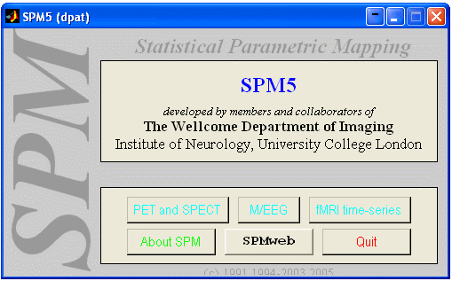

Select the fmri button. It'll still look very familiar:

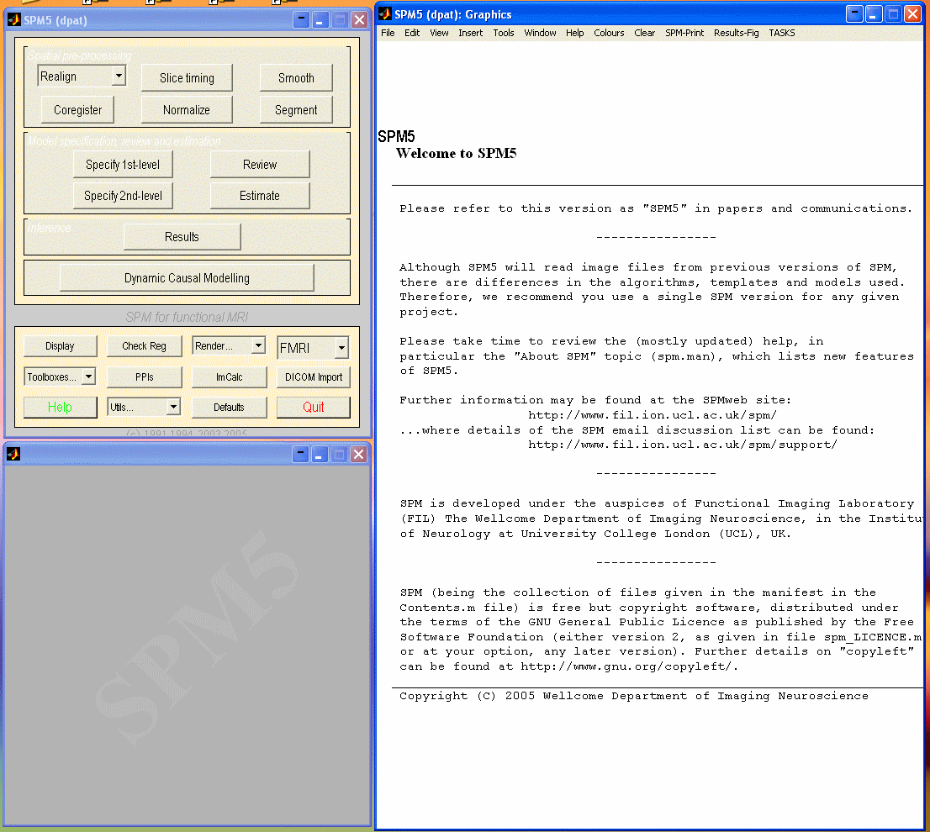

We'll call the upper left window the button window, the lower left window the input window and the big window on the right the Tree Building Window (a.k.a the graphics window).

Two Important Points:
- The analysis options have changed. Use Specify 1st level to do an analysis of a single subject. Specify 2nd level is for group stuff.
- At the top right of the Tree Building Window is a new item, TASKS, this will be very important for batching.

Let's look at the Tree Building Window in more detail. Choose TASKS->Defaults. You see the new interface of purple and yellow panels. Let's explore it: At the bottom of the Tree Building Window is a pale yellow panel that displays explanations and help. You'll see an in-depth explanation of the Tree Building Window.

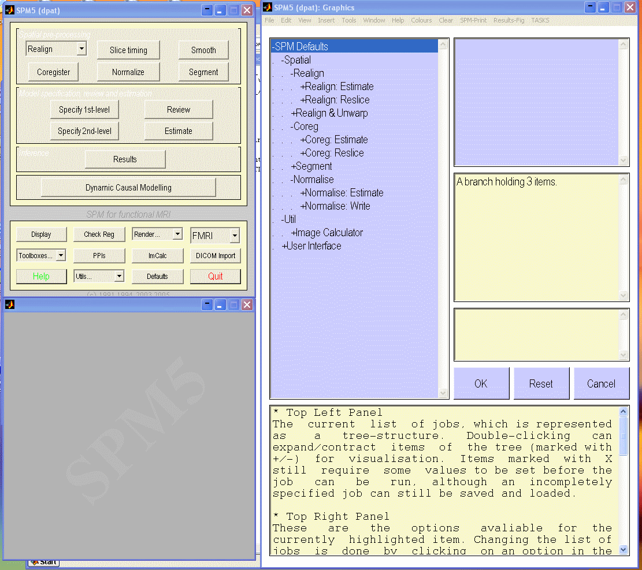

We'll go through realignment so you can work with the interface. Select Realign from the SPM button window (upper left). You are going to specify a set of parameters for realignment and then save them as a *.mat file, using the Save button. You can reuse any such saved mat file by loading it with the Load button, and then choosing Run. In addition, after loading a mat file, you can modify it and save or run the modified version (e.g., you might change what data it runs on). You'll be able to save such a mat file for any part of preprocessing, analysis etc, make dozens of them if you like, and retrieve them with the Load button. You'll be able to run multiple steps once they are defined. More on that when we discuss batching.

Choose "New "Realign Estimate and Reslice".

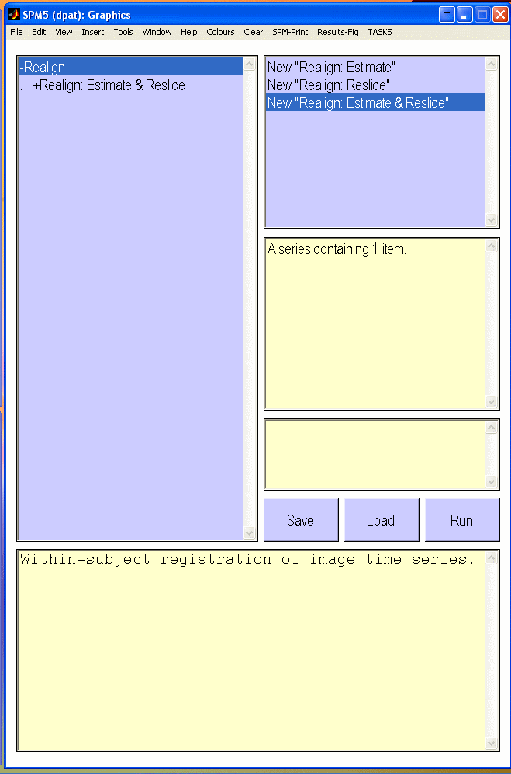

On the left is a tall purple "tree" panel. Here we will specify a tree of data processing options, including the data. There are several important things about the tree:
- If there is a + on the left of a branch, you can double click the branch to see the sub-branches.
- If there is an X on the right of a branch, then you MUST specify that option for the tree (else you can't run the tree).
- Options for a branch are available on the right.
- Help is at the bottom.
- There will be times when you get trigger happy and add an option you don't want. On the upper right of the tree building window is an options panel, you'll see, for example, options to remove a branch.

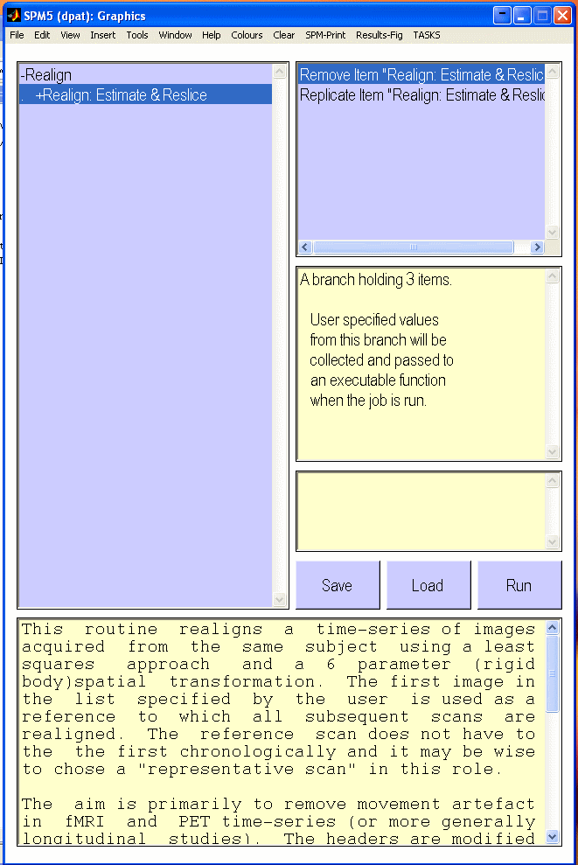

Expand the Realign Estimate and Reslice branch. We want to choose Data and New Session so we can Specify Files. Note that once we add the new session, a session branch is added to our tree, …Session<-X. The X to the right of the Session branch:
indicates that we need to finish something (in this case, we need to pick the data).

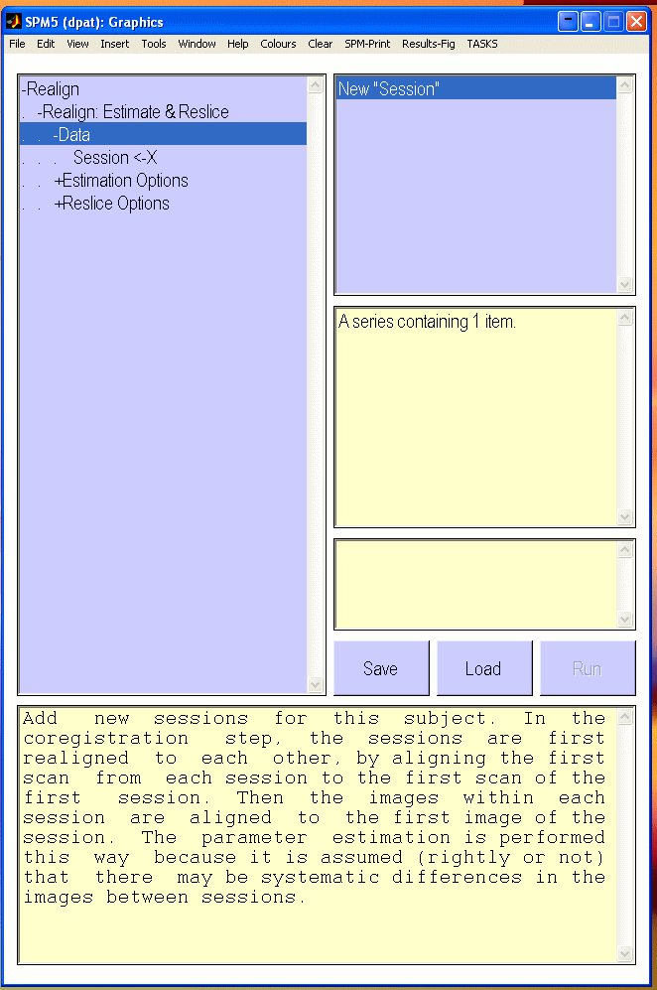

Highlight …Session<-X and choose Specify Files from the options panel. A new window pops up. Indicate the range of volumes you want to see. For example, the facehouse tutorial data has 125 volumes. Specify 1:125 to list all 125 volumes from the nifti file:

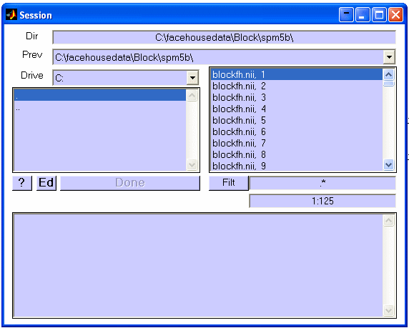

Once all volumes are listed, they can be selected for an operation. Select the relevant files (probably all of them) from the panel on the right. They will move to the panel at the bottom. Then we choose Done to finish the file selection process.
Notes:
- If you want to remove a file or bunch of files from the lower purple panel, highlight them, right click and choose "unselect all".
- In addition, when you select files, you are selecting the whole absolute path to those files. If you change the directory name after specifying the data, then you'll have to change the data specification.

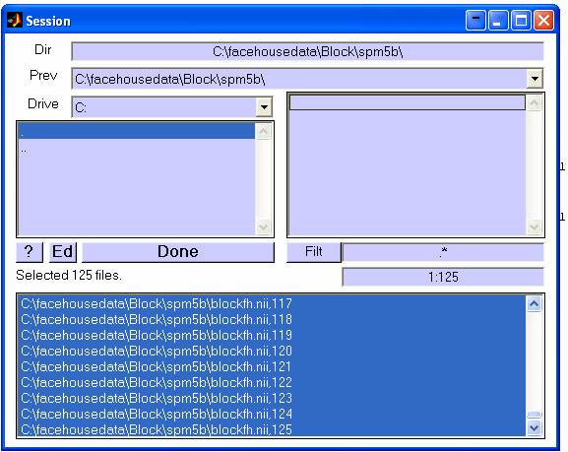

Now that we've specified our data, we see it listed in the middle right panel of the tree building window:

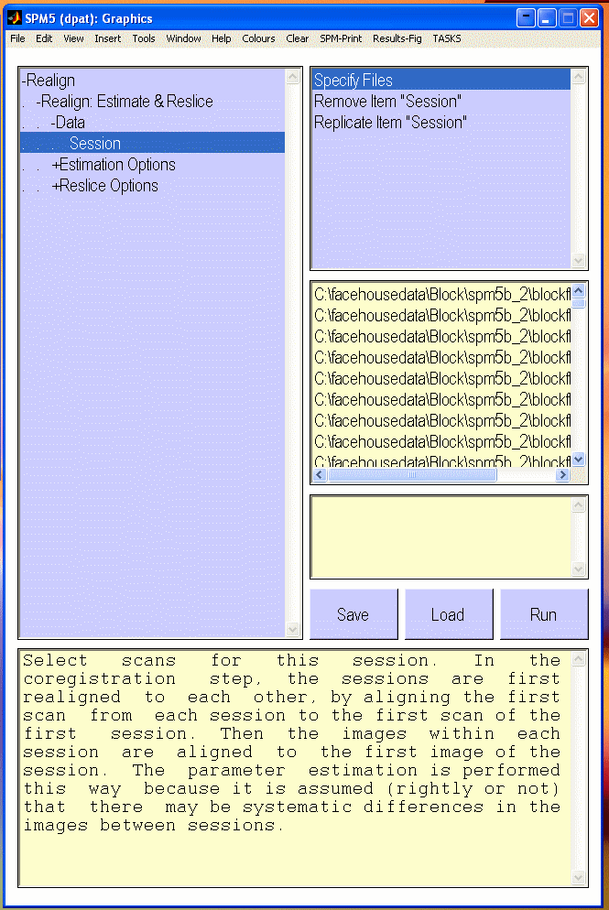

The tree let's you see a lot of realignment options that you could change (e.g., see the Estimation Options branch). Clearly, spm5b gives you easy access to more information than previous spms. This provides you with new opportunities to experiment.

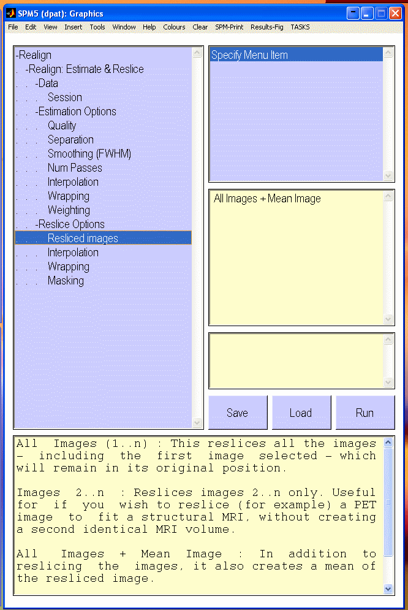

Let's build a mean image only. Expand the Reslice Options branch. Choose Resliced images, and on the upper right, Specify Menu Item.

Now we see familiar options, choose Mean Image Only. That option now appears in the middle right pale yellow panel, confirming that you were successful.

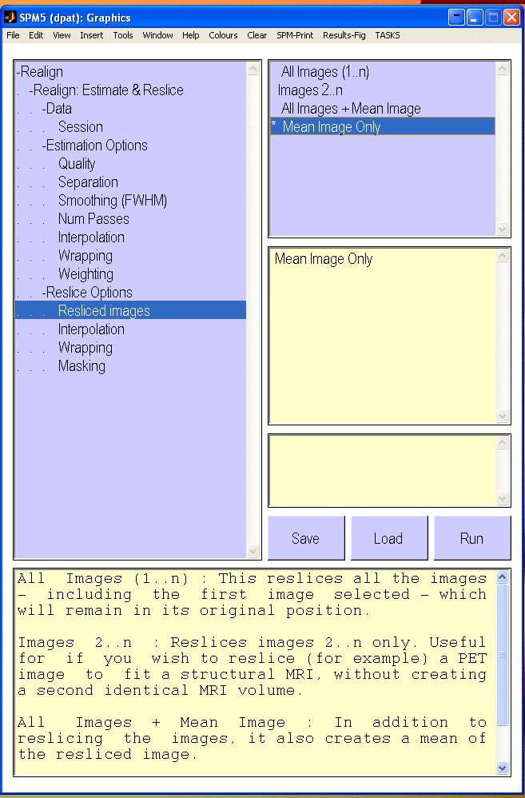

At this point, you should be able to save and run your realignment specification. In the future, you can simply Load it, modify it and Run it.

Batching
If you want to specify a series of steps (preprocessing and/or analysis), use the TASKS button in the upper right corner of the Tree Building Window. Under TASKS->Batch, you can specify all of the steps for data processing in one big file. The batch interface is smart. It knows what files will exist, given the steps you've already specified. For example, under Tasks->Batch, choose New "Spatial". Highlight -Spatial in your SPM Jobs tree, and select New "Realign" from the options panel.

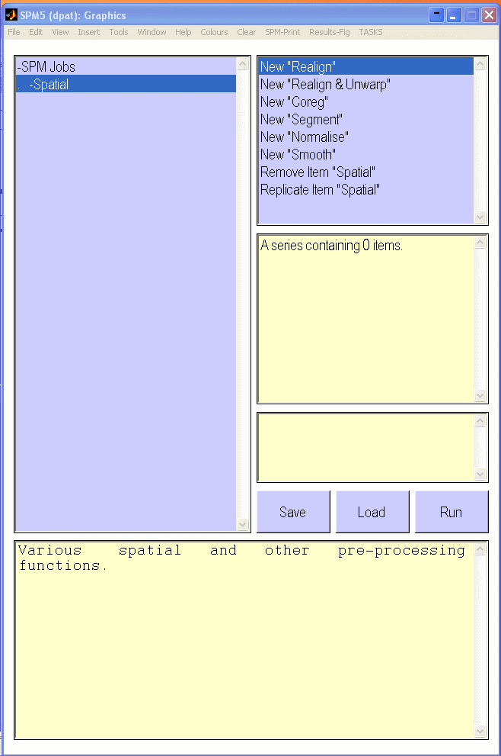

Specify the details of realignment as we did above. Now when you add a normalization step to your SPM Jobs tree, you'll see the option of choosing r* files for normalizing, despite the fact that you have not yet actually generated r* files. So, batch is very intelligent and predicts your needs.

If you have generated several batch jobs, you can run them all using
TASKS->Util->Execute Batch Jobs. This utility allows you to select any set of mat files to run (not just batch jobs)

If you miss the old spm interface (you don't want to save a reusable mat file as a record of what you've done and you'd like to just sit in front of the computer and watch it all work, you are in luck! Under TASKS, choose Sequential and then the process you want to run. There will be no tree. Options will appear in the spm input window and when you finish choosing options, it'll run.

