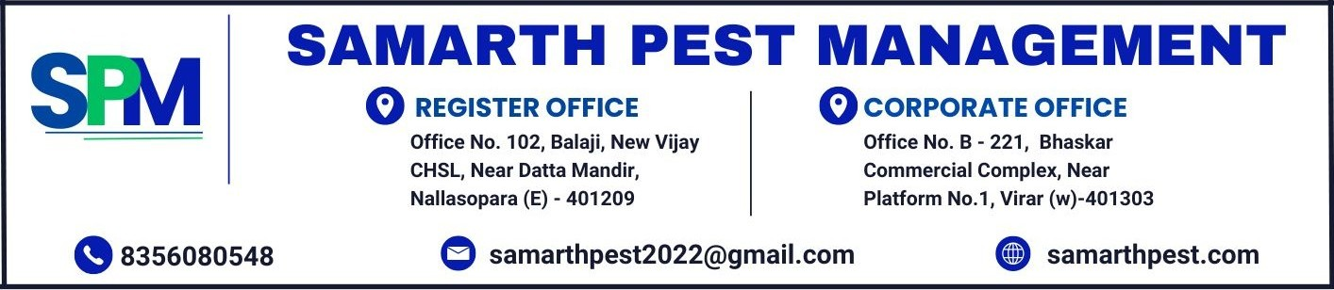
SERVICE PAPER
JOB NO - SPM/OTJ/2026/0001

Client Name : Acme Test Corp,
123 Test Street, Mumbai 400001.
Address :

Contact Person : John Doe
Contact Number : 9876543210

DESCRIPTION
Type of Service | General Pest Control
Premises Area | Office - 2000 sq ft
Location of Pest | Pantry and Server Room
Service Frequency | One Time Job
Service Charges | Rs. 4,500.00/--
Service | 1ST Service / ONE TIME | 2ND Service / Complaint | 3RD Service / Complaint
Service Date | 07/09/2026
Service Time | 11:00 AM
Operator Name | Mr. Rahul Kamble
Client Signature
Payment Details | Paid via GPay
Remark | Customer requested eco-friendly chemicals.

- Payment can be made via GPAY no. 8356080548
- All payments should be made payable to Samarth Pest Management.

Thanks & Regards
BANK DETAILS: For SAMARTH PEST MANAGEMENT 