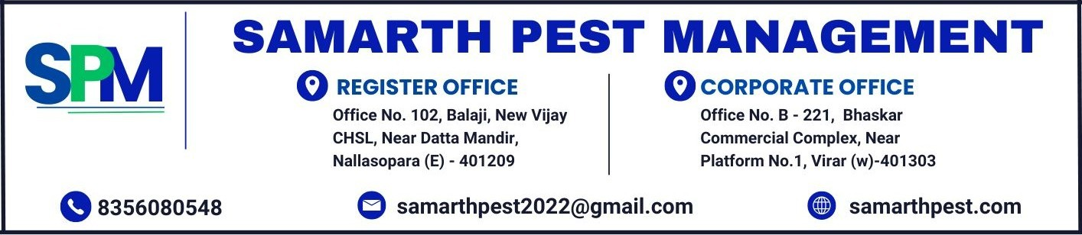

PC QUOTATION
DATE : {quotationDate}
QTN NO : {quotationNumber}
sss
TO,
{customerName},

Reference: Quotation for Pest Management Services from Samarth Pest Management.
Respected Sir / Madam,
We thank you very much for your enquiry and the opportunity given to us to quote our rates. Further to your instructions, we are pleased to submit our quotation as below. It is our commitment to provide you with the best and reliable services.

For more information about our extensive range of services and what you can expect from our expertise and initiatives, please refer to our company website: samarthpest.com

About SPM – Samarth Pest Management:

At SPM, we are committed to providing safe, effective, and eco-friendly pest control solutions. With years of experience, our team ensures your home or business remains pest-free.”

Over the past four years, we’ve built a reputation for excellence through professional expertise, innovative solutions, and a relentless focus on customer satisfaction. We believe in providing high-quality services that are safe, effective, and long-lasting.

At SPM, we use scientific and innovative techniques to minimize chemical usage, ensuring an odourless, safe, and eco-friendly approach to pest control. Our solutions are designed to deliver results that not only tackle current infestations but also prevent future ones.
Based on the observations during the inspection, please find below our proposal which consists of -
- Annexure I – SPM commercial proposal for pest management services
- Annexure II – SPM Service description and abbreviation with Targeted Pests and service procedure.
Annexure I
SPM commercial proposal for pest management services
Premises to be Treated | {premisesTreated}

NO | Location to be Treated | Service Name | Frequency | Service Cost
{#services}{serviceNumber} | {location} | {serviceName} | {frequency} | {amount}{/services}
TOTAL AMOUNT |  |  |  |  | {totalAmount}

- The above quote is exclusive of GST and will be charged as per applicable rate.
- Payment Term : Within 10 days from the date of invoice submission.
- Billing Term : {billingTerm}
We trust that our proposed solution is acceptable to you and we await your favourable reply. Thank you for your interest in Samarth Pest Management.

Yours faithful
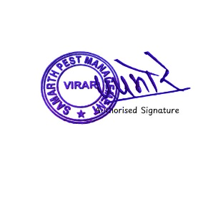
For Samarth Pest Management

Annexure II

Service description and abbreviation with Targeted Pests & Treatment Procedure

Service code | Service Name | Pests covered | Treatment Procedure
GPC | GENERAL PEST CONTROL | COCKROACH & ANTS | INSECTICIDES SPRAY AND GEL APPLICABLE
BB | BED BUG | BED BUG | INSECTICIDES SPRAY
RC | RAT CONTROL | RAT, MOUSE | BAITING OF POISON / GLUE BOARD TRAPPING / RAT GUARD INSTALLATION
MQ | MOSQUITO CONTROL | MOSQUITOES, LARVA | INSECTICIDES SPRAY AND THERMAL FOGGING
ATT - POST | ANTI TERMITE –POST CONSTRUCTION | TERMITE | INSECTICIDES SPRAY, DRILLING, SEALING
ATT - PRE | ANTI TERMITE –PRE CONSTRUCTION | TERMITE | INSECTICIDES SPRAY
SC | SNAKE CONTROL | SNAKE | INSECTICIDES SPRAY AND POWDER DUSTING
HB | HONEYBEE SERVICE | HONEY BEE | INSECTICIDES SPRAY
FL | FLY CONTROL (HOUSEFLY/DARIN) | FLY | INSECTICIDES SPRAY / GRANULES BAITING
WB | WOOD BORER | WOOD BORER | INSECTICIDES SPRAY
SP | SPIDER CONTROL | SPIDER | INSECTICIDES SPRAY
LZ | LIZARD CONTROL | LIZARD | INSECTICIDES SPRAY
SS | SANITIZATION SERVICE | PATHOGENTS | INSECTICIDES SPRAY

Terms and conditions
- Note that pests like bats, birds, dogs, cats, monkeys, squirrels, scorpions, etc. are not covered in above services.
- Rodent Station are property of SPM and shall be taken back in case of expiry or termination of service contract.
- Charges are levied for misplacement or damage of rodent station that will be installed in your premises.
- The customer understands that SPM technicians have instructions not to handle the customer's property to avoid any inadvertent damage.
A representative of the customer should be present during the pest management treatment to remove and shift all articles as necessary.
- SPM does not give any express or implied warranty or assurance on elimination or eradication of the pests in respect whereof this agreement is signed, during the period of this service contract,
- SPM shall be obliged to carry out the necessary pest management operation without incurring any liability or obligation for any inconvenience, loss, injury or damage that may be caused to the customer or any occupant of, or visitor to, to the premises or to any property of any such persons.
- SPM shall not be liable for any loss, injury or damage to the customer or any occupant or visitor to the premises or to any property of any such persons by reason of or as a consequence of the pest management operations and treatment carried out by SPM pursuant to this agreement. Ensuring the safety of all valuables in the customer premises is solely the customer's responsibility.
- The customer has understood his/her obligation to ensure that shelter, entry and food are denied to pests as possible and to maintain hygienic conditions in the premises.
- All material(s) and equipment kept by SPM in customer's premises for carrying out/during service, remains the sole property of SPM and customer has no right over it/ them whatsoever.
- In the event of termination of agreement by either party or upon expiry, SPM will take back all equipment and other property such as Rodent bait-Station, etc. from the customer's premises.
- All annexures are part and parcel of this proposal.
- Services shall be rendered during working hrs with All days.

