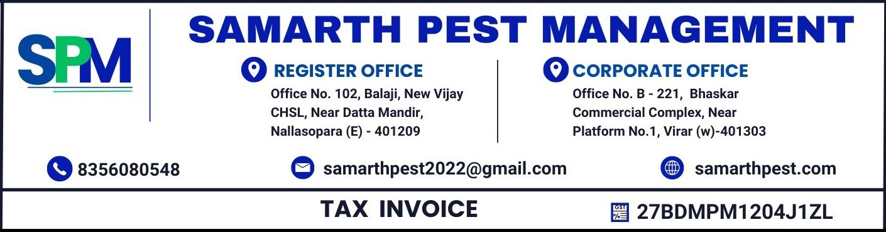
TO,  {customerName},  {customerAddress}  GST NO. : 27AACCD9800E1ZV CODE : 27 | Invoice No : {invoiceNumber}  Invoice Date : {invoiceDate}  BILLING PERIOD : {billingPeriod}
 | HSN - {hsnCode} | SAC CODE - {sacCode}
WORK ORDER NO : {workOrderNumber}
WORK ORDER DATE : {workOrderDate}
Particulars |  |  | Amount
Being Charges for pest management service rendered as details mentioned below.  {#treatments}  PREMISES TREATED: {premisesTreated}  TYPE OF TREATMENT: {treatmentType}  {/treatments} |  |  | Rs. {subtotal}
ADD CGST (9%) |  |  | Rs. {cgstAmount}
ADD SGST (9%) |  |  | Rs. {sgstAmount}
AMOUNT IN WORDS:- RUPEES EIGHT HUNDRED TWENTY FOUR AND PAISA SIXTY FOUR ONLY |  |  | Rs. {totalAmount}

- Payment can be made via CHEQUE or NEFT/RTGS.
- All payments should be made payable to Samarth Pest Management.
Thanks & Regards
BANK DETAILS: - For Samarth Pest Management
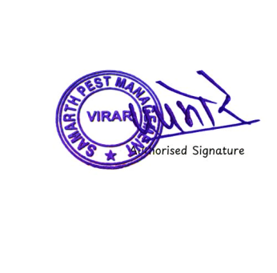
BANK NAME - {bankName}
A/C NO - {accountNumber}
IFSC CODE - {ifsc}

