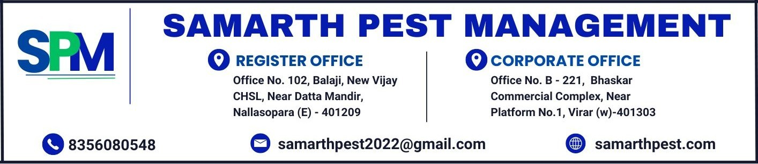
CONTRACT FORM
Date : {renewalDate}
TO,
{customerName},
{customerAddress}

Sub : Pest Management Treatment to your premises.
Respected Sir/ Madam,
M/S Samarth Pest Management (SPM) Company is grateful for your cooperation. This is to inform you that the pest control service contract signed with your company for your premises. We kindly request you to continue the pest control services by renewing the contract as per the existing terms, rules, and conditions mentioned in the agreement.
The services will continue as per the agreed schedule subject to your approval.
If you agree to renew the contract, please cooperate by signing the given agreement.

Service Name | Frequency | Location to be Treated | Price
{#services}{serviceName} | {frequency} | {location} | {amount}{/services}
AMOUNT IN WORDS – {amountInWords} |  |  | {totalAmount}

- Contract Period : {contractPeriod}
- All payments should be made payable to Samarth Pest Management via GPAY / RTGS / Cheque.
- The above quote is exclusive of GST and will be charged as per applicable rate.
- Payment Term: {paymentTerm}.

Terms and conditions
- GST, is applicable as per the prevailing rate while invoicing and any changes in tax structure as bought in by the Government of India shall be binding on either parties.
- Note that pests like bats, birds, dogs, cats, monkeys, squirrels, scorpions, etc. are not covered in above services.
- Rodent Station are property of SPM and shall be taken back in case of expiry or termination of service contract.
- Charges are levied for misplacement or damage of rodent station that will be installed in your premises.
- The customer understands that SPM technicians have instructions not to handle the customer's property to avoid any inadvertent damage.
- A representative of the customer should be present during the pest management treatment to remove and shift all articles as necessary.
- SPM does not give any express or implied warranty or assurance on elimination or eradication of the pests in respect whereof this agreement is signed, during the period of this service contract,
- SPM shall be obliged to carry out the necessary pest management operation without incurring any liability or obligation for any inconvenience, loss, injury or damage that may be caused to the customer or any occupant of, or visitor to, to the premises or to any property of any such persons.
- SPM shall not be liable for any loss, injury or damage to the customer or any occupant or visitor to the premises or to any property of any such persons by reason of or as a consequence of the pest management operations and treatment carried out by SPM pursuant to this agreement. Ensuring the safety of all valuables in the customer premises is solely the customer's responsibility.
- The customer has understood his/her obligation to ensure that shelter, entry and food are denied to pests as possible and to maintain hygienic conditions in the premises.
- All material(s) and equipment kept by SPM in customer's premises for carrying out/during service, remains the sole property of SPM and customer has no right over it/ them whatsoever.
- In the event of termination of agreement by either party or upon expiry, SPM will take back all equipment and other property such as Rodent bait-Station, etc. from the customer's premises.
- Services shall be rendered during working hrs with All days.
Yours Faithfully
SAMARTH PEST MANAGEMENT
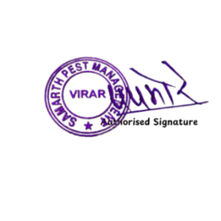
WE HAVE READ ALL THE ABOVE RULES, TERMS AND CONDITIONS OF SERVICE AND WE / I ACCEPT THE SAME.
WE HEREBY CONFIRM

{contracteeName} {contracteeMobile}

