TO,  NON GST TEST CUSTOMER PVT LTD,  Plot 10, Sector 4, Airoli, Navi Mumbai | Invoice No : INV-NG-2026-001  Invoice Date : 10/10/2026
 | BILLING PERIOD : 01 OCTOBER 2026 to 31 OCTOBER 2026
 | Contract Period : undefined
Particulars |  | Amount
Being Charges for pest management service rendered as details mentioned below.  PREMISES TREATED: undefined  TYPE OF TREATMENT: undefined |  | Rs. undefined
AMOUNT IN WORDS:- RUPEES FIVE THOUSAND ONLY |  | Rs. 5,000.00
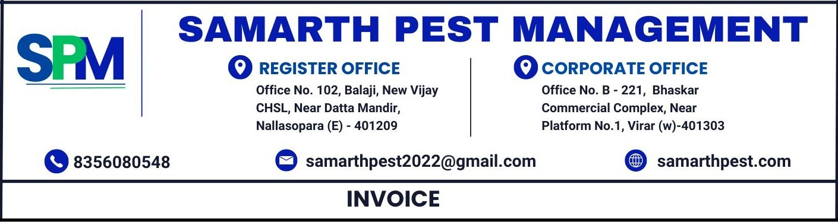

- Payment can be made via GPAY / CHEQUE or NEFT / RTGS.
- All payments should be made payable to Samarth Pest Management.

Thanks & Regards
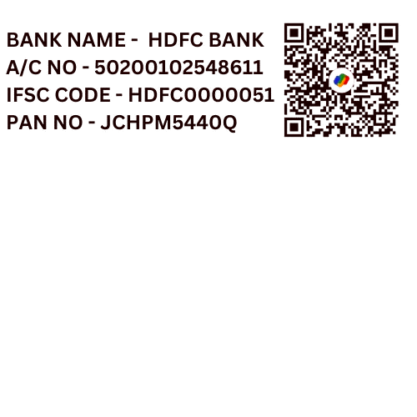
BANK DETAILS: For SAMARTH PEST MANAGEMENT
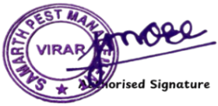
BANK NAME - undefined
A/C NO - undefined
IFSC CODE - undefined
PAN NO- undefined

