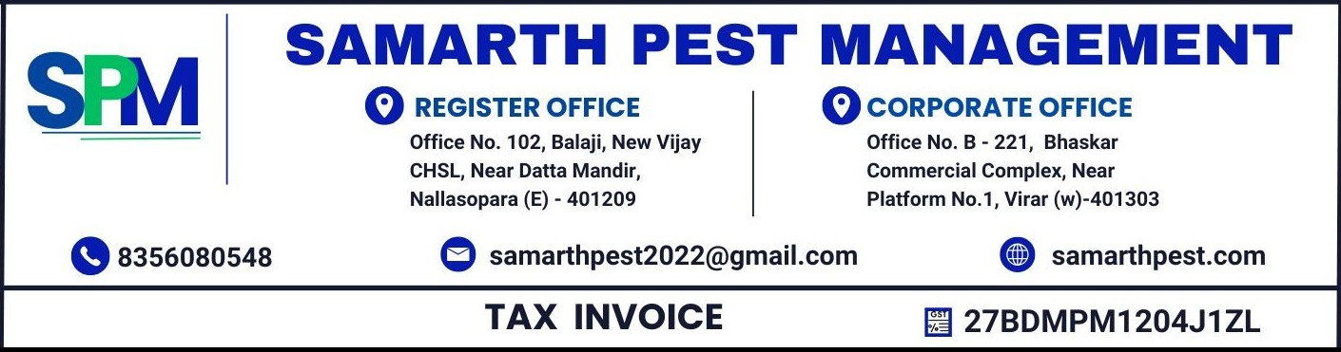
TO,  ACME ENTERPRISES PRIVATE LIMITED,  Plot 45, Industrial Zone, Andheri East, Mumbai - 400093  GST NO. : 27AACCD9800E1ZV CODE : 27 | Invoice No : INV-2026-9999  Invoice Date : 10/10/2026  BILLING PERIOD : 01 OCTOBER 2026 to 31 OCTOBER 2026
 | HSN - undefined | SAC CODE - undefined
WORK ORDER NO : WO-8877
WORK ORDER DATE : 01/10/2026
Particulars |  |  | Amount
Being Charges for pest management service rendered as details mentioned below. |  |  | Rs. 10,000.00
ADD CGST (9%) |  |  | Rs. 900.00
ADD SGST (9%) |  |  | Rs. 900.00
AMOUNT IN WORDS:- RUPEES EIGHT HUNDRED TWENTY FOUR AND PAISA SIXTY FOUR ONLY |  |  | Rs. 11,800.00

- Payment can be made via CHEQUE or NEFT/RTGS.
- All payments should be made payable to Samarth Pest Management.
Thanks & Regards
BANK DETAILS: - For Samarth Pest Management
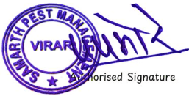
BANK NAME - undefined
A/C NO - undefined
IFSC CODE - undefined

