TO,  , | Invoice No :  Invoice Date :
TO,  , | BILLING PERIOD :
TO,  , | Contract Period :
Particulars |  | Amount
Being Charges for pest management service rendered as details mentioned below. |  | Rs. 0.00
AMOUNT IN WORDS:- |  | Rs. 0.00
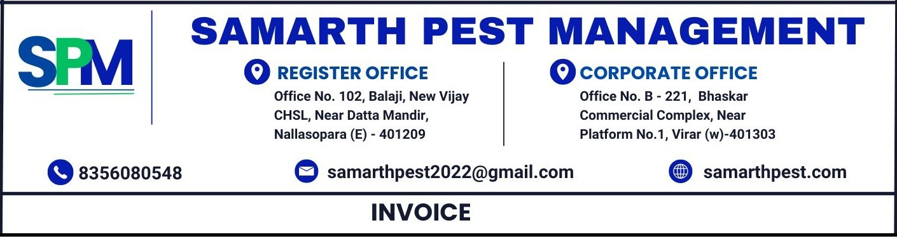

- Payment can be made via GPAY / CHEQUE or NEFT / RTGS.
- All payments should be made payable to Samarth Pest Management.

Thanks & Regards
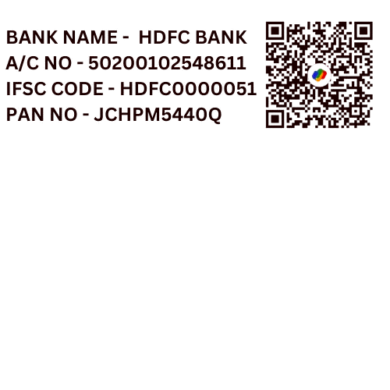
BANK DETAILS: - For SAMARTH PEST MANAGEMENT
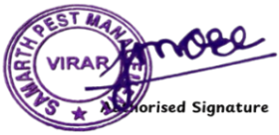
BANK NAME - HDFC BANK
A/C NO - 50200102548611
IFSC CODE - HDFC0000051

