Stakeholder

|  |
| --- |
| 3 |
| 13 |
| 2 |
| 1 |
| 7 |
| 5 |
| 12 |
| 8 |
| 4 |
| 11 |
| 9 |
| 10 |
| 6 |

***Priority***

* Doctors (must be familiar with the product, assess usability, can help marketing the product, overview the product usage/need for the product, problem validation via networking)
* Nurses (may have to be familiar with the product)
* Patients (problem validation, end-consumer, assess usability, health is at risk, may be a customer)
* Hospitals, doctor‘s offices (customers, can assess the need of the product in numbers, access to patients)
* Insurance companies (have to accept the product, have financial interest, are indirectly/(directly) paying for the product)
* Universities (research partner, provide manpower, help finding networking contacts, can give inside on the state of the art)
* Research labs (possible research partner)
* Pharma industry (possible research partner, decide on the price/use of Vancomycin, are interested in success of our product to sell more Vancomycin)
* Investors, Sponsors (early source of revenue, have interest in success of the product, can be familiar with similar technologies, provide help/guidance, want share of revenue)
* Competitors (try to steal/copy the product, competing for market share and patents, beat us to the market, can be source of ideas)
* Supplier/Manufacturers (producing the product, determine manufacturing costs)
* Medical press (help marketing the product, ideas for improvement)
* 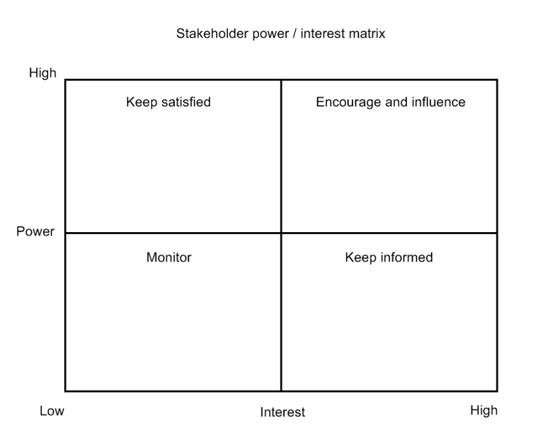Regulators (setting the standards the product needs to meet, deciding on the usage of Vancomycin, testing/assessing the product)

**Hospitals, doctor’s offices**

**Suppliers/Manufacturers**

**Research labs**

**Nurses**

**Regulators**

**Insurance companies**

**Competitors**

**Medical press**

**Pharma industry**

**Investors, Sponsors**

**Patients**

**Doctors**

**Universities**

**Stakeholder power / interest** **matrix**