**Step 1:** **Understand and Define the Problem (Analyse)**

**Goal:** Design an automated pet feeder for cats and dogs and monitor food availability to ensure pets are fed reliably. 

**Constraints:** The automated feeder must be low cost, reliable, safe for pets, and implementable using Arduino and affordable components like servo motors and sensors.

**Feeder's Functions and features:**

* The feeder is designed for cats and dogs.
* Portion sizes are adjustable, generally ranging from 50 grams to 300 grams per feeding.
* The system supports up to four feeding times per day (e.g., 8 AM, 12 PM, 6 PM, 9 PM).
* Sensors include a food level sensor inside the dispenser and a weight sensor under the bowl.
* Alerts notify staff or owners if food runs low or if food is not eaten within 10 minutes after dispensing with a buzzer.

**Feeder’s Specifications:**

* **Pet type:** Cats and dogs
* **Portion size:** Adjustable, 50 g – 300 g per feeding
* **Feeding times:** Up to 4 scheduled feedings per day (e.g., 08:00, 12:00, 18:00(9 PM), 21:00(9 PM))
* **Sensors:**
  + Food level sensor (inside dispenser)
  + Weight sensor (under bowl)
* **Alerts:**
  + Low food level alert
  + Uneaten food alert (if food remains after 10 minutes)
  + If weight doesn’t change after 10 minutes of dispensing food

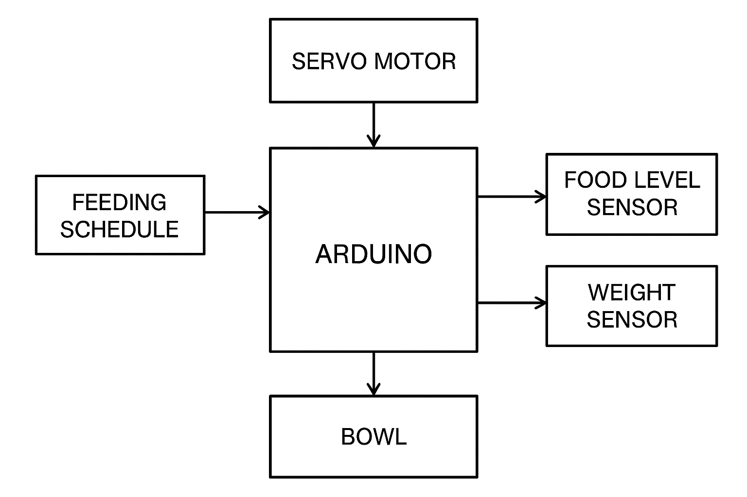

DISPLAY

 