5FPS 🡺 Time = 200mSec, 10FPS 🡺 100mSec [Thus 150mSec can be adjusted for capture/compress/transmit/render]

|  |  |  |  |  |  |
| --- | --- | --- | --- | --- | --- |
| **IMAGE** | **Time (mSec)** | **Quality** | **Pellet** | **Type** | **SIZE ?** |
| 162K | 355 | Distorted | 256 | PelleteQuantizer |  |

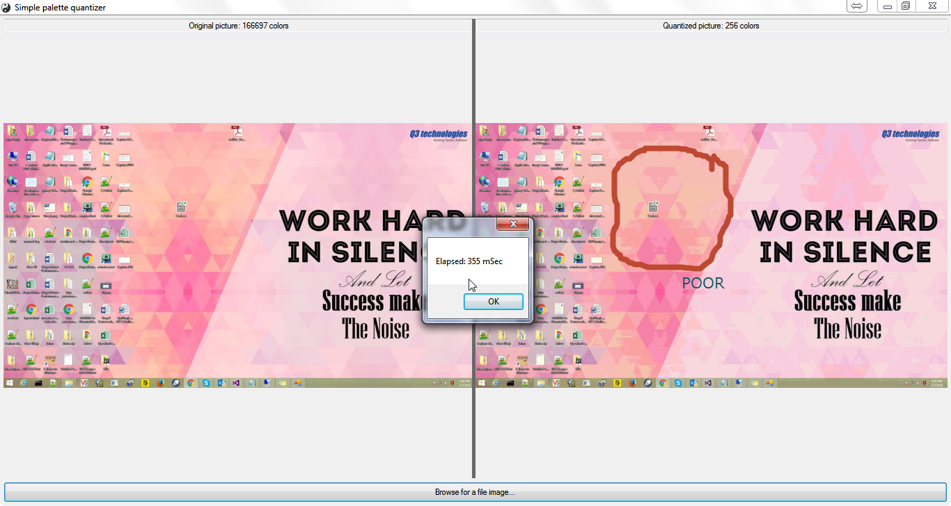

|  |  |  |  |  |  |
| --- | --- | --- | --- | --- | --- |
| **IMAGE** | **Time (mSec)** | **Quality** | **Pellet** | **Type** | **SIZE ?** |
| 82K | 264 | Distorted | 256 | PelleteQuantizer |  |

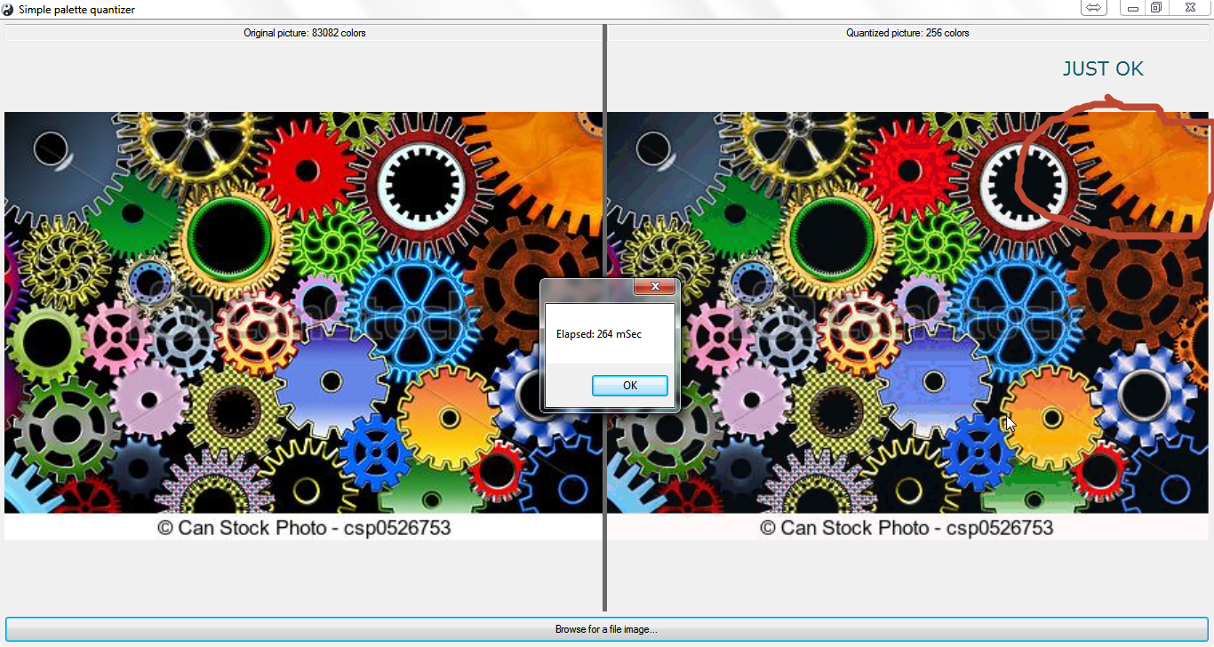

|  |  |  |  |  |  |
| --- | --- | --- | --- | --- | --- |
| **IMAGE** | **Time (mSec)** | **Quality** | **Pellet** | **Type** | **SIZE ?** |
| 415K | 240 | Ok, fine | 256 | PelleteQuantizer |  |

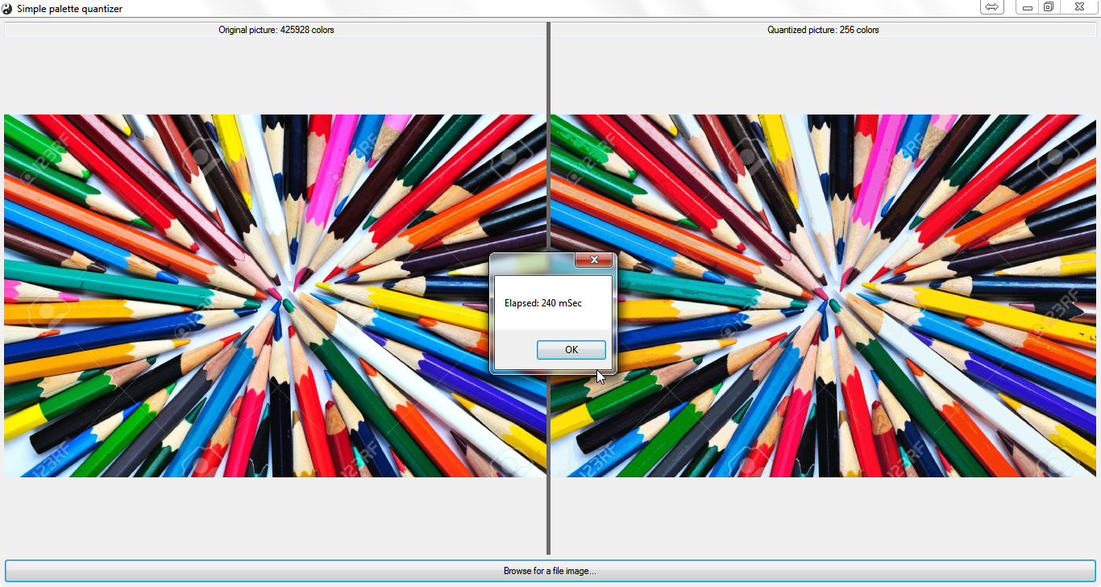

|  |  |  |  |  |  |  |
| --- | --- | --- | --- | --- | --- | --- |
| **SOFTWARE** | **IMAGE** | **Time (mSec)** | **Quality** | **Pellet** | **Type** | **SIZE ?** |
| V1 | 415K | 240 | Ok, fine | 256 | PelleteQuantizer |  |
|  | 82K |  |  |  |  |  |
|  | 162K |  |  |  |  |  |
|  |  |  |  |  |  |  |