Wavelet Sharpen T22 – Documentation
DRAFT 4

Version guide
Versions starting with a T are considered Testing versions, and you're the one invited for testing.
When a version is considered stable and usable by the community, it will be rereleased as R version, meaning Release

Basic Usage

Always judge sharpening at 100% view

If your output files look different than the previews, check if you enabled

Output Sharpening in the queue settings.

You might want to experiment a bit until you find some options that match your desired camera/output combination, and then store it as a preset.

Gradient
The Gradient filter works by looking for gradients and then tries to make that gradients steeper. It doesn't create any overshoots or halos.

It works best at low intensities to get reduce the slight unsharpness that the sensors AA filter introduces. Extreme settings can cause posterization/water color like effects, as it will sharpen broad gradients, too.

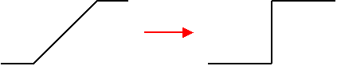

After the Gradient Sharpen filter, there's a microcontrast enhancement stage, which tries to boost texture sharpness. Again, its best used at low intensity levels (5-10)

Controls:
- Strength Steepness of the edges
- Width/Iter Number of iterations to perform, this roughtly translates into the width of the gradients to be considered. Increasing this value has a huge impact on the filter speed
- Microcontrast Boosts microcontrast in non edge Zones, Low values (5- 10) should give best results, higher values mostly boost noise and demosaicing artifacts to much

USM
USM was incorporated into WS as a way to do local contrast enhancements (LCE) aka. „Clarity“. Of course it can also be used as a sharpening Tool, but using the Wavelet Filters usually gives a much better Result.

USM works by adding back a high pass filtered version of the image. See http://en.wikipedia.org/wiki/Unsharp_mask

Controls:
- Amount Intensity of the Filter
- Radius Radius of the filter in arbitrary units. Controls how wide the effect is
- Threshold Threshold in arbitrary units, Changes lower than threshold won't be applied, use this to reduce impact on noise
- Clarity Mode Make the Blend Behavior dependent on the originals luminosity. This is very similar to the Clarity Control found in a well known raw developer.

Wavelet Sharpen
Wavelet Sharpen is the general purpose sharpening algorithm in the Plugin. Its provided twice to enable two pass sharpening. It works like a slightly smarter version of the classical USM Filter

Controls:
- Amount Intensity of the filter, Higher values give sharper edges, but also more halos
- Radius Radius in arbitrary units, controls which spatial frequency gets sharpened
- Edge Controls the Edge awareness of the filter. A value of 0 means that the edge awareness is disabled, a value of 100 means full edge awareness. Everything in between is a linear blend.
- S+P Reduction On some images WS boosts some noise patterns, resulting in Salt and Pepper Style noise. If you notice it, enable this option

- If you see lots of noise/halos after enabling it, set Bibble sharpening to 0

Technical Notes
My famous flow charts :)

Basic Flow
The Wavelet Sharpen plugin consists of 3 Pipeline Stages.

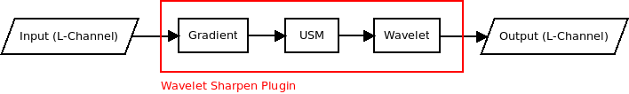
The plugin only operates on the L (Luminance) Channel.

Gradient Filter
See http://www.rawness.es/sharpening/?lang=en for a full explaination of the algorithm (Original author). WS uses an adapted and optimized Version of the code.
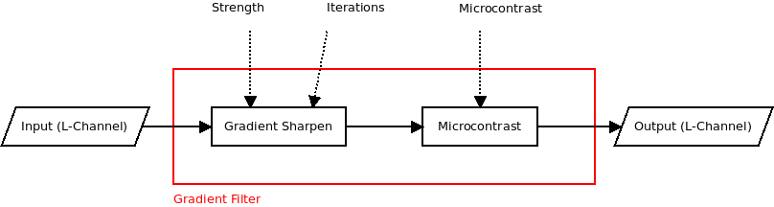

USM Filter
A basic gaussian core, combined with Luminance based blending
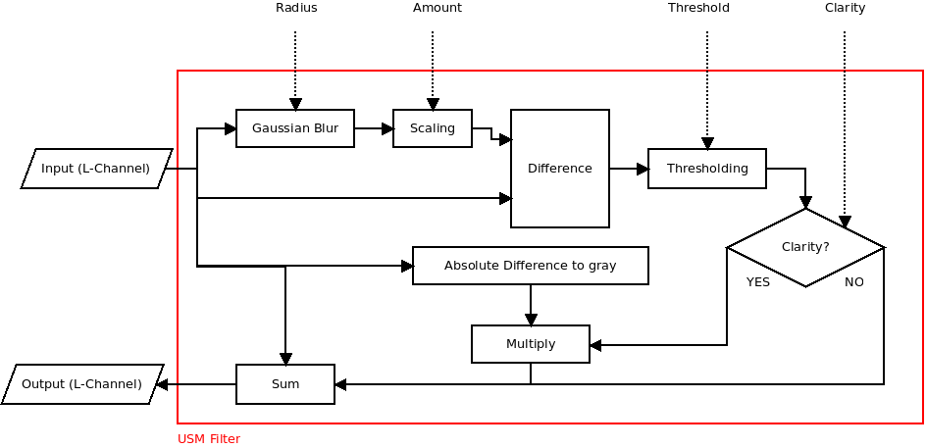

Wavelet Filter
The Wavelet Filter doesn't really use wavelets, despite its name. The original code comes from the marcors gimp plugin http://registry.gimp.org/node/9836 . It works very similar to a pyramid sharpening approach. I kept the name, as the filter itself got well known as a gimp plugin with the same name. The original core was modified to work on L*A*B space, and extended with S+P supression, and Edge based masking.

Shown is only a single stage, the second stage is identical

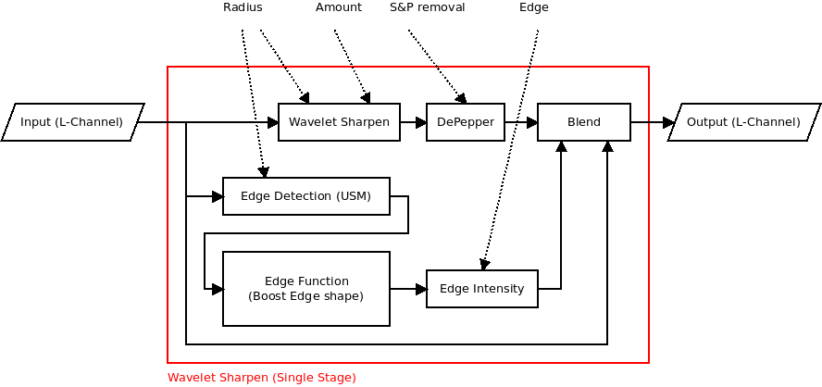
The original Filter was enhanced with an edge based blend and a Salt and Pepper Style Noise Reducer

About
WS originaly started as a port over of my favorite Gimp plugin, to replace the IMHO inadequate sharpening algorithm of Bibble with a more sofisticated method. WS gets developed entirely in my spare time as a hobby project. I'm neighter a large scale company nor do i make a living out of it. Still, if you enjoy the Plugin, I kindly ask you to send me a small donation at http://web.student.tuwien.ac.at/~e0326004/bibble/

Legal
THE AUTHOR IS FURNISHING THIS PLUGIN 'AS IS'. THE AUTHOR DOES NOT PROVIDE ANY WARRANTY OF THE PLUGIN WHATSOEVER, WHETHER EXPRESS, IMPLIED, OR STATUTORY, INCLUDING, BUT NOT LIMITED TO, ANY WARRANTY OF MERCHANTABILITY OR FITNESS FOR A PARTICULAR PURPOSE OR ANY WARRANTY THAT THE CONTENTS OF THE PLUGIN WILL BE ERROR-FREE. IN NO RESPECT SHALL THE AUTHOR BE LIABLE FOR ANY CLAIM, DAMAGES, DATA LOSS OR OTHER LIABILITY, WHETHER IN ANY ACTION OF CONTRACT, TORT OR OTHERWISE, ARISING FROM, OUT OF OR IN CONNECTION WITH THE PLUGIN OR THE USE OR OTHER DEALINGS IN THE PLUGIN.

The source code is available on request under the terms of the GPL.

