Final Project
Sources-
- Unstructured-
https://www.kaggle.com/datasets/anandhuh/covid-abstracts
The dataset has Title, Abstract and URL of 10,000 Covid Research Papers.
Attribute Information
- title - Title of research paper
- abstract - Abstract of the research paper
- url - URL of the research paper

- Semi-structured-
https://www.kaggle.com/datasets/siddhantrajhans/10000-unique-medical-tweets/data
The dataset consists of 100,000 tweets, each with a unique identifier, keyword, location, text, and target label. The target label indicates whether the tweet is relevant to a medical condition (1) or not (0).
id: A unique identifier for each tweet
keyword: A particular keyword from the tweet (e.g. disease, symptom, medication)
location: The location the tweet was sent from (may be blank)
text: The text of the tweet
target: Denotes whether a tweet is about a real medical condition (1) or not (0)
- Structured-
https://data.cdc.gov/Chronic-Disease-Indicators/U-S-Chronic-Disease-Indicators/hksd-2xuw/about_data
The dataset is for chronic disease indicators. CDC's Division of Population Health provides a cross-cutting set of 115 indicators developed by consensus among CDC, the Council of State and Territorial Epidemiologists, and the National Association of Chronic Disease Directors. These indicators allow states and territories to uniformly define, collect, and report chronic disease data that are important to public health practice in their area. In addition to providing access to state-specific indicator data, the CDI web site serves as a gateway to additional information and data resources.
Data types-
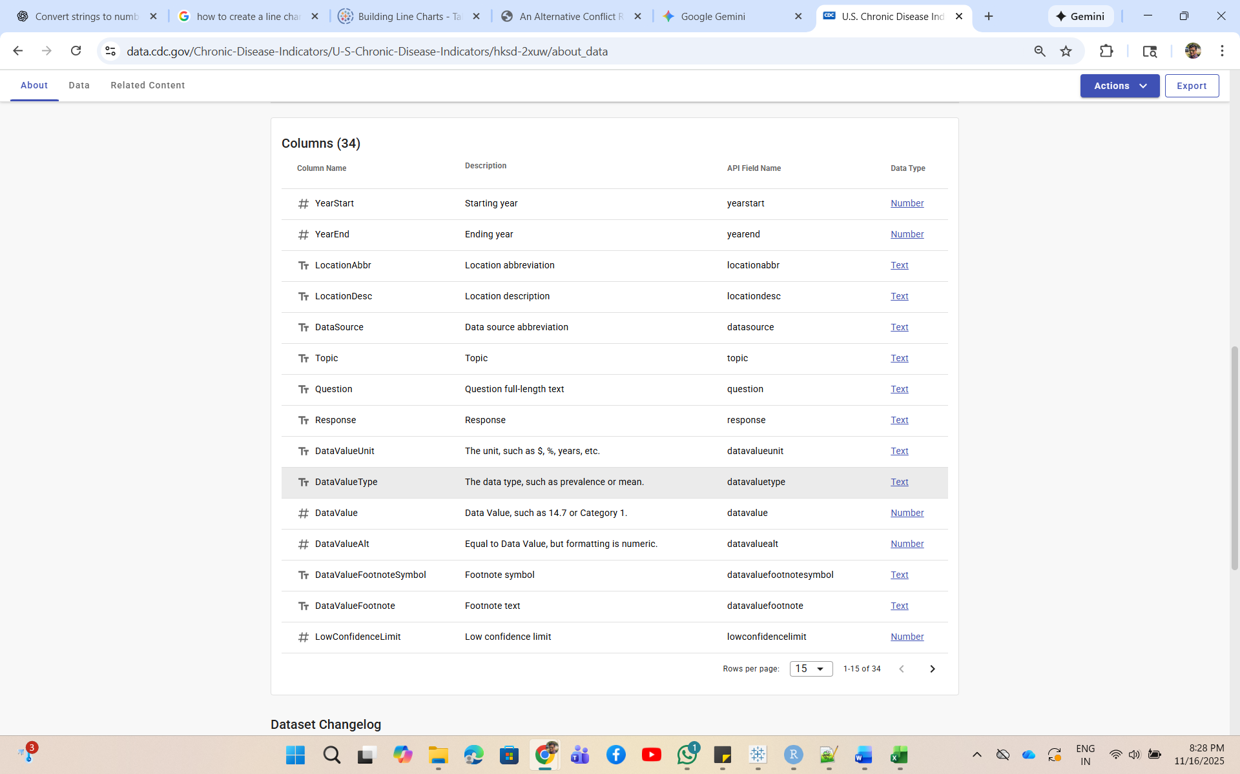
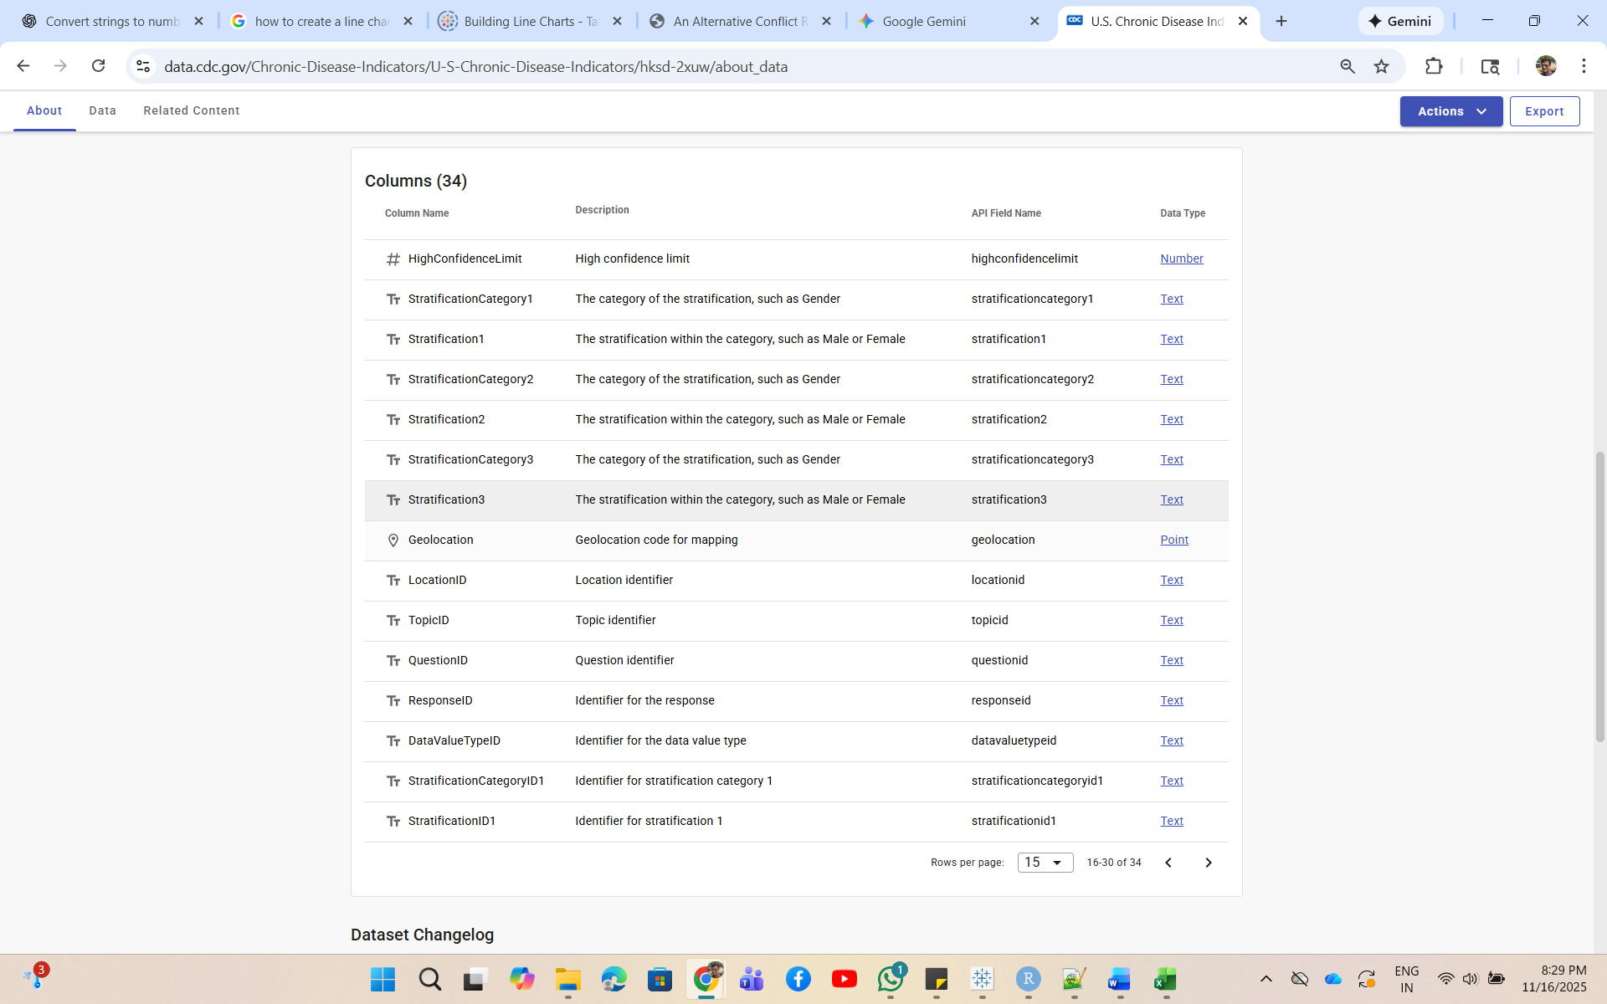
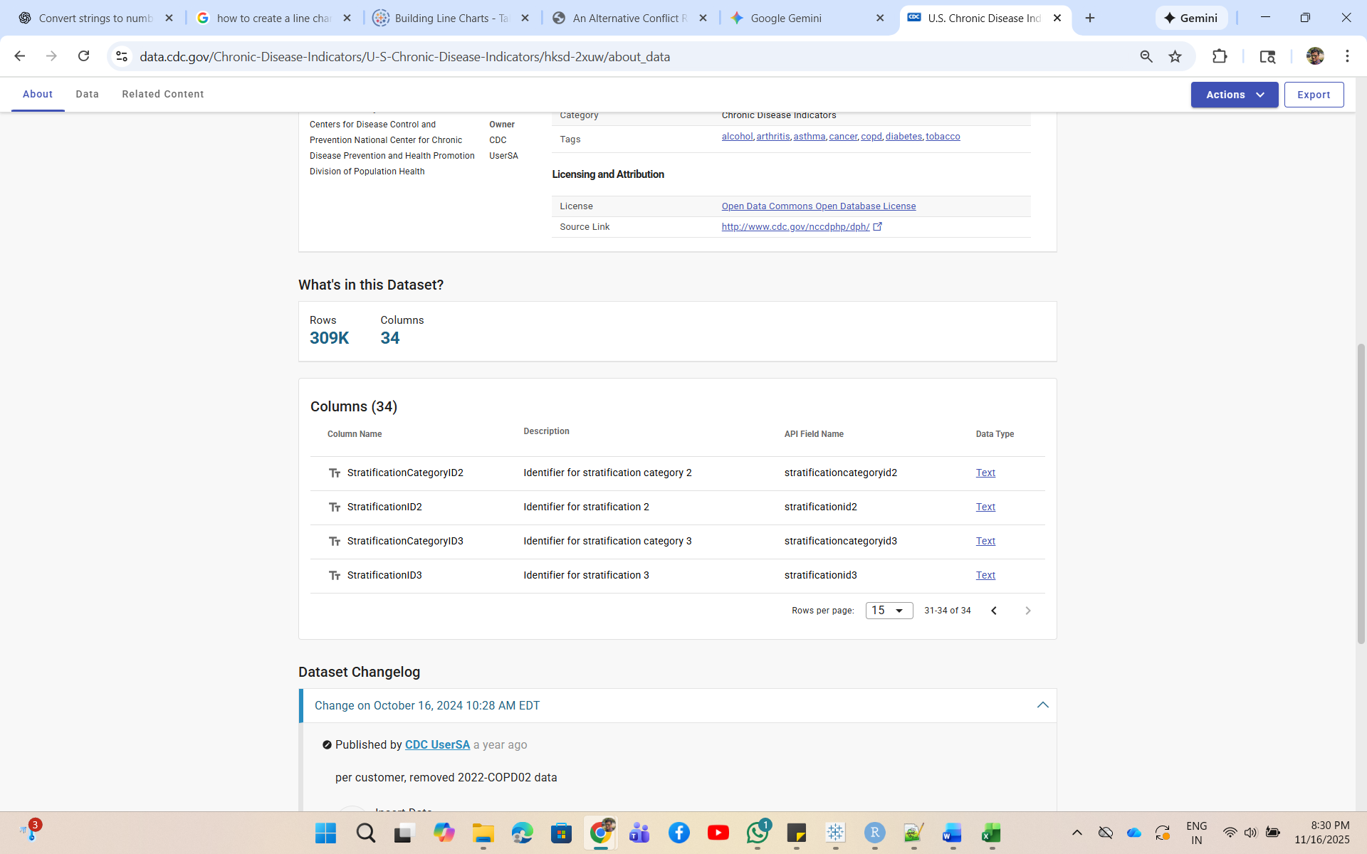
Questions to be answered-
I wanted to analyze some questions like the below. This is the reason why I have selected all the datasets.
- Based on Dataset1-
- What are the major research themes (topics) when grouped by keyword presence (e.g., “vaccine”, “variant”, “long covid”)?
- Based on Dataset2-
- What are the most frequently mentioned medical terms or diseases?
- What are the top keywords per Country?
- Based on Dataset3-
- How does chronic disease vary per states?
- How do chronic disease/risk-factor rates differ by demographic subgroup (age group, sex, race/ethnicity)?
- How do chronic disease prevalence rates vary by state?

Data Pre-processing-
This section is including all the preprocessing required before going for visualizations.
- Used “Long Stopword List” in https://www.ranks.nl/stopwords to remove commonly used English stop words from Dataset2 (Text field).
- I have skipped null values wherever applicable.
Tableau Visualizations-
Question 1- What are the most frequently mentioned medical terms or diseases?
Selected Dataset- Dataset2
WordCloud-
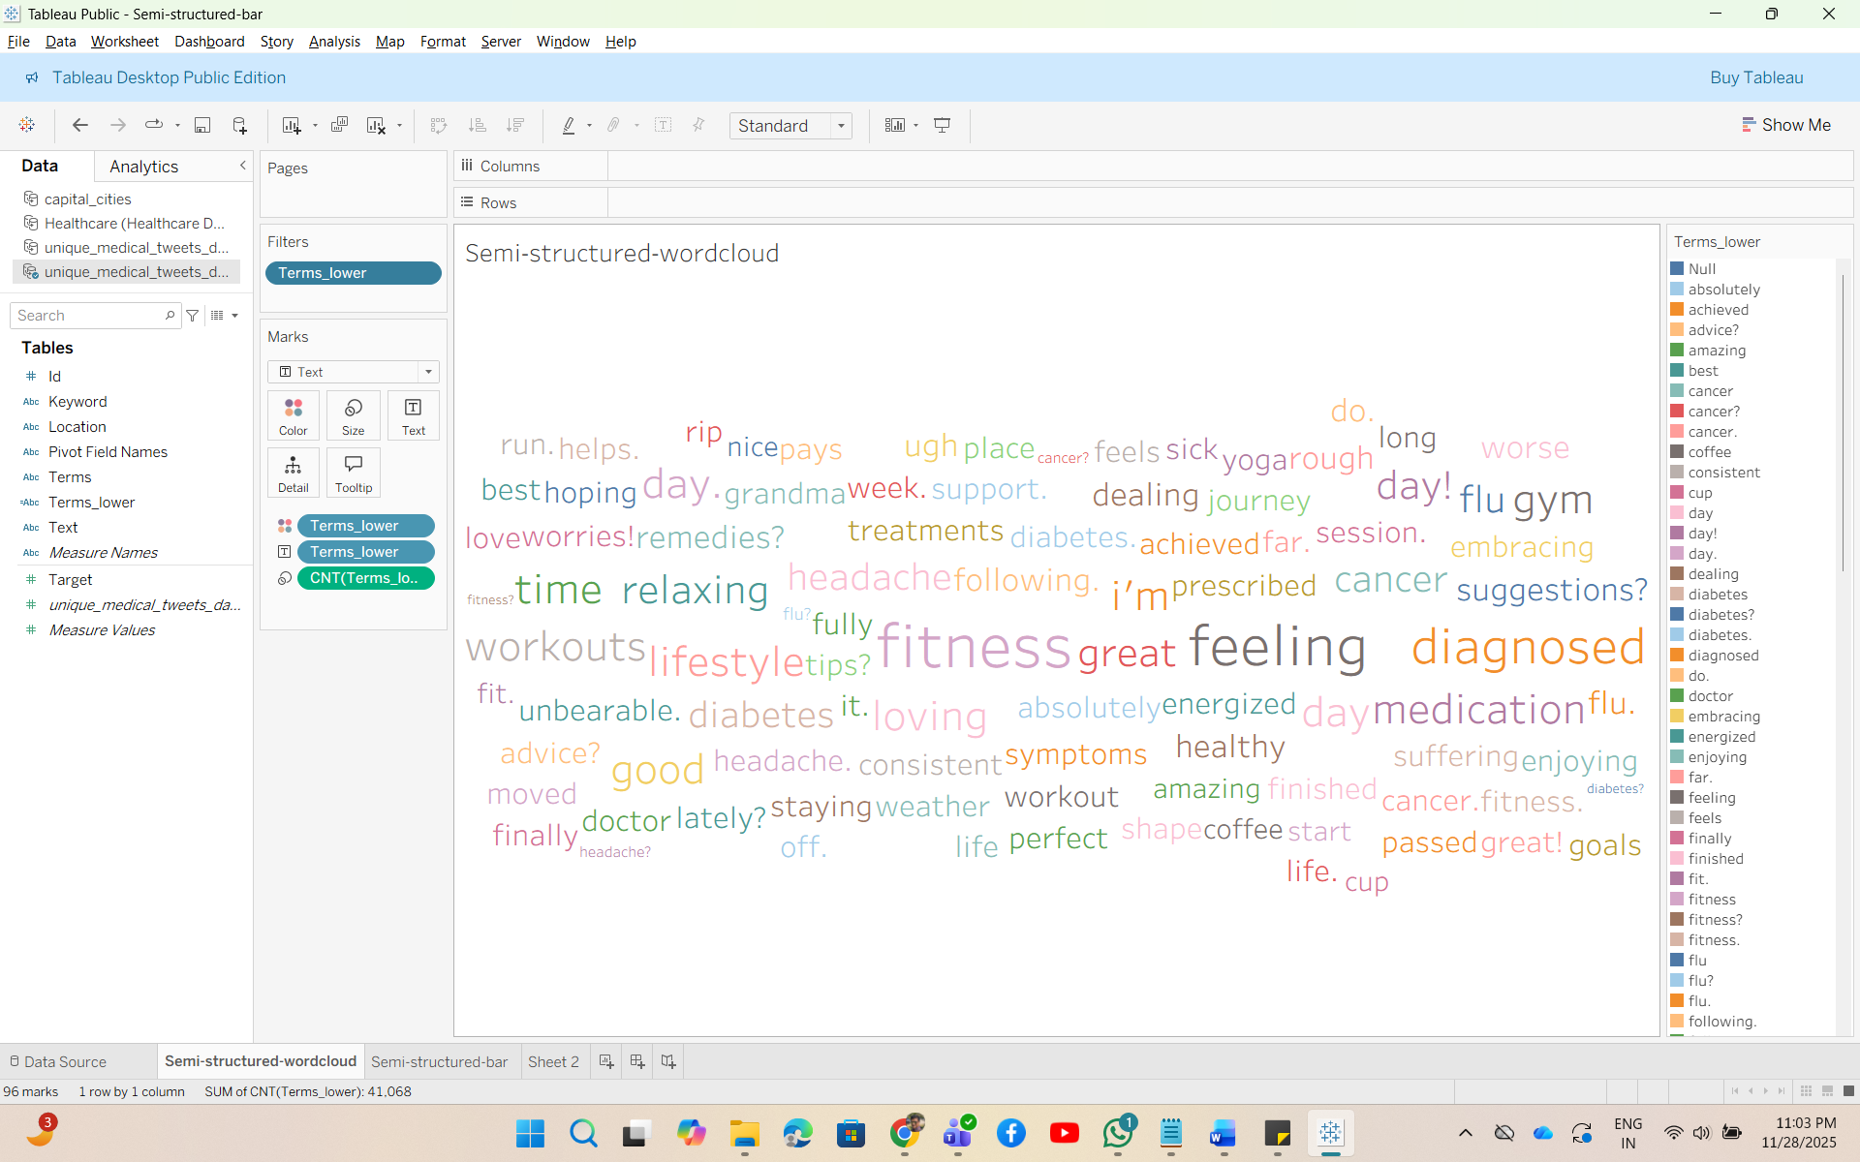

Bar Plot-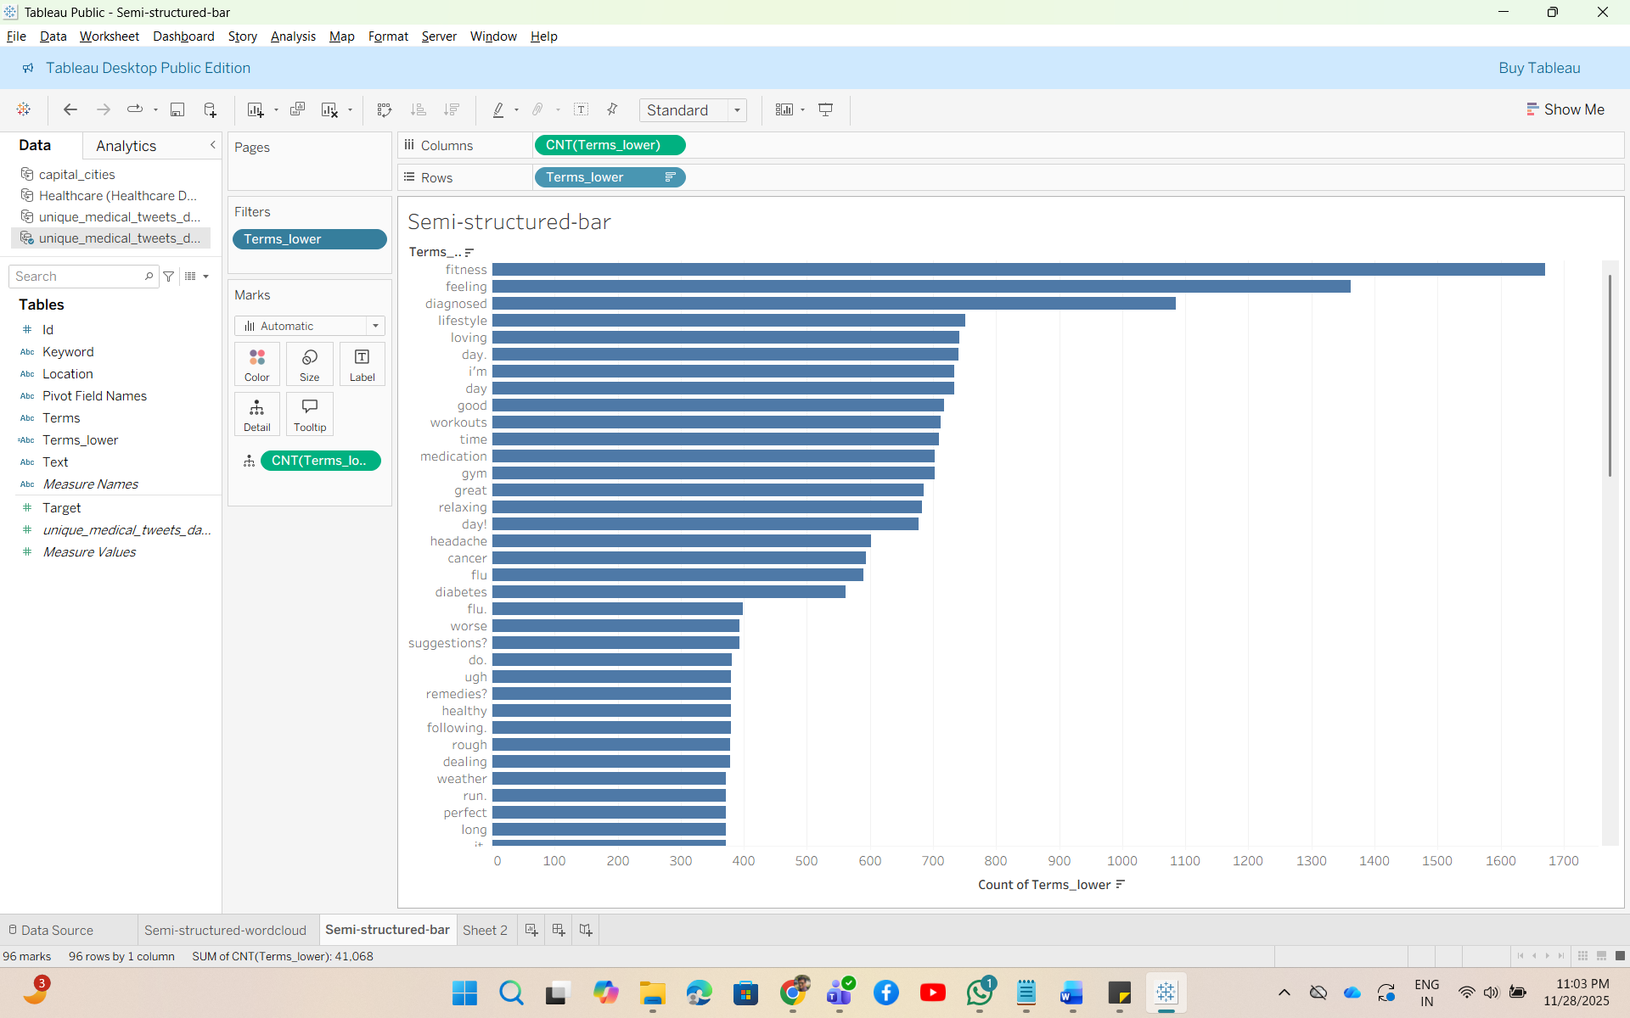
Bubble Plot-
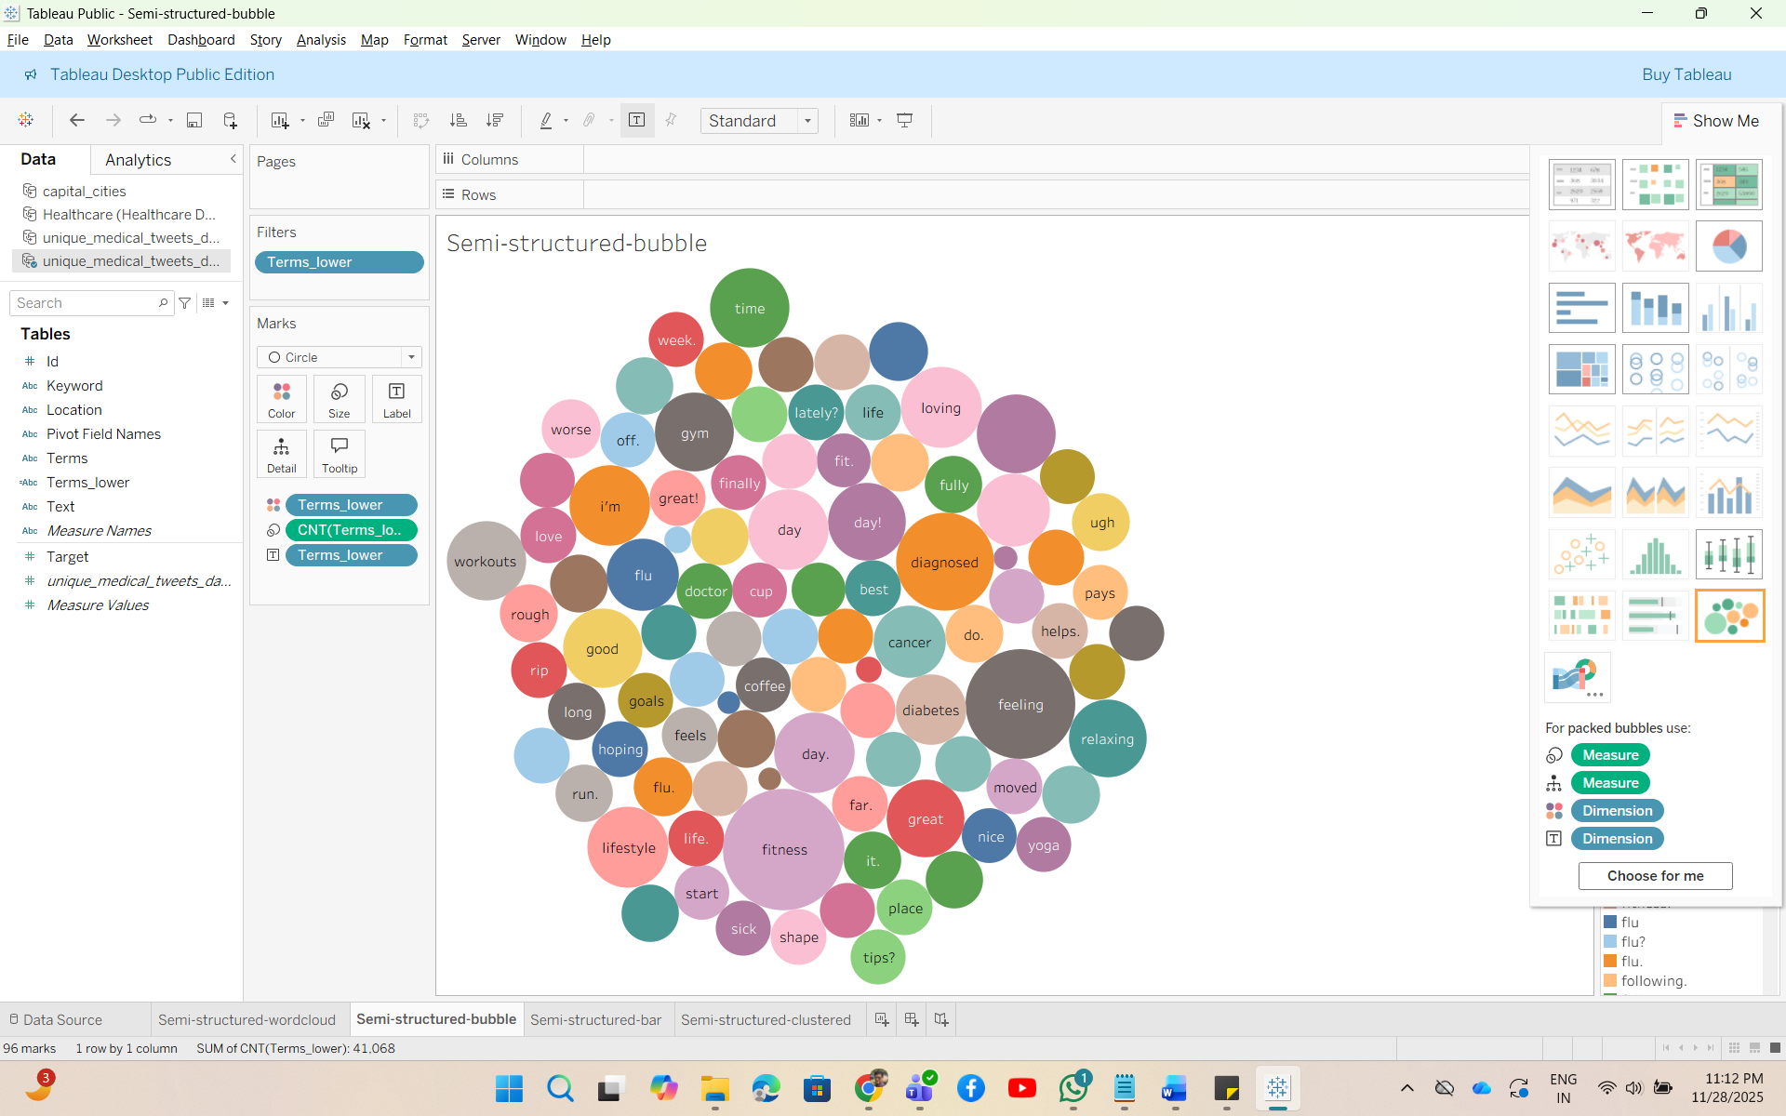
Top 5 Terms tweeted-
- Fitness- 1670 times
- Feeling- 1362 times
- Diagnosed- 1085 times
- Lifestyle- 751
- Loving- 742
Top 5 diseases/diagnoses Medical Terms tweeted-
- Medication- 703
- Headache- 602
- Cancer- 594
- Flu- 589
- Diabetes- 561
Question 2- What are the top keywords per Country?
Selected Dataset- Dataset2
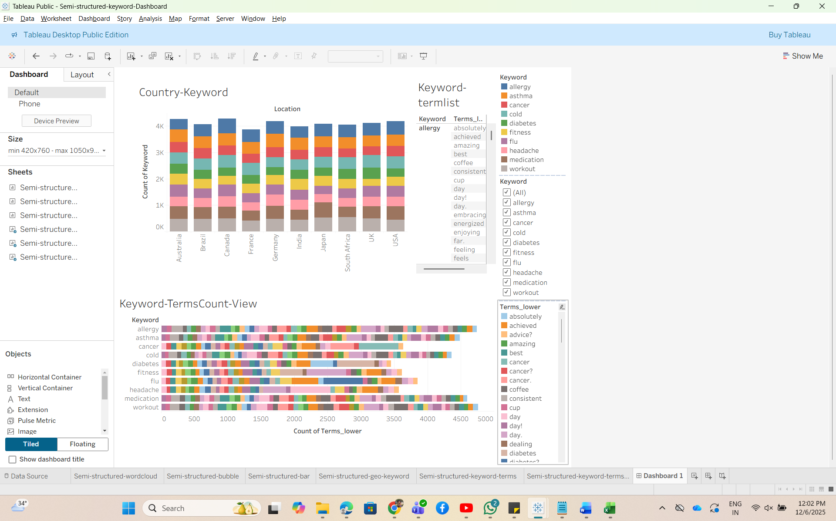
The interactive dashboard shows 3 plots.
- “Country-keyword” is showing Country and the top keywords tweeted in them.
- “Keyword-TermsCount-View” is showing different terms count used per keyword category.
- If we wanted to see which specific terms in each keyword, “Keyword-TermsList” is showing it.
Question 3- How does chronic disease vary per states?
Selected Dataset- Dataset3
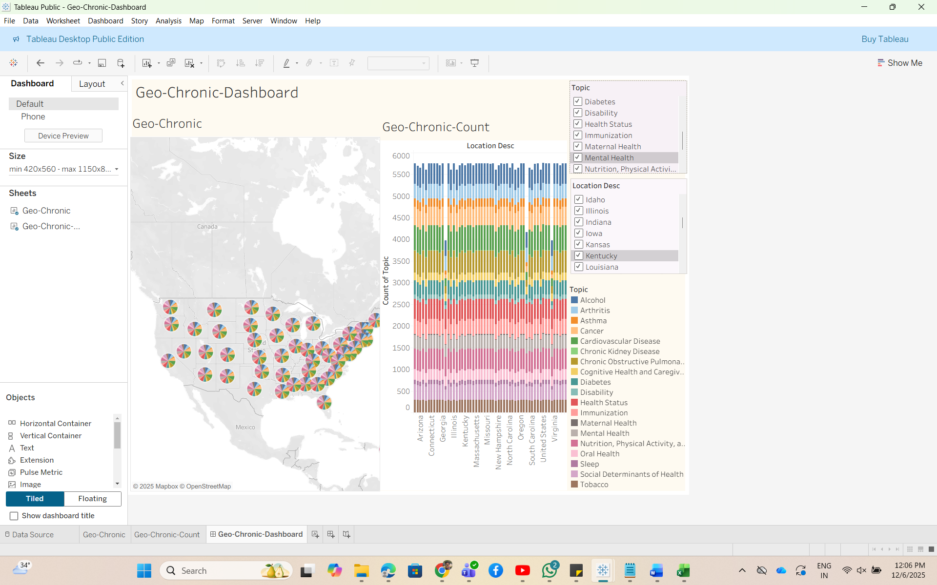
This interactive Dashboard is showing different chronic diseases (Topic) distribution in various locations.
- “Geo-Chronic” is showing all location with pie-charts showing different topics.
- “Geo-Chronic-Count” is showing different counts of topics or chronic diseases in various locations.
- There are filters for topics and locations.
- If we select any specific location or topic, both plots will show respective graphs interactively.
- If we want to explore Asthma patient distribution across different states, the graph will showcase it. Similarly, we can analyze any chronic disease distribution.
Question 4- How do chronic disease/risk-factor rates differ by demographic subgroup (age group, sex, race/ethnicity)?
Selected Dataset- Dataset3
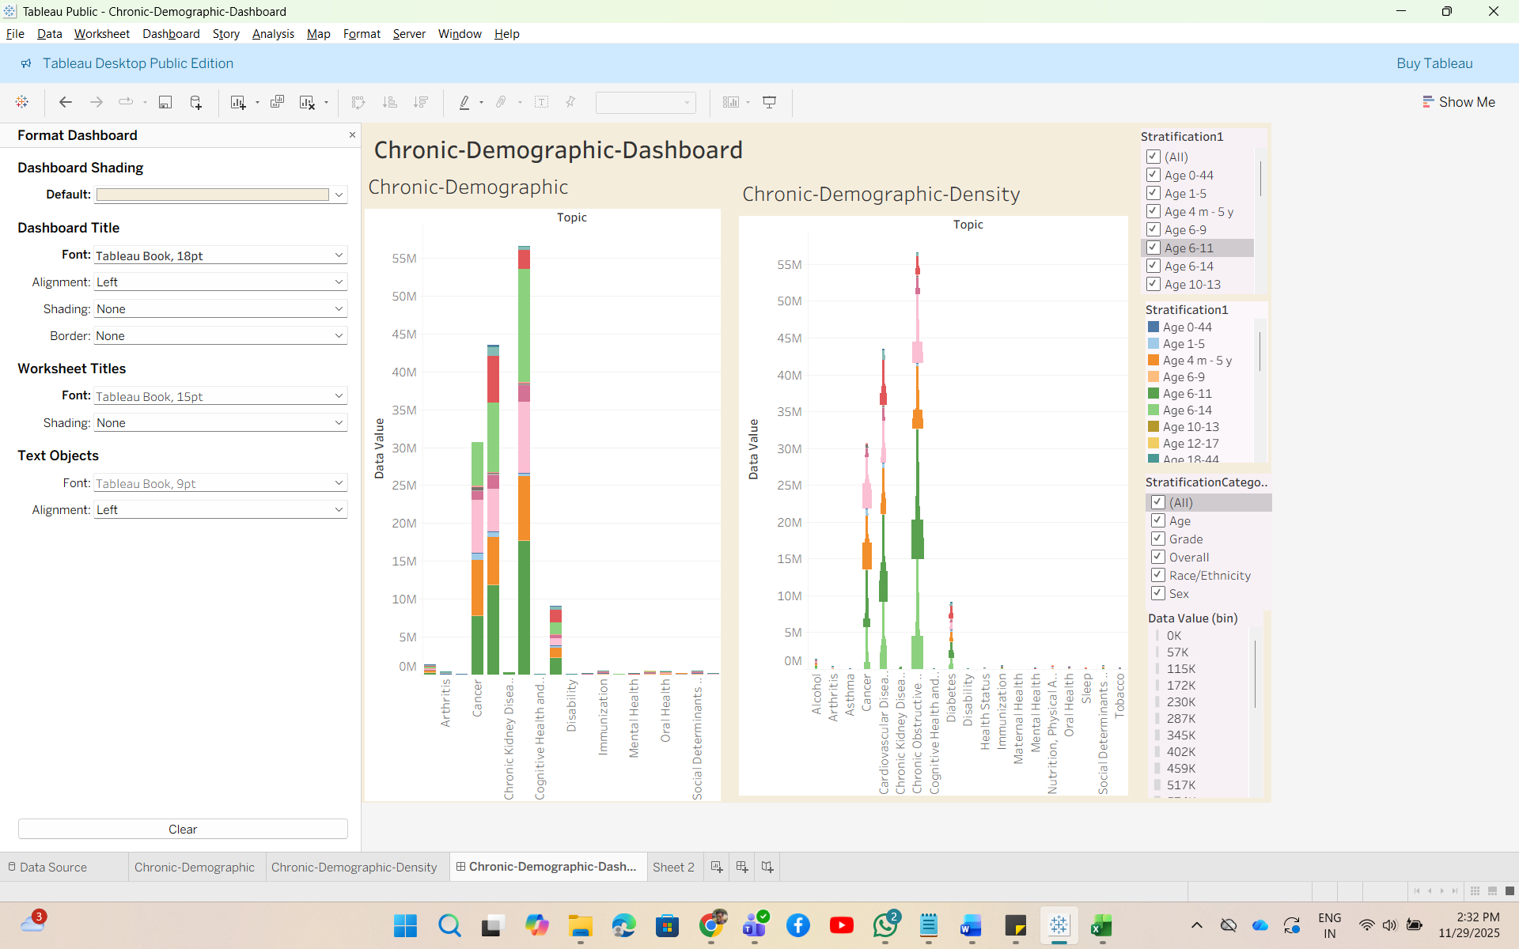
This interactive dashboard is showing different demographic distribution for chronic diseases.
- “Chronic-Demographic” is showing chronic diseases with demographic data (Stratification1, StratificationCategory1).
- “Chronic-Demographic-Density” is showing chronic diseases with demographic data (Stratification1, StratificationCategory1) along with Density of distribution of data value.
- If we see both graphs together, we will be able to analyze how Cancer patient distribution is present per age group or per ethnicity etc.
Chronic-Demographic Story-
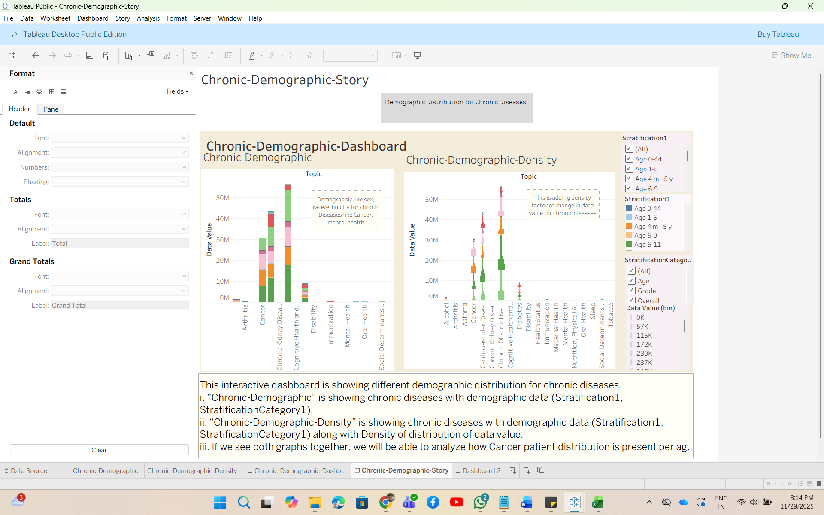
This is a story telling the same points as mentioned in Dashboard.
R Studio Implementation-
- Analyze Dataset1 (Unstructured Dataset)- Question- What are the major research themes (topics) when grouped by keyword presence (e.g., “vaccine”, “variant”, “long covid”)?
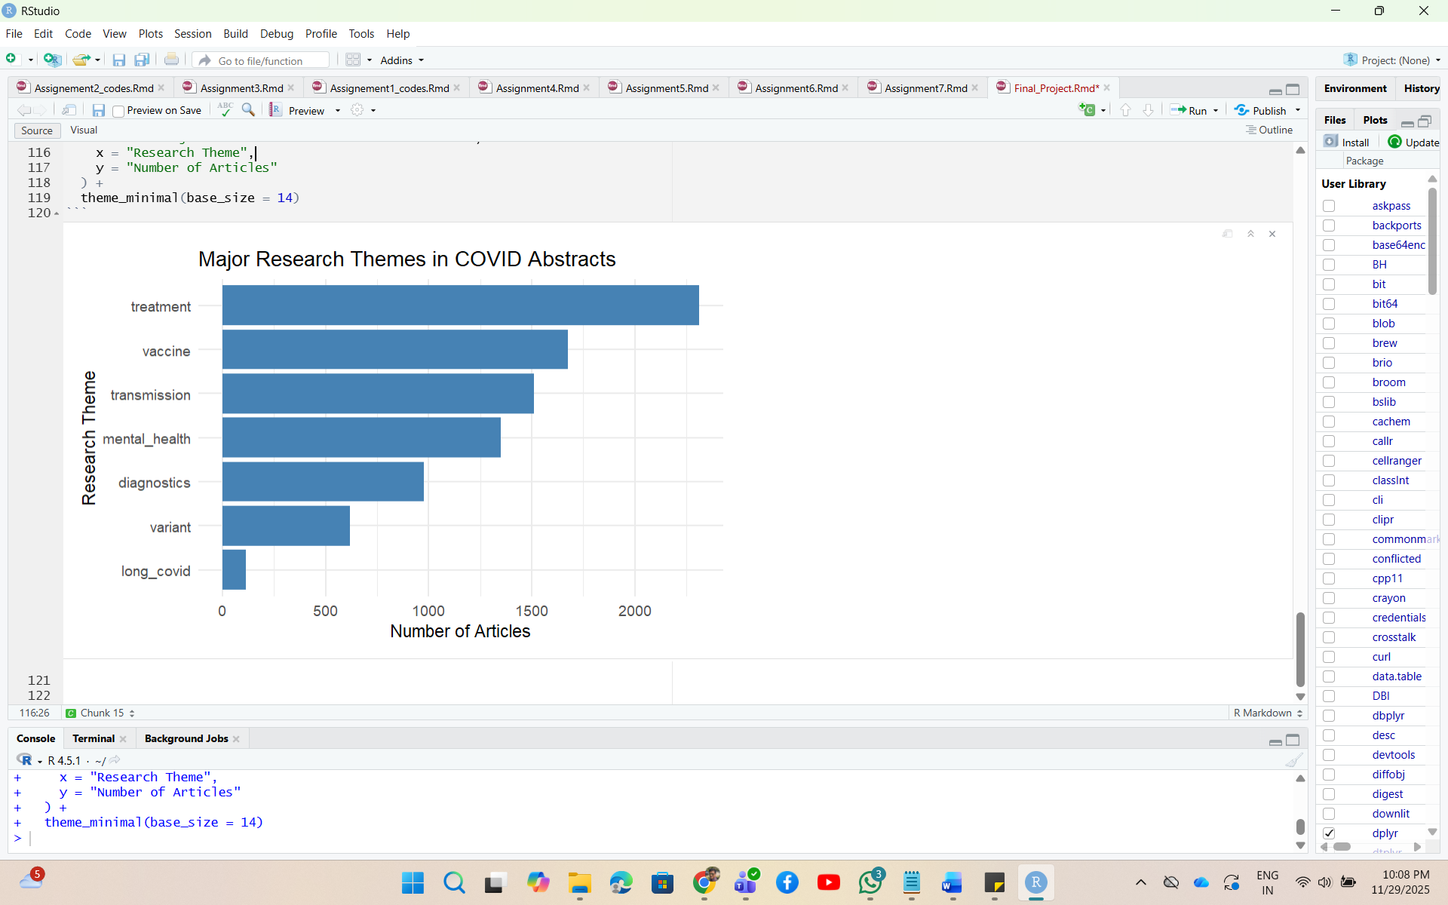
The graph is showing frequency of different keyword themes in the unstructured dataset (Dataset1 which has abstracts lists of covid19).
- I have created themes as below:
vaccine = ("vaccine", "vaccination", "mrna", "pfizer", "moderna", "immunization"),
variant = ("variant", "delta", "omicron", "mutation", "lineage", "strain"),
long_covid = ("long covid", "post-acute", "pasc", "post covid"),
transmission = ("transmission", "spread", "infectivity"),
diagnostics = ("diagnostic", "pcr", "rapid test", "antigen"),
treatment = ("treatment", "therapy", "antiviral", "remdesivir", "icu"),
mental_health = ("stress", "mental health", "anxiety", "depression")
- The highest number of keywords are of category “treatment” while the lowest is “long covid”.

- Analyze Dataset3(Structured Dataset)- Question- How do chronic disease prevalence rates vary by state?
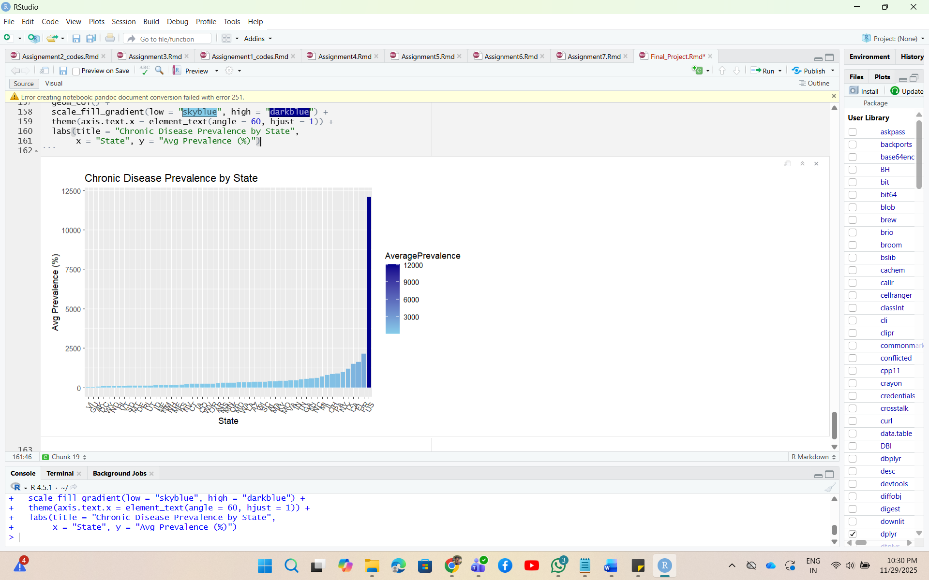
The above plot is showing Average Prevalence for each state available in dataset.
- I skipped all records having null or no value for “DataValue”.
- Computed average prevalence as mean of DataValue by grouping LocationDesc, LocationAbbr.
- As the graph is showing US is having highest average prevalence as most of datavalue are defaulted to US. The next big state is PR.

