- Download Athena ODBC driver for windows-
https://docs.aws.amazon.com/athena/latest/ug/odbc-v2-driver.html

- Install aws CLI for windows-
https://docs.aws.amazon.com/cli/latest/userguide/getting-started-install.html

- Once msi file is installed, configure in ODBC Data Source Administrator >> System DSN >> Amazon Athena ODBC Configuration

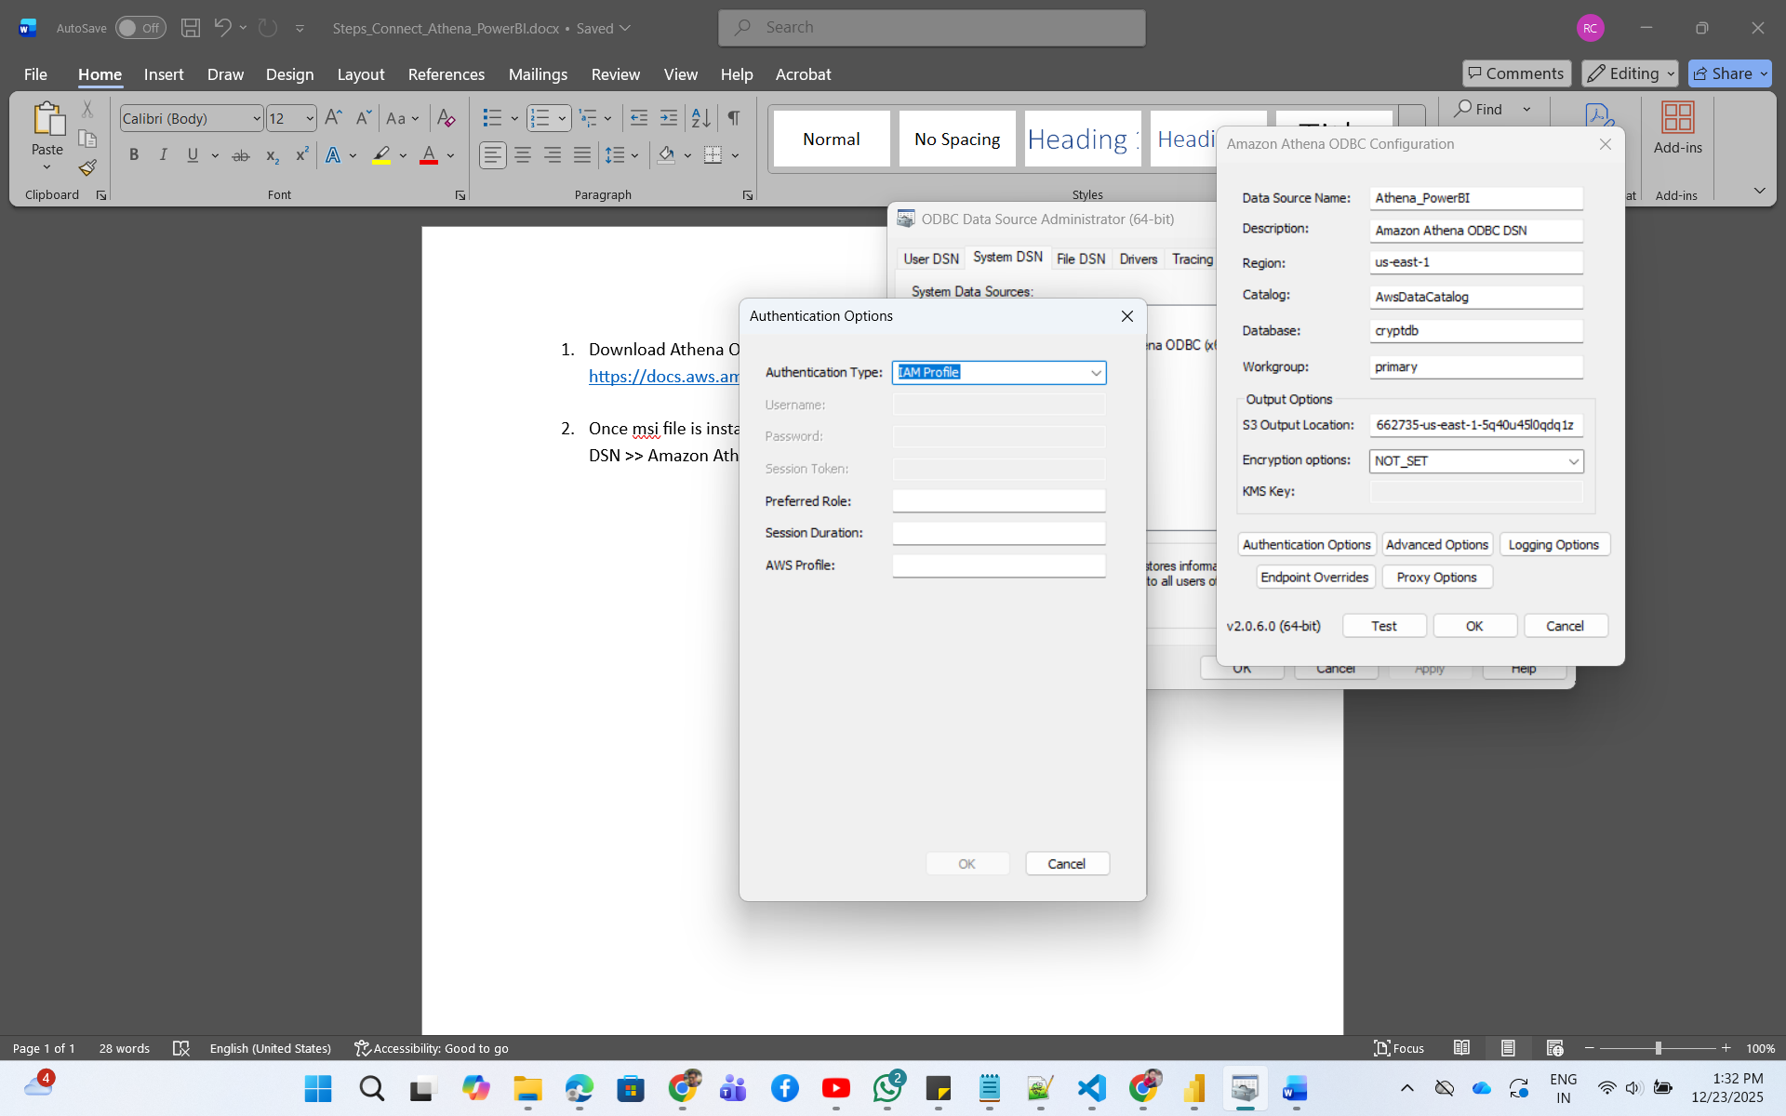

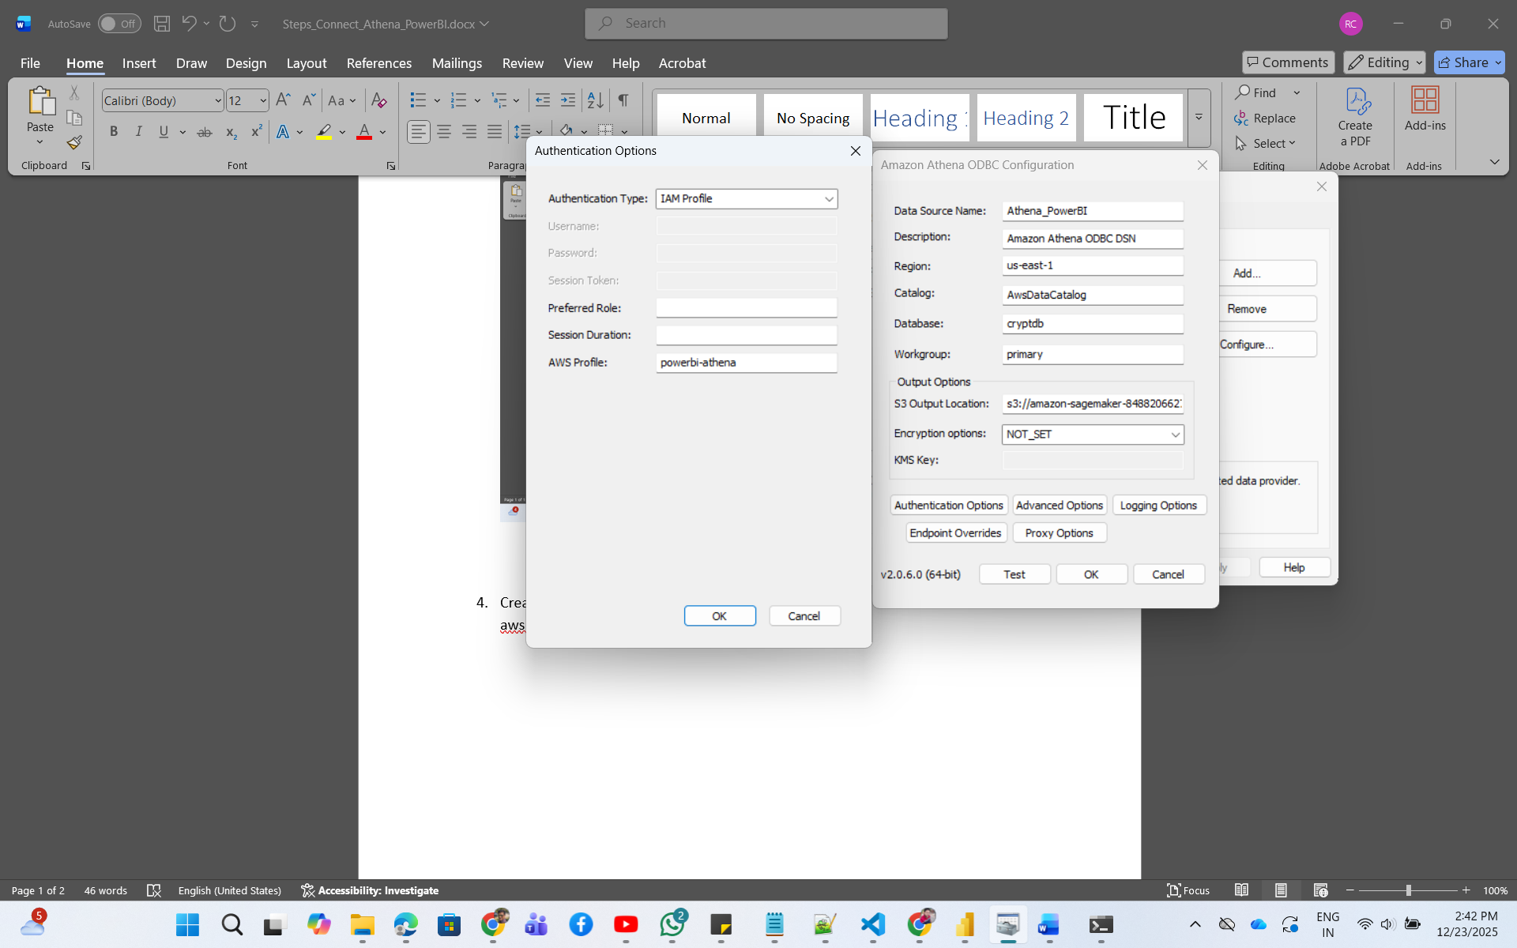

- Create IAM Profile-
aws configure --profile powerbi-athena

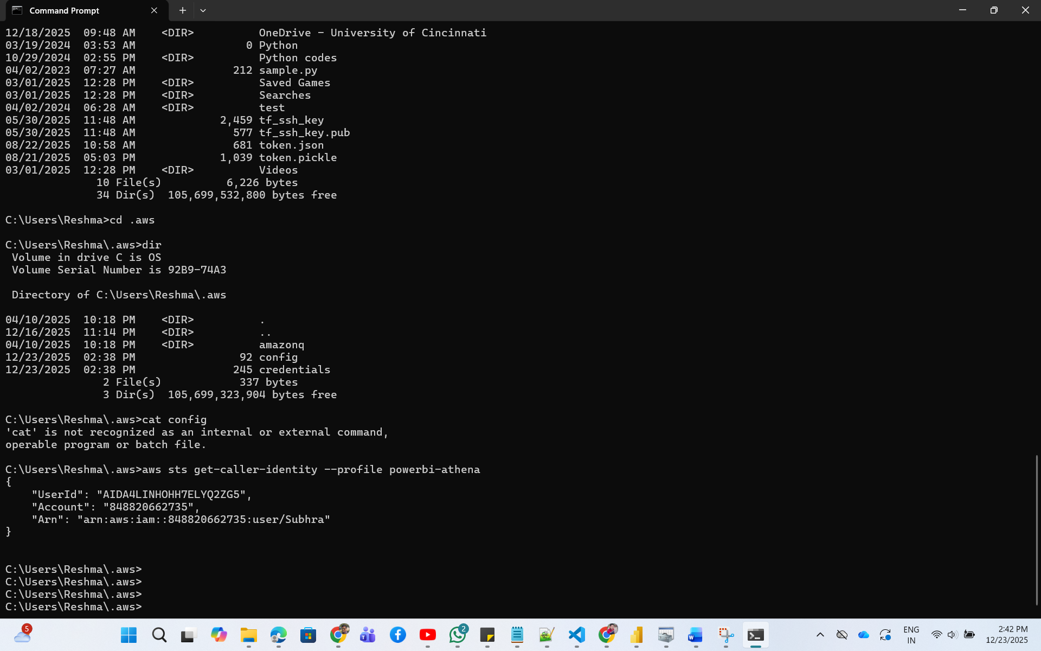

Test connection-
aws sts get-caller-identity --profile powerbi-athena

- Configure PowerBI for connection-

Get Data ODBC System DSN name

