IT Project
Cryptocurrency Price Prediction using deep learning and sentiment analysis
A multimodal approach
By
Subhra Ojha

Submitted to:
Professor Kemi Akanbi

Table of Contents

Table of Contents 2
Abstract 3
Introduction 4
Literature Review 5
Methodology 6
List of Figures 21
Expected Result 23
Conclusion and Future Work 23
Limitation and Future Work 24
References 25

Abstract
Cryptocurrency represents a very volatile and complex market to understand and predict EMH (Efficient Market Hypothesis) and time series forecasting. Numerous studies have been established to understand impact of social media X or news feeds on possible trend of crypto currency. Furthermore, there have been various attempts of different deep learning model to efficiently predict the transient value. This research paper attempts to figure out if combining both sentiment analysis and deep learning models are efficient enough to predict various crypto values such as Bitcoin (BTC-USD), Ethereum (ETH-USD), Binance Coin (BNB-USD), XRP (XRP-USD), and Litecoin (LTC-USD). Sentiment analysis is accompanying by NLP methods applied to X, news feeds with technical analysis indicator such as OHLCV, RSI, MACD, Bollinger Bands. As part of deep learning on transient real-time crypto feeds, this research paper focuses on XGBoost, Temporal Fusion Transformers (TFT), and Graph Neural Networks (GNN). Various metrics as regression metrics (MAE, RMSE, MAPE), directional accuracy, Granger Causality testing, Pearson and Spearman correlation coefficients, and SHAP (Shapley Additive explanations) values are used interpretably to understand deep about the inter-relational impact of sentiments on cryptocurrency.
Keywords: Cryptocurrency Price Prediction, Sentiment Analysis, Efficient Market Hypothesis, Temporal Fusion Transformers, Granger Causality, Deep Learning, Time-Series Forecasting, Multi-Modal Learning, Granger Causality testing, Pearson and Spearman correlation coefficients, directional accuracy

Introduction
Cryptocurrency markets operate on 24*7 mode which makes it most transient, complex and unpredictable market. Occasions of movement of more than 20% of crypto market justifies this theory. Each crypto market such as Bitcoin (BTC-USD), Ethereum (ETH-USD), Binance Coin (BNB-USD), XRP (XRP-USD), and Litecoin (LTC-USD) behave in their own unique way and that brings the complexity even more brutal. Behavioral finance theory (Kahneman & Tversky, 1979; Shiller, 2000) argues that investor decisions are systematically influenced by cognitive biases and emotional states rather than purely rational utility maximization. The abundance of social media platforms such as X, Reddit, Youtube videos, news feeds are just few of the whole lot and they seem to play a crucial role in oscillation movement of crypto market. Empirical evidence suggests these social signals are not merely reflections of price movements but may actually precede and drive them (Garcia & Schweitzer, 2015). This research paper is attempting to utilize contribution of researchers in both sentiment analysis field and deep learning models such as LSTM, TFT and GNN together to discover the underneath complexity of crypto currency prediction.
CoinGecko API is the primary source of real-time data collection for all 5 crypto currencies considered for the research i.e. Bitcoin (BTC-USD), Ethereum (ETH-USD), Binance Coin (BNB-USD), XRP (XRP-USD), and Litecoin (LTC-USD). X/Twitter API, Reddit API and News API are major source of information for any topic related to crypto. Careful consideration has been applied for selective keywords related to crypto currency fields. There is exclusion criteria considered as well specifically promotional ads keywords and LLM generated blog content keywords. Media text preprocessing follows the NLP pipeline standard (Manning & Schütze, 1999): (1) URL removal, (2) HTML entity decoding, (3) hashtag and @-mention normalization, (4) emoji-to-text translation using the emoji Python library to preserve affective content, (5) lowercasing, (6) tokenization using SpaCy, (7) lemmatization, and (8) stop-word removal. Critically, negation handling is applied before stop-word removal to preserve negation context (e.g., ‘not good’ must not be reduced to ‘good’). The research paper further uses Transformer-based sentiment scoring models such as VADER, FinBERT (Araci, 2019) to classify text feed as positive, negative or neutral sentiment. Granger Causality test is one of most critical features in the research. Granger (1969) formalized a pragmatic notion of causality in time series: a variable X is said to Granger-cause Y if past values of X contain statistically significant information for predicting Y, beyond what is contained in Y’s own past values alone. The formal test involves comparing the forecast error of a restricted VAR (Vector Autoregression) model using only Y’s lags against an unrestricted VAR that includes lags of both X and Y. Only sentiment-cryptocurrency pairs that reject the null hypothesis (p < 0.05) will be included as features in this study. The final phase in the implementation is the fusion of cryptocurrency real-time metrics features and sentiment features. There are few critical mathematical metrics used in the study (RSI, MACD, Bollinger Band position, VWAP) which are explicitly used for cryptocurrencies. XGBoost, Temporal Fusion Transformer (TFT) and Graph Neural Network (GNN) are considered as deep learning models which will be fed with above features with standard considerations of train-test, hyperparameter optimization and prediction of accuracy. Directional accuracy, accuracy, F1 score, balanced accuracy, predictive lift are major matrices which will determine the outcome of the fusion model and SHAP values are specifically used for interpretability of how much effective either sentiment or crypto mathematical metrices are in deciding final prediction accuracy. This is the key objective of the research paper and will conclude the answers to research questions. The research paper will further discuss on remaining future works and derive conclusion on all research methods and results received.
Research Questions:
- Can the integration of multi-modal social media sentiment signals with technical price indicators produce statistically superior cryptocurrency price predictions compared to models using technical indicators alone?
- Which hybrid deep learning architecture (XGBoost, TFT, or GNN) achieves the best directional accuracy and RMSE in the joint prediction task?
This research paper is making following original contributions:
- A theoretically grounded multi-modal sentiment-technical fusion pipeline for real-time cryptocurrency price prediction, explicitly connecting design decisions to theoretical frameworks from behavioral finance and information theory.
- A systematic comparative evaluation of two deep learning architectures (XGBoost, TFT) on the joint prediction task, evaluated under a common experimental protocol.
- Furthermore, the interdependency of multi-modal sentiment-analysis with transient cryptocurrency movement are explored with help of technical indicators and statistical study.

Literature Review
- Role of Media in Stock Market
The formal investigation of sentiment as a predictor of financial markets predates the cryptocurrency era. Tetlock (2007) established a foundational quantitative link between media sentiment and stock market behavior, demonstrating through a lexicon-based analysis of Wall Street Journal columns that negative media sentiment predicts downward pressure on broad market returns. Garcia and Schweitzer (2015) extended this framework specifically to Bitcoin, using psycholinguistic lexicon-based sentiment analysis of Twitter data. Their VAR (Vector Autoregression) model revealed bidirectional causality between emotional valence in tweets and Bitcoin trading volume, and designed an algorithmic trading strategy achieving a Sharpe ratio of 1.823. Both the studies are quite influential in stepping stone of this research paper.
- Sentiment Data Source with Feature Engineering
Pang, Sundararaj, and Ren (2019) used the Thomson Reuters MarketPsych Index (TRMI), a professionally curated sentiment dataset, alongside LSTM models. This model is a benchmark contribution which demonstrated sentiment features outperforms mathematical model-based cryptocurrency matrix-based model. Though they emphasized that there is limitation in commercially curated dataset and further highlighted need of study of real time news feeds of appropriate size. Kristoufek (2013) took a non-NLP approach, using Wikipedia search volumes and Google Trends data as proxies for investor interest, finding strong correlations with Bitcoin price at weekly resolution.
- Deep Learning in Cryptocurrency
Mazinani, Davoli, and Ferrari (2025) conducted a comprehensive comparative analysis of deep learning methods for cryptocurrency price prediction, evaluating LSTM, GRU, CNN-LSTM, and transformer-based models. It is baseline study which proved that neural network models are comparatively outperforming accuracy models of simpler models. The Temporal Fusion Transformer (TFT), introduced by Lim et al. (2021), is architecturally designed for multi-horizon, multi-input time-series problem, integrating variable selection networks, gated residual networks, and multi-head attention in a single architecture, making it theoretically well-suited for the joint sentiment-technical prediction task.
- Transformers for statistical expression of Sentiments
Zhi and Chan (2024) applied transformer-based clustering of social media posts to Bitcoin price prediction, demonstrating that grouping semantically similar posts before sentiment scoring improves prediction accuracy. This multi-platform-oriented sentiment prediction model is one of key door of this research paper and used for modelling sentiment as positive, negative or neutral with context of cryptocurrency.
The contextual content of each of above literature are baseline of this research paper. There are definite references adopted from each of the above literature, however there are considerable gaps and the ideology of this research papers is to address the same. Following is a matrix illustrating different key studies, methods and gaps identified in each of them.
Study | Method | Gap Addressed by This Research
Tetlock (2007) | Lexicon-VAR | No deep learning; no crypto
Garcia & Schweitzer (2015) | Lexicon-VAR | No transformer NLP; single asset
Pang et al. (2019) | LSTM | Proprietary data; no open-source pipeline
Mazinani et al. (2025) | LSTM, GRU, CNN | No sentiment integration
Hagio & Sano (2023) | ResNet | No NLP; single modality
Zhi & Chan (2024) | Transformer | No Granger causality; no SHAP
This Research | TFT + GNN + XGBoost | All gaps addressed

Methodology
- Preliminaries
  - Data Collection
CoinGecko API is primary source for real-time crypto currency values for all 5 cryptos i.e. Bitcoin (BTC-USD), Ethereum (ETH-USD), Binance Coin (BNB-USD), XRP (XRP-USD), and Litecoin (LTC-USD). Historical OHLCV (Open, High, Low, Close, Volume) data are fetched for all 5 crypto currencies from it. All the values are extracted in 5 minute’s interval. Crypto market has standard metrices such as Relative Strength Index (RSI)-momentum oscillator taken over 14 days period, Moving Average Convergence Divergence (MACD)- momentum indicator showing the relationship between two exponential moving averages (12-period and 26-period EMAs), with signal line (9-period EMA of MACD), Bollinger bands- market volatility indicator are major matrices utilized in this research. The metrices are collected and evaluated over 15 minutes interval.
Twitter/X API, Fear ang Greed API and newsfeed API are major sources for real time data collection with inclusion criteria as terms related to crypto market and exclusion criteria as non-LLM generated and promotional content terms. The frequency of retrieval is 5 mins.
Calculated and Observed Indicators-
- OHLCV:
For a given time window (example: 1-minute candle):
open → First trade price in interval
High → Maximum trade price
Low → Minimum trade price
Close → Last trade price
Volume → Sum of traded quantity

Often types of Aggregations are following types:
- Time-Based (1m, 5m, 1h, 1d etc.)
- Volume-Based Bars- Aggregate after fixed traded volume (used in HFT)
- Tick Bars- Aggregate after fixed number of trades
- Dollar Bars- Aggregate after fixed traded notional value
Time based aggregation technique is selected for the purpose of this research paper. I have experimented with both 1m and 5m windows.
- RSI (Relative Strength Index):
As per Shah, N.P. and Patel, Momentum (overbought / oversold conditions). Crypto is highly momentum-driven. RSI captures short-term behavioral overreaction. General behavior of RSI is that RSI > 70 refers are overbought, RSI < 30 refers to oversold and RSI as 50 is considered as neutral.
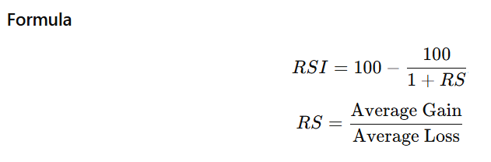
- MACD — Moving Average Convergence Divergence
As per Chong, T.T.-L. and Ng., The MACD is a momentum-based trend-following indicator that captures the relationship between two exponential moving averages (EMAs) of a price time series.
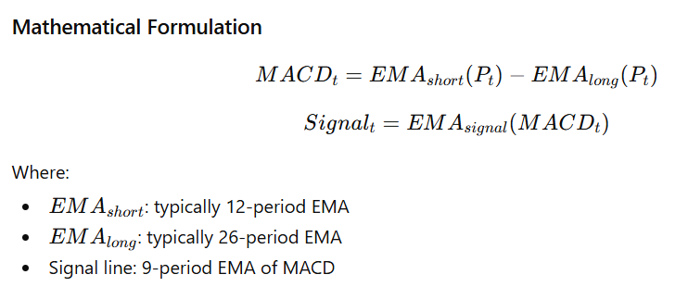
Normal interpretation says that MACD>0 refers to bullish momentum and MACD<0 bearish momentum. If it is at signal line, it often indicates trading signal.
- Bollinger Bands:
As per John Bollinger, it is a volatility indicator often consists of middle band as moving average and 2 bands around it.

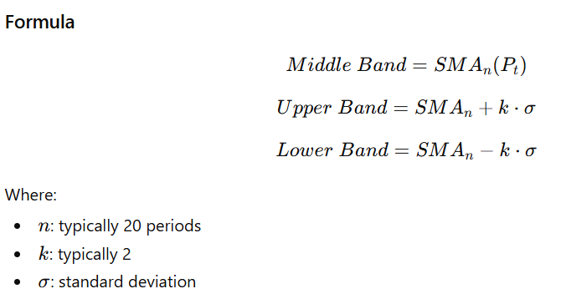
SMA- Simple moving Average
It often implies that if price near upper band, it is situation of overbought. If price is near lower band, it strongly implies oversold. If the band width is continuously increasing, then it indicates a volatile market.
- VWAP (Volume Weighted Average Price)
As per Daniel Mitchell, The VWAP is the average price of an asset weighted by trading volume over a specific time horizon.
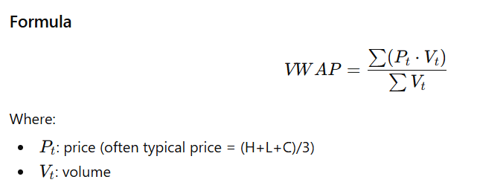
We can strongly say that if crypto currency price is above VWAP, then it is bullish market condition and vice versa.
  - Pre-processing
This step is explicitly for textual content from Twitter, Reddit and newsfeed. As part of pre-processing, we are performing below steps.
- URL removal
- HTML entity decoding
- hashtag and @-mention cleanup
- emoji-to-text translation using the emoji Python library
- lowercasing
- tokenization using SpaCy
- lemmatization
- stop-word removal
The Augmented Dickey-Fuller (ADF) test is a statistical tool used in time series analysis to determine whether a given dataset is stationary or contains a unit root (non-stationary). This is a common test applied to every time-series data and features failing p>0.05 will be left out before ingesting to deep learning models.
  - Sentiment Feature Extraction
FinBERT is a widely popular transformer-based model pre-trained with cryptocurrency data, popular news feeds as of one of major source data, is a perfect model for the feature extraction process. The objective of this model is categorizing texts into multiple classes as positive, negative and neutral sentiments.
The continuous sentiment score s(t) for time interval t is computed as:
s(t) = Σᵢ wᵢ × (P(positiveᵢ) − P(negativeᵢ)) / Σᵢ wᵢ
where wᵢ is the weight of post i, computed as a function of its engagement metrics (retweets, likes, comment depth) following the interaction-weighted sentiment formulation of Garcia & Schweitzer (2015).
Primary source of sentiment scoring is by Claude Haiku using AWS bedrock. The model filters and scores crypto related sentiments with probabilistic scoring.
Furthermore, a secondary lexicon-based scoring pipeline using the VADER (Valence Aware Dictionary and sentiment Reasoner) model will be run in parallel to perform a comparative study. We have used a smart way of using VADER sentiment categorization with Weighted Composite Sentiment Index and normalization techniques. While twitter sentiments are considered 50%, Newsapi 30% and fear & greed as 20% weights.
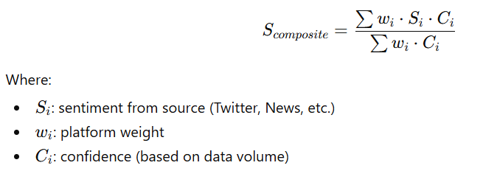
Both the sentiment scoring models are combined together to predict a sentiment probabilistic scoring. While VADER sentiment score contributes to baseline, Claude Haiku further improves the scoring. The model is considering likes, retweets, comments as additional factors for scoring.
Core formula used:
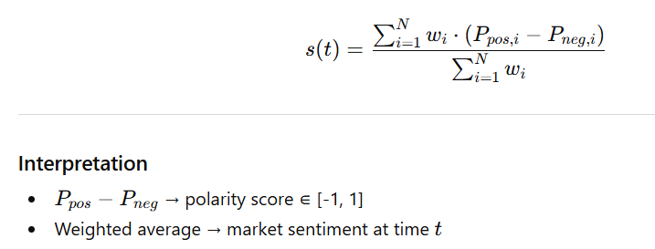
If s(t)>0 indicates bullish, s(t)<0 bearish and 0 as neutral sentiment.
Furthermore, enlisting all the features which are further processed through Granger Causality and AI models.
Selected Features:
coin_id,timestamp_bucket,open,high,low,close,volume,rsi,macd,macd_signal,macd_histogram,bb_upper,bb_middle,bb_lower,bb_position,vwap,sentiment_composite,sentiment_twitter,sentiment_news,twitter_count,news_count,sentiment_method,fear_greed_value,fear_greed_classification,fear_greed_count,google_trends_value,google_trends_count,sentiment_platform,source,ttl
  - Granger Causality
As per Ali Shojaie & Emily B., Granger causality is a statistical concept used to determine if one time series is useful in forecasting another. Mathematically,
Granger defined the causality relationship based on two principles:
- The cause happens prior to its effect.
- The cause has unique information about the future values of its effect.
Given these two assumptions about causality, Granger proposed to test the following hypothesis for identification of a causal effect of $X$on $Y$:
$$P[Y(t+1)∈A∣I(t)]≠P[Y(t+1)∈A∣I_{-X}(t)],$$
$P$ refers to probability, $A$is an arbitrary non-empty set, and $I(t)$ and $I_{-X}(t)$respectively denote the information available as of time $t$ in the entire universe, and that in the modified universe in which $X$is excluded. If the above hypothesis is accepted, we say that $X$ Granger-causes $Y$
This is a key pretest before feeding to deep learning models because only sentiment-cryptocurrency pairs that reject the null hypothesis (p < 0.05) will be included as features. We are excluding the rest.
  - Model Ingestion & result Evaluation
There will be a fusion dataset as feature which includes sentiment and crypto feeds together.
F(t) = [P(t), V(t), TA(t), S_twitter(t), S_feargreed(t), S_news(t), GoogleTrends(t)]
where P(t) is the price vector, V(t) the volume vector, TA(t) the technical analysis feature vector (RSI, MACD, Bollinger Band position), and S_*(t) the platform-specific sentiment scores.
Three primary architectures will be trained, each theoretically motivated:
- XGBoost:
As per Chen, T., & Guestrin, C., XGBoost (eXtreme Gradient Boosting) is a highly efficient, scalable machine learning library implementing optimized gradient-boosted decision trees. It designed to enhance performance and speed for supervised learning (regression/classification) by using parallel computing, handling missing values automatically, and applying regularization to prevent overfitting, making it ideal for large-scale, structured data.
XGBoost model is quite effective for our use case as we are using tabular data for supervised classification. We further trained XGBoost model with hybrid features of crypto indicators and normalized composite sentiment scores. The feature selection process is further improved by adding lag features such as Xt−1​,Xt−2​,Xt−4​,Xt−8​,Xt−12​. There are pre-exclusion criteria of features having high zero rate, low variance and low uniqueness. The model has conditional parameter to either consider tertiary (UP, DOWN and FLAT) sentiment classification of prediction or binary in case of +90% FLAT values of sentiments. The hyper-parameter optimization is carried through OPTUNA and considered MaxBalance Accuracy as major optimization technique.
XGBoost predicts the future value:
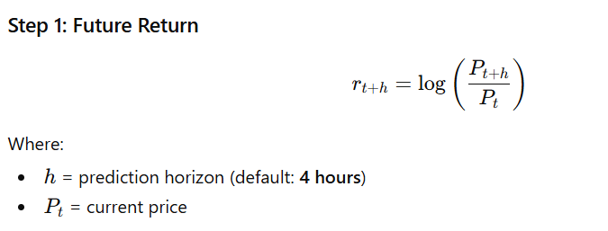
The prediction is further leveled as:
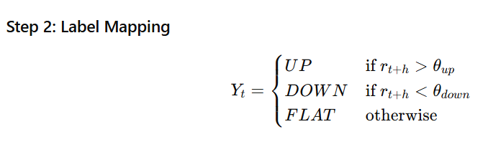
I have used SHAP analysis to select top 10 features which contribute to final prediction. Furthermore, I have selected accuracy, balanced accuracy, F1 score, MCC, AUC, predictive lift for metrics evaluation of the model. Predictive lift helps me predicting importance of sentiments in correlation with crypto indicators to final predictability. This is one of answer to my research question.
- Temporal Fusion Transformer (TFT):
The TFT architecture (Lim et al., 2021) is theoretically the most principled architecture for multi-input multi-horizon time-series forecasting. Its variable selection networks explicitly learn the relative importance of different input features (technical vs. sentiment), its gated residual networks provide adaptive nonlinear transformations, and its multi-head self-attention layer captures long-range temporal dependencies. TFT is the primary proposed architecture.
TFT is a natural go-to model for time series based crypto currency forecasting. I have selectively used variable selection network to interpret output with best fitted features. LSTM encoder-decoder is helping in finding short term patterns and sequential dependencies among features. TFT also has feature of attention mechanism to pop out past timestamps which matters most. A conditional logic flow is implemented to find adequacy of input features, removal of sparse features. The model is trained with both regression and classificational metrices such as accuracy, balanced accuracy, macro F1, MCC. A special metric is available in TFT which is multi-horizon evaluation which interprets the model with short-term, mid-term and long-term window selection of crypto currency time series. TFT is heavy computational model which requires huge dataset availability. A careful consideration of hyper parameters is opted keeping system configuration in mind. I have also opted for fast and prolonged TFT models with hyperparameter tuning.
- Graph Neural Network (GNN):
As per Gori et al, A Dynamic Graph Convolutional Network (DGCNN) where nodes represent individual cryptocurrencies and edge weights are computed as time-varying cross-correlation coefficients. This architecture is theoretically motivated by the multi-asset dependency structure of cryptocurrency markets: BTC price shocks demonstrably propagate through the market to altcoin prices with a measurable time lag.
The core components of GNN model are: a) Cryptocurrencies such as BTC, ETH etc. represent nodes b) Currencies correlation represents edges c) Node features are technical, sentimental and lagged signals d) Binary classification (UP/DOWN) are the tasks. As the number of FLAT sentiments are over 90%, we have excluded them for GNN model.
All above 3 models are fed with 80-10-10 train-validation-test dataset. There will be careful consideration for hyperparameter tuning for each used case in each model. Various measurements such as directional accuracy, balanced accuracy, macroF1, MCC are major matrices which will determine the outcome of the fusion model and SHAP values are specifically used for interpretability of how much effective either sentiment or crypto mathematical metrices are in deciding final prediction accuracy.
- Experimental Setup
The most necessary requirement for success of the research paper is to evaluate the models with various test scenarios and test dataset types. The datasets differ with varying span of time, freshness or real time data gathering and volume. The veracity remains the same across different test conditions.
  - Datasets Types
    - Monthly real-time data collection
This dataset consists of close to 1 month of high-frequency (15-minute interval) real-time data which includes:
- Cryptocurrency OHLCV data (via CoinGecko API)
- Twitter sentiment scores with real-time extraction with twitterapi.io
- News sentiment scores (aggregated from financial news sources)
- Fear & Greed Index values
- Google Trends signals
I have captured available sources for free research. There are numerous sources available for the crypto currency related feeds with billing options which are out of scope for the research.
The objective of collecting a real time dataset to understand frequency and lagging correlation factor between sentiments, crypto currency movement.
    - Yearly historical data collection
This dataset includes 1 year of historical cryptocurrency data, combined with:
- OHLCV data (15-minute intervals) with Binance API
- Fear & Greed Index
- Google Trends signals
Characteristics:
- Strategic historical depth up to 1 year
- Unavailability of more relevant twitter data
- Limited sentiment diversity
- Invariance in macro signals of crypto

    - 4 years of historical data collection with stale data
This dataset spans 4 years of historical data (2021 to 2023 and 2025 and 2026), incorporating:
- Binance API driven OHLCV data
- Kaggle-derived Twitter sentiment dataset
- Fear & Greed Index
Characteristics:
- Possible misaligned sentiment and OHLCV crypto data
- Historical high volume which is a requirement for model-based approaches
- Historical perspective understanding of bucket lagging between sentiment and crypto values

  - Data interpretation
Understanding data variance and distribution behavior is key to analyze and further formulate the models.
The following graph shows technical indicators (Price, RSI, MACD, Bollinger Band), sentiment score variance together.
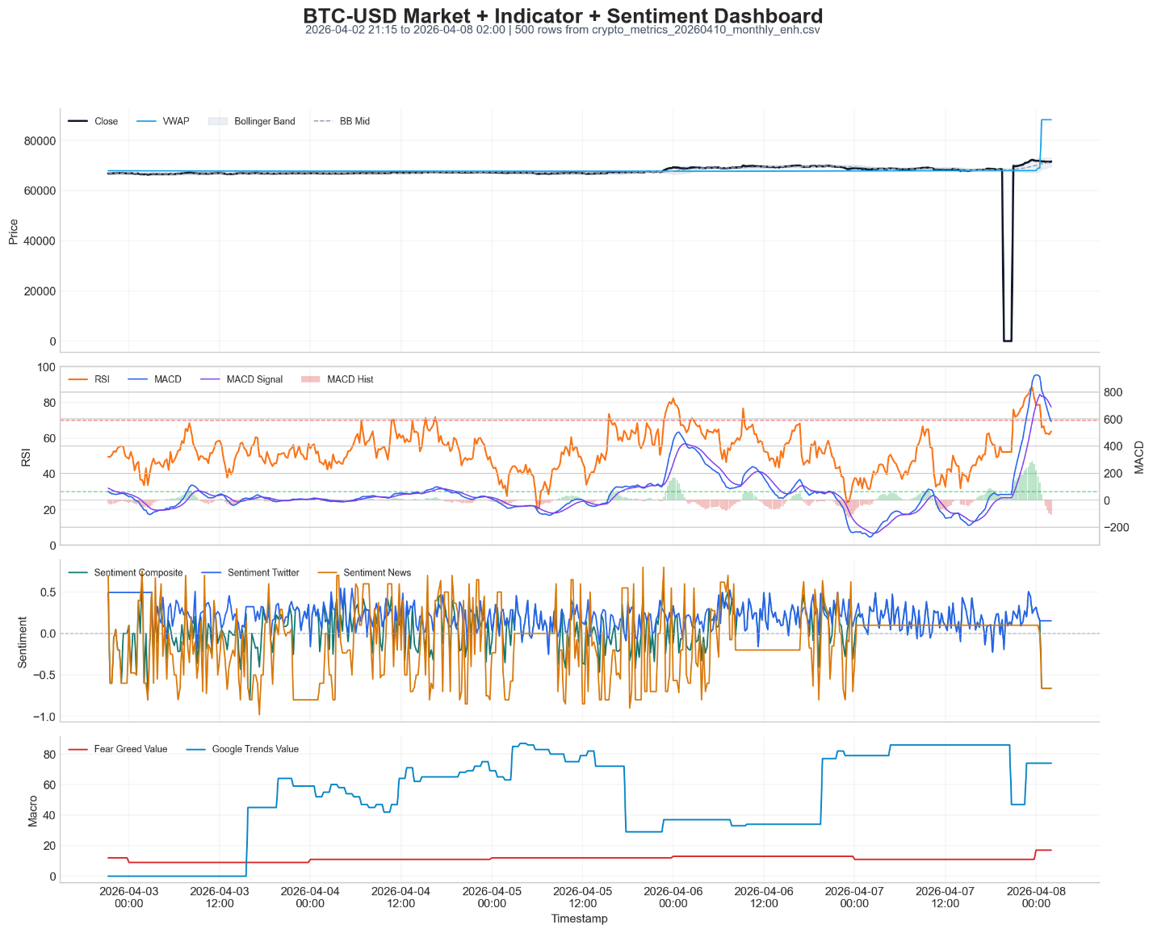
Observation-
- Twitter, news and fear greed sentiments show different pictures. This is key as it shows importance of adding more sentiments feed.
- Twitter sentiments are more stable.
- Fear and greed is close to 20 which shows fear in crypto market in general.
- There is sudden drop of crypto price which shows missing data not a real market mishap.
- VWAP closely follows price which means it is showing low divergence.
- Strong bullish near end of chart. Important to note that I have randomly selected 500 records for the graph.

  - Model Setup
Three models are implemented as XGBoost, Temporal Fusion Transformer (TFT), and Graph Neural Network (GNN). Each model was trained and tested across all dataset types.
    - XGBoost
- Hyperparameters selection
The XGBoost model was configured with:
- n_estimators: 300–500
- max_depth: 6–10
- learning_rate: 0.01–0.1
- subsample: 0.8
- colsample_bytree: 0.8
- scale_pos_weight: adjusted for class imbalance

Differential results for different types of datasets with Metrics
Monthly Dataset- (Binary UP/DOWN Classification)
Coin | Mode | Accuracy | Bal.Acc | MacroF1 | MCC | AUC | Lift
BTC-USD | binary | 0.5121 | 0.5735 | 0.5109 | 0.1419 | 0.5741 | -0.0531
ETH-USD | binary | 0.411 | 0.5 | 0.2913 | 0 | 0.4141 | 0
BNB-USD | binary | 0.467 | 0.5355 | 0.4663 | 0.0689 | 0.6034 | -0.0881
XRP-USD | binary | 0.6504 | 0.6539 | 0.6485 | 0.3131 | 0.6912 | 0.0088
LTC-USD | binary | 0.5443 | 0.5135 | 0.3763 | 0.1206 | 0.4176 | 0

Yearly Dataset- (3 class)
Coin | Mode | Accuracy | Bal.Acc | MacroF1 | MCC | AUC | Lift
BTC-USD | ternary | 0.374 | 0.346 | 0.2696 | 0.0296 | 0.5064 | 0.0262
ETH-USD | ternary | 0.4033 | 0.3953 | 0.3799 | 0.0991 | 0.5693 | 0.0267
BNB-USD | ternary | 0.3585 | 0.3524 | 0.3504 | 0.0297 | 0.5119 | 0.0417
XRP-USD | ternary | 0.3735 | 0.3657 | 0.3383 | 0.0517 | 0.5409 | 0.0386
LTC-USD | ternary | 0.4387 | 0.3387 | 0.3342 | 0.0283 | 0.5289 | -0.0672

I have also approached by increasing the horizon or bucketing hours. There is always a possibility of lagged behavioral impact of sentiment vs crypto values. The result says the impact and the improvement.
Coin | Accuracy | Directional Acc | MacroF1 | AUC | Lift
BTC-USD | 0.4444 | 0.4444 | 0.393 | 0.5577 | 0.0074
ETH-USD | 0.5323 | 0.5323 | 0.3191 | 0.5744 | 0.0162
BNB-USD | 0.307 | 0.307 | 0.2476 | 0.4563 | 0.0175
XRP-USD | 0.641 | 0.641 | 0.509 | 0.8622 | 0.0085
LTC-USD | 0.4912 | 0.4912 | 0.4503 | 0.7116 | -0.0263

4 Yearly Dataset- (3 class)
Coin | Accuracy | Directional Accuracy | MacroF1 | AUC | Lift
BTC-USD | 0.3723 | 0.3723 | 0.3421 | 0.5833 | -0.0073
ETH-USD | 0.384 | 0.384 | 0.2636 | 0.4563 | 0
BNB-USD | 0.3391 | 0.3391 | 0.3304 | 0.4954 | 0.0782
XRP-USD | 0.5254 | 0.5254 | 0.3212 | 0.5472 | -0.0509
LTC-USD | 0.3913 | 0.3913 | 0.3941 | 0.527 | 0.0261

Interpretations:
- Generic interpretation is that all accuracy models are filled with high amount of noise in all regimes.
- Lift often shows negative or zero which means they are often non-productive.
- Accuracy for 2 class monthly dataset prediction is much better compared to 3 class as 90% of data is FLAT category.
- XRP has better predictive numbers but still not effective enough for absolute value.
    - TFT
- Hyperparameters selection
The TFT model was configured with:
- hidden_size: 32–64
- lstm_layers: 1–2
- dropout: 0.1–0.3
- attention_heads: 4
- learning_rate: 1e-3
- batch_size: tuned based on GPU constraints
Monthly:
Coin | Direction Accuracy | Balanced Accuracy | Macro F1 | MCC | MAE | RMSE
BTC-USD | 0.4872 | 0.3333 | 0.2457 | 0 | 0.00129 | 0.001985
ETH-USD | 0.4952 | 0.3333 | 0.2231 | 0 | 0.001703 | 0.002664
BNB-USD | 0.4977 | 0.3333 | 0.2363 | 0 | 0.001224 | 0.001769
XRP-USD | 0.0856 | 0.3333 | 0.3053 | 0 | 0.001161 | 0.003032
LTC-USD | 0.4844 | 0.3333 | 0.264 | 0 | 0.001129 | 0.00199

Yearly:
Coin | Dir.Acc | Bal.Acc | MacroF1 | MCC | MAE | RMSE
BTC-USD | 0.4525 | 0.3333 | 0.2159 | 0 | 0.001664 | 0.002608
ETH-USD | 0.4203 | 0.3333 | 0.2065 | 0 | 0.002108 | 0.003524
BNB-USD | 0.403 | 0.3333 | 0.2345 | 0 | 0.001384 | 0.002262
XRP-USD | 0.2035 | 0.3333 | 0.2694 | 0 | 0.001533 | 0.003206
LTC-USD | 0.1668 | 0.3333 | 0.3032 | 0 | 0.001004 | 0.005531

Term-wise:
Horizon | Step | Samples | Dir.Acc | Bal.Acc | MacroF1 | MCC | MAE | RMSE
short | 1 | 3487 | 0.4609 | 0.3333 | 0.2159 | 0 | 0.001672 | 0.002637
mid | 9 | 3487 | 0.4525 | 0.3333 | 0.216 | 0 | 0.001663 | 0.002603
long | 16 | 3487 | 0.4442 | 0.3333 | 0.2161 | 0 | 0.001659 | 0.002597

TFT Variable Importance:
Rank | Feature | Importance
1 | fear_greed_value | 531.8095
2 | bb_position | 490.7319
3 | is_weekend | 311.3513
4 | rsi | 247.7075
5 | volatility_1h | 238.9441
6 | fear_greed_normalized | 184.9353
7 | day_sin | 133.6753
8 | vwap_deviation | 114.2194
9 | day_cos | 112.851
10 | macd_histogram | 112.3294

Interpretations:
- Directional accuracy below 0.5 shows random walk behavior
- Balanced accuracy around 0.33 shows unpredictability of classes
- Monthly data prediction numbers are slightly better capturing short term micro patterns, but still not enough
- TFT struggles with long-range crypto forecasting due to non-stationarity and regime shifts.
- If we observe horizon wise directional accuracy, short term stands out better temporal dependency compared to long term.
- Fear & Greed and Bollinger bands are top drivers for overall performance prediction.

    - GNN
Hyperparameters selection
The GNN model was configured with:
- hidden_dim: 16–32
- epochs: 60–80
- learning_rate: 1e-3
- weight_decay: 1e-4
- dropout: 0.1–0.15
Monthly:
Coin | Accuracy | Balanced Accuracy | Macro F1 | MCC | AUC
BTC-USD | 0.5647 | 0.5 | 0.3609 | 0 | 0.3697
ETH-USD | 0.5539 | 0.4888 | 0.3681 | -0.0694 | 0.4182
BNB-USD | 0.5398 | 0.4897 | 0.3718 | -0.0545 | 0.4756
XRP-USD | 0.6268 | 0.4765 | 0.406 | -0.0956 | 0.4021
LTC-USD | 0.4686 | 0.4933 | 0.4344 | -0.0165 | 0.3666

Asset Pair | Weight
BTC-USD ↔ ETH-USD | 0.1911
ETH-USD ↔ BNB-USD | 0.1761
BTC-USD ↔ BNB-USD | 0.1745
ETH-USD ↔ XRP-USD | 0.1496
BTC-USD ↔ XRP-USD | 0.1464
BNB-USD ↔ XRP-USD | 0.1441
XRP-USD ↔ LTC-USD | 0.0404
BTC-USD ↔ LTC-USD | 0.0395

Yearly:
Coin | Accuracy | Balanced Accuracy | Macro F1 | MCC | AUC
BTC-USD | 0.4509 | 0.4503 | 0.4494 | -0.0999 | 0.4392
ETH-USD | 0.4746 | 0.4736 | 0.4683 | -0.054 | 0.464
BNB-USD | 0.4827 | 0.4824 | 0.4706 | -0.0369 | 0.4619
XRP-USD | 0.416 | 0.4037 | 0.396 | -0.2001 | 0.3992
LTC-USD | 0.6578 | 0.6123 | 0.6086 | 0.2188 | 0.6119

Asset Pair | Weight
BTC-USD ↔ ETH-USD | 0.1521
ETH-USD ↔ XRP-USD | 0.1296
BTC-USD ↔ XRP-USD | 0.1227
ETH-USD ↔ BNB-USD | 0.0997
BTC-USD ↔ BNB-USD | 0.0996
BNB-USD ↔ XRP-USD | 0.0956
XRP-USD ↔ LTC-USD | 0.0484
ETH-USD ↔ LTC-USD | 0.0432

Interpretation:
- Though accuracy is more than 0.52, MCC less than 0 indicates the model is only marginally better than random and likely biased toward dominant class.
- LTC in yearly setup has by far good numbers to believe on.
- There is strong clustering among large-cap coins (BTC and ETH)

List of Figures
- System Architecture
I have used AWS services for designing the whole architecture.
- Eventbridge scheduler for scheduling the API extraction in every 5 mins
- Lambda function to interact with all APIs (CoinGecko, Binance, Twitter API, Newsfeed, Google trends, Fear & Greed) and create JOSN feeds in S3 bucket
- S3 bucket as storage service
- Kinesis data streams for real-time data processing of crypto values and social media messages
- DynamoDB as data storage database
- Claudi Haiku Bedrock model for sentiment extraction
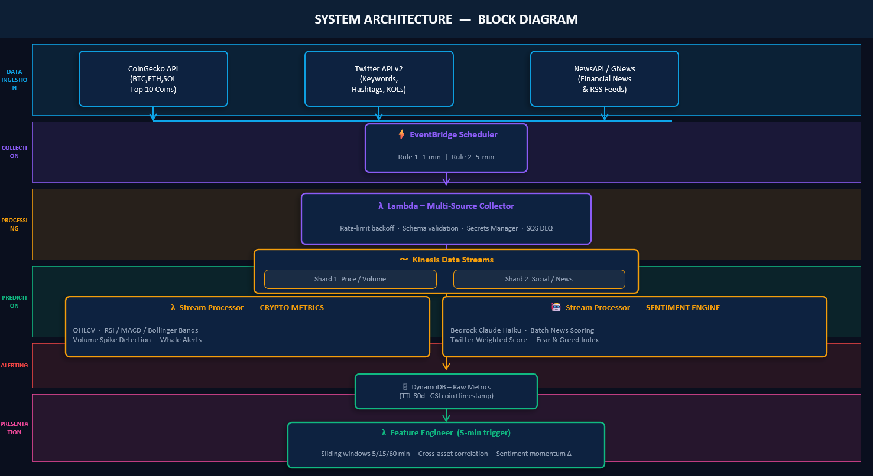
- Flow Diagram
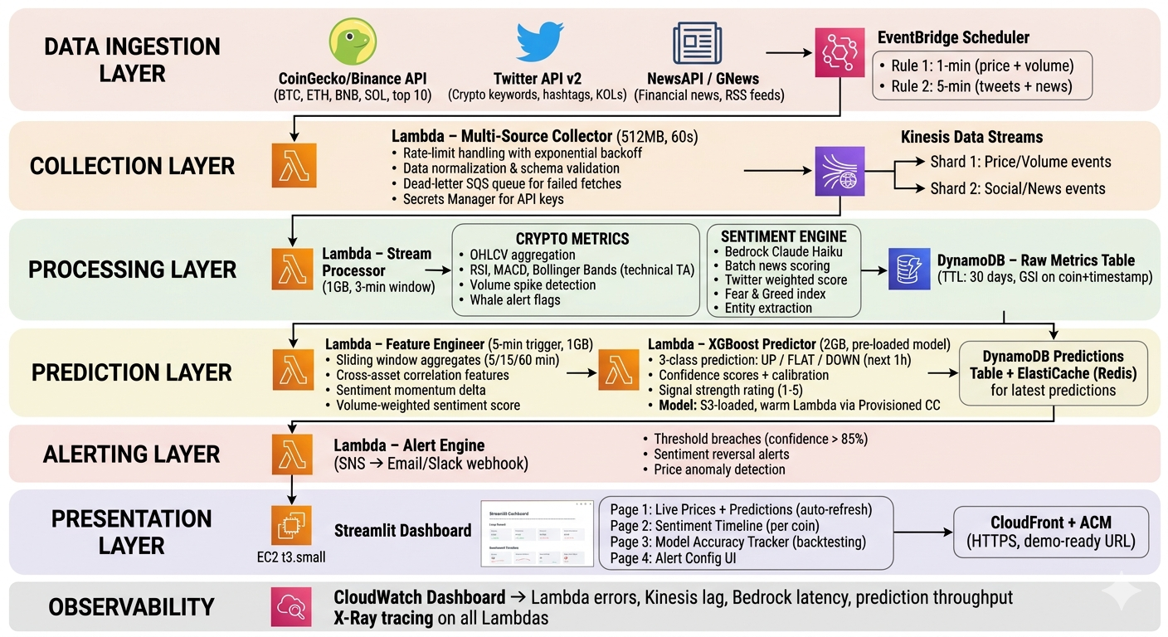

Expected Result
The expectation from the research paper results is aligned with answers to research questions. The expected result is one of following:
- Strong Sentiment Effect showing majority of sentiment-cryptocurrency pairs, and the TFT model with multi-modal features achieves directional accuracy ≥ 60%
- Weak Sentiment Effect showing majority of sentiment-cryptocurrency pairs, and the TFT model with multi-modal features achieves directional accuracy < 60% depicts very marginal correlation
- Neutral Sentiment Effect showing most pairs, and multi-modal models show no statistically significant improvement

Conclusion and Future Work
The research is strongly emphasizing impact of social media platforms on hugely unpredictable cryptocurrency market by intriguing both sentiment analytical study and crypto-driven matrices together with help of FinBERT model, granger causality pre-test and deep learning models such as XGBoost, TFT and GNN. The research has included theoretical framework such as Efficient Market Hypothesis, Behavioral Finance, Information Theory, Time-Series Stationarity, and Granger Causality and these are pioneer baseline for the prime idea of the research. The outcome is measurable and is contributing to 3 possible outcomes such as strong or weak or neutral sentiment-cryptocurrency correlation. Results show that XRP achieving 65% of temporal accuracy, most other cryptocurrencies achieving baseline accuracy of 35-50%. The predictive lift has been around 0 or negative for most cases which shows cryptocurrencies have not much predictive power than random baseline. GNN model shows higher correlation between large-cap coins as ETH-BTC. SHAP analysis and TFT variable importance reveal that aggregated sentiment indices (Fear & Greed) and technical indicators (Bollinger Bands, RSI) dominate feature importance, while granular social media sentiment contributes minimally. This research clearly shows that sentiments through handful of platforms will not drive the result. Preferably if more platforms can be included such as Reddit, coin-desk, coin-telegraph which are billing based and possible to access for industrial projects, then results will say a different story. Furthermore, there is a factor of window size of 15min – 1hr- 4hr-16hr and the predictability of model like XGBoost improves significantly with it. This research is providing empirical significance to future researchers or industry implementers about importance of applicability of Efficient Market Analysis to cryptocurrency market, effectiveness of transformer model in predicting sentiment.

Limitation and Future Work
The research is approaching to solve few key problems and hence a step forward in absolution prediction of cryptocurrency. However, there are huge problematic areas which need further work. Non-stationary crypto sampling and selection of social media platforms are key limitations. There is always a new cryptocurrency dataset in real-time. Similarly, social medias are different across country, religion and so on. There is no unique platform which binds people and hence there is abundance of possibility. Market Manipulation is one of major burster. There are often global instances such as war, health hazards, earth outcry etc. which impact crypto market and hence are absolutely impossible to predict. There is need of huge real-time data collection preferably more than 1 year. Exclusion of on-chain data: Blockchain-native features (e.g., active wallet counts, transaction volumes, miner behavior) are theoretically strong predictors but are outside the scope of this project. Possibility of including non-English languages will help improve overall predictability. Abundance of real-time dataset will also boost the objective. Training separately for bear/bull/consolidation markets will help improving model baseline and therefore it will definitely improve overall predictability.

References
[1] Araci, D. (2019). FinBERT: Financial sentiment analysis with pre-trained language models. arXiv preprint arXiv:1908.10063.
[2] Bahdanau, D., Cho, K., & Bengio, Y. (2015). Neural machine translation by jointly learning to align and translate. ICLR 2015.
[3] Bansal, P., & Jain, S. (2022). Cryptocurrency price prediction using Twitter and news articles analysis. IC3-2022. ACM. https://doi.org/10.1145/3549206.3549248
[4] Box, G. E. P., & Jenkins, G. M. (1970). Time Series Analysis: Forecasting and Control. Holden-Day.
[5] Fama, E. F. (1970). Efficient capital markets: A review of theory and empirical work. Journal of Finance, 25(2), 383–417.
[6] Garcia, D., & Schweitzer, F. (2015). Social signals and algorithmic trading of Bitcoin. Royal Society Open Science, 2(9), 150288.
[7] Granger, C. W. J. (1969). Investigating causal relations by econometric models and cross-spectral methods. Econometrica, 37(3), 424–438.
[8] Hagio, T., & Sano, M. (2023). Evaluation of price prediction models for cryptocurrencies based on convolutional neural networks trained on candlestick charts. ICSIM 2023. ACM. https://doi.org/10.1145/3584871.3584875
[9] Kahneman, D., & Tversky, A. (1979). Prospect theory: An analysis of decision under risk. Econometrica, 47(2), 263–291.
[10] Kristoufek, L. (2013). BitCoin meets Google Trends and Wikipedia: Quantifying the relationship between phenomena of the Internet era. Scientific Reports, 3, 3415.
[11] Lim, B., Arık, S. Ö., Loeff, N., & Pfister, T. (2021). Temporal Fusion Transformers for interpretable multi-horizon time series forecasting. International Journal of Forecasting, 37(4), 1748–1764.
[12] Manning, C. D., & Schütze, H. (1999). Foundations of Statistical Natural Language Processing. MIT Press.
[13] Mazinani, A., Davoli, L., & Ferrari, G. (2025). Deep learning algorithms for cryptocurrency price prediction. Distrib. Ledger Technol. 4(1), Article 5. https://doi.org/10.1145/3699966
[14] Murphy, J. J. (1999). Technical Analysis of the Financial Markets. New York Institute of Finance.
[15] Nadarajah, S., & Chu, J. (2017). On the inefficiency of Bitcoin. Economics Letters, 150, 6–9.
[16] Pang, Y., Sundararaj, G., & Ren, J. (2019). Cryptocurrency price prediction using time series and social sentiment data. BDCAT 2019. ACM. https://doi.org/10.1145/3365109.3368785
[17] Puoti, F., Pittorino, F., & Roveri, M. (2025). Quantifying cryptocurrency unpredictability. AIMLSystems 2024. ACM. https://doi.org/10.1145/3703412.3703420
[18] Shannon, C. E. (1948). A mathematical theory of communication. Bell System Technical Journal, 27(3), 379–423.
[19] Shiller, R. J. (2000). Irrational Exuberance. Princeton University Press.
[20] Tetlock, P. C. (2007). Giving content to investor sentiment: The role of media in the stock market. Journal of Finance, 62(3), 1139–1168.
[21] Urquhart, A. (2016). The inefficiency of Bitcoin. Economics Letters, 148, 80–82.
[22] Vaswani, A., et al. (2017). Attention is all you need. NeurIPS 2017.
[23] Zhi, Y., & Chan, T-H. H. (2024). Clustering social media data for Bitcoin price prediction with transformer model. MLNLP 2023. ACM. https://doi.org/10.1145/3639479.3639508
[24] Zhi, Y., Kong, L., Atouati, S., Chan, T-H. H., & Sozio, M. (2024). Explaining cryptocurrency price trends. CACML 2024. ACM. https://doi.org/10.1145/3654823.3654866
[25] Priya Bansal and Shikha Jain. 2022. Cryptocurrency Price Prediction Using Twitter and News Articles Analysis. In Proceedings of the 2022 Fourteenth International Conference on Contemporary Computing (IC3-2022). Association for Computing Machinery, New York, NY, USA, 225–233. https://doi.org/10.1145/3549206.3549248
[26] Yan Pang, Ganeshkumar Sundararaj, and Jiewen Ren. 2019. Cryptocurrency Price Prediction using Time Series and Social Sentiment Data. In Proceedings of the 6th IEEE/ACM International Conference on Big Data Computing, Applications and Technologies (BDCAT '19). Association for Computing Machinery, New York, NY, USA, 35–41. https://doi.org/10.1145/3365109.3368785
[27] Shah, N.P. and Patel, T.M. 2015. A Comparative Study on Technical Analysis by Bollinger Band and RSI. International Journal in Management and Social Science, 3(6)
https://www.researchgate.net/publication/331987303_A_Comparative_Study_on_Technical_Analysis_by_Bollinger_Band_and_RSI
[28] Chong, T.T.-L. and Ng, W.-K. 2008. Technical analysis and the London Stock Exchange. Applied Economics Letters, 15(14), 1111–1114.
[29] Bollinger, John. Bollinger on Bollinger bands. New York: McGraw-Hill, 2002.
[30] Daniel Mitchell, Jȩdrzej Białkowski & Stathis Tompaidis. (2020) Volume-weighted average price tracking: A theoretical and empirical study. IISE Transactions 52:8, pages 864-889.
[31] Ali Shojaie, Emily B. Fox. 2022. Granger Causality: A Review and Recent Advances. Annual Review Statistics and Its Application. 9:289-319. https://doi.org/10.1146/annurev-statistics-040120-010930
[32] Chen, T., & Guestrin, C. (2016). XGBoost: A Scalable Tree Boosting System. In Proceedings of the 22nd ACM SIGKDD International Conference on Knowledge Discovery and Data Mining (pp. 785-794).
[33] Gori et al. (2005) and Scarselli et al. (2009), "The Graph Neural Network Model."

