All Queries-
GET _search
{
"query": {
"match_all": {}
}
}

GET _cat/indices

GET resume-index-v3/_search
{
"query": {
"match_all": {}
}
}

GET resume-index/_search
{
"query": {
"term": {
"section_name": "Projects"
}
}
}

GET resume-index/_search
{
"_source": ["resume_sections"],
"query": {
"match": {
"_id":"resume/20260105_030439_Resume_Subhra_Ojha.pdf#Work_Experience"
}
}
}

GET resume-index/_search
{
"_source": ["resume_sections"],
"query": {
"match_all": {}
}
}

GET resume-index-v3/_search
{
"_source": ["resume_sections"],
"query": {
"match_all": {}
}
}

GET resume-index-v2/_mapping

GET resume-index-v2/_search
{
"_source": ["similarity_score_raw"],
"query": {
"match_all": {}
}
}

GET resume-index/_mapping

GET resume-index/_search
{
"query": {
"match": {
"_id":"resume/20260105_030439_Resume_Subhra_Ojha.pdf#Work_Experience"
}
}
}

Query results-
Full Index-
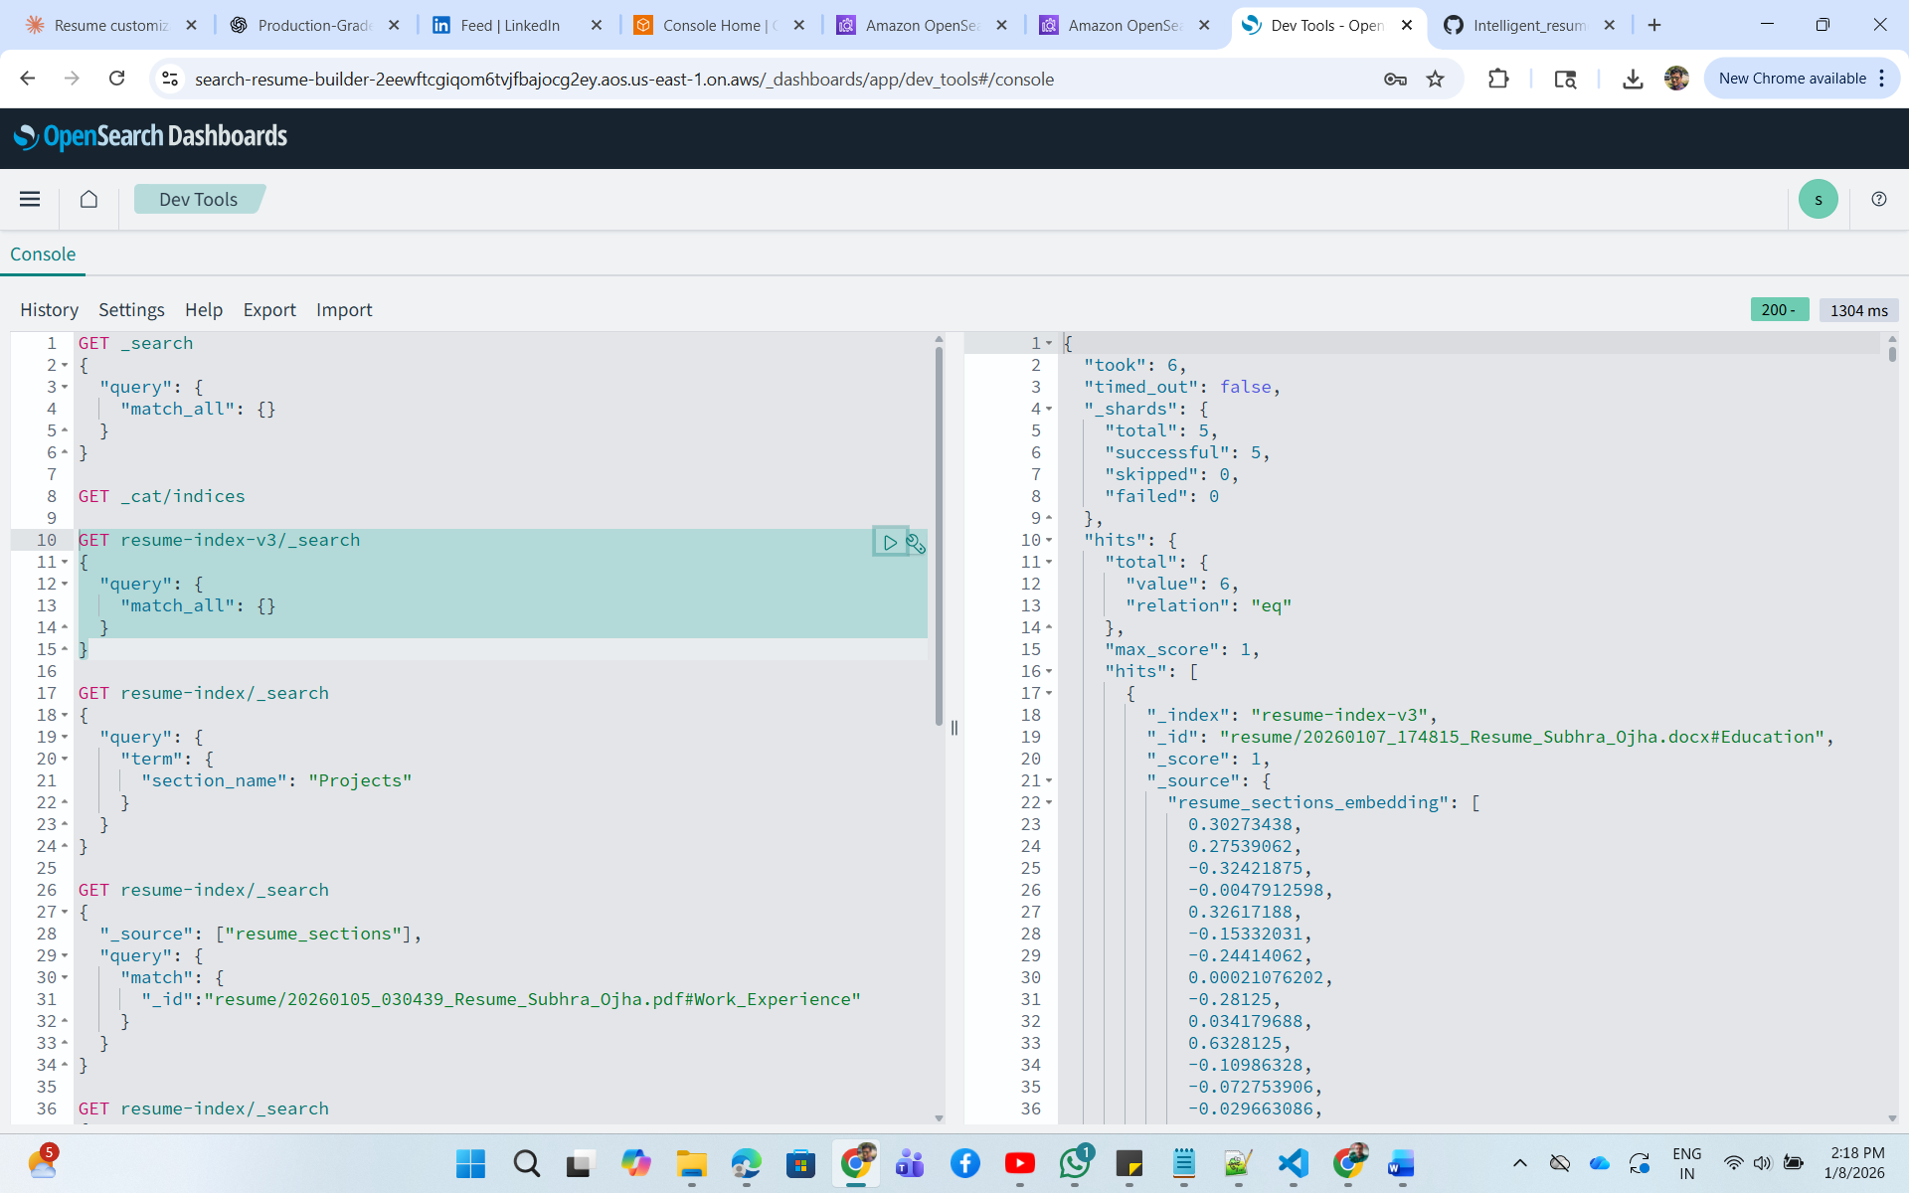
Mapping-
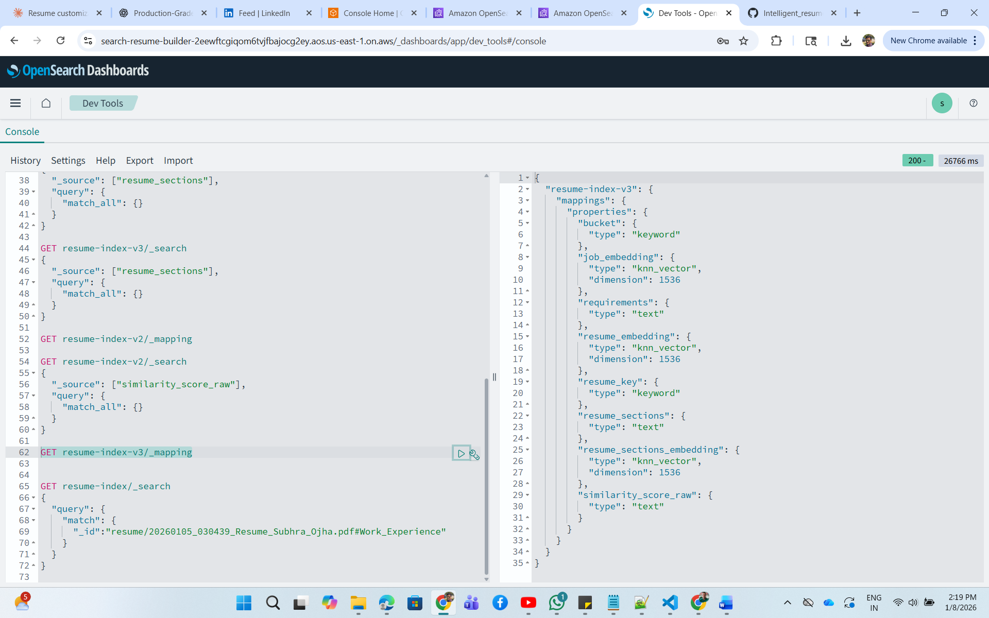
Embeddings-
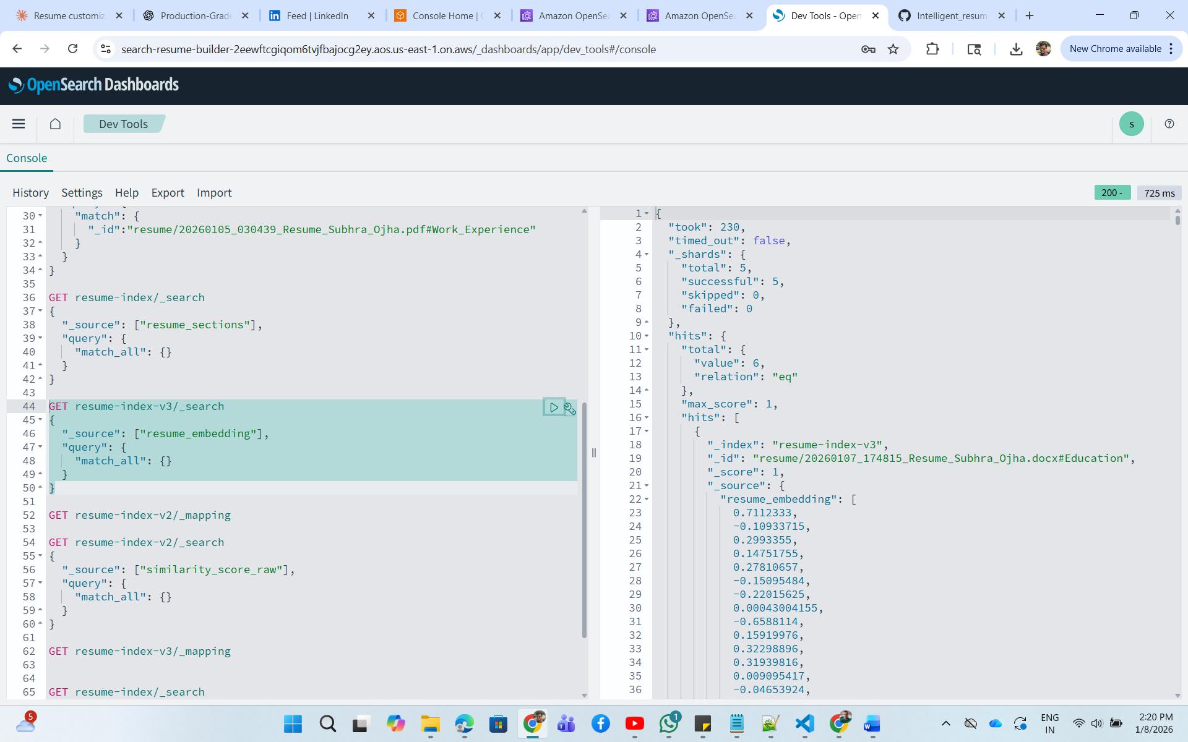
Resume Sections-
