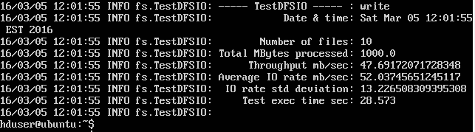

Test of hdfs WRITE

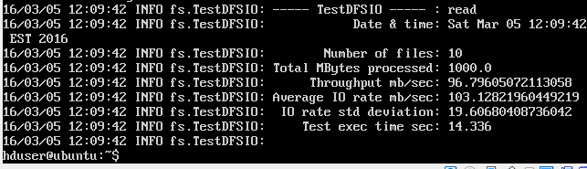

Test of hdfs READ

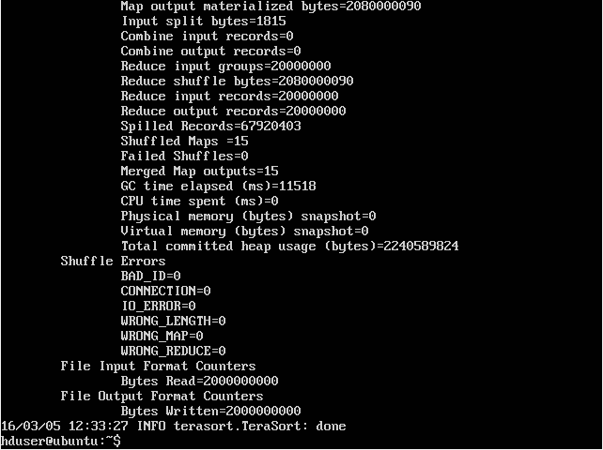

First test of terasort

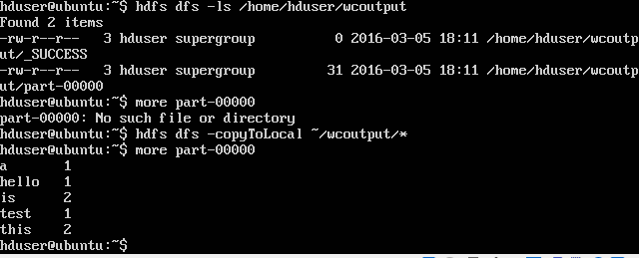

Task 9 ^ MapReduce word count

