May 26th, 2020

Federal Trade Commission

600 Pennsylvania Avenue NW

Washington, DC, 20580

(860) 992-2789

[william.j.violette@gmail.com](mailto:william.j.violette@gmail.com)

To Whom It May Concern,

Thank you for considering this paper. The analysis uses proprietary data from agreements with GeoTerraImage, a private company from South Africa, the Center for Affordable Housing and Finance in Africa, an NGO based in South Africa, as well as Statistics South Africa. While the agreements do not permit publishing the data publicly, I would happily provide our code and detailed instructions for obtaining the data for future researchers. Please let me know if you have any questions.

This research did not receive any financial support. This research benefitted from research partnerships with GeoTerraImage, the Center for Affordable Housing and Finance in Africa, as well as Statistics South Africa, which each provided access to data.

Sincerely,

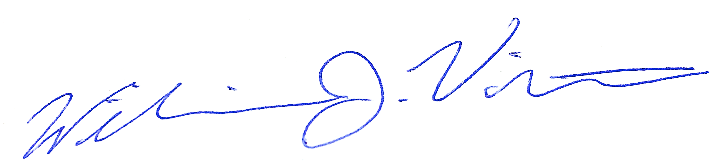

William J. Violette