COMP3123 – Assignment 1

API Testing and Screenshot Evidence
Student ID: 101578885
Course: COMP3123 – Full Stack Development I
Assignment: Assignment 1 – Backend API

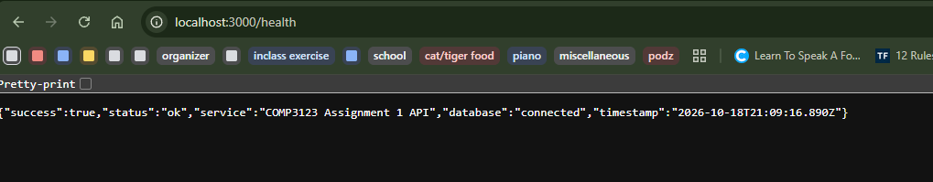
Figure 1: Health Check – 200 OK

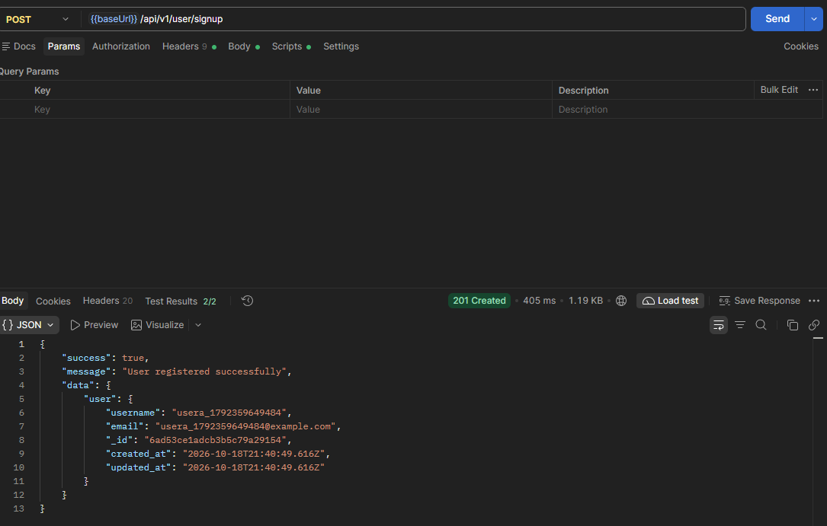
Figure 2: User Registration – 201 Created
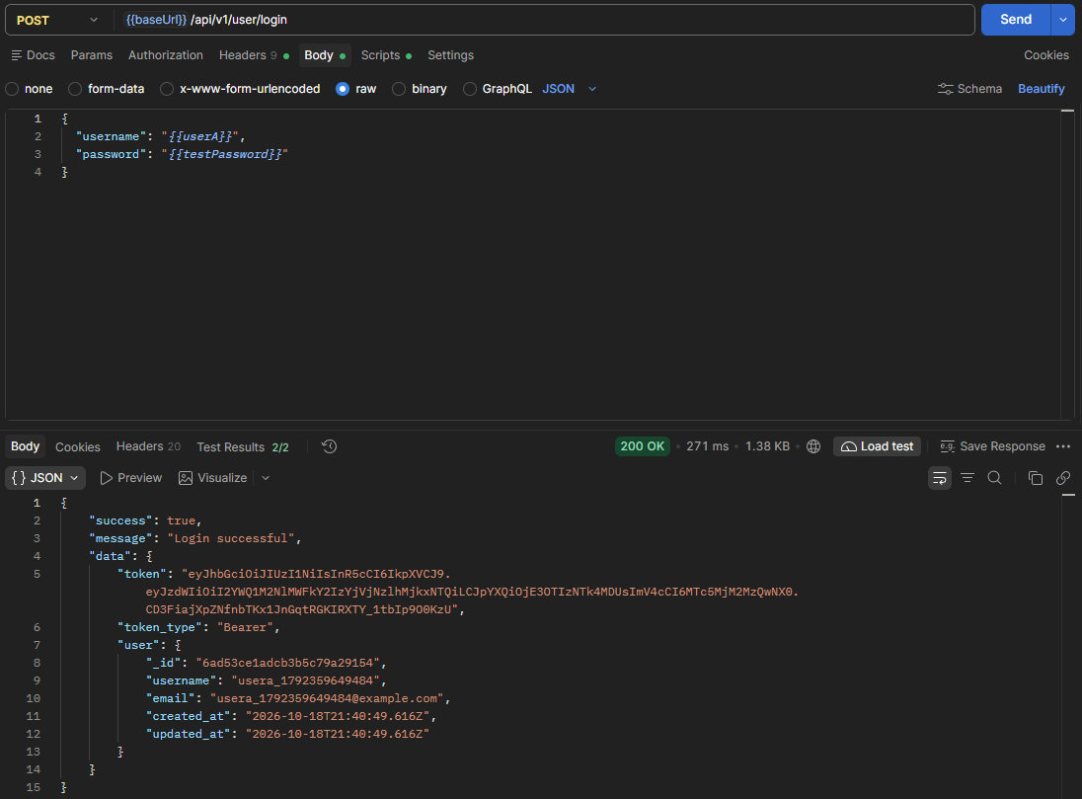
Figure 3: Login Using Username – 200 OK
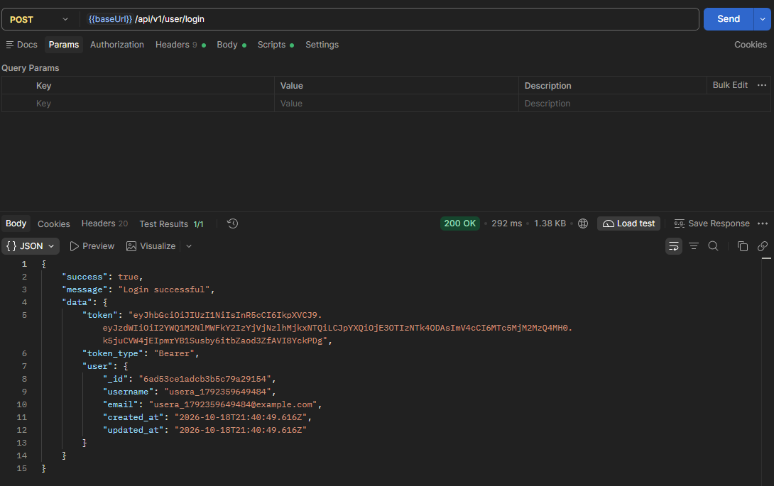
Figure 4: Login Using Email – 200 OK
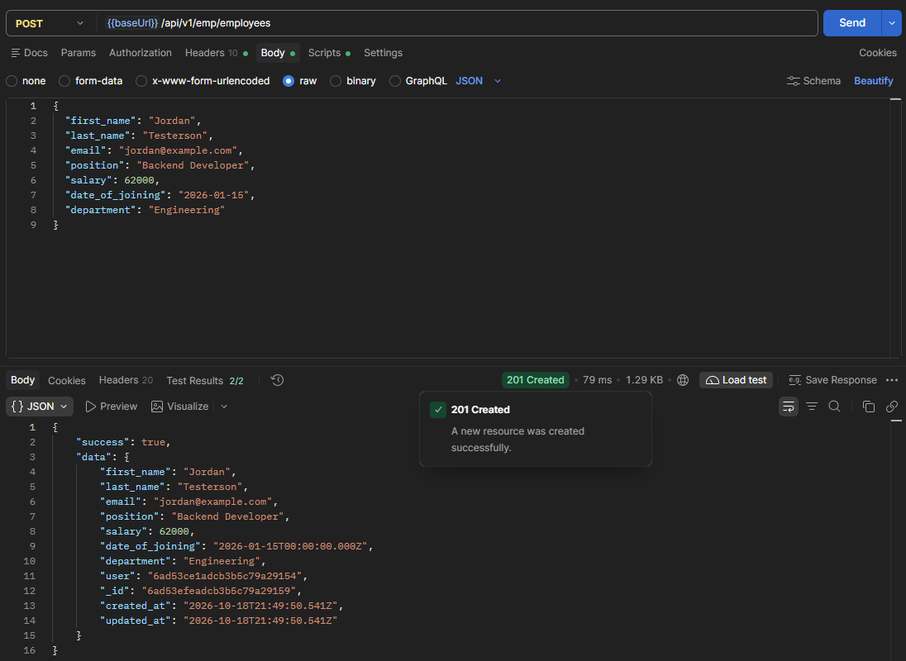
Figure 5: Employee Creation – 201 Created
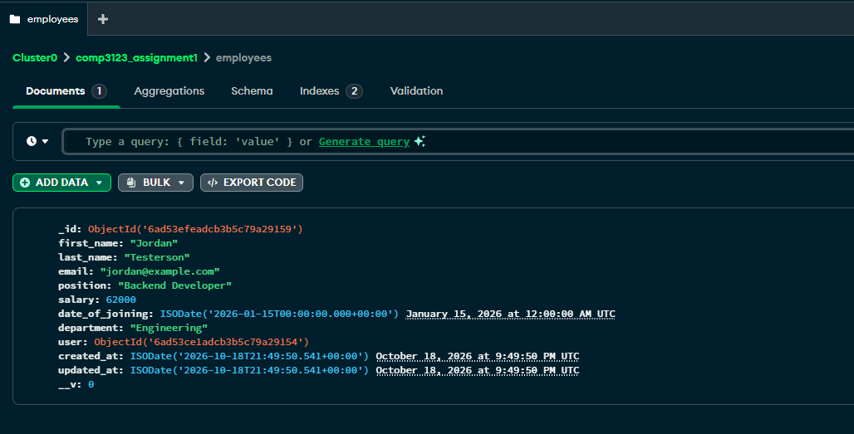
Figure 6: MongoDB Employees Collection

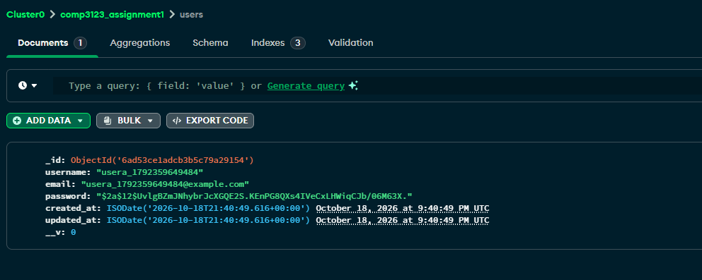
Figure 7: MongoDB Users Collection and Password Hashing
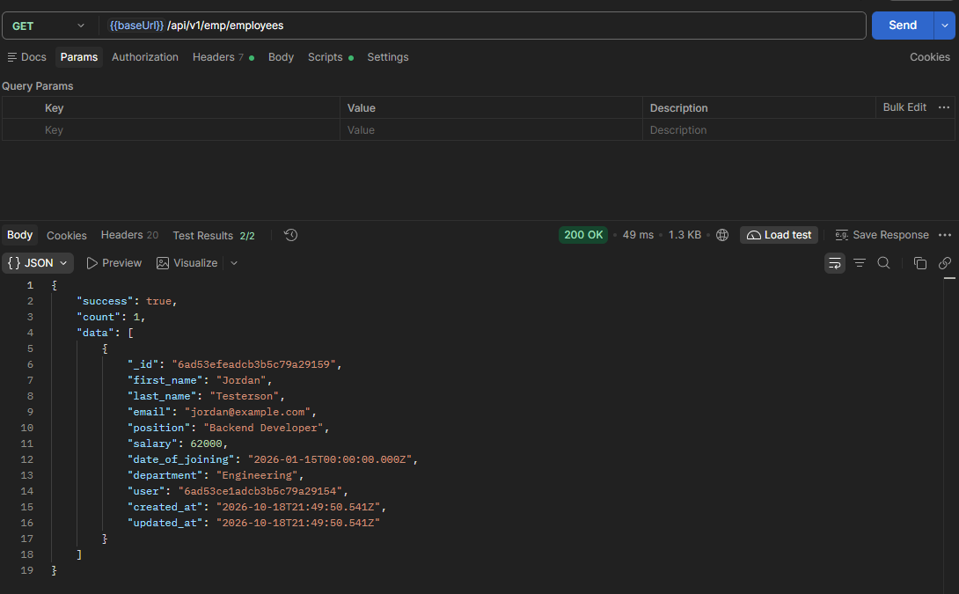
Figure 8: Retrieve All Employees – 200 OK
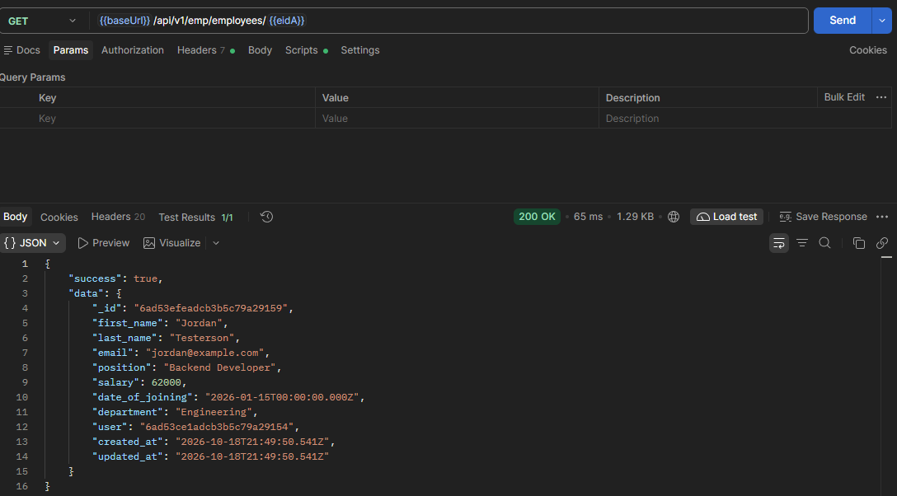
Figure 9: Retrieve Employee by ID – 200 OK
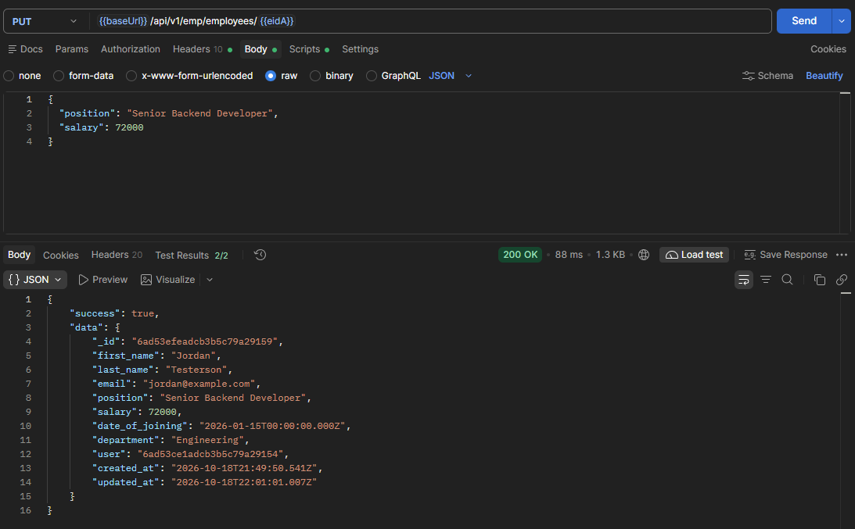
Figure 10: Update Employee – 200 OK

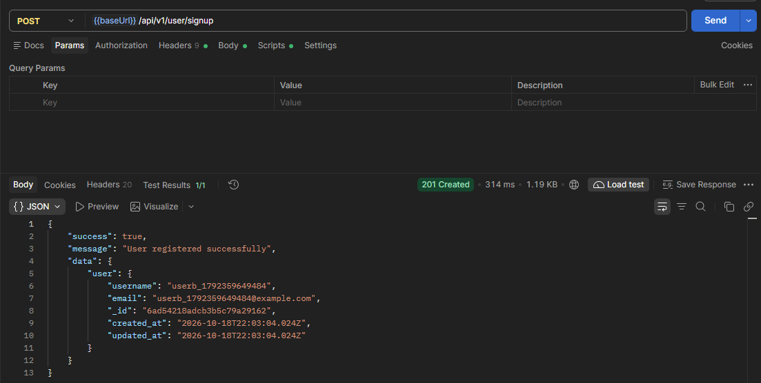
Figure 11: User B Registration – 201 Created

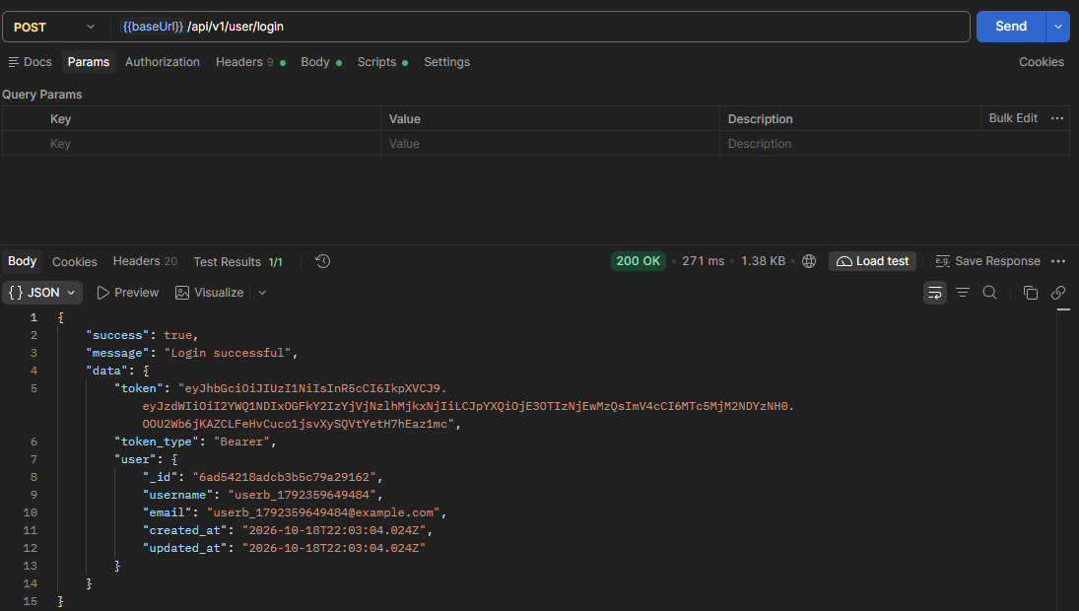
Figure 12: User B Login – 200 OK
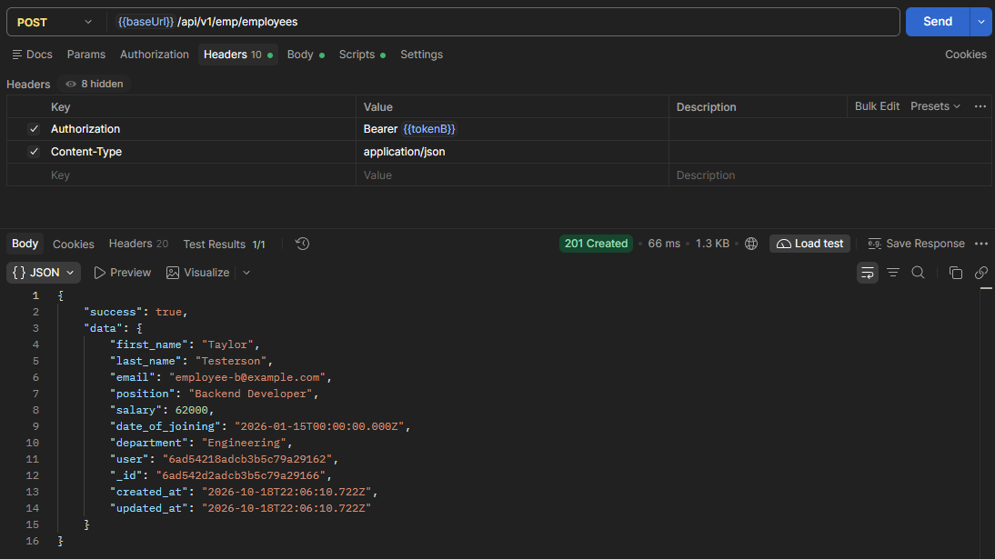
Figure 13: User B Employee Creation – 201 Created
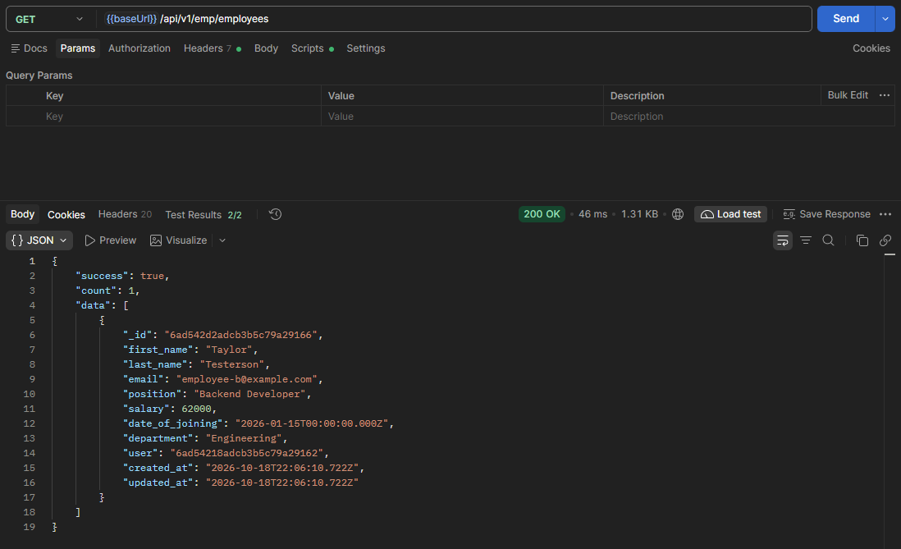
Figure 14: User B Employee List – 200 OK

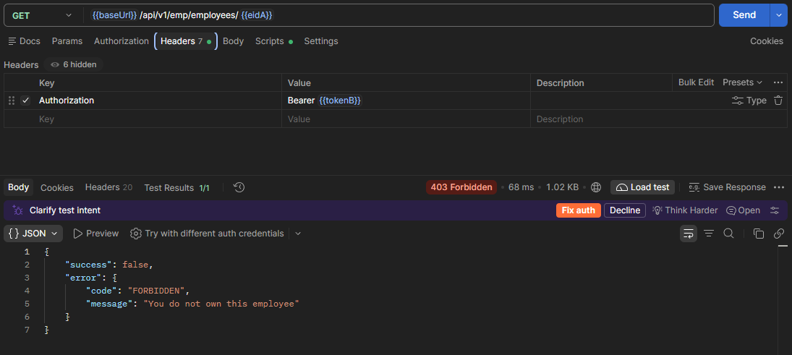
Figure 15: Unauthorized Employee Access – 403 Forbidden
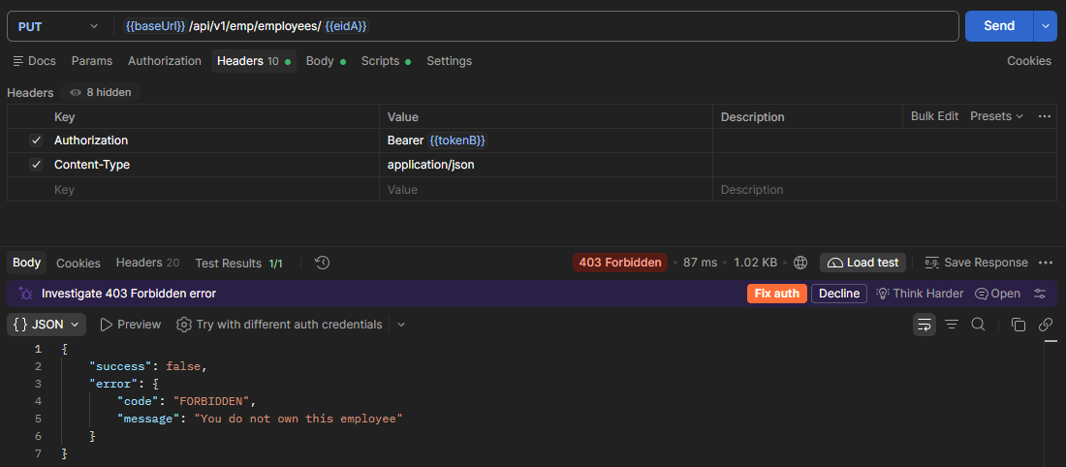
Figure 16: Unauthorized Employee Update – 403 Forbidden
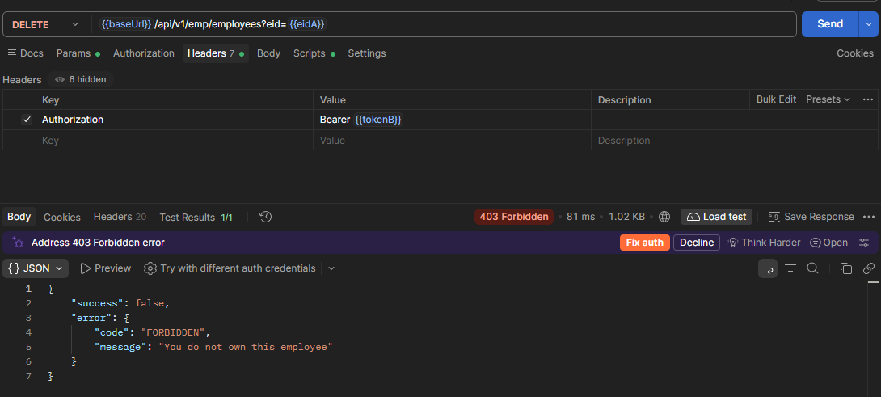
Figure 17: Unauthorized Employee Deletion – 403 Forbidden
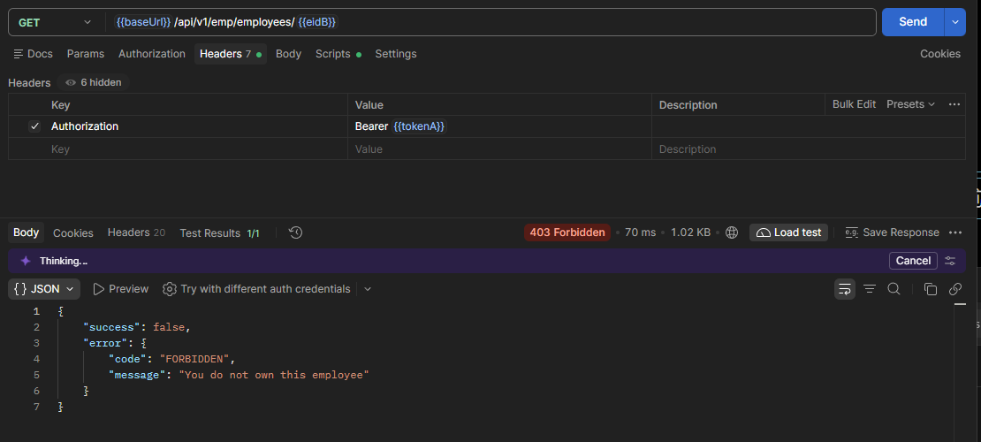
Figure 18: Reverse Ownership Access Test – 403 Forbidden
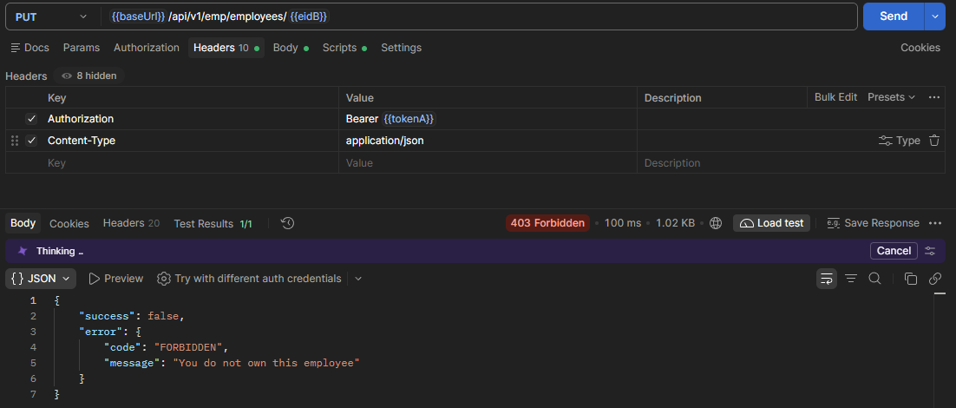
Figure 19: Reverse Unauthorized Update – 403 Forbidden
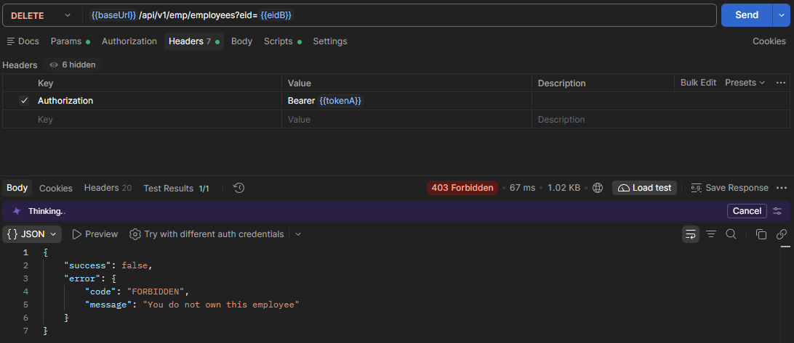
Figure 20: Reverse Unauthorized Deletion – 403 Forbidden
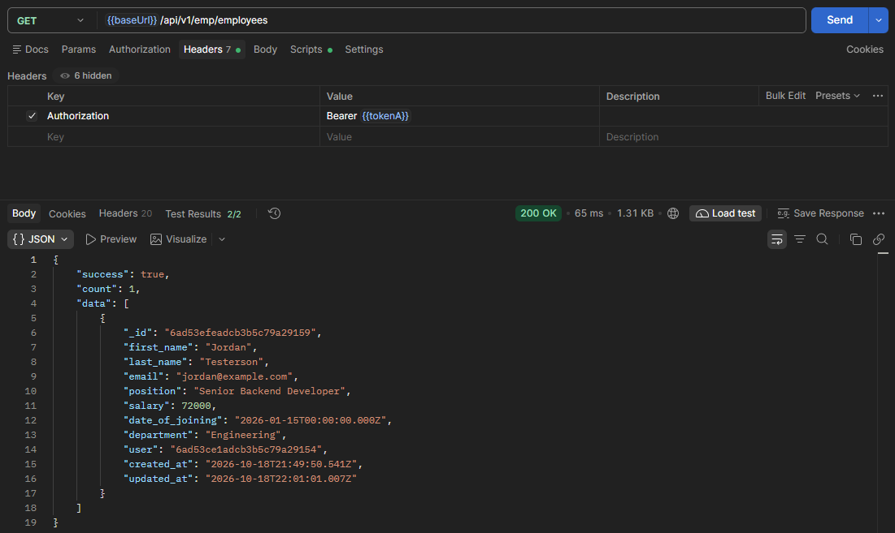
Figure 21: User A Ownership Verification – 200 OK
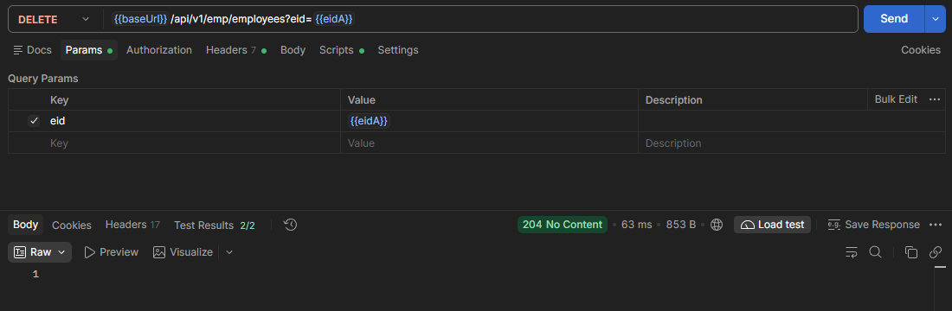
Figure 22: Successful Employee Deletion – 204 No Content
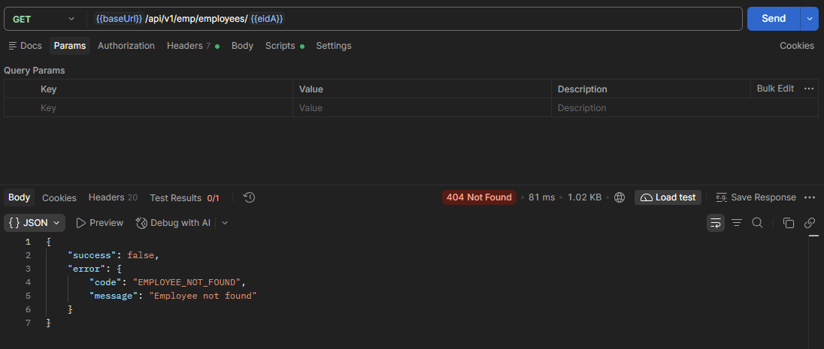
Figure 23: Deleted Employee Not Found – 404 Not Found
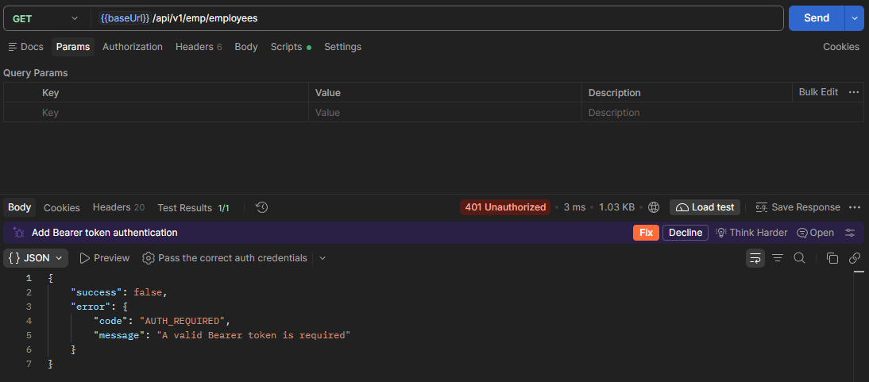
Figure 24: Missing JWT Authentication – 401 Unauthorized
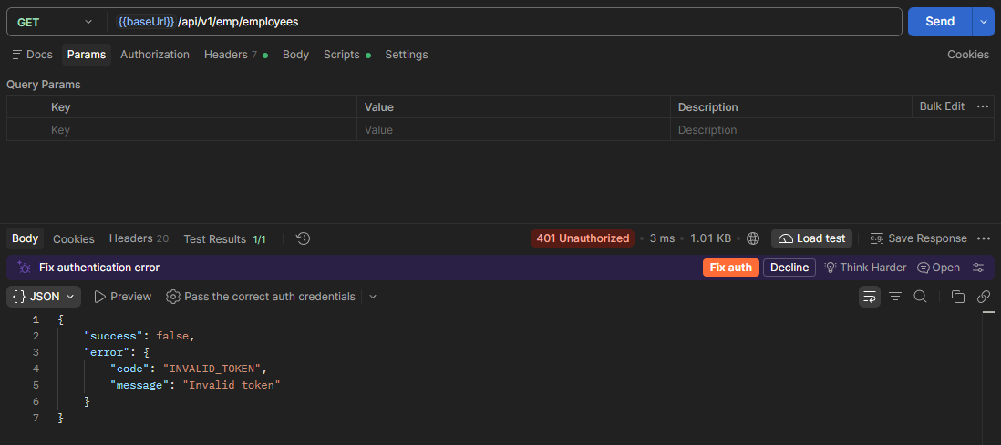
Figure 25: Invalid JWT Authentication – 401 Unauthorized
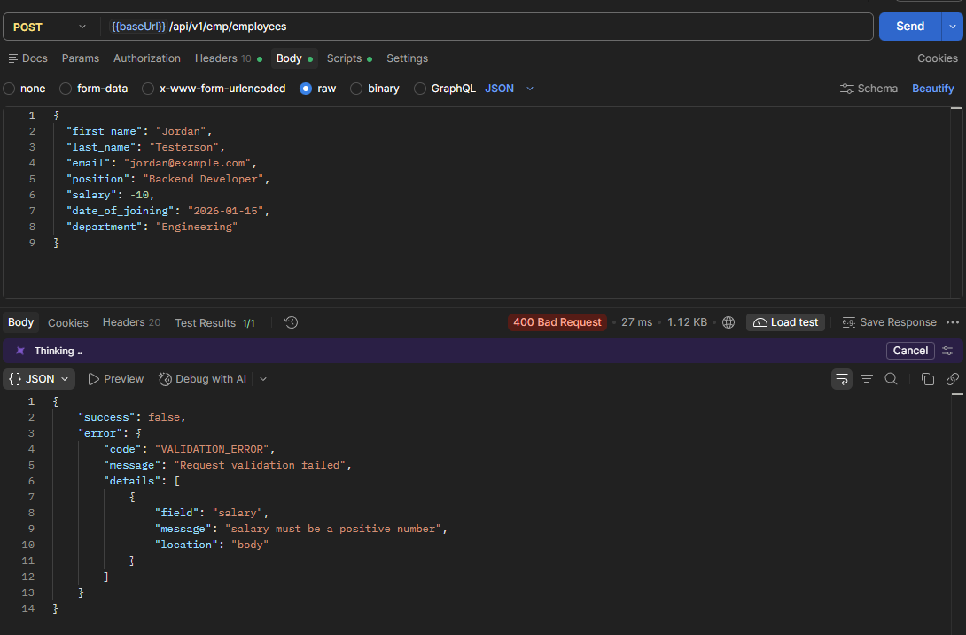
Figure 26: Invalid Employee Salary – 400 Bad Request
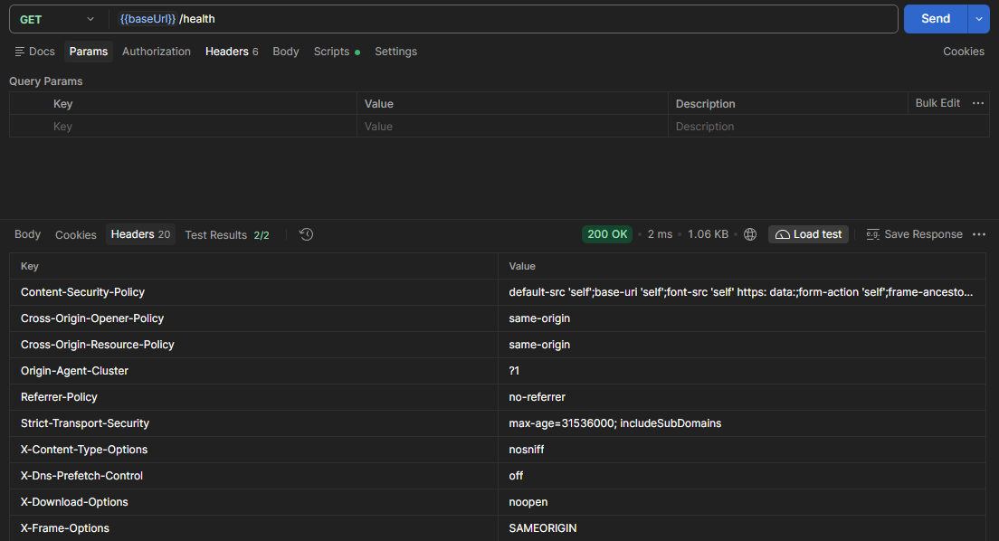
Figure 27: Helmet Security Headers
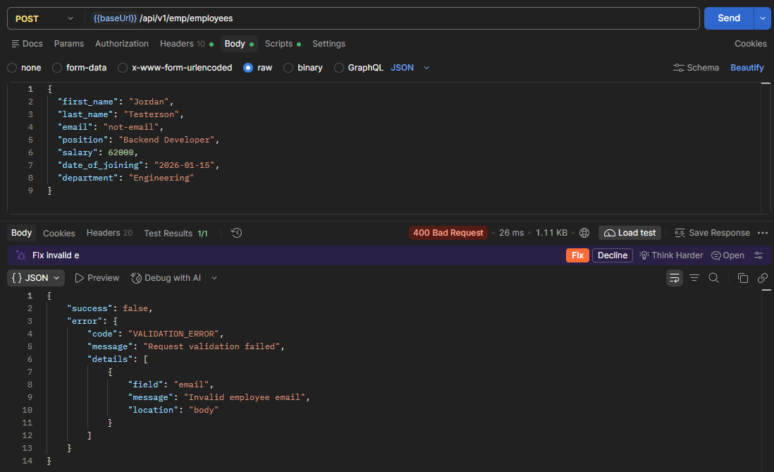
Figure 28: Invalid Employee Email – 400 Bad Request
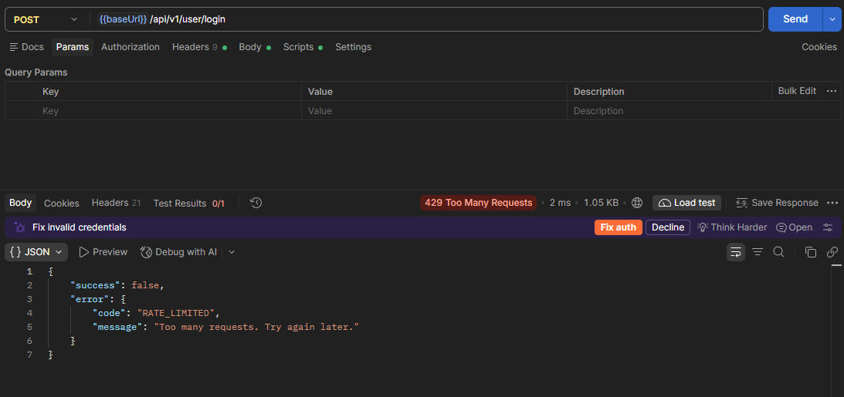
Figure 29: API Rate Limiting – 429 Too Many Requests
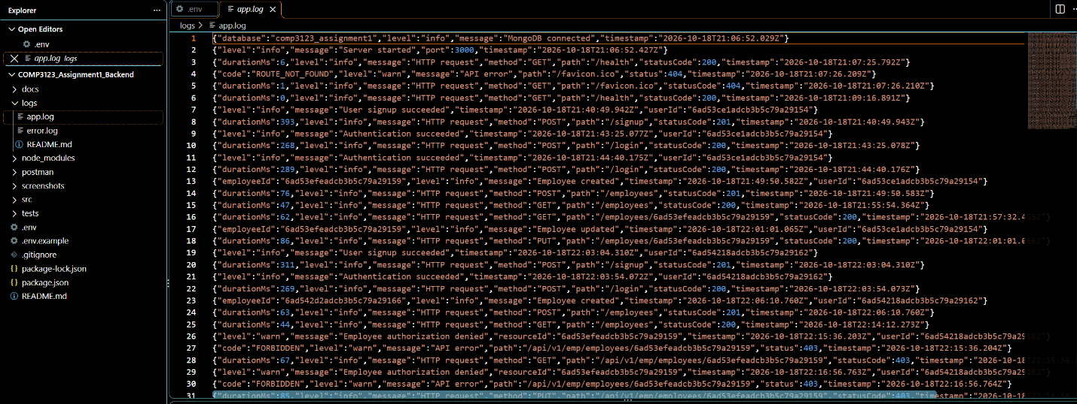
Figure 30: Local Application Logging

