Upgrade LowPoly version office scene to HDRP version office scene.

1. Open our LowPoly version office scene.
2. Import the Snap Art Office HDRP package.
3. Import the Snap asset swap tool.
4. Go to Package Manager and install High Definition RP package, also upgrade it to the newest version, at least 7.3.0 version.



1. Go to Package Manager and install OpenVR Desktop package.



1. Right now, the prefab in the scene may also have pink material, you should go to Edit, choose Render Pipeline, and then choose Upgrade Project Materials to High Definition Materials.

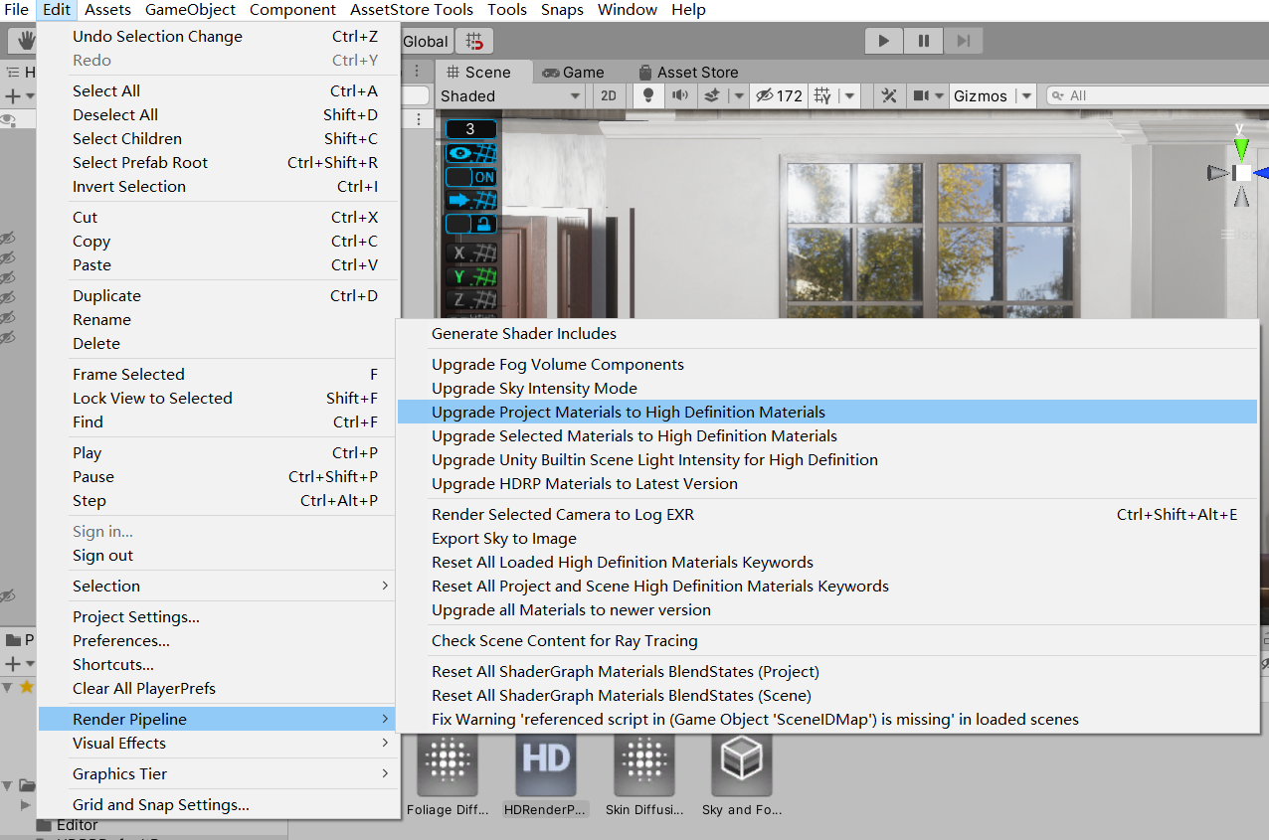

1. Go to Window, choose Render Pipeline, choose HD Render Pipeline Wizard, in HDRP tab, fix all errors. Then choose HDRP+VR tab fix all errors. Don’t need to fix Legacy VR System error, just leave it be.

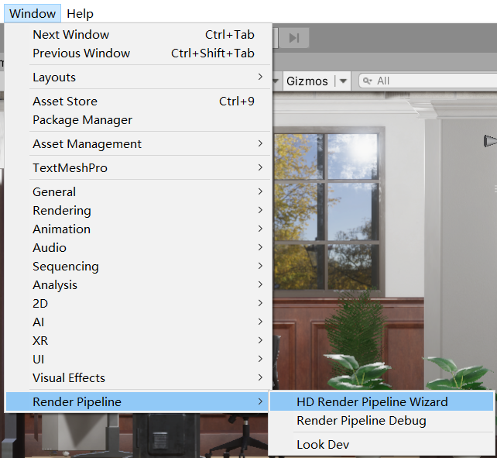

1. Go to Snaps, choose Asset Swap Tool.

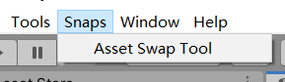

1. Choose “Select a different project directory for Snaps Prototype prefabs”. And then select the “_SNAPS_PrototypingAssets” folder and select “ModernOffice_Interior” folder.
2. Choose “Select a different project directory for Snaps Art/Art HD prefabs”. And then select the “SnapsArtOffice” folder.
3. Then click Swap All to Snaps Art HD prefabs. Then you can see all prefab in the scene now change to HD version.

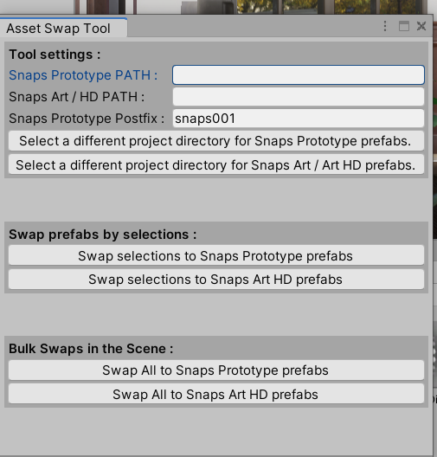

1. Go to Edit, Project Settings, choose player, go to the XR Settings tab, enable Virtual Reality supported. In Virtual Reality SDKS, add OpenVR if you use HTC VIVE, add Oculus if you use oculus. In the below Stereo Rendering Mode, choose Single Pass Instanced.

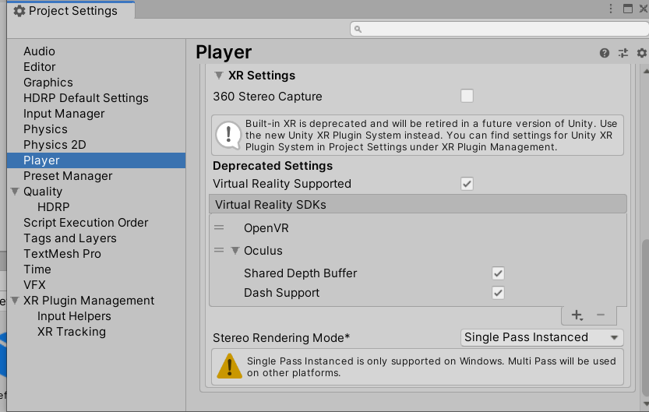

1. Since you already install the HDRP package, you should see HDRPDefaultResources in the Project, Assets. Choose that folder, and find HDRenderPipelineAsset, in the XR tab, enable Single Pass and Occlusion Mesh.

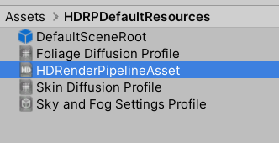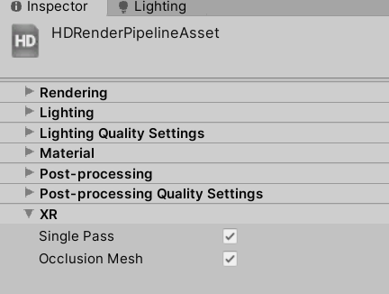

1. Then should adjust light. Please refer to this document, Adjusting Lighting Part.

<https://docs.unity3d.com/Packages/com.unity.render-pipelines.high-definition@8.0/manual/Upgrading-To-HDRP.html>

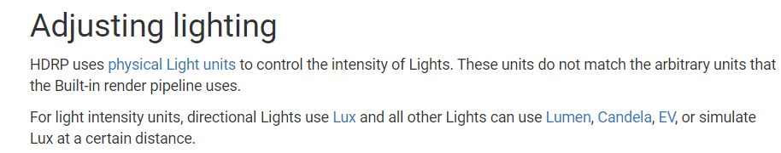

1. Result: Now you can use HDRP version office in VR.