**7-6｜三种IO代码**

**BIO**

关于BIO的服务端代码如下：

|  |
| --- |
| Java package bio;  import java.io.IOException; import java.io.InputStream; import java.net.InetSocketAddress; import java.net.ServerSocket; import java.net.Socket;  /**  * @Author idea  * @Date: Created in 20:50 2023/7/1  * @Description  */ public class BioServer {   public static void main(String[] args) throws IOException {  ServerSocket serverSocket = new ServerSocket();  serverSocket.bind(new InetSocketAddress(9090));  Socket socket = serverSocket.accept();  while (true) {  InputStream inputStream = socket.getInputStream();  byte[] bytes = new byte[20];  inputStream.read(bytes);  System.out.println("读取到的数据是：" + new String(bytes));  }  } } |

关于BIO的客户端代码如下：

|  |
| --- |
| Java package bio;  import java.io.IOException; import java.io.OutputStream; import java.net.InetSocketAddress; import java.net.Socket;  /**  * @Author idea  * @Date: Created in 20:52 2023/7/1  * @Description  */ public class BioClient {   public static void main(String[] args) throws IOException, InterruptedException {  Socket socket = new Socket();  socket.connect(new InetSocketAddress(9090));  OutputStream outputStream = socket.getOutputStream();  while (true) {  outputStream.write("test".getBytes());  outputStream.flush();  System.out.println("发送数据");  Thread.sleep(1000);  }  } } |

如果希望在BIO的服务端使用异步的思路去进行优化，那么可以参考如下版本的代码去进行实践：

|  |
| --- |
| Java package bio;   import java.io.IOException; import java.io.InputStream; import java.net.InetSocketAddress; import java.net.ServerSocket; import java.net.Socket; import java.util.ArrayList; import java.util.List; import java.util.concurrent.ArrayBlockingQueue; import java.util.concurrent.ThreadPoolExecutor; import java.util.concurrent.TimeUnit;   /**  * @Author idea  * @Date: Created in 20:50 2023/7/1  * @Description  */ public class BioServer2 {   private static ThreadPoolExecutor threadPoolExecutor = new ThreadPoolExecutor(10, 10, 3, TimeUnit.MINUTES, new ArrayBlockingQueue<>(100));   public static void main(String[] args) throws IOException {  ServerSocket serverSocket = new ServerSocket();  //绑定端口9090  serverSocket.bind(new InetSocketAddress(9090));  while (true) {  try {  Socket socket = serverSocket.accept();  threadPoolExecutor.execute(() -> {  try {  InputStream inputStream = socket.getInputStream();  byte[] bytes = new byte[10];  //阻塞调用  inputStream.read(bytes);  System.out.println("服务端收到的数据是：" + new String(bytes));  } catch (IOException e) {  throw new RuntimeException(e);  }  });  } catch (IOException e) {  throw new RuntimeException(e);  }  }  } } |

但是如果按照上边的这段代码去实现的话，会存在一定的性能问题。

每次来一个请求，就创建一个连接，假设我们极端情况下，一台服务器下维持了1000条连接，但是这一千条连接都是没有数据发送的状态，那么我们的服务端就必须要有1000条线程去进行维持，并且都是处于read的阻塞状态。这不就是白白的资源浪费么？

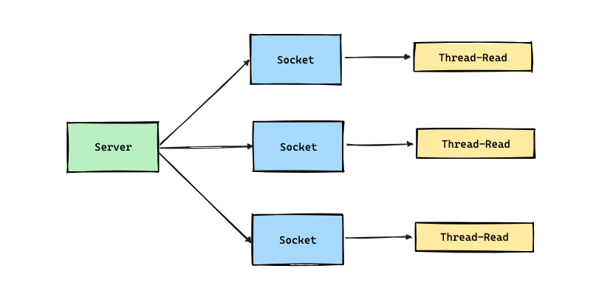

这种模型的并发度并不会有很好的一个表现，因为它的并发度取决于后台可以创建的线程数。

那么下边，让我们再来看看NIO的实现思路是怎样的。

**NIO**

简单的NIO服务端代码案例如下，

|  |
| --- |
| Java package nio;  import java.io.IOException; import java.net.InetSocketAddress; import java.nio.ByteBuffer; import java.nio.channels.ServerSocketChannel; import java.nio.channels.SocketChannel; import java.util.ArrayList; import java.util.List;  /**  * @Author idea  * @Date: Created in 21:59 2023/7/1  * @Description  */ public class NioSimpleServer {   private static List<SocketChannel> acceptSocketList = new ArrayList<>();   public static void main(String[] args) throws IOException {  ServerSocketChannel serverSocketChannel = ServerSocketChannel.open();  serverSocketChannel.socket().bind(new InetSocketAddress(9090));  serverSocketChannel.configureBlocking(false);  System.out.println("服务启动成功");  new Thread(() -> {  while (true) {  for (SocketChannel socketChannel : acceptSocketList) {  try {  ByteBuffer byteBuffer = ByteBuffer.allocate(10);  socketChannel.read(byteBuffer);  System.out.println("收到数据:" + new String(byteBuffer.array()));  } catch (IOException e) {  throw new RuntimeException(e);  }  }  try {  Thread.sleep(1000);  } catch (InterruptedException e) {  throw new RuntimeException(e);  }  }  }).start();  while (true) {  SocketChannel socketChannel = serverSocketChannel.accept();  if (socketChannel != null) {  System.out.println("连接成功了");  socketChannel.configureBlocking(false);  acceptSocketList.add(socketChannel);  }  }  } } |

基于Selector去实现的NIO代码，底层执行链路如下所示：

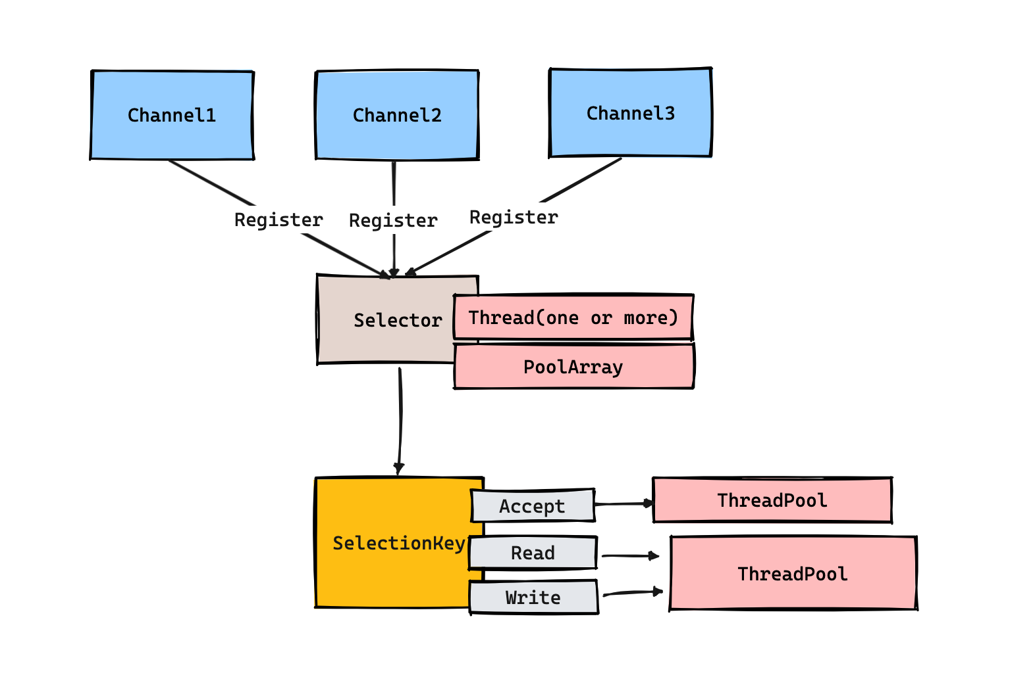

基于Selector实现NIO服务端的代码实现如下：

|  |
| --- |
| Java package nio;  import java.io.IOException;  import java.net.InetSocketAddress;   import java.net.ServerSocket;   import java.nio.ByteBuffer;   import java.nio.channels.SelectionKey;   import java.nio.channels.Selector;   import java.nio.channels.ServerSocketChannel;   import java.nio.channels.SocketChannel;   import java.util.Iterator;   import java.util.Set;     public class NIOSelectorServer {    /*标识数字*/   private int flag = 0;   /*缓冲区大小*/   private int BLOCK = 4096;   /*接受数据缓冲区*/   private ByteBuffer sendbuffer = ByteBuffer.allocate(BLOCK);   /*发送数据缓冲区*/   private ByteBuffer receivebuffer = ByteBuffer.allocate(BLOCK);   private Selector selector;     public NIOSelectorServer(int port) throws IOException {  // 打开服务器套接字通道   ServerSocketChannel serverSocketChannel = ServerSocketChannel.open();   // 服务器配置为非阻塞   serverSocketChannel.configureBlocking(false);   // 检索与此通道关联的服务器套接字   ServerSocket serverSocket = serverSocketChannel.socket();   // 进行服务的绑定   serverSocket.bind(new InetSocketAddress(port));   // 通过open()方法找到Selector   selector = Selector.open();  System.out.println(selector);  // 注册到selector，等待连接   serverSocketChannel.register(selector, SelectionKey.OP_ACCEPT);   System.out.println("Server Start----8888:");   }      // 监听   private void listen() throws IOException {   while (true) {   // 这里如果没有IO事件抵达 就会进入阻塞状态  selector.select();  System.out.println("select");  // 返回此选择器的已选择键集。   Set<SelectionKey> selectionKeys = selector.selectedKeys();   Iterator<SelectionKey> iterator = selectionKeys.iterator();   while (iterator.hasNext()) {   SelectionKey selectionKey = iterator.next();   iterator.remove();   handleKey(selectionKey);   }   }   }     // 处理请求   private void handleKey(SelectionKey selectionKey) throws IOException {   // 接受请求   ServerSocketChannel server = null;   SocketChannel client = null;   String receiveText;   String sendText;   int count=0;   // 测试此键的通道是否已准备好接受新的套接字连接。   if (selectionKey.isAcceptable()) {   // 返回为之创建此键的通道。   server = (ServerSocketChannel) selectionKey.channel();   // 接受到此通道套接字的连接。   // 非阻塞模式这里不会阻塞  client = server.accept();  // 配置为非阻塞   client.configureBlocking(false);   // 注册到selector，等待连接   client.register(selector, SelectionKey.OP_READ);   } else if (selectionKey.isReadable()) {   // 返回为之创建此键的通道。   client = (SocketChannel) selectionKey.channel();   //将缓冲区清空以备下次读取   receivebuffer.clear();   //读取服务器发送来的数据到缓冲区中   count = client.read(receivebuffer);   if (count > 0) {   receiveText = new String( receivebuffer.array(),0,count);   System.out.println("服务器端接受客户端数据--:"+receiveText);   client.register(selector, SelectionKey.OP_WRITE);   }   } else if (selectionKey.isWritable()) {   //将缓冲区清空以备下次写入   sendbuffer.clear();   // 返回为之创建此键的通道。   client = (SocketChannel) selectionKey.channel();   sendText="message from server--" + flag++;   //向缓冲区中输入数据   sendbuffer.put(sendText.getBytes());   //将缓冲区各标志复位,因为向里面put了数据标志被改变要想从中读取数据发向服务器,就要复位   sendbuffer.flip();   //输出到通道   client.write(sendbuffer);   System.out.println("服务器端向客户端发送数据--："+sendText);   client.register(selector, SelectionKey.OP_READ);   }   }     /**   * @param args   * @throws IOException   */   public static void main(String[] args) throws IOException {   int port = 9090;  NIOSelectorServer server = new NIOSelectorServer(port);  server.listen();   }   } |

在LInux环境中，java.nio.channels.Selector的子类叫做 sun.nio.ch.EPollSelectorImpl ，其底层是基于Epoll模型去实现的IO多路复用器。



对于Epoll模型 我们需要了解到它底层的三个函数

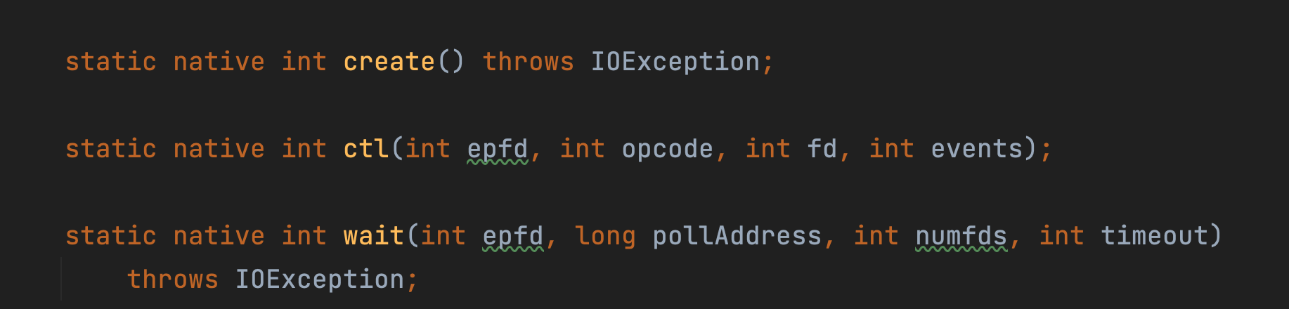

在JDK实现的底层中，EPollSelectorImpl在初次创建的时候，会调用create函数去内存块中开辟一块空间。然后再调用ctl方法，往这个内存块中创建一颗红黑树，并且将socket对象插入到树上。然后再调用wait方法，让出CPU。

整体的执行过程如下图所示：

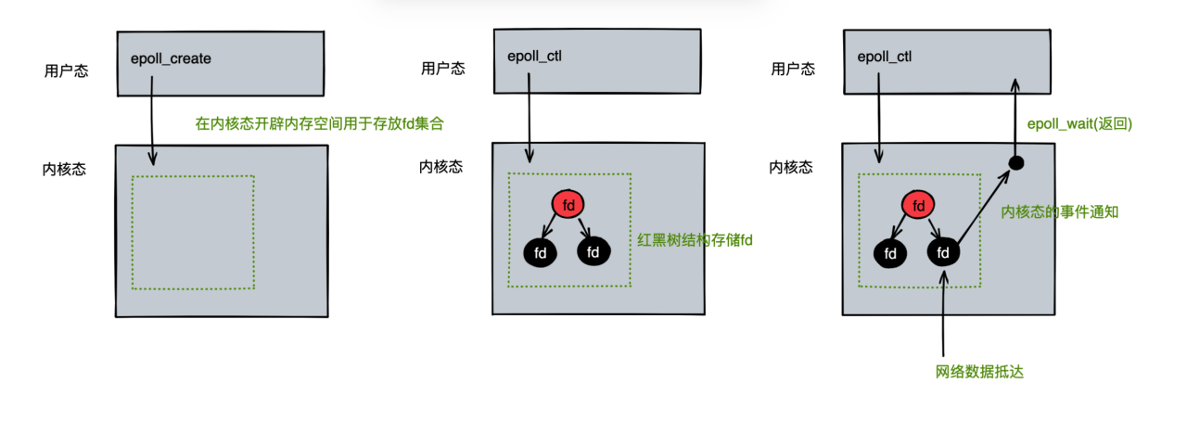

等待到有数据抵达的时候，这个wait的阻塞方法，才会继续执行下去。

**AIO**

AIO代码的流程如下图所示：

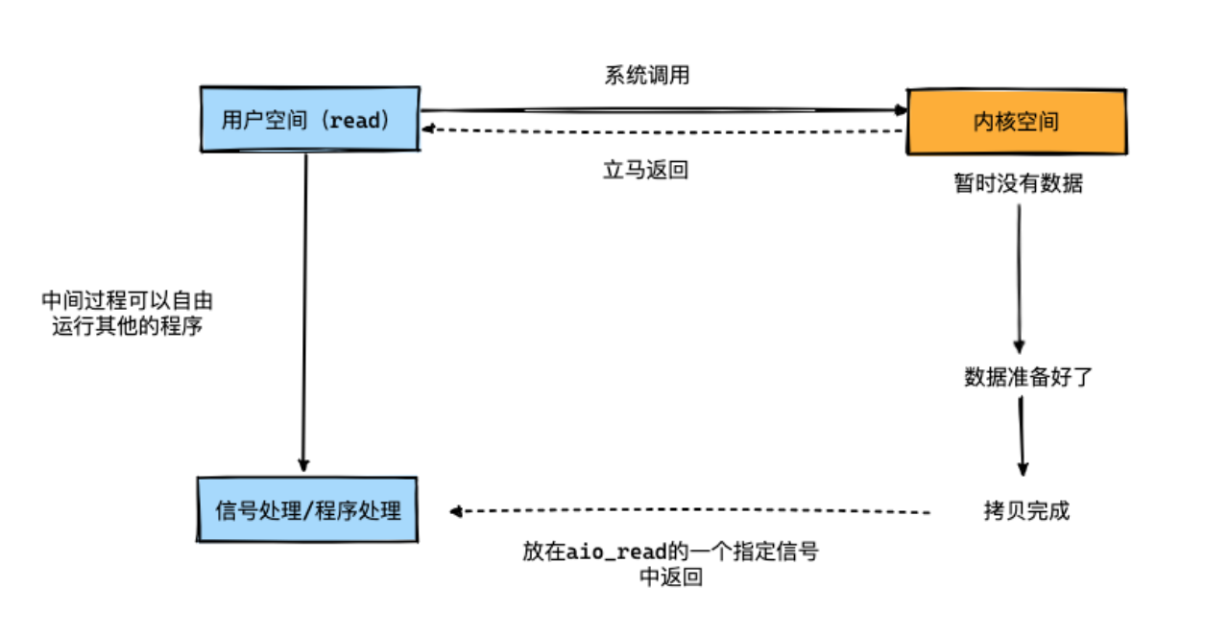

在代码实现上，可以基于一个回调通知的形式来进行开发，其服务端代码如下：

|  |
| --- |
| Java package aio;  import java.io.IOException; import java.net.InetSocketAddress; import java.nio.ByteBuffer; import java.nio.channels.AsynchronousServerSocketChannel; import java.nio.channels.AsynchronousSocketChannel; import java.nio.channels.CompletionHandler; import java.nio.charset.Charset; import java.util.concurrent.ExecutionException; import java.util.concurrent.Future; import java.util.concurrent.TimeUnit; import java.util.concurrent.TimeoutException;   public class AIOServer {   public final static int PORT = 9888;  private AsynchronousServerSocketChannel server;   public AIOServer() throws IOException {  server = AsynchronousServerSocketChannel.open().bind(  new InetSocketAddress(PORT));  }   /**  * 不推荐使用future的方式去进行编程，这种方式去实现AIO其实本质和BIO没有太大的区别  *  * @throws InterruptedException  * @throws ExecutionException  * @throws TimeoutException  */  public void startWithFuture() throws InterruptedException,  ExecutionException, TimeoutException {  while (true) {// 循环接收客户端请求  Future<AsynchronousSocketChannel> future = server.accept();  AsynchronousSocketChannel socket = future.get();// get() 是为了确保 accept 到一个连接  handleWithFuture(socket);  }  }   public void handleWithFuture(AsynchronousSocketChannel channel) throws InterruptedException, ExecutionException, TimeoutException {  ByteBuffer readBuf = ByteBuffer.allocate(2);  readBuf.clear();   while (true) {// 一次可能读不完  //get 是为了确保 read 完成，超时时间可以有效避免DOS攻击，如果客户端一直不发送数据，则进行超时处理  Integer integer = channel.read(readBuf).get(10, TimeUnit.SECONDS);  System.out.println("read: " + integer);  if (integer == -1) {  break;  }  readBuf.flip();  System.out.println("received: " + Charset.forName("UTF-8").decode(readBuf));  readBuf.clear();  }  }   /**  * 即提交一个 I/O 操作请求，并且指定一个 CompletionHandler。  * 当异步 I/O 操作完成时，便发送一个通知，此时这个 CompletionHandler 对象的 completed 或者 failed 方法将会被调用。  *  * @throws InterruptedException  * @throws ExecutionException  * @throws TimeoutException  */  public void startWithCompletionHandler() throws InterruptedException,  ExecutionException, TimeoutException {  server.accept(null,  new CompletionHandler<AsynchronousSocketChannel, Object>() {  public void completed(AsynchronousSocketChannel result, Object attachment) {  server.accept(null, this);// 再此接收客户端连接  handleWithCompletionHandler(result);  }   @Override  public void failed(Throwable exc, Object attachment) {  exc.printStackTrace();  }  });  }   public void handleWithCompletionHandler(final AsynchronousSocketChannel channel) {  try {  final ByteBuffer buffer = ByteBuffer.allocate(4);  final long timeout = 10L;  channel.read(buffer, timeout, TimeUnit.SECONDS, null, new CompletionHandler<Integer, Object>() {  @Override  public void completed(Integer result, Object attachment) {  System.out.println("read:" + result);  if (result == -1) {  try {  channel.close();  } catch (IOException e) {  e.printStackTrace();  }  return;  }  buffer.flip();  System.out.println("received message:" + Charset.forName("UTF-8").decode(buffer));  buffer.clear();  channel.read(buffer, timeout, TimeUnit.SECONDS, null, this);  }   @Override  public void failed(Throwable exc, Object attachment) {  exc.printStackTrace();  }  });  } catch (Exception e) {  e.printStackTrace();  }  }   public static void main(String args[]) throws Exception { // new AIOServer().startWithFuture();  new AIOServer().startWithCompletionHandler();  Thread.sleep(100000);  } } |

客户端代码如下：

|  |
| --- |
| Java package aio;  import java.net.InetSocketAddress; import java.nio.ByteBuffer; import java.nio.channels.AsynchronousSocketChannel;  public class AIOClient {   public static void main(String... args) throws Exception {  AsynchronousSocketChannel client = AsynchronousSocketChannel.open();  client.connect(new InetSocketAddress("localhost", 9888)).get();  while (true) {  client.write(ByteBuffer.wrap("123456789".getBytes()));  Thread.sleep(1000);  }  } } |

**为什么Netty没有使用AIO而是采用NIO的思路去进行设计？**

引用了创始人的一段话来解释下这个原因：

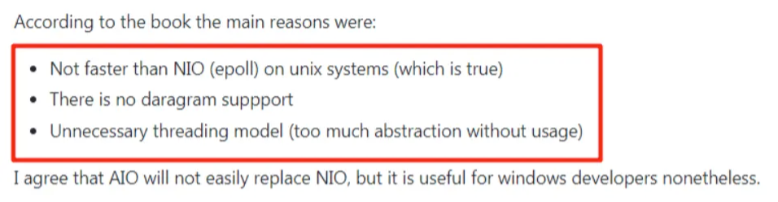

* 不比nio快在Unix系统上
* 不支持数据报
* 不必要的线程模型（太多没什么用的抽象化）

总而言之，可以理解为，在Unix系统上AIO性能综合表现不如NIO好，所以Netty使用了NIO作为底层的核心。